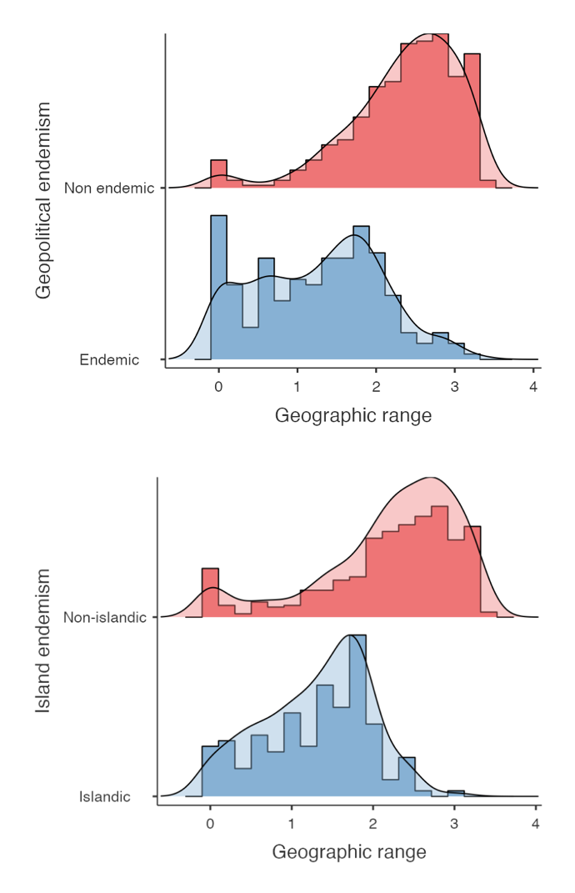
Supplementary Figure 4. Relationship of geographical range to island endemism and geopolitical endemism showing the relatedness of both variables.

