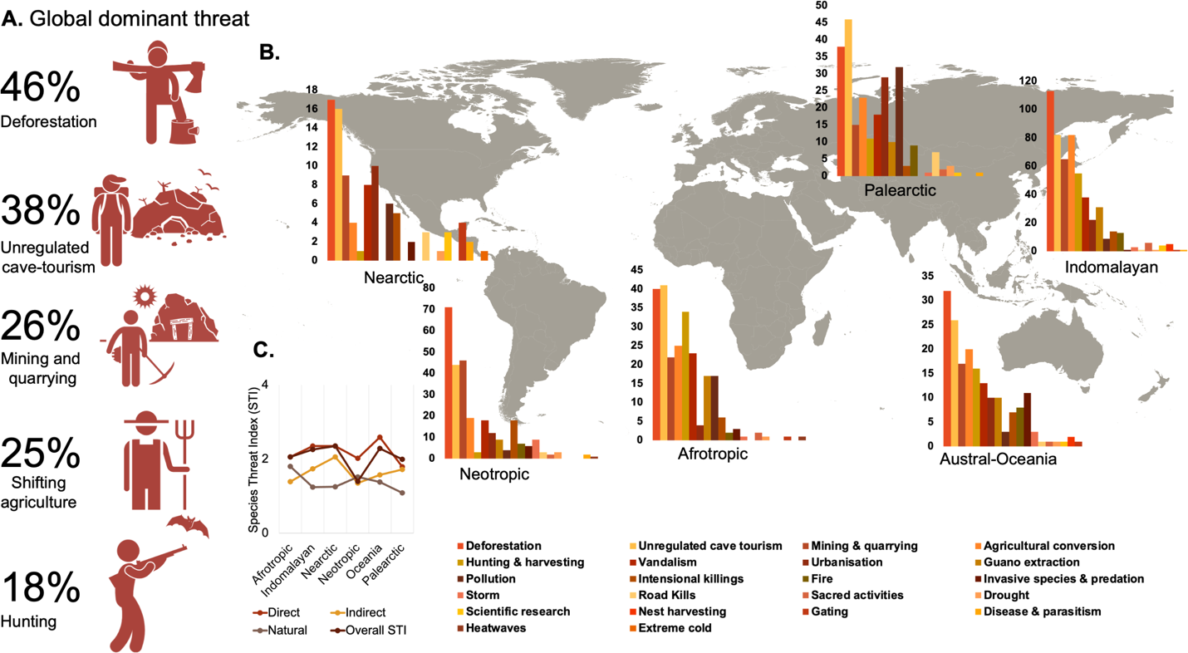
Supplementary Figure 2. Distribution of global dominant threats (A) and biogeographical patterns (frequency) of threatening process (B) and mean threat index (C). Complete threat distribution per species are supplemented in Supplementary Data 1.

