Supplementary Information
Title: CD39 activities in the treated acupoints contributed to the analgesic mechanism of acupuncture on arthritis rats
Journal: Purinergic Signaling
Authors: Yu-Jia Li¹, Jie Lin¹, Si-Qi Tang¹, Wei-Min Zuo¹, Guang-Hong Ding³, Xue-Yong Shen^{1, 2}, Li-Na Wang^{1, 2}
- School of Acupuncture-Moxibustion and Tuina, Shanghai University of Traditional Chinese Medicine, Shanghai 201203, China
- Shanghai Research Center for Acupuncture and Meridians, Shanghai 201203, China
- Shanghai Key Laboratory of Acupuncture Mechanism and Acupoint Function (21DZ2271800), Department of Aeronautics and Astronautics, Fudan University, Shanghai 200433, China.
Li-Na Wang: lnwang@shutcm.edu.cn
Xue-Yong Shen: sxy1@shutcm.edu.cn
Yu-Jia Li: 12022020@ shutcm.edu.cn
Jie Lin: 22022043@shutcm.edu.cn
Si-Qi Tang: tangsq1117@163.com
Wei-Min Zuo: wmZuo0207@163.com
Guang-Hong Ding:ghding@fudan.edu.cn

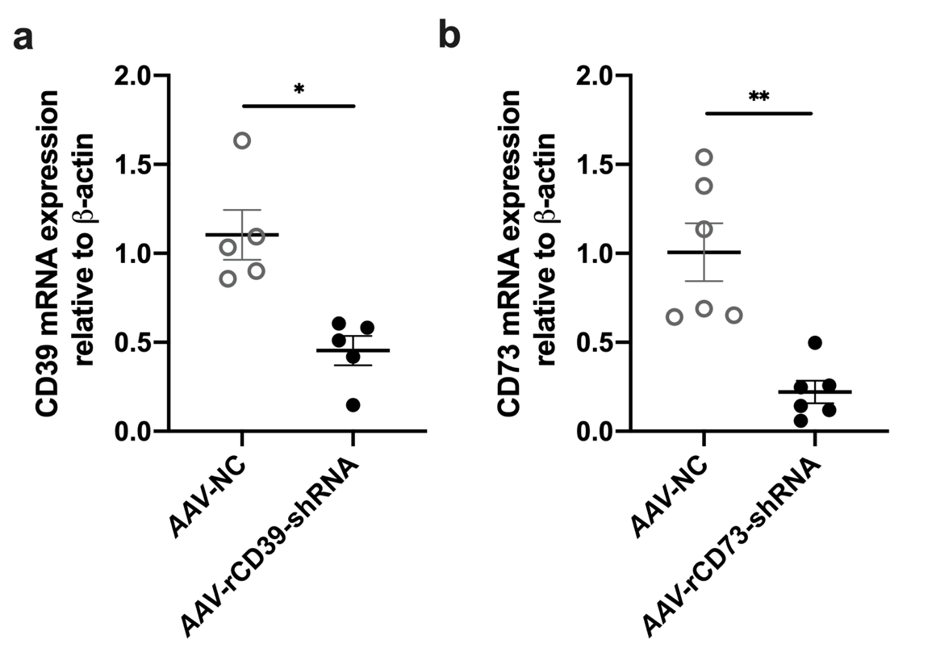
Online Resource 1 qRt-PCR determination of ST36 treated with AAV-rCD73-shRNA, when negative control (AAV-NC) rats as contrast (n=5-6). * p<0.05 ** p<0.01.

