Supplementary Figure 1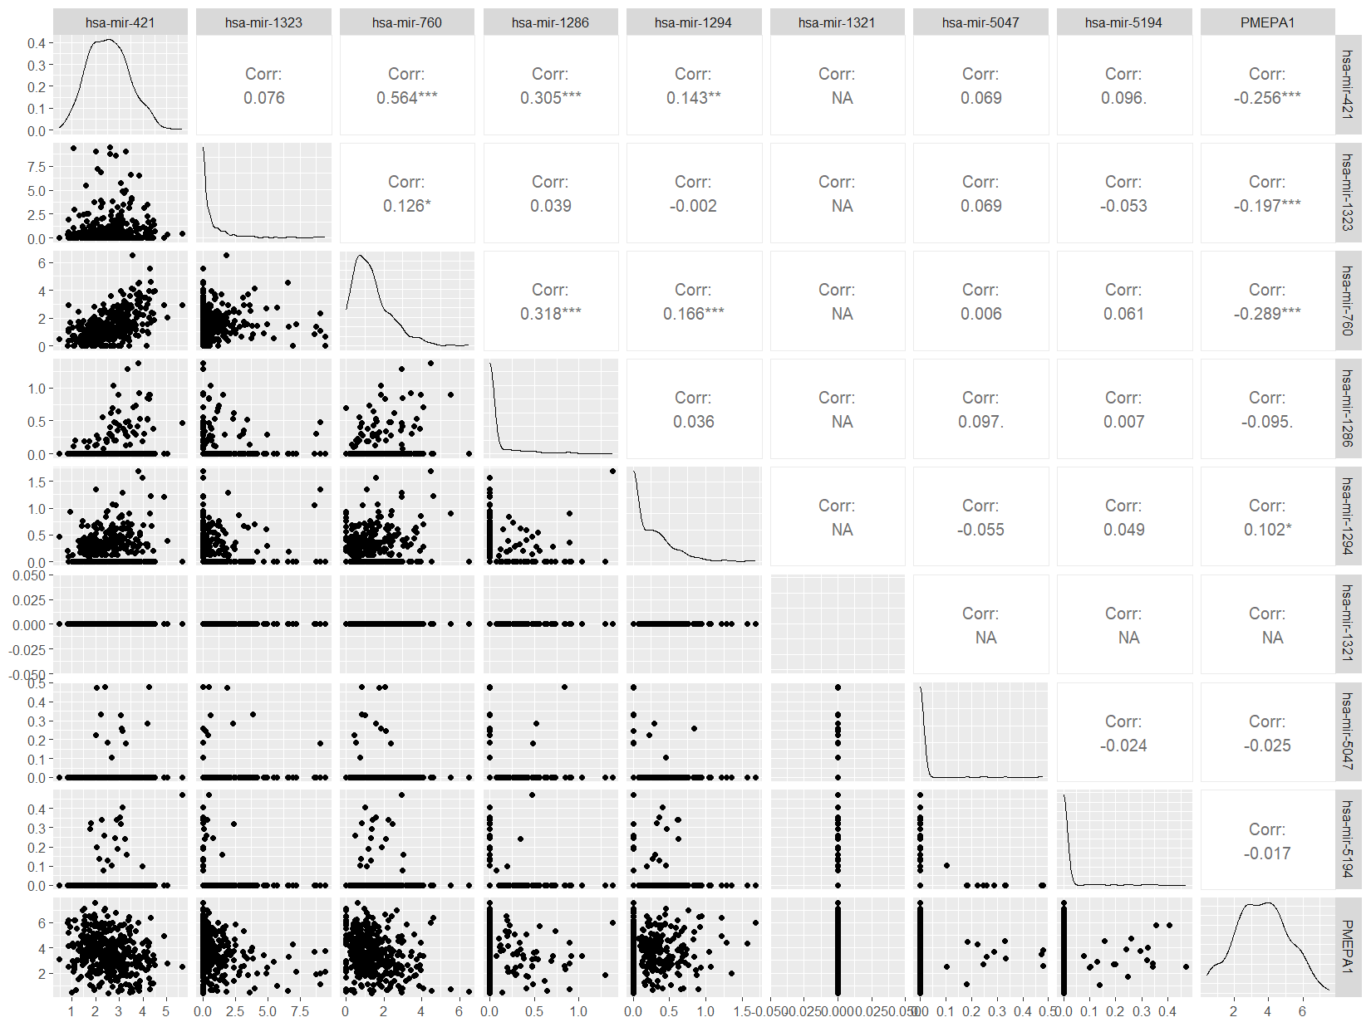
Supplementary Figure 1: Correlation analysis of PMEPA1 and 8 potential interacting microRNAs in bladder cancer samples from the TCGA-BLCA dataset. miR-421, miR-1323, and miR-760 showed a significant negative correlation with PMEPA1 expression (p < 0.001).

Supplementary Figure 2
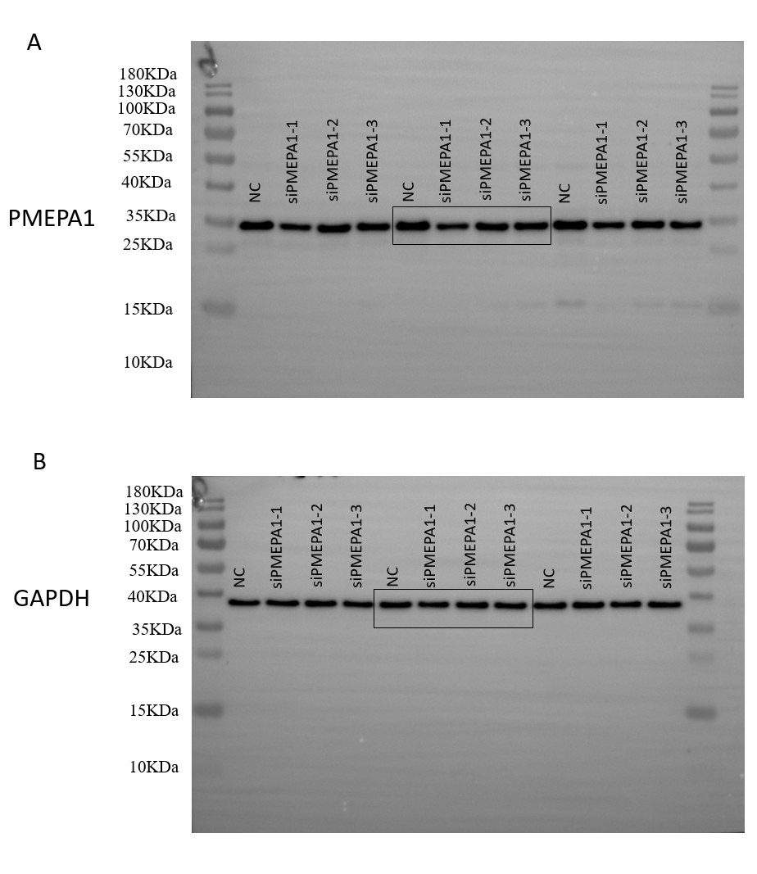
Supplementary Figure 2: Full-length blots of Figure 2C
Supplementary Figure 3
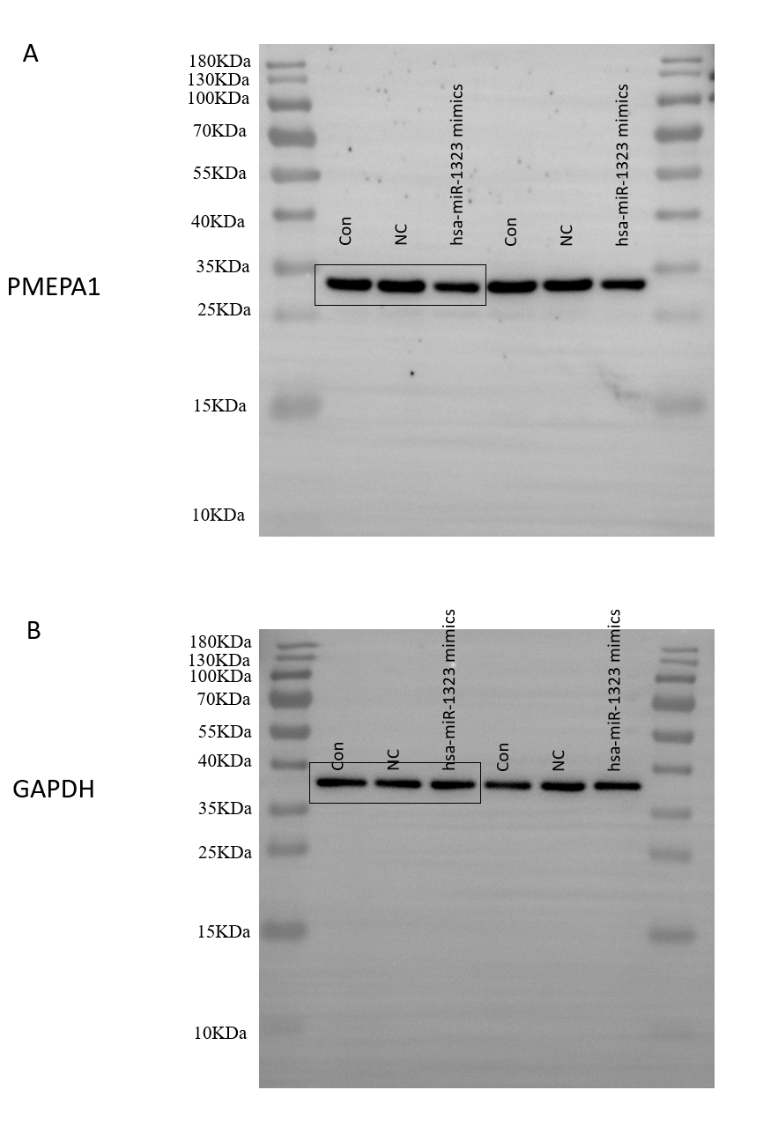
Supplementary Figure 3: Full-length blots of Figure 3D

Supplementary Figure 4
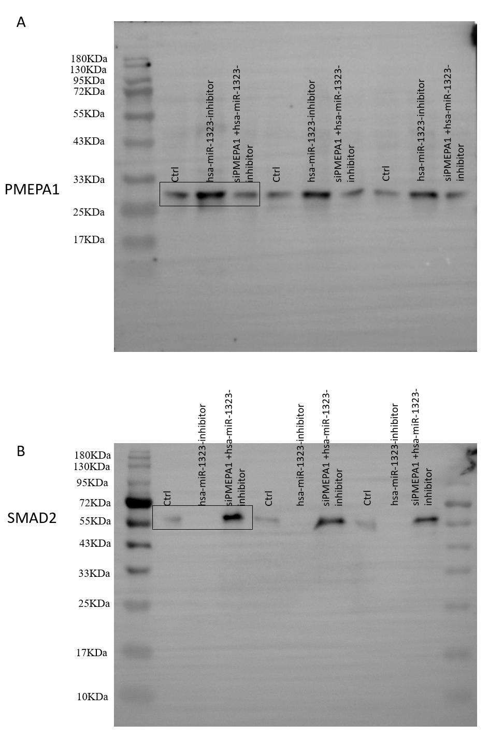
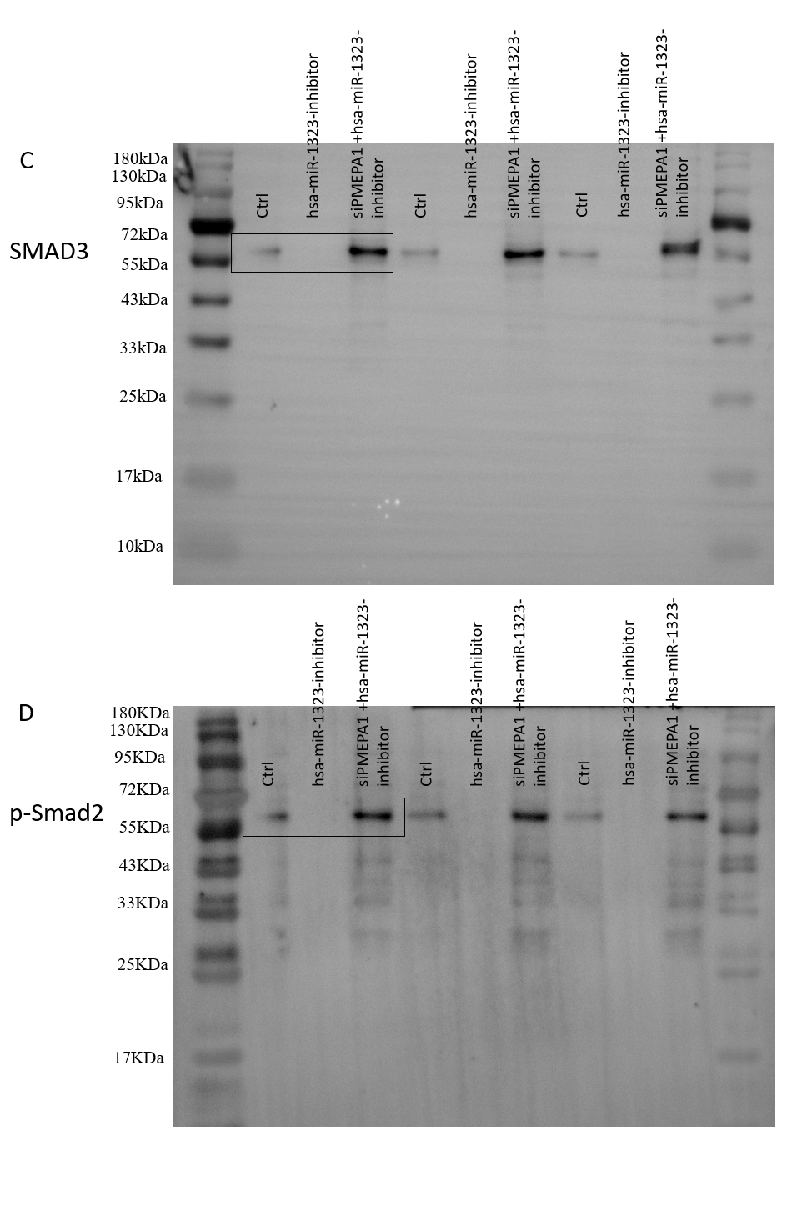
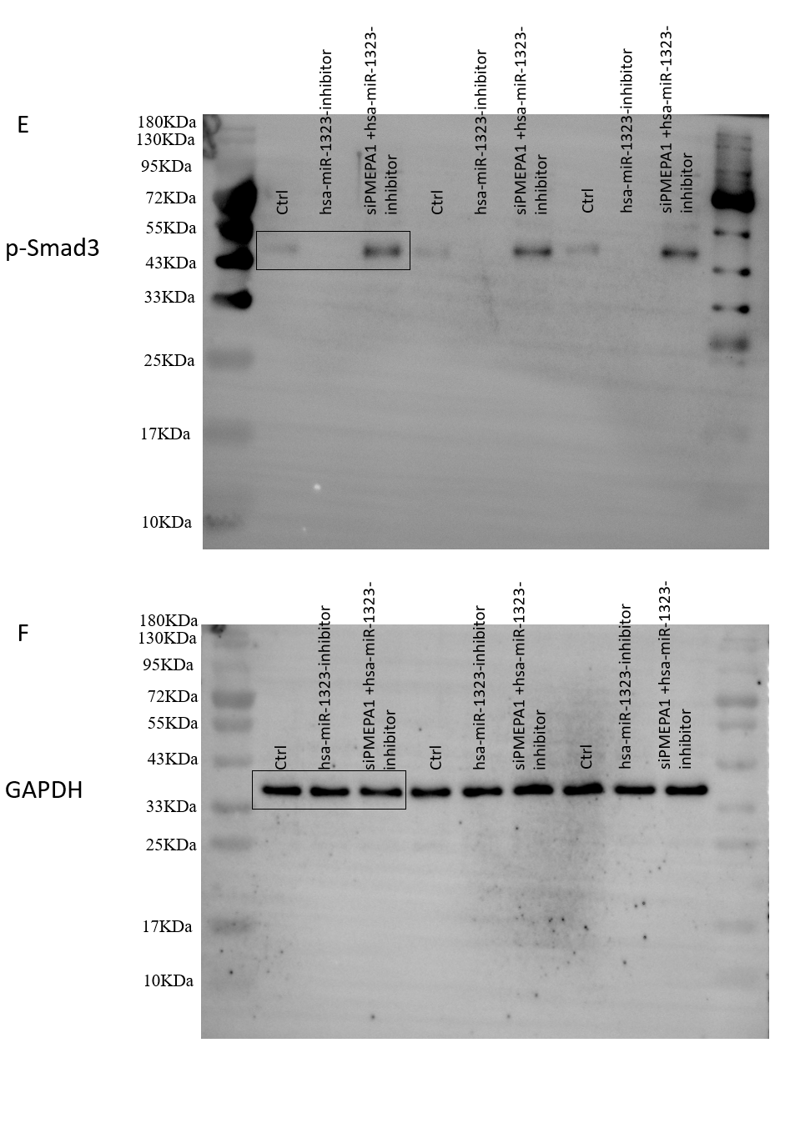
Supplementary Figure 4: Full-length blots of Figure 5E

Supplement Table 1
TargetScan_8.0
miRNA | Position in  the UTR | seed match | context++  score | context++ score  percentile | weighted context++  score
hsa-miR-1323 | 1866-1873 | 8mer | -0.03 | 69 | -0.02
hsa-miR-421 | 671-677 | 7mer-m8 | -0.02 | 37 | -0.02
hsa-miR-760 | 2589-2595 | 7mer-m8 | -0.02 | 24 | -0.01

Supplement Table 1：The TargetScan 8.0 database predicts the scores of potential miRNAs that may bind to the PMEPA1 3' UTR region.

