Table 3: Physical and Chemical data of substituted imidazoles (10a-10g)
Compounds | Aldehyde | Imidazole | Time (h) | Yield (%) | m.p.(⁰C)
1, 10a | 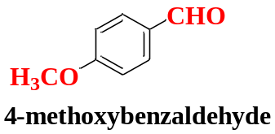 | 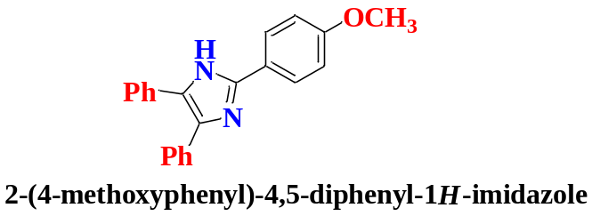 | 0.40 | 87 | 229-230
2, 10b | 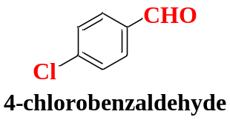 | 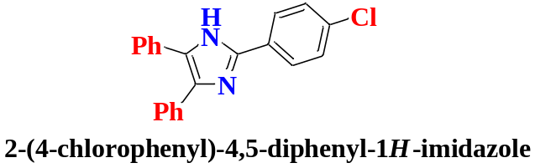 | 0.35 | 82 | 160-162
3, 10c | 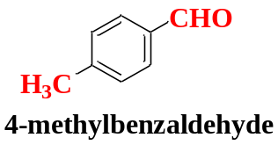 | 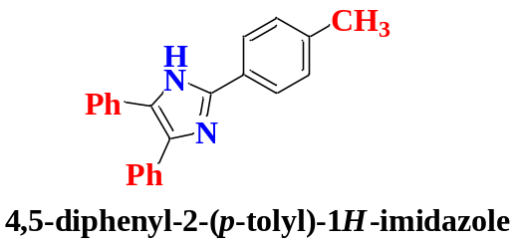 | 0.45 | 83 | 233-235
4, 10d | 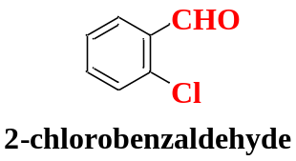 | 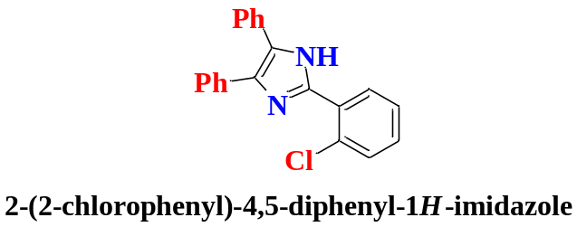 | 1.00 | 80 | 195-197
5, 10e | 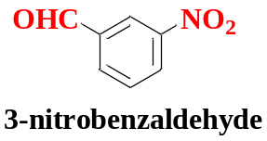 | 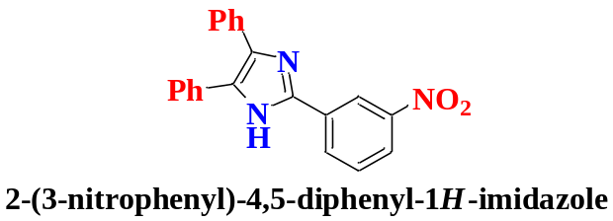 | 0.50 | 78 | 197-198
6, 10f | 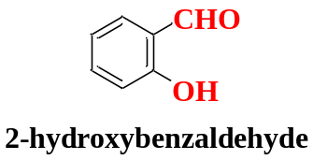 | 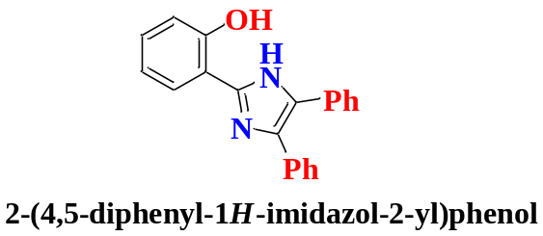 | 0.50 | 80 | 119-120
7, 10g | 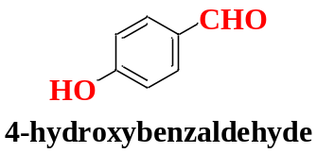 | 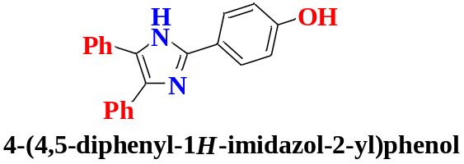 | 0.45 | 81 | 254-256

