Partial unidirectional translocation from 5AL to 7BS leads to dense spike in an EMS-induced wheat mutant
Xiaoyu Zhang^{1,#}, Yongfa Wang^{1,#}, Yongming Chen¹, Yazhou Li², Kai Guo¹, Jin Xu¹, Panfeng Guan¹, Tianyu Lan¹, Mingming Xin¹, Zhaorong Hu¹, Weilong Guo¹, Yingyin Yao¹, Zhongfu Ni¹, Qixin Sun¹, Ming Hao^{2,*} and Huiru Peng^{1,*}
¹Frontiers Science Center for Molecular Design Breeding, Key Laboratory of Crop Heterosis and Utilization, Beijing Key Laboratory of Crop Genetic Improvement, China Agricultural University, Beijing 100193, China.
²Triticeae Research Institute, Sichuan Agricultural University, Chengdu, 611130, Sichuan, China.
#These authors contributed equally: Xiaoyu Zhang, Yongfa Wang
*Correspondence: Ming Hao (haomingluo@foxmail.com), Huiru Peng (penghuiru@cau.edu.cn; penghuiru1452@163.com)

INVENTORY
Fig.S1 PCR amplification of polymorphic markers.
Fig.S2 The UT 7BS-5AL and RT 1DL-3AS.3AL in ds1.
Fig.S3 Phenotype of NIL-Y3002, NIL-ds1, and Y3002 at the heading stage.
Fig.S4 Q gene genomic sequence comparison between ND3753 and ds1.

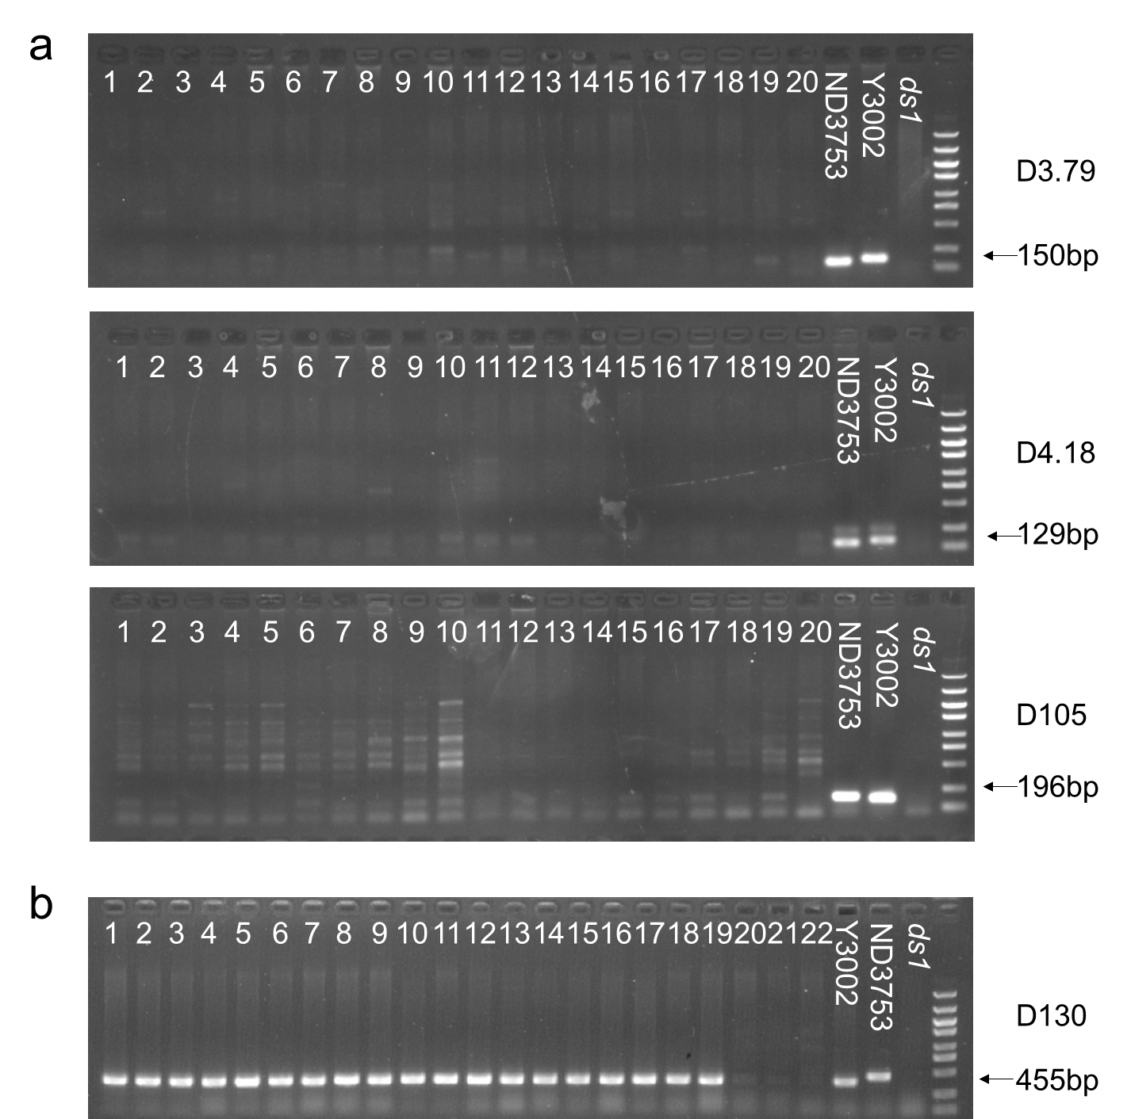
Fig.S1 PCR amplification of polymorphic markers. (a)Amplification of markers D3.79, D4.18, D105 in 20 progenies from R4. (b) Amplification of marker D130 in F_{4:5} progenies of the important recombinants; 1-19, plants with long spike, 20-22, plants with dense spike. Arrows indicate polymorphic DNA bands. M, DNA Ladder 5000.

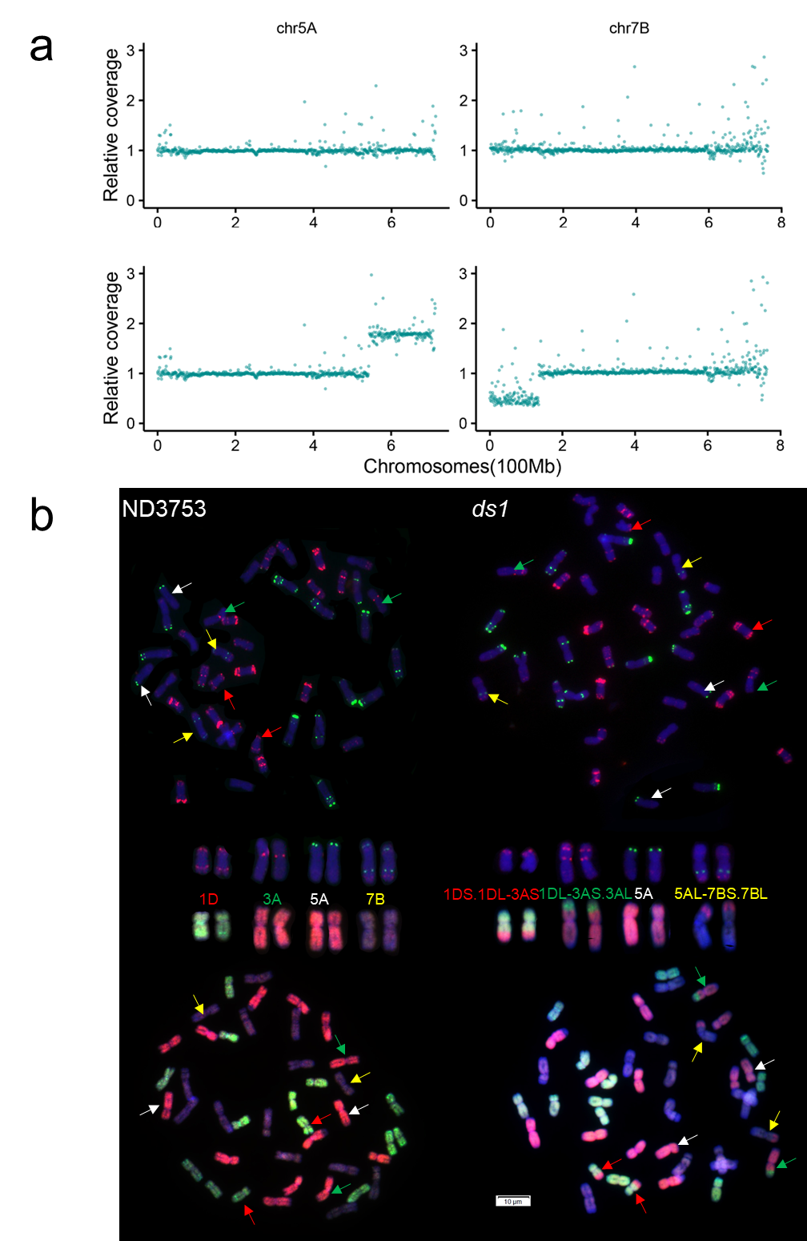
Fig.S2 The UT 7BS-5AL and RT 1DL-3AS.3AL in ds1. (a) The 5A and 7B chromosomes relative reads coverages of long-spike bulk (upper) and dense-spike bulk (below) from the ND3753 and ds1 population; (b) Fluorescence in situ hybridization/genomic in situ hybridization illustration of ND3753 and ds1. The different colorful arrow bar: red, green, white and yellow point to chromosomes 1D, 3A, 5A and 7B respectively. There has UT 5AL-7BS.7BL and RT 1DL-3AS.3AL in ds1. UT, unidirectional translocation; RT, reciprocal translocation.

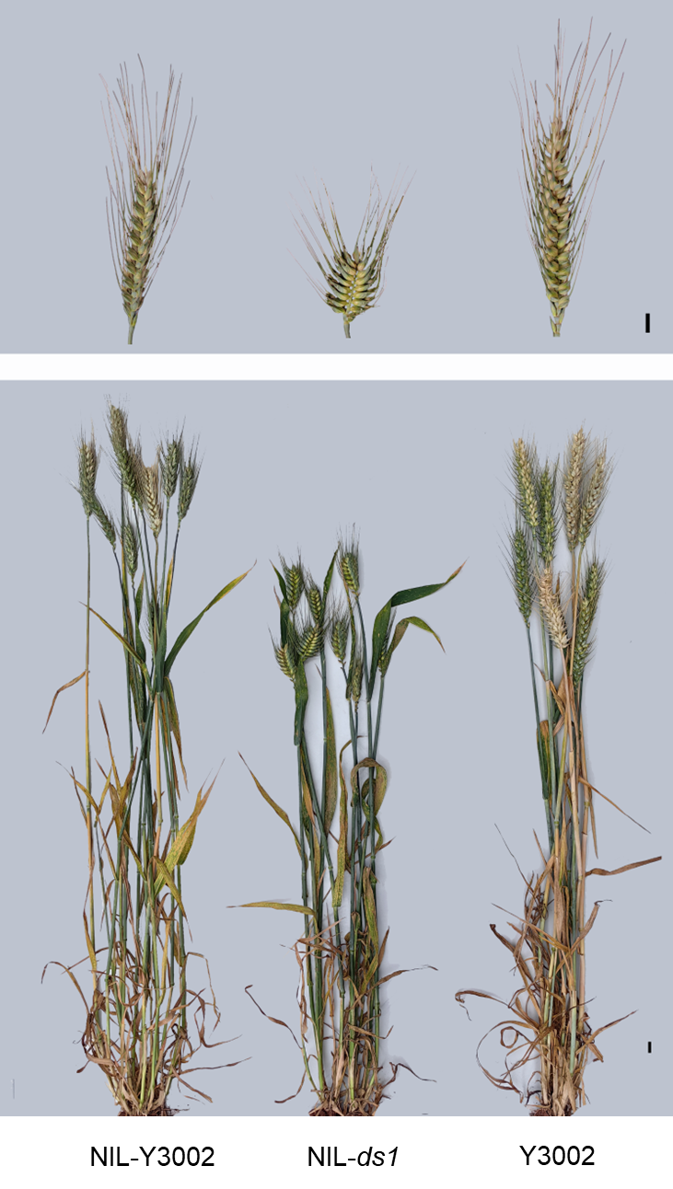
Fig.S3. Phenotype of NIL-Y3002, NIL-ds1, and Y3002 at the heading stage. Scale bar: 1 cm.

Fig.S4 Q gene genomic sequence comparison between ND3753 and ds1. Compared with ND3753, the sequence of Q gene was no variation in ds1.

