Dragonfly: A Portable Molecular Diagnostic Platform for Rapid Point-of-Care Detection of Mpox and Other Diseases
Matthew L. Cavuto^{1,2,&}, Kenny Malpartida-Cardenas^{1,2,&}, Ivana Pennisi^{1,2}, Marcus Pond³, Sohail Mirza^{1,2}, Nicholas Moser^{2,4}, Mark Comer², Isobel Stokes⁵, Lucy Eke⁵, Sian Lant⁵, Katarzyna M. Szostak², Luca Miglietta¹, Oliver W. Stringer^{1,2}, Rebecca P. Sumner⁵, Frances Bolt^{1,2}, Shiranee Sriskandan¹, Alison Holmes¹, Pantelis Georgiou^{2,4}, David O. Ulaeto⁶, Carlos Maluquer de Motes⁵, Jesus Rodriguez-Manzano^{1,2,*}
¹ Department of Infectious Disease, Faculty of Medicine, Imperial College London, London, UK
² ProtonDx Ltd, Translation & Innovation Hub, Imperial College London, London, UK
³ Department of Infection and Immunity, Imperial College Healthcare NHS Trust, London, UK
⁴ Department of Electrical and Electronic Engineering, Imperial College London, London, UK
⁵ Department of Microbial Sciences, School of Biosciences and Medicine, University of Surrey, Guildford, UK
⁶ CBR Division, Defence Science and Technology Laboratory, Salisbury, UK
& These authors contributed equally
* Corresponding author: j.rodriguez-manzano@imperial.ac.uk

Table of Contents
Table S1. LAMP assays sequences used in this study 2
Table S2. Summary of the LAMP assays used in this study 4
Table S3. Sample-to-result analytical sensitivity performance 5
Table S4. PCR assays sequences used in this study 6
Figure S1. Standard curves of LAMP assays used in this study 7
Figure S2. Confusion matrices of diagnostic performance 8
Figure S3. Histogram showing the distribution of the C_{t} values obtained from the all the clinical samples 9

Table S1. LAMP assays sequences used in this study.
Target | LAMP assay ID | Sequence (5' to 3')
OPXV | LAMP-OPV-E9L-F3 | AACATTTTTGGCAGAGAGAG
OPXV | LAMP-OPV-E9L-B3 | ATAGATGGCCTTTTCAGTTGAAC
OPXV | LAMP-OPV-E9L-LF | GCTAAGAGTTGCACATCCATAGG
OPXV | LAMP-OPV-E9L-LB | GATAACTCTGCTCCATTTAGTACC
OPXV | LAMP-OPV-E9L-FIP | ATCTTGTACGTATAYTGCATGGAATC-AAAGATGYTAAAACAGGCTACC
OPXV | LAMP-OPV-E9L-BIP | AGTGCTCTATACTCATACGCTTCG-TCTAGATACAAKATCATTCTACGTCC
OPXV | LAMP-OPV-F13L-F3 | ATTTGGCCATAGTTCCCAC
OPXV | LAMP-OPV-F13L-B3 | CRTCGTCGACTATYAACAAT
OPXV | LAMP-OPV-F13L-LF | ACTCCTCTATTAATGGCTGCTT
OPXV | LAMP-OPV-F13L-LB | CCGCCAGAAGTCTAGACGC
OPXV | LAMP-OPV-F13L-FIP | CCAATTACCRACTARAAGTCTGA-ATTGGCCYGACATTTACAAC
OPXV | LAMP-OPV-F13L-BIP | AACGACGTATATTCTATGGCAAC-ACCTTCACAGATAGATCATTTTGRA
MPXV | LAMP-MPXV-G2R-F3 | ACGAAAGACTGGATCACAATC
MPXV | LAMP-MPXV-G2R-B3 | TCTAAAACAAAGTGTGGAATAGG
MPXV | LAMP-MPXV-G2R-LF | CACATCGTGTACTCGGAC
MPXV | LAMP-MPXV-G2R-LB | GAAGAGACGGTGTGAGAATATG
MPXV | LAMP-MPXV-G2R-FIP | GATGTGGAAATTAACCTGTATCCAGTC-GACGTTGAGATGGATTCGC
MPXV | LAMP-MPXV-G2R-BIP | GTATTGCTGGTTACGACGGG-ACGTCATCTGTTCTCCGTG
MPXV | LAMP-MPXV-A9L-F3 | GATTGATATCGCATAGAAATAGAAAAG
MPXV | LAMP-MPXV-A9L-B3 | CAGCACAAGATCRACCCC
MPXV | LAMP-MPXV-A9L-LB | CGTTTGGTAATGGCAATGTATTAAG
MPXV | LAMP-MPXV-A9L-FIP | TGTATGAACAGTACTTTGTCGATG-CTCATCATTGAAGATTACTCTGTTAC
MPXV | LAMP-MPXV-A9L-BIP | GATGAGATGTTTATATGTTGGCATAGTAG-GATGCTGCTAGACATTATGGAG
VZV | LAMP-VZV-ORF62-F3 | TCAGAAGCCTCACATCCTCC
VZV | LAMP-VZV-ORF62-B3 | CGTACTGTACCCCCGAAAC
VZV | LAMP-VZV-ORF62-LF | AGTGGAGGCGCTGCGACGGA
VZV | LAMP-VZV-ORF62-LB | CGCAGGGCGCCAGGCCGTGG
VZV | LAMP-VZV-ORF62-FIP | GACGGTTTGGTCCACCCAGC-TCTGGGATCTGCCGCATC
VZV | LAMP-VZV-ORF62-BIP | GGCGCCGGGATCAAAGCTTA-GGTCGACGACCCATTGTTTC
VZV | LAMP-VZV-ORF28-F3 | CCAATACGACCACCGGATC
VZV | LAMP-VZV-ORF28-B3 | GGACTGGCTTCGTCTCG
VZV | LAMP-VZV-ORF28-LF | CGAAATGTAGGATATAAAGG
VZV | LAMP-VZV-ORF28-LB | CATCGGGAATAACATCCTTATATTC
VZV | LAMP-VZV-ORF28-FIP | CTCCCACTGGTACGTCAAGTG-AGGGTCAAAAACCCTGGC
VZV | LAMP-VZV-ORF28-BIP | CATCTCTTCCTCAACATCCCCG-TACCCGATGGGGGATACC
HSV-1 | LAMP-HSV1-UL1-2-F3 | CAGCCACACACCTGTGAA
HSV-1 | LAMP-HSV1-UL1-2-B3 | TCCGTCGAGGCATCGTTAG
HSV-1 | LAMP-HSV1-UL1-2-LF | AAATCCTGTCGCCCTACACAGCGG
HSV-1 | LAMP-HSV1-UL1-2-LB | CACCCCGCGACGGGACGCCG
HSV-1 | LAMP-HSV1-UL1-2-FIP | CCAGACGTTCCGTTGGTAGGTC-ACTTTGACTATTCGCGCACC
HSV-1 | LAMP-HSV1-UL1-2-BIP | CCATCATCGCCACGTCGGAC-TCGGCGTCTGCTTTTTGTG
HSV-2 | LAMP-HSV2-US4-F3 | CCGTCAGCCCATCCT
HSV-2 | LAMP-HSV2-US4-B3 | GCCCACCTCTACCCAC
HSV-2 | LAMP-HSV2-US4-LF | GTCTTTGGGGACGGCG
HSV-2 | LAMP-HSV2-US4-LB | GCGGAGACATTCGAGTACC
HSV-2 | LAMP-HSV2-US4-FIP | CCGCCCTGGTACGTGTA-AGTATGGAGGGTGTCGC
HSV-2 | LAMP-HSV2-US4-BIP | TCGTAAATGCTTCCCTGCTG-TCGCCGCCGAGTTC

Table S2. Summary of the LAMP assays used in this study.
Assay _ID | Target | Gene | LOD (copies/reaction) | TTP (min) | Ref.
LAMP-OPV_E9L | OPXV | E9L | 10 | < 10 | This study
LAMP-OPV_F13L | OPXV | F13L | 500 | < 15 | This study
LAMP-MPXV_G2R | MPXV | G2R | 100 | < 15 | This study
LAMP-MPXV_A9L | MPXV | A9L | 500 | < 15 | This study
LAMP-VZV_ORF62 | VZV | ORF62 | 100 | < 15 | Okamoto et al. 2004
LAMP-VZV_ORF28 | VZV | ORF28 | 100 | < 15 | This study
LAMP-HSV1_UL1 | HSV1 | UL1-2 | 500 | < 15 | Kaneko et al. 2005
LAMP-HSV2_US4 | HSV2 | US4 | 500 | <25 | This study

Table S3. Input concentrations of viral particles into Dragonfly for sample-to-result analytical sensitivity performance.
MPXV Viral particles |  |  | HSV1/VZV Viral particles |  |  | HSV2 Viral particles
ID tube | copies per mL | copies per reaction | ID tube | copies per mL | copies per reaction | ID tube | copies per mL | copies per reaction
Tube 1 | 5.00E+04 | 2.00E+03 | Tube 1 | 2.00E+04 | 8.00E+02 | Tube 1 | 2.87E+04 | 1.15E+03
Tube 2 | 1.00E+04 | 4.00E+02 | Tube 2 | 7.00E+03 | 2.80E+02 | Tube 2 | 1.00E+04 | 4.01E+02
Tube 3 | 7.00E+03 | 2.80E+02 | Tube 3 | 2.50E+03 | 1.00E+02 | Tube 3 | 3.58E+03 | 1.43E+02
Tube 4 | 2.50E+03 | 1.00E+02 | Tube 4 | 1.25E+03 | 5.00E+01 | Tube 4 | 1.79E+03 | 7.17E+01
Tube 5 | 1.25E+03 | 5.00E+01 | Tube 5 | 7.50E+02 | 3.00E+01 | Tube 5 | 1.08E+03 | 4.30E+01
Tube 6 | 7.50E+02 | 3.00E+01

Table S4. PCR assays sequences used in this study.
PCR assay ID | Sequence (5′ to 3′) | Reference
HSV1-F | CGGCCGTGTGACACTATCG | Weidmann et al., 2003
HSV1-R | CTCGTAAAATGGCCCCTCC | Weidmann et al., 2003
HSV1-P | FAM-CCATACCGACCACACCGACGAACC-TAMRA | Weidmann et al., 2003
HSV2-F | CGCTCTCGTAAATGCTTCCCT | Weidmann et al., 2003
HSV2-R | TCTACCCACAACAGACCCACG | Weidmann et al., 2003
HSV2-P | FAM-CGCGGAGACATTCGAGTACCAGATCG-TAMRA | Weidmann et al., 2003
VZV-F | CGGCATGGCCCGTCTAT | Weidmann et al., 2003
VZV-R | TCGCGTGCTGCGGC | Weidmann et al., 2003
VZV-P | FAM-ATTCAGCAATGGAAACACACGACGCC-TAMRA | Weidmann et al., 2003
MPXV-WA-F | CACACCGTCTCTTCCACAGA | Li et al., 2010
MPXV-WA-R | GATACAGGTTAATTTCCACATCG | Li et al., 2010
MPXV-WA-P | FAM-AACCCGTCGTAACCAGCAATACATTT-BHQ1 | Li et al., 2010
OPXV-E9L-F | TCAACTGAAAAGGCCATCTATGA | Li et al., 2006
OPXV-E9L-R | GAGTATAGAGCACTATTTCTAAATCCC | Li et al., 2006
OPXV-E9L-P | Cy5-CCATGCAATATACGTACAAGATAGTAGCCAAC-BHQ2 | Li et al., 2006

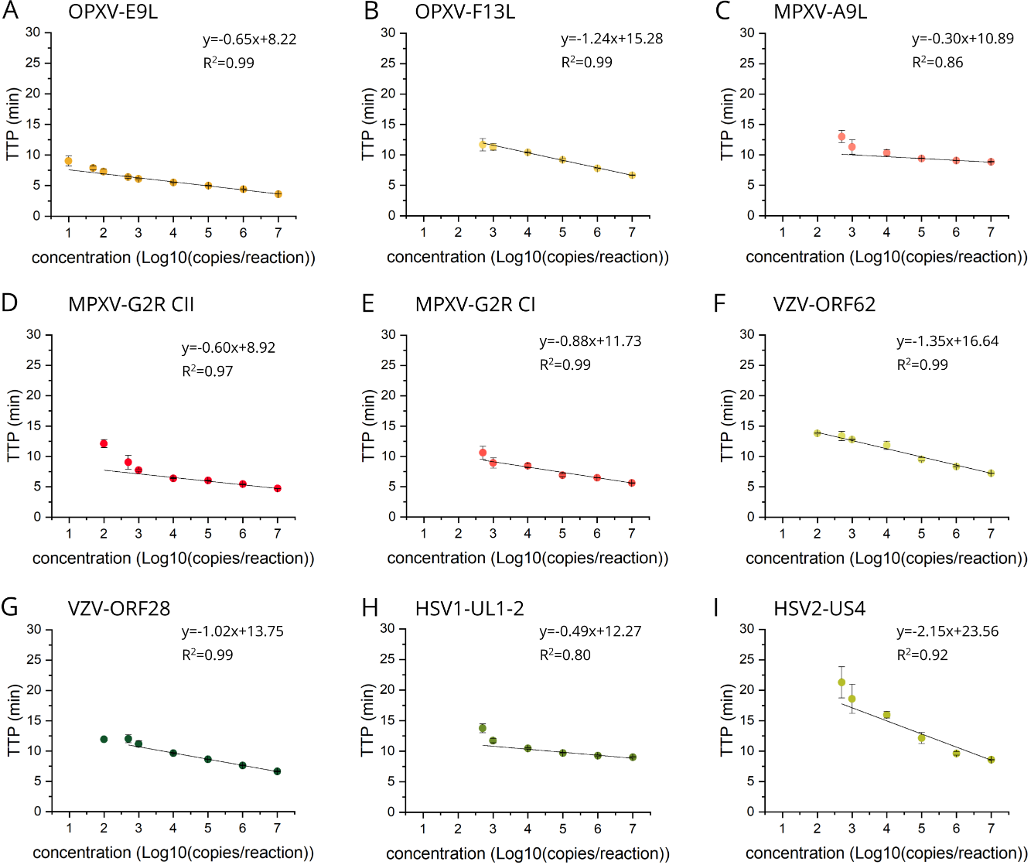
Figure S1. Standard curves of LAMP assays used in this study.

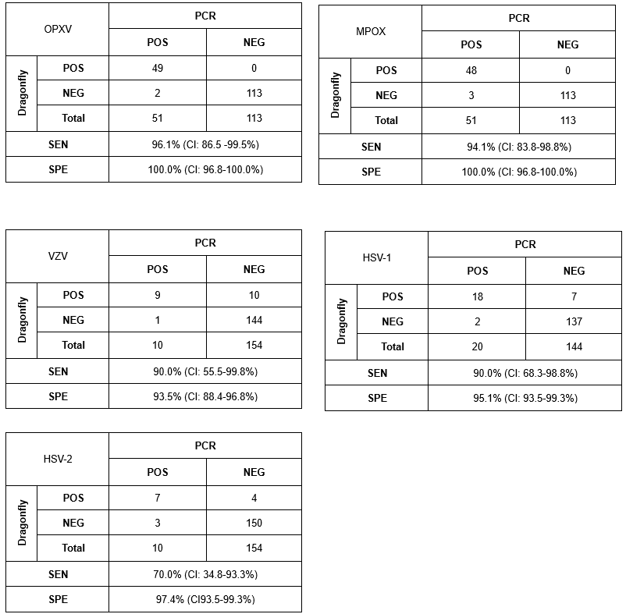

Figure S2. Confusion matrices of diagnostic performance.

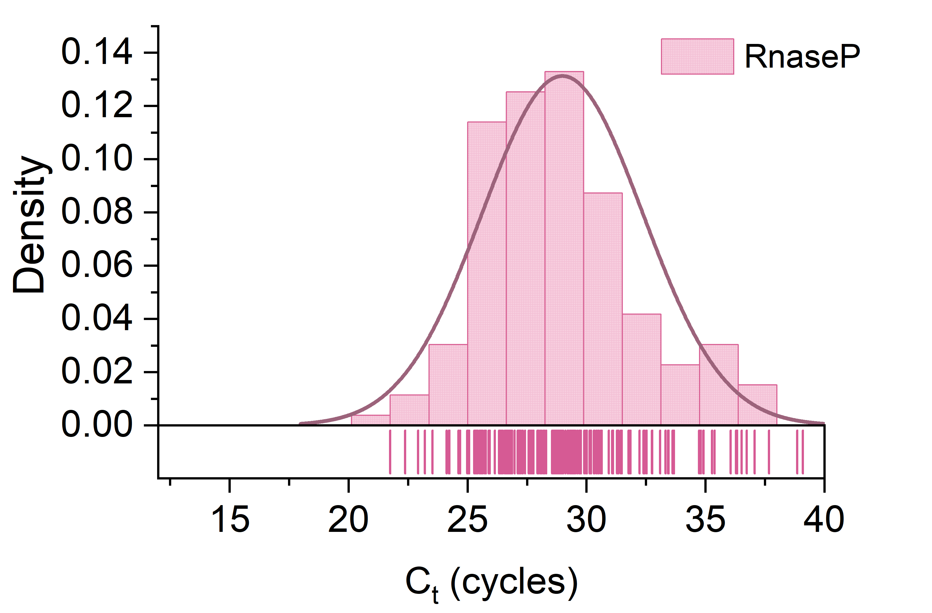
Figure S3. Histogram showing the distribution of the C_{t} values obtained from the all the clinical samples, using the TaqMan assay for RNaseP.

