Supplementary data
Novel Furan-2(3H)-one derivatives as promising anticancer agents against liver and breast cancers cell lines: Green Synthesis, Spectroscopic analysis, in Vitro Antiproliferative Activity, and DFT study
Eman M. Azmy¹, Eslam A. Mohamed^{2*}, Amal A. Altalhi³, Ibrahim F. Nassar⁴, Sameh A. Rizk⁵, Hanem M. Awad⁶ & Walaa H. Lashin¹
1 Department of Chemistry, Faculty of Women, Ain Shams University, Heliopolis, Cairo, 11457, Egypt;
2- Petroleum Applications Department, Egyptian Petroleum Research Institute, P.O. 11776, Nasr City, Cairo, Egypt
3- Department of Chemistry, College of Science, Taif University, P.O. Box 11099, Taif 21944, Saudi Arabia
4-Faculty of Specific Education, Ain Shams University, 365 Ramsis Street, Abassia, Cairo, Egypt;
5- Chemistry Department, Faculty of Science, Ain Shams University, Aassia, Cairo, Egypt;
6- Tanning Materials and Leather Technology Department, National Research Centre, El-Behouth St, Dokki, Cairo, Egypt.
* Corresponding authors: eslamazmy60@yahoo.com (Eslam A. Mohamed)
4. Experimental
4.1. Chemistry
All melting points were determined on a Gallenkamp apparatus and are uncorrected. Microwave irradiation reactions were performed using a Galanz microwave oven, WP1000AP30-2 (1000 watt, 30-80% of its total power) at chemistry department, Ain Shams University. Ultrasonic reactions, (ultrasonic cleaner “ Branson” B-12, 220/ 240 volts, 50/60 HZ, and 4AMPS) were performed at chemistry department, Ain Shams University. The IR spectra were measured on a Pye-UnicamSP300 instrument in potassium bromide discs. The ¹H-NMR and ¹³C-NMR spectra were recorded on Varian Mercury VX (400 MHz) spectrometer (with operating frequencies 500 MHz for ¹H using TMS as an internal standard and 125 MHz for ¹³C). Chemical shifts (δ) are reported in parts per million (ppm) and coupling constants (J) are reported in Hertz (Hz). NMR spectra were referenced to the residual signals of DMSO-d6. Mass spectra were run on a MAT Finnigan SSQ 7000 spectrometer, using the electron impact technique (EI). Elemental analyses were carried out by the Micro Analytical Center of Cairo University, Giza, Egypt. The progression of the reactions was monitored using TLC Merck Kieselgel 60 F254 aluminum packed plates.

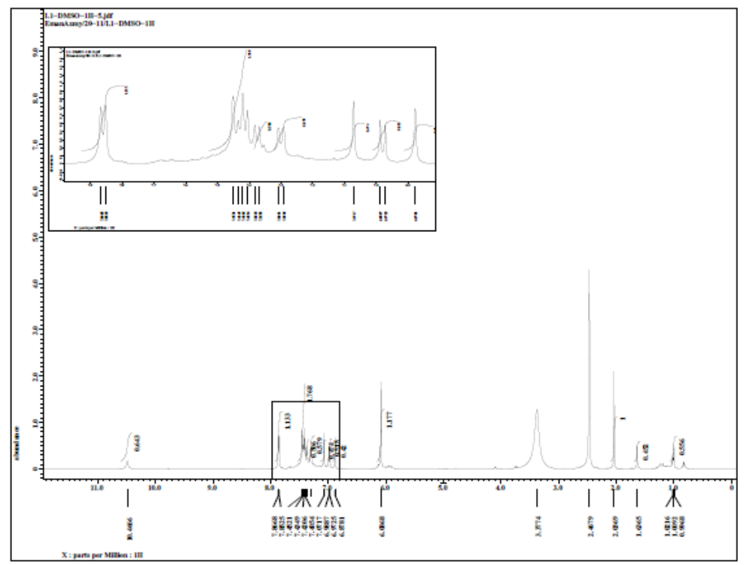
Figure S1:1HNMR of compound L1
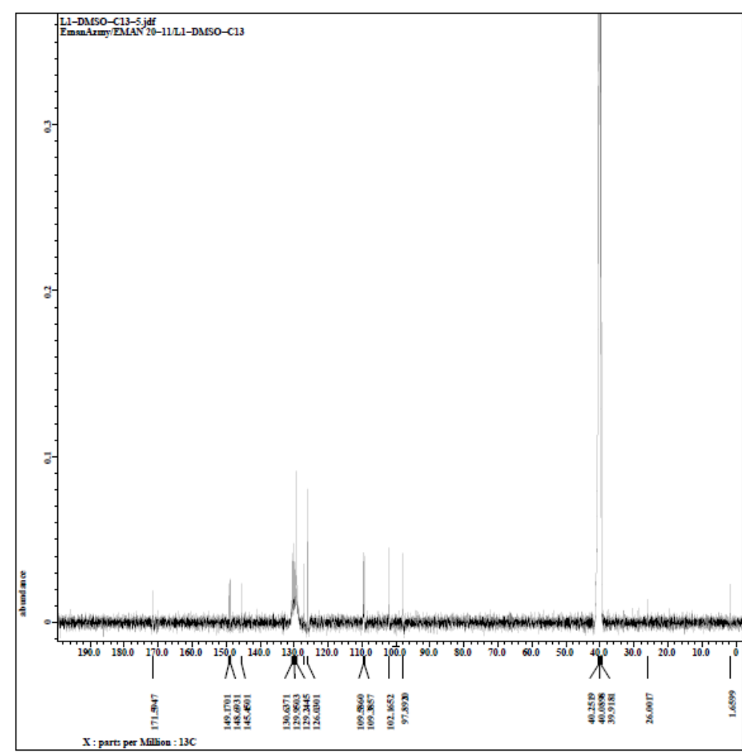
Figure S2: 13CNMR of compound L1

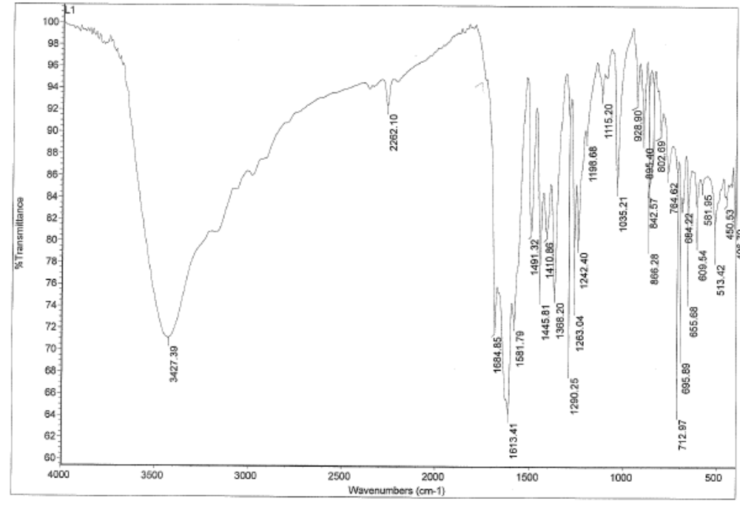

Figure S3: IR of compound L1

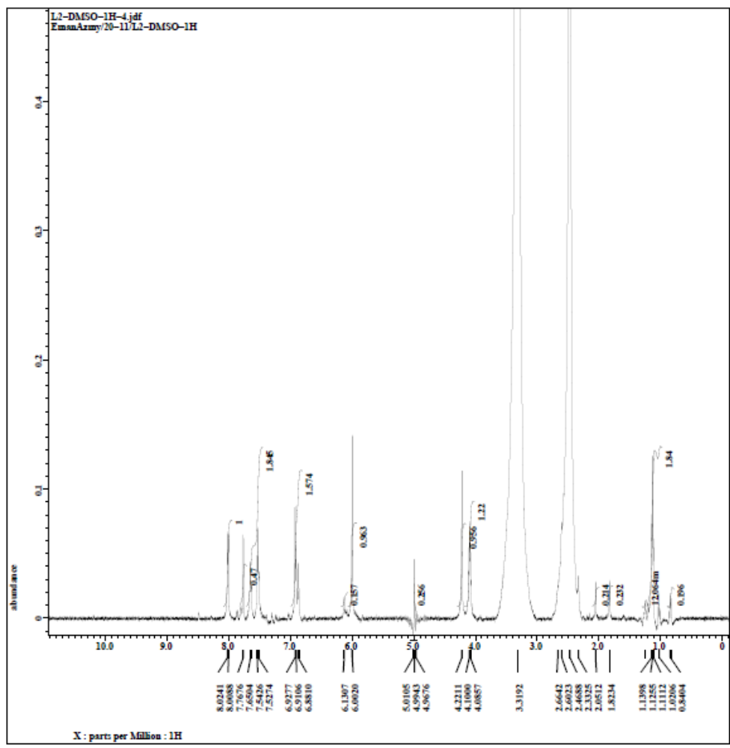

Figure S4: 1HNMR of compound L2

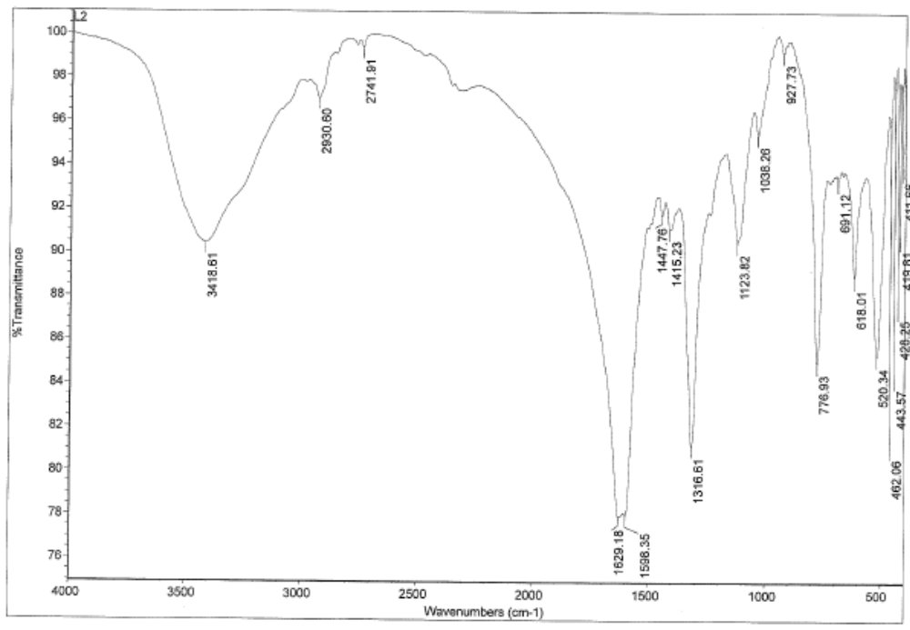

Figure S5: IR of compound L2

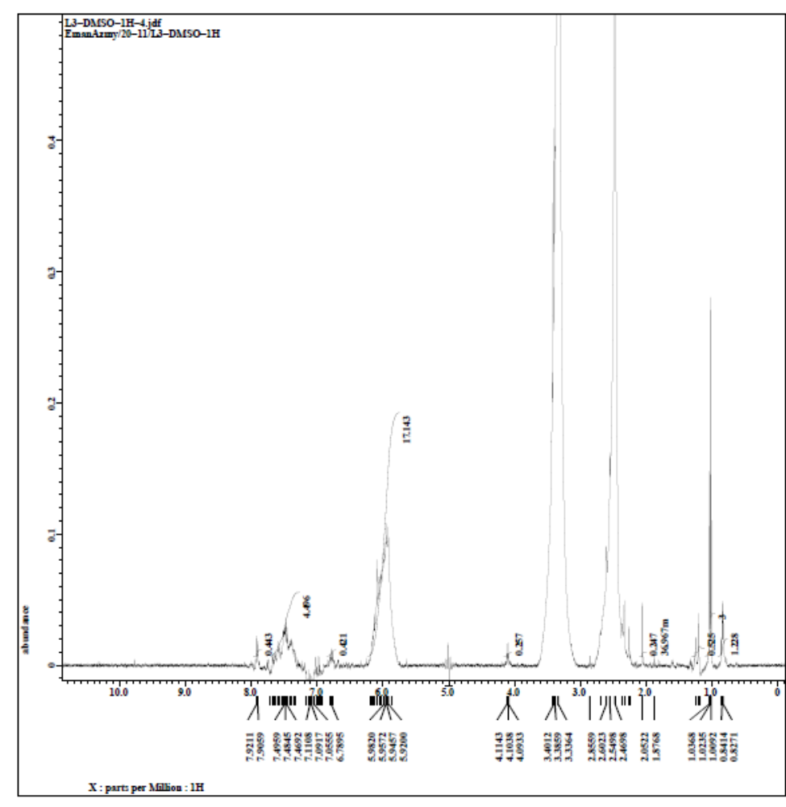
Figure S6:1HNMR of compound L3
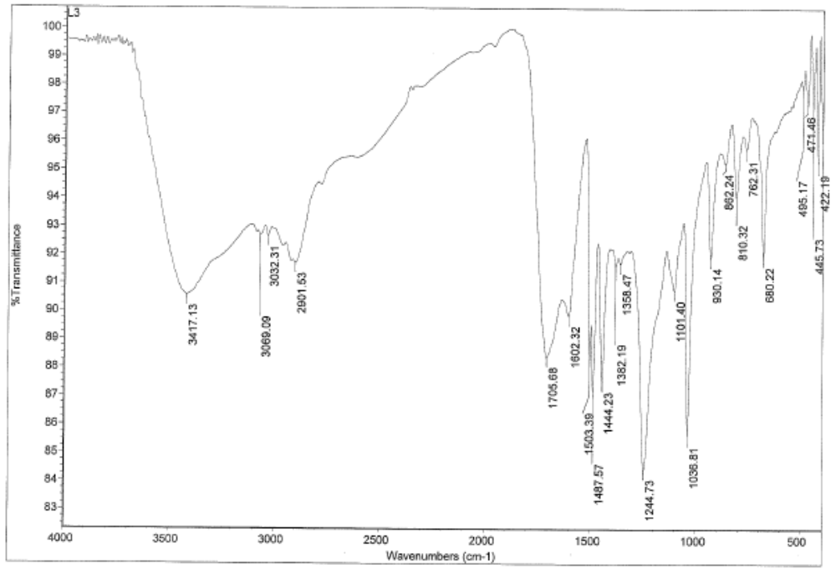

Figure S7: IR of compound L3

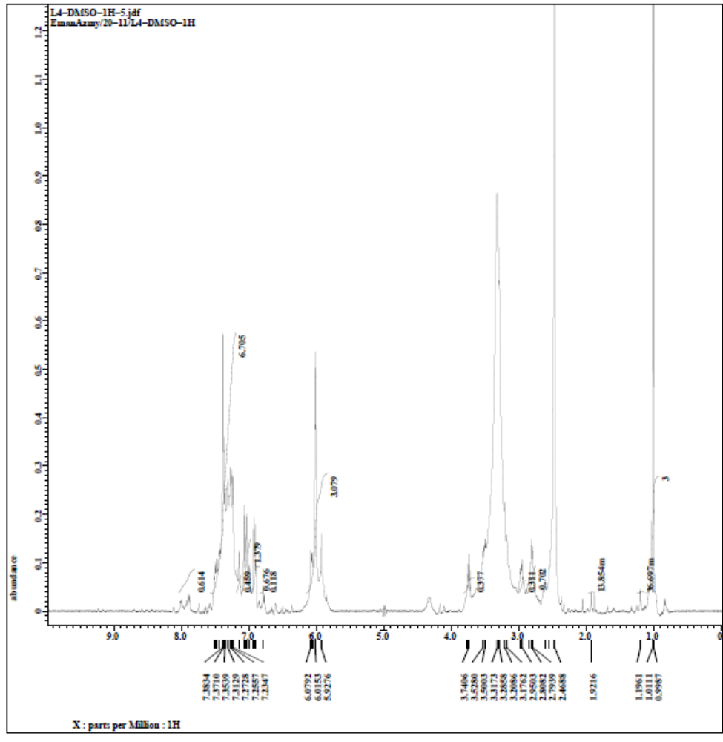

Figure S8:1HNMR of compound L4
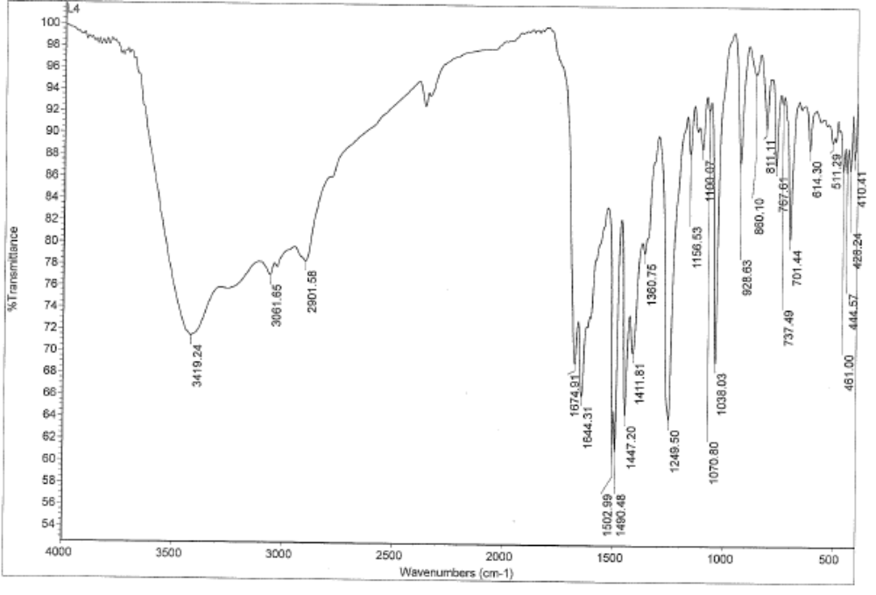
Figure S9:IR of compound L4

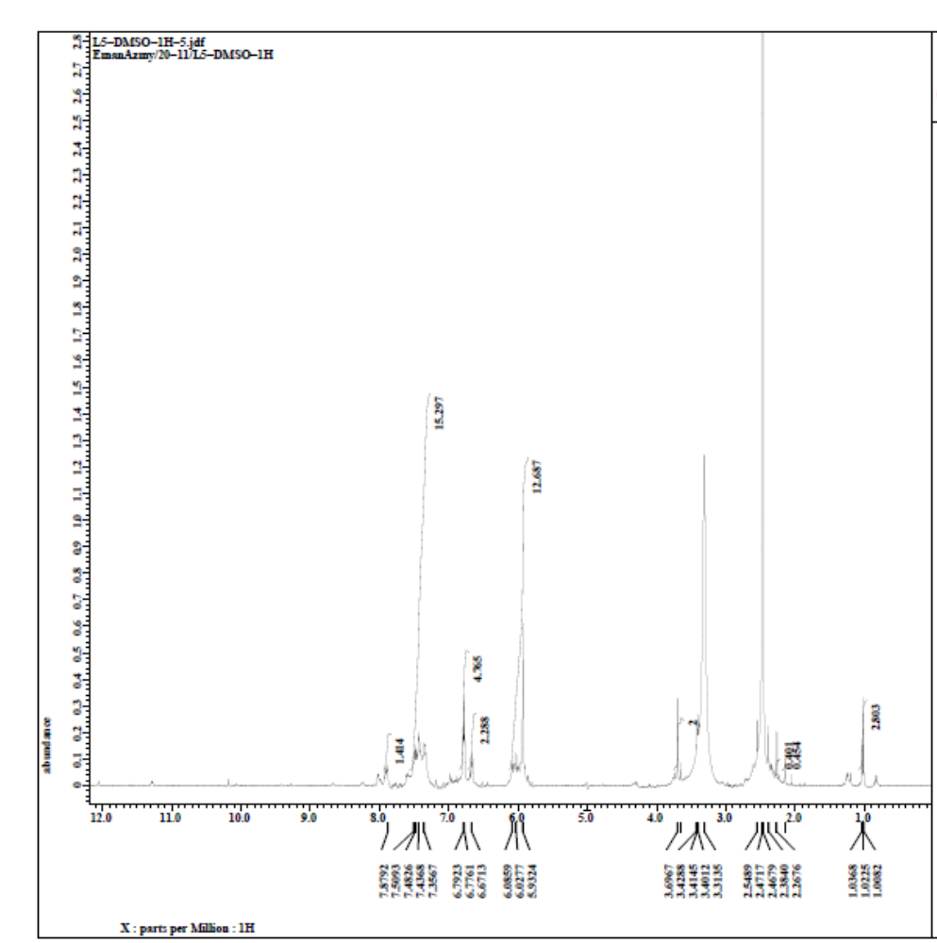

Figure S10:1HNMR OF compound L5

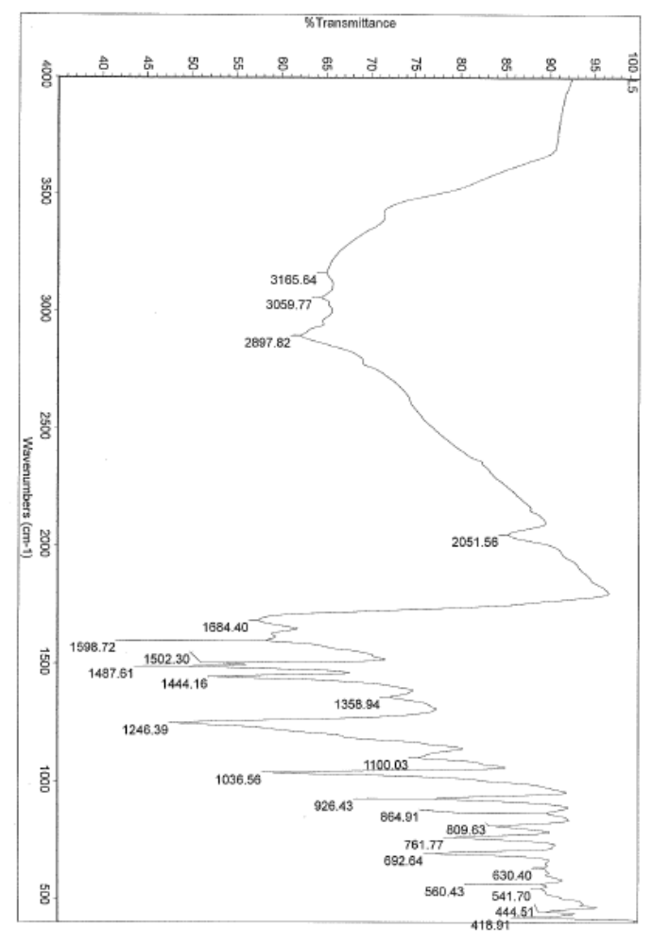
Figure S11:IR of compound L5

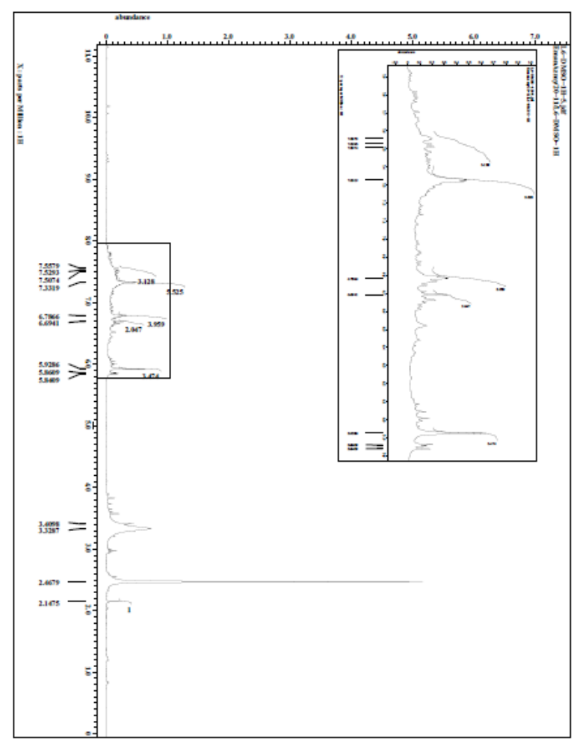
Figure S12:1HNMR OF compound L6

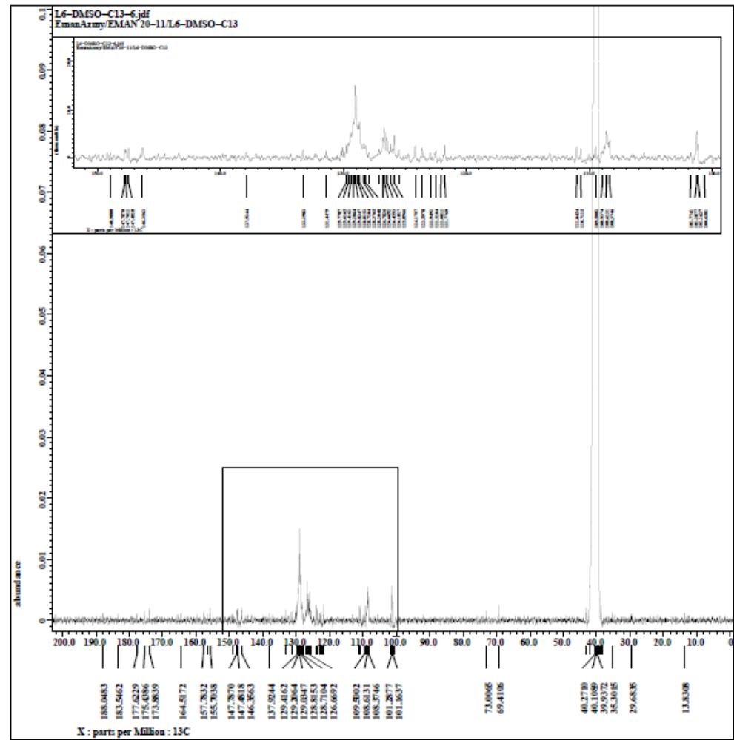

Figure S13:13CNMR of compound L6

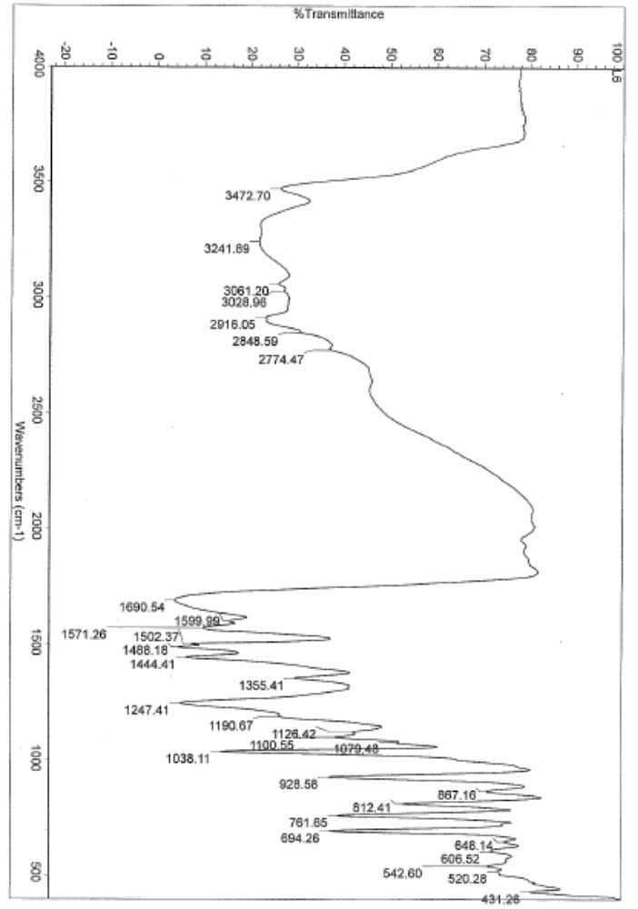

Figure S14:IR of compound L6

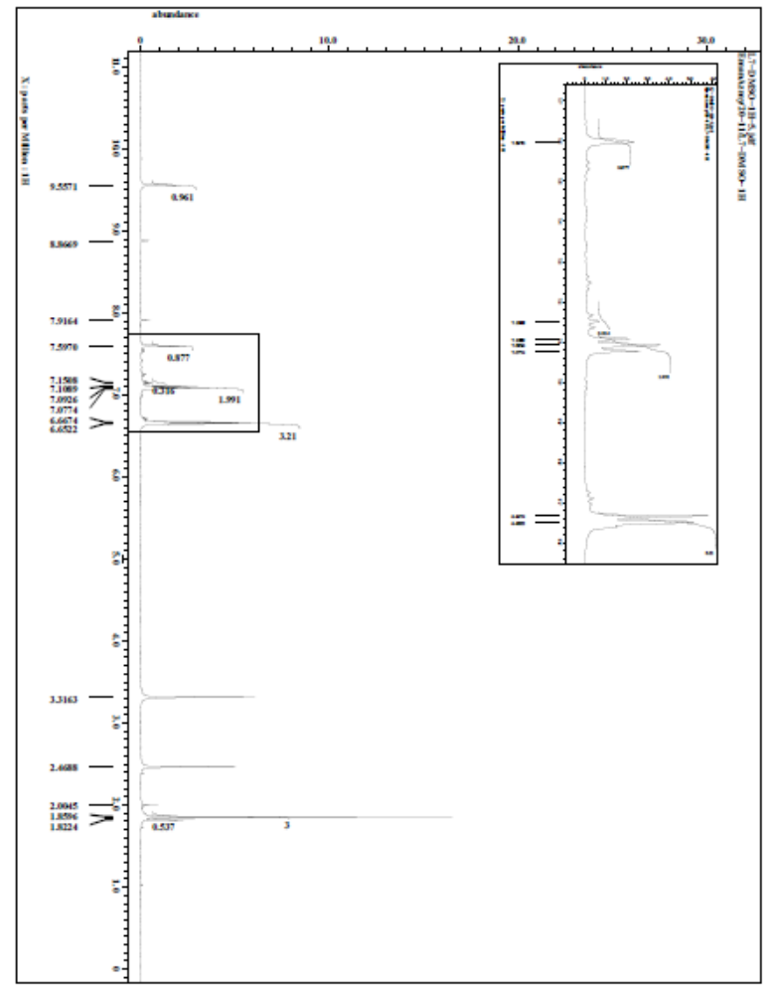

Figure S15:1HNMR of compound L7

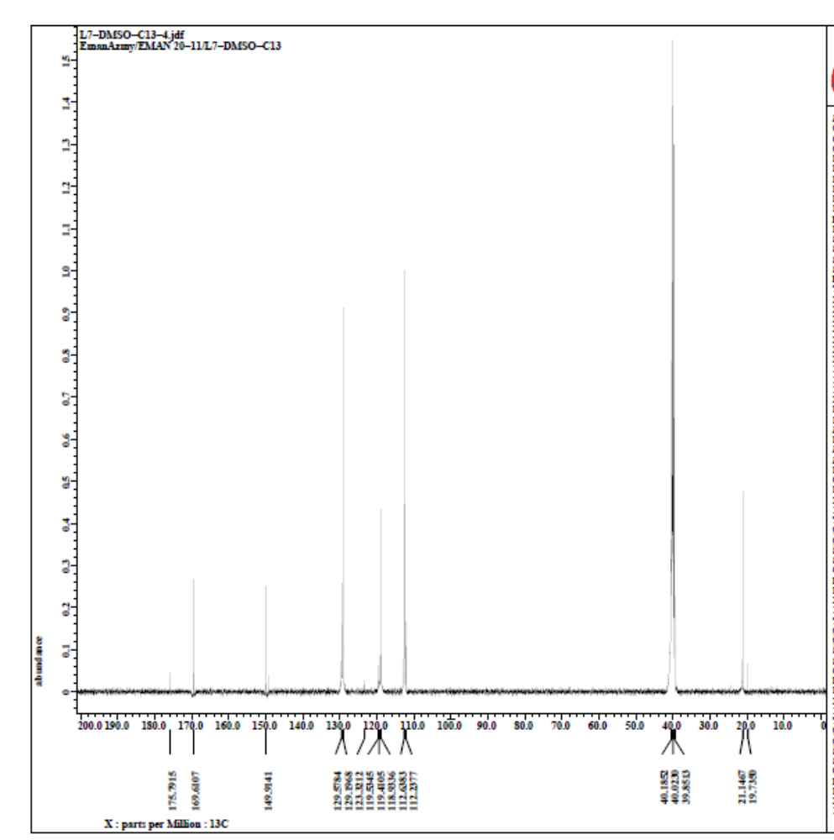

Figure S16:13CNMR of compound L7

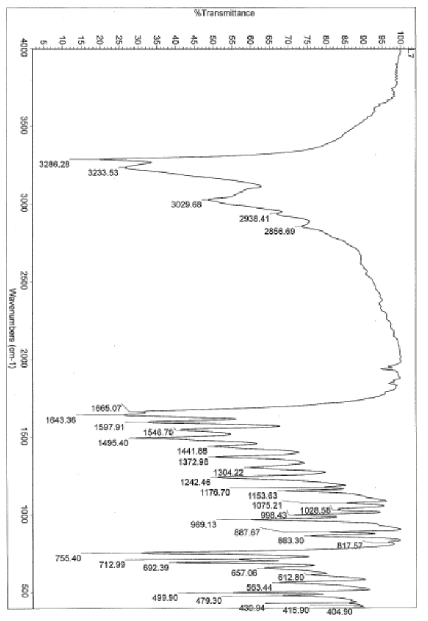
Figure S17:IR of compound L7

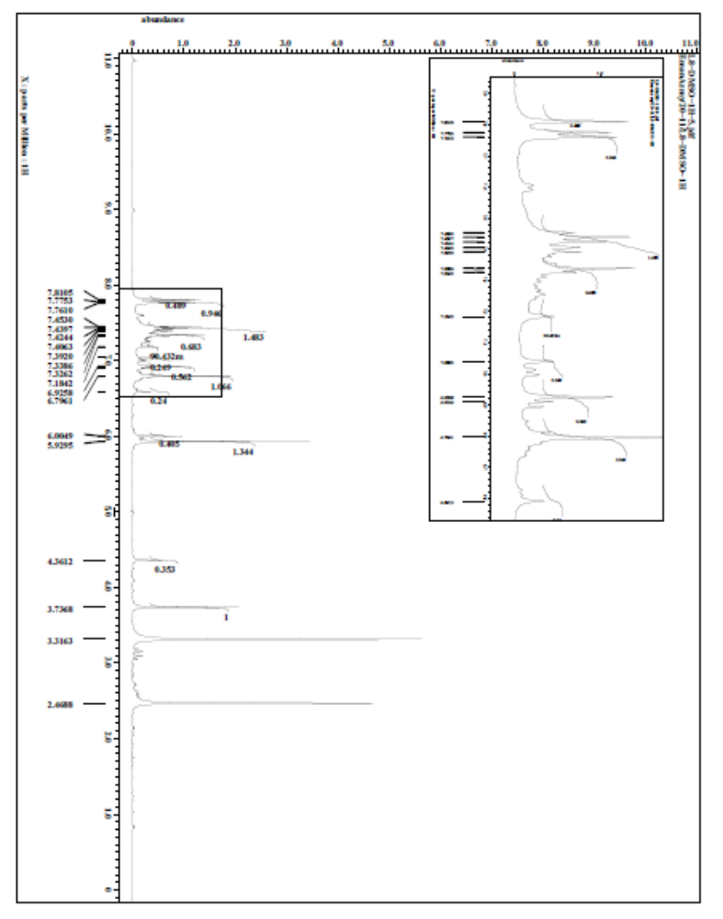

Figure S18:1HNMR of compound L8

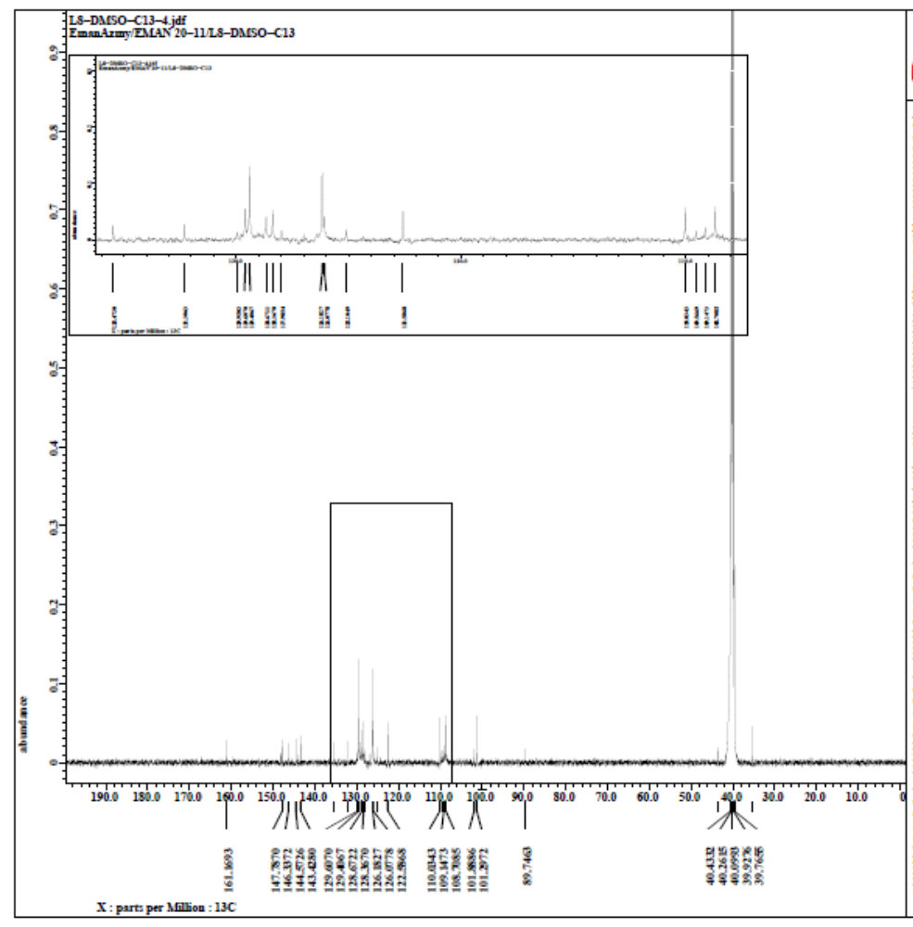

Figure S19:13CNMR of compound L8

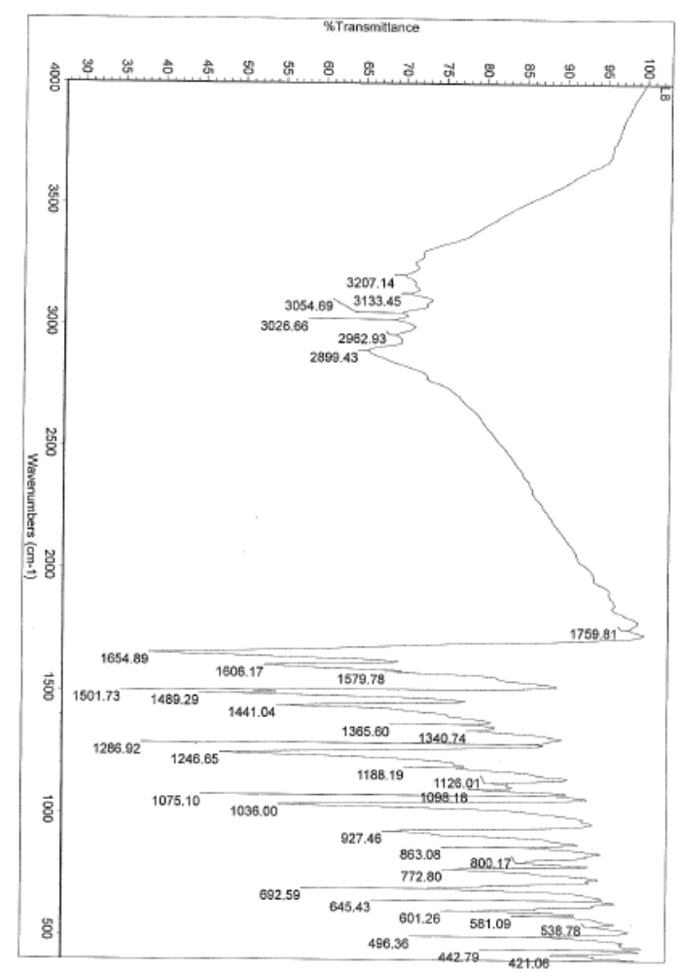

Figure S20:IR of compound L8

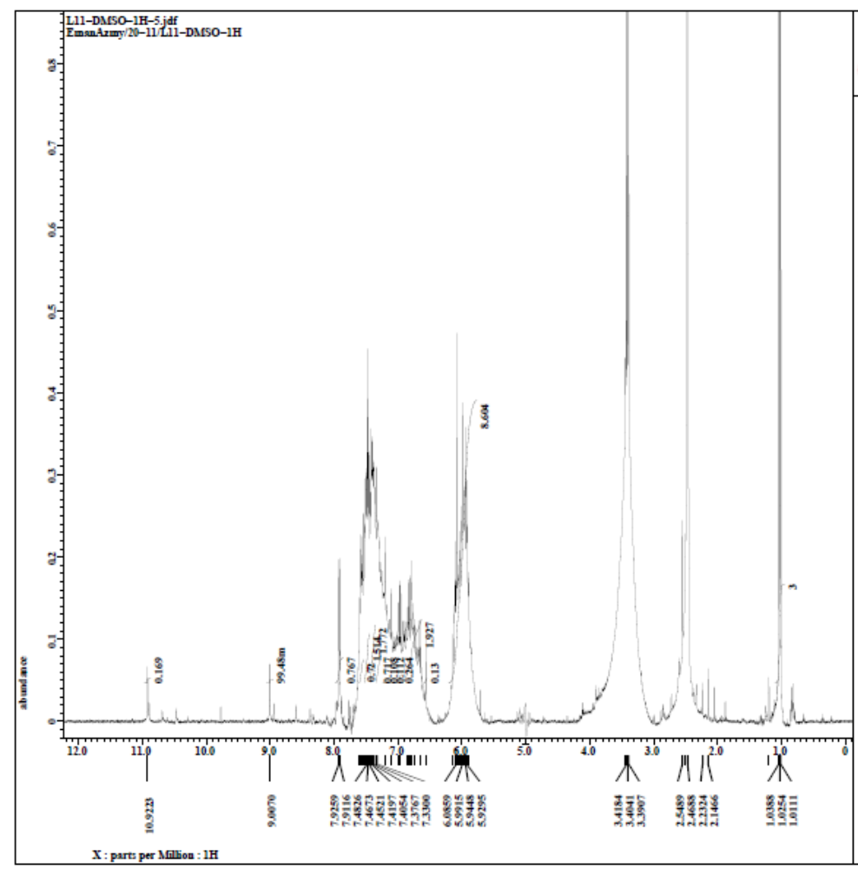

Figure S21:1HNMR of compound L11

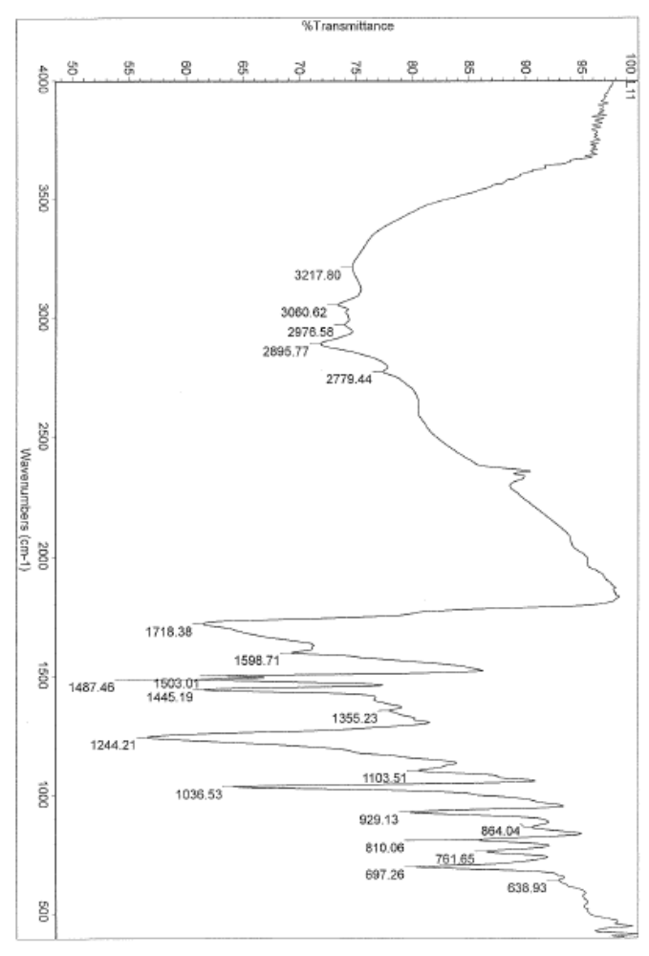

Figure S22:IR of compound L11

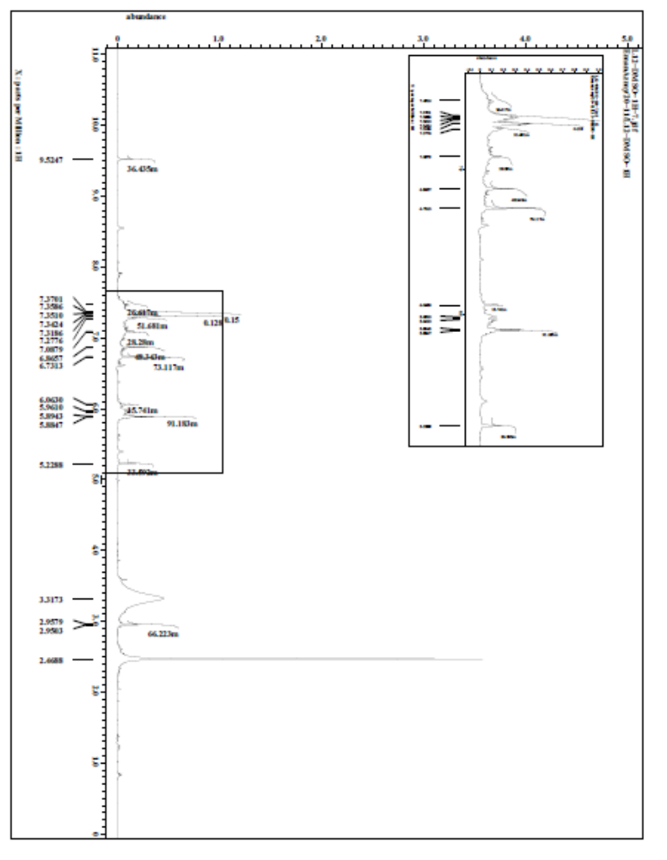

Figure S23:1HNMR of compound L12

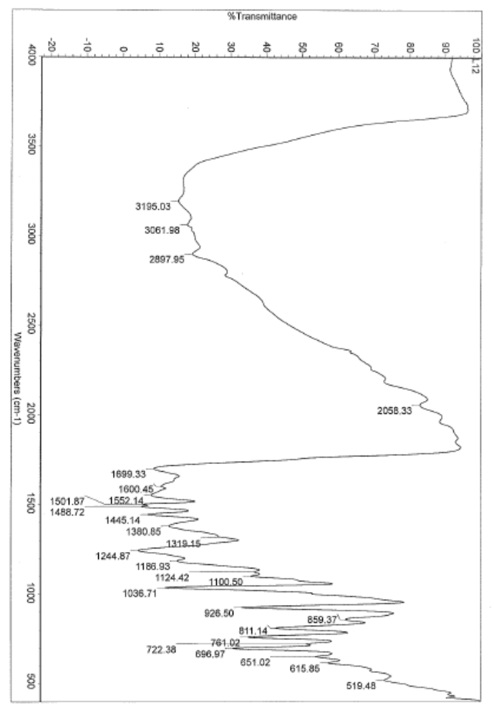

Figure S24:IR of compound L12

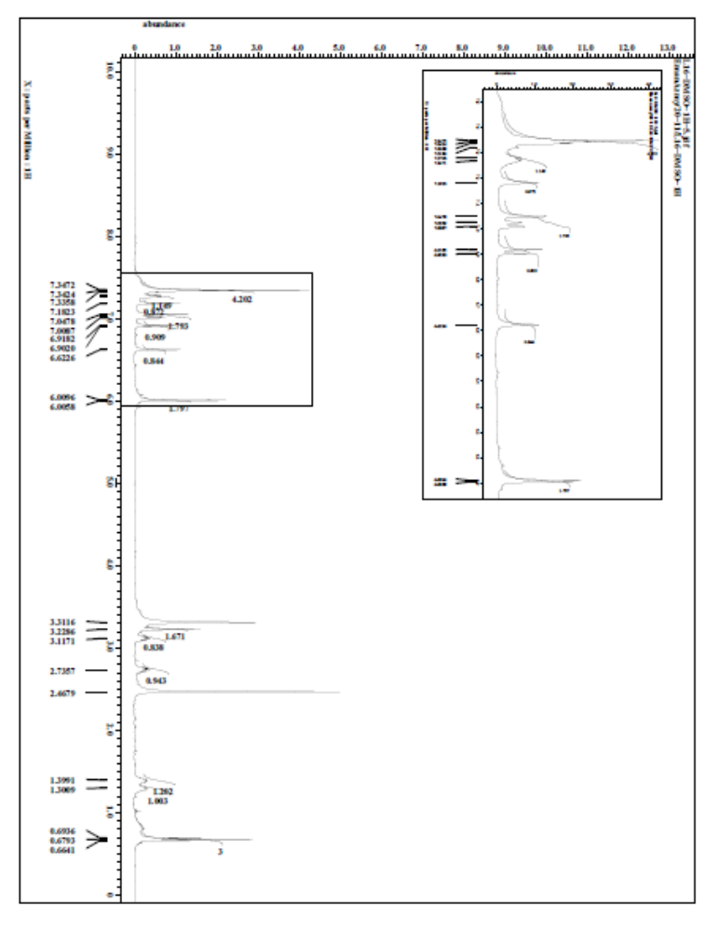

Figure S25:1HNMR of compound L16

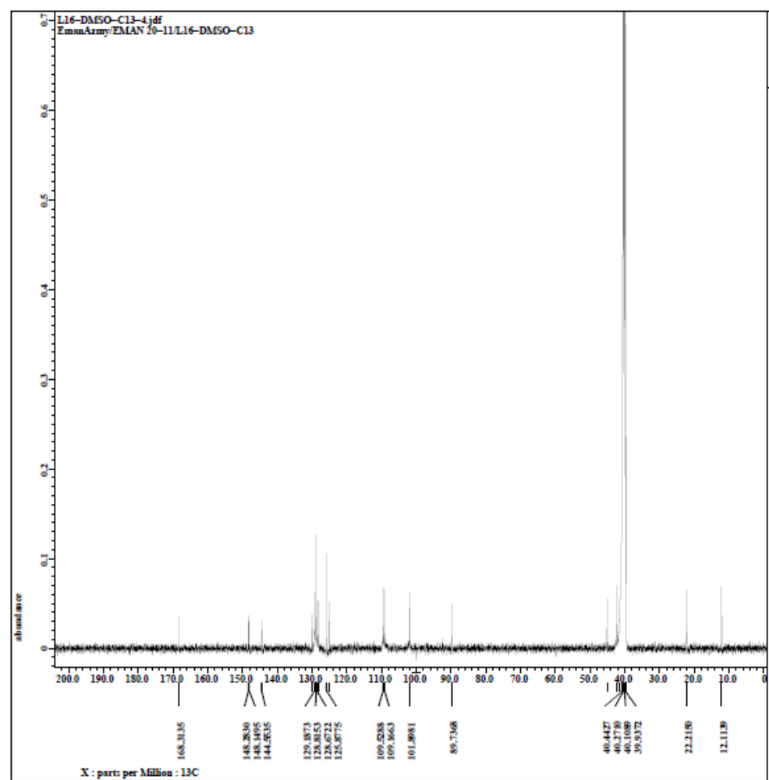

Figure S26:13CNMR of compound L16

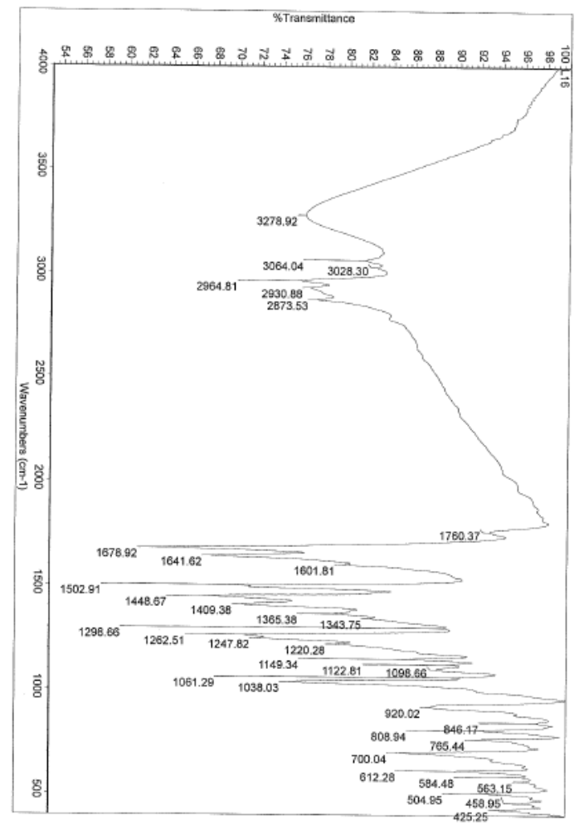

Figure S27:IR of compound L16

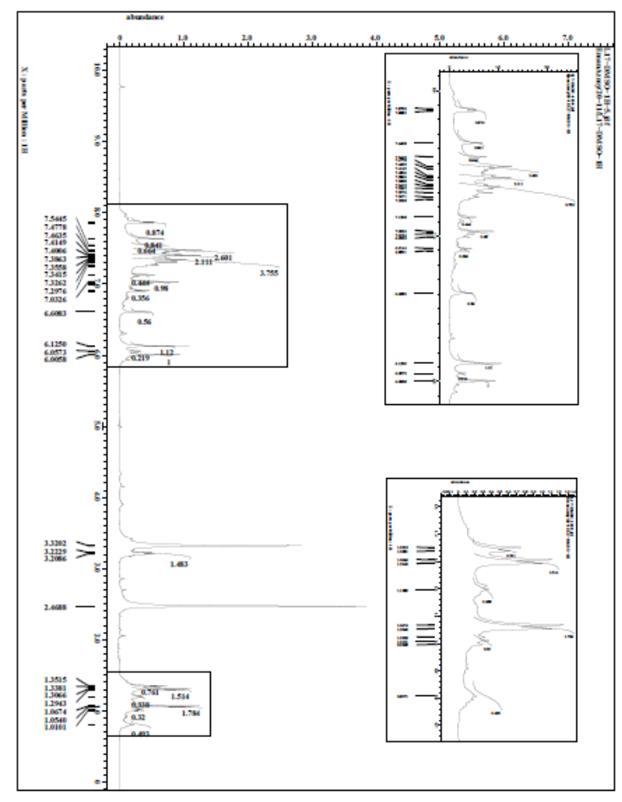

Figure S28:1HNMR of compound L17

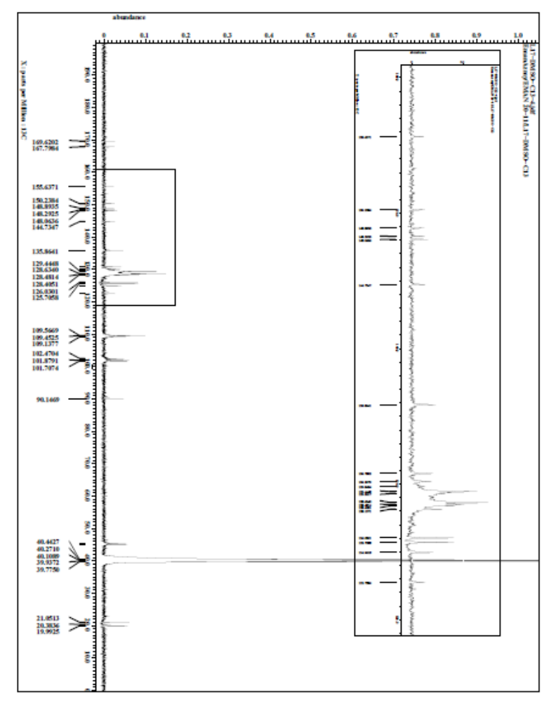

Figure S29:13CNMR of compound L17

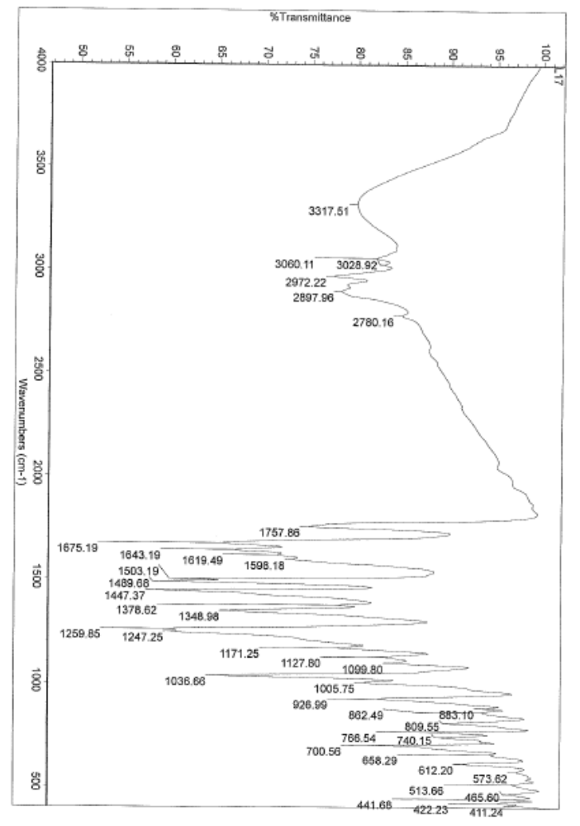

Figure S30:IR of compound L17

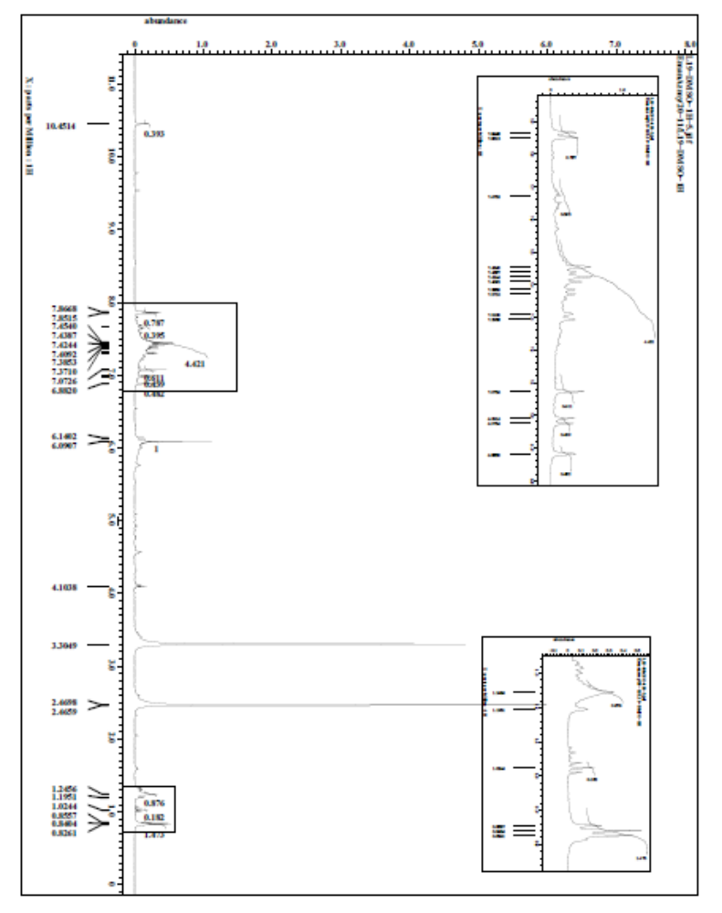

Figure S31:1HNMR of compound L19

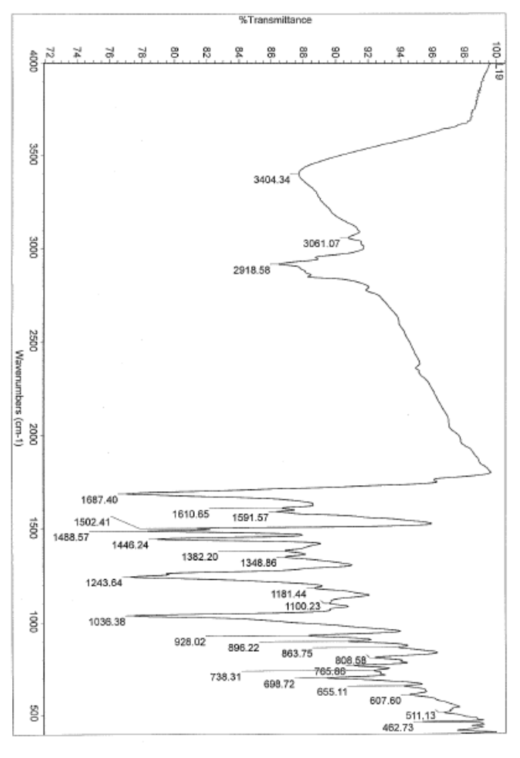

Figure S32:IR of compound L19

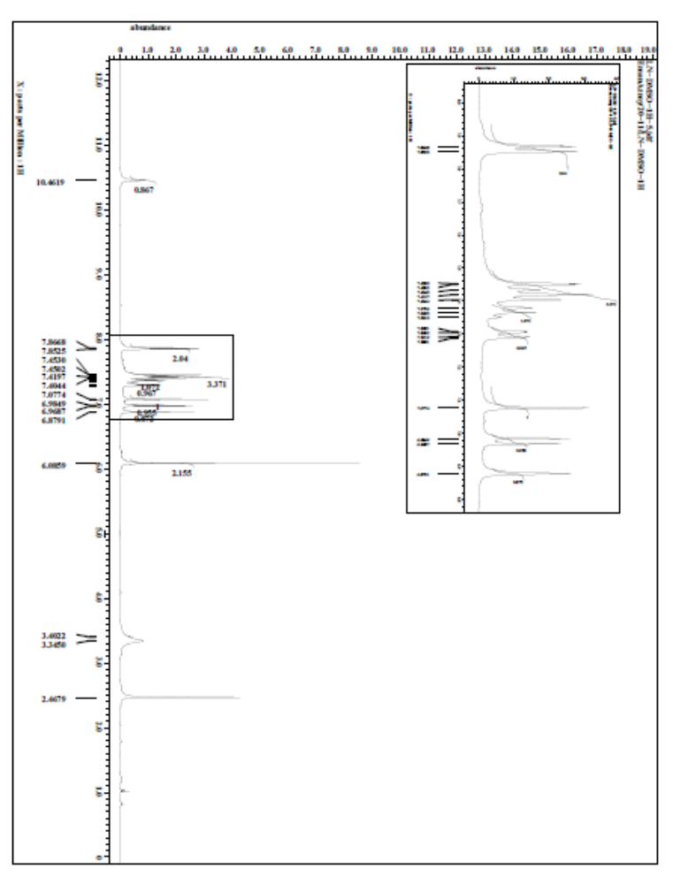

Figure S33:1HNMR of compound LN

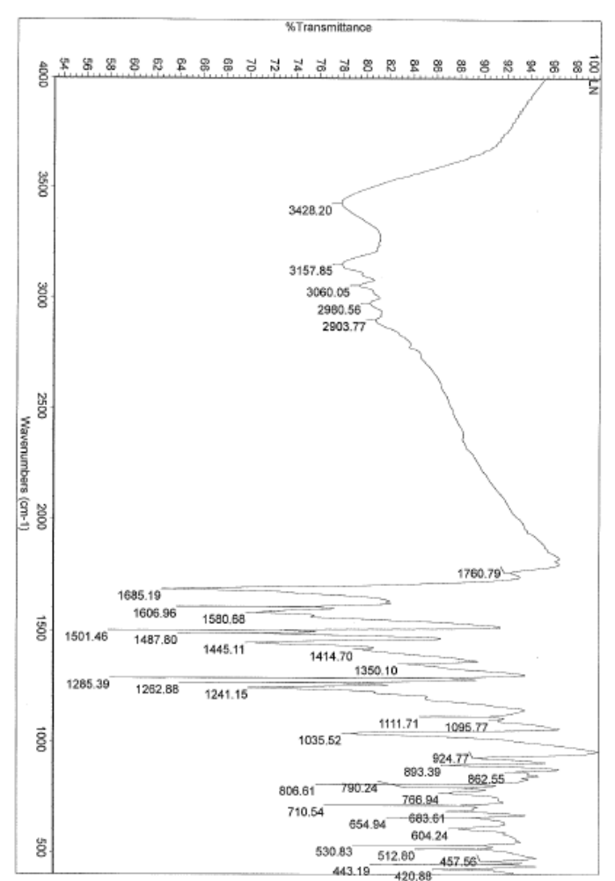

Figure S34:IR of compound LN

