Supplementary figures:
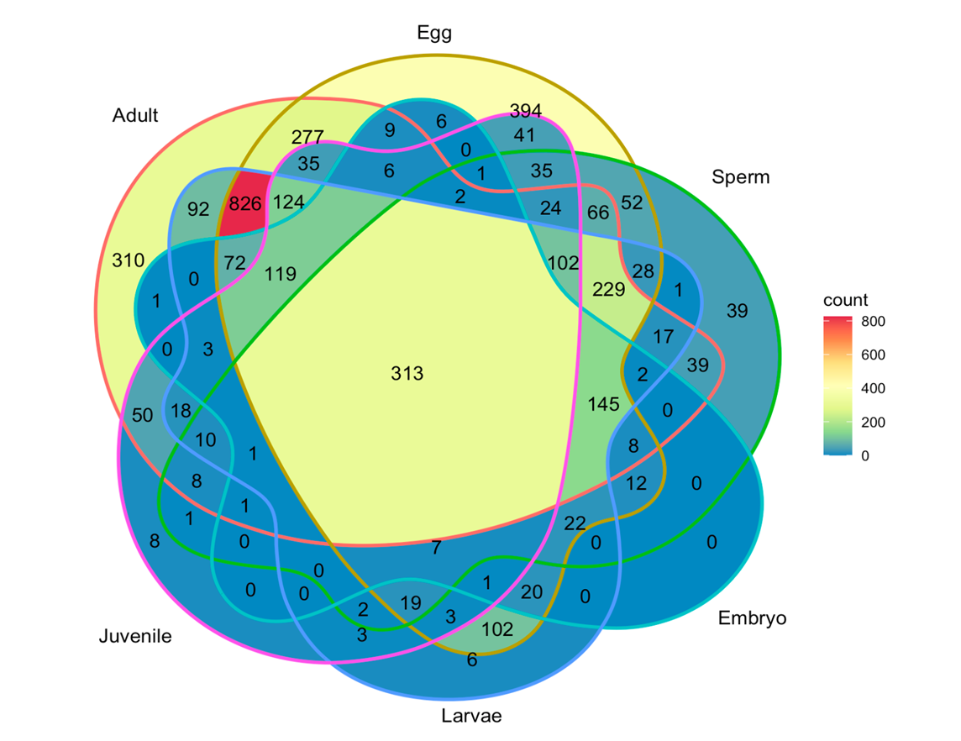
Figure S1. Venn diagram of all metabolites by life history stage.
Figure S2. Box and whisker plots of Shannon entropy by phenotype across all life history stages. Asterisks represent significant differences based on Wilcoxon Tests with alpha values of 0.99 (***), 0.95 (**), and 0.90 (*).
Figure S3. Molecular assignments from CANOPUS and associations with bleaching history phenotype by coral life history stage. The manually classified betaine lipid DGCC group is shown for comparison. Asterisks represent significant differences based on Mann-Whitney tests with alpha values of 0.99 (***), 0.95 (**), and 0.90 (*).

Figure S4. (A) Variable importance plots of metabolites that discriminate between historically bleached and non-bleached corals. Blue bars represent that the metabolite was significantly higher in historically non-bleached parental corals and yellow bars represent that the metabolite was significantly higher in historically bleached parental corals. (B) box and whisker of the average variable importance of specific metabolites across all life history stages.

Figure S5. Relative abundance of all DGTA and DGTS betaine lipids detected in the metabolome dataset by life history stage and parental bleaching phenotype. Blue bars represent that the metabolite was significantly higher in historically non-bleached parental corals and yellow bars represent that the metabolite was significantly higher in historically bleached parental corals.
Figure S6. Relative abundance and hydrophobicity score of phosphocholine lipids in corals through life history stages based on bleaching history. Blue bars represent that the metabolite was significantly higher in historically non-bleached parental corals and yellow bars represent that the metabolite was significantly higher in historically bleached parental corals. Asterisks represent significant differences based on Mann-Whitney Tests with alpha values of 0.99 (***), 0.95 (**), and 0.90 (*).

Figure S7. Box and whisker plots of betaine lipid biochemistry by algal genotype. Red represents Cladocopium only algal communities, green represents Durusdinium only algal communities, and blue represents mixed algal communities.

