Blocking of Efflux Transporters in Rats Improves Translational Validation of Brain Radioligands
Vladimir Shalgunov^{1,2,#}, Mengfei Xiong^{1,3,4,#}, Elina T. L’Estrade^{1,3,5}, Nakul R. Raval³, Ida V. Andersen^{1,3}, Fraser G. Edgar¹, Nikolaj R. Speth³, Simone L. Baerentzen³, Hanne D. Hansen^{3,6}, Lene L. Donovan³, Arafat Nasser³, Siv T. Peitersen³, Andreas Kjaer^{2,7}, Gitte M. Knudsen³, Stina Syvänen⁴, Mikael Palner^{3,8}, Matthias M. Herth^{1,2}*
- Department of Drug Design and Pharmacology, Faculty of Health and Medical Sciences, University of Copenhagen, Jagtvej 160, 2100 Copenhagen, Denmark
- Department of Clinical Physiology, Nuclear Medicine & PET, Copenhagen University Hospital, Rigshospitalet, Blegdamsvej 9, 2100 Copenhagen, Denmark
- Neurobiology Research Unit and CIMBI, Rigshospitalet and University of Copenhagen, Blegdamsvej 9, 2100 Copenhagen, Denmark
- Department of Public Health and Caring Sciences/Geriatrics, Uppsala University, Rudbeck Laboratory, 75185 Uppsala, Sweden
- Radiation Physics, Nuclear Medicine Physics Unit, Skånes University Hospital, Barngatan 3, Lund 222 42, Sweden
- A. A. Martinos Center for Biomedical Imaging, Massachusetts General Hospital, 149 13th Street, 02129 Charlestown, MA, USA
- Cluster for Molecular Imaging, Department of Biomedical Sciences, Faculty of Health and Medical Sciences, University of Copenhagen, Blegdamsvej 3, 2200 Copenhagen, Denmark
- Center for Translational Neuromedicine, Faculty of Health and Medical Sciences, University of Copenhagen, Blegdamsvej 3B, 2200 Copenhagen, Denmark.
# These authors contributed equally to this work.
* Corresponding author
Matthias Herth
Associate Professor, University of Copenhagen, Department of Drug Design and Pharmacology
e-mail: matthias.herth@sund.ku.dk
ORCID: 0000-0002-7788-513X

Keywords: P-gp, efflux transporter, PET, rodents, pigs, translation, species differences

Table of Contents

Pig PET experiments 3
Supplementary Figures 5
Supplementary Tables 12
References 15

Pig PET experiments
Two female pigs (crossbreed of Landrace × Yorkshire × Duroc) weighing on average 20 kg (approx. 9 weeks old) were used in the present study. Animals were sourced from local farms and acclimatized for 7–9 days in an enriched environment prior to experiments. Pig anesthesia was induced approximately 3 h prior to scanning by i.m. injection of 0.13 ml/kg zoletil veterinary mixture (11.36 mg/mL xylazine, 11.36 mg/ml ketamine, 1.82 mg/ml butorphanol, 1.82 mg/ml methadone) and maintained by 15 mg/kg/h propofol infusion i.v.. Femoral arteries, ear veins and mammary veins were used for intra vascular access. Endotracheal intubation allowed for ventilation with 20% oxygen in air at 10 ml/kg. Urine catheter was placed to avoid discomfort and stress. The animals were closely monitored throughout the experiment, with peripheral O₂ and end-tidal CO₂ saturation, heart rate, blood pressure, blood glucose and temperature. Pigs were scanned in the HRRT scanner (Siemens AG, Munich, Germany). One animal was scanned at baseline with [¹⁸F]fallypride (injected activity = 518 MBq, injected mass = 5.61 µg). A second animal was scanned with [¹¹C]BA-10 at baseline (injected activity = 262 MBq, injected mass = 0.51 µg) and after pretreatment (injected activity = 517 MBq injected mass = 0.58 µg) with the 5-HT₇ receptor antagonist SB-269970 (1 mg/kg/h, Tocris Bioscience, Abingdon, United Kingdom) Infusion of SB-266970 was initiated 30 min prior to the injection of the tracer.
Manual arterial blood samples for the [¹¹C]BA-10 scans were drawn at 2.5, 5, 10, 20, 30, 45, 60 and 90 min after injection, while an ABSS autosampler (Allogg Technology, Sweden) continuously measured arterial whole blood radioactivity during the first 30 min. Manual blood samples were used for the measurements of total radioactivity in whole blood and plasma using a gamma well counter (Cobra 5003; Packard Instruments, Meriden, USA), which was cross-calibrated to the HRRT scanner and to the autosampler. Radiolabeled parent compound and metabolites were measured in plasma using HPLC with column switching and online radioactivity detection as previously described [1].
PET image reconstruction: For [¹¹C]BA-10 scans, 90-minute list-mode PET data was reconstructed into 38 dynamic frames of increasing length (6 × 10, 6 × 20, 4 × 30, 6 × 60, 2 × 180, 8 × 300, and 3 × 600 s). For [¹⁸F]fallypride scans, 150-minute list-mode PET data was reconstructed into 58 dynamic frames of increasing length (6 × 10, 6 × 20, 6 × 30, 9 × 60, 4 × 120, 16 × 300, 8 × 150 and 3 × 300 s). While a similar reconstruction method for the two tracers used an ordinary Poisson three-dimensional ordered-subset expectation maximization with point spread function modeling (OP-3D-OSEM-PSF), 16 subsets and 10 iterations with all standard corrections [2,3]. Attenuation correction was done using the HRRT maximum a posteriori transmission reconstruction method (MAP-TR) μ-map [4]. Images consist of 207 planes of 256 × 256 voxels of 1.22 × 1.22 × 1.22 mm in size. Brain parcellation was performed as previously described [5].
Data analysis: PMOD 3.0 (PMOD Technologies, Switzerland) was used for kinetic modeling. BP_{ND} values for [¹⁸F]Fallypride were calculated using a simplified refernce tissue model (SRTM) with the Cerebellum (non-vermis) as a reference region [6,7]. V_{T} values for the [¹¹C]BA-10 were calculated using the 1 tissue compartment (1TC) model. We calculated the occupancy of SB-269970 and non-displaceable volume of distribution (V_{ND}) using the V_{T} values from the 1TC model in a Lassen plot [8]. Nondisplaceable-uptake-normalized binding potentials (BP_{ND}) were determined by reverse calculations from 1TC V_{T}’s using Equation I:
${\text{BP}}_{\text{ND}}\text{=}\frac{\text{(}{\text{V}}_{\text{T}}\text{-}{\text{V}}_{\text{ND}}\text{)}}{{\text{V}}_{\text{ND}}}$ (Eq. I)

Supplementary Figures
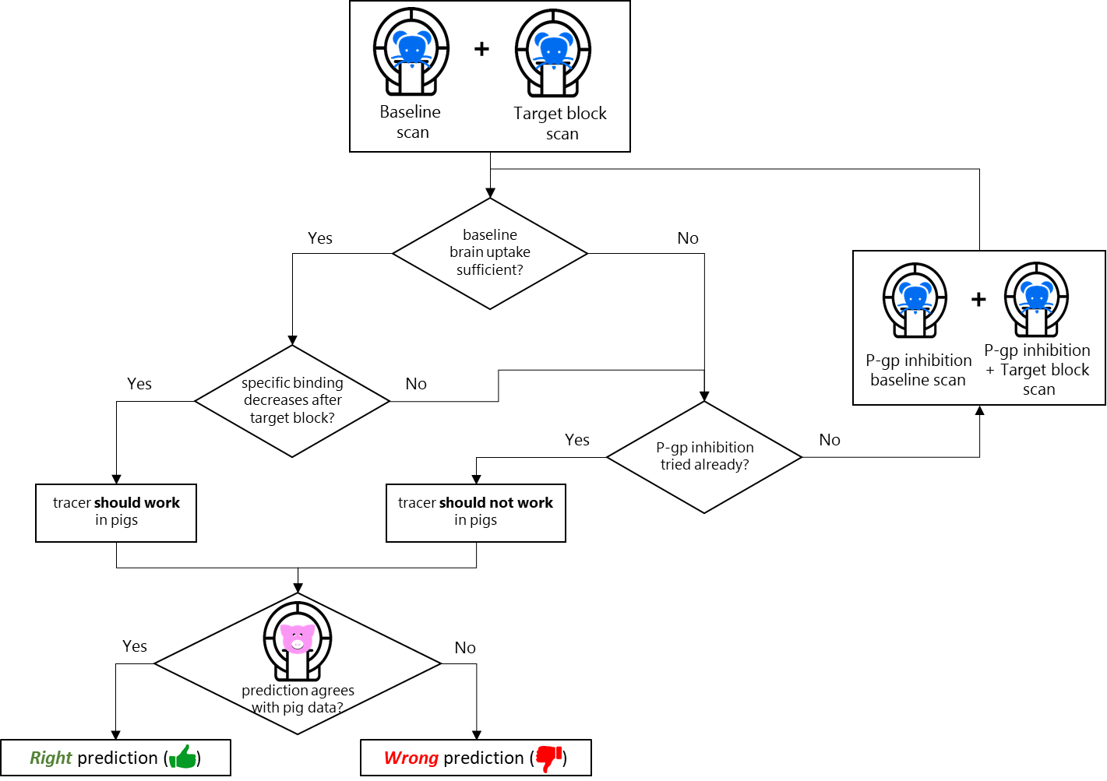
Supplementary Fig. S1. Experimental design and decision making tree.
First, tracer uptake is evaluated in rats at baseline and target block conditions without P-gp inhibition. If brain uptake at baseline is too low, or no blocking of apparent specific binding can be observed, new baseline and target block scans in rats are performed, now with inhibition of P-gp action. If, either with or without P-gp inhibition, the tracer shows preferential accumulation in the target-rich region, which decreases after target block, a prediction is made that sufficient brain uptake and specific target binding should also be observed in pigs, i.e. the tracer “should work”. If no specific binding can be detected by comparing baseline and block scans in rats either with or without P-gp inhibition, or if baseline tracer uptake stays low even after P-gp inhibition, the tracer is predicted not to work in pigs.
Icons are modified by Freepik from Flaticon.

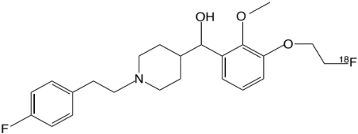
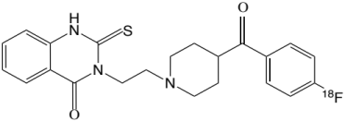
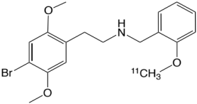
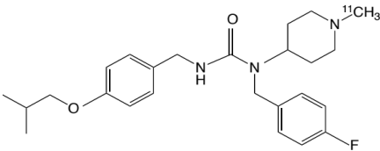
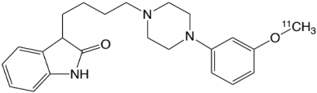
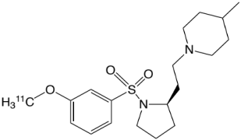
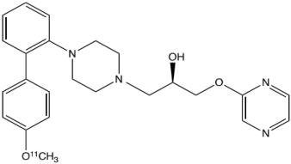
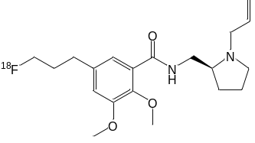Supplementary Fig. S2. Chemical structures of all studied compounds.
[¹⁸F]MH.MZ
[¹⁸F]Altanserin
[¹¹C]Cimbi-36
[¹¹C]Pimavanserin
[¹¹C]Cimbi-717
[¹¹C]Cimbi-701
[¹⁸F]Fallypride
[¹¹C]BA-10

A
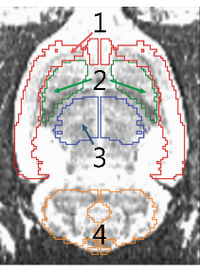
B | Receptor-rich regions | Reference region | Whole brain
[¹⁸F]MH.MZ | mPFC | Cb | Wb
[¹⁸F]Altanserin | FC | Cb | Wb
[¹¹C]Pimavanserin | mPFC | Cb | Wb
[¹¹C]Cimbi-36 | mPFC | Cb | Wb
[¹¹C]Cimbi-717 | Tha | Cb | Wb
[¹¹C]Cimbi-701 | Tha | Cb | Wb
[¹⁸F]ENL30 | Tha | Cb | Wb
[¹¹C]BA-10 | Tha | Cb | Wb
[¹⁸F]Fallypride | Str | Cb | Wb
mPFC: medial prefrontal cortex; FC: frontal cortex; Cb: cerebellum; Tha: thalamus; Str: striatum; Wb: whole brain.

Supplementary Fig. S3. A: MR image of rat brain co-registered with ROIs and rat template (W.Schiffer-FDG): cortex (1), striatum (2), thalamus (3) and cerebellum (4). B: Table of selected ROIs for all radiotracers.

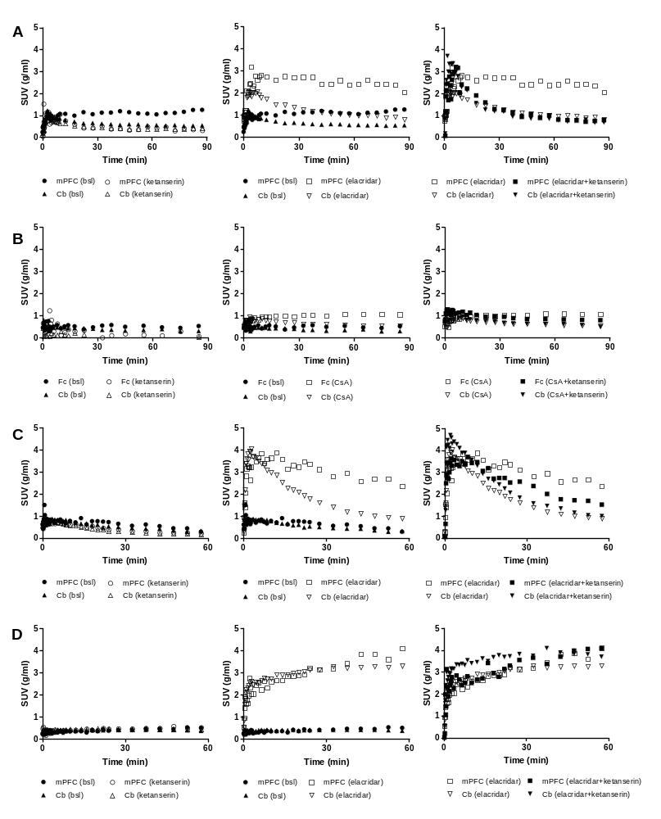
Supplementary Fig. S4. Time activity curves for all radiotracers at baseline and target block conditions (left), baseline and with Pgp inhibition (middle), Pgp inhibition only and Pgp inhibition + target block regime (Right). A: [¹⁸F]MH.MZ, B: [¹⁸F]Altanserin, C: [¹¹C]Cimbi-36, D: [¹¹C]Pimavanserin.

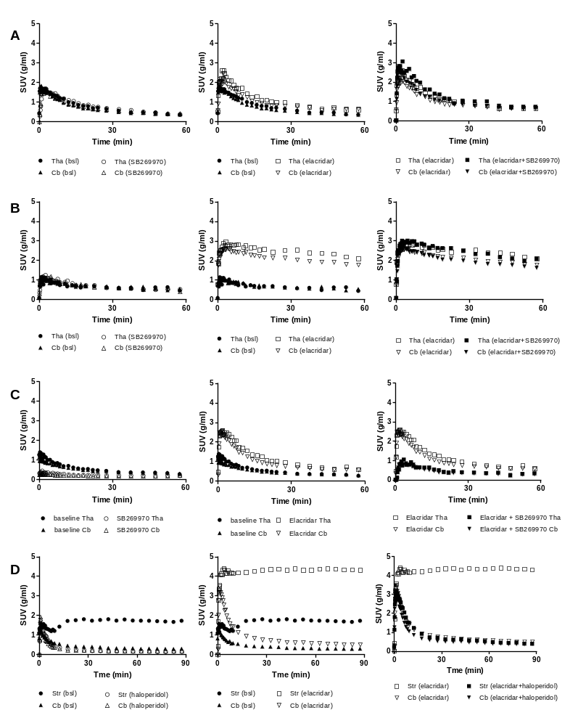
Supplementary Fig. S5. Time activity curves for all radiotracers at baseline and target block condition (left), baseline and with Pgp inhibition (middle), Pgp inhibition only and Pgp inhibition + target block regime (Right). A: [¹¹C]Cimbi-717, B: [¹¹C]Cimbi-701, C: [¹¹C]BA-10, D: [¹⁸F]Fallypride.

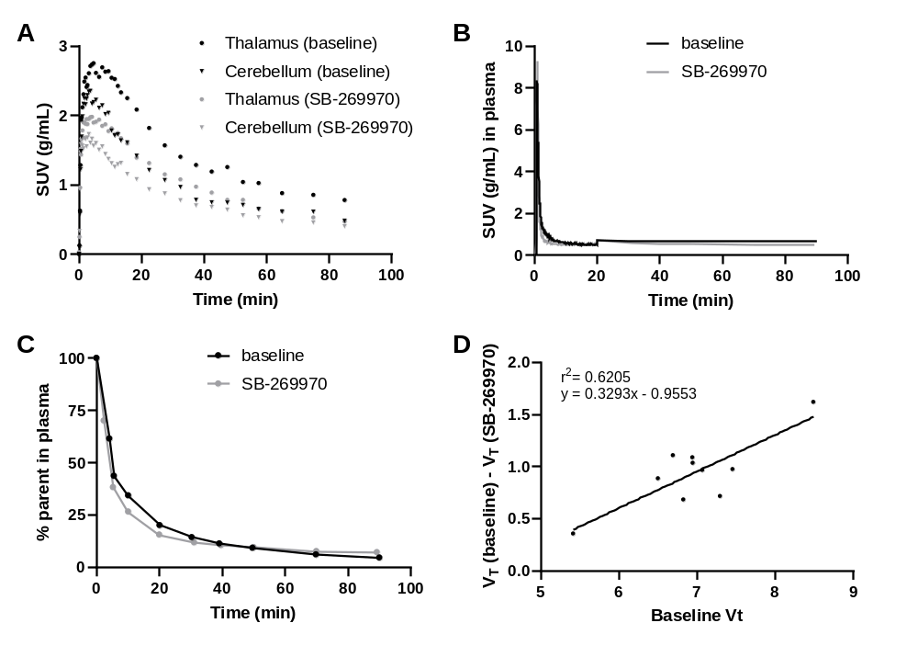
Supplementary Fig. S6. Evaluation of [¹¹C]BA-10 in a pig.
A: Regional time-activity curves for thalamus and cerebellum at baseline and after receptor block with SB-269970 (1 mg/kg/h).
B: Time-activity curves for arterial plasma.
C: Percentage of unmetabolized [¹¹C]BA-10 in arterial plasma.
D: Lassen plot. Linear regression and goodness-of-fit (r²) are indicated in the plot. Occupancy determined from the plot is 35.21% and non-displaceable distribution volume V_{ND} equals 4.28. Regions used for calculation are: thalamus, insular cortex, frontal cortex, cingulate cortex, occipital cortex, temporal cortex, somatosensory cortex, hippocampus, dorsal striatum and cerebellum.

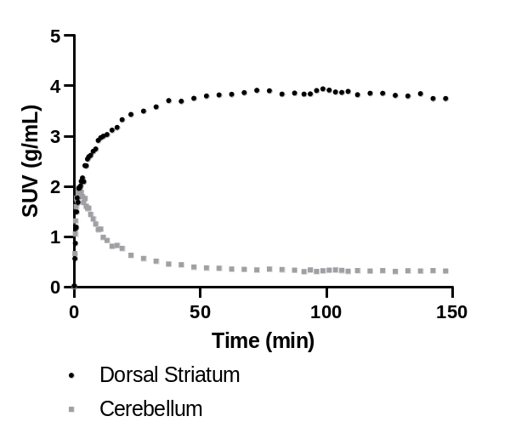
Supplementary Fig. S7. Time-activity curves of [¹⁸F]fallypride in a pig.
Regional time-activity curves of [¹⁸F]fallypride are shown for the dorsal striatum and cerebellum at baseline.

Supplementary Tables
Supplementary Table S1: AUC values (min×g/mL) in the ROIs of rat brain
 | [¹⁸F]MH.MZ |  |  | [¹⁸F]Altanserin |  |  | [¹¹C]Pimavanserin |  |  | [¹¹C]Cimbi-36
 | mPFC | Cb | Wb | Fc | Cb | Wb | mPFC | Cb | Wb | mPFC | Cb | Wb
Baseline | 94.5±6.6 | 55.3±1.6 | 73.1±3.8 | 41.8±1.4 | 31.5±1.5 | 39.7±0.4 | 22.8±1.0 | 22.4±0.3 | 21.9±0.4 | 35.5±2.2 | 30.1±1.9 | 32.7±1.9
Ketanserin | 42.3±2.0 | 41.4±0.7 | 41.7±0.8 | 16.7±8.5 | 8.8±4.2 | 15.9±2.2 | 25.8±0.5 | 24.9±0.6 | 24.7±0.3 | 23.7±0.7 | 21.5±0.4 | 22.6±0.3
P-gp inhibition | 219±4 | 107±2 | 145±3 | 85.0±1.8 | 54.6±0.8 | 65.1±0.4 | 180±3 | 174±3 | 167±2 | 174±2 | 106±1 | 127±1
P-gp inhibition & ketanserin | 110 | 106 | 108 | 76.8±1.2 | 58.1±0.8 | 64.8±0.3 | 190 | 210 | 184 | 141 | 124 | 131

 | [¹¹C]Cimbi-717 |  |  | [¹¹C]Cimbi-701 |  |  | [¹¹C]BA-10
 | Tha | Cb | Wb | Tha | Cb | Wb | Tha | Cb | Wb
Baseline | 42.5±1.2 | 38.8±1.0 | 38.7±1.1 | 37.8±1.1 | 38.2±1.1 | 40.4±0.6 | 29.3±0.3 | 27.2±0.2 | 23.6±1.2
SB-269970 | 45.1±1.2 | 41.3±0.9 | 40.5±0.9 | 39.6±0.9 | 39.4±0.6 | 43.4±0.2 | 13.1±1.2 | 11.4±1.1 | 12.1±1.2
P-gp inhibition | 62.5±1.5 | 54.8±1.0 | 53.4±0.7 | 142±4 | 121±3 | 177±3 | 64.7±0.9 | 55.6±0.6 | 56.3±0.6
P-gp inhibition & SB-269970 | 71.2±1.5 | 59.0±1.2 | 61.2±0.7 | 139±2 | 114±2 | 116±1 | 25.5 | 23.3 | 23

 | [¹⁸F]Fallypride
 | Str | Cb | Wb
Baseline | 146±3 | 35.4±0.6 | 60.7±0.8
haloperidol | 23.9±0.5 | 23.6±0.8 | 28.1±0.7
P-gp inhibition | 374±13 | 73.8±1.5 | 135±4
P-gp inhibition & haloperidol | 69.2±0.8 | 56.8±0.6 | 64.2±0.6

AUC values calculated for the whole duration of the PET scans: 60 min for ¹¹C-labeled tracers, 90 min for ¹⁸F-labeled tracers.
Regions of interest: mPFC – medial prefrontal cortex, FC – frontal cortex, Tha – thalamus, Str – striatum, Cb – cerebellum, Wb – whole brain.
All values presented as mean±SE. Absence of SE means the AUC value was derived from a single animal. Numbers of animals per condition are listed in Supplementary Table S2.

Supplementary Table S2: Number of rats scanned per experimental condition
 | Baseline | Block | P-gp inhibition | P-gp inhibition & block
[¹⁸F]MH.MZ | 4 | 2 | 2 | 1
[¹⁸F]Altanserin | 3 | 3 | 3 | 3
[¹¹C]Pimavanserin | 2 | 2 | 2 | 1
[¹¹C]Cimbi-36 | 3 | 2 | 2 | 1
[¹¹C]Cimbi-701 | 2 | 2 | 2 | 2
[¹¹C]Cimbi-717 | 3 | 2 | 2 | 2
[¹¹C]BA-10 | 2 | 2 | 2 | 1
[¹⁸F]Fallypride | 2 | 2 | 2 | 2

Supplementary Table S3: Comparison of tracer evaluation outcomes in rats and pigs.
Tracer | rat  |  |  |  |  |  | pig  |  |  |  |  | Confirmed target-specific binding |  |  | Prediction outcome^{d}
Tracer | 60 min AUCª,  min×g/mL |  | Target-specific binding |  |  |  | 60 min AUCª, min×  g/mL | Target-specific binding |  |  |  |  |  |  | Prediction outcome^{d}
Tracer |  |  | Std^{b} |  | P-gpI^{c}
Tracer | Std^{b} | P-gpI^{c} | Baseline SBR | SBR change, % | Baseline SBR | SBR change, % | 60 min AUCª, min×  g/mL | Baseline BP_{ND} | Achieved blocking effect, % | Method | Ref | rats  Std^{b} | rats  P-gpI^{c} | pigs | Prediction outcome^{d}
[¹⁸F]MH.MZ | 60 | 147 | 0.71 | –97 | 1.04 | –96 | 105 | 3.3 | 81 | BP_{ND} | [9] | Yes | Yes | Yes | 
[¹⁸F]Altanserin | 28 | 53 | 0.33 | +172 | 0.56 | –42 | 122 | 0.68 | 78 | BP_{ND} | [9] | No | Yes | Yes
[¹¹C]Pimavanserin | 23 | 180 | 0.02 | +110 | 0.03 | –395 | 103 | 0.25 | n.e.^{e} | vis .ex.^{e} | [10] | No | No | No
[¹¹C]Cimbi-36 | 36 | 174 | 0.18 | –44 | 0.65 | –79 | 75 | 0.70 | 63 | BP_{ND} | [11] | Yes | Yes | Yes
[¹¹C]Cimbi-717 | 43 | 62 | 0.10 | –5 | 0.14 | +46 | 155 | 6.40 | 60 | LP | [12] | No | No | Yes | 
[¹¹C]Cimbi-701 | 38 | 142 | –0.01 | –165 | 0.18 | +23 | 118 | 2.26 | 63 | LP | [13] | No | No | Yes
[¹¹C]BA-10 | 29 | 65 | 0.08 | +92 | 0.16 | –44 | 107 | 0.98 | 35 | LP | this work | No | Yes | Yes
[¹⁸F]Fallypride | 95 | 244 | 3.11 | –100 | 4.07 | –95 | 191 | 9.82 | n.d.^{f} | none | this work | Yes | Yes | Yes
Scan duration in rats was 60 min for ¹¹C-tracers and 90 min for ¹⁸F-tracers. Scan duration in pigs was 150 min for [¹⁸F]MH.MZ and [¹⁸F]Fallypride, 90 min for [¹¹C]Pimavanserin, [¹¹C]Cimbi-36, [¹¹C]Cimbi-717, [¹¹C]Cimbi-701 and [¹¹C]BA-10, 60 min for [¹⁸F]Altanserin. Values that characterize target-specific binding are calculated from full-length scan data, while AUC values characterizing brain uptake are all truncated to the first 60 min of the scan. In pig experiments, the same drugs were used for target block as in rat experiments. Blocking effect is expressed as a decrease in BP_{ND} in the target region [14] or as an occupancy value calculated from the Lassen plot (LP) [8]. Detailed descriptions of the pig experiments can be found in the respective references and in the “Pig PET experiments” section above. BP_{ND} for [¹¹C]Pimavanserin is calculated from cortical and cerebellar V_{T} values reported in [10] using Equation I (see “Pig PET experiments”). TACs for [¹¹C]BA-10 and [¹⁸F]fallypride and Lassen plot for [¹¹C]BA-10 in pigs are presented in Supplementary Fig. 6-8.
ª Average AUC values are shown for target receptor-rich regions of the brain (medial prefrontal cortex / frontal cortex / cortex for 5-HT_{2A} tracers, thalamus for 5-HT₇ tracers, striatum for D_{2/3} tracers) ^{b} Std = standard evaluation workflow without P-gp inhibition; ^{c} P-gpI = P-gp inhibition; ^{d} Prediction outcome indicates if the evaluation outcome in pigs could (thumb up) or could not (thumb down) be correctly predicted from evaluation outcome in rats; ^{e} no effect detected by visual examination of TACs at baseline and after target block; ^{f} not determined

References

1. Hansen HD, Lacivita E, Di Pilato P, Herth MM, Lehel S, Ettrup A, et al. Synthesis, radiolabeling and in vivo evaluation of [¹¹C](R)-1-[4-[2-(4-methoxyphenyl)phenyl]piperazin-1-yl]-3-(2-pyrazinyloxy)-2-propanol, a potential PET radioligand for the 5-HT₇ receptor. Eur J Med Chem. 2014;79:152–63.
2. Hong IK, Chung ST, Kim HK, Kim YB, Son YD, Cho ZH. Ultra Fast Symmetry and SIMD-Based Projection-Backprojection (SSP) Algorithm for 3-D PET Image Reconstruction. IEEE Trans Med Imaging. 2007;26:789–803.
3. Sureau FC, Reader AJ, Comtat C, Leroy C, Ribeiro M-J, Buvat I, et al. Impact of Image-Space Resolution Modeling for Studies with the High-Resolution Research Tomograph. J Nucl Med. 2008;49:1000–8.
4. Keller SH, Svarer C, Sibomana M. Attenuation Correction for the HRRT PET-Scanner Using Transmission Scatter Correction and Total Variation Regularization. IEEE Trans Med Imaging. 2013;32:1611–21.
5. Villadsen J, Hansen HD, Jørgensen LM, Keller SH, Andersen FL, Petersen IN, et al. Automatic delineation of brain regions on MRI and PET images from the pig. J Neurosci Methods. 2018;294:51–8.
6. Cumming P, Rosa-Neto P, Watanabe H, Smith D, Bender D, Clarke PB., et al. Effects of acute nicotine on hemodynamics and binding of [¹¹C]raclopride to dopamine D_{2,3} receptors in pig brain. Neuroimage. 2003;19:1127–36.
7. Lammertsma AA, Hume SP. Simplified Reference Tissue Model for PET Receptor Studies. Neuroimage. 1996;4:153–8.
8. Cunningham VJ, Rabiner EA, Slifstein M, Laruelle M, Gunn RN. Measuring drug occupancy in the absence of a reference region: the Lassen plot re-visited. J Cereb Blood Flow Metab. 2010;30:46–50.
9. Hansen HD, Ettrup A, Herth MM, Dyssegaard A, Ratner C, Gillings N, et al. Direct comparison of [¹⁸F]MH.MZ and [¹⁸F]altanserin for 5-HT_{2A} receptor imaging with PET. Synapse. 2013;67:328–37.
10. Andersen VL, Hansen HD, Herth MM, Dyssegaard A, Knudsen GM, Kristensen JL. ¹¹C-labeling and preliminary evaluation of pimavanserin as a 5-HT_{2A} receptor PET-radioligand. Bioorganic Med Chem Lett. 2015;25:1053–6.
11. Ettrup A, Hansen M, Santini MA, Paine J, Gillings N, Palner M, et al. Radiosynthesis and in vivo evaluation of a series of substituted ¹¹C-phenethylamines as 5-HT_{2A} agonist PET tracers. Eur J Nucl Med Mol Imaging. 2011;38:681–93.
12. Hansen HD, Herth MM, Ettrup A, Andersen VL, Lehel S, Dyssegaard A, et al. Radiosynthesis and In Vivo Evaluation of Novel Radioligands for PET Imaging of Cerebral 5-HT₇ Receptors. J Nucl Med. 2014;55:640–6.
13. L ’Estrade ET, Shalgunov V, Edgar FG, Strebl-Bantillo MG, Xiong M, Crestey F, et al. Radiosynthesis and preclinical evaluation of [¹¹C]Cimbi-701 - Towards the imaging of cerebral 5-HT₇ receptors. J Label Compd Radiopharm. 2020;63:46–55.
14. Innis RB, Cunningham VJ, Delforge J, Fujita M, Gjedde A, Gunn RN, et al. Consensus nomenclature for in vivo imaging of reversibly binding radioligands. J Cereb Blood Flow Metab. 2007;27:1533–9.

