Supplementary Information

AI and Entrepreneurship:
Facial Recognition Technology Detects Entrepreneurs, Outperforming Human Experts

Appendix A: Technical details, further analyses, and robustness checks
This online appendix provides additional technical details regarding our method and analyses. To keep the online appendix more self-contained, we repeat some parts of the main text verbatim.

A.1 Full facial image-based classifier

A.1.1 Face detector
The location of the face in the input image is detected using the widely used MTCNN face detection technique which is proposed in Zhang et al. (2016). Despite being lightweight, this technique allows us to generate real-time inferences. MTCNN achieves competitive results in FDDB (Jain and Learned-Miller, 2010) and WIDER FACE (Yang et al., 2016) benchmarks, outperforming numerous baselines (e.g., Chen et al., 2014; Yang et al., 2015; Yang et al., 2016). This face detection method utilizes three stages of CNNs in its pipeline. In the first stage, candidate windows for the face region are produced through a proposal network. These proposals are fed to another CNN (Refine Network) which further rejects the false candidates. In the final stage, the bounding box is properly aligned to the face by detecting five facial landmarks’ positions, namely, the eyes, nose, and the corners of the mouth. Utilizing this framework, we detect the face region of each input image. Then, the detected faces are resized to 224×224 pixels prior to the facial feature extraction.

A.1.2 Extracting facial features using convolutional neural networks
We employ the model proposed in Cao et al. (2018) pre-trained using VGG-Face 2 dataset as our facial feature extractor. The VGG-Face 2 architecture (Cao et al., 2018) utilizes ResNet-50 (He et al., 2016), which is a particular CNN structure, as its backbone for facial feature extraction from the input face images. Then, Cao et al. (2018) pass these features through Squeeze-and-Excitation blocks (Hu et al., 2018), which explicitly model the channel-wise relationships within the RGB channels in the input image. Hu et al. (2018) demonstrate that this method has been able to learn improved facial representations in terms of facial features, allowing them to achieve competitive results in the VGG-Face 2 dataset for both face identification and face verification tasks. Therefore, we utilize this model that was pre-trained on the VGG-Face 2 dataset and extract features from the ‘activation 40’ layer, which produces a 14×14×1024 feature vector when presented with an input face image.

A.1.3 Classifier
Convolutional Neural Networks (CNNs) have achieved tremendous success in a variety of face-related tasks, including, face recognition (Masi et al., 2018), fake face generation (Gao et al., 2018), and fake face detection (Hsu et al., 2018). For instance, in face verifications, where a candidate image is compared against a target image to verify whether the two face images are coming from the same person or not, CNNs outperform humans (Shepley, 2019). Furthermore, CNNs have been able to generate realistic-looking synthetic faces which are able to fool humans (Hao, 2019). Considering the recent success of CNNs we propose to utilize a classifier based on CNNs.
Our AI model (visually illustrated in Figure 1 in the paper) is composed of two identical shared feature processing blocks, each with two convolution 2D layers, two activation layers, a batch normalization layer, and a dropout layer. The shared feature processing blocks allow our classifier to seamlessly compare the features from left and right images, without adding a significant parameter overhead.
Each convolution 2D layer has a 3×3 convolution layer with 32 filters. The dropout rate of the respective dropout layers (Srivastava et al., 2014) is indicated within brackets. Subsequently, these features are passed through a dense layer with 512 and Relu activation and a dropout layer with a 0.5 dropout rate. The output is fed into a dense layer with sigmoid activation to generate the binary classification; class 0 if the left image is of an entrepreneur or class 1 if the right image is of an entrepreneur. This classifier is trained using binary cross-entropy loss and Adam (Kingma and Ba, 2014) optimizer with a learning rate of 0.001 and a decay of 1×10⁻⁶ for 100 epochs.

A.2 Facial landmarks-based classifier

A.2.1 Detection of facial landmarks
First the input facial images (after detecting the faces) are passed through a popular facial landmark detection algorithm named face alignment network which is proposed in Bulat and Tzimiropoulos (2017). This architecture is constructed using Hour-Glass network architecture (Newell et al., 2016), where the authors stack two hourglass modules for processing spatial information in multiple scales for dense prediction. This architecture has been able to achieve competitive results for 2D and 3D face alignment and landmark detection in multiple benchmarks, including the AFLW2000-3D dataset (Zhu et al., 2016).
As the facial landmarks, we use the eyes, nose, and mouth regions. After detecting these regions rest of the face is masked out such that it contains information only for a particular landmark region and the rest of the pixels of the image are composed of zeros. Figure SI2 provides examples of nose, eyes, and mouth regions.

A.2.2 Feature extraction
To draw a direct comparison between the two experiments, we apply the same feature extraction strategy in Section where we pass the generated images through the VGG-Face2 model and extract facial features from the ‘activation 40’ layer.

A.2.3 Classifier
Once the non-facial landmark regions are masked out only a smaller region within the extracted feature vector contains informative details. Therefore, a shallow model (with a smaller number of trainable parameters) can be utilized compared to our initial entrepreneurship classifier which receives the full facial image.
This model consists of two modules each with a 3×3 convolutional layer with 64 filters followed by batch normalization, a Relu nonlinearity, and a dropout layer with a 0.25 dropout rate. Then we pass the resultant feature vector through a max pooling layer with 2×2 pool size and the final entrepreneurship classification is generated by a dense layer with sigmoid activation. This classifier is trained using binary cross-entropy loss and Adam (Kingma and Ba, 2014) optimizer with a learning rate of 0.001 and a decay of 1×10⁶ for 100 epochs.
For each landmark (eye, nose, and mouth), 75% of the data is randomly chosen for training and 25% of the data for testing, and a separate model is trained for each land- mark. We repeated this process three times and the average accuracy on the test set is chosen as the final accuracy. We also evaluate the accuracy of combining these three landmarks. In this model, we first pass the individual landmarks through two convolution- batch-normalization - Relu-nonlinearity - dropout modules as defined previously and then through a 2×2 max pooling layer. Then we concatenate the outputs from the individual landmark streams and generate the final classification by a dense layer with sigmoid activation.

A.3 Further analysis regarding gender
Deep learning models learn task specific features automatically. These features are represented in a model specific, higher dimensional embedding space. However, this embedding space is not human interpretable, and we need to use embedding space visualization techniques make it interpretable. Therefore, to better understand what features of the face region are extracted by the face classifier and to understand whether these identified features have any bias towards a specific gender, we generate an embedding space visualization for a set of randomly chosen samples. Our VGG-Face 2 feature extractor extracts features from each facial image that is in the given pair of images which represent the important features in that particular face. This extracted feature vector is of size 512, as such, it can be seen as representing the 224×224 = 50,176 pixels in the input face image in 512 values. Therefore, each image in our training set of face images is represented with 512 values and we call this space as our embedding space. The embedding space is the learned representation space where each image is represented based on its salient characteristics. To visualize this embedding space, we need to map the 512 dimensions either into 2 dimensions (2D) or into 3 dimensions using a dimensionality reduction scheme such as principal component analysis. To analyze whether the grouping (or clustering) of the samples in the embedding space is based on gender or whether it’s governed by the learned entrepreneurship characteristics we generated a 2D embedding space visualization for 250 male and 60 female samples that were randomly chosen from the test set.
In both categories, 50% of the sample are facial images from entrepreneur (ENT) and the remaining 50% are from non-entrepreneurs (Non-ENTs). We apply the PCA algorithm (Wold et al., 1987) on the output of the feature extractor to visualize the embeddings in 2D. The resulting plot is displayed in Figure SI3. This analysis shows that the AI model’s learned embedding space separation is based on the ENT/Non-ENT labels and does not seem to be biased towards a specific gender. We would like to note that the examples of the same color (ENT: pink, Non-ENT: green) are clustered together irrespective of the shape (circles-males, stars-females). This shows that the proposed AI model has been able to automatically retrieve ENT-specific features from the input faces irrespective of their gender.

References
Bulat, A., Tzimiropoulos, G. (2017). How far are we from solving the 2d & 3d face alignment problem? (And a dataset of 230,000 3d facial landmarks). Proceedings of the IEEE International Conference on Computer Vision, 1021–1030.
Cao, Q., Shen, L., Xie, W., Parkhi, O. M., Zisserman, A. (2018). VGGFace2: a dataset for recognizing faces across pose and age. 2018 13th IEEE International Conference on Automatic Face & Gesture Recognition (FG 2018), 67–74.
Chen, D., Ren, S., Wei, Y., Cao, X., Sun, J. (2014). Joint cascade face detection and alignment. European Conference on Computer Vision, 109–122.
Gao, F., Yang, Y., Wang, J., Sun, J., Yang, E., Zhou, H. (2018). A deep convolutional generative adversarial networks (dcgans)-based semi-supervised method for object recognition in synthetic aperture radar (sar) images. Remote Sensing, 10(6), 846.
Hao, K. (2019). The biggest threat of deepfakes isn’t the deepfakes themselves. Available at: https://www.technologyreview.com/2019/10/10/132667/the-biggest-threat-ofdeepfakes-isnt-the-deepfakes-themselves, last accessed: June 19, 2024.
He, K., Zhang, X., Ren, S., Sun, J. (2016). Deep residual learning for image recognition. Proceedings of the IEEE Conference on Computer Vision and Pattern Recognition, 770–778.
Hsu, C.-C., Lee, C.-Y., Zhuang, Y.-X. (2018). Learning to detect fake face images in the wild. 2018 International Symposium on Computer, Consumer and Control (IS3C), 388–391.
Hu, J., Shen, L., Sun, G. (2018). Squeeze-and-excitation networks. Proceedings of the IEEE Conference on Computer Vision and Pattern Recognition, 7132–7141.
Jain, V., Learned-Miller, E. (2010). Fddb: A benchmark for face detection in unconstrained settings. UMass Amherst Technical Report.
Kingma, D. P., Ba, J. (2014). Adam: A method for stochastic optimization. arXiv preprint arXiv:1412.6980.
Masi, I., Wu, Y., Hassner, T., Natarajan, P. (2018). Deep face recognition: a survey. 2018 31st SIBGRAPI Conference on Graphics, Patterns and Images (SIBGRAPI), 471–478.
Newell, A., Yang, K., Deng, J. (2016). Stacked hourglass networks for human pose estimation. European Conference on Computer Vision, 483–499.
Shepley, A. J. (2019). Deep learning for face recognition: a critical analysis. arXiv preprint arXiv:1907.12739.
Srivastava, N., Hinton, G., Krizhevsky, A., Sutskever, I., Salakhutdinov, R. (2014). Dropout: a simple way to prevent neural networks from overfitting. The Journal of Machine Learning Research, 15(1), 1929–1958.
Wold, S., Esbensen, K., Geladi, P. (1987). Principal component analysis. Chemometrics and Intelligent Laboratory Systems, 2(1–3), 37–52.
Yang, S., Luo, P., Loy, C.-C., Tang, X. (2015). From facial parts responses to face detection: a deep learning approach. Proceedings of the IEEE international conference on computer vision, 3676–3684.
Yang, S., Luo, P., Loy, C.-C., Tang, X. (2016). Wider face: a face detection bench- mark. Proceedings of the IEEE conference on computer vision and pattern recognition, 5525–5533.
Zhang, K., Zhang, Z., Li, Z., Qiao, Y. (2016). Joint face detection and alignment using multitask cascaded convolutional networks. IEEE Signal Processing Letters, 23(10), 1499–1503.
Zhu, X., Lei, Z., Liu, X., Shi, H., Li, S. Z. (2016). Face alignment across large poses: a 3d solution. Proceedings of the IEEE conference on computer vision and pattern recognition, 146–155.

Figures
Figure SI1: Training and validation accuracy curves, suggesting that overfitting is not a major concern.
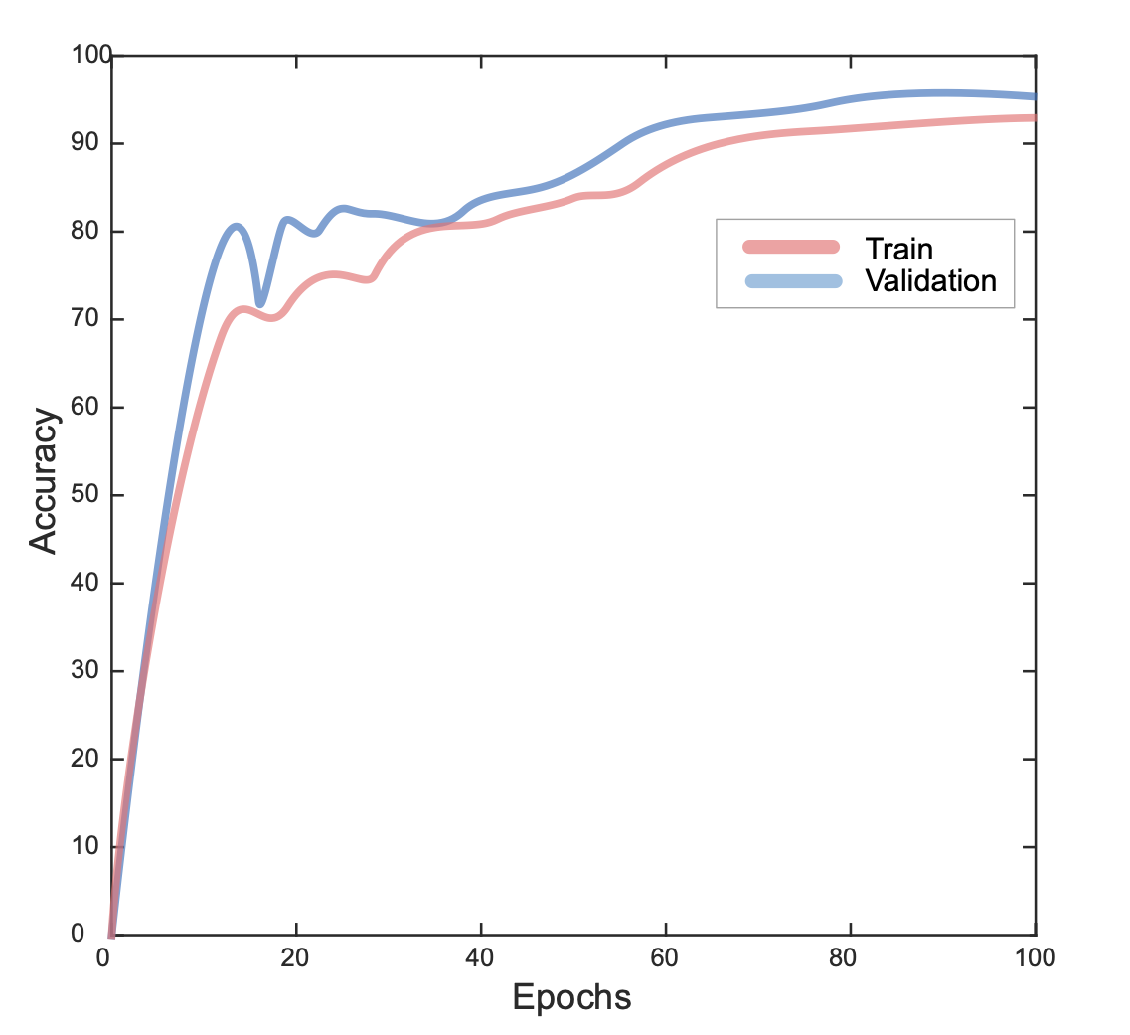

Figure SI2: Examples for the landmark images.
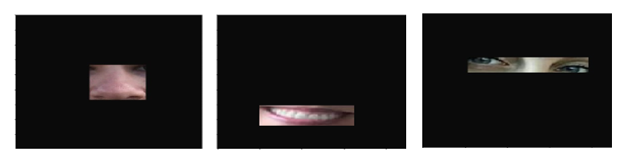

Figure SI3: Model bias and sensitivity analysis.
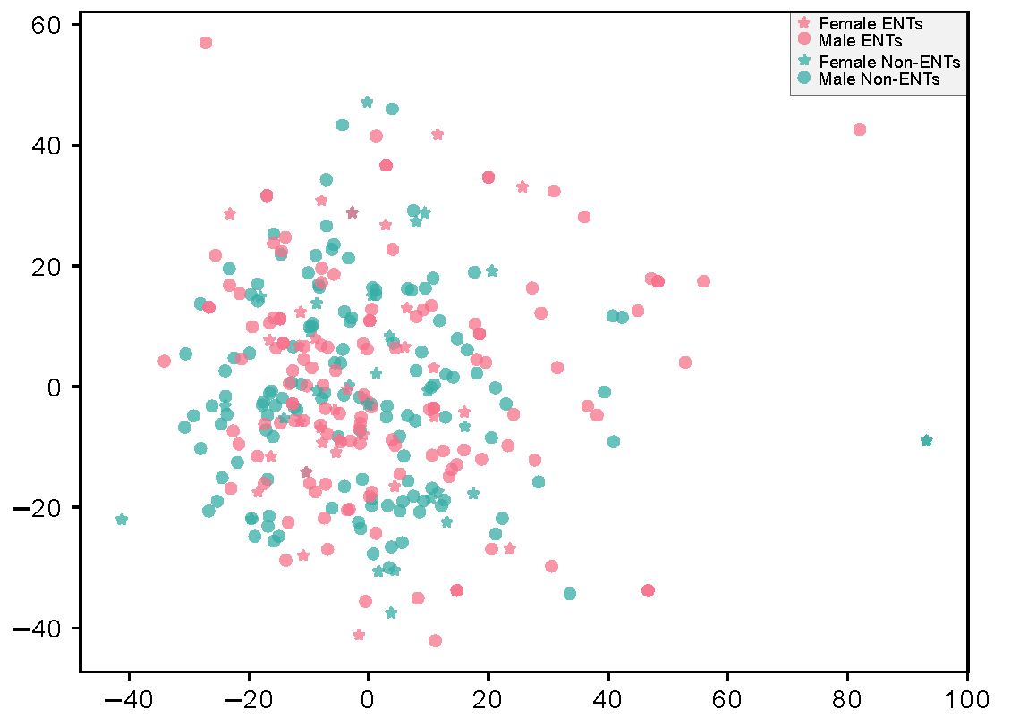
Notes: 2D embedding space visualization showing a randomly chosen 250 male and 60 female samples from the test set. In both categories, 50% of the samples are ground truth entrepreneur (ENT) faces and the remaining 50% are from non-entrepreneurs (Non-ENTs). Both male and female ENTs are clustered together irrespective of gender. Similarly, Non-ENTs are also clustered together.

Figure SI4: Estimated entrepreneurship trait from the AI model for the researchers involved in this study. The model successfully distinguishes between entrepreneurship and non-entrepreneurship scholars.
(1) Martin Obschohnka  (entrepreneurship scholar) |  | (2) Christian Fisch  (entrepreneurship scholar) |  | (3) Clinton Fookes  (machine learning scholar) |  | (4) Tharindu Fernando  (machine learning scholar)
 |  |  |  |  |  | 
Notes: The authors agree with their images being used here and displayed.

Appendix B: Training material
This online appendix provides the slides we used to train humans. Note that the actual facial images and the link to the online experiment shown during the training are not presented here.

We use the following implementation: https://github.com/ipazc/mtcnn
We use the following implementation: https://github.com/WeidiXie/Keras-VGGFace2-ResNet50

