Geographical accessibility and inequalities in access to childbirth care in the Grand Conakry metropolitan area, Guinea: a spatial modelling study
Fassou Mathias Grovogui^{1,2,3,4ⱡ}, Nafissatou Dioubate^{2,3}, Hawa Manet³, Pepe Kpogomou², Tamba Mina Millimouno², Aline Semaan⁴, Lenka Beňová^{4,5}, Alexandre Delamou^{1,2,3*}, Peter M Macharia^{4,6*}

- Department of Public Health, Faculty of Health Sciences and Techniques, Gamal Abdel Nasser University, Conakry, Republic of Guinea
- African Center of Excellence for the Prevention and Control of Communicable Diseases (CEA-PCMT), Gamal Abdel Nasser University, Conakry, Republic of Guinea
- Centre National de Formation et de Recherche en Santé Rurale de Maferinyah, Forécariah, Guinea
- Department of Public Health, Institute of Tropical Medicine, Antwerp, Belgium
- Faculty of Epidemiology and Population Health, London School of Hygiene & Tropical Medicine, London, UK
- Population & Health Impact Surveillance Group, Kenya Medical Research Institute-Wellcome Trust Research Programme, Nairobi, Kenya

ⱡ Corresponding author:
*Joint last authors

Figure S1. Maps of factors that affect travel time in Grand Conakry

Figure S1.1 – Road Network (2023 – OpenStreetMap) | Figure S1.2 – Sentinel-2 land cover at 10m spatial resolution from 2023 | Figure S1.3 – Shuttle Radar Topography Mission digital elevation model (DEM) at 30m spatial resolution
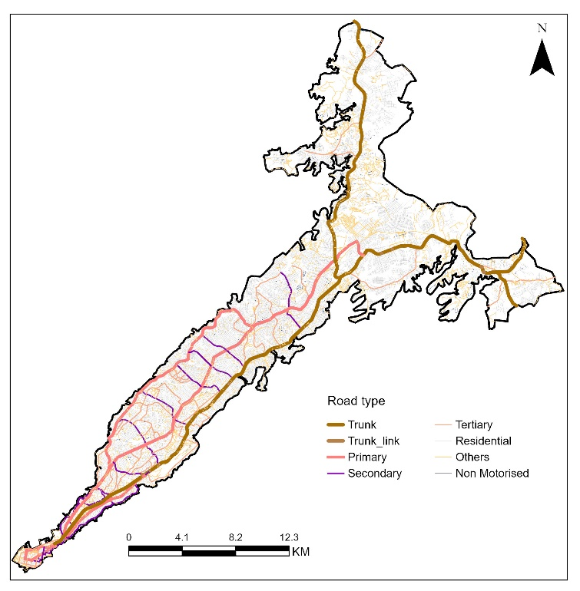 | 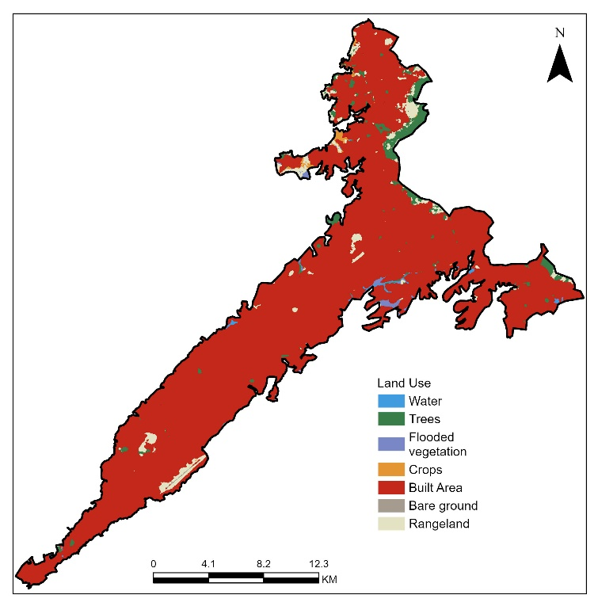 | 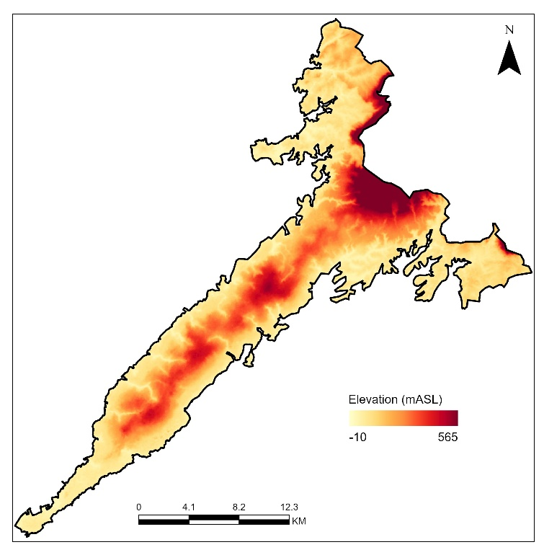

Table S1. Travel times experiences to the nearest health facilities using different speed scenarios in the Grand Conakry, by communes

 | Communes | All Health Facilities |  | Public Health Facilities |  | All Hospitals |  | Public Hospitals
 | Communes | Ave [Max - Min] | Ave (UQ - LQ] | Ave [Max - Min] | Ave (UQ - LQ] | Ave [Max - Min] | Ave (UQ - LQ] | Ave [Max - Min] | Ave (UQ - LQ]
Conakry | Sonfonia | 4.2[2.4-21.6] | 4.2[3.2-5.2] | 5.3[3.0-27.6] | 5.3[4.0-6.7] | 7.8[4.0-45.6] | 7.8[5.9-10.1] | 13.2[6.4-77.7] | 13.2[10.1-17.6]
Conakry | Lambagny | 4.4[2.5-21.9] | 4.4[3.4-5.5] | 4.7[2.6-24.1] | 4.7[3.6-5.9] | 5.6[3.0-29.2] | 5.6[4.4-7.2] | 9.6[5.1-50.9] | 9.6[7.2-12.3]
Conakry | Kaloum | 3.0[1.8-12.2] | 3.0[2.5-3.7] | 4.5[2.5-18.6] | 4.5[3.7-5.7] | 3.3[1.9-15.4] | 3.3[2.7-4.3] | 4.6[2.5-20.6] | 4.6[3.8-6.0]
Conakry | Matam | 3.2[1.8-11.5] | 3.2[2.6-4.0] | 3.6[2.0-13.5] | 3.6[2.9-4.7] | 4.1[2.2-16.4] | 4.1[3.3-5.3] | 4.5[2.4-18.7] | 4.5[3.6-6.0]
Conakry | Dixinn | 3.2[2.0-13.0] | 3.2[2.6-4.0] | 3.4[2.0-14.3] | 3.4[2.8-4.3] | 4.5[2.5-18.0] | 4.5[3.7-5.9] | 5.2[2.7-21.3] | 5.2[4.2-6.8]
Conakry | Ratoma | 3.8[2.2-17.7] | 3.8[3.0-4.7] | 4.5[2.6-21.9] | 4.5[3.5-5.7] | 5.7[3.0-30.2] | 5.7[4.5-7.3] | 9.8[4.7-51.7] | 9.8[7.7-13.1]
Conakry | Gbessia | 3.0[2.4-15.1] | 3.0[3.2-4.9] | 4.4[2.6-17.0] | 4.4[3.5-5.4] | 7.2[3.8-29.0] | 7.2[5.8-9.3] | 13.6[6.2-46.8] | 13.6[10.9-18.5]
Conakry | Tombolia | 4.5[2.6-20.3] | 4.5[3.4-5.7] | 5.4[3.0-23.9] | 5.4[4.1-6.9] | 7.1[3.6-27.1] | 7.1[5.5-9.2] | 14.5[6.8-72.9] | 14.5[11.2-19.4]
Conakry | Matoto | 4.5[2.5-17.1] | 4.5[3.5-5.7] | 5.0[2.7-20.0] | 5.0[3.9-6.4] | 5.7[3.1-21.8] | 5.7[4.4-7.2] | 12.3[6.1-61.2] | 12.3[9.3-16.1]
Dubréka | Dubréka | 9.7[5.4-35.3] | 9.7[7.6-12.1] | 9.8[5.5-36.1] | 9.8[7.7-12.3] | 32.8[17.3-118.2] | 32.8[26.3-40.5] | 32.8[17.3-118.2] | 32.8[26.3-40.5]
Dubréka | Kagbélen | 10.9[5.8-42.7] | 10.9[8.4-13.9] | 11.7[6.2-47.6] | 11.7[9.0-14.9] | 24.8[12.3-88.9] | 24.8[19.3-32.1] | 32.8[15.5-122.9] | 32.8[25.9-43.1]
Coyah | Coyah | 8.5[4.9-35.1] | 8.5[6.6-10.5] | 8.5[4.9-35.1] | 8.5[6.6-10.5] | 12.1[6.4-43.9] | 12.1[9.6-15.6] | 12.1[6.4-43.9] | 12.1[9.6-15.6]
Coyah | Manéah | 14.7[7.5-47.4] | 14.7[11.6-19.1] | 14.7[7.5-47.4] | 14.7[11.6-19.1] | 26.4[12.1-70.3] | 26.4[21.4-35.7] | 27.9[12.5-73.1] | 27.9[22.6-37.7]
Coyah | Sanoyah | 7.1[3.7-25.9] | 7.1[5.5-9.2] | 7.3[3.8-26.3] | 7.3[5.7-9.6] | 22.1[9.9-58.5] | 22.1[17.3-29.8] | 32.6[13.4-91.9] | 32.6[26.5-45.7]
Overall |  | 7.9[4.3-30.4] | 7.9[6.2-10.1] | 8.4[4.5-32.9] | 8.4[6.5-10.7] | 17.3[8.6-60.6] | 17.3[13.7-22.3] | 21.6[10.4-80.3] | 21.6[17.2-28.4]

Table S2. Geographic coverage of women of childbearing age within 0.25-hr, 0.5-hr, 1-hr to the nearest public health facility and any hospital by commune within Grand Conakry
 |  |  | %WoCBA in 15 minutes |  |  | %WoCBA in 30 minutes |  | %WoCBA in 60 minutes
 | Communes | Pop of WoCBA | Ave[Min-Max] | Ave[LQ-UQ] |  | Ave[Min-Max] | Ave[LQ-UQ] | Ave[Min-Max] | Ave[LQ-UQ]
 | Public Health facilities
Conakry | Sonfonia | 71251 | All WoCBA | All WoCBA |  | 100.0%[68.7%-100.0%] | All WoCBA | - | -
Conakry | Lambagny | 53893 | All WoCBA | All WoCBA |  | 100.0%[71.3%-100.0%] | All WoCBA | - | -
Conakry | Kaloum | 1629 | All WoCBA | All WoCBA |  | 100.0%[96.2%-100.0%] | All WoCBA | - | -
Conakry | Matam | 5625 | All WoCBA | All WoCBA |  | 100.0%[97.9%-100.0%] | All WoCBA | - | -
Conakry | Dixinn | 6698 | All WoCBA | All WoCBA |  | All WoCBA | All WoCBA | - | -
Conakry | Ratoma | 51057 | All WoCBA | All WoCBA |  | 100.0%[85.0%-100.0%] | All WoCBA | - | -
Conakry | Gbessia | 90355 | All WoCBA | All WoCBA |  | 100.0%[97.5%-100.0%] | All WoCBA | - | -
Conakry | Matoto | 158866 | All WoCBA | All WoCBA |  | 100.0%[90.9%-100.0%] | All WoCBA | - | -
Conakry | Tombolia | 131698 | All WoCBA | 100.0%[99.7%-100.0%] |  | 100.0%[79.6%-100.0%] | All WoCBA | - | -
Dubréka | Kagbélen | 181041 | 81.5%[81.5%-100.0%] | 81.5%[63.6%-95.3%] |  | 100.0%[28.5%-100.0%] | 100.0%[99.5%-100.0%] | - | -
Dubréka | Dubréka | 78951 | 98.2%[98.2%-100.0%] | 98.2%[94.0%-98.4%] |  | 99.8%[59.5%-100.0%] | 99.8%[99.8%-100.0%] | - | -
Coyah | Coyah | 19070 | 97.6%[97.6%-100.0%] | 97.6%[96.5%-100.0%] |  | 100.0%[79.2%-100.0%] | All WoCBA | - | -
Coyah | Manéah | 112022 | 67.2%[67.2%-100.0%] | 67.2%[35.9%-86.9%] |  | 100.0%[31.3%-100.0%] | 100.0%[95.9%-100.0%] | - | -
Coyah | Sanoyah | 94749 | 98.0%[98.0%-100.0%] | 98.0%[95.8%-98.3%] |  | 99.8%[63.1%-100.0%] | 99.8%[99.7%-100.0%] | - | -
Overall |  | 1056903 | 93.4%[24.7%-100.0%] | 93.4%[86.2%-98.2%] | 100.0%[65.3%-100.0%] |  | 100.0%[99.9%-100.0%] | - | -
 | All Hospitals
Conakry | Sonfonia | 71251 | 99.0%[6.5%-100.0%] | 99.0%[90.4%-100.0%] | 100.0%[31.4%-100.0%] |  | All WoCBA | All WoCBA | All WoCBA
Conakry | Lambagny | 53893 | 100.0%[10.7%-100.0%] | All WoCBA | 100.0%[56.3%-100.0%] |  | All WoCBA | All WoCBA | All WoCBA
Conakry | Kaloum | 1629 | 100.0%[58.2%-100.0%] | All WoCBA | All WoCBA |  | All WoCBA | All WoCBA | All WoCBA
Conakry | Matam | 5625 | 100.0%[38.8%-100.0%] | All WoCBA | 100.0%[95.4%-100.0%] |  | All WoCBA | All WoCBA | All WoCBA
Conakry | Dixinn | 6698 | 100.0%[29.8%-100.0%] | All WoCBA | 100.0%[92.8%-100.0%] |  | All WoCBA | All WoCBA | All WoCBA
Conakry | Ratoma | 51057 | 100.0%[7.6%-100.0%] | All WoCBA | 100.0%[39.7%-100.0%] |  | All WoCBA | All WoCBA | All WoCBA
Conakry | Gbessia | 90355 | 95.6%[10.7%-100.0%] | 95.6%[90.3%-100.0%] | 100.0%[66.8%-100.0%] |  | All WoCBA | All WoCBA | All WoCBA
Conakry | Matoto | 158866 | 100.0%[26.1%-100.0%] | 100.0%[99.9%-100.0%] | 100.0%[85.8%-100.0%] |  | All WoCBA | All WoCBA | All WoCBA
Conakry | Tombolia | 131698 | 100.0%[24.3%-100.0%] | 100.0%[95.6%-100.0%] | 100.0%[71.0%-100.0%] |  | All WoCBA | All WoCBA | All WoCBA
Dubréka | Kagbélen | 181041 | 28.8%[2.3%-77.8%] | 28.8%[23.8%-35.3%] | 67.9%[7.3%-100.0%] |  | 67.9%[42.0%-99.1%] | 100.0%[21.9%-100.0%] | All WoCBA
Dubréka | Dubréka | 78951 | 26.4%[2.7%-72.3%] | 26.4%[20.3%-39.1%] | 78.9%[7.2%-99.3%] |  | 78.9%[65.9%-89.3%] | 99.3%[22.3%-100.0%] | 99.3%[98.8%-100.0%]
Coyah | Coyah | 19070 | 93.2%[27.9%-100.0%] | 93.2%[79.3%-99.5%] | 100.0%[70.4%-100.0%] |  | All WoCBA | 100.0%[91.9%-100.0%] | All WoCBA
Coyah | Manéah | 112022 | 10.7%[0.1%-86.1%] | 10.7%[3.8%-21.4%] | 70.1%[6.4%-99.5%] |  | 70.1%[34.8%-94.8%] | 99.5%[47.4%-100.0%] | 99.5%[99.4%-100.0%]
Coyah | Sanoyah | 94749 | 31.8%[0.0%-98.2%] | 31.8%[7.8%-58.8%] | 85.1%[10.3%-98.7%] |  | 85.1%[63.9%-98.3%] | 98.7%[65.8%-100.0%] | 98.7%[98.8%-100.0%]
Overall |  | 1056903 | 66.3%[10.7%-92.8%] | 66.3%[60.3%-72.7%] | 88.8%[40.3%-100.0%] |  | 88.8%[77.7%-98.7%] | 100.0%[71.0%-100.0%] | All WoCBA

Table S3. Geographic coverage of pregnant women within 0.25-hr, 0.5-hr, 1-hr to any nearest health facility, hospital, public health facility and any public hospital by commune within Grand Conakry
All Health Facilities
District | Communes | Pop of PW | %PW in 15 minutes |  | %PW in 30 minutes |  | %PW in 60 minutes
District | Communes | Pop of PW | Ave[Min-Max] | Ave[LQ-UQ] | Ave[Min-Max] | Ave[LQ-UQ] | Ave[Min-Max] | Ave[LQ-UQ]
Conakry | Sonfonia | 7559 | 97.7[24.7;97.3] | 97.7[97.5;97.3] | 97.3[83.7;100.0] | 97.3[97.3;100.0] | - | -
Conakry | Lambagny | 5643 | 99.3[25.0;99.1] | 99.3[99.3;99.1] | 99.1[77.2;100.0] | 99.1[99.1;100.0] | - | -
Conakry | Kaloum | 175 | 96.6[75.5;96.3] | 96.6[96.5;96.3] | 96.3[93.6;100.0] | 96.3[96.3;100.0] | - | -
Conakry | Matam | 599 | 99.7[74.2;100.4] | 99.7[99.8;100.4] | 100.4[100.4;100.0] | 100.4[100.4;100.0] | - | -
Conakry | Dixinn | 716 | 96.7[67.4;96.7] | 96.7[96.4;96.7] | 96.7[95.3;100.0] | 96.7[96.7;100.0] | - | -
Conakry | Ratoma | 5432 | 98.8[48.5;98.7] | 98.8[98.7;98.7] | 98.6[90.8;100.0] | 98.6[98.7;100.0] | - | -
Conakry | Gbessia | 9661 | 100.4[64.7;100.3] | 100.4[100.3;100.3] | 100.3[99.2;100.0] | 100.3[100.3;100.0] | - | -
Conakry | Matoto | 16264 | 99.7[51.3;99.7] | 99.7[99.7;99.7] | 99.7[95.0;100.0] | 99.7[99.7;100.0] | - | -
Conakry | Tombolia | 14121 | 95.9[47.1;96.0] | 95.9[96.0;96.0] | 95.9[83.1;100.0] | 95.9[96.0;100.0] | - | -
Dubréka | Kagbélen | 19001 | 79.0[10.8;96.8] | 79.0[64.4;91.1] | 96.8[39.9;100.0] | 96.8[95.8;100.0] | - | -
Dubréka | Dubréka | 8199 | 91.7[29.1;92.5] | 91.7[88.5;92.2] | 92.7[61.3;100.0] | 92.7[92.2;100.0] | - | -
Coyah | Coyah | 2008 | 93.7[42.7;96.5] | 93.7[90.5;96.2] | 96.5[75.4;100.0] | 96.5[96.5;100.0] | - | -
Coyah | Manéah | 11669 | 65.3[5.0;95.6] | 65.3[34.2;84.4] | 95.5[30.3;100.0] | 95.5[91.6;100.0] | - | -
Coyah | Sanoyah | 10053 | 96.6[12.5;96.9] | 96.6[95.1;96.9] | 97.0[65.9;100.0] | 97.0[96.5;100.0] | - | -
Overall |  | 111100 | 90.9[31.8;97.2] | 90.9[84.7;95.1] | 97.2[70.3;100.0] | 97.2[96.6;100.0] | - | -
All Hospitals
District | Communes | Pop of PW | %PW in 15 minutes |  | %PW in 30 minutes |  | %PW in 60 minutes
District | Communes | Pop of PW | Ave[Min-Max] | Ave[LQ-UQ] | Ave[Min-Max] | Ave[LQ-UQ] | Ave[Min-Max] | Ave[LQ-UQ]
Conakry | Sonfonia | 7559 | 97.2[6.8;99.2] | 97.2[89.2;99.1] | 99.2[31.5;99.2] | 99.2[98.6;100.0] | 99.2[79.2;100.0] | 99.2[98.6;100.0]
Conakry | Lambagny | 5643 | 99.5[10.6;99.2] | 99.5[99.5;99.1] | 99.2[55.2;99.2] | 99.2[99.7;100.0] | 99.2[100.1;100.0] | 99.2[99.7;100.0]
Conakry | Kaloum | 175 | 95.5[57.4;95.5] | 95.5[96.1;95.5] | 95.7[95.7;95.5] | 95.5[96.3;100.0] | 95.5[95.7;100.0] | 95.5[96.3;100.0]
Conakry | Matam | 599 | 93.6[39.2;95.1] | 93.6[95.7;94.9] | 95.1[90.5;95.1] | 95.1[95.9;100.0] | 95.1[95.4;100.0] | 95.1[95.9;100.0]
Conakry | Dixinn | 716 | 99.1[29.7;99.2] | 99.1[97.5;99.2] | 99.4[91.3;99.2] | 99.2[99.4;100.0] | 99.2[99.1;100.0] | 99.2[99.4;100.0]
Conakry | Ratoma | 5432 | 98.0[8.2;99.5] | 98.0[97.5;99.4] | 99.6[39.0;99.5] | 99.5[99.4;100.0] | 99.5[101.4;100.0] | 99.5[99.4;100.0]
Conakry | Gbessia | 9661 | 92.5[11.1;97.1] | 92.5[87.3;96.5] | 97.3[65.1;97.0] | 96.8[97.5;100.0] | 96.8[96.6;100.0] | 96.8[97.5;100.0]
Conakry | Matoto | 16264 | 100.1[27.0;100.0] | 100.1[100.2;100.0] | 99.9[85.3;100.0] | 100.0[99.8;100.0] | 100.0[99.8;100.0] | 100.0[99.8;100.0]
Conakry | Tombolia | 14121 | 98.4[23.3;98.1] | 98.4[94.8;98.3] | 97.8[68.4;98.1] | 98.0[97.8;100.0] | 98.0[97.8;100.0] | 98.0[97.8;100.0]
Dubréka | Dubréka | 8199 | 25.9[2.9;70.6] | 25.9[21.5;38.4] | 77.0[7.2;97.2] | 97.2[95.5;100.0] | 97.2[22.1;100.0] | 97.2[95.5;100.0]
Dubréka | Kagbélen | 19001 | 29.0[2.4;76.5] | 29.0[23.9;35.1] | 67.2[7.5;99.5] | 99.5[99.2;100.0] | 99.5[21.8;100.0] | 99.5[99.2;100.0]
Coyah | Coyah | 2008 | 89.8[26.5;97.5] | 89.8[78.6;95.0] | 98.4[67.1;97.7] | 97.7[98.5;100.0] | 97.7[87.8;100.0] | 97.7[98.5;100.0]
Coyah | Manéah | 11669 | 10.7[0.2;85.0] | 10.7[3.9;21.0] | 68.9[6.5;98.3] | 98.3[98.0;100.0] | 98.3[46.4;100.0] | 98.3[98.0;100.0]
Coyah | Sanoyah | 10053 | 31.2[0.0;96.9] | 31.2[7.5;58.0] | 84.1[9.0;97.6] | 97.5[97.2;100.0] | 97.5[65.2;100.0] | 97.5[97.2;100.0]
Overall |  | 111100 | 65.4[10.9;91.3] | 87.3[76.4;97.3] | 87.3[76.4;97.3] | 87.3[39.5;98.6] | 98.6[69.9;100.0] | 98.6[98.3;100.0]
Public Health Facilities
District | Communes | Pop of PW | %PW in 15 minutes |  | %PW in 30 minutes |  | %PW in 60 minutes
District | Communes | Pop of PW | Ave[Min-Max] | Ave[LQ-UQ] | Ave[Min-Max] | Ave[LQ-UQ] | Ave[Min-Max] | Ave[LQ-UQ]
Conakry | Sonfonia | 7559 | 97.7[15.7;97.3] | 97.7[97.5;97.3] | 97.3[64.5;100.0] | 97.3[97.3;100.0] | - | -
Conakry | Lambagny | 5643 | 99.3[18.2;99.1] | 99.3[99.3;99.1] | 99.1[68.1;100.0] | 99.1[99.1;100.0] | - | -
Conakry | Kaloum | 175 | 96.6[37.8;96.3] | 96.6[96.5;96.3] | 96.3[90.2;100.0] | 96.3[96.3;100.0] | - | -
Conakry | Matam | 599 | 99.7[56.4;100.4] | 99.7[99.8;100.4] | 100.4[98.7;100.0] | 100.4[100.4;100.0] | - | -
Conakry | Dixinn | 716 | 96.7[62.6;96.7] | 96.7[96.4;96.7] | 96.7[95.6;100.0] | 96.7[96.7;100.0] | - | -
Conakry | Ratoma | 5432 | 98.8[35.8;98.7] | 98.8[98.7;98.7] | 98.6[83.6;100.0] | 98.6[98.7;100.0] | - | -
Conakry | Gbessia | 9661 | 100.4[56.4;100.3] | 100.4[100.3;100.3] | 100.3[96.4;100.0] | 100.3[100.3;100.0] | - | -
Conakry | Matoto | 16264 | 99.7[39.6;99.7] | 99.7[99.7;99.7] | 99.7[92.6;100.0] | 99.7[99.7;100.0] | - | -
Conakry | Tombolia | 14121 | 95.7[30.6;96.0] | 95.7[95.7;96.0] | 95.9[77.0;100.0] | 95.9[96.0;100.0] | - | -
Dubréka | Kagbélen | 19001 | 78.1[5.2;96.8] | 78.1[61.3;91.0] | 96.8[27.5;100.0] | 96.8[95.8;100.0] | - | -
Dubréka | Dubréka | 8199 | 91.7[21.8;92.5] | 91.7[88.4;92.2] | 92.5[58.8;100.0] | 92.5[92.2;100.0] | - | -
Coyah | Coyah | 2008 | 93.7[41.5;96.5] | 93.7[90.5;96.2] | 96.5[75.4;100.0] | 96.5[96.5;100.0] | - | -
Coyah | Manéah | 11669 | 65.3[5.1;95.6] | 65.3[34.2;84.4] | 95.5[30.2;100.0] | 95.5[91.6;100.0] | - | -
Coyah | Sanoyah | 10053 | 96.6[12.2;96.9] | 96.6[94.4;96.9] | 97.0[64.8;100.0] | 97.0[96.5;100.0] | - | -
Overall |  | 111100 | 90.7[24.0;97.2] | 90.7[84.1;95.1] | 97.2[64.4;100.0] | 97.2[96.6;100.0] | - | -
Public Hospitals
District | Communes | Pop of PW | %PW in 15 minutes |  | %PW in 30 minutes |  | %PW in 60 minutes
District | Communes | Pop of PW | Ave[Min-Max] | Ave[LQ-UQ] | Ave[Min-Max] | Ave[LQ-UQ] | Ave[Min-Max] | Ave[LQ-UQ]
Conakry | Sonfonia | 7559 | 70.7[0.6;99.2] | 70.7[42.3;93.4] | 99.2[7.1;99.2] | 99.2[98.0;99.0] | 99.2[32.6;100.0] | 99.2[98.6;100.0]
Conakry | Lambagny | 5643 | 95.3[3.0;99.2] | 95.3[66.7;99.1] | 99.2[11.7;99.2] | 99.2[99.7;99.1] | 99.2[56.9;100.0] | 99.2[99.7;100.0]
Conakry | Kaloum | 175 | 95.5[36.1;95.5] | 95.5[96.1;95.5] | 95.7[85.0;95.5] | 95.7[96.0;95.3] | 95.5[95.5;100.0] | 95.5[96.3;100.0]
Conakry | Matam | 599 | 93.6[30.3;95.1] | 93.6[95.7;94.9] | 95.1[86.3;95.1] | 95.1[95.9;95.1] | 95.1[95.1;100.0] | 95.1[95.9;100.0]
Conakry | Dixinn | 716 | 99.1[18.3;99.2] | 99.1[97.5;99.2] | 99.4[81.5;99.2] | 99.4[98.9;99.0] | 99.2[99.2;100.0] | 99.2[99.4;100.0]
Conakry | Ratoma | 5432 | 95.4[3.3;99.5] | 95.4[49.2;99.4] | 99.6[10.1;99.5] | 99.6[99.3;99.6] | 99.5[47.0;100.0] | 99.5[99.4;100.0]
Conakry | Gbessia | 9661 | 64.6[0.0;97.1] | 64.6[18.8;88.8] | 97.5[4.9;97.0] | 97.5[95.7;96.4] | 96.9[78.0;100.0] | 96.9[97.5;100.0]
Conakry | Matoto | 16264 | 74.8[0.2;100.0] | 74.8[32.4;100.0] | 99.9[2.2;100.0] | 99.9[100.0;100.1] | 100.0[27.2;100.0] | 100.0[99.8;100.0]
Conakry | Tombolia | 14121 | 49.3[2.1;98.1] | 49.3[25.3;76.6] | 97.9[4.6;98.1] | 97.9[91.6;98.4] | 98.0[14.2;100.0] | 98.0[97.8;100.0]
Dubréka | Kagbélen | 19001 | 0.0[0.0;55.6] | 0.0[0.0;1.5] | 44.8[.;99.5] | 44.8[7.7;83.6] | 99.5[1.3;100.0] | 99.5[99.0;100.0]
Dubréka | Dubréka | 8199 | 25.9[2.9;70.6] | 25.9[21.5;38.4] | 77.0[7.2;97.2] | 77.0[64.4;88.8] | 97.2[22.2;100.0] | 97.2[95.5;100.0]
Coyah | Coyah | 2008 | 89.8[26.7;97.5] | 89.8[78.6;95.0] | 98.4[66.8;97.7] | 98.4[96.0;96.0] | 97.7[87.7;100.0] | 97.7[98.5;100.0]
Coyah | Manéah | 11669 | 10.7[0.2;82.3] | 10.7[3.9;21.0] | 68.2[6.3;98.3] | 68.2[34.2;86.3] | 98.3[46.4;100.0] | 98.3[93.9;100.0]
Coyah | Sanoyah | 10053 | 0.0[0.0;88.7] | 0.0[0.0;0.0] | 49.2[0.0;97.6] | 49.2[1.3;84.3] | 97.5[0.2;100.0] | 97.5[97.2;100.0]
Overall |  | 111100 | 43.1[1.7;86.6] | 43.1[23.0;56.7] | 80.2[6.4;98.6] | 80.2[64.0;92.8] | 98.6[29.6;100.0] | 98.6[97.9;100.0]

Figure S2: Equiplots of travel time (geographic accessibility) by relative wealth index by different travel speeds (lower quartile, upper quartile), facility type and subnational area.

