APPENDIX.
Figure A1 - Diagram of the NACR design in the MINT trial. The grey dots represent the measurements taking place long after the exposure period.
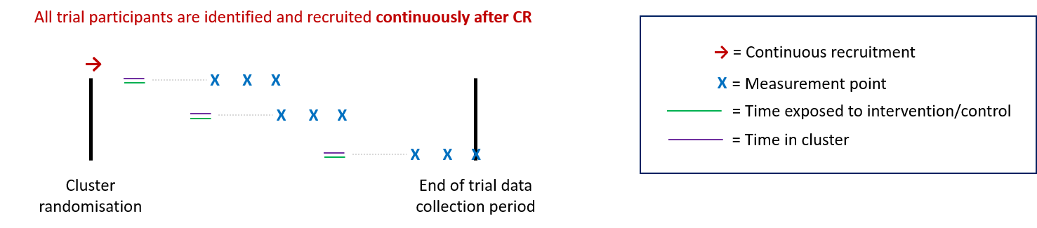

Figure A2 - Diagram of the NACR design in the PEARL trial.
