SUPPLEMENTARY FIGURES
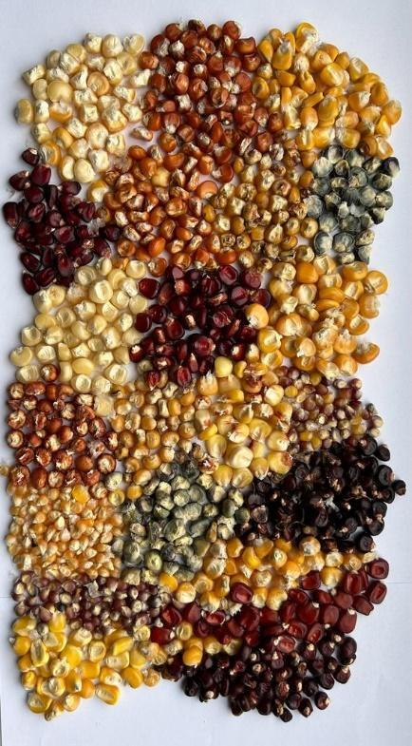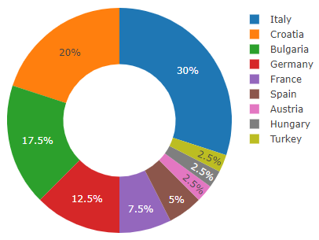
Figure S1. A. Diversity in seed color, size, and shape of the 40 landrace populations used for this study, and B. the representation of each country in the total sample .

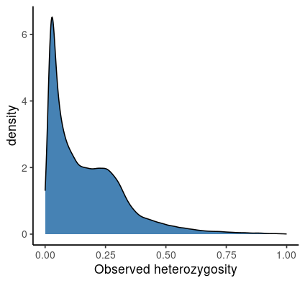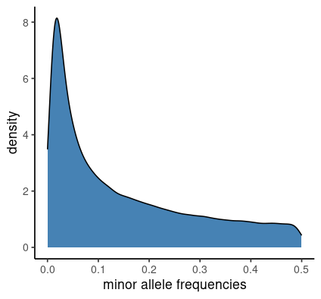
Figure S2. Distribution of heterozygosity and minor allele frequencies of the 152,671 SNP markers used for this study
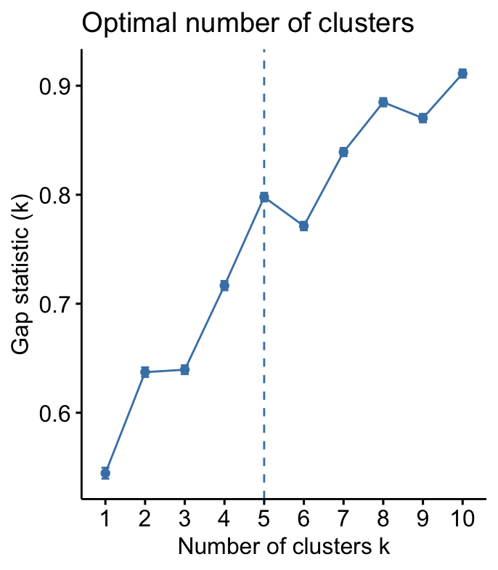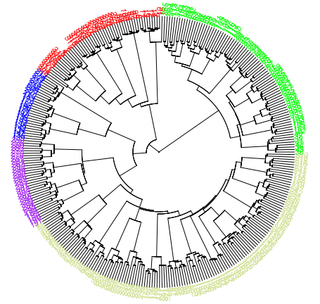
Figure S3. Line graph showing K= 5 has the optimal number of clusters detected using the K-means clustering (Left). Hierarchical clustering at K=5 using genetic distance matrix.
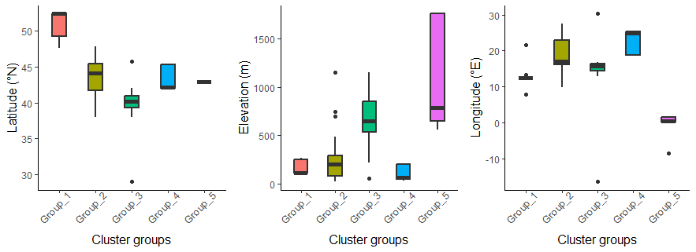Figure S4 Distribution of latitude, elevation, and longitude across the five identified groups.
​​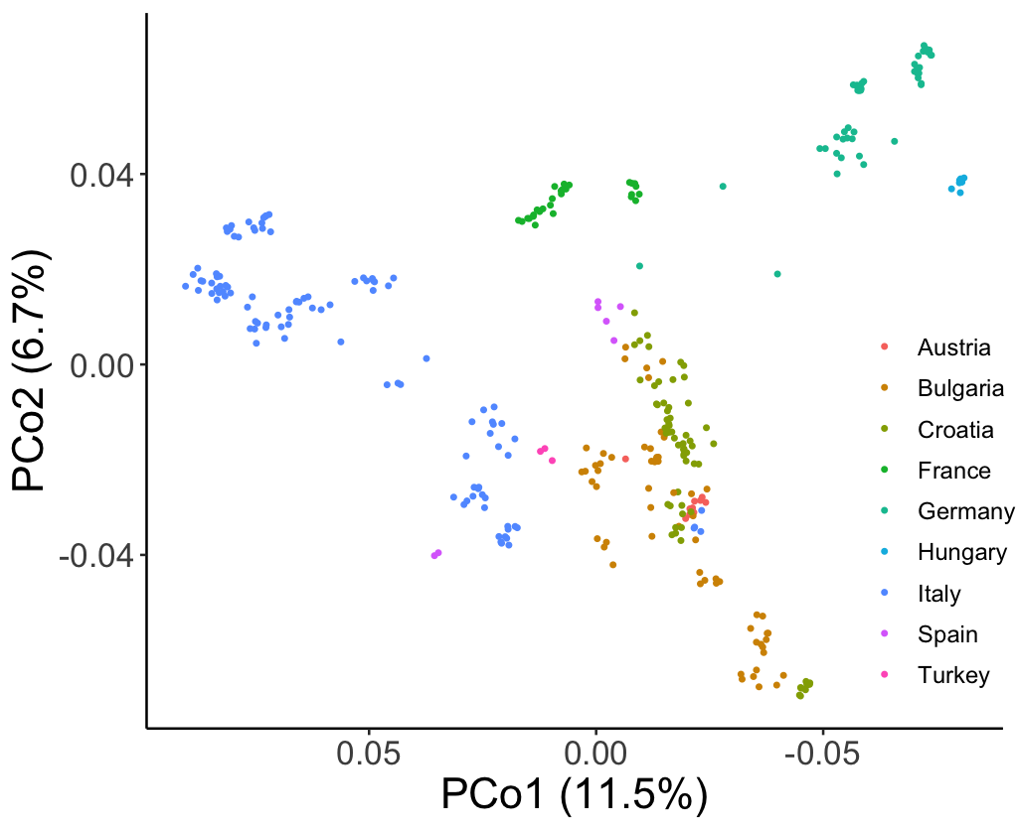 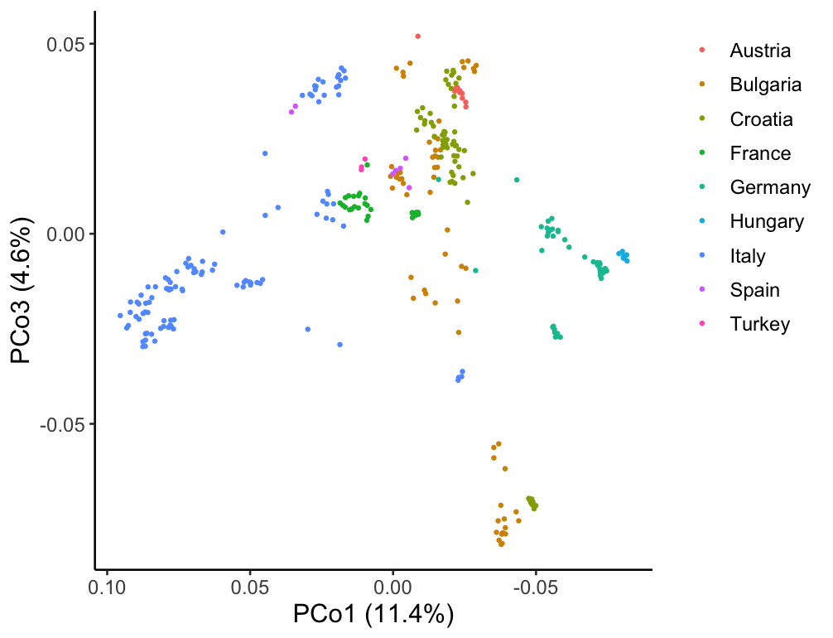
Figure S5 Principal coordinate analysis coloured by country of origin.
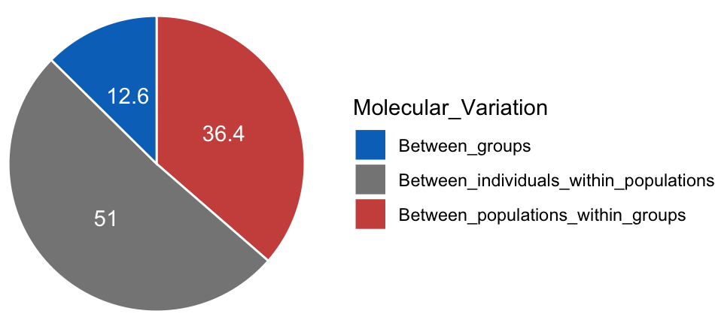
Figure S6 Pie-chart for analysis of molecular variance showing the partitioning of genetic variance between groups, between populations within groups, and between individuals within the populations. 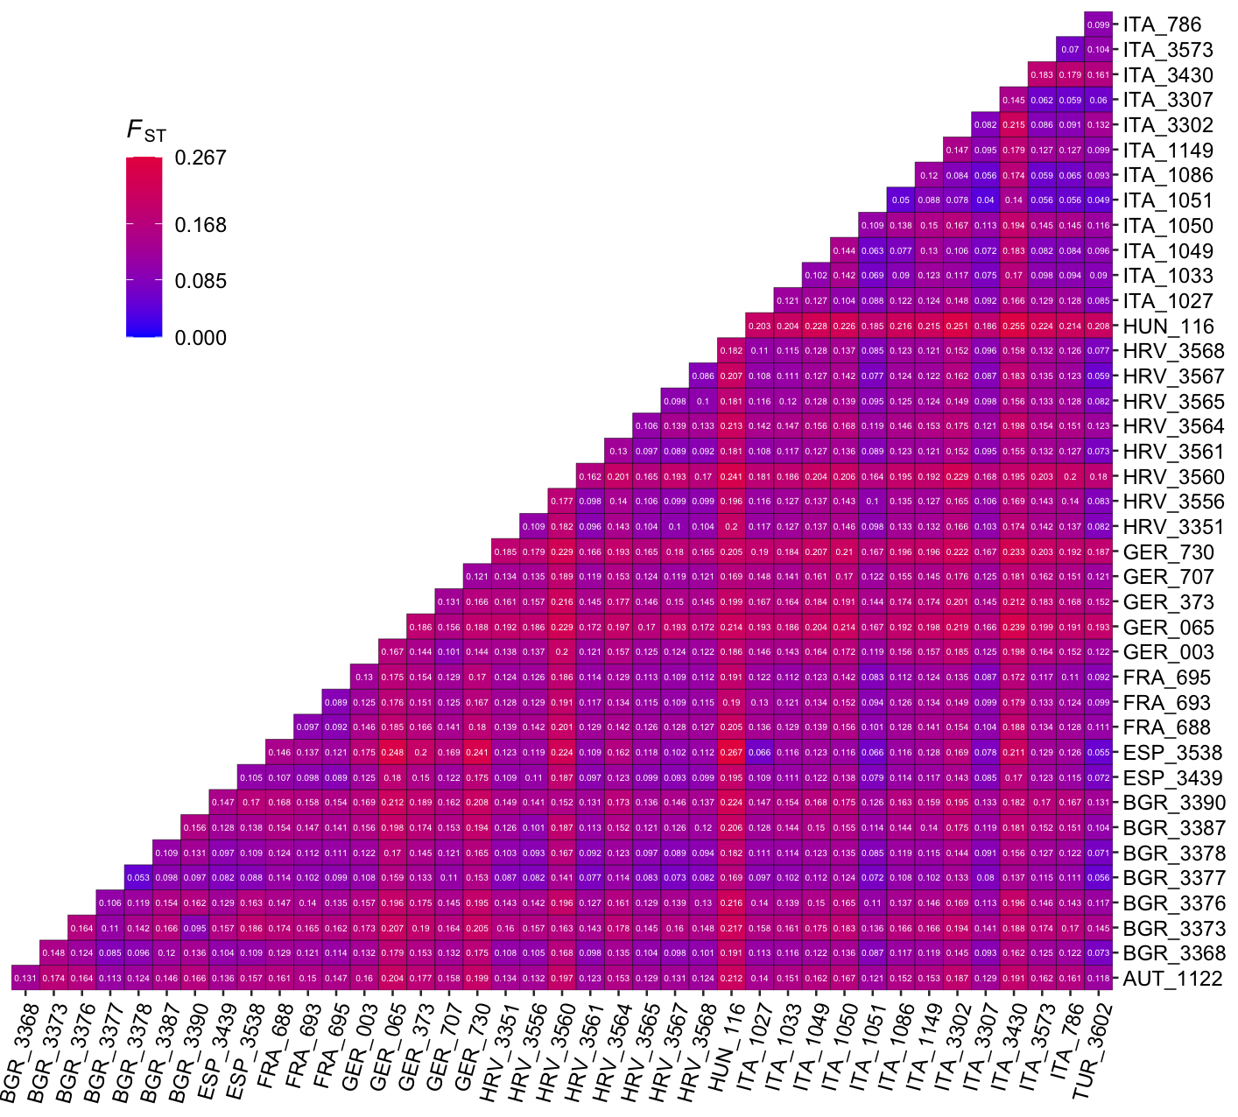
Figure S7. Fst showing the genetic differentiation between the 40 EMLPs. Fst value ranges from
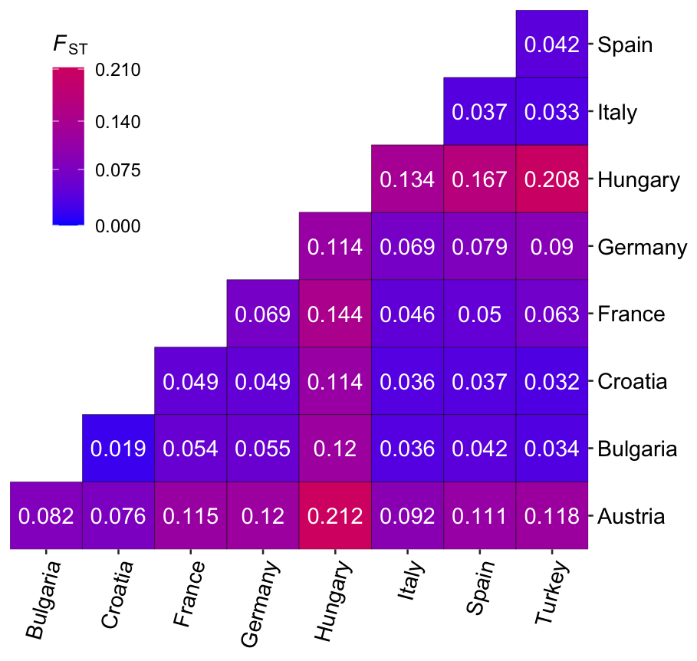
Figure S8. Fst showing the genetic differentiation between the nine countries of origins of our EMLPs.
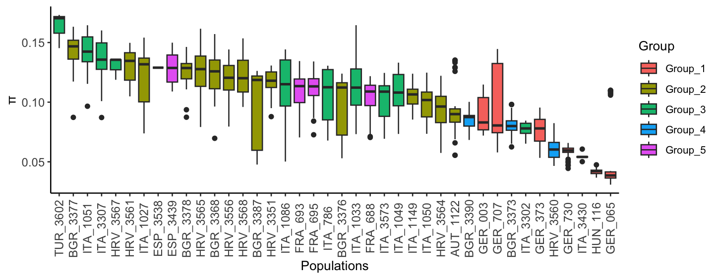
Figure S9. Nucleotide diversity shows the degree of heterogeneity within each population.

SUPPLEMENTARY TABLES
Table 1. List of landrace population, center of origin, and geographical properties.
List of EMLP and their information

Table 2. List of all significantly associated SNPs and reported QTLs.
List of reported and new qtls from this study

Table 3. List of all 137 candidate genes and their GO terms
List of all candidate genes

