Supplementary note
This supplementary note uses theory, BSETS data and simulations to show that 1) certain sleep metrics, specifically sleep onset latency, WASO and sleep efficiency follow a gamma distribution, 2) in the case of such a variable, the dependence of the means and standard deviations is a mathematical necessity, 3) simulations confirm that changes in SD result in changes in the mean as well, rendering the statistical control of the mean as a nuisance variable problematic.

The distribution of sleep metrics
The figure below shows the empirical distribution of all sleep metrics and normal, gamma and beta distributions fitted to them. p-values from Kolmogorov-Smirov tests comparing the empirical and fitted distributions are displayed.
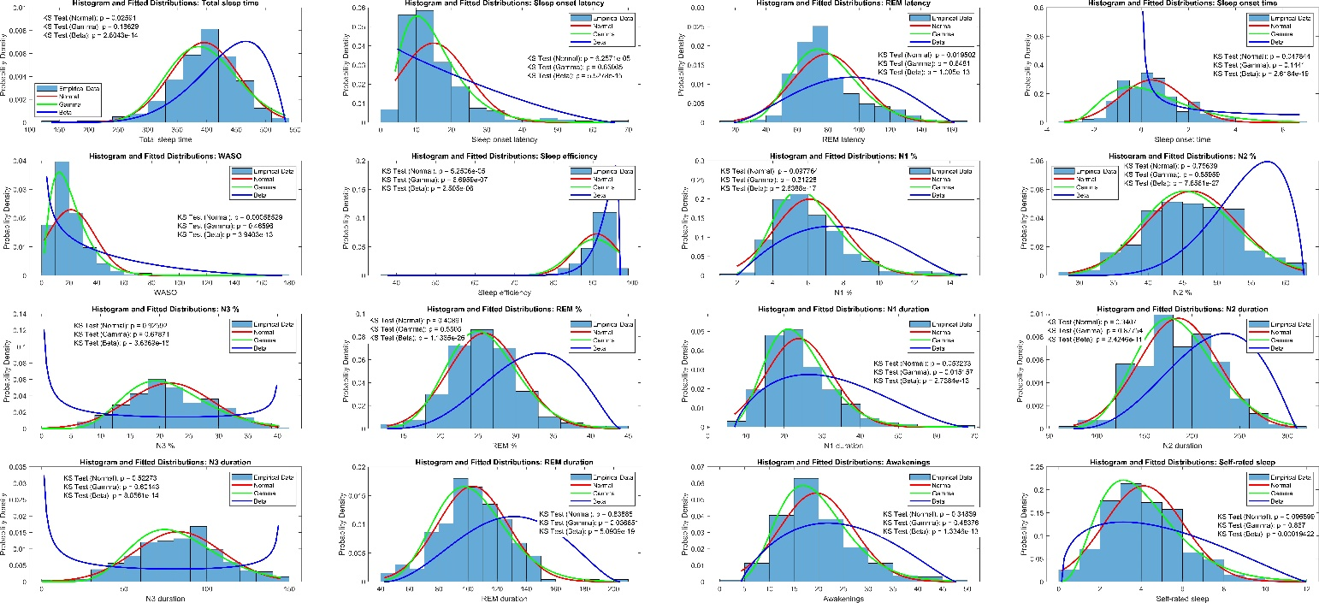
The distribution of sleep metrics with fitted normal, gamma and beta distributions. Variables with negative values were shifted to a zero minimum before fitting the gamma distribution. All variables were divided by their maximum value (after shifting to a zero minimum in case of negative values) before fitting the beta distribution. Fitted distributions were shifted back to the original data for plotting.
For most sleep metrics, both normal and gamma distributions fit well. The beta distribution did not fit any variables well. For key variables sleep onset latency and WASO the gamma distribution fit the data substantially better (highly significant K-S p-value for the normal distribution and non-significant for gamma) with a smaller advantage of gamma over normal for total sleep time and sleep onset time. For sleep efficiency, neither distribution fit well, but the skewed distribution of this variable makes the assumption of a gamma distribution sensible.

Means and SDs of the gamma distribution
The shape of the gamma distribution is defined by two parameters, shape parameter k and scale parameter θ. The mean is given as
$$μ=kθ$$
and the standard deviation is given as
$$σ=θ\sqrt{k}$$
Thus, the standard deviation can be expressed as the mean divided by the square root of the shape parameter:
$$σ=\frac{μ}{\sqrt{k}}$$
Means and standard deviations are directly proportional to $θ$, but means increase more rapidly with increasing k as the two quantities are directly proportional, while the standard deviation is directly proportional only to $\sqrt{k}$. Either way, changes to either the means or standard deviations affect the other quantity in a gamma-distributed variable due to their dependence of the same distributional parameters.

Simulating means and standard deviations
In a simulation, we generated 7 observations each for 1000 persons of a gamma-distributed variable, illustrating seven values per person of a skewed sleep metric. We set fixed means in the range [1 10] and fixed standard deviations in the range [0.05 0.5] in 20 equal increments each. For each fixed mean/standard deviation, we simulated all 1000 persons with this mean/standard deviation by selecting a random k parameter and setting $θ$ so that $θ=targetSD/\sqrt{k}$ (for fixed standard deviations), or $θ=targetSD/k$ (for fixed means). The other non-fixed statistic was allowed to freely vary across participants in both simulations due to the random k parameters.
As expected, manipulating both means and standard deviations resulted in higher values of the other statistic, with virtually equal correlations (r_{fixedSD}=0.7, r_{fixedMean}=0.69). The relationship between the two metrics is illustrated in the figure below.

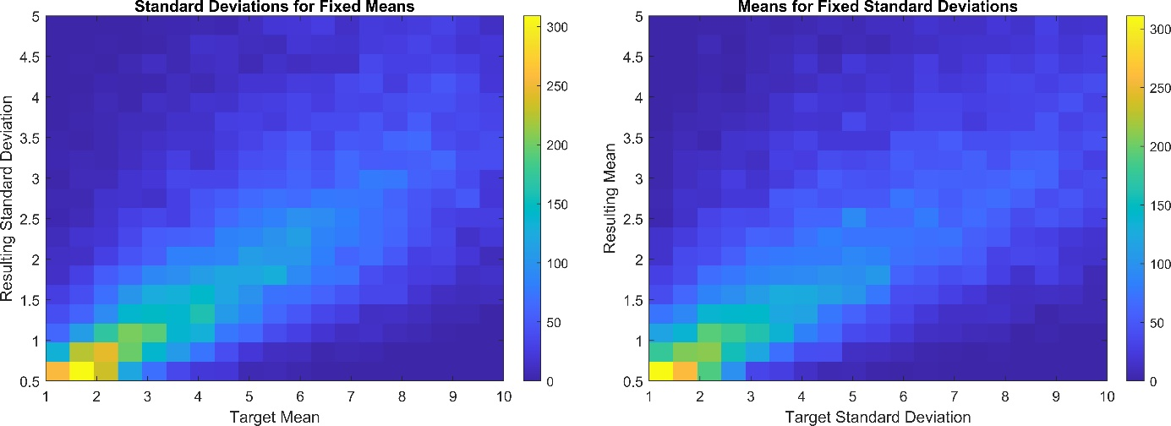
2D histogram of observed standard deviations as a function of increasing fixed means (left), and observed means as a function of increasing fixed standard deviations (right). Color values show the density of observed values.
Observed correlations in BSETS were in a similar range, actually slightly exceeding the simulated values (r_{SOL}=0.746, r_{WASO}=0.789, r_{Sleep_efficiency}=-0.751, see also Supplementary table S1).
In conclusion, both theory, simulations and real-world data supports that in case variables with a gamma-like distribution such as many sleep metrics the means and standard deviations are necessarily related. Our view is that it is premature to conclude that means should be statistically controlled because changes in means are the trivial cause in changes of standard deviations. While means and standard deviations are indeed correlated, causation can work both ways and as our simulations show, the mean itself can be changed by manipulating the standard deviation. We believe that in real-life settings it should be carefully considered if it was the means of sleep parameters that affected standard deviations or vice versa, and the means should not necessarily be corrected statistically when the correlates of the standard deviations of sleep metrics are investigated.

