 | RMSSD | Rolling differences | Variable mean | Social jetlag | Social jetlag, relative | EEG SJL | EEG relative SJL | R² day of week | R² weekday/ weekend
Total sleep time | 0,904 | 0,892 | -0,230 | 0,141 | 0,140 | 0,295 | 0,076 | 0,028 | 0,000
Sleep onset latency | 0,958 | 0,898 | 0,746 | 0,067 | 0,096 | 0,081 | -0,017 | 0,004 | 0,000
REM latency | 0,920 | 0,870 | 0,589 | -0,005 | 0,067 | 0,050 | 0,104 | 0,003 | 0,002
Sleep onset time | 0,957 | 0,940 | 0,456 | 0,152 | 0,078 | 0,563 | 0,180 | 0,025 | 0,006
WASO | 0,948 | 0,929 | 0,789 | -0,033 | 0,082 | 0,098 | 0,048 | 0,002 | 0,001
Sleep efficiency | 0,922 | 0,882 | -0,751 | 0,007 | 0,073 | 0,094 | -0,070 | 0,004 | 0,000
N1 % | 0,908 | 0,892 | 0,543 | -0,031 | 0,036 | 0,003 | -0,169 | 0,004 | -0,001
N2 % | 0,875 | 0,850 | -0,102 | 0,036 | -0,028 | 0,065 | -0,080 | 0,000 | 0,000
N3 % | 0,895 | 0,880 | 0,398 | 0,115 | 0,025 | 0,216 | 0,094 | 0,011 | 0,001
REM % | 0,906 | 0,871 | 0,189 | 0,071 | 0,015 | 0,175 | -0,027 | 0,016 | 0,001
Awakenings | 0,924 | 0,917 | 0,575 | -0,054 | 0,059 | 0,002 | -0,008 | 0,009 | 0,000
SRI |  |  |  | -0,195 | -0,154 | -0,567 | -0,214
Self-rated sleep | 0,825 | 0,800 | 0,366 | -0,116 | -0,075 | -0,013 | 0,004 | 0,028 | 0,002
Supplementary table S1. Correlations between the individual standard deviations of sleep variables (rows) with two alternative variability metrics (RMSSD and ARD), individual means, and absolute/relative social jetlag estimated either by the MCTQ or EEG data. The last two columns (italics) show the proportion of variance in sleep metrics accounted for by day of the of week. Variance accounted for indicates adjusted incremental R² from a multilevel model with random intercepts by participant ID and day of the week as a fixed factor over a null model with only random intercepts. For the SRI, unlike for the other metrics, daily values are not defined and thus the corresponding cells are left blank.

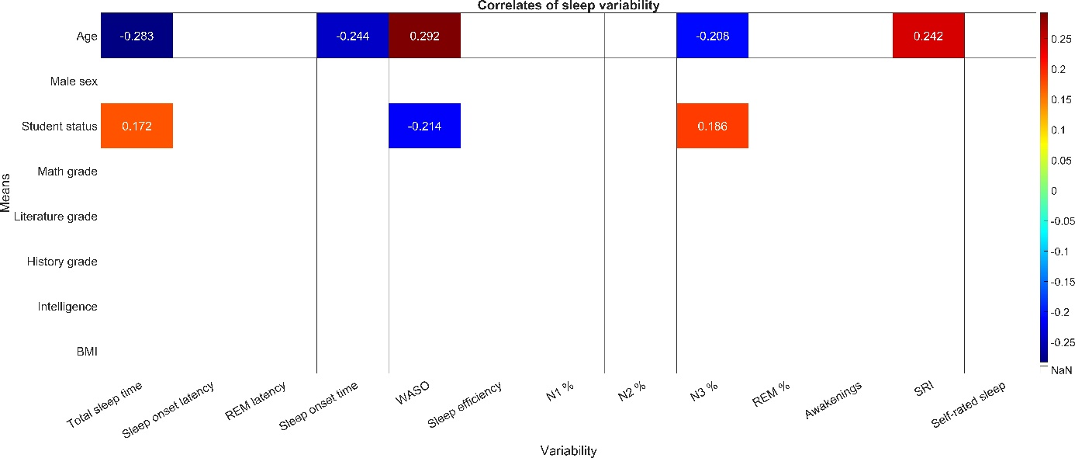
Supplementary figure S1. Zero-order correlations between sleep variability and demographic characteristics. Each cell shows the correlation between the individual standard deviation of sleep variables (horizontal axis) and the means of demographic characteristics (vertical axis). Unlike the figures in the main manuscript, these correlations are not corrected for either age or the means of sleep metrics. Only significant correlations (p<0.01) are shown.
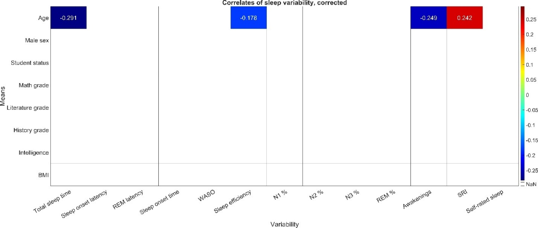
Supplementary figure S2. Age-corrected correlations between sleep variability and demographic characteristics. Each cell shows the correlation between the individual standard deviation of sleep variables (horizontal axis) and the means of demographic characteristics (vertical axis). Unlike the figures in the main manuscript, these correlations were also corrected for the means of sleep metrics. Only significant correlations (p<0.01) are shown.

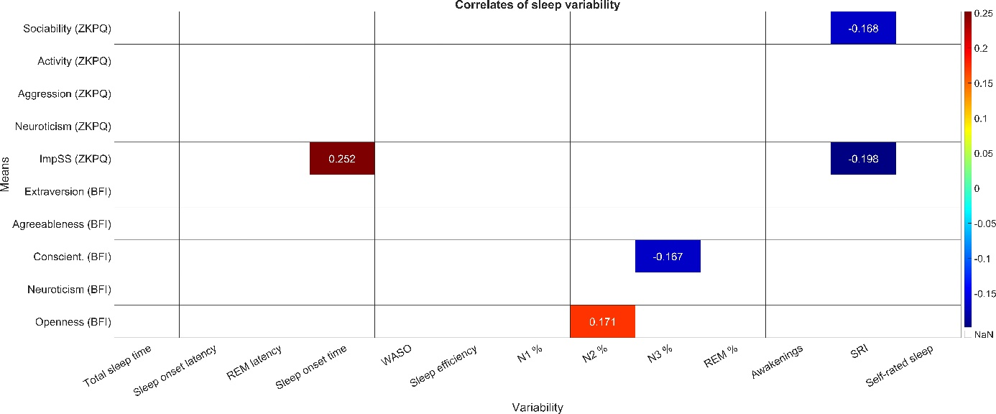
Supplementary figure S3. Zero-order correlations between sleep variability and personality. Each cell shows the correlation between the individual standard deviation of sleep variables (horizontal axis) and the means of personality (vertical axis). Unlike the figures in the main manuscript, these correlations are not corrected for either age or the means of sleep metrics. Only significant correlations (p<0.01) are shown.

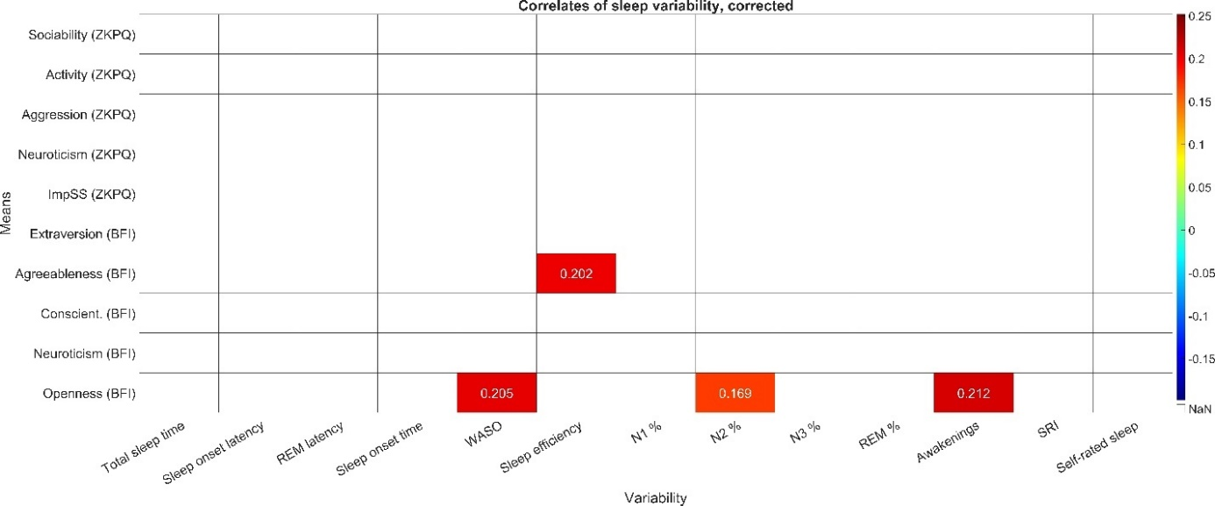
Supplementary figure S4. Age-corrected correlations between sleep variability and personality. Each cell shows the correlation between the individual standard deviation of sleep variables (horizontal axis) and the means of demographic characteristics (vertical axis). Unlike the figures in the main manuscript, these correlations were also corrected for the means of sleep metrics. Only significant correlations (p<0.01) are shown.

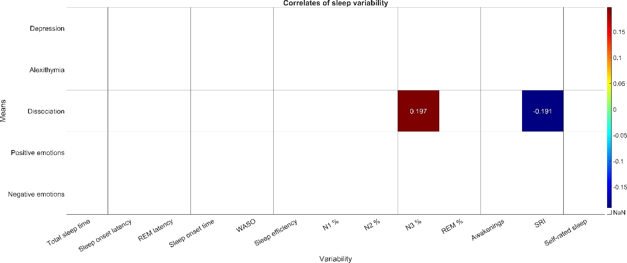
Supplementary figure S5. Zero-order correlations between sleep variability and mental health. Each cell shows the correlation between the individual standard deviation of sleep variables (horizontal axis) and the means of mental health indicators (vertical axis). Unlike the figures in the main manuscript, these correlations are not corrected for either age or the means of sleep metrics. Only significant correlations (p<0.01) are shown.

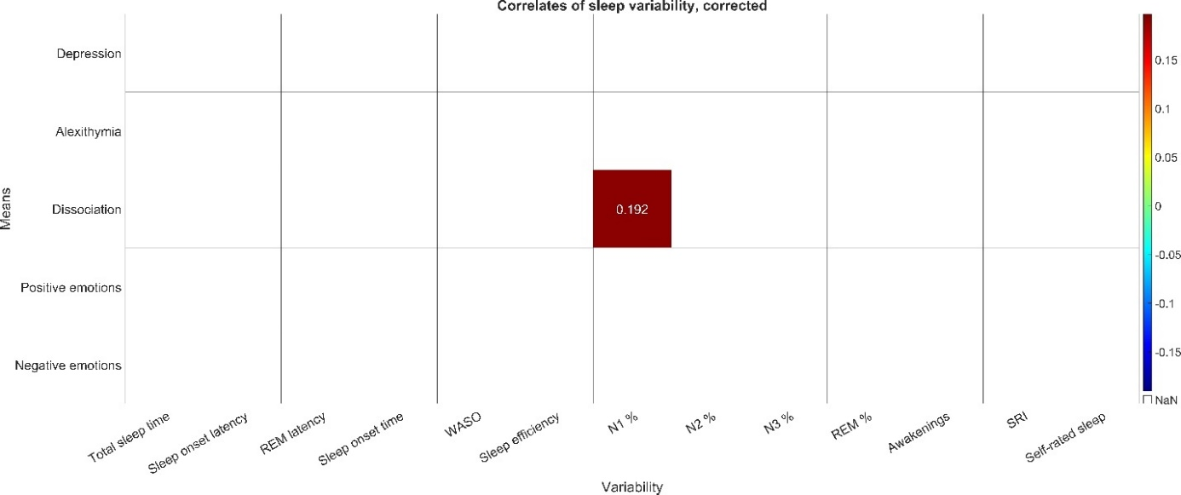
Supplementary figure S6. Age-corrected correlations between sleep variability and mental health. Each cell shows the correlation between the individual standard deviation of sleep variables (horizontal axis) and the means of demographic characteristics (vertical axis). Unlike the figures in the main manuscript, these correlations were also corrected for the means of sleep metrics. Only significant correlations (p<0.01) are shown.

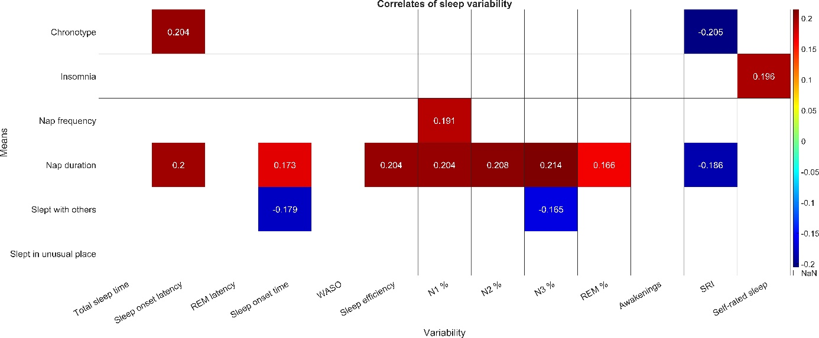
Supplementary figure S7. Zero-order correlations between sleep variability and sleep characteristics. Each cell shows the correlation between the individual standard deviation of sleep variables (horizontal axis) and the means of sleep characteristics (vertical axis). Unlike the figures in the main manuscript, these correlations are not corrected for either age or the means of sleep metrics. Only significant correlations (p<0.01) are shown.

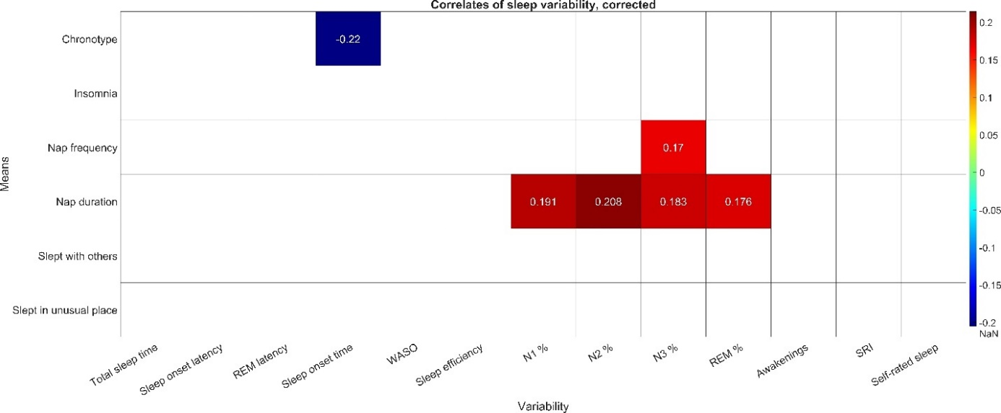
Supplementary figure S8. Age-corrected correlations between sleep variability and sleep characteristics. Each cell shows the correlation between the individual standard deviation of sleep variables (horizontal axis) and the means of demographic characteristics (vertical axis). Unlike the figures in the main manuscript, these correlations were also corrected for the means of sleep metrics. Only significant correlations (p<0.01) are shown.

