Supplementary information

Link to Video

Control experiment
In order to test whether recruits behave differently if they had not explored the test area during their orientation flights, we located a colony in an area 4.400 m SE of the test area behind a hill (50°47`35.78``N, 8°55`36.32``E). Both the ground structure and the skyline differed substantially from the conditions in the test area. The dancers were trained in an urban area to a feeder 373 m away from the hive under an angle of 69° (50°47`40.87``N, 8°55`53.17``E). The flight distance and direction of the dancers resembled the conditions in the main experiment. The recruits were caught at the hive exit in the same way as in the main experiment, stored in a catching device and transported within 15 minutes to one of two RSs (R2, R5) in the test area, equipped with a transponder and radar tracked. A different colony was placed close to the radar in the test area and a group of bees was trained to F in the same way as in the main experiment. As in the main experiment a group of bees shuttled forth and back regularly between hive and F.

Recruits of the control experiments performed much less vector flights than recruits of the main experiment: At R2: 48 % (n=23) of the control bees as compared to 70% (n=34) of the bees in the main experiment, at R5: 13% (n=30) as compared to 79% (n=34). Flight distances of vector flights in control experiment were significantly shorter: R2: average accumulated vector distance: 159±69 m, average linear vector distance: 128±57 m) as compared to those in the main experiment (average accumulated distance: 366±156m, average linear vector distance: 314±133 m (p<0.01 for accumulated distance, p<0.05 for linear distance); R5: average accumulated distance: 158 ±80 m, average linear vector distance: 128 ±46m as compared to those in the main experiment: average accumulated distance: 274±149 m, average linear vector distance: 223±127m, Man-Whitney U-Test p<0.01 for accumulated distance, p<0.05 for linear vector distance). Flight speed was significantly lower in control animals (R2 control experiment: 3.5 ±0.86 m/s, R2 main experiment: 6.7±1.7 m/s, Man-Whitney U-test p<0.01). Similar results were found for the release site R5. The directions of vector flights were significantly different in R2 released bees as expressed in the deviation from the ideal vector Δα (control experiment (Δα=34.3±14.7°. main experiment: average Δα= -7.5±16.4°. Thus the vector flights in the main experiment were more tilted to F. This difference is highly significant (p<0.01 Man-Whitney U-test). No significant difference was found for R5 released bees.

Thus recruits in the control experiment performed significantly less vector flights at both release sites and shorter vector flights. This difference was larger at R5 than at R2. The direction of the vector flight was not tilted toward F as it was for the recruits in the main experiment. The distances flown during search flights were significantly different for R5 but not for R2. It appeared that recruits starting at R2 may have found the area less unfamiliar than when starting at R5 since they had explored an urban area with houses, gardens and streets, and the area west of R2 resembled such structures at least in part. None of the recruits of the control experiment showed any tendency to fly toward the feeder F.

Search Centroids
The centroid of a search is the mean of the longitudinal and latitudinal coordinates of the fixes (a 2-element vector, the first element giving the average of the east-west elements, the 2nd the average of the north-south elements). Supplementary Figure 1 plots the cumulative distribution functions of the longitudinal (Sup Fig 1a) and latitudinal (Sub Fig 1b) elements on panels with verticals at the coordinates of the release sites, the true location of the food (F) and its virtual locations (vF).

The groups released at or somewhat west of the hive (HR, R1 & R2) are plotted with solid lines; those released east of the food are plotted with dotted lines (R5, R6, R7). The solid distributions in Sup Fig 1b straddle the corresponding vF longitudes (which are near the F longitude). By contrast, the dotted distributions fall far to the left (west) of the corresponding vF longitudes. Recruits released at or slightly west of the hive mostly searched 200-600 meters to the east of their release site. None searched more than a few meters to the west of it. By contrast, substantial fractions of recruits released east of F, focused their search well to the west of their release site (and, therefore far to the west of their vF). As a result of this pronounced difference in the compass sectors of the search foci, the dotted CDFs fall much closer to the solid CDFs than would be expected if recruits had no map and just searched around the termini of their vector flight. Put another way, when they terminated their vector flight, displaced recruits tended to focus their searches in the compass sector in which F lay —to the east in those released west of the food and to the west in those released east of it.
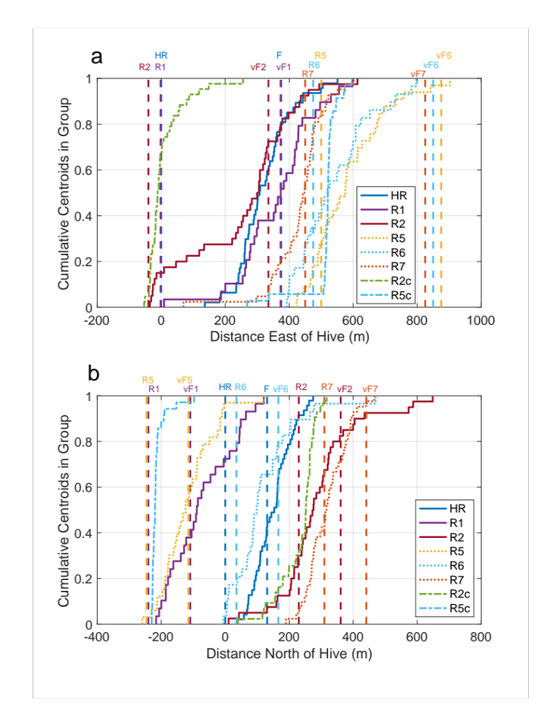
Suppementary Figure S1. Cumulative distributions of the longitudinal (Panel a) and latitudinal (Panel b) elements of the search centroids. Vertical dashed lines give the longitudes (a) or latitudes (b) of the release sites, the true location of the food (F) and the release-site-dependent vFs—in colors that match the corresponding CDF colors.

Gravitation toward F by hive released recruits
Gravitation toward vF, RS and F were calculated with the formula given in the main text. The panels in Supplementary Figure 2 plot G_{F}, gravitation toward F, and G_{RS}, gravitation toward RS, for 15 of the bees released at the hive. In this group, F and vF are identical, so the vF plot (blue) superposes on the F plot (red), making it invisible in the figure. All but one of these plots shows one or more segments in which the recruit gravitates to F, that is, multiple fix-fix segments during which G_{F} rises well above 0. By contrast, the gravitational strength to the release site is generally negative (below the horizontal dashed line). With one exception (upper left panel), it never becomes strongly positive.
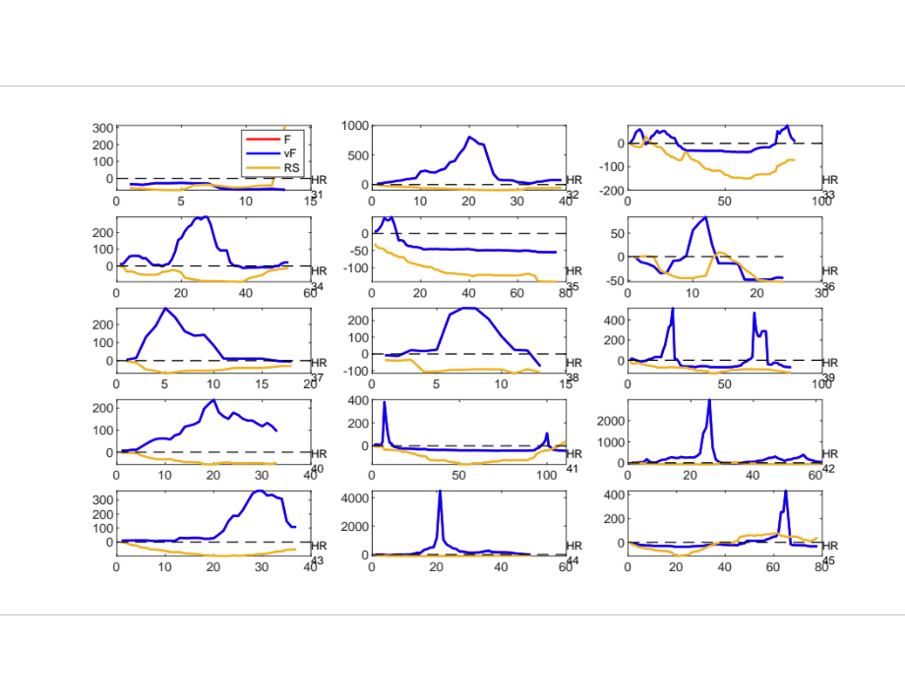
Supplementary Figure S2. Gravitations toward F (blue) and toward RS (yellow) in 15 hive-released bees. Note the differences in the y-axis scale between panels; the gravitation toward a given goal, G_{g}, ranges into the tens of thousands in cases where there is a sustained run in that direction that brings the bee to within a few meters of the goal.

Directional component β of vector flights as examined by likelihood-based model calculations.

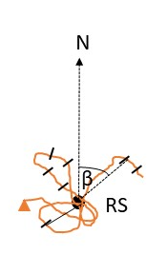
Supplementary Figure S3 Likelihood-based model calculations of the direction of search (β) as seen from the release site. The angle β describes the direction of search flights as seen from the release site (R) to any search fix. Thus β is the angle between the line from each search fix to R relative to N.

After confirming that the respective β distributions (Supplementary Figure S3) for each RS were not randomly distributed (Rayleigh test) we applied multimodal non-parametric likelihood-based model calculations that test simultaneously null and multiple alternative hypotheses based on the Akaike information criterion (AIC, ⁴² applying the script in R reported in ⁴² .We calculated the AIC for each model and selected the one out of 10 models with the smallest AIC as the best model. An AIC relative to the best model (ΔAIC)<2 were considered to be well supported, those with (ΔAIC) between 2 and 7 as rarely to be dismissed, and models with (ΔAIC)>9 as having little support. All ΔAIC for the first model were <0.001. All hive released bees had unimodal β distributions, R5 released bees had 15 unimodal and 18 bimodal distributions in the first model, and 21 unimodal and 12 bimodal distributions in the second. The corresponding numbers for R6 released recruits are: first model: unimodal: 14 bimodal: 20, second model: unimodal: 18, bimodal: 16, and for R7 released recruits: first model: 32 unimodal, 11 bimodal, second model: 29 unimodal, 14 bimodal. Notice that the arrow described by ϕ1 in unimodal distributions can either be directed toward vF or F depending on the respective animal. In bimodal distributions ϕ1 or ϕ2 are directed to vF and F respectively (Supplementary Fig. S4 ).
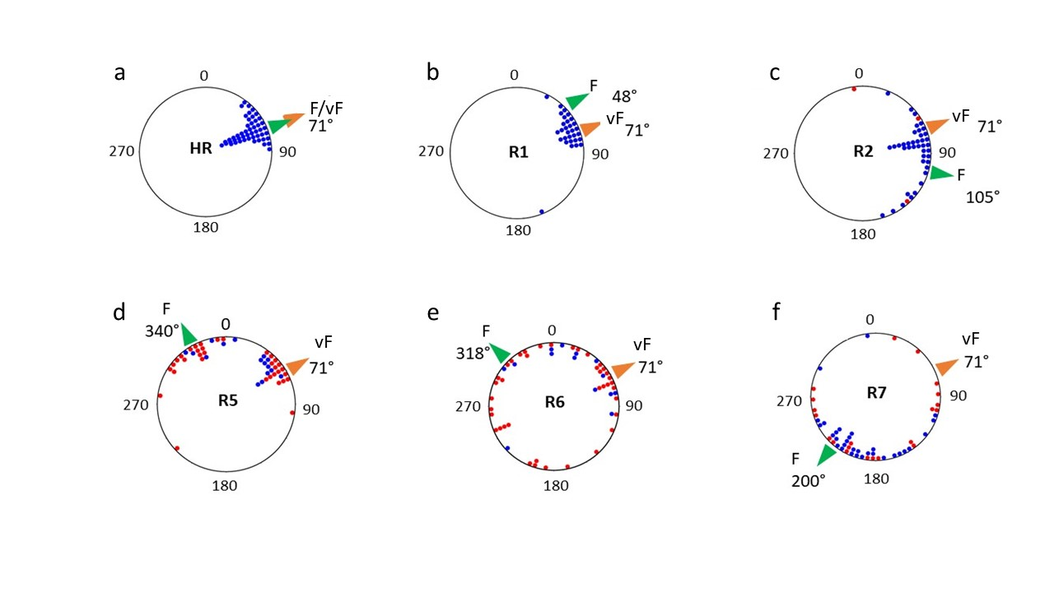Supplementary Figure S4 Directions of search of recruits released at the hive (HR) or at one of five other RS (R1, R2, R5, R6, R7). Distributions of the angles ϕ1 (for unimodal and bimodal distributions of angle β, blue dots) and ϕ1 (blue dots) and ϕ2 (red dots) for bimodal distributions of β as determined by multimodal non-parametric likelihood-based model calculations. Each ϕ1 and ϕ2 of the best model gives the mean direction of search for each recruit at 4 release sites (hive, H, R5, R6 and R7, Table S1 for statistics). Notice that bimodal distributions lead to two angles (ϕ1, ϕ2) in each recruit. R1 releases lead only to unimodal distributions, and those at R2 to bimodal distributions only in three recruits. The green arrow heads point to F and the orange arrow heads to vF. N at 0/360°. R5 recruits (N=33) searched clearly in either the direction of vF or F. About half of them had a bimodal distribution (N=18), the other half (N=15) a unimodal distribution. The corresponding angles β for R6 recruits (N=34) were less focused within the respective angular ranges including 14 animals with unimodal distributions and 20 animals with bimodal distributions. R7 recruits (N=43) had less bimodal distributions (N=11) than unimodal distributions (N=32).

