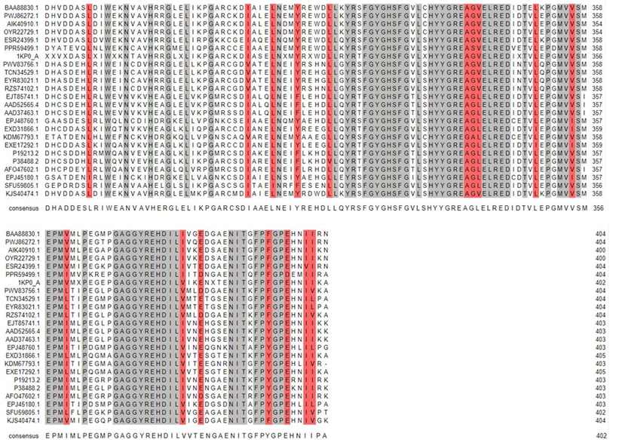
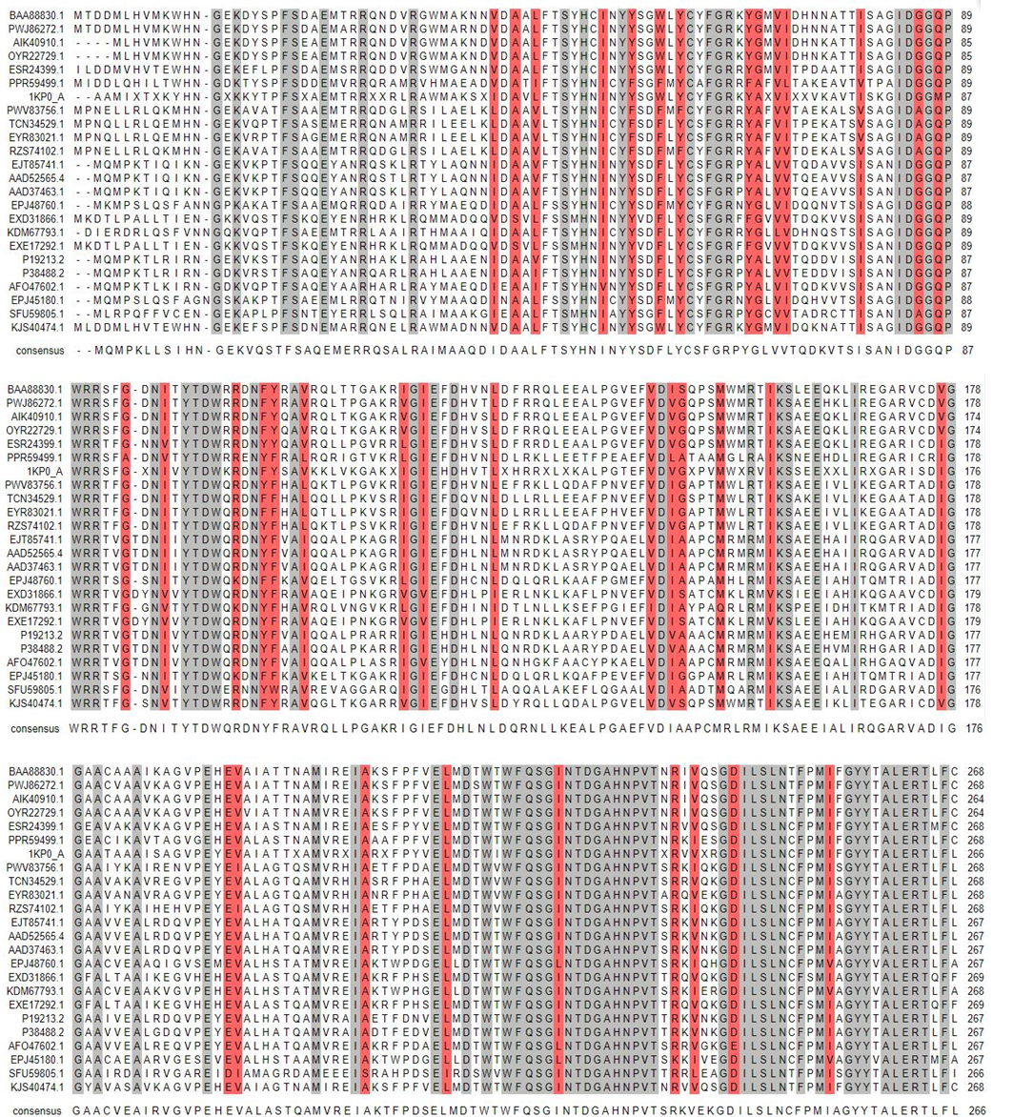
Supplementary data:
Fig.S1. afCR homologous sequence alignment.

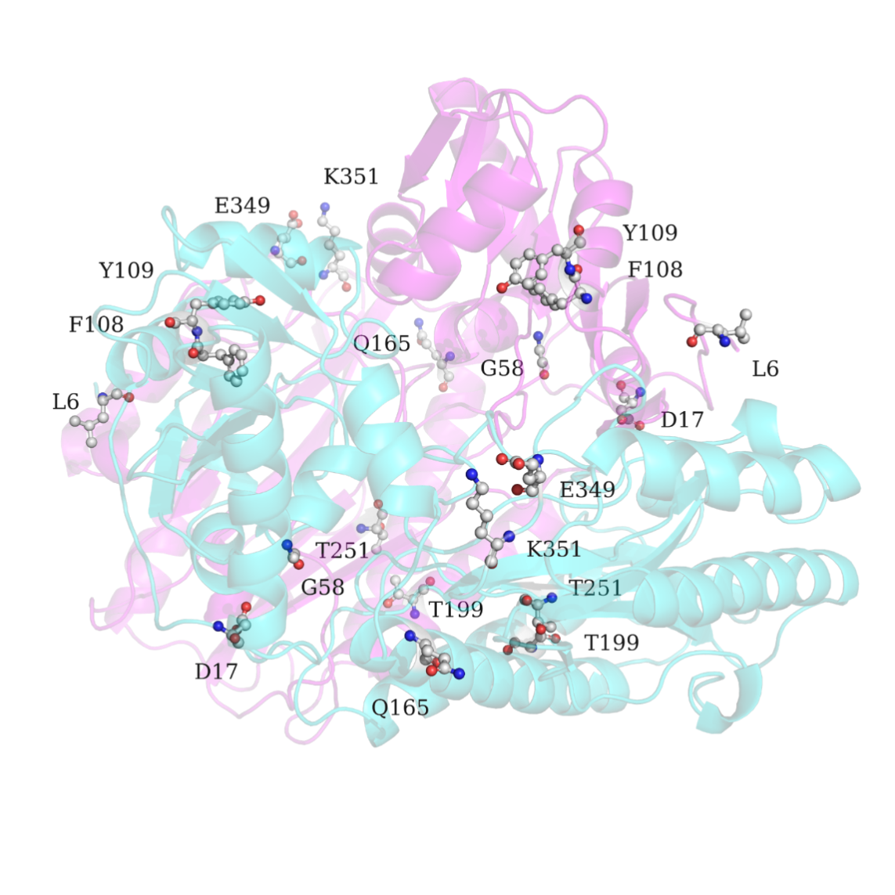
Fig.S2. Distribution of the stability mutation sites in the CR structural homology model.

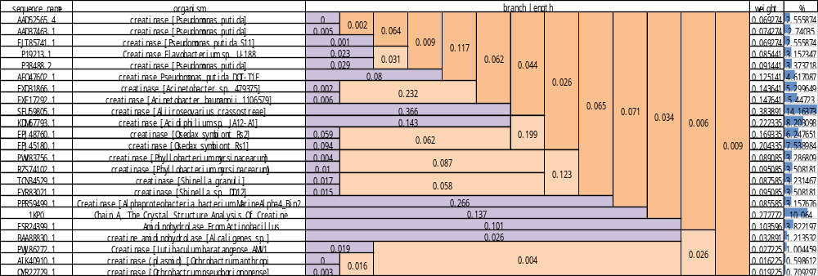
Fig.S3. Sequence information and branch weight results.

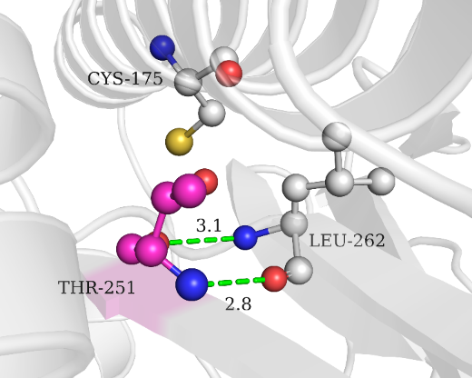
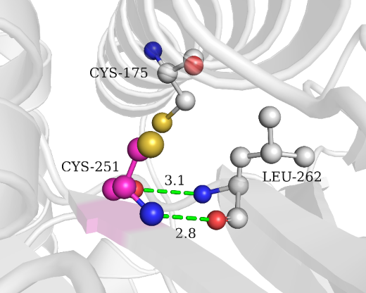
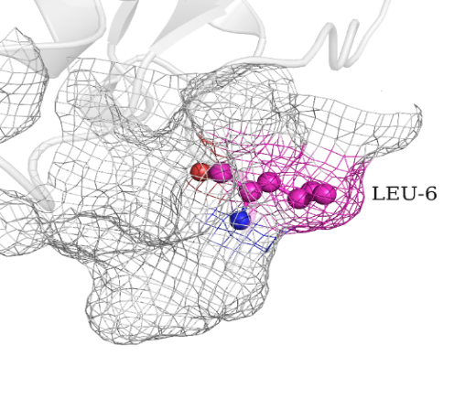
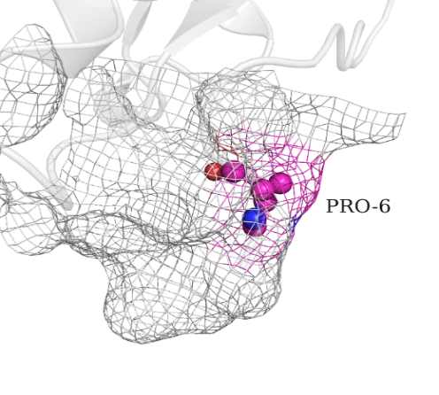
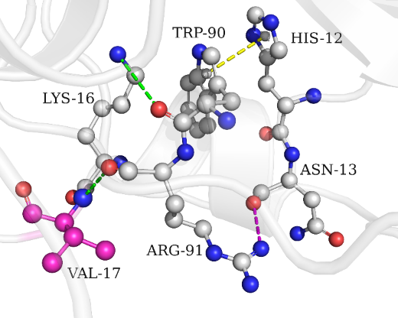
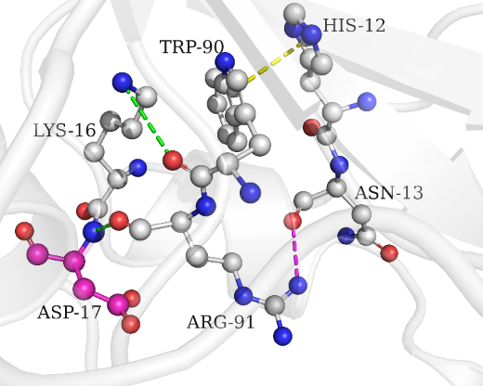
A
B
C

Fig.S4. The structural comparison between the wild type and thermostability-associated mutant CR variants. (A) T251C, (B) L6P, (C) D17V wild type structures (left) compared mutated variants (right) in structural homology model.

Table S1. Primers of afCR single-site mutants.
Mutant | Primer
L6P | GATGATATGCCGCATGTGATGAAATGGCATAATG  CATCACATGCGGCATATCATCGGTCATGGATCC
D17V | GTGAAAAAGTTTACAGTCCGTTTAGTGATGCCGAAATG  GGACTGTAAACTTTTTCACCATTATGCCATTTCATCAC
P20T | GATTACAGTACCTTTAGTGATGCCGAAATGACCCGTCG GGCATCACTAAAGGTACTGTAATCTTTTTCACCATTATGCC
C52N | CAGCTATCATAATATTAATTACTACAGTGGTTGGCTG  GTAATTAATATTATGATAGCTGGTAAACAGTGCTGC
G58D | TACTACAGTGATTGGCTGTATTGTTATTTTGGTCG ATACAGCCAATCACTGTAGTAATTAATACAATGATAGC
D73T | GTATGGTTATTACCCATAATAACGCCACCACCATTAG  GCGTTATTATGGGTAATAACCATACCATATTTGCGAC
F108Y | CGTGATAATTATTATCGTGCAGTGCGCCAGCTGACCAC CTGCACGATAATAATTATCACGACGCCAATCGGTATAG
K166A | GAAGAACAGGCACTGATTCGCGAAGGTGCCCGTGTTTG GCGAATCAGTGCCTGTTCTTCCAGACTCTTAATGGTAC
K351E | GATACCGAACTGGAACCGGGTATGGTTGTTAGTATG  CATACCCGGTTCCAGTTCGGTATCAATATCTTCGCG
V33L | CAGAATGATCTTCGCGGTTGGATGG  GTCTTACTAGAACGGCCAACCTACC
W59F | GTGGTTTCCTGTATTGTTATTTTGGTCGC  CACCAAAGGACATAACAATAAAACCAGCG
Y109F | GATAATTTTTTTCGTGCAGTGCGCCAGC  CTATTAAAAAAAGCACGTCACGCGGTCG
L162A | TAAGAGTGCTGAAGAACAGAAACTGATTCGCGAAGG  ATTCTCCGACTTCTTGTCTTTGACTAAGCGCTTCC
T117P | GCCAGCTGCCTACCGGTGCAAAGAGAATTG  CGGTCGACGGATGGCCACGTTTCTCTTAAC
Q165I | GAAGAAATTAAACTGATTCGCGAAGGTGCC  CTTCTTTAATTTGACTAAGCGCTTCCACGG
T199S | GCCTCTACCAATGCAATGATTCGTGAAATTG  CGGAGATGGTTACGTTACTAAGCATTTAAC
T251C | GAATTGCTTTCCGATGATTTTTGGC  CTTAACGAAAGGCTACTAAAAACCG
E349V | GATACCGTTCTGAAACCGGGTATGGTTG  CTATGGCAAGACTTTGGCCCCATACCAAC
V362I | GAACCGATGATTATGCTGCCGGAAGGCATGCCT  CTTGGCTACTAATACGACGGCCCTTCCGTACGGA
V340L | GAAGCCGGTCTGGAACTGCGCGAAGATATTGATACC  CTTCGGCCAGACCTTGACGCGTTCTATAACTATGG
C331S | GTGCTGTCTCATTATTATGGTCGCGAAGCC  CACGACAGAGTAATATACCAGCGCCTTCGG
Table S2. Molecular mechanism of the stabilizing mutations.
Mutant | Putative mutation mechanism
F108Y | Hydrogen bond
Y109F | π-π interaction
K351E | Salt bridge, hydrophobic interactions
T251C | Disulfide bond
L6P | Conformational entropy, buried hydrophobic interactions
T199S | Hydrophobic interactions, surface charge
G58D
D17V | Improved hydrophobic packing in the protein interior, increased the interaction network
Q165I
E349V

