Temperature-Dependent Pathways in Carbon Dioxide Electroreduction

Shiqiang Liu¹, Yaoyu Yin,^{1,2} Jiahao Yang,^{1,2} Wenling Zhao,^{1,2} Meng Zhou,^{1,2} Huisheng Qin,^{1,2} Jiapeng Jiao,³ Yiyong Wang,^{1,2} Hengan Wang,^{1,2} Xing Tong,^{1,2} Yi Xu,^{1,2} Xiaofu Sun,^{1,2} Qinggong Zhu,^{1,2} Maohong Fan,^{4,5} Xinchen Kang^{1,2}*, Buxing Han^{1,2,3}*

1. Beijing National Laboratory for Molecular Sciences, CAS Laboratory of Colloid and Interface and Thermodynamics, CAS Research/Education Centre for Excellence in Molecular Sciences, Centre for Carbon Neutral Chemistry, Institute of Chemistry, Chinese Academy of Sciences, Beijing 100190 (China)
2. School of Chemistry, University of Chinese Academy of Sciences, Beijing, 100049 (China)
3. Shanghai Key Laboratory of Green Chemistry and Chemical Processes, School of Chemistry and Molecular Engineering, East China Normal University, Shanghai, 200062 (China)
4. Departments of Chemical and Petroleum Engineering, University of Wyoming, Laramie, 82071 (United States)
5. School of Civil and Environmental Engineering, Georgia Institute of Technology, Atlanta, 30332 (United States)

Supplementary Figures
Supplementary Fig. 1 The configurations of Cu(111) (a), *CO adsorbed Cu(111) surface (b) and *H adsorbed Cu(111) surface (c) from top (top) and side (bottom) view.
Supplementary Fig. 2 The adsorption Gibbs free energy (ΔG_{ad}) plot of *CO and *H at Cu(111) surface at various temperatures.

Supplementary Fig. 3 Plot of total energy fluctuations of 33 water with 1 KOH vs time at Cu(111) surface by AIMD simulations at −40 °C (a), 0 °C (b) and 40 °C (c), respectively.

Supplementary Fig. 4 Plot of total energy fluctuations of 50 CO molecules in 1000 waters at Cu(111) surface vs time at Cu(111) surface by MD simulations at −40 °C (a), 0 °C (b) and 40 °C (c), respectively.

Supplementary Fig. 5 Plot of total energy fluctuations of 50 KOH in 1000 waters at Cu(111) surface vs time at Cu(111) surface by MD simulations at −40 °C (a), 0 °C (b) and 40 °C (c), respectively.

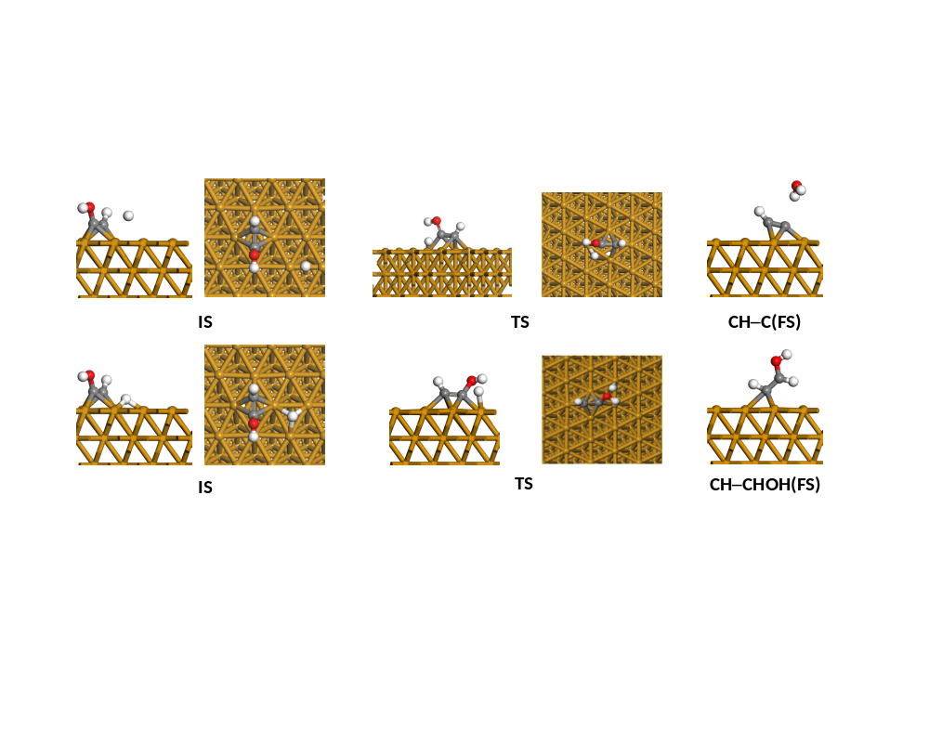
Supplementary Fig. 6 The initial states (IS), TS and final states (FS) of *CH–COH+H→*CH–C (top) and *CH–COH+H→*CH–CHOH (bottom) pathways.

Supplementary Fig. 7 (a–c) The normal distribution fitting of the vibration of O–H bond (a), C–O bond (b) and C–C bond (c) in *CH–COH at various temperature. (d) The main vibration mode of *CH–COH.

Supplementary Fig. 8 The COHP (a–b) and ELF (c–d) of C–O bond of *CH–COH on the Cu(111) surface. pCOHP is projected crystal orbital Hamilton population and corresponding integrated pCOHP values are presented in a and b. The C–O bonds were stretched to 0.97 (a,c) and 1.03 (b,d) times to the original length, respectively.
.

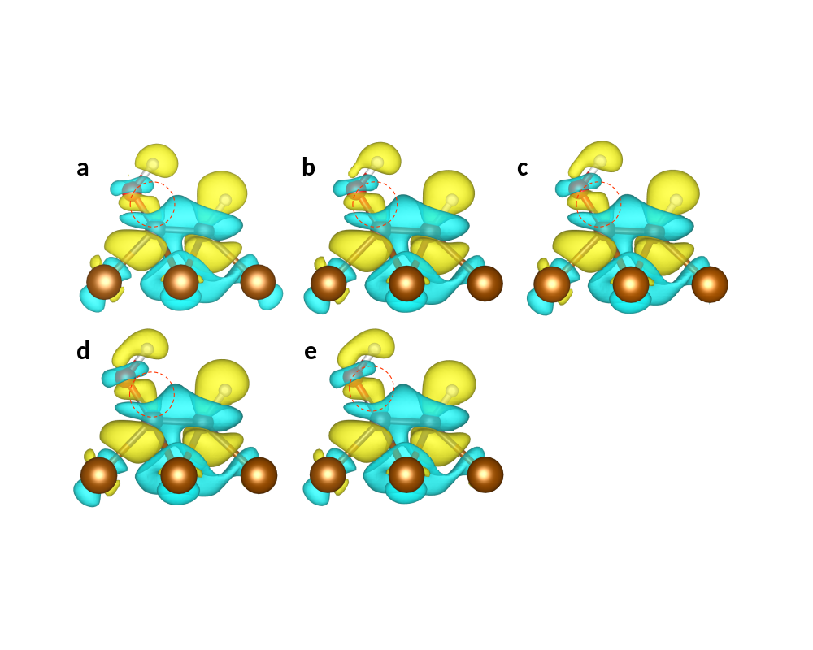
Supplementary Fig. 9 The change density difference of *CH–COH on the Cu(111) surface with C–O bond stretching to 0.94 (a), 0.97 (b), 1 (c), 1.03 (d) and 1.06 (e) times to its original length. The yellow and cyan show the positive and negative charges, respectively. The isosurface values are 0.0025e/Å³.

Supplementary Fig. 10 XRD patterns of Cu-NR (a) and Cu-NP (b) electrodes.

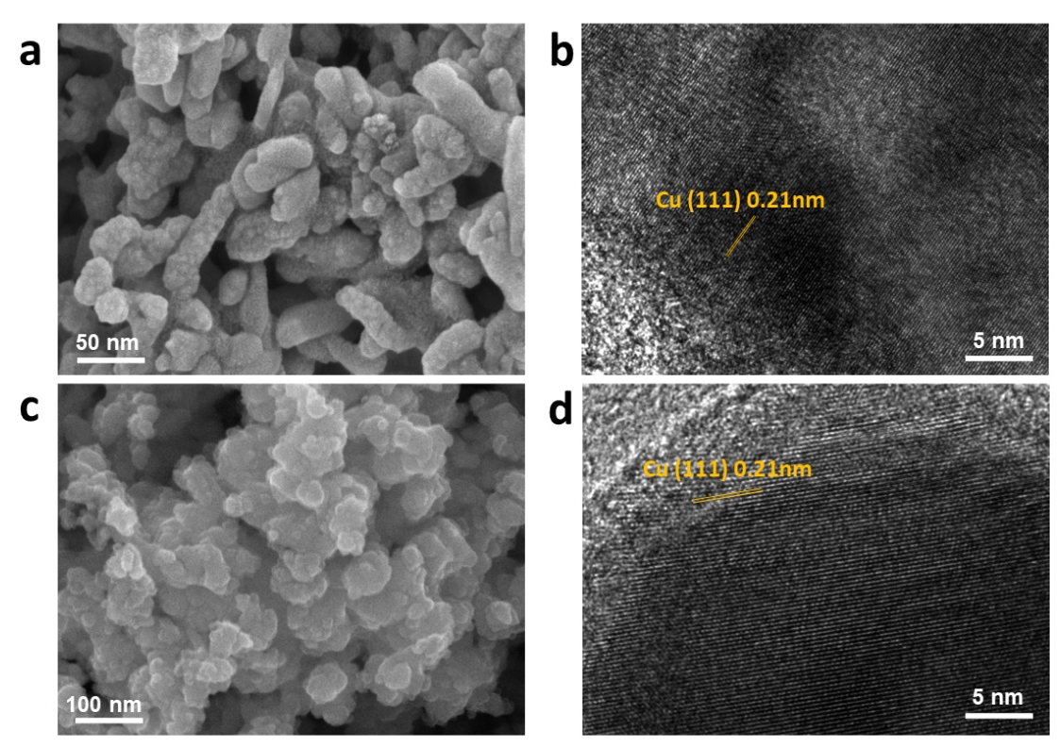
Supplementary Fig. 11 (a) SEM image of Cu-NR electrode. (b) TEM image of Cu-NR electrode. (c) SEM image of Cu-NP electrode. (d) TEM image of Cu-NP electrode.

Supplementary Fig. 12 XPS spectra of Cu-NR (a) and Cu NP (b) electrodes.

Supplementary Fig. 13 In situ K-edge XANES spectra of Cu-NR electrode during CO₂RR in 1 M KOH at various temperatures. CuO, Cu₂O and Cu foil are used as references.

Supplementary Fig. 14 CO₂RR Performance in 1 M KOH over Cu-NR electrode at 10 °C (a) and 5 °C (b).

Supplementary Fig. 15 (a) Plot of FE of various products vs potential in 3 M KOH over Cu-NR electrode at 20 ºC. (b) Plot of FE of various products vs potential in 3 M KOH over Cu-NR electrode at −3 °C. (c) Plot of FE of various products vs potential in 1 M KOH over Cu-NP electrode at 20 ºC. (d) Plot of FE of various products vs potential in 1 M KOH over Cu-NP electrode at −3 °C.

Supplementary Fig. 16 In situ ATR-SEIRAS spectra of CO₂RR over Cu-NR electrode at various potentials at 20 °C.

Supplementary Fig. 17 LSV curves over Cu-NR electrode at various temperatures.

Supplementary Fig. 18 (a–c) CV scans with different scan rates over Cu-NR electrode in 1 M KOH at 40 °C (a), 20 °C (b) and −3 °C (c). (d) Plot of Δj vs scan rate over Cu-NR electrode in 1 M KOH at various temperatures.

Supplementary Fig. 19 (a) Plot of j_{C2+} vs potential at various temperatures over Cu-NR electrode in 1 M KOH. (b) Plot of normalized j_{C2+} vs potential at various temperatures over Cu-NR electrode in 1 M KOH. The ECSA (74.6 mF·cm⁻²) of Cu-NR electrode at 40 °C was set to the 1 for the normalization.

Supplementary Tables
Supplementary Table 1 The vibration frequency of the IS, FS and obtained TS.ª
 |  | CH–COH+H→CH–C |  | CH–COH+H→CH–CHOH
 | CH–COH | TS1 | CH–C | TS2 | CH–CHOH
1 | 3638.64 | 3533.73 | 3183.02 | 3647.75 | 3722.95
2 | 3037.23 | 3068.12 | 1545.67 | 3039.03 | 3008.60
3 | 1374.66 | 1368.70 | 766.42 | 1364.59 | 2911.10
4 | 1199.12 | 1124.94 | 637.66 | 1195.81 | 1514.48
5 | 1066.00 | 997.99 | 399.63 | 1179.33 | 1316.33
6 | 972.58 | 965.64 | 332.28 | 1045.24 | 1242.16
7 | 792.64 | 851.60 | 305.67 | 969.06 | 1130.65
8 | 594.80 | 788.01 | 247.10 | 937.93 | 1075.69
9 | 499.74 | 713.83 | 232.96 | 762.57 | 899.69
10 | 394.16 | 548.51 | - | 580.71 | 777.94
11 | 357.47 | 402.13 | - | 503.84 | 595.78
12 | 309.27 | 360.80 | - | 433.54 | 446.49
13 | 251.38 | 288.43 | - | 335.77 | 258.84
14 | 191.16 | 256.83 | - | 276.08 | 210.02
15 | 128.07 | 245.46 | - | 246.42 | 193.98
16 | - | 186.24 | - | 161.37 | 151.44
17 | - | 76.68 |  | 154.13 | 129.53
18 | - | 1272.26 (i)^{b} |  | 826.68 (i)^{b} | 57.09 (i)^{c}
ªThe unit of the vibration frequency is cm⁻¹.
^{b}The presence of only one imaginary frequency can confirm the accuracy of the obtained TS. For IS and FS, the absence of any imaginary frequency indicates their stability.
^{c}The presence of a small imaginary frequency below 81 cm⁻¹ (10 meV) indicates that achieving full relaxation is very difficult and the resultant change in the DFT energy is negligible¹.

References
1. Svane, K. L., Reda, M., Vegge, T. & Hansen, H. A. Improving the activity of M−N₄ catalysts for the oxygen reduction reaction by electrolyte adsorption. ChemSusChem 12, 5133-5141 (2019).

