SUPPLEMENTARY MATERIAL

Table S1 Main physical and chemical characteristics of Paysandú and Tacuarembó by soil horizon. (Bentancor et al., [31])
 |  |  |  |  |  |  |  |  |  |  |  |  | Tacuarembó
Horizon |  |  | Depth |  | Clay |  | Silt |  | Sand |  | %OM |  | pH† |  |  |  | Extractable cations |  |  |  |  |  |  |  |  |  |  |  |  |  | Base
 |  |  |  |  |  |  |  |  |  |  |  |  | H₂O |  | KCl |  | Al |  | Ca |  | Mg |  | K |  | Na |  | Total Bases |  | CECe |  | Sat.
 |  |  | cm |  | --------- g kg⁻¹ --------- |  |  |  |  |  |  |  |  |  |  |  | ------------------- cmol_{c} kg⁻¹ ------------------- |  |  |  |  |  |  |  |  |  |  |  |  |  | %
A |  |  | 46 |  | 14,7 |  | 24,3 |  | 61,0 |  | 1,2 |  | 4,7 |  | 3,8 |  | 1,0 |  | 2,7 |  | 1,0 |  | 0,3 |  | 0,2 |  | 4,2 |  | 5,3 |  | 79,2
AB |  |  | 18 |  | 18,0 |  | 29,6 |  | 52,4 |  | 1,0 |  | 4,6 |  | 3,8 |  | 1,0 |  | 3 |  | 1,3 |  | 0,3 |  | 0,2 |  | 4,8 |  | 5,8 |  | 82,8
Bt |  |  | 27 |  | 35,6 |  | 40,1 |  | 31,1 |  | 0,8 |  | 4,8 |  | 3,7 |  | 0,9 |  | 5,3 |  | 2,6 |  | 0,4 |  | 0,4 |  | 8,5 |  | 10,4 |  | 81,7
BC |  |  | 18 |  | 36,4 |  | 31,7 |  | 32,0 |  | 0,8 |  | 5,1 |  | 4,1 |  | 0,7 |  | 6,5 |  | 3,1 |  | 0,3 |  | 0,6 |  | 10,5 |  | 11,2 |  | 93,8
C |  |  | 13 |  | 27,5 |  | 36,8 |  | 35,8 |  | 0,8 |  | 5,1 |  | 4,1 |  | 0,6 |  | 5,1 |  | 2,5 |  | 0,3 |  | 0,2 |  | 8,0 |  | 8,6 |  | 93,0
 |  |  |  |  |  |  |  |  |  |  |  |  |  | Paysandú
Horizon |  |  |  | Depth |  | Clay |  | Silt |  | Sand |  | %OM |  | pH† |  |  |  | Extractable cations |  |  |  |  |  |  |  |  |  |  |  |  |  | Base
 |  |  |  |  |  |  |  |  |  |  |  |  |  | H₂O |  | KCl |  | Al |  | Ca |  | Mg |  | K |  | Na |  | Total Bases |  | CECe |  | Sat.
 |  |  |  | cm |  | --------- g kg⁻¹ --------- |  |  |  |  |  |  |  |  |  |  |  | ------------------- cmol_{c} kg⁻¹ ------------------- |  |  |  |  |  |  |  |  |  |  |  |  |  | %
A |  |  |  | 43 |  | 13,1 |  | 27,2 |  | 59,7 |  | 1,1 |  | 4,8 |  | 3,7 |  | 0,8 |  | 2,1 |  | 0,8 |  | 0,1 |  | 0,2 |  | 3,2 |  | 4,0 |  | 80,0
E |  |  |  | 24 |  | 12,6 |  | 25,3 |  | 62,1 |  | 0,5 |  | 4,8 |  | 3,7 |  | 0,8 |  | 1,9 |  | 0,8 |  | 0,1 |  | 0,2 |  | 3,0 |  | 3,8 |  | 79,0
Bt |  |  |  | 40 |  | 30,3 |  | 31,7 |  | 38,0 |  | 0,6 |  | 5,1 |  | 4,1 |  | 0,6 |  | 9,6 |  | 3,2 |  | 0,4 |  | 0,3 |  | 13,4 |  | 14,1 |  | 95,0
BC |  |  |  | 26 |  | 29,0 |  | 36,2 |  | 34,8 |  | 0,3 |  | 5,4 |  | 4,2 |  | 0,3 |  | 11 |  | 3,7 |  | 0,4 |  | 0,4 |  | 15,4 |  | 15,7 |  | 98,1

Note: † pH: soil: solution relation v/v 1:2.5; Extractable Al: extracted by KCl 1M; Extractable bases: extracted by Ammonium Acetate 1M;
CECe: effective Cation Exchange Capacity; Base Sat.: (Total Bases/CECe)*100. Source: Bentancor et al. [31].

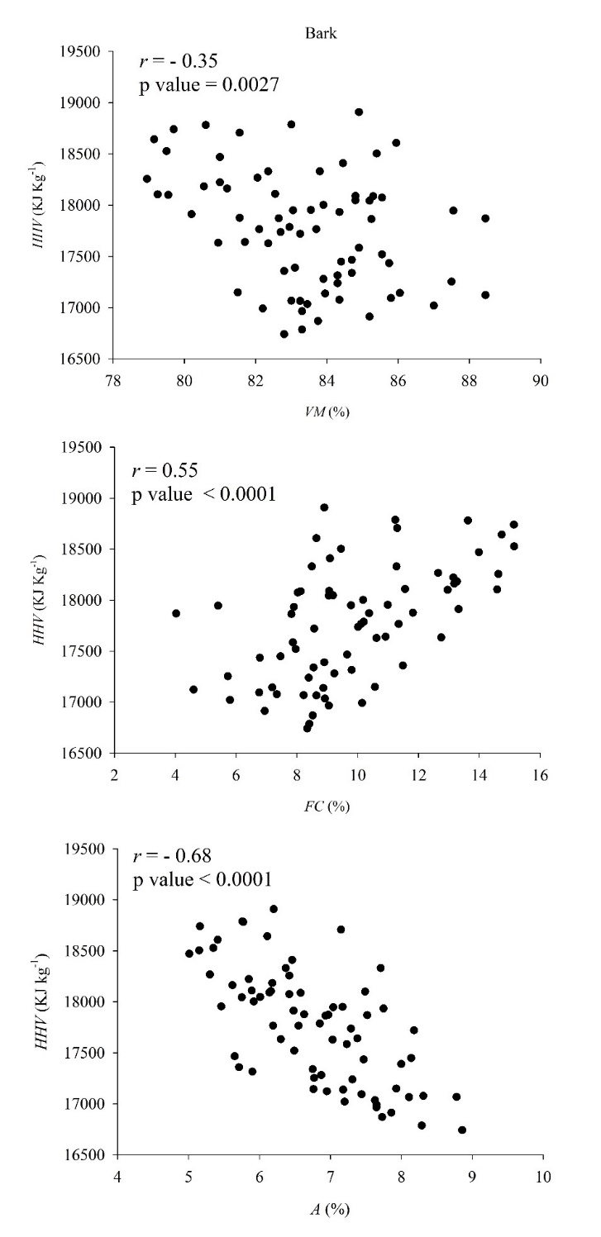
Fig. S1 Relationships between VM, FC and A with the HHV of the bark fraction for all species and plantation densities in both sites.

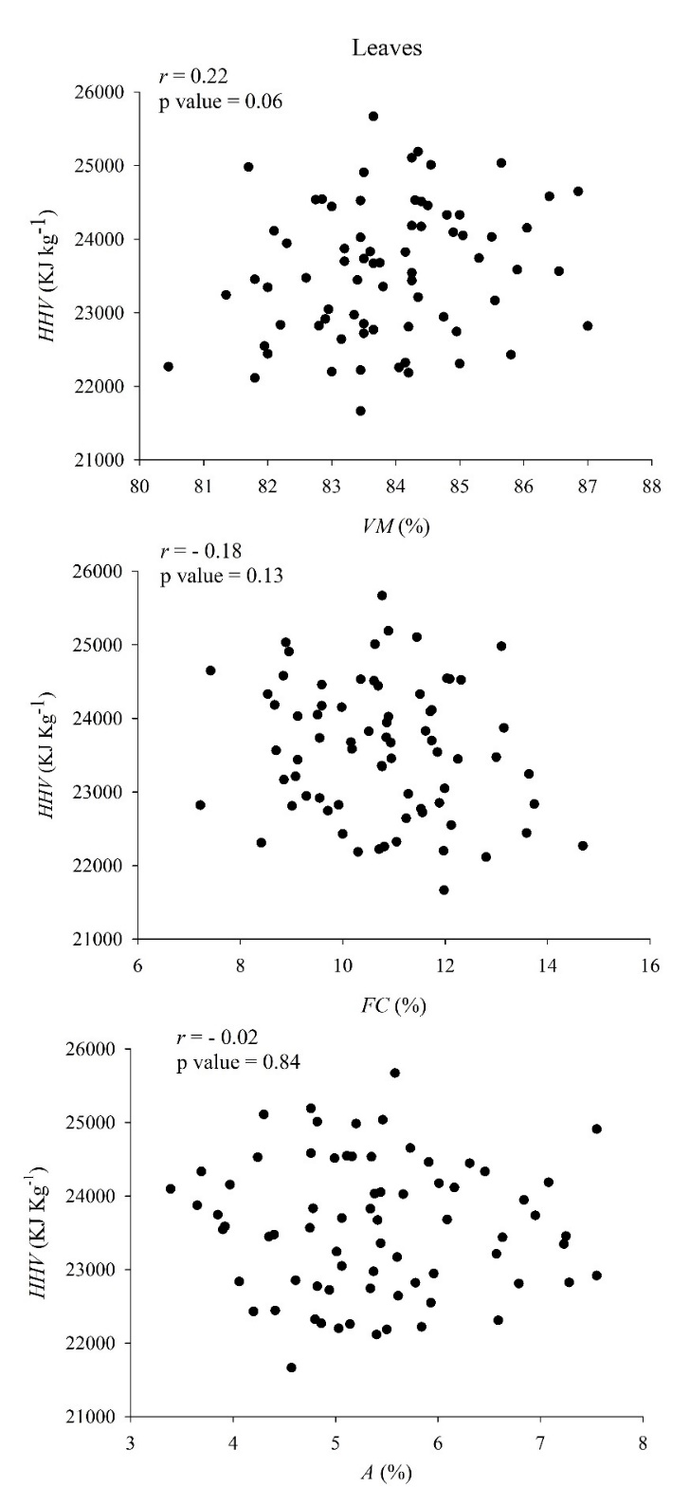
Fig. S2 Relationships between VM, FC and A with the HHV of the leave fraction for all species and plantation densities in both sites.
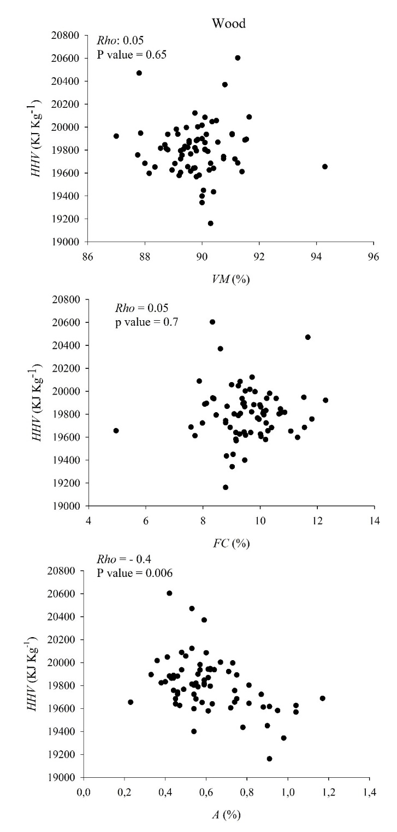
Fig. S3 Relationships between VM, FC and A with the HHV of the wood fraction for all species and plantation densities in both sites.
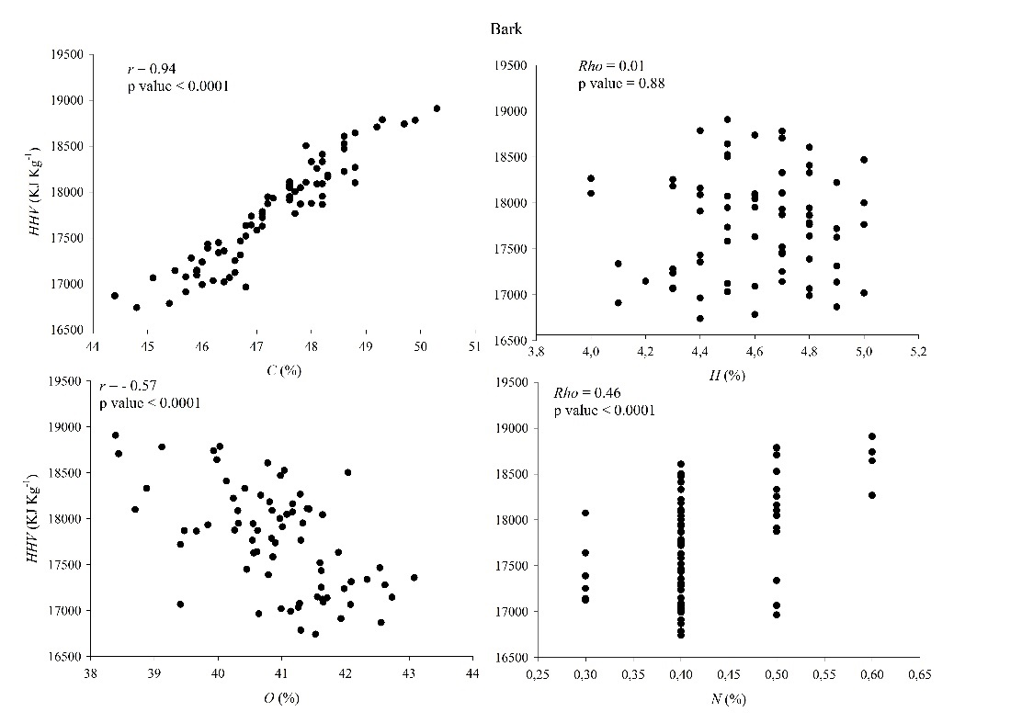
Fig. S4 Relationships between C, O, H and N with the HHV of the bark fraction for all species and planting densities in both sites.

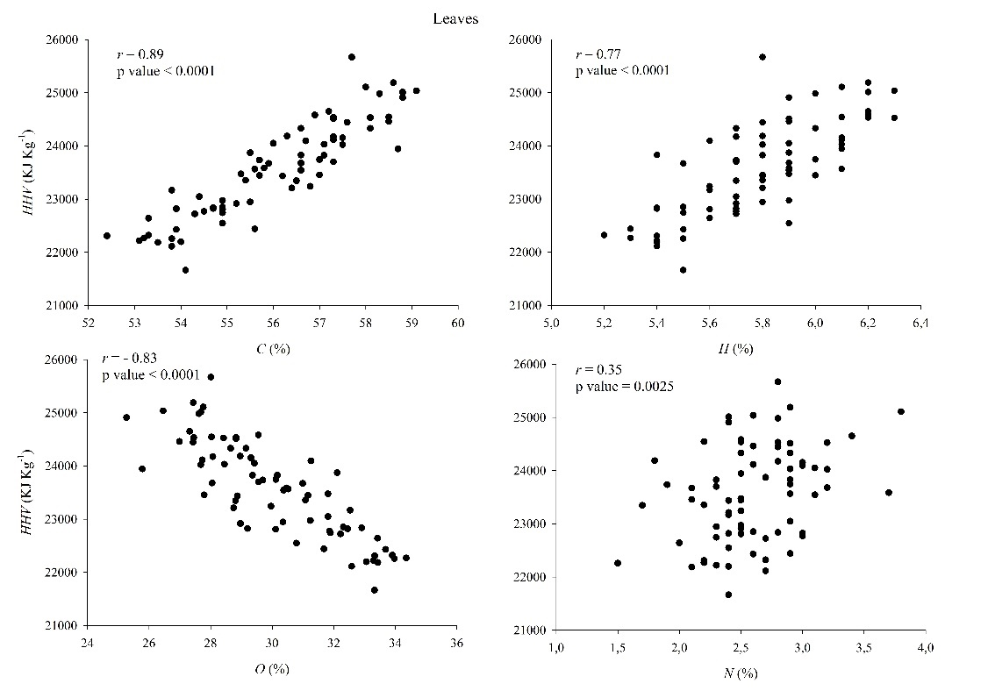
Fig. S5 Relationships between C, O, H and N with the HHV of the leaves bark fraction for all species and plantation densities in both sites.

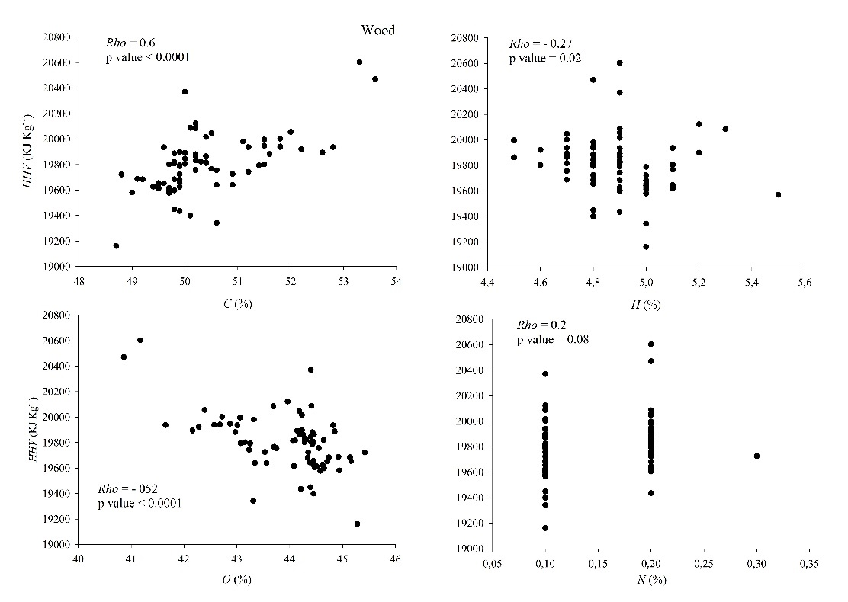
Fig. S6 Relationships between C, O, H and N with the HHV of the wood fraction for all species and plantation densities in both sites.

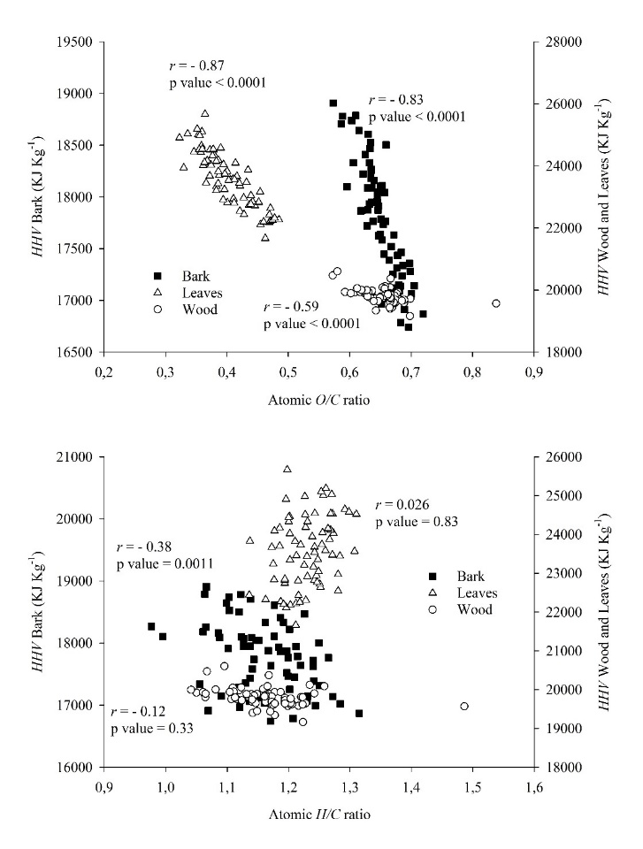
Fig.S7 Atomic relationships between O/C and H/C with the HHV of the bark, leaves and wood fractions for all species and planting densities in both sites.

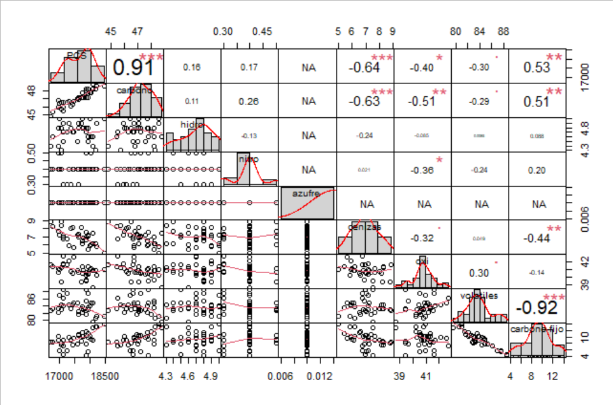
Fig. S8 Partial correlations between the components of the UA and PA with the HHV for the bark fraction.

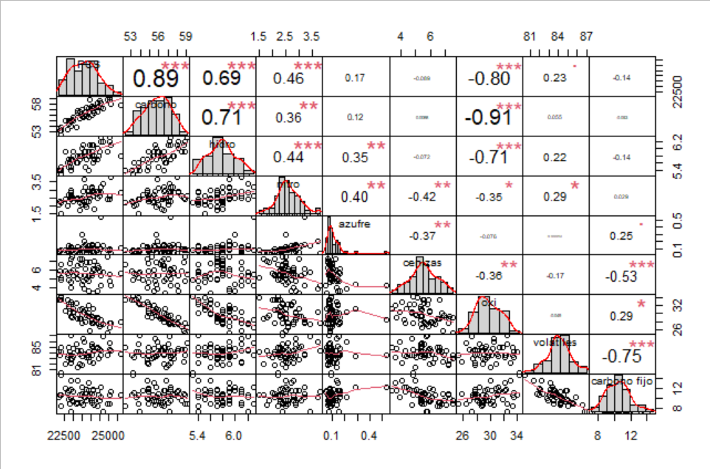
Fig. S9 Partial correlations between the components of the UA and PA with the HHV for the leaves fraction.
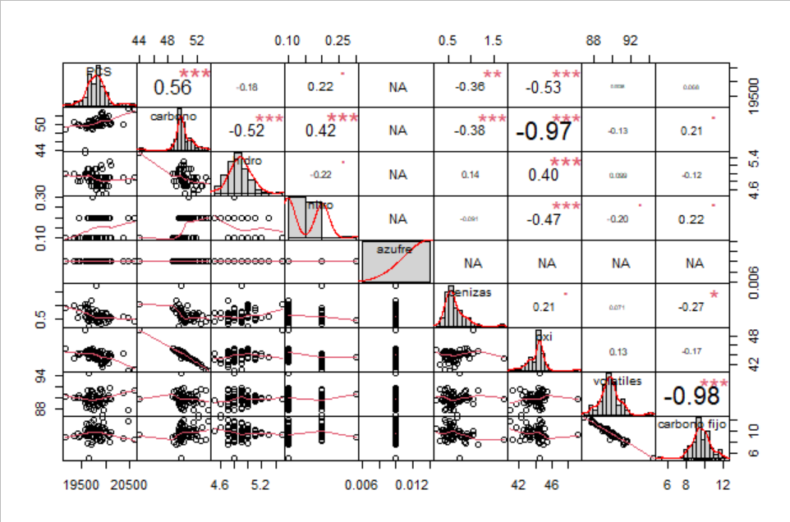
Fig. S10 Partial correlations between the components of the UA and PA with the HHV for the wood fraction.

Table S2 Mean Wdw and FVI values (±SE) of the wood, bark, and leaves fractions for the species and plantation densities were evaluated at both sites at 56 months age.
Site | Species | Planting  density  (trees ha⁻¹) |  | Wdw  (g m⁻³) | FVI
Tacuarembó | E. benthamii |  | 2220 | 0.409 (0.01) Aa | 1508 (232) Aa
Tacuarembó |  | 3330 |  | 0.415 (0.02) Aa | 1728 (118) Aa
Tacuarembó |  | 4440 |  | 0.405 (0.02) Aa | 1474 (223) Aa
Tacuarembó |  | 6660 |  | 0.423 (0.03) Aa | 2081 (630) Aa
Tacuarembó | E. dunnii | 2220 |  | 0.445 (0.03) Aa | 1294 (117) Aa
Tacuarembó | E. dunnii | 3330 |  | 0.428 (0.02) Aa | 1025 (101) Aa
Tacuarembó | E. dunnii | 4440 |  | 0.417 (0.04) Aa | 1157 (84) Aa
Tacuarembó | E. dunnii | 6660 |  | 0.418 (0.02) Aa | 1301 (84) Aa
Tacuarembó | E. grandis | 2220 |  | 0.368 (0.02) Ba | 1704 (220) Aa
Tacuarembó | E. grandis | 3330 |  | 0.368 (0.03) Ba | 1537 (58) Aa
Tacuarembó | E. grandis | 4440 |  | 0.365 (0.03) Ba | 1530 (131) Aa
Tacuarembó | E. grandis | 6660 |  | 0.345 (0.02) Ba | 1416 (139) Aa
Paysandú | E. benthamii | 2220 |  | 0.445 (0.02) Ba | 1346 (137) Aa
Paysandú |  | 3330 |  | 0.447 (0.01) Ba | 1158 (339) Aa
Paysandú |  | 4440 |  | 0.441 (0.02) Ba | 1606 (90) Aa
Paysandú |  | 6660 |  | 0.443 (0.02) Ba | 1435 (78) Aa
Paysandú | E. dunnii | 2220 |  | 0.458 (0.01) Aa | 891 (88) Ba
Paysandú |  | 3330 |  | 0.458 (0.02) Aa | 903 (61) Ba
Paysandú |  | 4440 |  | 0.466 (0.01) Aa | 977 (6) Ba
Paysandú |  | 6660 |  | 0.475 (0.01) Aa | 986 (100) Ba
Paysandú | E. grandis | 2220 |  | 0.379 (0.02) Ca | 1610 (196) Aa
Paysandú |  | 3330 |  | 0.388 (0.01) Ca | 1238 (24) Aa
Paysandú |  | 4440 |  | 0.379 (0.04) Ca | 1408 (80) Aa
Paysandú |  | 6660 |  | 0.366 (0.02) Ca | 1113 (62) Aa

Different capital letters indicate significant differences between species and different lowercase letters indicate significant differences between planting densities, by means of the Tukey test posteriori of the ANOVA, for each site, with a probability level of 5%.
Table S3 Values of partial correlations between the variables LHV, A, and Wdw with the
FVI of the wood fraction for each site, jointly considering the species and planting densities.
Sites | Partial correlation FVIA.Wdw,LHV |  | Partial correlation  FVIWdw.A,LHV |  | Partial correlation  FVILHV.A,Wdw
 | r | p-value | r | p-value | r | p-value
Paysandú | -0.89 | <0.0001 | 0.43 | 0.019 | 0.27 | 0.150
Tacuarembó | -0.91 | <0.0001 | 0.67 | <0.0001 | -0.24 | 0.170

