Supplementary Information to

Fundamentals of hydrogen production and use in a decarbonising power system

Gert Jan Kramer^{1,4}, Wouter van de Graaf², Vinzenz Koning^{1,3,4,*}
¹Copernicus Institute of Sustainable Development, Faculty of Geoscience, Utrecht University
²N.V. Nederlandse Gasunie
³Centre of Complex Systems Studies, Utrecht University
⁴These authors contributed equally
*Correspondence: v.koning@uu.nl

Supplementary Discussion S1 Sensitivity to battery storage
In this section we consider the effect of one key assumption, namely of the neglect of demand fluctuations and the prospects of demand-side management and short-duration storage in batteries. These will in fact modify the renewable power supply curves and induce a correlation between supply and demand. In this SI we carry out a sensitivity analysis for the case of batteries for our reference geography, thereby establishing a quantitative measure for the validity (or accuracy) of our model. Subsequently, we repeat this sensitivity analysis for Spain, and compare the impact of batteries for these two countries.

The Netherlands
To obtain a plausible range for the total battery capacity, $p_{b, c}$, in the Netherlands, we analyse the same scenarios as in Figure 7 by CE Delft¹, Gasunie², Berenschot³, Quintel Intelligence⁴ and Berenschot & Kalavasta⁵ (see also Supplementary Data S2). For the energy store of the battery, $E_{b, c}$, we will assume that $E_{b, c}/p_{b, c}=T =4h$, i.e. a charging and discharging duration, $T,$ of 4 hours at maximum rate. For large scale batteries and household batteries we extract the energy storage capacity from the scenarios and divide by this time scale ($T$) to obtain $p_{b, c}$. Most scenarios include electric vehicle batteries which serve transportation purposes rather than power balancing. In our calculations we assume that batteries are always ‘on grid’ and charge and discharge whenever possible. Their future availability in vehicle-to-grid mode is as yet unknown, but it is clear that their availability will be partial. Following suggestions in the scenario descriptions we have assumed that the scenario charging capacity contributes fully to our $p_{b, c}$, with an energy store of $E_{b, c}=p_{b, c}T$, effectively assuming that a fraction (~15%) of the vehicle fleet capacity is ’on grid’ and incorporated in $E_{b, c}$.
As expected, given the inherent uncertainties of energy futures, we find that there is large variation in battery capacity among the scenarios (see Table S2).

Statistic | $$p_{b, c}/r$$
Average | 0.59
Minimum | 0.00
10th percentile | 0.03
First quartile | 0.35
Median | 0.50
Third quartile | 0.77
90th percentile | 1.05
Maximum | 1.46
Table S1 | Statistics on power capacity of batteries found in Dutch scenarios.

We will first investigate changes to the required deployment of renewables and electrolysers for $p_{b, c}=0.5r$ – the median found among the scenarios – for the reference cost scenario, and then vary $p_{b, c}$ from 0 to $r$ – approximately the 90th percentile – and consider other cost scenarios to get a broader view on the impact of battery storage on our results.
Since our model uses the power duration curve for assessment of hydrogen production, we consider how battery storage modifies the instantaneous power (Figure S1) and subsequently, how battery storage modifies the power curve. This recognizes that batteries come before electrolysers in the merit curve for supply-demand management. However, it neglects possible interactions between electrolysis and battery storage, i.e. charging and discharging of batteries to improve the utilisation of electrolyser capacity. For simplicity, and in order not to underestimate the role of batteries, we will assume charging and discharging efficiencies of 100%. In addition, we will assume there is no self-discharge. We reinterpret $p\left(t\right)$ as the instantaneous power production from intermittent renewables through the year after application of batteries. We will assume that battery capacity will be proportional to the average renewable power generation. As before, from $p\left(t\right)$ we construct a power duration curve $\overline{p}\left(τ\right)$ after the application of batteries. Next, we repeat the method developed in the main text to find the cost-optimal combination of average renewable power generation and electrolyser capacity, and check for consistency between the average renewable power generation $r$ assumed in the $p\left(t\right)$ and the optimal $r$ found by the method in the main text. Figure S2 shows the resulting optimal deployment of renewables and electrolysers for full power decarbonisation when $p_{b, c}=0.5r$.
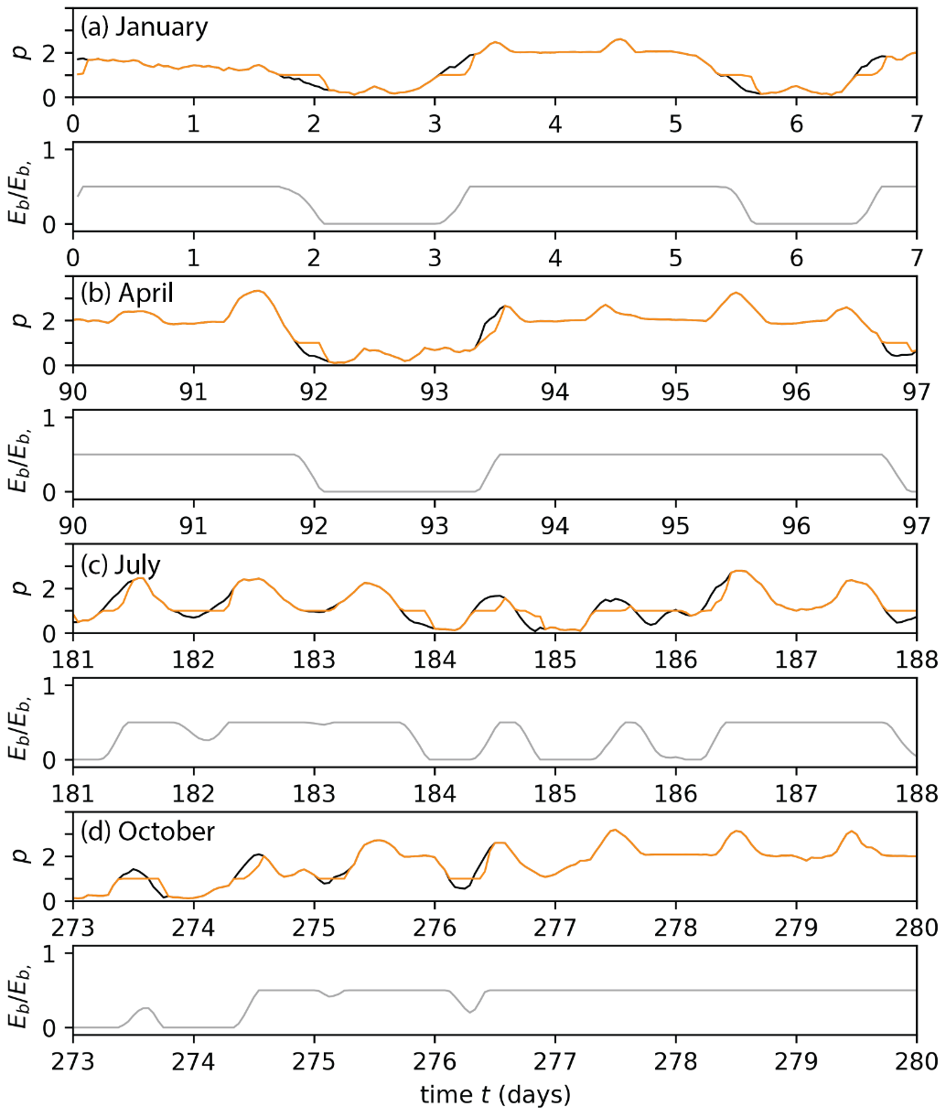
Figure S1 | Charging and discharging of batteries in the Netherlands. The top panels shows instantaneous power production from intermittent renewables before (black) and after (orange) application of batteries, $p\left(t\right)$, with a total capacity $p_{b, c}=0.5r$ for the cost-optimal $r$ that we find under the reference geography in this paper for a week in (a) January, (b) April (c) July, (d) October. The bottom panels shows the energy stored, $E_{b}$, in the batteries relative to the total storage capacity, $E_{b, c}$, for a week in (a) January, (b) April (c) July, (d) October.

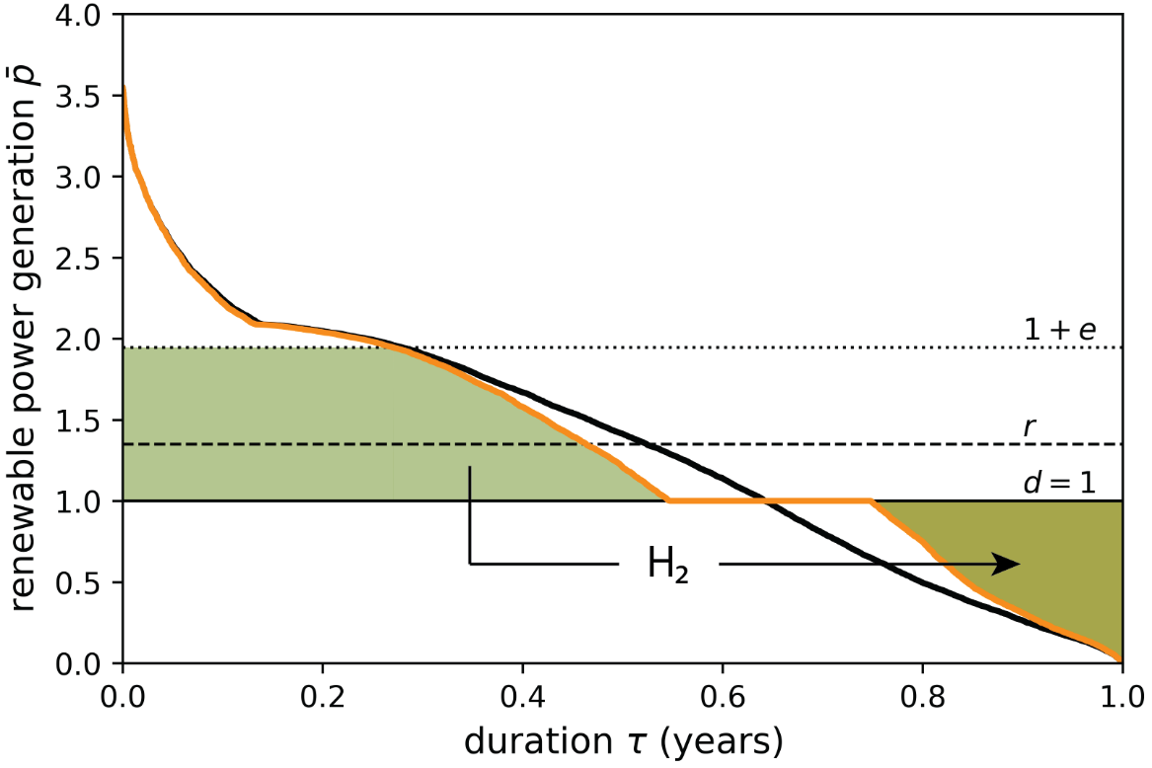
Figure S2 | Balancing annual solar and wind power production via batteries and hydrogen for the Netherlands. This chart shows the variable renewable power duration curve $\overline{p}\left(τ\right)$before (solid black line) and after (solid orange line) the application of batteries with a total capacity $p_{b, c}=0.5r$ for the cost-optimal configuration that we find under the reference geography in this paper (i.e. mix of 20% solar and 80% wind in the Netherlands). In order to meet the average demand ($d$) of 1 that does not come from batteries, we have to install $r=1.32$ of average renewable power. As indicated by the filled regions, 0.87 of electrolyser capacity ($e$) is needed to convert part of the excess power into hydrogen, which is converted back into power to make up for unmet demand in times of insufficient direct renewable production with an overall efficiency of 35%.
To decarbonise the power system completely when $p_{b, c}=0.5r$, we find that $e=0.95$ and $r=1.35$ are needed. This should be contrasted with $e=1.09$ and $r=1.42$ when $p_{b}=0$, as was found in Figure 1. Thus, when batteries are deployed, slightly less renewable power and electrolyser capacity needs to be deployed.
Table S2 presents a comprehensive comparison of the required renewables and electrolyser capacity and their associated investment cost, including more extreme battery adoption scenarios (i.e. $p_{b, c}=r$) and other cost scenarios.

Scenario | $$CR$$ |  | $$r^{*}$$ |  |  |  | $$e^{*}$$ |  |  |  | $C^{*}$ (€/W)
Scenario | $$CR$$ | $$p_{b, c} \\ =0$$ | $$p_{b, c} \\ =0.5r$$ | $$p_{b, c} \\ =r$$ |  | $$p_{b, c} \\ =0$$ | $$p_{b, c}=0.5r$$ | $$p_{b, c} \\ =r$$ |  | $$p_{b, c} \\ =0$$ | $$p_{b, c}=0.5r$$ | $$p_{b, c} \\ =r$$
Current | 2 | 1.47 | 1.40  (-4%) | 1.38  (-6%) |  | 0.98 | 0.82  (-16%) | 0.71  (-27%) |  | 8.80 | 8.15  (-7%) | 7.81  (-11%)
Reference | 3 | 1.42 | 1.35  (-5%) | 1.32  (-7%) |  | 1.09 | 0.95  (-13%) | 0.86  (-21%) |  | 8.02 | 7.49  (-7%) | 7.23  (-10%)
Future | 6 | 1.40 | 1.33  (-5%) | 1.29  (-8%) |  | 1.16 | 1.02  (-12%) | 0.99  (-15%) |  | 7.18 | 6.75  (-6%) | 6.54  (-9%)
Table S2 | The effect of batteries on full power system decarbonisation in the Netherlands. The average renewable power generation, electrolyser capacity and investment costs in electrolysers and renewables for full power system decarbonisation when battery capacity is included (i.e. $p_{b, c}=0.5r$ or $p_{b, c}=r$) and excluded (i.e. $p_{b, c}=0$) from the analysis. The numbers in parentheses indicate the relative change of battery inclusion.
We find that for all cases considered the inclusion of batteries leads to a reduction in the renewables and electrolyser capacity required. The displacement of electrolysers is largest in the current cost scenario, whereas the displacement of renewables is largest in the future cost scenario. Overall, the displacement of renewables is relatively modest, i.e not more than ~5% when mid-range levels of expected battery capacity (i.e. $p_{b, c}=0.5r$) and not more than ~8% even in the case of a more extreme battery deployment. In the latter case the electrolyser displacement is substantial however, namely up to about a reduction of ~27% when $CR=2$. Nevertheless, for more modest battery deployment the displacement of electrolyser capacity is substantially less, namely ~12-16%. The reduction in the amount of renewables and electrolysers required lead to lower investments into these technologies. This value is higher when battery capacity is still small since batteries are more effective then. For the reference cost scenario, this amounts to about 0.53€/W when $p_{b, c}=0.5r$; adding the same amount of battery capacity again leads to a further lowering of the investment cost of only 0.26€/W. Obviously, in exchange, investments in battery capacity will have to be made. These costs amount to ~300€/kWh for utility scale storage to ~1300€/kWh for small (residential) scale storage⁶, or equivalently ~1.2€/W to 5.2€/W. For $p_{b, c}=0.5r$, an additional investments in batteries of ~0.8€/W to 3.4€/W of electric demand is required. This implies that dedicated on-grid battery storage have limited appeal in a copper-plate power system which we model. The case of vehicle-to-grid batteries is different as the battery is bought for the primary purpose of vehicle range. The flip side is limited on-grid time as accounted for in our estimate for $p_{b, c}$ and $E_{b, c}$.
We conclude that the impact of batteries on the required levels of electrolyser capacity and renewable power to fully decarbonise the power system is in the order of 15% and 5%, respectively, for expected mid-range levels of battery deployment, leading to reduced cost of investment in these assets of ~7%.
Looking at the deployment pathway toward full power system decarbonisation, we find also find only a small impact of batteries on our results. Equation 1 of the main text still describes the relation between electrolyser and renewables deployment well. Figure S3 shows the cost optimal deployment pathway when including batteries, assuming $p_{b, c}=0.5r$, and compares this with the pathway without batteries (as was already shown in Figure 3a). Depending on the relative cost of electrolysers to renewables, $ρ_{CR}$ increases with a small amount, up to $\sim 0.1$ in the current cost scenario, when electrolysers are the most expensive. This indicates that electrolysers will be needed in a slightly later stage of the transition if batteries are employed. We also observe a small increase in the electrolyser-to-renewables build out ratio; $ε_{CR}$ increases with $\sim 0.1-0.3$. Again, this parameter is most sensitive to battery capacity when electrolysers are expensive. From this results we conclude that even though batteries are able to delay the moment of introduction of electrolysis, electrolyser capacity will have to be deployed at a faster rate afterward.

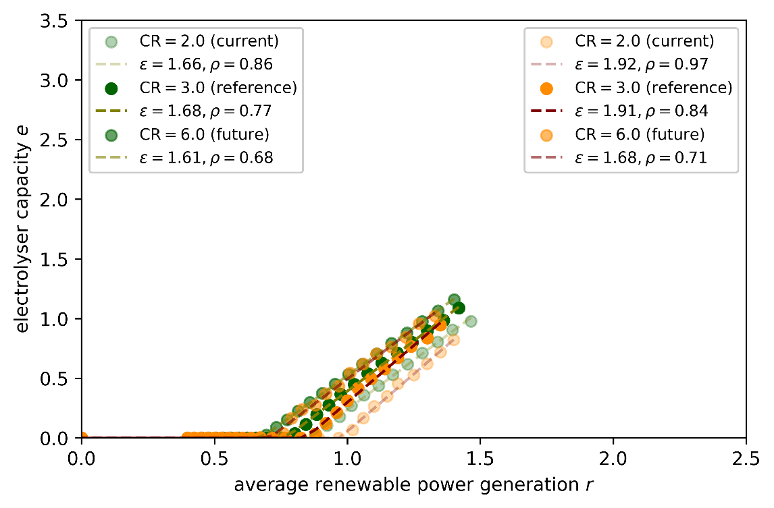
Figure S3 | Cost optimal paths of power system decarbonisation with and without batteries in the Netherlands. Cost optimal electrolysers and renewables deployment in $\left(r,e\right)$-space for a mix of wind (80%) and solar power (20%) in the Netherlands when batteries battery capacity of $p_{b, c}=0.5r$ is included (orange) and excluded (green). The dashed lines are fits of equation 1 in the main text, for battery inclusion (maroon) and exclusion (olive).

Spain
We repeat the same sensitivity analysis for Spain, a country with a very different resource base. In the Global Analysis scenario, variable renewable power supply is a mix of 45% wind and 55% solar power. Batteries are more attractive in this country than in the Netherlands, as they complement solar power (see Figure S4), leading in particular to reductions in required electrolyser capacity (see Figure S5). For the same level of battery deployment, we find reductions of about ~35%, ~8% and ~15% in electrolyser capacity, renewables, and their investment cost, respectively, to reach full power system decarbonisation with solar and wind power (see Table S3). If we take into account an existing share of hydropower in Spain, less firm capacity needs to displaced. The relative reductions in electrolyser capacity due to battery deployment are even larger for this case; relative reductions in renewables and investment cost do not change (see Table S4).
We observe that the cost reduction is comparable to the cost of additional battery storage. Therefore, depending, amongst others, on the actual cost developments of electrolysers and batteries, large-scale deployment of battery adoption may occur in Spain. If this indeed will be the case, the results presented in the main text overestimate the amount of electrolyser capacity.
Despite the large overestimate in electrolyser capacity, the path of deployment of renewables and electrolysers toward power system decarbonisation, as described by eq. 1, is somewhat less impacted by battery storage (see Figure S6). Like for the Netherlands, deployment of electrolysers is necessary at a later point in time – $ρ_{CR}$ shifts with about $\sim 0.15$ when $p_{b, c}=0.5r$, but the subsequent electrolyser-to-renewables deployment rate is not strongly affected.
We also note that the variation in the deployment pathway due to battery storage is less than the variation due to the uncertainty in electrolyser cost. This can be inferred from Figure S6 (and for the Netherlands from Figure S3) visually: the difference between the orange and green lines is smaller than the spacing between the green lines.

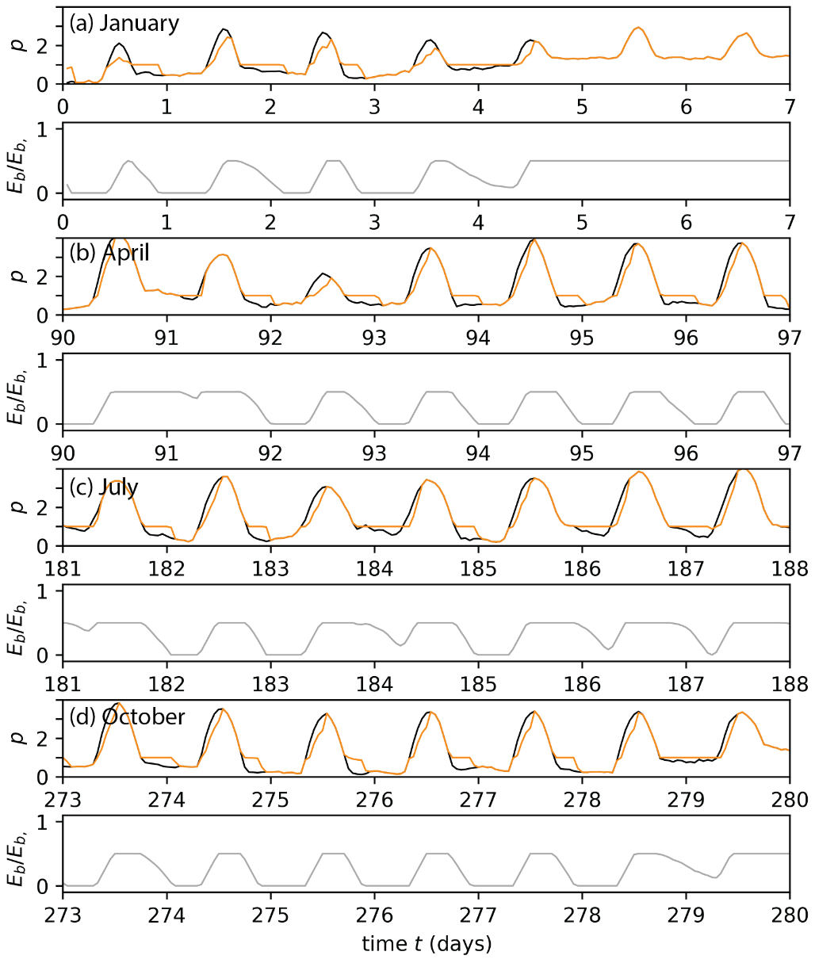
Figure S4 | Charging and discharging of batteries for Spain. The top panels shows instantaneous power production from intermittent renewables before (black) and after (orange) application of batteries, $p\left(t\right)$, with a total capacity $p_{b, c}=0.5r$ for the cost-optimal $r$ that we find for Spain for a week in (a) January, (b) April (c) July, (d) October. The bottom panels shows the energy stored, $E_{b}$, in the batteries relative to the total storage capacity, $E_{b, c}$, for a week in (a) January, (b) April (c) July, (d) October.

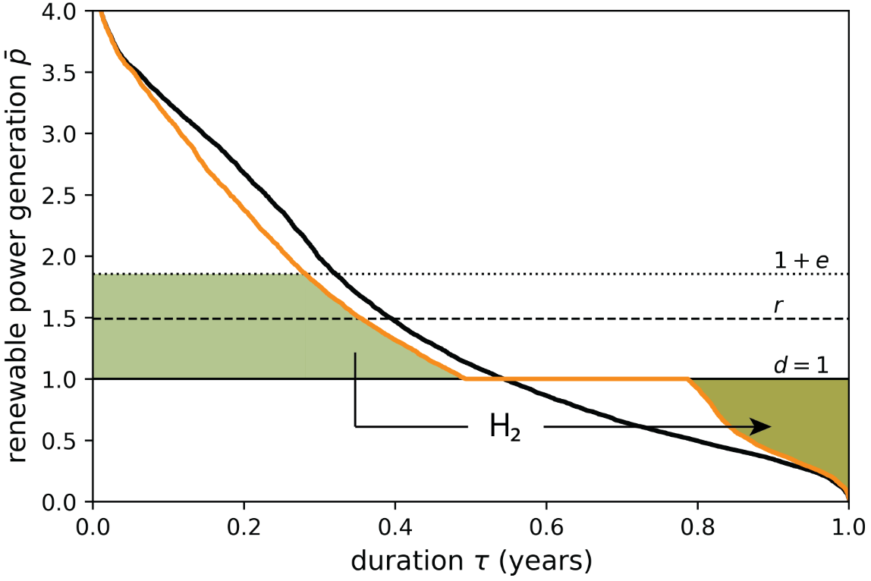
Figure S5 | Balancing annual solar and wind power production via batteries and hydrogen for Spain. This chart shows the variable renewable power duration curve $\overline{p}\left(τ\right)$before (solid black line) and after (solid orange line) the application of batteries with a total capacity $p_{b, c}=0.5r$ for the cost-optimal configuration that we find for Spain. In order to meet the average demand ($d$) of 1 that does not come from batteries, we have to install $r=1.49$ of average renewable power. As indicated by the filled regions, 0.85 of electrolyser capacity ($e$) is needed to convert part of the excess power into hydrogen, which is converted back into power to make up for unmet demand in times of insufficient direct renewable production with an overall efficiency of 35%.

Scenario | $$CR$$ |  | $$r_{f=0}$$ |  |  |  | $$e_{f=0}$$ |  |  |  | $C_{f=0}$ (€/W)
Scenario | $$CR$$ | $$p_{b, c} \\ =0$$ | $$p_{b, c} \\ =0.5r$$ | $$p_{b, c} \\ =r$$ |  | $$p_{b, c} \\ =0$$ | $$p_{b, c}=0.5r$$ | $$p_{b, c} \\ =r$$ |  | $$p_{b, c} \\ =0$$ | $$p_{b, c}=0.5r$$ | $$p_{b, c} \\ =r$$
Current | 1.8 | 1.74 | 1.58  (-9%) | 1.45  (-17%) |  | 1.06 | 0.66  (-38%) | 0.42  (-60%) |  | 9.46 | 7.88  (-17%) | 6.82  (-28%)
Reference | 2.7 | 1.60 | 1.49  (-7%) | 1.38  (-14%) |  | 1.37 | 0.85  (-38%) | 0.58  (-58%) |  | 8.54 | 7.32  (-14%) | 6.45  (-24%)
Future | 5.4 | 1.48 | 1.37  (-7%) | 1.29  (-13%) |  | 1.81 | 1.31  (-28%) | 0.93  (-48%) |  | 7.36 | 6.53  (-11%) | 5.93  (-19%)
Table S3 | The effect of batteries on full power system decarbonisation with solar and wind for Spain. The average renewable power generation, electrolyser capacity and investment costs in electrolysers and renewables for full power system decarbonisation, plus displacement of hydropower (i.e. $f=0)$, when battery capacity is included (i.e. $p_{b, c}=0.5r$ or $p_{b, c}=r$) and excluded (i.e. $p_{b, c}=0$) from the analysis. The numbers in parentheses indicate the relative change of battery inclusion.

Scenario | $$CR$$ |  | $$r^{*}$$ |  |  |  | $$e^{*}$$ |  |  |  | $C^{*}$ (€/W)
Scenario | $$CR$$ | $$p_{b, c} \\ =0$$ | $$p_{b, c} \\ =0.5r$$ | $$p_{b, c} \\ =r$$ |  | $$p_{b, c} \\ =0$$ | $$p_{b, c}=0.5r$$ | $$p_{b, c} \\ =r$$ |  | $$p_{b, c} \\ =0$$ | $$p_{b, c}=0.5r$$ | $$p_{b, c} \\ =r$$
Current | 1.8 | 1.45 | 1.32  (-9%) | 1.17  (-19%) |  | 0.60 | 0.20  (-67%) | 0.01  (-98%) |  | 7.24 | 5.79  (-20%) | 4.76  (-34%)
Reference | 2.7 | 1.34 | 1.23  (-8%) | 1.17  (-13%) |  | 0.85 | 0.39  (-54%) | 0.01  (-99%) |  | 6.70 | 5.58  (-17%) | 4.75  (-29%)
Future | 5.4 | 1.22 | 1.17  (-5%) | 1.12  (-8%) |  | 1.28 | 0.64  (-50%) | 0.22  (-83%) |  | 5.91 | 5.20  (-12%) | 4.71  (-20%)
Table S4 | The effect of batteries on full power system decarbonisation with solar, wind and hydropower for Spain. The average renewable power generation, electrolyser capacity and investment costs in electrolysers and renewables for full power system decarbonisation, up to $f=f_{hydro}=0.12$, when battery capacity is included (i.e. $p_{b, c}=0.5r$ or $p_{b, c}=r$) and excluded (i.e. $p_{b, c}=0$) from the analysis. The numbers in parentheses indicate the relative change of battery inclusion.
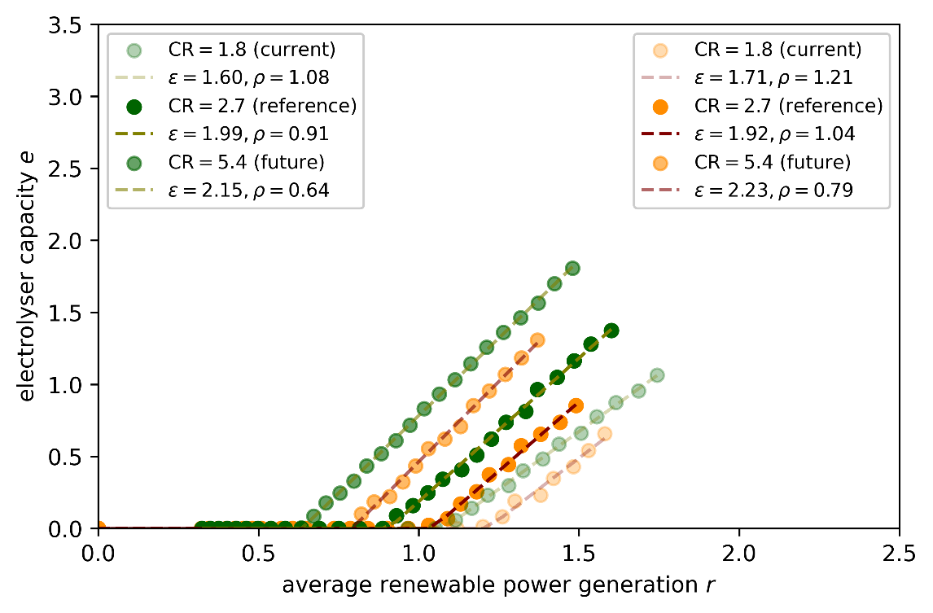
Figure S6 | Cost optimal paths of power system decarbonisation with and without batteries in Spain. Cost optimal electrolysers and renewables deployment in $\left(r,e\right)$-space for a mix of wind (45%) and solar power (55%) in Spain when batteries battery capacity of $p_{b, c}=0.5r$ is included (orange) and excluded (green). The dashed lines are fits of equation 1 in the main text, for battery inclusion (maroon) and exclusion (olive).

Supplementary references
1. Afman, M. & Rooijers, F. Net Voor de Toekomst. Achtergrondrapport. https://ce.nl/wp-content/uploads/2021/03/CE_Delft_3L53_Net_voor_de_Toekomst_Zonder_BIJL.pdf (2017).
2. GasUnie. Verkenning 2050. Discussiestuk. https://www.gasunie.nl/en/expertise/natural-gas/customised-gas/$4059/$4061 (2018).
3. den Ouden, B., Graafland, P. & Warnaars, J. Electronen En/of Moleculen: Twee Transitie Paden Voor Een CO2-Neutrale Toekomst. https://www.berenschot.nl/media/kjyb0p3s/cases-elektronen_enof_moleculen_twee_transitiepaden_voor_een_co2-neutrale_toekomst.pdf (2018).
4. Kerkhoven, J., Wirtz, A. & Kruip, C. Beelden van Een CO2-Arme Nederlandse Samenleving in 2050. https://s3-eu-west-1.amazonaws.com/static.quintel.com/publications/beelden_van_een_co2-arme_nederlandse_samenleving_in_2050_-_quintel_intelligence.pdf (2015).
5. den Ouden, B. et al. Klimaatneutrale Energiescenario’s 2050. Scenariostudie Ten Behoeve van de Integrale Infrastructuurverkenning 2030-2050. https://www.berenschot.nl/media/hl4dygfq/rapport_klimaatneutrale_energiescenario_s_2050_2.pdf (2020).
6. Lazard. LCOE+. https://www.lazard.com/media/2ozoovyg/lazards-lcoeplus-april-2023.pdf (2023).

