Supplemental Information
Energy-dependent broadening of Rashba-type spin splitting in a Au₂Sb surface alloy with periodic structural defects
Jinbang Hu^{1, +}; Xiansi Wang²; Anna Cecilie Åsland¹; Justin W. Wells^{1,3 +}
¹Department of Physics, Norwegian University of Science and Technology (NTNU), NO-7491, Trondheim, Norway.
²Hunan University, Changsha, 410082, China.
³Semiconductor Physics, Department of Physics, University of Oslo (UiO), NO-0371 Oslo, Norway.

Supplementary Figure 1: Experimental confirmation of the clean Au(111) surface.
Supplementary Figure 2: Characterization of structural phase of the Sb/Au(111) interface.
Supplementary Figure 3: ARPES imaging the Rashba-type band feature S₁.
Supplementary Figure 4: Calculated band structure of the Sb/Au(111) interface with a $\sqrt{3}×\sqrt{3}$ surface reconstruction.

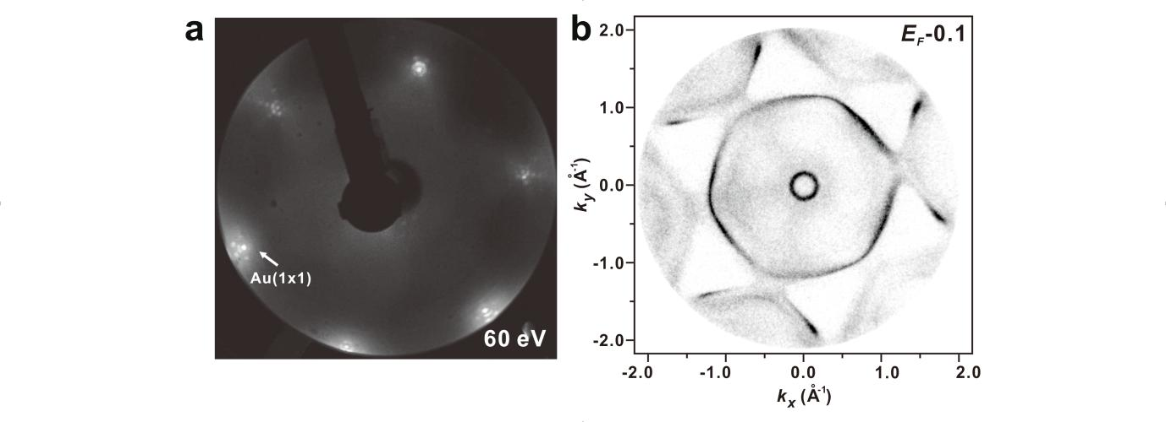
Figure S1. Experimental confirmation of the clean Au(111) surface. (a) LEED pattern (60 eV) of the clean Au(111) substrate. (b) ARPES data of the constant energy contour throughout the Au(111) SBZ at $E_{b}=0.1$ eV.

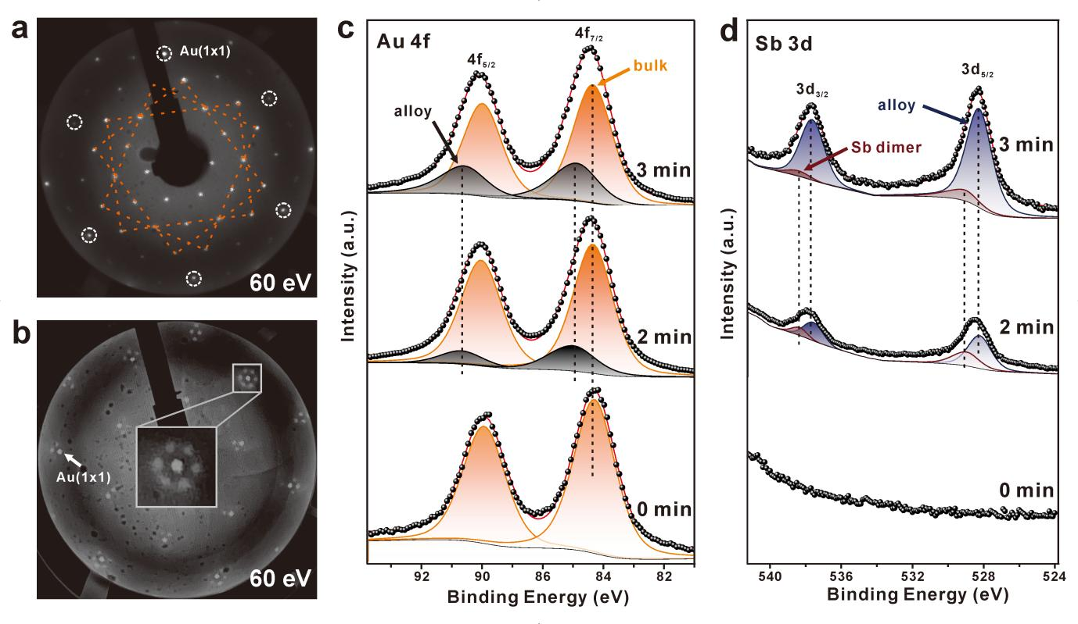
Figure S2. Characterization of structural phase of the Sb/Au(111) interface. (a) LEED pattern (60 eV) of a Sb monolayer grown on the Au(111) substrate. The unit cell of 2D Sb is proposed and highlighted by yellow dashed lines. (b) LEED pattern (60 eV) of the Au₂Sb surface alloy formed after 3min of Sb deposition at room temperature. The inset shows the details of the diffraction around the Au(1x1) diffraction spot, presenting an $8×8$ superstructure. (c-d) Evolution of Au 4f and Sb 3d core level as a function of Sb coverage at room temperature.
In Supplementary Figures 2c-d, the Au 4f and Sb 3d core levels are presented to monitor the deposition of Sb onto the Au(111) substrate, transitioning from the clean surface to the formation of the Au₂Sb surface alloy at room temperature. The Sb 3d signal appears after 1.5 minutes of Sb deposition at room temperature. Concurrently, the Au 4f core level shows alterations in both shape and energy. Our peak fitting of the Sb 3d signal reveals two components. The high binding energy component might be attributed to Sb dimers formed above the Au₂Sb surface alloy at low coverage, consistent with the STM observation in Ref.^{s1} The components at lower binding energies of 537.95 eV and 528.60 eV match well with the Au-Sb alloy signal, as discussed in the main text. Further Sb deposition on the Au surface enhances the Sb 3d signal, with a more pronounced component from the surface alloy, while the higher binding energy shoulder diminishes. This change is attributed to the surface phase transition from Sb dimers to the Au₂Sb surface alloy.
The fitting of the Au 4f core level indicates that the peak has a higher binding energy surface component, shifted by 0.5 eV from the bulk component. The surface component may result from the interaction between Au and Sb atoms in the surface alloy, and becomes consistently stronger as more Sb is deposited. The LEED pattern in Supplementary Figure 2b shows the $8×8$ superstructure of the Au₂Sb surface alloy, similar to the $8×8$ superstructure formed by the 2D Sb(110) rhombohedral phase on the Au(111) surface upon annealing to 400 °C, as discussed in the main text.

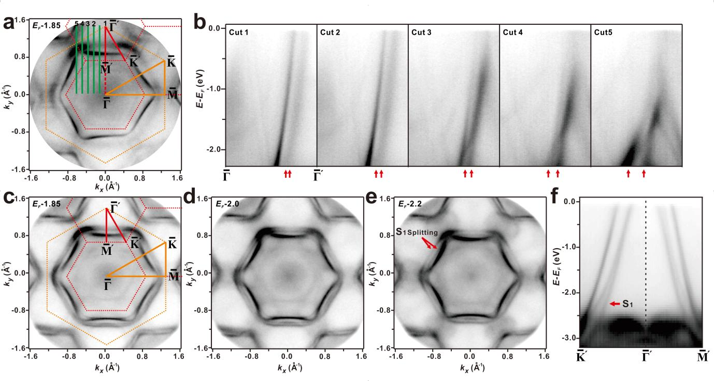
Figure S3. ARPES imaging the Rashba-type band feature S₁. (a) ARPES data of the Au₂Sb surface alloy showing the constant energy contour throughout the SBZ at 1.85 eV below the Fermi level. (b) Band dispersion along the lines marked as 1-5 in (a) to illustrate the evolution of the splitting of the S₁ band feature. (c-e) ARPES data of constant energy contours and (f) band dispersion along the high-symmetry directions of the 2nd SBZ of the Au₂Sn surface alloy, used as a reference to show the clear splitting of the Rashba-type band feature S₁.
Supplementary Figures 3a-b show the evolution of the splitting of band feature S₁ from the Au₂Sb surface alloy, normal to the $\overline{Γ}−\overline{Γ}'$ direction. We can clearly see the splitting of the band feature S₁ in cuts 2-5. For comparison, Supplementary Figures 3c-f present the electronic structure of the Au₂Sn surface alloy. The sample preparation of Au₂Sn surface alloy followed the procedure described in Ref.^{s2}. We found the two splitting branches of the S₁ band feature in the Au₂Sn surface alloy to be well separated.
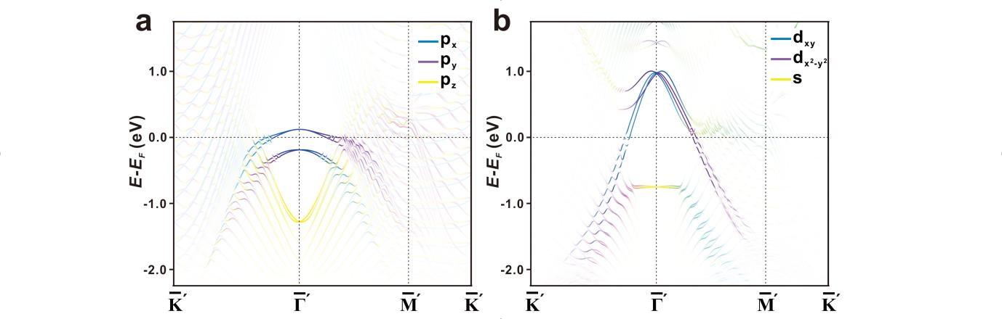
Figure S4. Calculated band structure of the Sb/Au(111) interface with a $\sqrt{3}×\sqrt{3}$ surface reconstruction. (a) Calculated band structure with SOC for the Sb absorbed above the Au(111) with a $\sqrt{3}×\sqrt{3}$ surface reconstruction. Blue, purple, and yellow symbols indicate contributions from $p_{x}$, $p_{y}$, and $p_{z}$ states projected from the absorbed Sb atom. (b) Calculated band structure with SOC for the model of the Au₂Sb surface alloy shown in Figure 1f. Yellow, blue, and purple symbols indicate contributions from $s$, $d_{xy}$ and $d_{x^{2}−y^{2}}$ states of the topmost Au₂Sb layer.
In Supplementary Figure 4a, the surface band projected from the absorbed Sb atom shows a clear band dispersion around the $\overline{Γ}'$ point, but its dispersion becomes less pronounced as the binding energy increases. This feature exhibits distinct differences compared to the calculated band structure of the Au₂Sb alloy model and the experimental ARPES data.

Reference
1 Zhou, D. et al. Interfacial effects on the growth of atomically thin film: Group VA elements on Au (111). Advanced Materials Interfaces 6, 1901050 (2019).
2 Shah, J. et al. Atomic and electronic structures of the Au₂Sn surface alloy on Au(111). Physical Review B 104, 125408 (2021).

