Supplemental Information

Flow Field Optimization for Inexpensive Optical Aerosol Particle Counting and Sizing

Charis Loizidis¹, Christoforos Skourides¹, Spyros Bezantakos¹, Neoclis Hadjigeorgiou¹ and George Biskos^{1,2}

¹Climate and Atmosphere Research Center, The Cyprus Institute, Nicosia 2121, Cyprus.
²Faculty of Civil Engineering and Geosciences, Delft University of Technology, Delft 2628CN, The Netherlands

S1. Mie scattering theory
When a light source of wavelength λ (nm) hits a particle of diameter d and refractive index m, a part of the incident light becomes extinct due to absorption and scattering so that¹:
$$σ_{ext}= σ_{abs}+σ_{sca} (S1)$$
Here, σ_{ext}, σ_{abs} and σ_{sca} are the light extinction, absorption and scattering cross-section, respectively. The parameter of interest for our study is the scattering cross-section, which is given by the following equation²:
$$σ_{sca}= \frac{2π}{k^{2}}∙\int{(i_{1}+i_{2})∙sin⁡(θ)∙Δφ(θ)∙dθ} (S2)$$
Here $k= {2∙π}/λ$ is the wave-number, where λ is the incident light wavelength, θ is the angle between the incident and the scattered light, whereas parameters i₁ and i₂ are the Mie scattering coefficients determined as³:
$$i_{1}= {\left|\sum_{n=1}^{∞}{\frac{2n+1}{n∙(n+1)}∙\left[a_{n}∙π_{n}\left(cosθ\right)+ b_{n}∙t_{n}(cosθ)\right]}\right|}^{2} (S3)$$
$$i_{2}= {\left|\sum_{n=1}^{∞}{\frac{2n+1}{n∙(n+1)}∙\left[a_{n}∙τ_{n}\left(cosθ\right)+ b_{n}∙π_{n}(cosθ)\right]}\right|}^{2} (S4)$$
The limit of summation n in the above Eqs. is defined as:
$$n_{max}=x+\left(4∙\sqrt[3]{x}\right)+2 (S5)$$
where x is the dimensionless size parameter proportional to the particle size-to-wavelength ratio, given by:
$$x= \frac{π∙d}{λ} (S6)$$
Parameters π_{n} and τ_{n} are functions of the scattering angle θ, which can be calculated as:
$$π_{n}\left(θ\right)=\left[\frac{2n-1}{n-1}∙cosθ∙π_{n-1}\left(θ\right)\right]-\left[\frac{n}{n-1}∙cosθ∙π_{n-2}\left(θ\right)\right] (S7)$$
$$τ_{n}\left(θ\right)=\left[n∙cosθ∙π_{n}\left(θ\right)\right]-[(n+1)∙π_{n-1}\left(θ\right) (S8)$$
The calculations can start by setting $π_{0}\left(θ\right)=0$, and $π_{1}\left(θ\right)=1$. The parameters α_{n} and b_{n} are functions of the parameter x and the particle refractive index m:
$$a_{n}= \frac{m^{2}∙j_{n}\left(mx\right)∙{\left[x∙j_{n}\left(x\right)\right]}^{'}- j_{n}\left(x\right)∙M∙[mx∙j_{n}\left(mx\right)]'}{m^{2}∙j_{n}\left(mx\right)∙{\left[x∙h_{n}^{(1)}\left(x\right)\right]}^{'}- h_{n}^{(1)}\left(x\right)∙M∙[mx∙j_{n}\left(mx\right)]'} (S9)$$
$$b_{n}= \frac{M∙j_{n}\left(mx\right)∙{\left[x∙j_{n}\left(x\right)\right]}^{'}- j_{n}\left(x\right)∙[mx∙j_{n}\left(mx\right)]'}{M∙j_{n}\left(mx\right)∙{\left[x∙h_{n}^{(1)}\left(x\right)\right]}^{'}- h_{n}^{(1)}\left(x\right)∙[mx∙j_{n}\left(mx\right)]'} (S10)$$
Here M is the relative magnetic permeability of the particles (typically having a value of unity). Functions j_{n}, h_{n} and their derivatives are calculated according to the following equations:
$$j_{n}\left(z\right)= \sqrt{\frac{π}{2z}}∙J_{n+0.5}\left(z\right) (S11)$$
$$h_{n}^{(1)}\left(z\right)= j_{n}+y_{n}∙i (S12)$$
$$y_{n}\left(z\right)= \sqrt{\frac{π}{2z}}∙Y_{n+0.5}\left(z\right) (S13)$$
Here J_{n} and Y_{n} are Bessel functions of the 1st and 2nd kind, respectively, and i is the imaginary unit. Variable z represents x or m·x so that:
$${\left[z∙j_{n}\left(z\right)\right]}^{'}=z∙j_{n-1}\left(z\right)- n∙j_{n}\left(z\right) (S14)$$
$${\left[z∙h_{n}^{(1)}\left(z\right)\right]}^{'}=z∙h_{n-1}^{(1)}\left(z\right)- n∙h_{n}^{\left(1\right)}\left(z\right) (S15)$$
The calculations can start by using the expressions: $j_{0}= \frac{sinz}{z}$ , and $y_{0}= -\frac{cosz}{z}$ . Having determined the parameters i₁ and i₂, we can move on to calculate the scattering cross-section light intensity σ_{sca} by integrating over the desirable scattering angles. Most often the integration is done across a circular area because the OPSs use circular cross-sectioned mirrors or lenses to gather the scattered light by the particles. Angle θ is the angle between the incident light beam and the scattering direction, whereas θ_{a} and θ_{b} define the range of the scattering angles gathered by the optics. Δφ is the angle of the scattered radiation around the incident beam, which is a function of angle θ. For a circular surface that receives the scattered light, Δφ(θ) is calculated as follows⁴:
$$Δφ\left(θ\right)= \cos^{-1}\left(\frac{\cos\left(\frac{θ_{b}-θ_{a}}{2}\right)-[cos\left(\frac{θ_{a}+θ_{b}}{2}\right)∙\cos{θ}] }{\sin\left(\frac{θ_{a}+θ_{b}}{2}\right)∙sinθ}\right) (S16)$$
In practice, detection of the scattered light happens at a mean distance r (assumed to be a spherical surface with a cross-sectional area of $σ_{g}=4π∙r^{2}$), away from the light-scattering particles. In the optical systems of OPSs, a big fraction of the scattered light is captured by a curved mirror and focused on photo-detector. As a result the photo-detector receives a part of the particle scattered light directly to its photo-sensitive surface and the another part from the mirror. This means that for the theoretical calculations we have to consider the particle-detector distance (r₁) and the particle-mirror together with the mirror-detector distance (r₂). The normalized scattering coefficient Q_{sca} (cf. Eq.1 in manuscript) over the spherical surface with distances r₁ and r₂ from the particles is given by:
$$Q_{sca} = \frac{σ_{sca}}{σ_{g}} = \frac{1}{{2∙k}^{2}∙{r_{1}}^{2}}\int_{θ_{1}}^{θ_{2}}{\left(i_{1}+i_{2}\right)∙\sin\left(θ\right)∙{Δφ}_{1}\left(θ\right)∙dθ} + \frac{1}{{2∙k}^{2}∙{r_{2}}^{2}}\int_{θ_{3}}^{θ_{4}}{\left(i_{1}+i_{2}\right)∙\sin\left(θ\right)∙{Δφ}_{2}\left(θ\right)∙dθ} (S17)$$
Note here that the integration is done between angles θ₁ and θ₂ for the light scattered directly to the photo-detector and between angles θ₃ and θ₄ for the scattered light that is reflected by the mirror. The above angle ranges are also used to calculate Δφ₁ and Δφ₂, respectively, according to Eq. S16. The reason why OPSs are designed to gather the widest possible scattering angle is not only because of the increased signal intensity, but also due to the oscillations that the scattered light intensity undergoes for a very small θ range⁵. Figure S1a shows an example of wide angle scattering versus narrow angle scattering. Figure S1b shows the scattered light intensity as a function of the scattering angle θ for different particle sizes. The effect of the incident light wavelength λ is shown in Figure S1c. Generally, larger incident light wavelengths will give higher scattered light intensities. Therefore, an OPS that uses a laser emitting light of small wavelength can be more sensitive when sizing small particles⁶. Finally, Figure S1d shows light scattering intensity as a function of particle size for different refractive indices m. The commonly used standard to calibrate OPSs is the PSL spheres, unless the particle refractive index of the sampled particles is known, in which case one can use it to derive other intrinsic properties from the OPS measurements⁷.
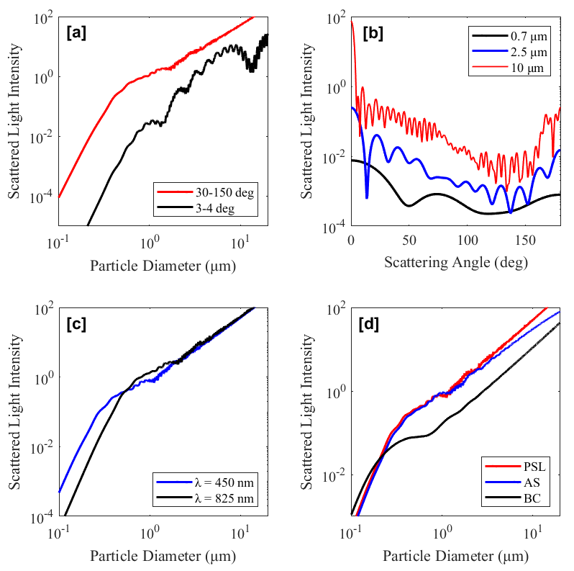
Figure S1: Mie theory calculation examples for (a) narrow-angle vs wide-angle scattered light intensity as a function of PSL sphere (m = 1.59 + 0i) diameter (λ = 683 nm), (b) scattered light intensity as a function of the scattering angle for different PSL sphere diameters ( λ = 683 nm), (c) wide-angle scattered light intensity as a function of PSL sphere diameters at different incident light wavelengths, and (d) wide-angle scattered light intensity as a function of the particle diameter (λ = 450 nm) for: PSL spheres, Ammonium Sulfate particles (AS; m = 1.521 + 0.002i) and black carbon particles (BC; m = 1.67 + 0.67i).

S2. OPS-OS design and manufacturing details
Figure S2a shows side view cross-section of the OPS-OS. All the parts of the OPS-OS are assembled together using M3-threaded metal screws, except for parts 13 and 15 that are aligned by tightening. The laser beam (horizontal purple line) passes through the center of the chamber and directed to the beam dump. The dump is designed to reflect the laser beam out of the OPS-OS chamber. The red circle indicates the center of the geometry, through which the particles cross the light beam. Light scattered from the particles is reflected by the mirror to the photo-detector as shown by the pink region of Figure S2a.
The distance between the center of the chamber and the mirror’s reflective surface defines the position where the photo-detector needs to be located. The focused region of the laser beam where the particles need to pass through is at a distance 15 mm away from the mirror’s reflecting surface (point A in Figure S2). Due of the spherical shape of the mirror and because the selected distances are such that the focusing point is further away from the detection volume, the light scattered by the particles is not focused exactly on one point (i.e., like they do from a parabolic mirror). As a result, the photo-detector must be placed at a distance that it gathers all the light reflected from the mirror. Following classical optics calculations, the photo-sensitive surface of the photo-detector has to be fixed at a distance of 13 mm from the detection volume (Point B in Fig. S2a). In that way, the mirror covers an angle range of about 90º ± 63º of the scattered light, whereas a smaller angle range of about 90º ± 5.5º is scattered directly to the photo-detector surface.
Figure S2b shows the top view of the custom-made OPS-OS. What is important to note here is the hollow design of the inlet flow nozzle (part 15), which offers the possibility to combine the sheath flow (indicated by the light-blue color in Figure S2b) and the aerosol flow (indicated by darker-blue color in Fig. S2b). The sheath flow is a particle-free flow, which dilutes the aerosol flow, helps to focus the aerosol flow, and prevents the optical components to get dirty from particle deposition on their surfaces⁸. The sheath flow inlet has small rod-shaped obstacles to make the flow laminar and also to support/align the inner tube of the aerosol flow.
It is important to provide a few more details here. As indicated in Fig. S2b, we use a cylindrical lens (with a back focal length of 23 mm) to focus the laser light beam (purple-color) in one direction, which must be perpendicular to the aerosol flow. This means that the cross-section of the focused laser beam through which the particles must pass, has the shape of a thin surface. Also, the light beam produced by the laser diode, is polarized⁹. In order to achieve the maximum focusing of the laser beam, the polarity direction of the laser diode light must be perpendicular to the curved surface of the focusing lens. Finally, the photo-detector has a cover (part 10) that prevents unwanted stray light reflections to enter its photo-sensitive area.
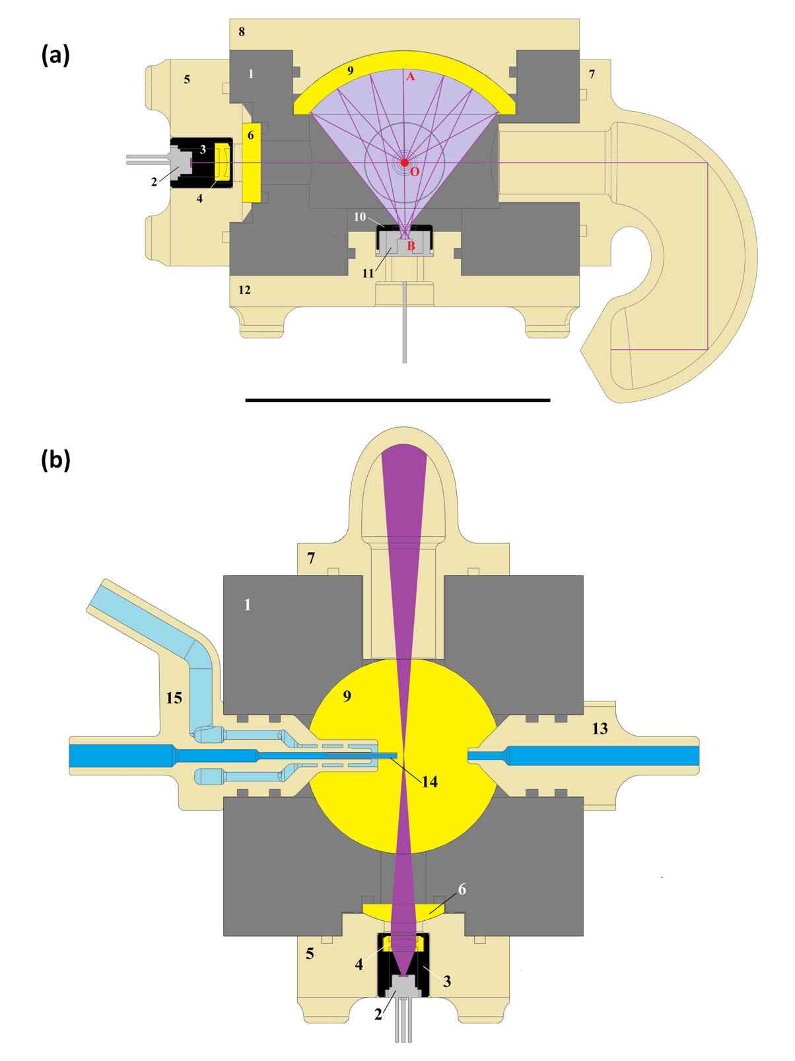

Figure S2: Cross-sections of the OPS-OS from (a) the side, and (b) the top. The purple-shaded area in S2a is the domain indicates the domain within which the light scattered by the particles are reflected effectively to the photo-detector. The purple-shaded area in S2b indicates the laser beam, whereas the light-blue and blue areas denote respectively the sheath flow and the aerosol flow streams.

S3. Electronic circuit design of the OPS-OS
Another important part of the OPS-OS is its electronic circuit that records drives and records the signal from the photo-detector. The electric signal of the photo-detector is very low and thus it needs a strong amplification. In addition, the response of the system must be fast enough to capture the single particle events, whereas the noise must also be as low as possible to be able to distinguish even pulses of small amplitude produced by the smaller particles. Figure S3 shows the circuit of the photo-detector amplification system.

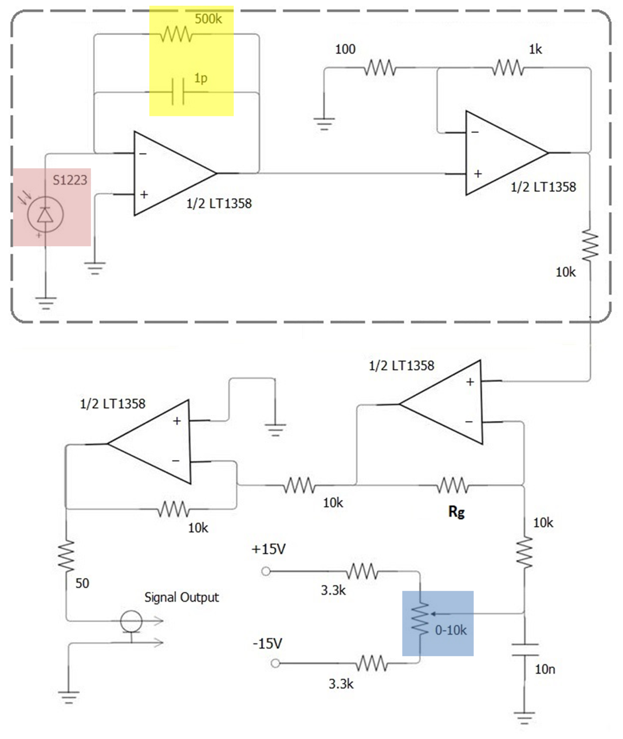
Figure S3: OPS-OS photo-detector amplifying circuit.

It is important to note that the optics shell (part 1 in Figure 1a of manuscript) must be connected to the circuit ground in order to reduce the noise level. The photo-detector in our circuit (indicated with pink color) has its anode (plus sign) connected to the ground so that it works in the ‘photo-voltaic’ mode¹⁰. We have four stages of amplification in the circuit. The first stage mainly defines the characteristics of the operational amplifiers that must be used for the specific application. The potentiometer (indicated with blue color in Figure S3) is used to regulate the DC offset of the output signal, so that it gives values around zero, while the resistor in the third amplification stage (R_{g}) can be changed by the user. This provides the flexibility to change the amplification gain for different applications. The amplification gain G in the circuit of the custom-made OPS optical system can be estimated as:
$$G= 11000000*\left(\frac{20000}{13300+R_{p}}\right) (S18)$$
We cannot derive exactly the value of G because R_{p} (i.e., the potentiometer resistance) is variable when we regulate the signal around zero. Thus, based on Eq. S18, the value of G can have values approximately between 1.1×10⁷ – 5.5×10⁷ Ω, depending on the value of R_{p} resistor. It is not recommended to put very high values of R_{p} resistor (i.e. > 50 kΩ), because the signal noise will also be significantly amplified. The R_{p} resistor used in this work is 20 kΩ.
The circuit operation bandwidth is inextricably linked to the response/rise time of the photo-detector. In order to have a good resolution in the pulses of our OPS-OS signal (i.e. to have minimum overlaps between successive events), the rise time of the pulses t_{r} needs to be ca. 2 μs, which is a typical value in reference OPS systems. This means that the bandwidth frequency must be at least ${0.35}/{t_{r}}$ = 175 kHz¹⁰. Given the above-mentioned requirement, we can calculate the bandwidth frequency of our circuit (shown in Figure S3) as $1/{2π∙\left(1pF\right)∙(500kΩ)}$ ≃ 320 kHz. Now, we can calculate the minimum gain-bandwidth product (GBP) of the operational amplifier as follows¹⁰:
$$\sqrt{\frac{GBP}{2π∙R_{f}∙(C_{f}+C_{j}+C_{a})}} > \frac{1}{2π∙R_{f}∙C_{f}} (S19)$$
where R_{f} and C_{f} (indicated with yellow color in Figure S3) have values of 500 kΩ and 1 pF, respectively. C_{j} is the junction capacitance of the S1223 photodiode when connected to ground, which is 68.8 pF (value given by the manufacturer), and C_{α} is the operational amplifier input capacitance that has a typical value of 3 pF. Following the above calculations, the GBP of the operational amplifier must be > 23.2 MHz. The amplifier used in our circuit (Analog Devices, model LT1358) is chosen to meet the above mentioned requirements. We should note here that Eq. S19 must be valid in order to have stability in our circuit.
The two first stages of amplification must be inside an electro-magnetic shield (EMI-gasket connected to ground), so that the initial signal is not affected by any external electro-magnetic field. This is very important because it reduces significantly the noise level of the circuit.
The laser diode that we use in this work (Ushio, HL-6365DG) emits light at a wavelength of 642 nm, and its output optical power is ~ 60 mW. The wavelength and the power of the laser diode define also the response of the photo-detector. The photo-sensitivity of the photo-detector is a function of the light wavelength. If the light emission power of the laser diode is not strong enough, then scattered light from smaller particles will not be detected. Figure S4 shows the photo-sensitivity of the photo-detector we employed (Hamamatsu, Model S1223) as a function of the laser wavelength.
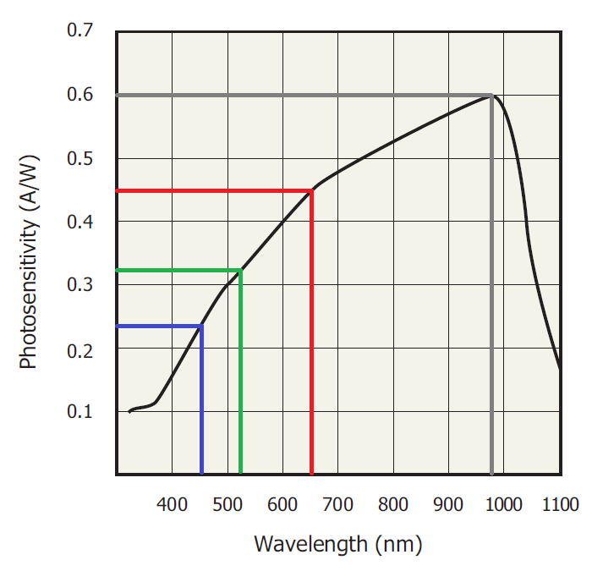
Figure S4: Photo-detector sensitivity as a function of the incident light wavelength.
We should note here that the factor A in Eq. 1 in the manuscript, which is related to the scattered light intensity from the particles, can be converted voltage from the OPS-OS electronics as follows:
$$A= P\left(λ\right)∙G∙I_{0}∙F (S20)$$
Here P is the photo-sensitivity of the photo-detector (in A/W) that is a function of the light beam wavelength λ, G is the factor of the electronic circuit that amplifies the photo-detector signal (in Ω), Ι₀ is the intensity of the light beam (in W), and F is a focusing factor of the laser beam that can be approximated as the area of the circular beam of the light source over the area of the focused light at the distance defined by the back focal length of the focusing-lens.
The illuminating power (i.e., intensity) of the laser diode employed in OPSs typically ranges from 30 to 110 mW⁶. However, the intensity of the laser-diode employed in OPS-OSs can vary according to different applications. For example, if the optical system will sample big particles (i.e. if it is employed in a condensation particle counter), using a laser diode of even ~ 5 mW intensity can be enough. On the other hand, if more sensitivity is needed for small particles, one need to increase the laser intensity even up to ~ 1 W¹¹ or more¹².
Another key component is the power supply of the laser diode, because the latter must function on specific current and voltage ranges. In order to achieve that, we use a constant DC voltage power supply, the output of which is passed through a low-pass inductor-capacitor (L-C) filter such that the cut-off frequency is ~ 5 Hz in order to reduce the circuit voltage noise. After the low-pass filter, we use the configuration of a constant current supply circuit, based on a LM-317 regulator. The constant current is the most important because if the laser diode current oscillates, the illuminating intensity will also change leading to different signal intensities and therefore to uncertainties in the particle sizing.
The laser-diode is also one of the most expensive parts of the OPS-OS (comprising ca. 1/3 of its total cost) and thus it is important to be protected. To do that, we put two diodes connected in parallel and with reverse polarity to the laser diode, in order to protect it from reverse current flow and from over-voltage. A common 1N-4007 diode protects from reverse current flow and a Zener-diode protects the circuit from any possible overvoltage.
The other important part of the power supplies is that used to operate the amplifiers from the photo-detector circuit. Again we use similar low-pass filters (as in the laser diode power supply). The only difference here is that we have a dual supply that gives positive and negative DC voltage output. The importance of a noise-free power supply for the amplifiers again is related to the stability/repeatability of the signal in order to reduce the particle sizing uncertainties.
All the above-mentioned details of the circuit were designed using ‘Eagle’ software (AutoDesk®), and manufactured as Printed Circuit Boards (PCBs) by ‘PCBway’. The PCBs are 1.6 mm thick, made of FR-4 material¹³. The internal connections in the PCBs are made of copper (Cu) and are placed in two layers.

S4. OPS-OS cost assessment
The total cost of the OPS-OS, taking into account the labor to assemble and test it, is €500. Figure S6 shows how this cost is broken down in different components. The cost analysis considers the price of all components when ordering 10 of them, as well as the labor to assemble and test 10 units which is estimated to about one week of full-time work by a specialized employee. All the transport and custom-clearance expenses from the components are included separately from their commercial cost, combined with the labor expenses.

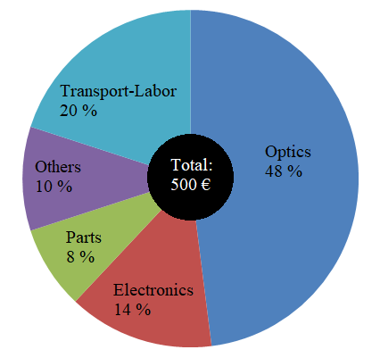
Figure S5: Breakdown of the OPS-OS production cost.

S5. OPS-OS flow field COMSOL simulation
The simulation of the flow-field inside the OPS-OS was done by using the turbulent flow k-ω interface provided by COMSOL. The equations solved by this interface are the Reynolds-averaged Navier-Stokes (RANS) equations¹⁴ for conservation of momentum and the continuity equation for conservation of mass. Turbulence effects are modeled using the Wilcox revised two-equation k-ω model with realizability constraints¹⁵. The k-ω model is a so-called low-Reynolds number model that can resolve the flow all the way down to the walls¹⁶.
The OPS-OS geometry was approximated as 2D-axisymmetric model in the simulation, using an ‘Extra-Fine’ meshing resolution. Figure S6 shows the meshing of the OPS-OS simulation at three different magnification scales. The y-axis in all the sub-plots is the symmetry axis of the geometry, whereas the beige triangle indicates the laser beam. An example of the 3D flow illustration of the simulation from the above model is shown in Figure S7.
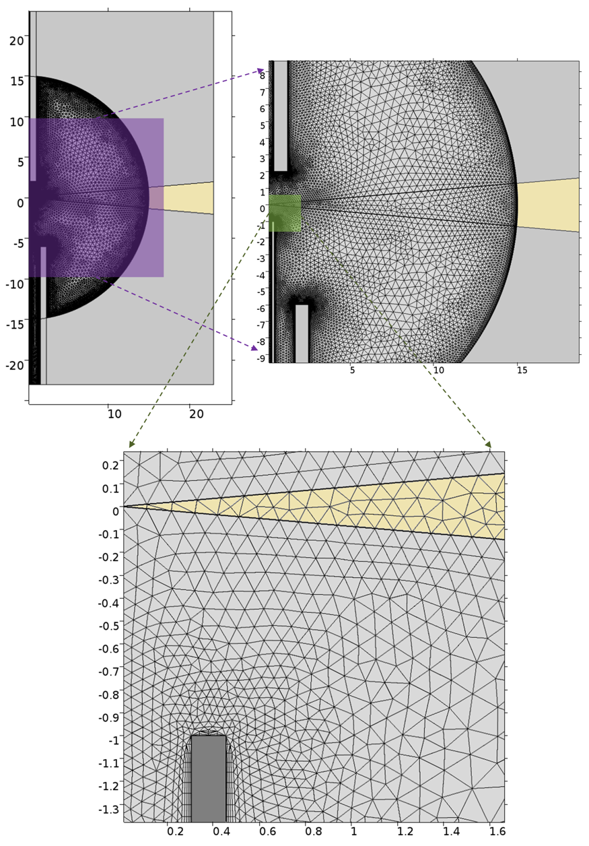
Figure S6: OPS-OS geometry meshing used for the COMSOL simulations.

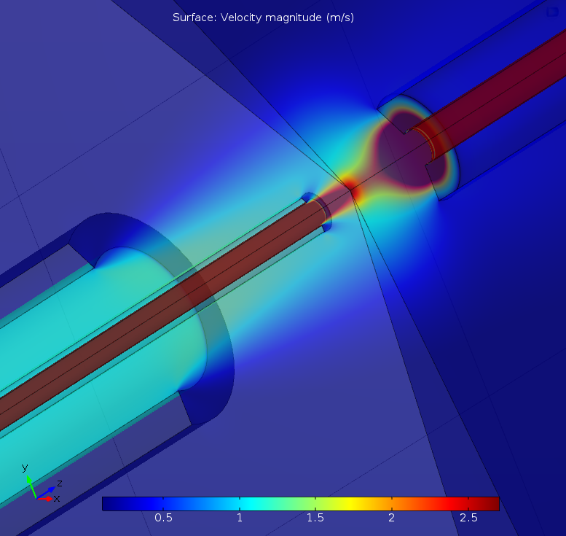
Figure S7: 3D illustration of the OPS-OS flow simulation.

S6. Analytical results of the flow optimization experiments
Table S1: Combinations of conditions used in all the experiments and simulations in our study. The two left columns indicate the Figures in the main manuscript and the supplement that show the respective results.
Figure in the main manuscript | Figure in the SI | Q_{s}  (L/min) | Q_{a}  (L/min) | D_{aer}  (mm) | X_{in}  (mm) | D_{out}  (mm) | X_{out}  (mm)
4a | S8a | 0.41 | 0.20 | 1.50 | 1.00 | 1.40 | 2.00
4a | S8b | 0.39 | 0.20 | 0.84 | 1.00 | 1.40 | 2.00
4a | S8c | 0.42 | 0.21 | 0.61 | 1.00 | 1.40 | 2.00
4a | S8d | 0.39 | 0.19 | 0.41 | 1.00 | 1.40 | 2.00
4a | S8e | 0.40 | 0.19 | 0.25 | 1.00 | 1.40 | 2.00
4b | S9a | 0.41 | 0.20 | 0.61 | 7.00 | 1.40 | 2.00
4b | S9b | 0.41 | 0.20 | 0.61 | 3.00 | 1.40 | 2.00
4b | S9c | 0.42 | 0.21 | 0.61 | 1.00 | 1.40 | 2.00
− | S10 | 0.41 | 0.19 | 0.61 | 1.00 | 0.84 | 2.00
− | S10 | 0.40 | 0.20 | 0.61 | 1.00 | 0.84 | 2.00
− | S10 | 0.40 | 0.19 | 0.61 | 1.00 | 1.00 | 2.00
− | S10 | 0.42 | 0.21 | 0.61 | 1.00 | 1.40 | 2.00
− | S10 | 0.41 | 0.20 | 0.61 | 1.00 | 1.40 | 7.00
− | S10 | 0.39 | 0.20 | 0.61 | 1.00 | 2.70 | 7.00
− | S10 | 0.40 | 0.20 | 0.61 | 1.00 | 4.00 | 7.00
4c | S11a) | 0.60 | 0.35 | 0.61 | 1.00 | 0.84 | 2.00
4c | S11b | 0.40 | 0.20 | 0.61 | 1.00 | 0.84 | 2.00
4c | S11c | 0.09 | 0.04 | 0.61 | 1.00 | 0.84 | 2.00
4d | S12a | 0.57 | 0.03 | 0.61 | 1.00 | 0.84 | 2.00
4d | S12b | 0.46 | 0.11 | 0.61 | 1.00 | 0.84 | 2.00
4d | S12c | 0.40 | 0.20 | 0.61 | 1.00 | 0.84 | 2.00
4d | S12d | 0.31 | 0.27 | 0.61 | 1.00 | 0.84 | 2.00
4d | S12e | 0.20 | 0.39 | 0.61 | 1.00 | 0.84 | 2.00
4d | S12f | 0.04 | 0.55 | 0.61 | 1.00 | 0.84 | 2.00
4d | S12g | 0.00 | 0.61 | 0.61 | 1.00 | 0.84 | 2.00

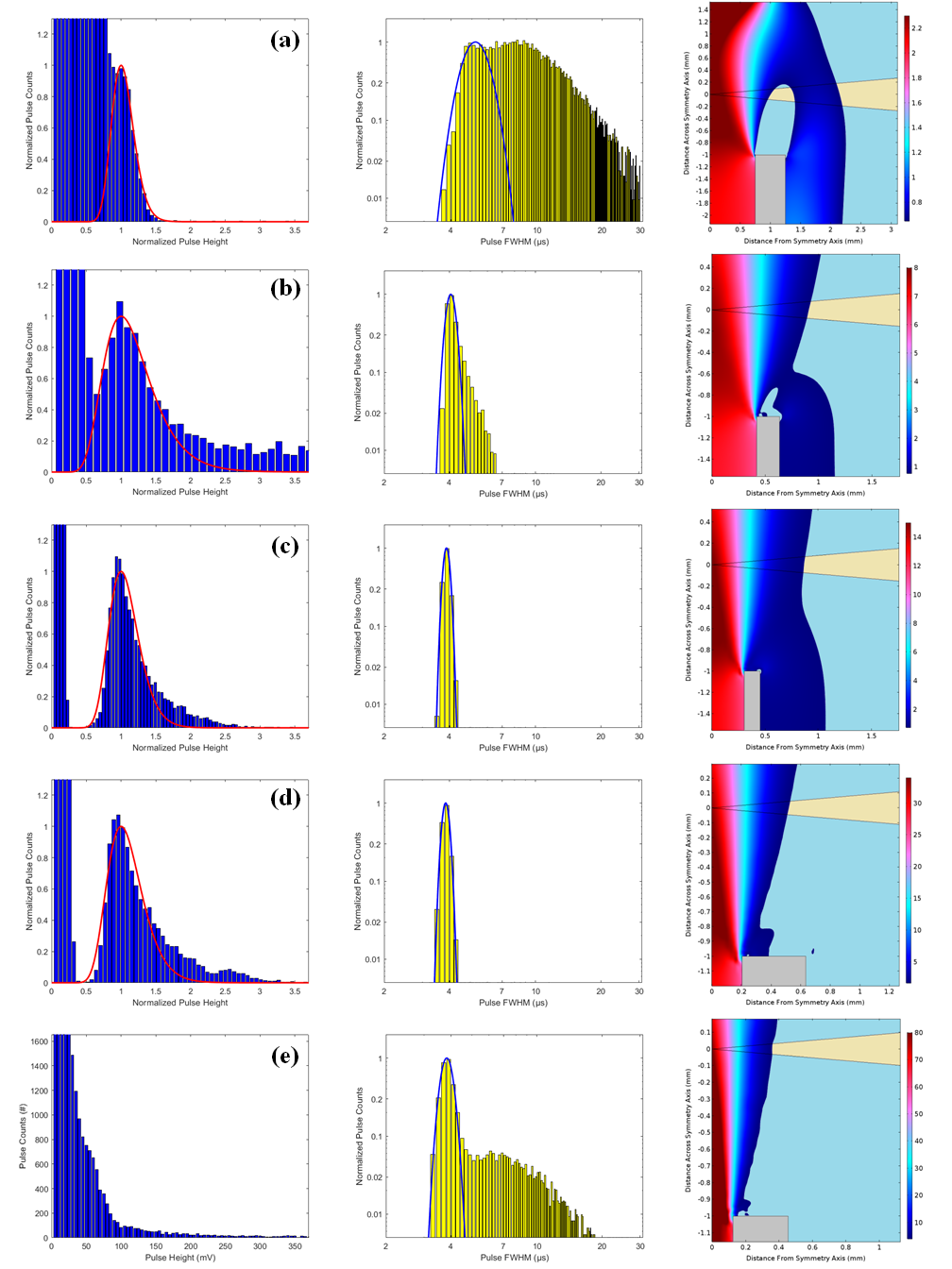
Figure S8: Measurements and simulations for different aerosol inlet tube diameters (D_{aer}).

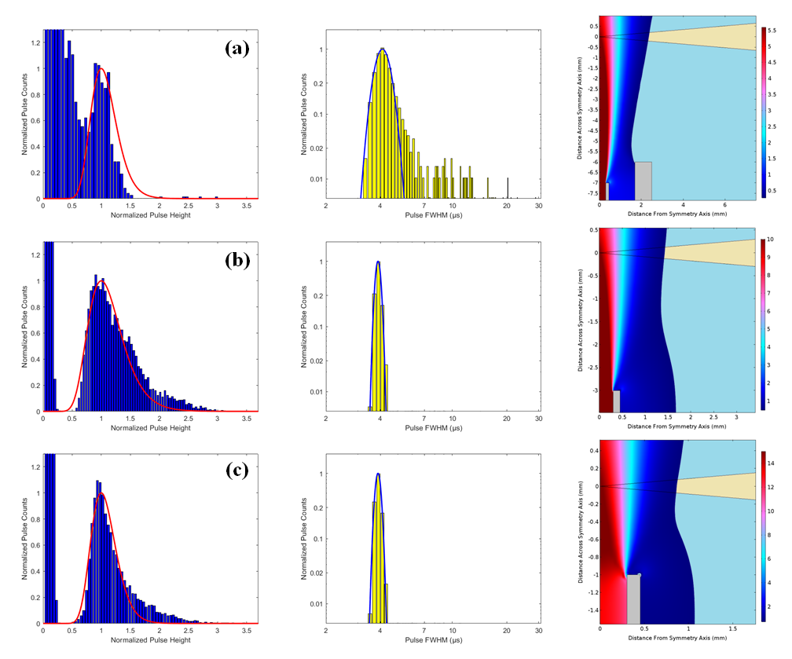
Figure S9: Measurements and simulations for different aerosol inlet tube distance from laser beam (X_{in}).

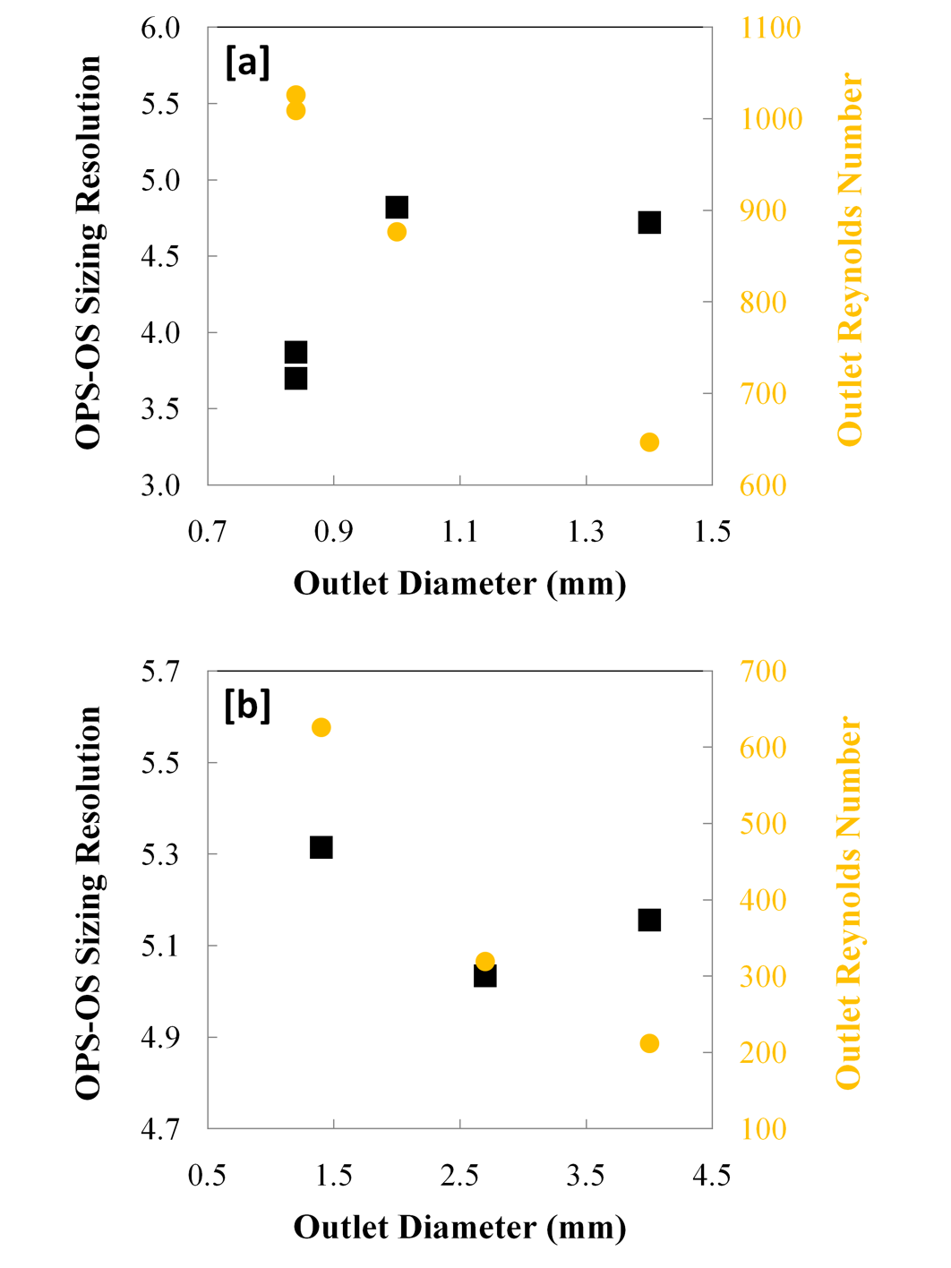
Figure S10: Measured OPS-OS sizing resolution (black squares) and simulated outlet Re number (yellow circles) for different outlet tube diameters for distances between the laser beam and the outlet tuber of (a) 2, and (b) 7 mm.

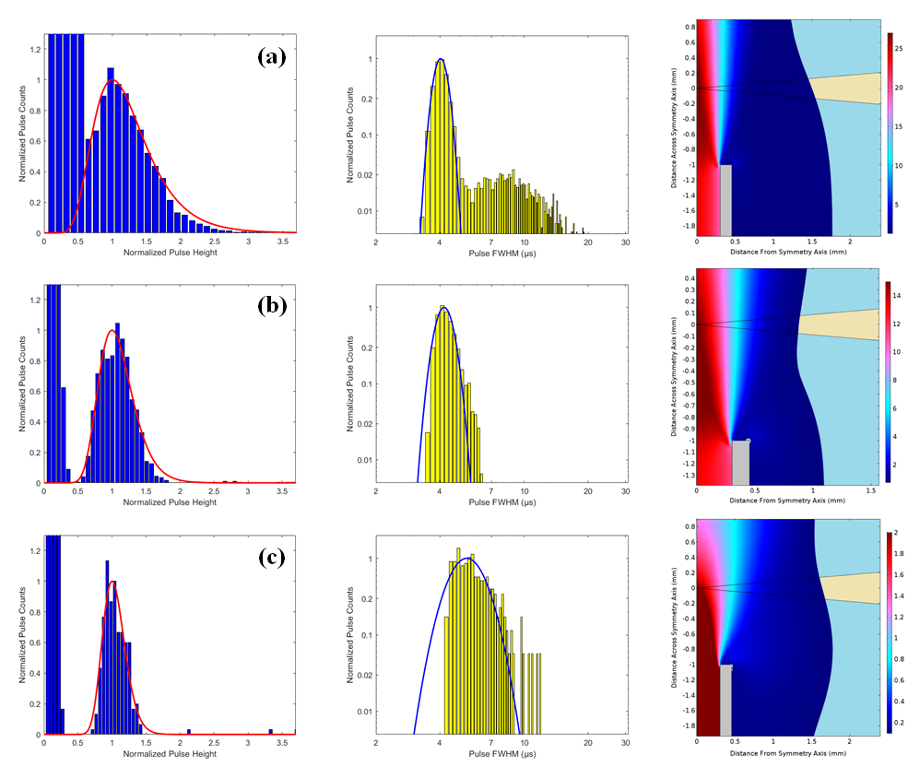
Figure S11: Measurements and simulations for different total sample flow-rates (Q).

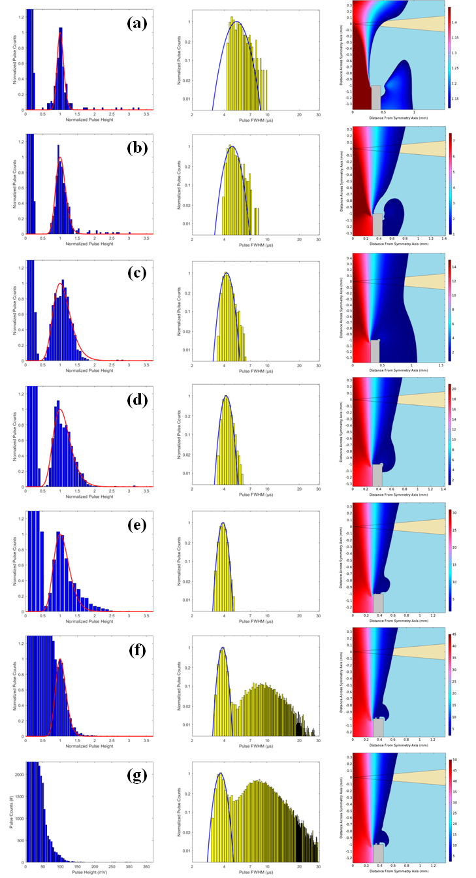
Figure S12: Measurements and simulations for different dilution factors (L).

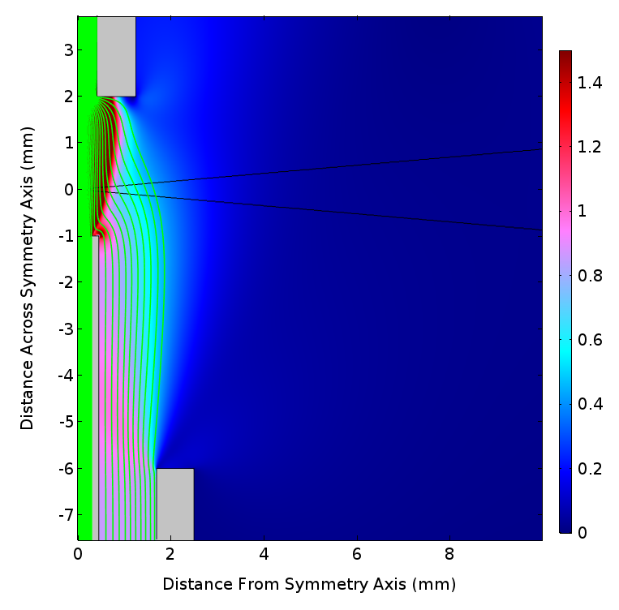
Figure S13: Example simulation showing the occurrence of turbulence (indicated by the green streamlines) within the OPS-OS. The flow conditions are those corresponding to the results presenting in Figure S12c (cf. Table S1).

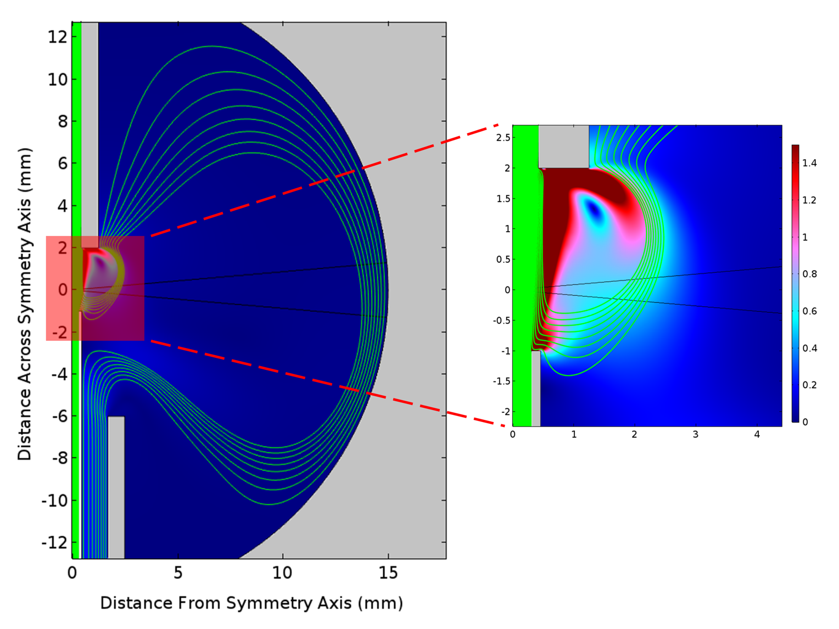
Figure S14: Example simulation showing the occurrence of turbulence (indicated by the green streamlines) within the OPS-OS. The flow conditions are those corresponding to the results presenting in Figure S12f (cf. Table S1).

Figure S15: OPS-OS sizing resolution as a function of Re number in the aerosol inlet tube.

S7. Additional results of the OPS-OS performance evaluation

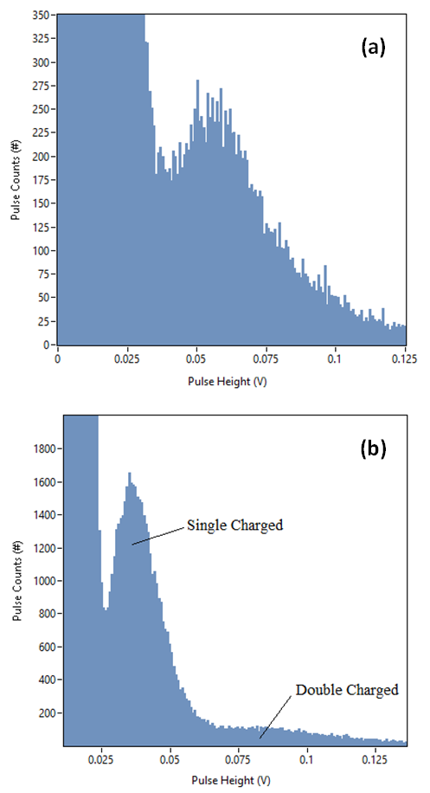
Figure S17: Custom made OPS-OS pulse height histograms recorded when sampling (a) 250-nm, and (b) 300-nm ammonium sulfate particles.

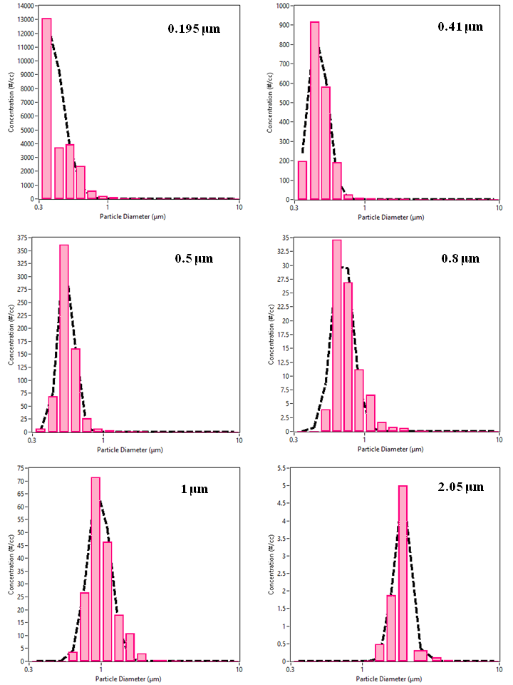

Figure S18: Size distributions determined by the custom-made OPS-OS when sampling PSL spheres of different sizes. Dashed black lines are log-normal fittings.
Annex
Table S2: Summary of ISO 21501-4 requirements.
 | ISO 21501-4 Parameter | Target Limit
1 | Particle sizing deviation | ± 10 %
2 | Counting efficiency at 1st channel – particle size | 50 ± 20 %
3 | Counting efficiency at 1.5-2 times the 1st channel – particle size | 100 ± 10 %
4 | Particle sizing resolution (at manufacturer specified size) | ≤ 15 %
5 | Zero count test (particle free sample) | ≤ 1# / 5 min
6 | Counting efficiency at max particle concentration | ≥ 10 %
7 | Sampling flow rate deviation (volumetric) | ± 5 %
8 | Sampling time deviation | ± 1 %
9 | Calibration frequency | ≤ 1 year

Table S3: Nomeclature.
Symbol | Unit | Description
V_{sig} | V | OPS-OS raw signal
A | V | Scattered light intensity factor
Q_{sca} | - | Particle scattering coefficient
C | #/cm³ | Particle number concentration
N | # | Pulse-particle counts
Q | L/min | Total sample flow-rate
t | s | Sampling time
Q_{a} | L/min | Aerosol flow-rate
Q_{s} | L/min | Sheath flow-rate
d | - | Dilution factor
V_{trig} | V | Voltage corresponding to signal noise level
y | V | Pulse height
h(y) | - | Pulse height probability density function fitting
α | - | h(y) amplitude
μ | V | h(y) mean value
σ | V | h(y) standard deviation
FWHM_{PDF} | - | Full width at half maximum of h(y) function
R | - | OPS-OS sizing resolution
yʺ | V/s² | Pulse 2nd derivative
FWHM_{p} | s | Pulse full width at half maximum
Re | - | Reynolds number

References
1. Hahn, D. Light Scattering Theory. (2004).
2. Rosenberg, P. et al. Particle sizing calibration with refractive index correction for light scattering optical particle counters and impacts upon PCASP and CDP data collected during the Fennec campaign. Atmos Meas Tech 5, 1147–1163 (2012).
3. Matzler, C. MATLAB functions for Mie scattering and absorption. IAP Res Rep 8, (2002).
4. Zhang, R. & Zhao, H. Small-Angle Particle Counting Coupled Photometry for Real-Time Detection of Respirable Particle Size Segmentation Mass Concentration. Sensors 21, 5977 (2021).
5. Heim, M., Mullins, B. J., Umhauer, H. & Kasper, G. Performance evaluation of three optical particle counters with an efficient “multimodal” calibration method. J. Aerosol Sci. 39, 1019–1031 (2008).
6. Gao, R. S. et al. A light-weight, high-sensitivity particle spectrometer for PM2.5 aerosol measurements. Aerosol Sci. Technol. 50, 88–99 (2016).
7. Zarzana, K. J., Cappa, C. D. & Tolbert, M. A. Sensitivity of Aerosol Refractive Index Retrievals Using Optical Spectroscopy. Aerosol Sci. Technol. 48, 1133–1144 (2014).
8. Lee, H., Jeong, Y.-S., Choi, K. & Shin, W. G. The effect of sheath flow rate on the particle trajectory inside an optical cavity with direct flow configuration. J. Aerosol Sci. 114, 146–156 (2017).
9. Laser Polarization: The Importance of Polarization in Laser Applications. https://www.edmundoptics.eu/knowledge-center/application-notes/lasers/the-importance-of-polarization-in-laser-applications/.
10. UDT_PhotodiodeCharacteristics.pdf.
11. Cai, Y., Montague, D. C., Mooiweer-Bryan, W. & Deshler, T. Performance characteristics of the ultra high sensitivity aerosol spectrometer for particles between 55 and 800nm: Laboratory and field studies. J. Aerosol Sci. 39, 759–769 (2008).
12. TSI_3340_Manual.pdf.
13. Haugan, E. T. & Dalsjø, P. Characterization of the Material Properties of Two FR4 Printed Circuit Board Laminates. 2013/01956 (2014).
14. Alfonsi, G. Reynolds-Averaged Navier–Stokes Equations for Turbulence Modeling. Appl. Mech. Rev. 62, (2009).
15. Ignat, L., Pelletier, D. & Ilinca, F. A universal formulation of two-equation models for adaptive computation of turbulent flows. Comput. Methods Appl. Mech. Eng. 189, 1119–1139 (2000).
16. The Turbulent Flow, k-ω Interface. https://doc.comsol.com/5.5/doc/com.comsol.help.cfd/cfd_ug_fluidflow_single.06.013.html.

