Supplemental File
Supplemental tables
Supplemental table 1
Target | Supplier | Reference
Myc | IDT PrimerTime®Std qPCR Assay | Hs.PT.58:39142481
CD19 | IDT PrimerTime®Std qPCR Assay | Hs.PT.56a.3773863
GAPDH | IDT PrimerTime®Std qPCR Assay | Hs.PT.39a.22214836
Bcl-2 | ThermoFisher | Hs 00608023m1
Supplemental table 1: Primers and probes references.

Supplemental table 2
Target | Supplier | Fluorochrome | Reference
CD19 | BioLegend® | PerCP/Cyanine5,5 | 302230
CD3 | Miltenyi Biotec | APC | 130-113-697
CD5 | BD BioSciences OptiBuildTM | BV421 | 742548
CXCR4 (CD184) | BioLegend | PE | 306506
Supplementary table 2: Antibody references for antibodies used in flow cytometry analyses.

Supplementary Table 3
Target | Supplier | Origin | Reference | Concentration
BTK | Cell Signaling | Rabbit | #8547S | 1:1000
Phospho-Y223-BTK | Cell Signaling | Rabbit | #87457S | 1:1000
ERK | Cell Signaling | Rabbit | #9102 | 1:1000
Phospho-T202/Y204ERK | Cell Signaling | Mouse | #9101S | 1:1000
IRAK1 | Cell Signaling | Rabbit | #4504 | 1:1000
c-MYC | Santa Cruz Biotechnology | Mouse | 9E10 sc-40 #EO813 | 1:200
IgM | Dako | Rabbit | A0426 | 1:5000
β-Actine | Sigma-Aldrich | Rabbit | A2066 | 2,5:5000
Goat anti-Rabbit | BIO-RAD | Goat | 1706515 | 1:5000
Goat anti-Mouse | BIO-RAD | Goat | 1706513 | 1:5000
F(ab’)₂ Fragment Anti-Human IgA+IgG+IgM (H+L) | Jackson Immuno Research | Goat | 109-006-064 | 10µg/ml
Supplementary table 3: Antibody references for antibodies used in western blot analyses.

Supplemental figures
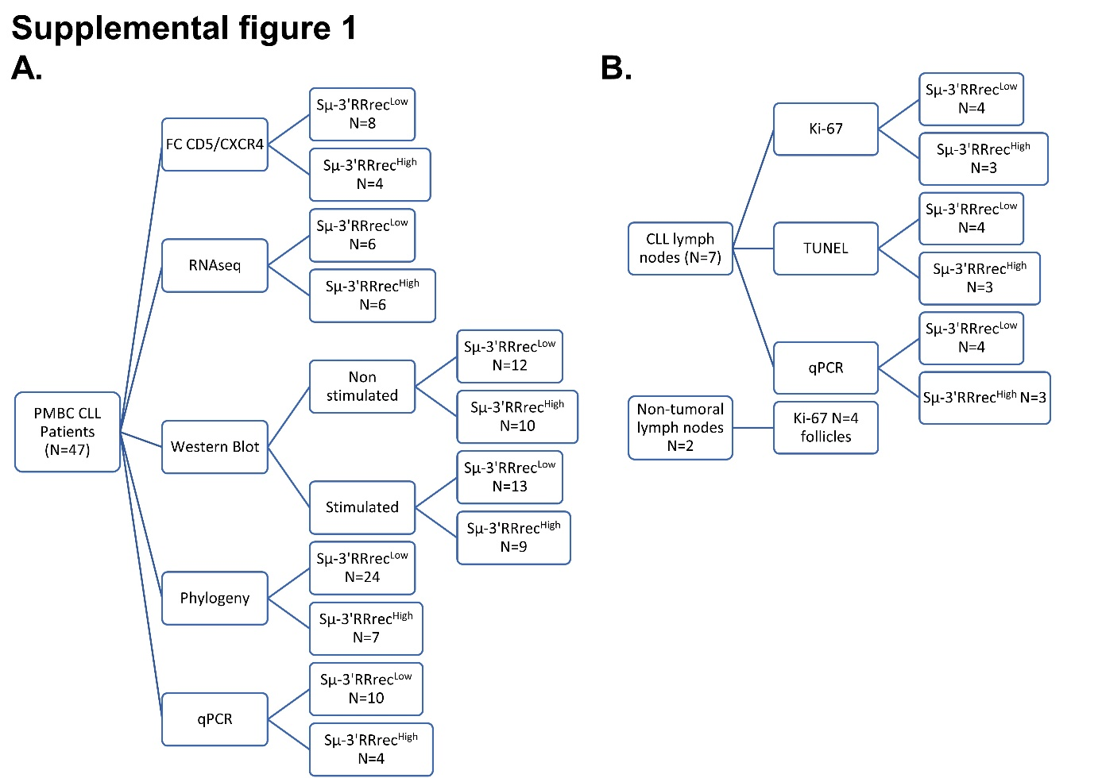
Supplemental figure 1: Patient samples and analyzes performed in this study. A. Biological material (cells, RNA, protein extracts and DNA) was obtained from cryopreserved patient PBMCs which were previously studied by Al Jamal et al.¹. B. Chronic lymphocytic leukemia and non-tumoral lymph node biopsies were cut into 8µm thick slices in Optimal Cutting Temperature (OCT) conservation and using a cryostat. Classification within Sµ-3’RRrec^{High}/^{Low} status was done according to with the ratio of MYC and Bcl2 transcripts (see Result section and figure 5).

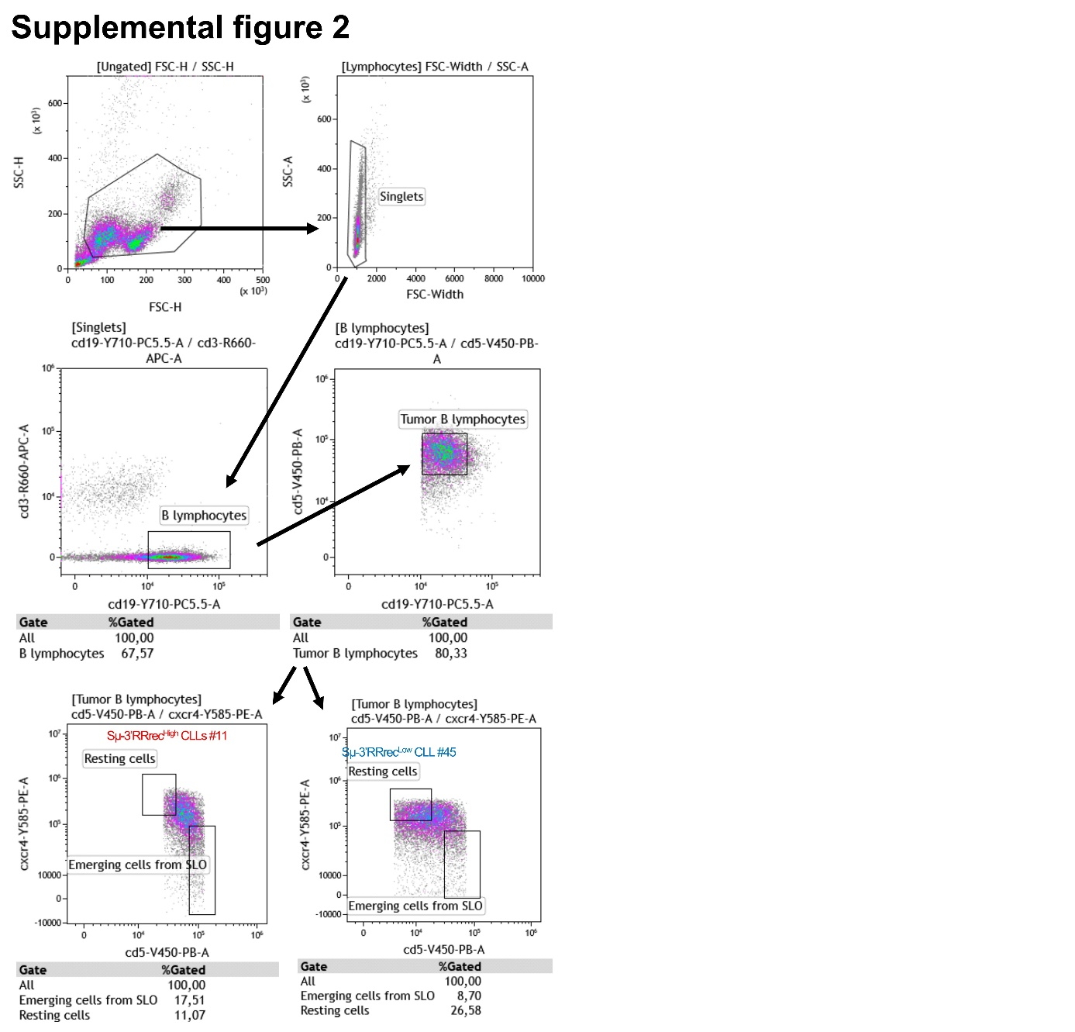
Supplemental figure 2: Back-gating strategy to determine CLL resting and SLO emergent cell populations. Analysis of Cxcr4^{Low}Cd5^{High} and Cxcr4^{High}Cd5^{Low} populations as secondary lymphoid organ emergent chronic lymphocytic leukemia (CLL) cells or resting CLL cells in the blood respectively was done by flow cytometry using the back-gating strategy on CD3- CD19+ CD5+ positive cells on peripheral blood mononuclear cells (PBMCs).

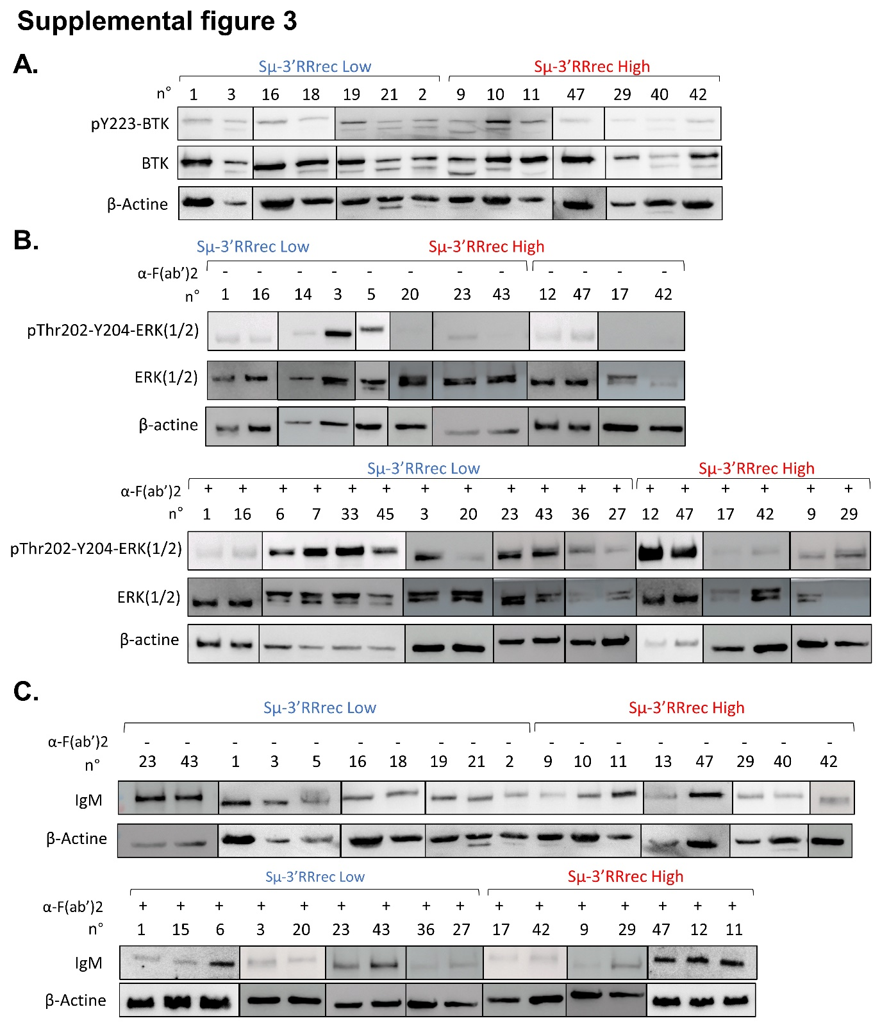
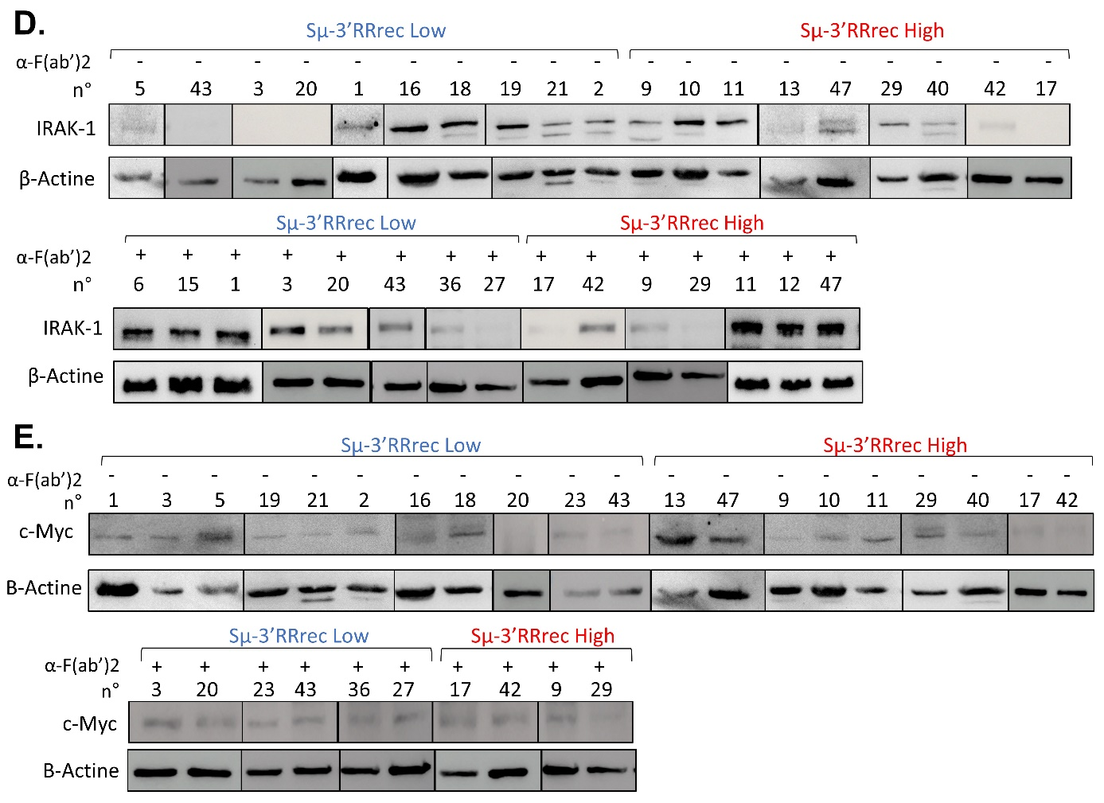
Supplemental figure 3: BCR and TLR signaling pathway component quantification in Sµ-3’RRrec^{Low} and Sµ-3’RRrec^{High} CLL patients. A. Western blot of phospho-Y²²³-BTK, total-BTK and β-actin in resting PBMCs. B. Western blot detection of phospho-Thr²⁰²-Y²⁰⁴-ERK (1/2), total-ERK (1/2) and β-actin without and after in vitro BCR stimulation. C. IgM and β-actin western blots without and after in vitro BCR stimulation. D. IRAK-1 and β-actin were detected without and after in vitro BCR stimulation. E. Protein detection of c-Myc and β-actin without and after in vitro BCR stimulation. A-B-C-D-E: All PBMCs stimulation were done for 15 minutes with anti-F(ab)’2 (IgA+IgG+IgM (H+L)).

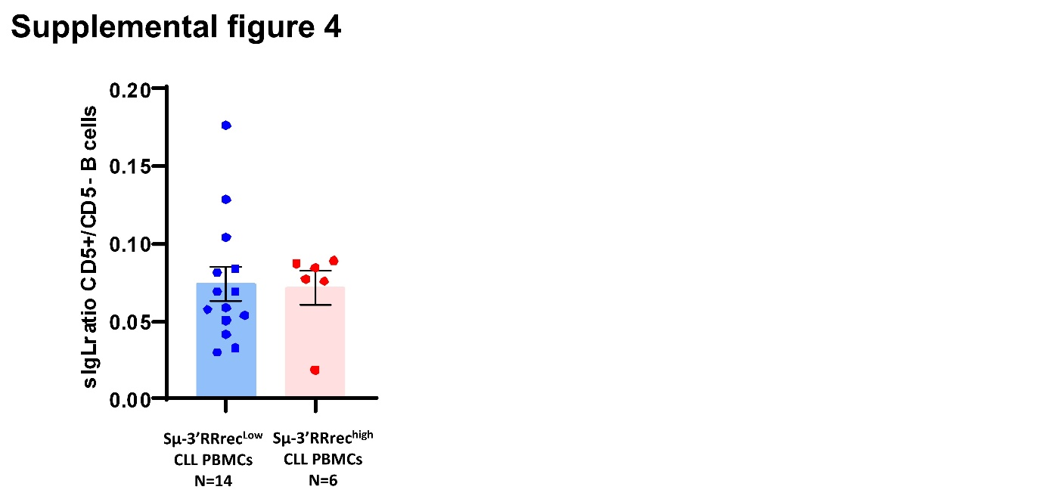
Supplemental figure 4: IgL expression at the CLL B-cell surface. Ratios of the mean fluorescence intensity (MFI) of surface IgL (sIgL), Igk or Igl, on tumoral CD5⁺CD19⁺cells on the sIgL MFI on normal CD5⁻CD19⁺ cells appear comparable between Sµ-3’RRrec^{Low} and Sµ-3’RRrec^{High} samples.
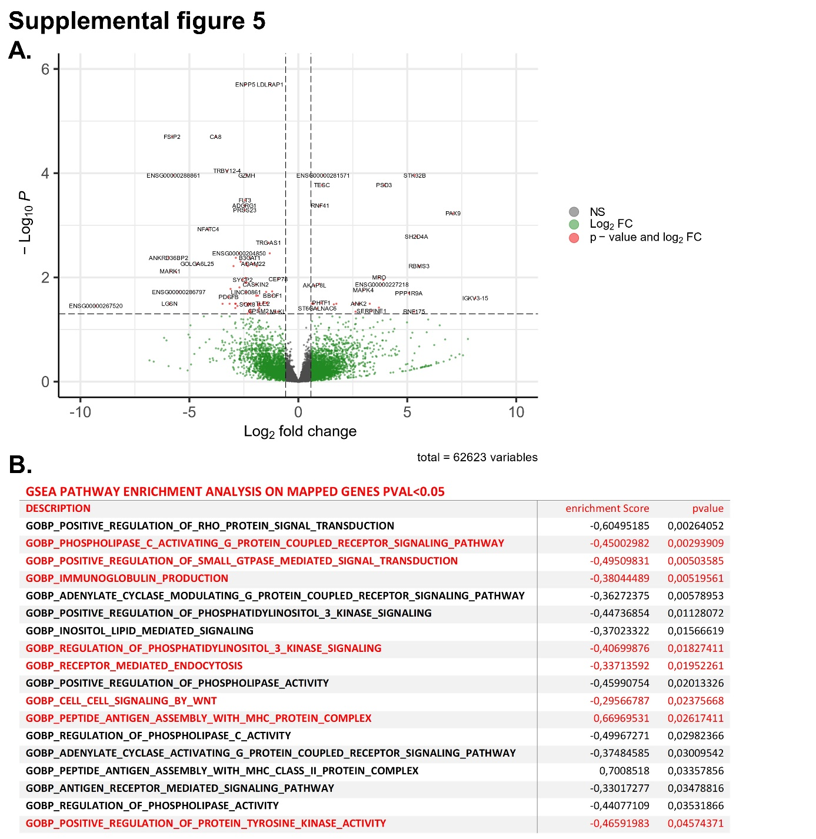Supplemental figure 5: differential total transcript analysis between Sµ-3’RRrec^{Low} and Sµ-3’RRrec^{High} samples. Analysis of total RNA from PBMC samples from Sµ-3’RRrec^{Low} CLLs (N=6) and Sµ-3’RRrec^{High} CLLs (N=6). Paired end reads were processed and aligned on GRCh38 human genome and gene-level raw counts were used with DESeq2. A. Volcano plot showing the differential expressed genes (red dots) in PBMCs from Sµ-3’RRrec^{Low} CLLs compared to Sµ-3’RRrec^{High} PBMCs (adjusted p value ≤0.05 and absolute log2foldchange ≥0.58). B. GO biological process from MSigDB v2023.1.Hs release were used to perform GSEA analysis which resulted in 28,920 genes mapped to pathways including pathways with a pVal ≤0.05. Selected biological pathways of interest in B cell signaling are presented in the table.

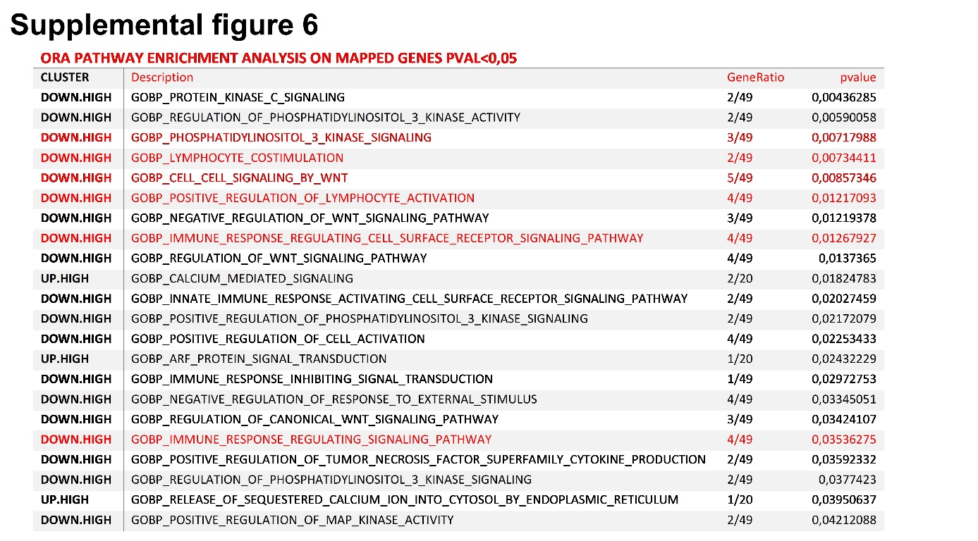Supplemental figure 6: Biological pathways implicated by differentially expressed genes in Sµ-3’RRrec^{Low} compared to Sµ-3’RRrec^{High} samples. Pathway enrichment analysis was applied to the differentially expressed genes and 89 genes were mapped to biological pathway (msigdb_c5_go_bp) with a pVal ≤0.05. Selected biological pathways of interest in B cell signaling are presented here.
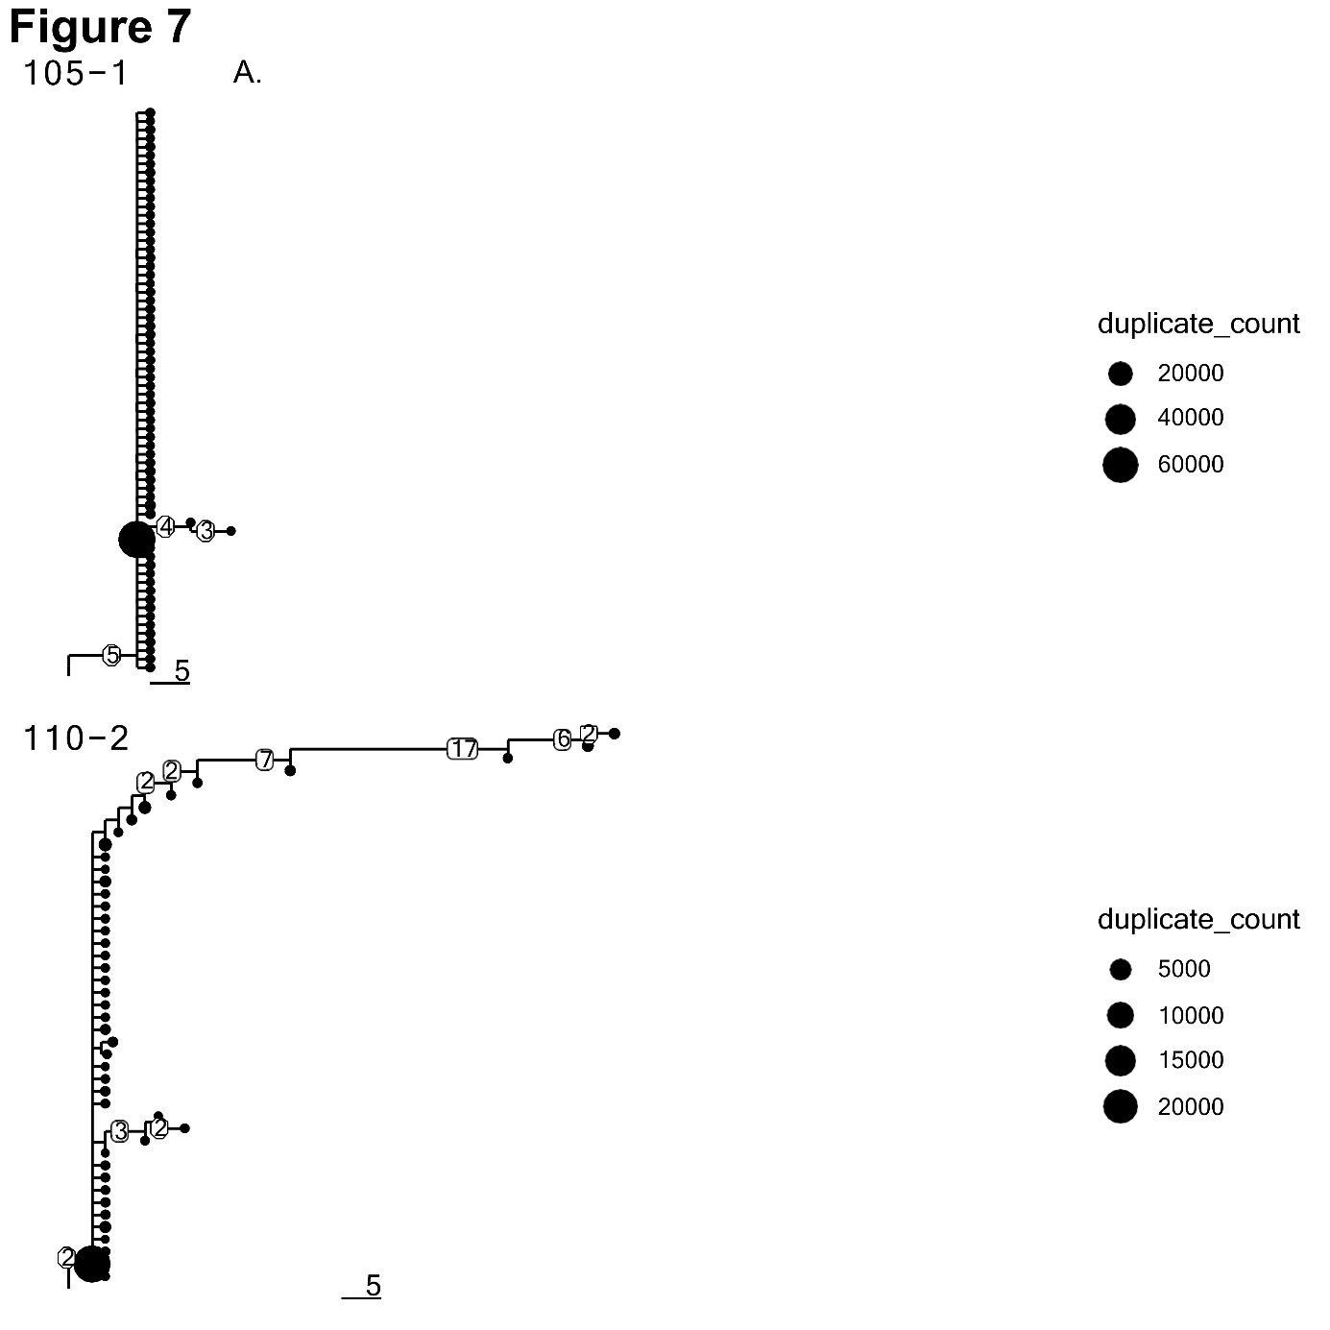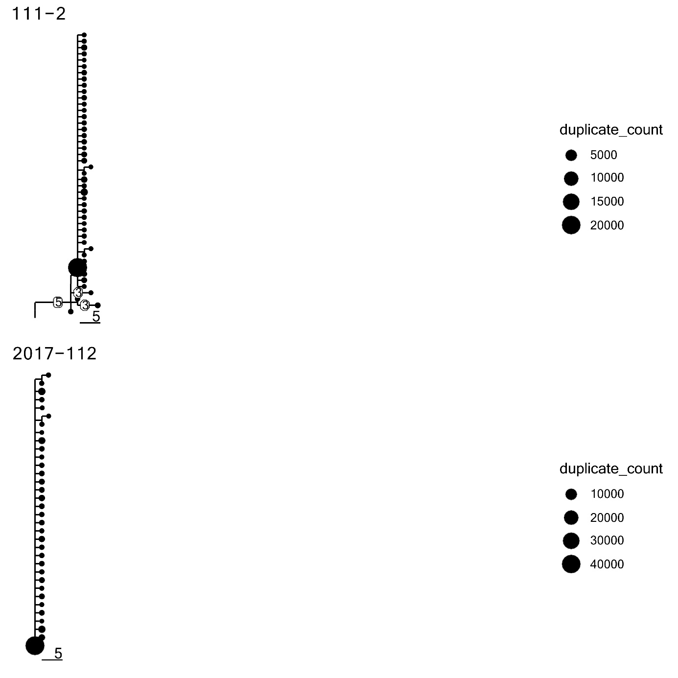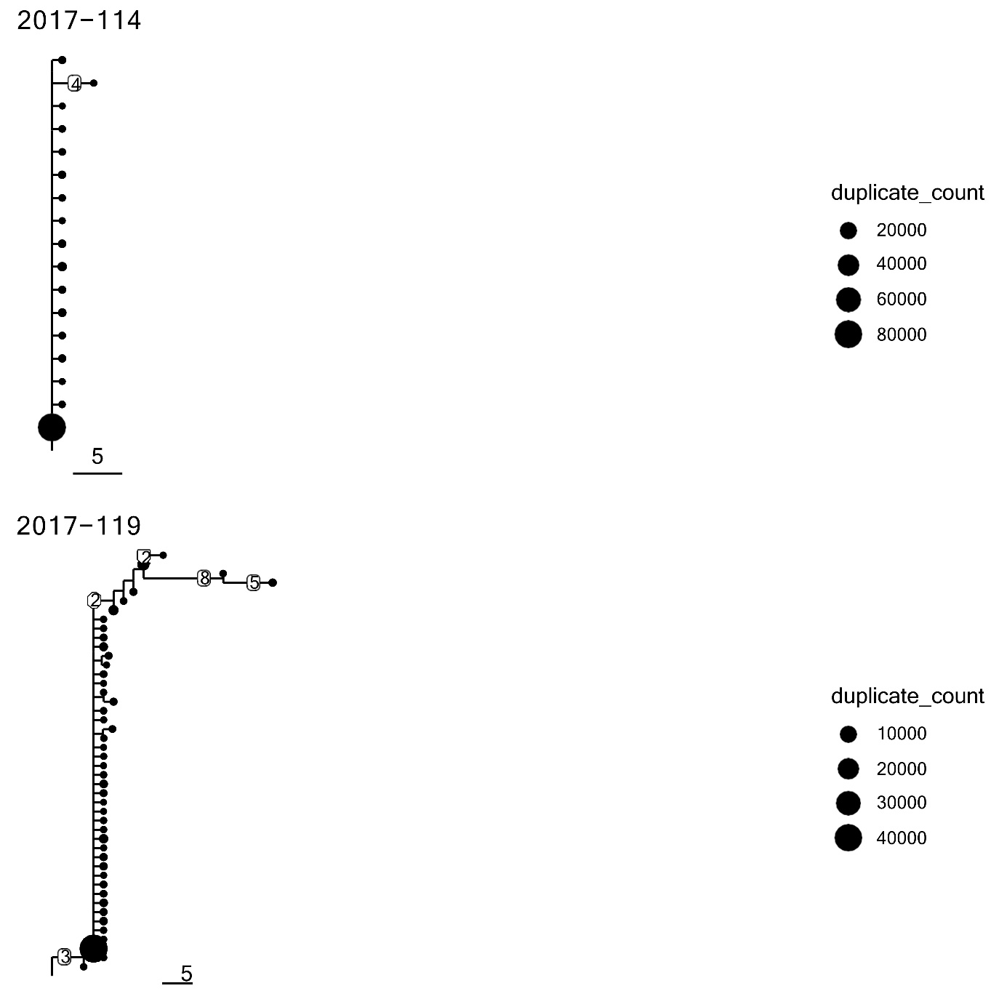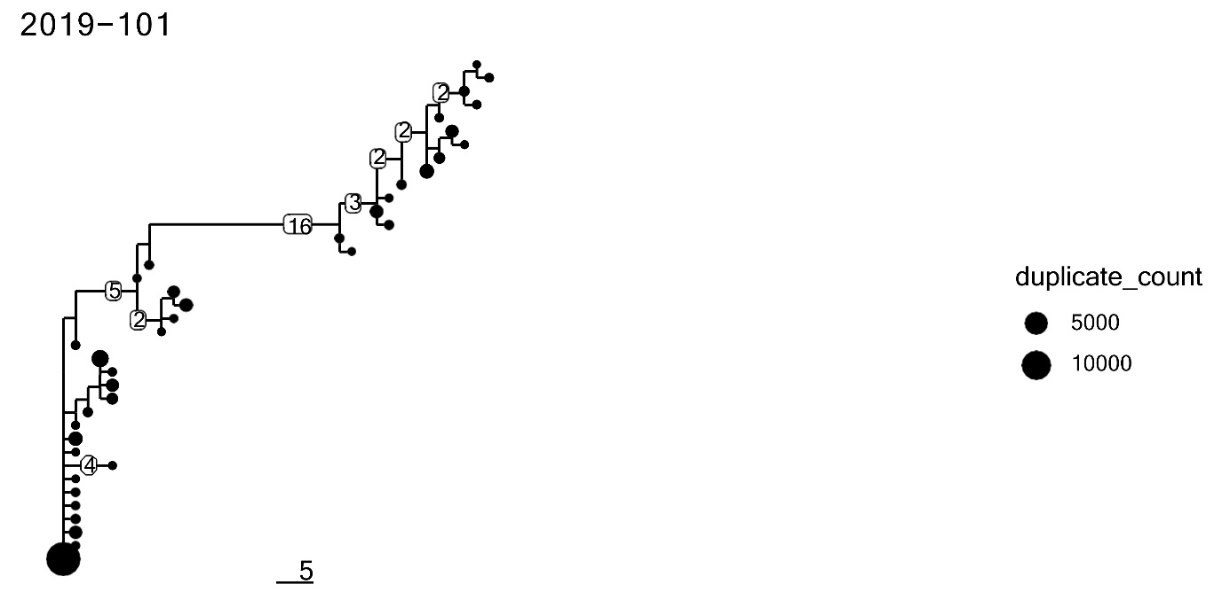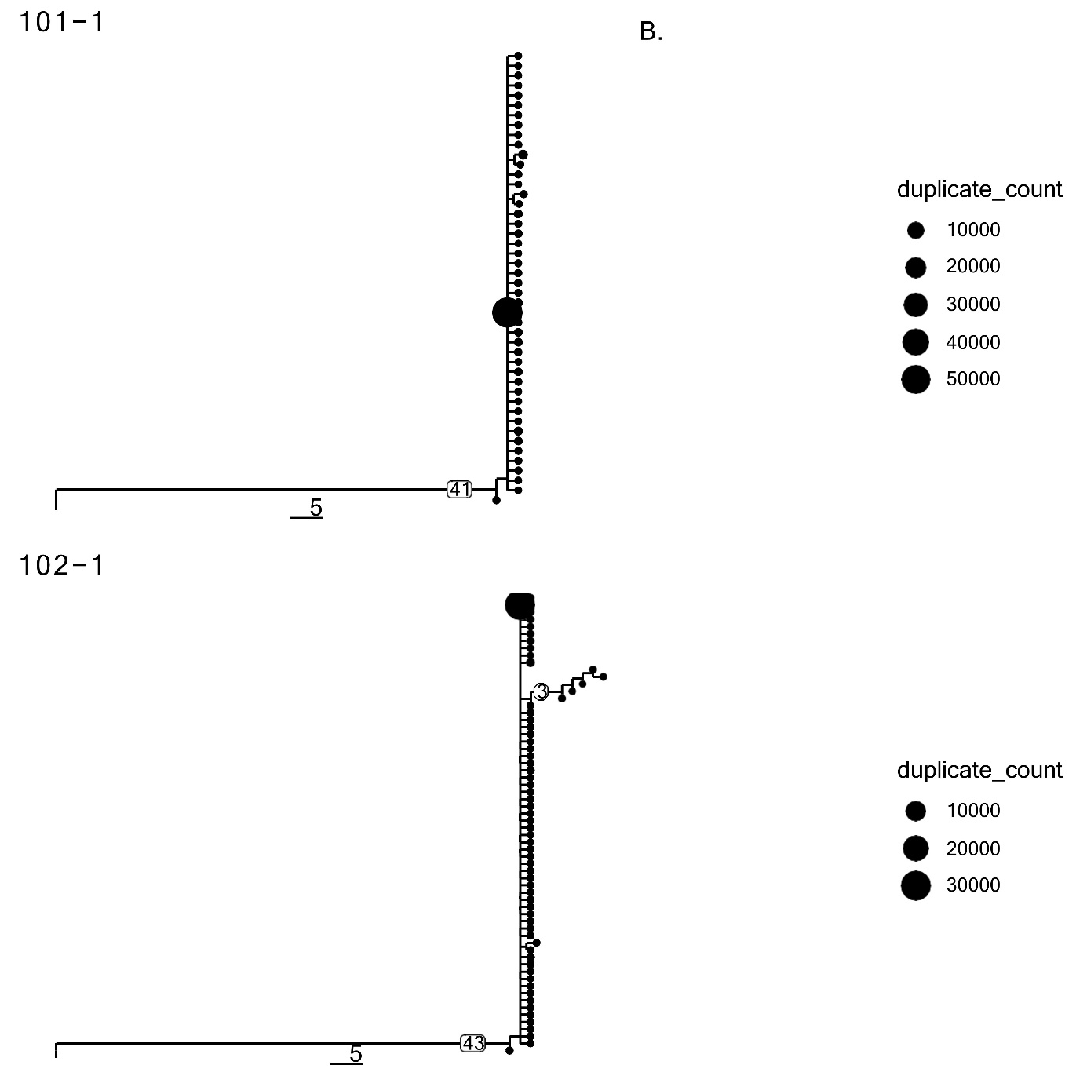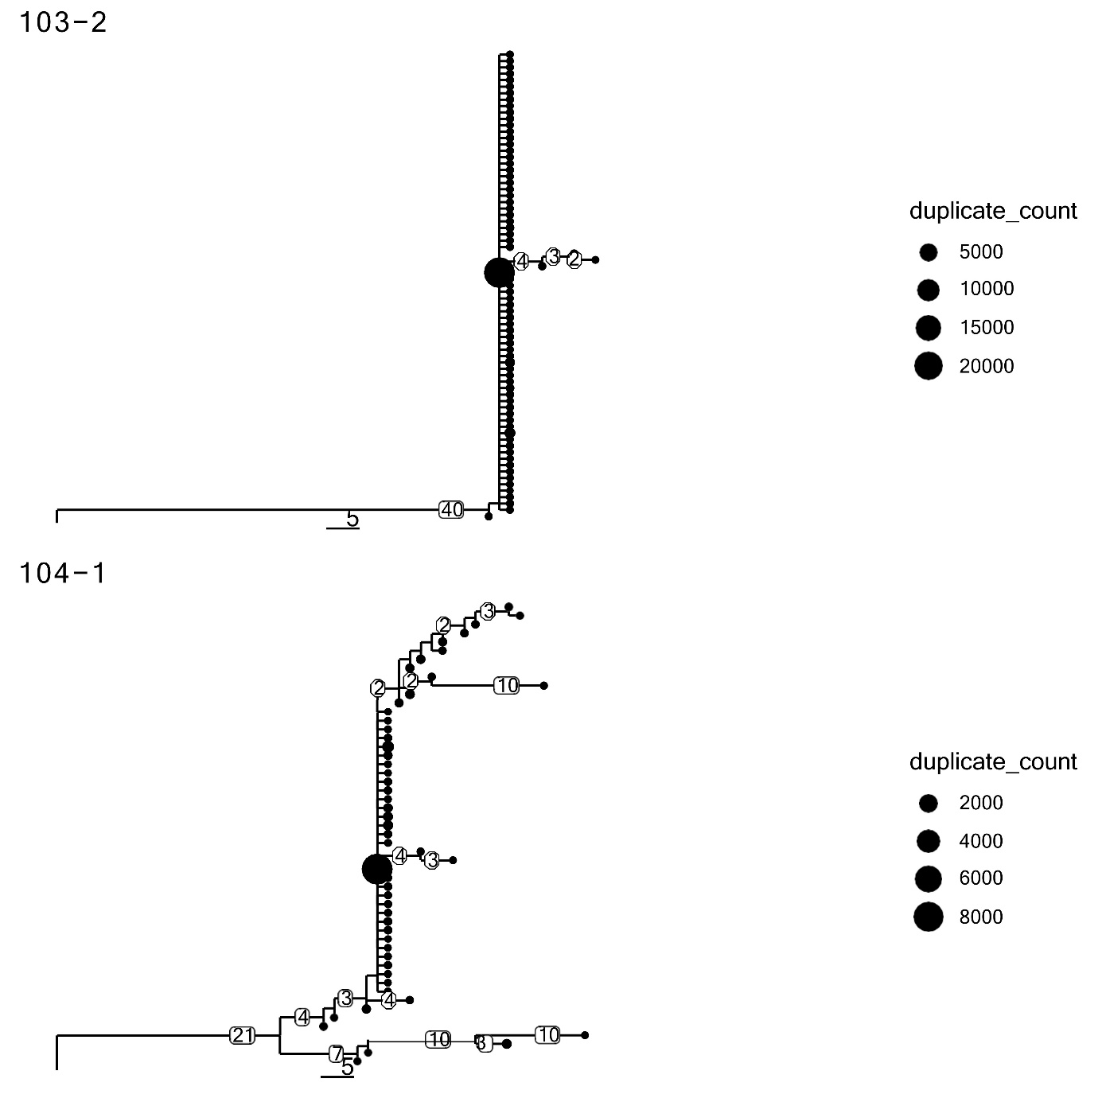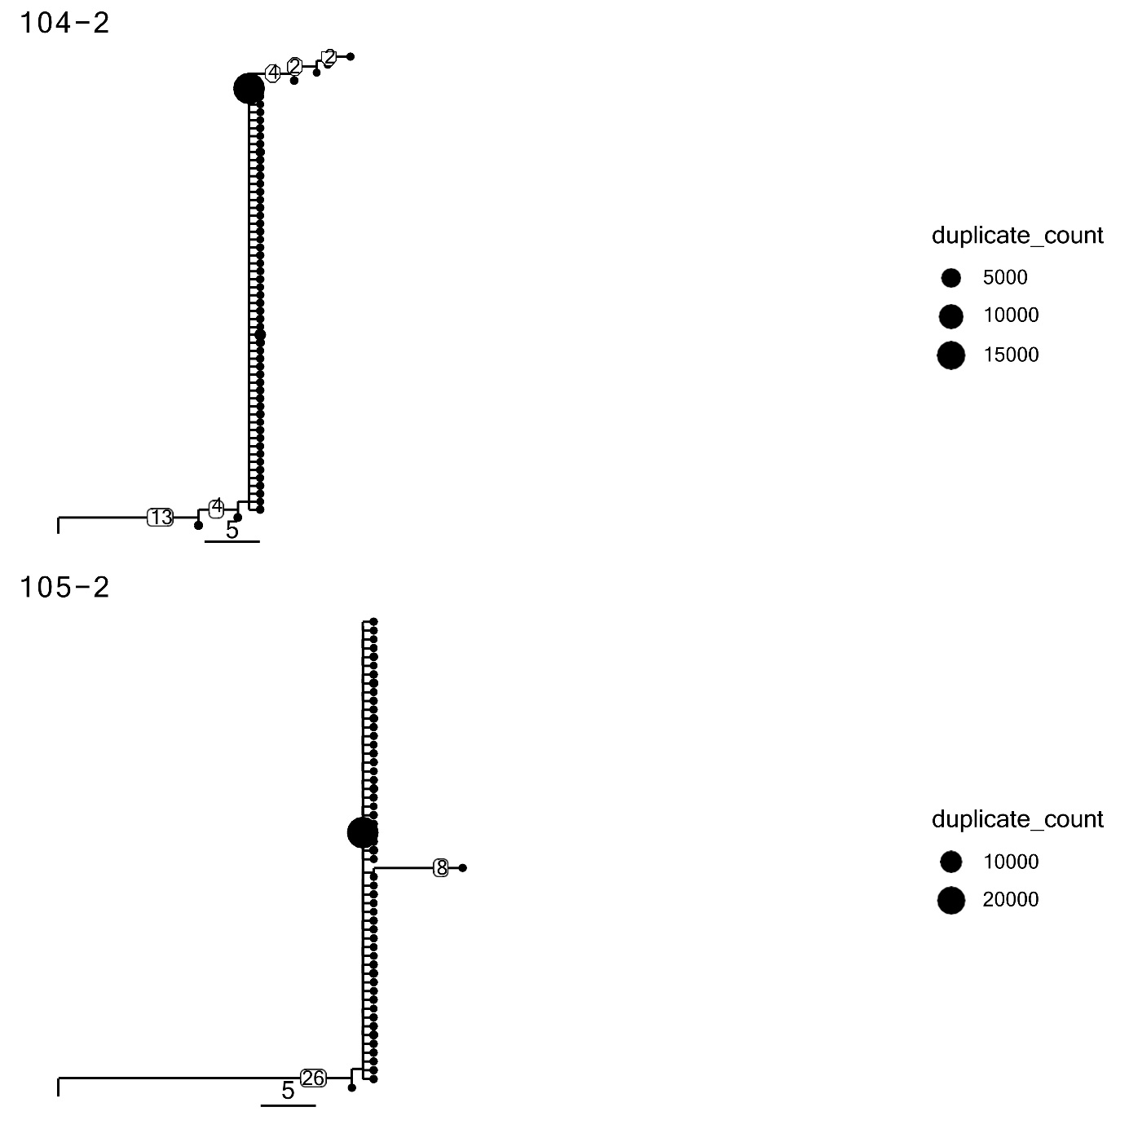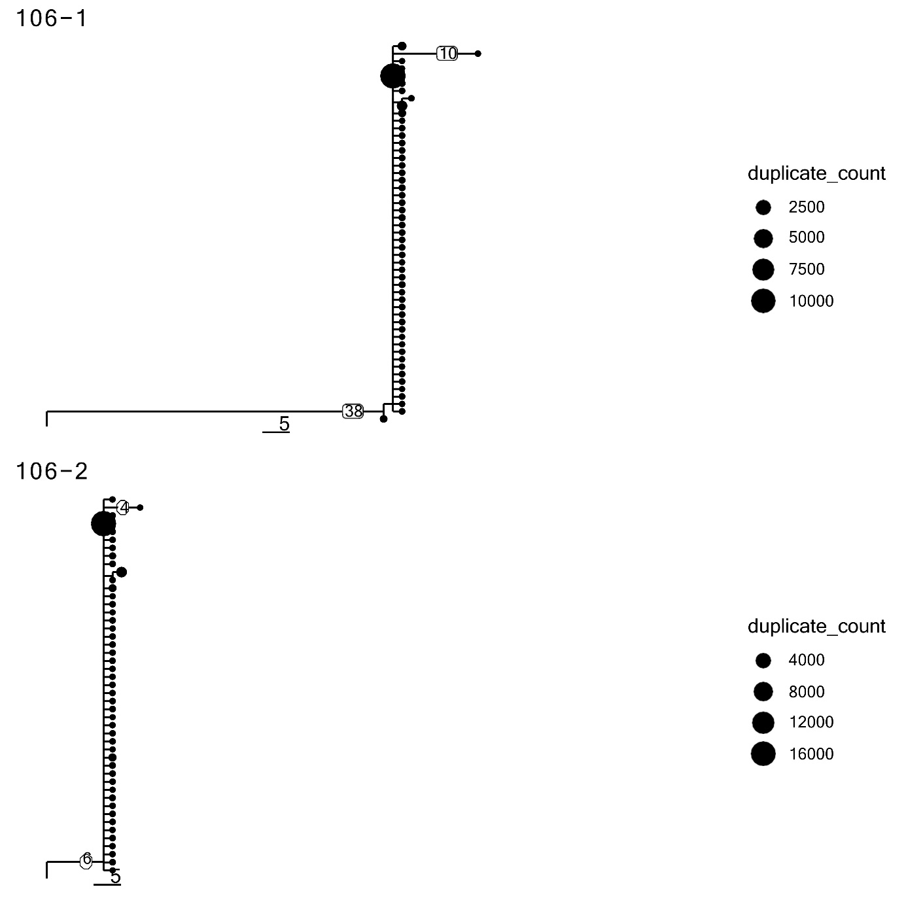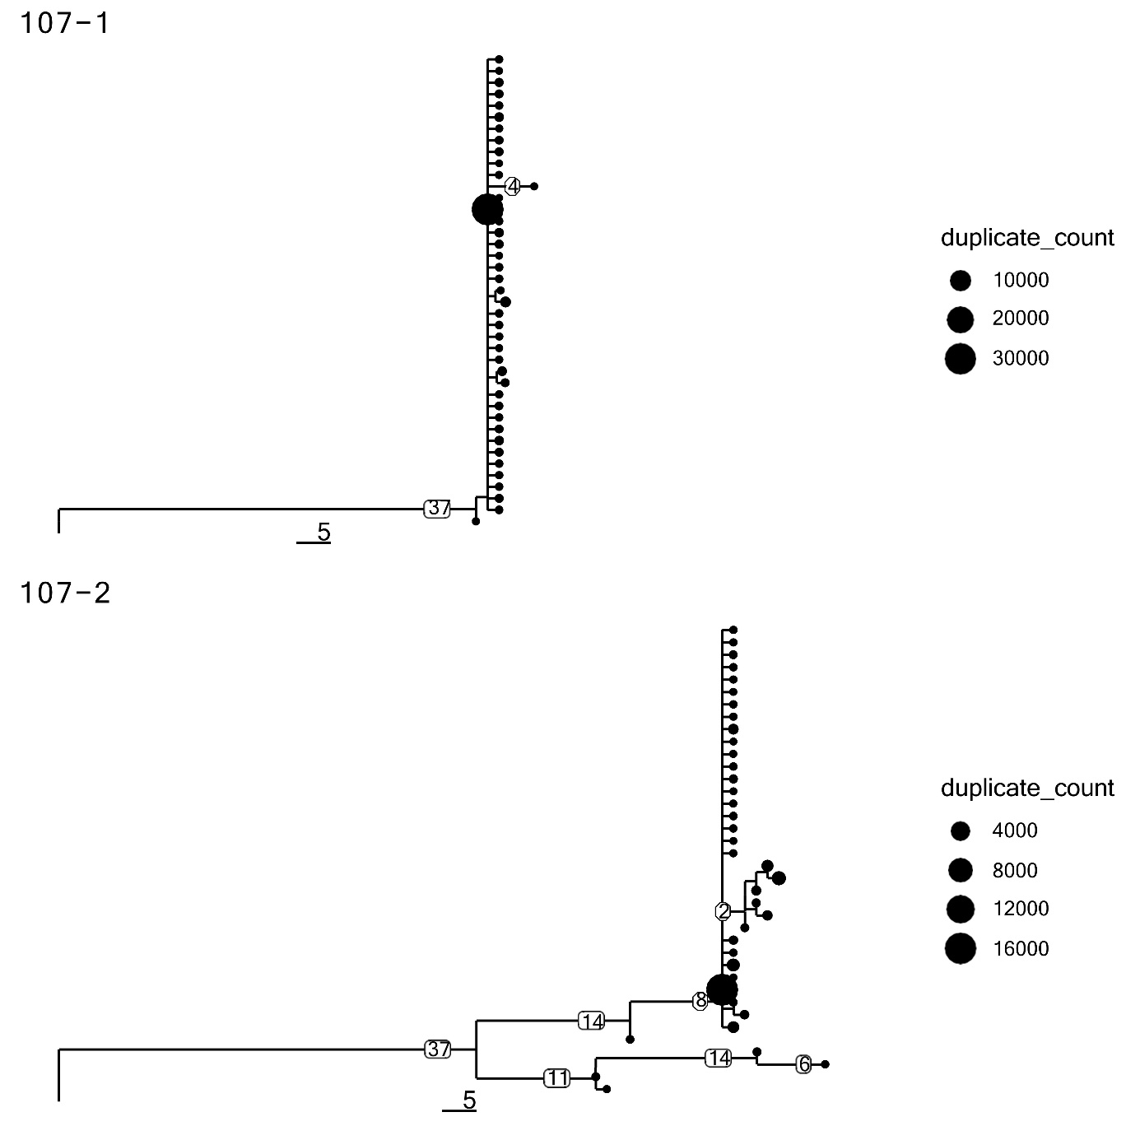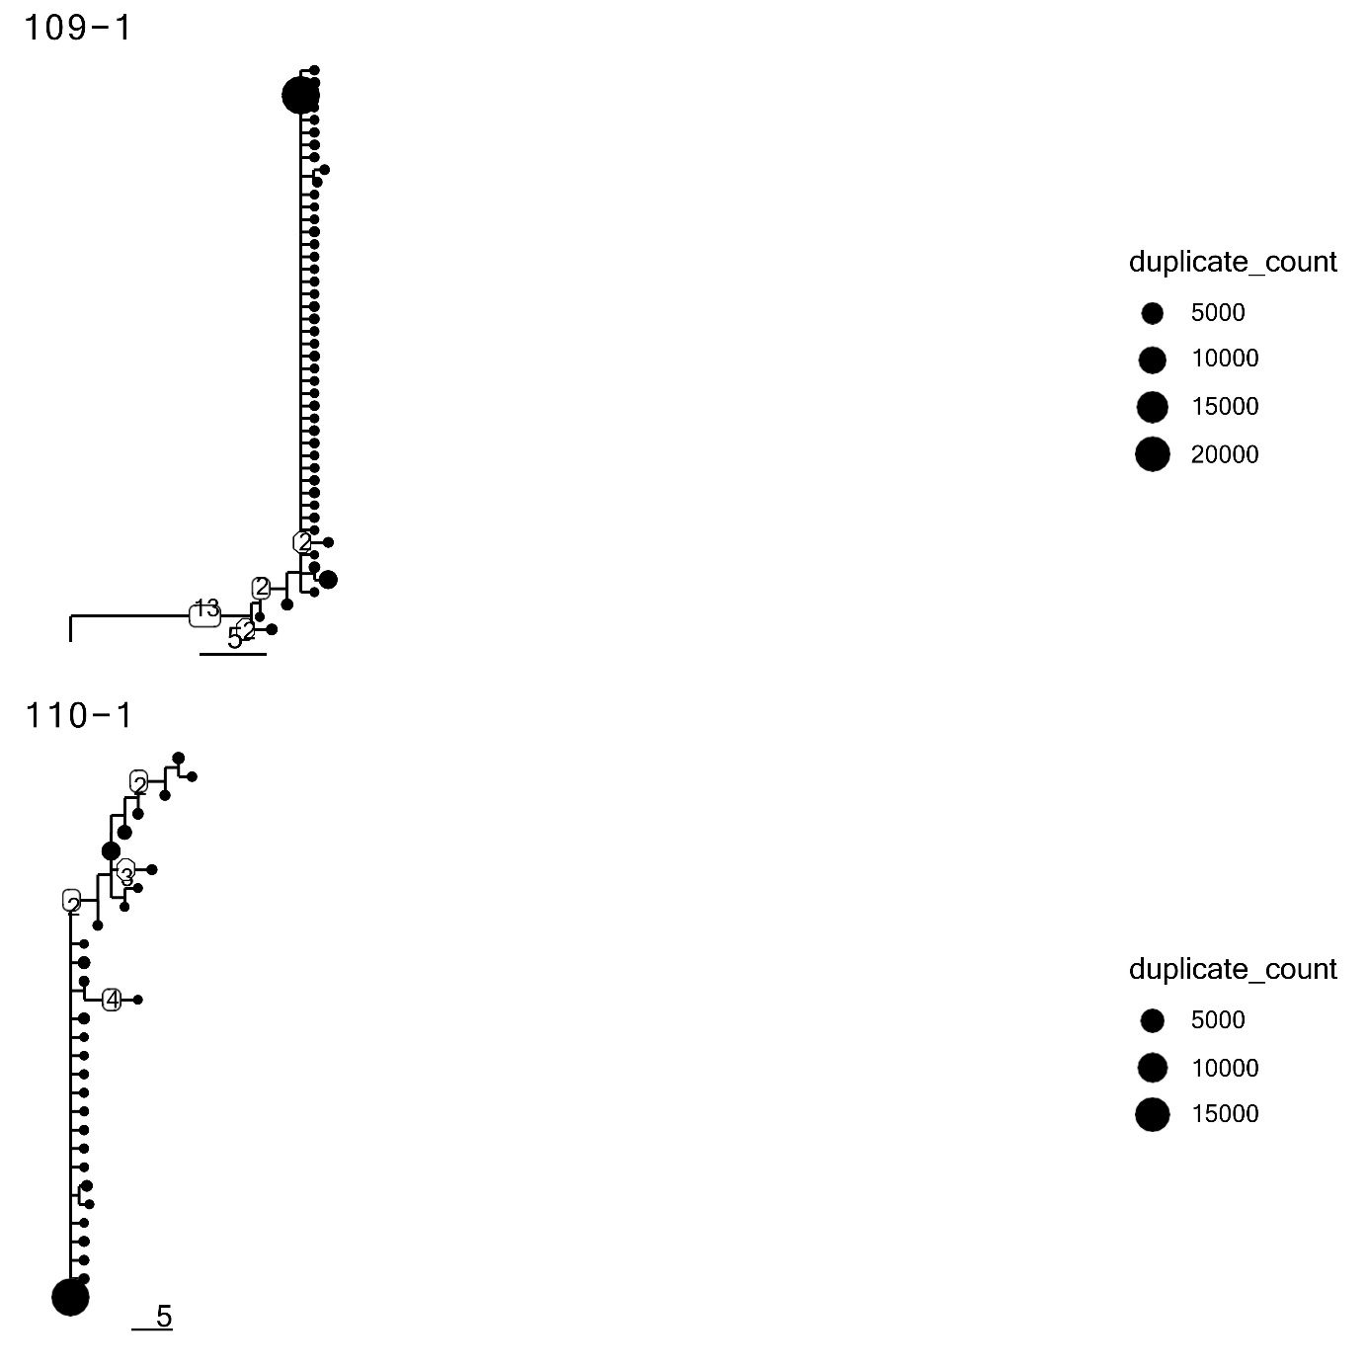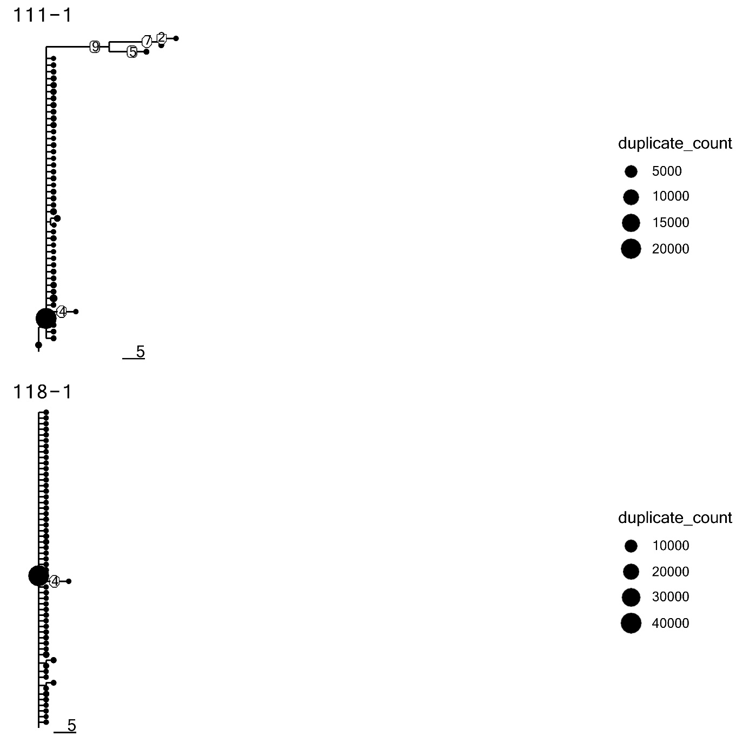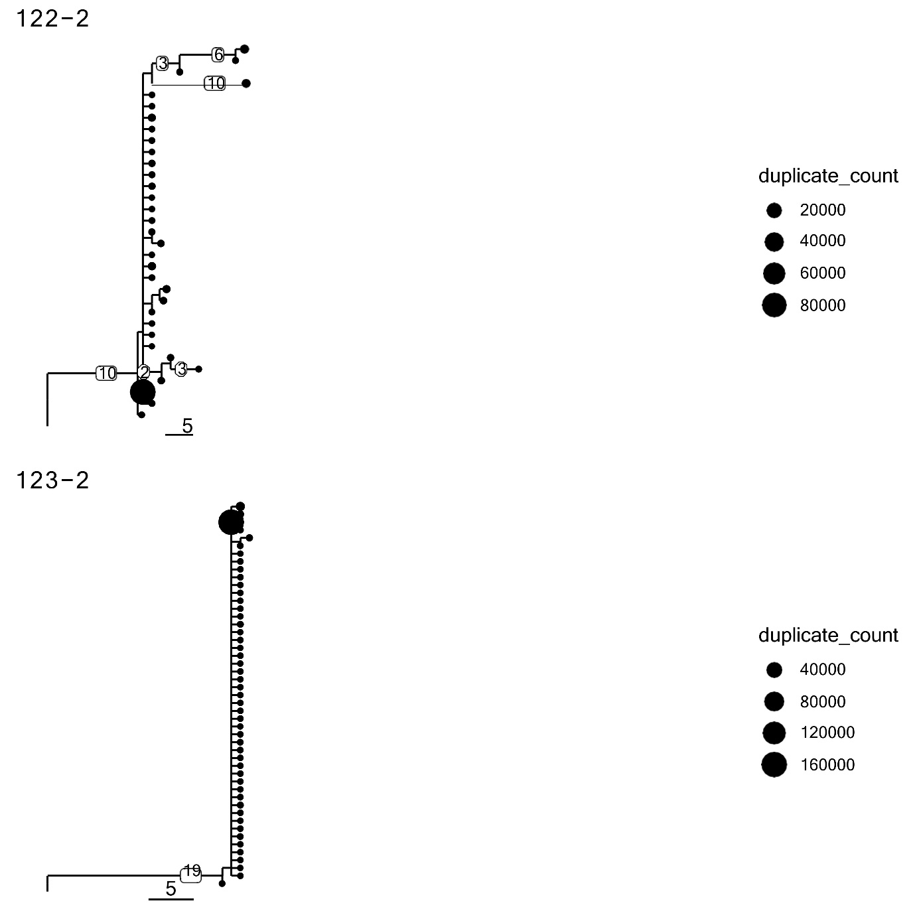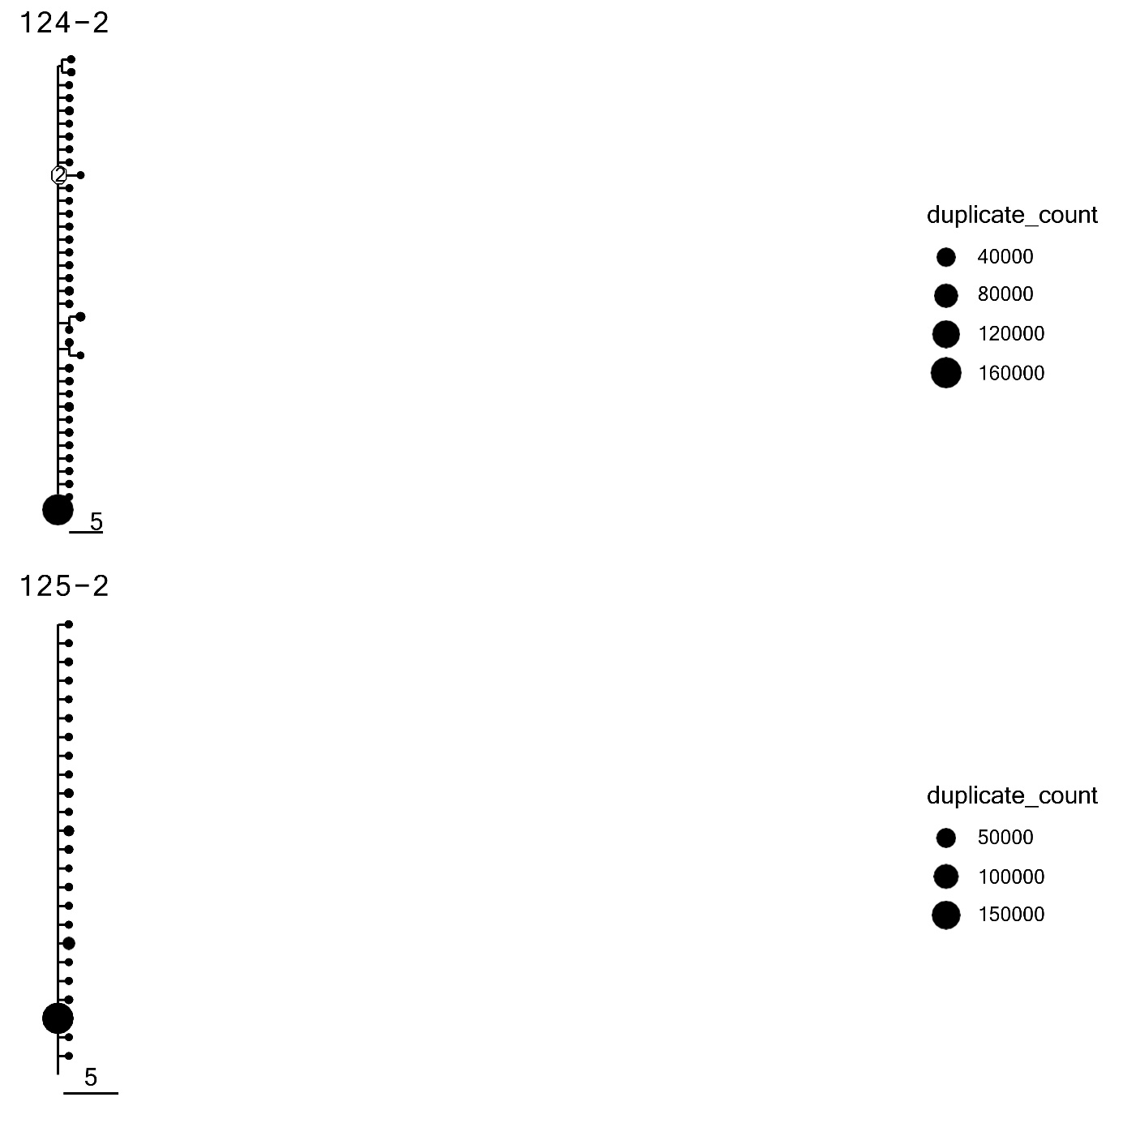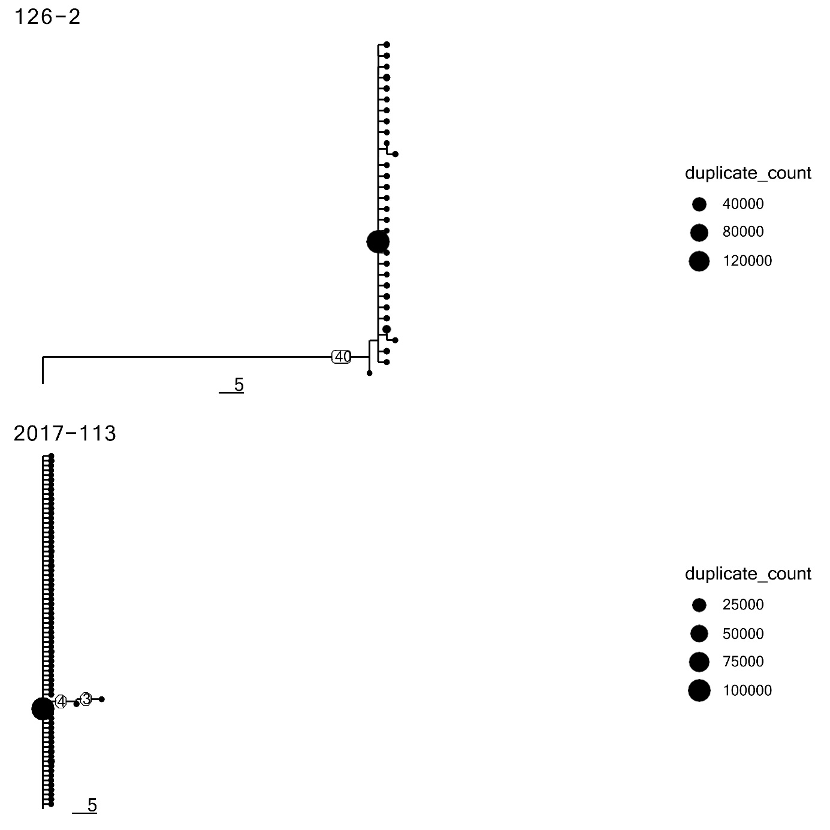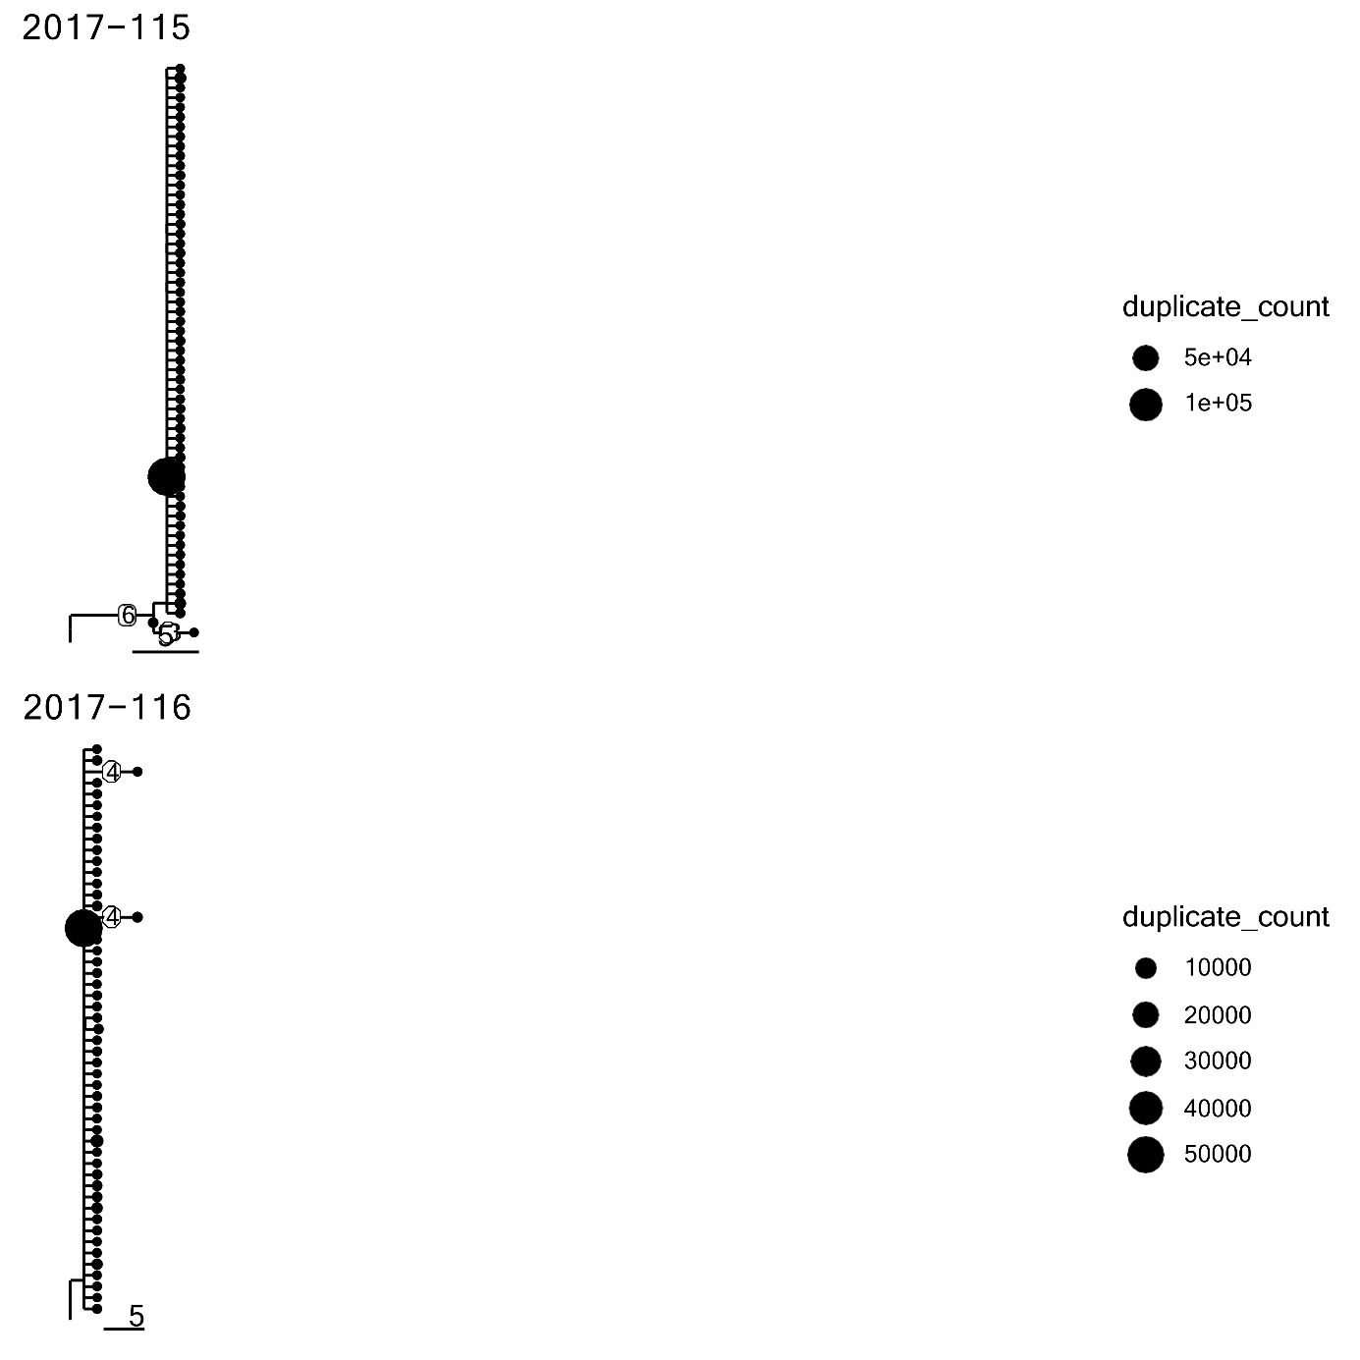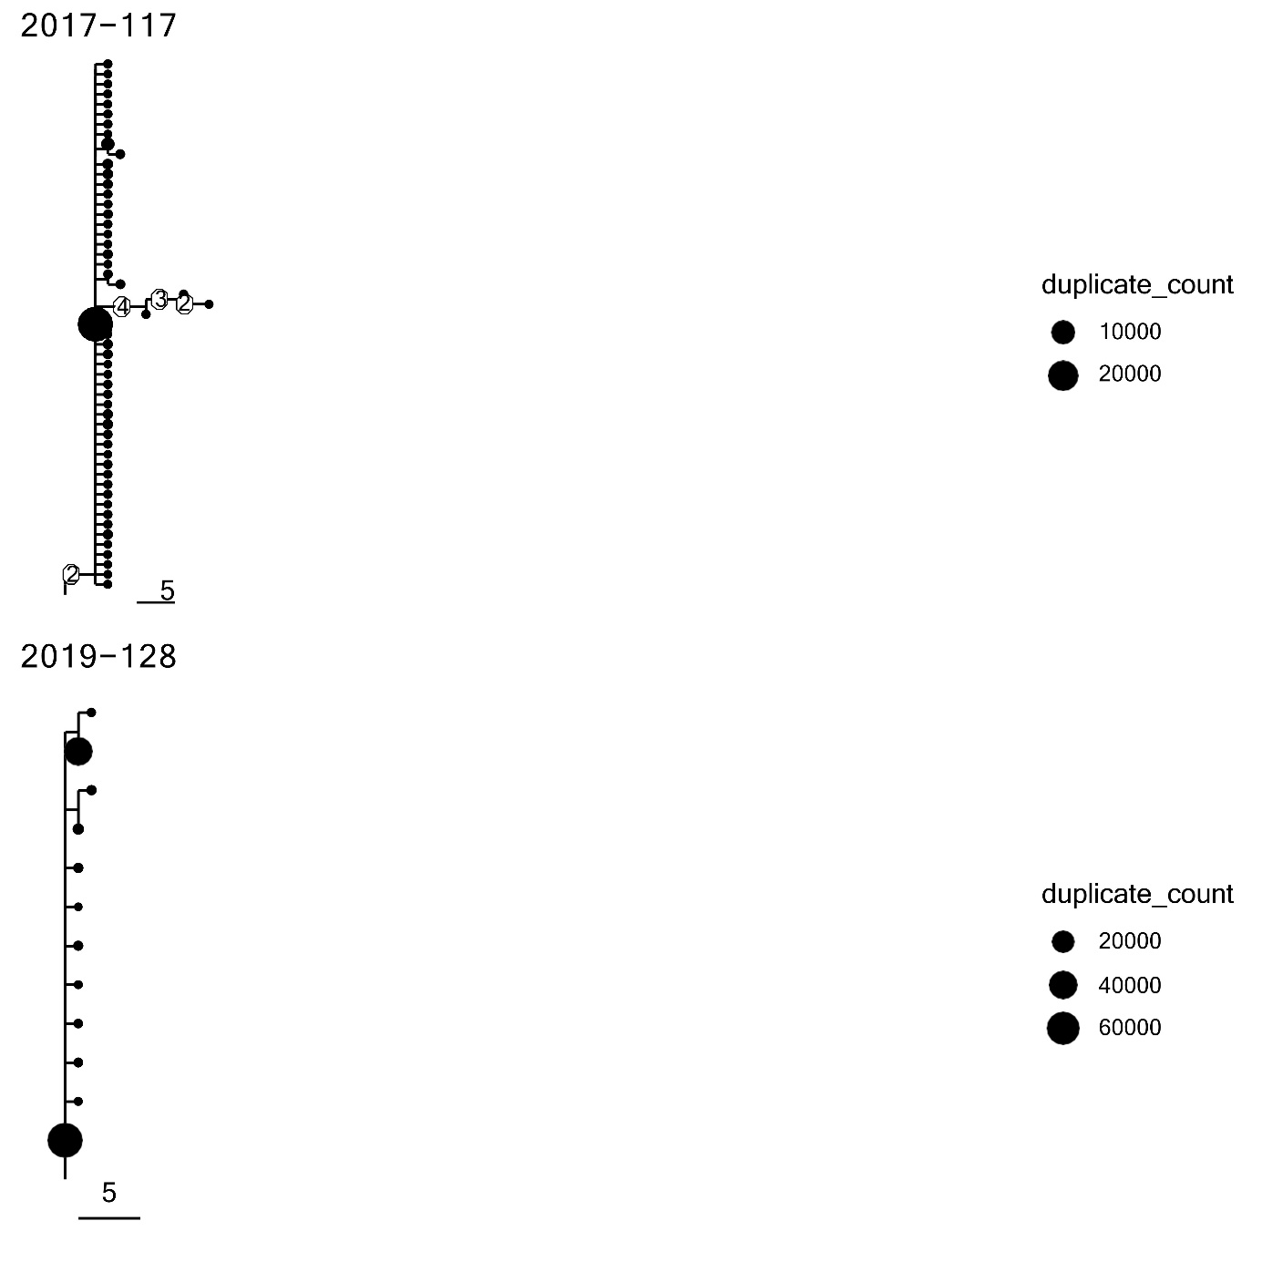

Supplemental figure 7: Sµ-3’RRrec^{High} and Sµ-3’RRrec^{Low} CLL tumoral lineage trees. Lineage tree analysis for CLL tumoral clone. Sequences that shared V, J segment with ≥85% junctional identity in Sµ-3’RRrec^{High} (n =7) (A.) and Sµ-3’RRrec^{Low} CLLs (n =24) (B.) were analyzed for lineage properties.

