Appendix
Table A 1 Sampling sites, water body names, water body types (WBT), and categorical information if sewer effluents are discharged max. 5 km upstream of the sampling site. C= canal, CB = canalized brook, L = lake, P = pond, R = river
Short name | Water body name | Location | WBT | sewer
AK | Spree | Alt Köpenick | R | Yes
BG | Hauptsee | Britzer Garten | P | No
BH | Tegeler See | Borsighafen | L | Yes
BK | Bäke | Bäke | CB | Yes
BV | Spree | Bellevue | R | Yes
DL | Landwehrkanal | Dreiländereck | C | Yes
EB | Engelbecken | Engelbecken | P | No
FG | Landwehrkanal | Flutgraben | C | Yes
FS | Fauler See | Lake outlet | L | Yes
GP | Görlitzer Parkteich | Görlitzer Park | P | No
HT | Landwehrkanal | Hallesches Tor | C | Yes
IJ | Spree | Insel der Jugend | R | Yes
KB | Spree | Katerblau | R | Yes
KL | Krumme Lanke | Lake inlet (north) | L | No
KS | Krumme Lanke | Lake outlet (south) | L | Yes
KT | Karpfenteich | Treptower Park | P | No
LS | Lietzensee | Bathing bay northern lake | L | No
MD | Eckernpfuhl | Alt-Mariendorf | P | No
MP | Spree | Mellowpark | R | Yes
NH | Westhafenkanal | Nordhafen | C | Yes
NU | Berlin-Spandauer-Schifffahrtskanal | Northern shore | C | Yes
OB | Obersee | West bay | L | Yes
OS | Orankesee | Bathing bay | L | No
PS | Plötzensee | Boat rental, south bay | L | No
RB | Spree | Rummelsburger Bucht | R | Yes
RP | Seerosenteich | Volkspark am Weinberg | P | No
RT | Spree | Reichstag | R | Yes
SB | Spree | Schlossbrücke | R | Yes
SD | Spree | Spreestr., height of river Dahme | R | Yes
SL | Schlachtensee | Height of train station | L | Yes
SP | Westlicher Abzugsgraben | Spandau | CB | Yes
ST | Stössensee | TU boathouse | L | Yes
TE | Teich am Teehaus | Tiergarten - Englisher Garten | P | No
TN | Neuer See | Tiergarten | L | No
TS | Landwehrkanal | Treptower Str. | C | Yes
UH | Landwehrkanal | Urbanhafen | C | Yes
VF | Großer Teich | Volkspark Friedrichshain | P | No
VK | Wasserfall | Viktoriapark | P | No
WH | Westhafenkanal | Westhafen | C | yes
WM | Wannsee | Middle part | L | no
WS | Weissensee | South bay | L | no
WW | Wannsee | Western shore | L | no
Table A 2 Percentage shares of different land-use classes in the 100 m buffer along studied surface waters and the connected sewer system catchment for the monitored surface waters according to land-use map LBM-2018 (BKG, 2018)
Sampling site | Resi-dential | Urban  green  spaces | Sports  and  leisure | Roads &  public transport | Public  areas | Pro-duction | Other
AK | 64.3 | 1.9 | 3.5 | 2.6 | 20.4 | 4.5 | 2.9
BG | 0.1 | 0.0 | 99.4 | 0.0 | 0.0 | 0.0 | 0.5
BH | 72.7 | 2.2 | 3.5 | 1.1 | 10.7 | 8.5 | 1.3
BK | 75.5 | 0.9 | 4.9 | 3.3 | 11.8 | 1.4 | 2.1
BV | 53.5 | 4.5 | 5.0 | 6.0 | 20.5 | 9.4 | 1.0
DL | 60.1 | 3.6 | 6.1 | 2.8 | 7.3 | 17.5 | 2.6
EB | 59.0 | 20.6 | 0.0 | 0.0 | 15.4 | 0.0 | 5.0
FG | 59.2 | 2.8 | 6.2 | 2.8 | 8.4 | 18.0 | 2.6
FS | 67.9 | 10.4 | 1.4 | 1.7 | 13.9 | 0.1 | 4.6
GP | 22.3 | 70.4 | 0.0 | 0.0 | 7.1 | 0.0 | 0.2
Hat | 60.0 | 4.1 | 8.6 | 2.7 | 17.9 | 5.6 | 1.2
IJ | 60.1 | 2.0 | 4.4 | 5.3 | 15.1 | 10.7 | 2.5
KB | 49.0 | 2.3 | 5.7 | 7.4 | 19.5 | 13.9 | 2.2
KL | 0.0 | 0.0 | 0.0 | 0.0 | 0.0 | 5.6 | 94.4
KS | 60.0 | 0.0 | 0.0 | 0.0 | 4.7 | 0.0 | 35.4
KT | 4.0 | 91.7 | 3.8 | 0.0 | 0.0 | 0.0 | 0.5
LS | 39.8 | 0.1 | 52.1 | 1.0 | 6.7 | 0.0 | 0.2
MD | 17.0 | 5.1 | 75.7 | 1.9 | 0.0 | 0.0 | 0.2
MP | 73.1 | 1.9 | 3.4 | 3.2 | 11.1 | 4.4 | 2.8
NH | 63.6 | 3.4 | 5.2 | 3.2 | 14.8 | 6.7 | 3.0
NU | 60.9 | 2.6 | 7.2 | 3.9 | 17.9 | 5.0 | 2.5
OB | 84.0 | 2.5 | 8.2 | 1.9 | 3.3 | 0.0 | 0.2
OS | 30.0 | 0.0 | 69.7 | 0.0 | 0.0 | 0.0 | 0.3
PS | 0.0 | 0.2 | 92.1 | 1.1 | 4.8 | 0.0 | 1.9
RB | 42.3 | 2.0 | 4.4 | 8.6 | 21.3 | 19.0 | 2.4
RP | 47.1 | 0.0 | 52.9 | 0.0 | 0.0 | 0.0 | 0.0
RT | 56.7 | 3.2 | 7.0 | 5.2 | 17.9 | 8.5 | 1.4
SB | 54.4 | 3.3 | 6.6 | 5.3 | 20.5 | 7.7 | 2.2
SD | 72.1 | 1.4 | 2.5 | 2.5 | 12.2 | 5.4 | 3.9
SL | 73.9 | 2.5 | 5.4 | 1.3 | 2.6 | 0.0 | 14.2
SP | 62.4 | 2.5 | 4.7 | 1.3 | 15.1 | 12.4 | 1.7
ST | 26.5 | 9.6 | 52.7 | 2.5 | 5.8 | 0.0 | 2.9
TE | 3.4 | 78.9 | 0.0 | 4.7 | 13.0 | 0.0 | 0.0
TN | 0.0 | 89.5 | 1.8 | 8.1 | 0.0 | 0.0 | 0.7
TS | 49.6 | 2.1 | 8.4 | 3.6 | 8.5 | 24.3 | 3.6
UH | 57.4 | 3.6 | 8.4 | 2.8 | 16.3 | 9.5 | 1.9
VF | 0.0 | 99.8 | 0.0 | 0.0 | 0.0 | 0.0 | 0.2
VK | 19.7 | 0.0 | 67.9 | 0.0 | 12.2 | 0.0 | 0.3
WH | 60.5 | 2.7 | 7.1 | 3.9 | 18.1 | 5.0 | 2.8
WM | 0.0 | 0.0 | 0.0 | 0.0 | 0.0 | 0.0 | 100.0
WS | 25.1 | 59.8 | 7.9 | 1.2 | 5.9 | 0.0 | 0.1
WW | 21.3 | 10.0 | 61.8 | 0.4 | 0.4 | 0.0 | 6.1

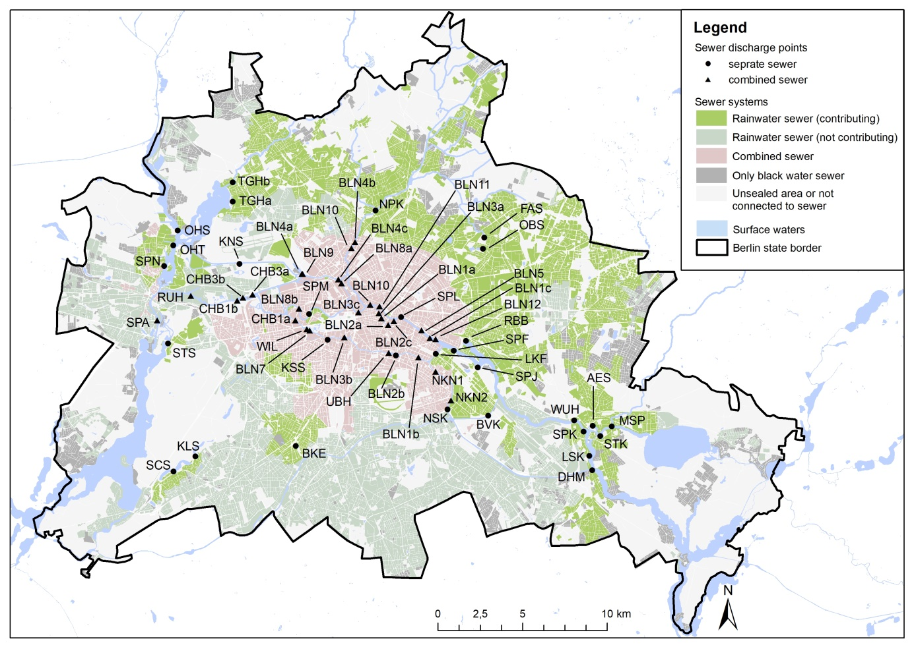
Fig A 1 Sewer discharge points

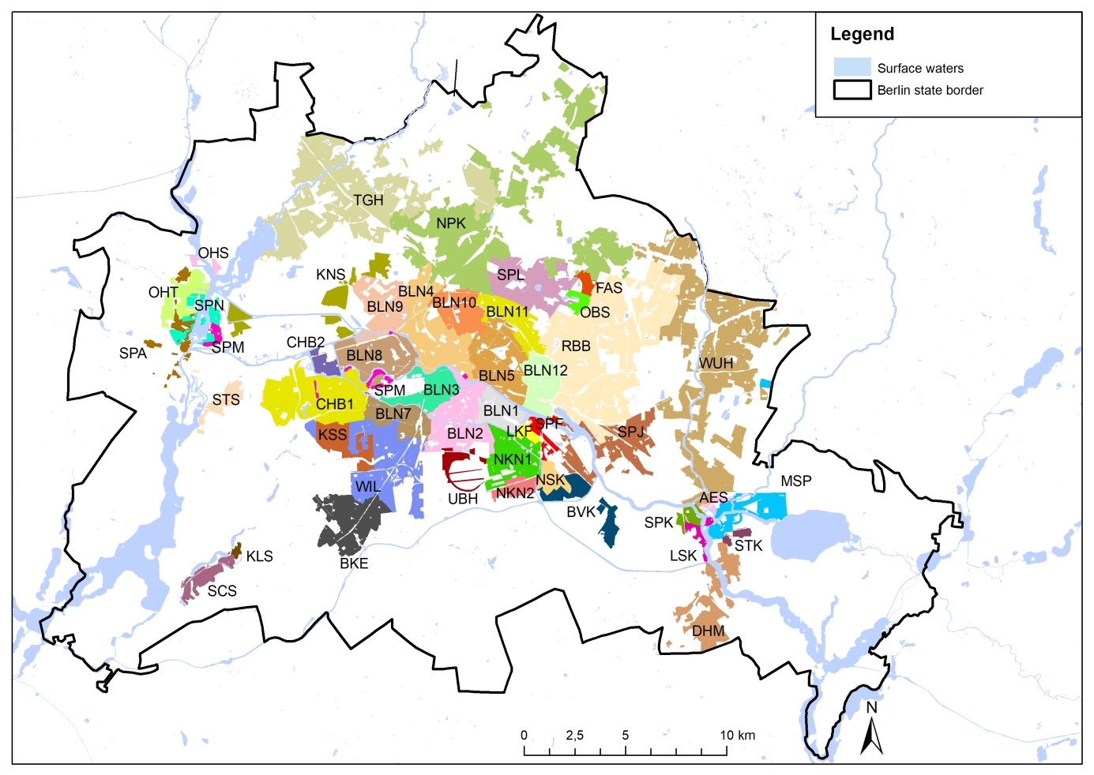
Fig A 2 Catchment of considered sewer systems

Table A 3 Discharge points of combined sewer catchments and the share of sewage discharged to different surface water sections
Short  Name | Name | Discharge  Point | RecievingWater | Share
BLN1 | Berlin I | BLN1a | Kupfergraben | 6.4
BLN1 | Berlin I | BLN1b | Landwehrkanal | 91.7
BLN1 | Berlin I | BLN1c | Spree | 1.9
BLN2 | Berlin II | BLN2a | Kupfergraben | 2.6
BLN2 | Berlin II | BLN2b | Landwehrkanal | 96.2
BLN2 | Berlin II | BLN2c | Spree | 1.2
BLN3 | Berlin III | BLN3a | Kupfergraben | 15.9
BLN3 | Berlin III | BLN3b | Landwehrkanal | 49.7
BLN3 | Berlin III | BLN3c | Spree | 34.4
BLN4 | Berlin IV | BLN4a | Berlin-Spandauer-Schifffahrtskanal | 64.0
BLN4 | Berlin IV | BLN4b | Panke | 3.5
BLN4 | Berlin IV | BLN4c | Spree | 32.5
BLN5 | Berlin V | BLN5 | Spree | 100
BLN7 | Berlin VII | BLN7 | Landwehrkanal | 100
BLN8 | Berlin VIII | BLN8a | Berlin-Spandauer-Schifffahrtskanal | 1.0
BLN8 | Berlin VIII | BLN8b | Spree | 99.0
BLN9 | Berlin IX | BLN9 | Berlin-Spandauer-Schifffahrtskanal | 100
BLN10 | Berlin X | BLN10a | Panke | 98.0
BLN10 | Berlin X | BLN10b | Spree | 2.0
BLN11 | Berlin XI | BLN11 | Spree | 100
BLN12 | Berlin XII | BLN12 | Spree | 100
CHB1 | Charlottenburg I | CHB1 | Landwehrkanal | 26.7
NKN1 | Neuköln I | NKN1 | Neuköllner Schifffahrtskanal | 89.5
NKN2 | Neuköln II | NKN2 | Neuköllner Schifffahrtskanal | 100
WIL | Wilmersdorf | WIL | Landwehrkanal | 100

Table A 4 Discharge points of separate sewer catchments and the share of sewage discharged to different surface water sections
Short  Name | Name | Discharge  Point | Receiving Water | Share
AES | Alte Erpe, Alte Spree | AES | Alte Erpe | 100
BKE | Bäke | BKE | Bäke | 100
BVK | Britzer Verbindungskanal | BVK | Britzer Verbindungskanal | 100
DHM | Dahme | DHM | Dahme | 100
FAS | Fauler See | FAS | Fauler See | 100
KLS | Krumme Lanke, süd | KLS | Krumme Lanke | 100
KNS | Kanäle nördlich der Spree | KNS | Kanäle nördlich der Spree | 100
KSS | Kanäle südlich der Spree | KSS | Neukoellner Schifffahrtskanal and Landwehrkanal | 100
LKF | Landwehrkanal Flutgraben | LKF | Landwehrkanal and Flutgraben | 100
LSK | Langer See Köpenick | SKP | Langer See | 100
MSP | Müggelspree, upstream Köpenick | MSP | Müggelspree | 100
NPK | nördliche Panke | NPK | nördliche Panke | 100
NSK | Neuköllner Schifffahrtskanal | NSK | Neuköllner Schifffahrtskanal | 100
OBS | Obersee | OBS | Obersee | 100
OHV | Oberhavel (Tegeler See bis Schleuse Spandau) | OHV | Oberhavel | 100
RBB | Rummelburger Bucht | RBB | Rummelburger Bucht | 100
SCS | Schlachtensee | SCS | Schlachtensee | 100
STF | Stadtspree, Flutgraben | STF | Stadtspree | 100
SIJ | Stadtspreee, Insel der Jugend | SIJ | Stadtspree | 100
SPN | Spandau | SPN | westlicher Abzugsgraben | 100
STK | Stichkanal | STK | Stichkanal | 100
STM | Stadtspree bis Mündung | STM | Stadtspree | 100
STS | Stoessensee | STS | Stoessensee | 100
TGH | Tegelersee, Borsighafen | TGH | Tegelersee / Borsighafen | 100
UBH | Urbanhafen | UBH | Urbanhafen | 100
WUH | Wuhle | WUH | Wuhle | 100

Table A 5 HPLC gradient at 0.4 ml/min flow rate
Time (min) | Eluent A (%) | Eluent B (%)
0 | 95 | 5
3,0 | 95 | 5
4,5 | 5 | 95
6,0 | 5 | 95
A post-time of 4.5 min was included.

Table A 6 Mass spectrum operating settings
Gas Temperature (°C) | 170
Gas Flow (l min-1) | 11
Nebulizer (psi) | 55
Sheath Gas Heater (°C) | 300
Sheath Gas Flow (l min-1) | 11
Capillary (V) | 2000
Nozzle (V) | 500
Delta EMV (+) | 400

Table A 7 Substance-specific parameters of the LC-MS/MS method
Compound Name | Precursor Ion | Product Ion | Fragmentor | Collision Energy
Nicotine | 163.1 | 132.1 | 109 | 14
nicotine | 163.1 | 130.1 | 109 | 22
nicotine | 163.1 | 117.1 | 109 | 30
nicotine | 163.1 | 84 | 109 | 20
d4-nicotine | 167.2 | 134.1 | 109 | 22
d4-nicotine | 167.2 | 121.1 | 109 | 30
d4-nicotine | 167.2 | 84 | 109 | 24

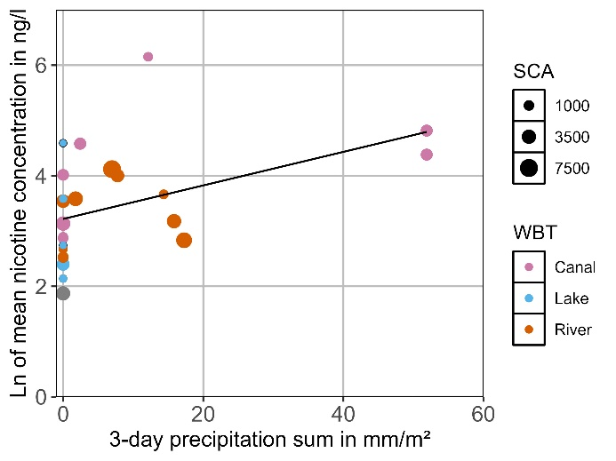
Fig A 3 Ln of mean nicotine concentration at sampling sites connected to a sewer catchment in dependency from 3-day precipitation sum > 0 mm/m² (n = 25, r² = 0.17, p = 0.02)

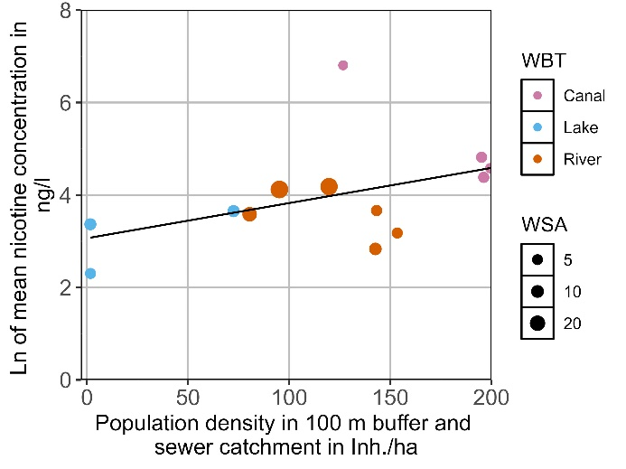
Fig A 4 Ln of mean nicotine concentration per sampling site with 3-day precipitation sum > 0 mm/m², excluding ponds, in dependency from population density (n = 13, r² = 0.13, p = 0.1), distinguished for water body types (WBT). Point size represents the surface water area in km² (WSA)

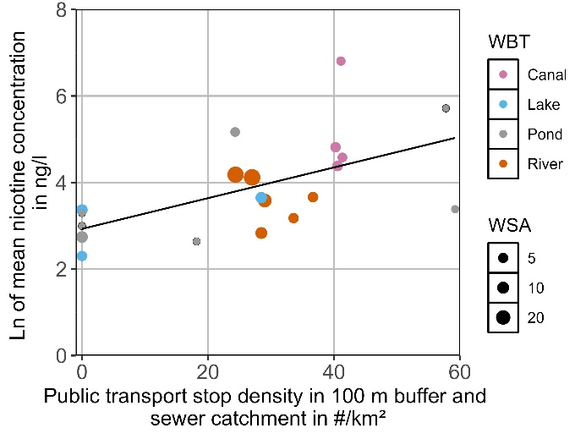
Fig A 5 Ln of mean nicotine concentration per sampling site with 3-day precipitation sum > 0 mm/m² and connected to a sewer catchment in dependency from public transport stop density (n = 20, r² = 0.31, p = 0.01), distinguished for water body types (WBT). Point size represents the surface water area in km² (WSA)

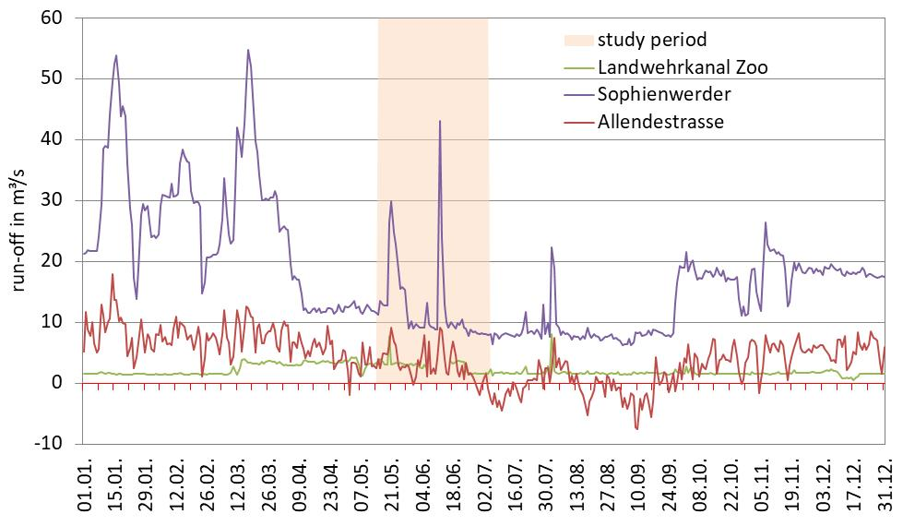
Fig A 6 Observed runoff in 2019 and the study period at three gauging stations in Berlin

