Extended Data
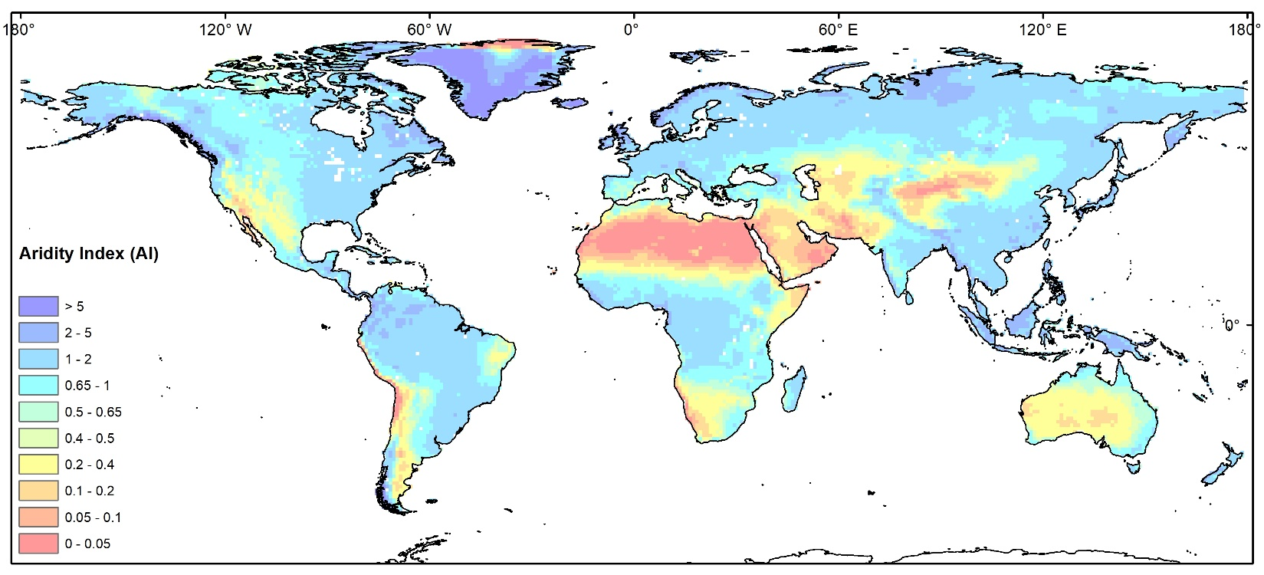
Extended Data Fig. 1 Global Aridity Index (AI) for the period of 2003–2022
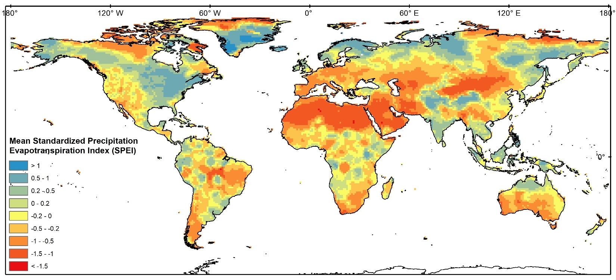
Extended Data Fig. 2 Mean annual standardized precipitation evapotranspiration index (SPEI) for the period of 2003–2022
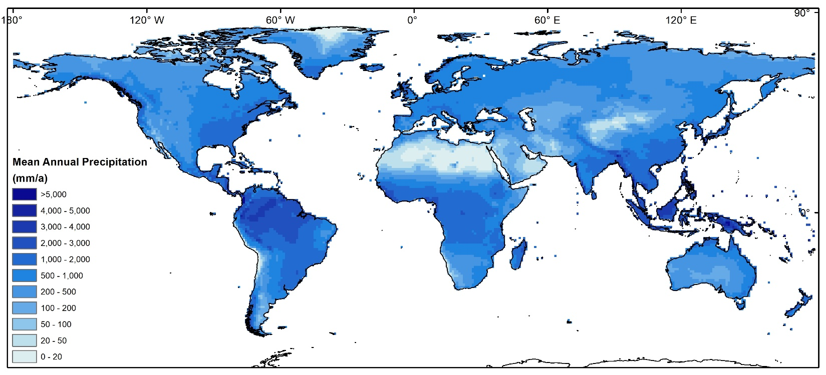
Extended Data Fig. 3 Mean annual precipitation for the period of 2003–2022 (mm/a)
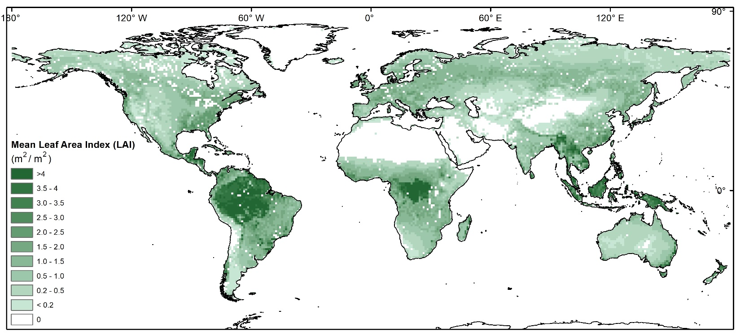
Extended Data Fig. 4 Mean annual leaf area index (LAI) for the period of 2003–2022 (m²/m²)
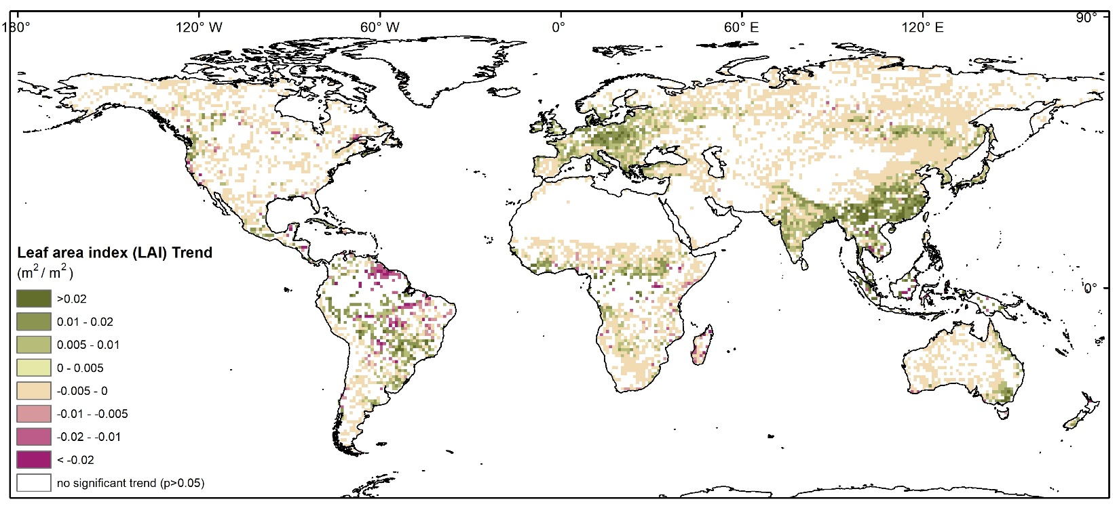
Extended Data Fig. 5 Mean annual trend of leaf area index (LAI) for the period of 2003–2022(m²/m²)
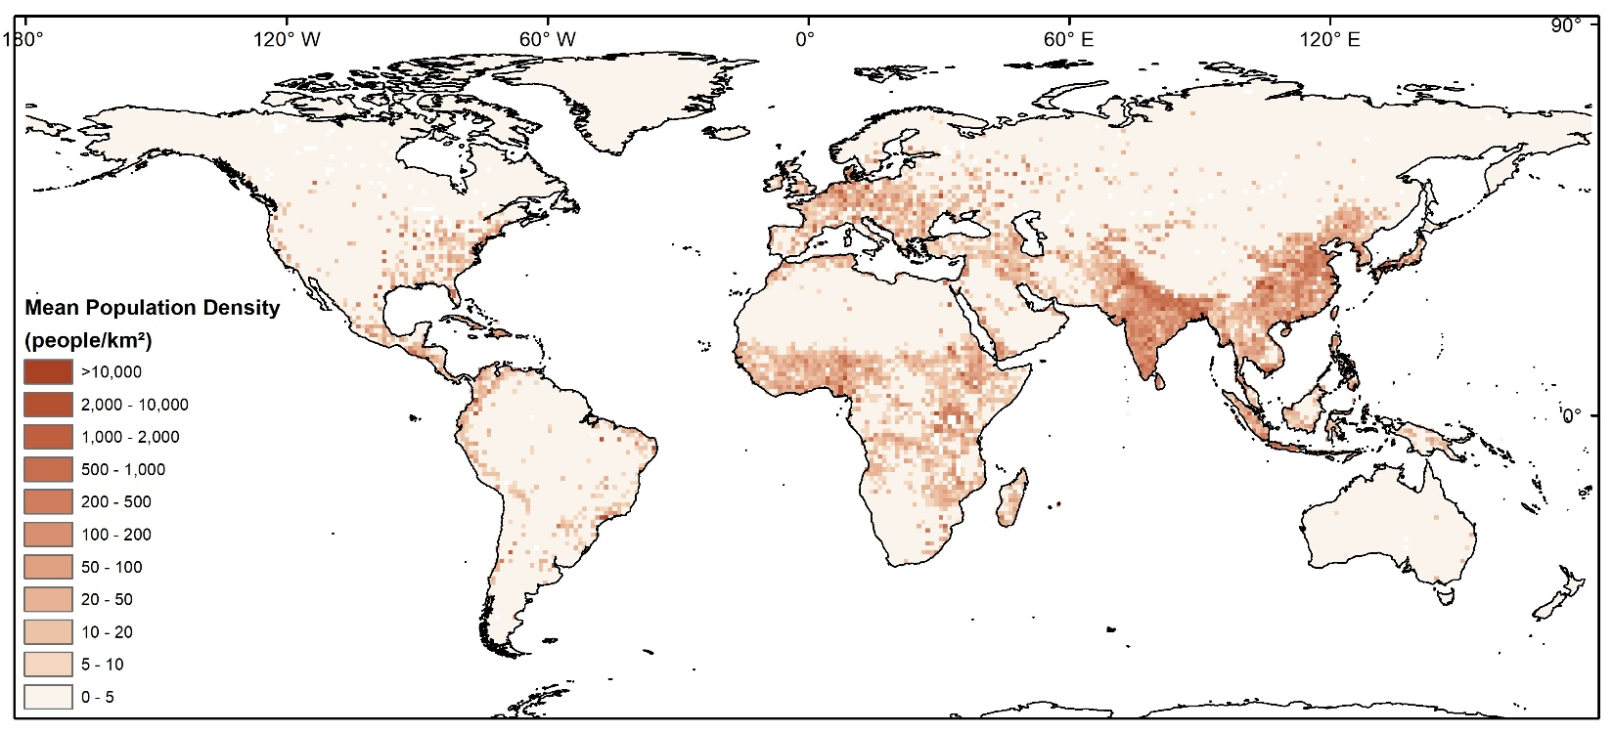
Extended Data Fig. 6 Mean annual population density for the period of 2003–2020 (people/km²)
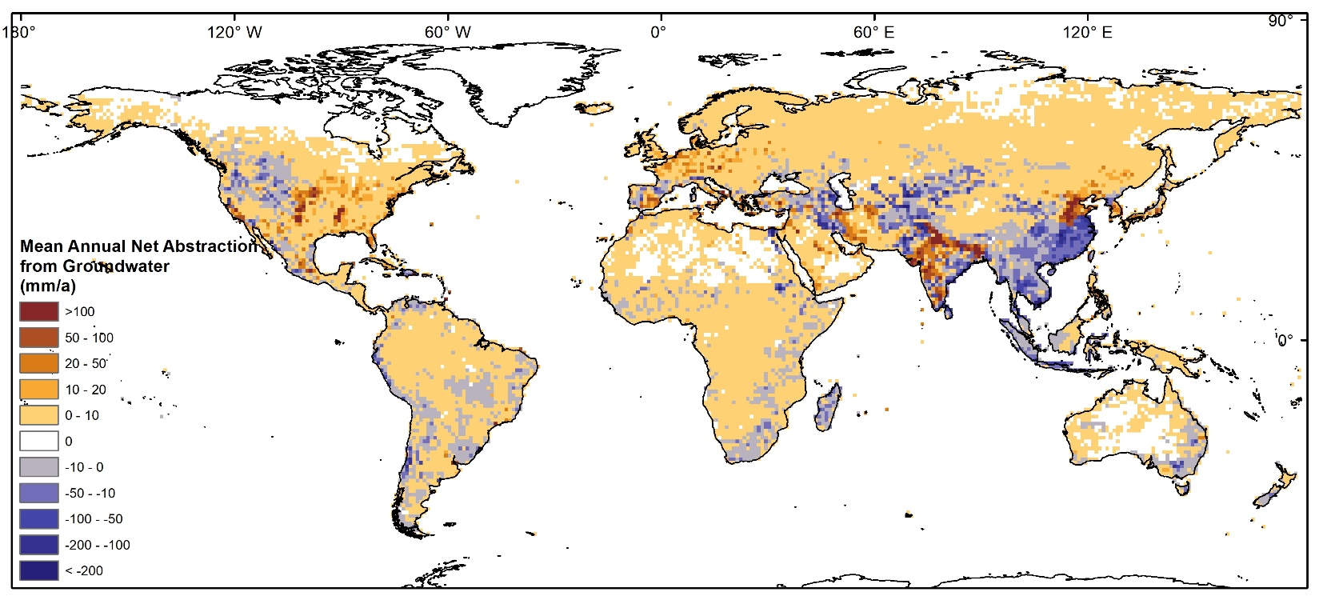
Extended Data Fig. 7 Mean annual net abstraction from groundwater for the period of 2003–2020 (mm/a)

