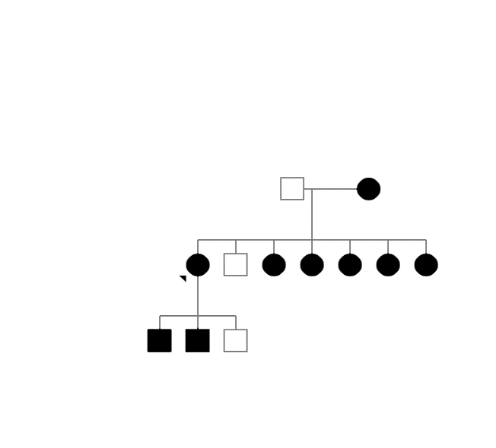
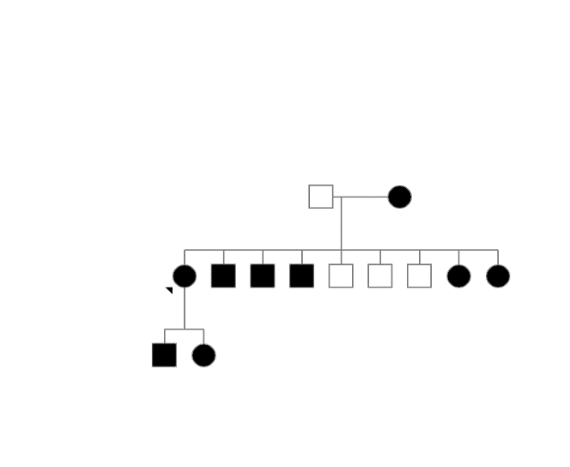
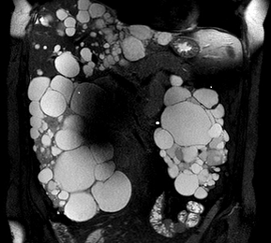
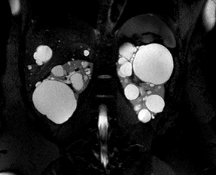
Supplementary Figures
PT1
PT2
A
↑

B

Figure S1 - Family pedigrees (A) and Magnetic Resonance Images (B) of both ADPKD patients (PT1 and PT2).

A
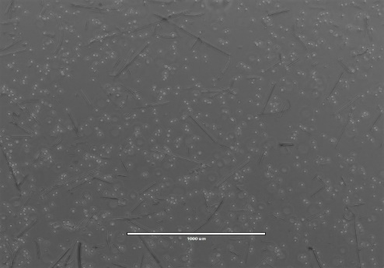
Patient 2
Patient 1

B
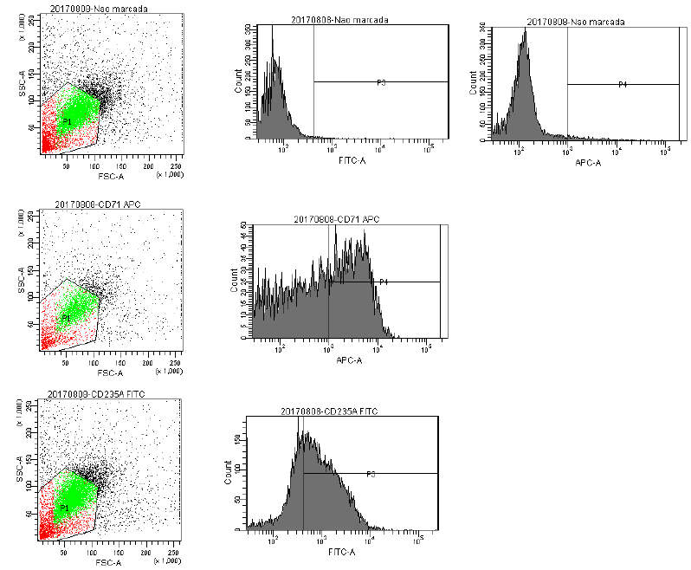
Figure S2. Expansion and characterization of the progenitor erythroid cells (EP). A. Cell culture. EP were maintained during 48 days in specific expansion medium to reach a concentration of 1x10⁶ cells. B. Flow cytometry analysis. Upper panel: Negative marker. Middle panel: EP population were positive for CD235A (Glycophorin A) with 70.9% FITC marker. Lower panel: cells were positive for CD 71 (transferrin receptor) with 65.1% APC marker.

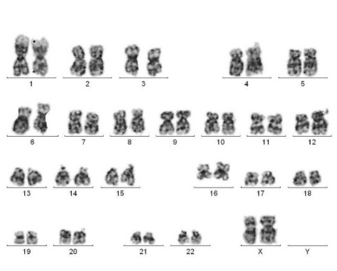
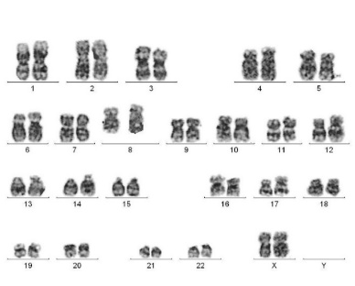
Patient 1
Patient 2

Figure S3. G-banded karyotyping analysis. iPSCs showed perseveration of chromosomal integrity (46, XY) over the course of the reprogramming process in both of ADPKD patients.

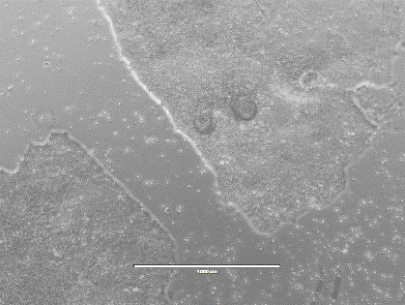
A
B

Figure S4. Similarity of iPSC colonies A: typical image of iPSC from H9 embryo commercial cells. B: iPSC from progenitor erythroid cells of the healthy control

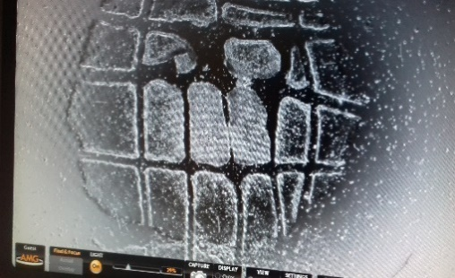
B
A

Figure S5. A. The iPSC colonies were passaged manually by mechanical fragmentation, using a pipet tip under microscopy within the laminar flow. B. The colonies were dissociated by enzymatic digestion as recommendation by Gentle Cell (Life technologies) at 37⁰C for 7 minutes until edges of the colonies loose integrity and begin to lift from the dish.. Images taken using 20X magnification.

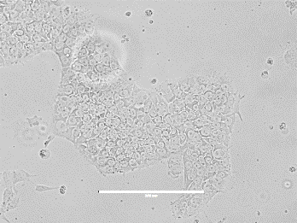
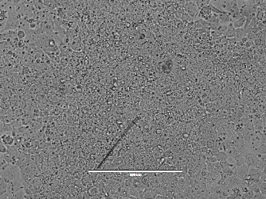
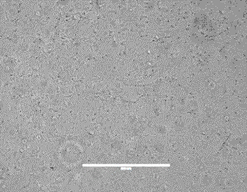
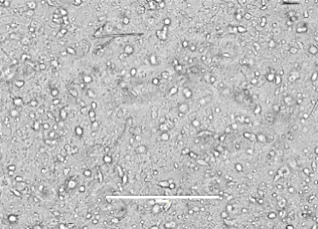
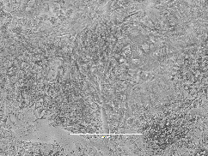
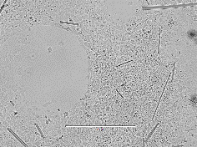
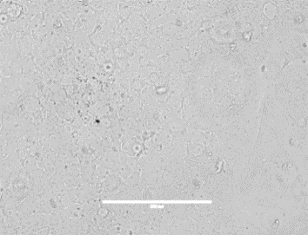
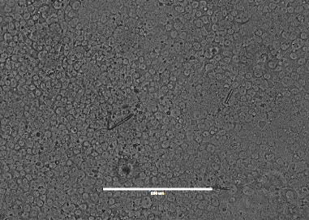
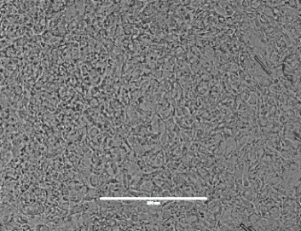
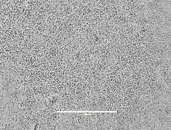
ENDO
MESO
ECTO
DAY 0
DAY 5
DAY 3
DAY 7

Figure S6. Representative Images of the ability of iPSCs from the HC donor to differentiate into the three germ layers according STEMdiff Trilineage Differentiation protocol. Endoderm and mesoderm differentiation occurred over 5 days and ectoderm over 7 days.

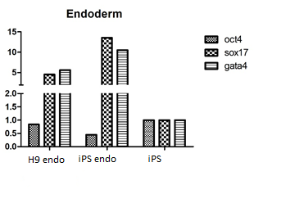
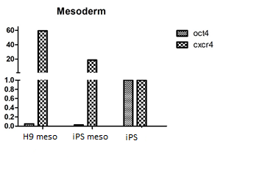
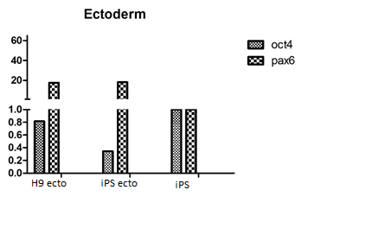
GENE EXPRESSION
GENE EXPRESSION
GENE EXPRESSION

Figure S7. Gene expression by RT-PCR of the markers of the 3 germ lineages from undifferentiated (iPSC) and differentiated iPSC (endo, meso and ecto) of the healthy control donor. H9 embryo cells were used as positive control. OCT4 was used as pluripotency marker. SOX7 and GATA4 was used for Endoderm, CXCR4 for Mesoderm and PAX6 for Ectoderm.

A
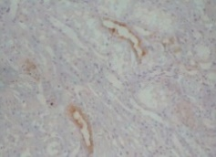
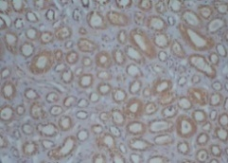
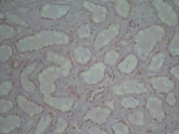
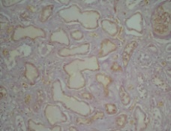
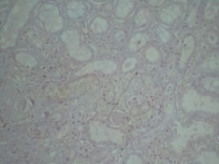
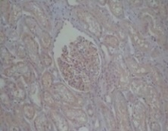
AQP2
ECAD
NHE3
WT1
NPHS2
AQP1

NEGATIVE
CONTROL
TYPICAL
MORPHOLOGY
DAPI
B

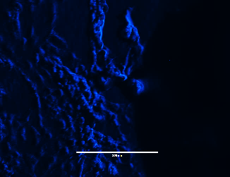
ECAD D


NPHS2


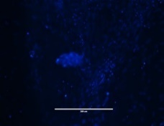
AQP1


AQP2


NHE3

Figure S8. Control analysis for the antibodies. A. Human renal tissue was used as a positive control for antibodies by IHC. B. Negative control. Primary antibodies were absent in IF reactions in kidney organoids.

GENE | PRIMER SEQUENCE
AQP1 | F - GAAGTCGTAGATGAGTACAGCCAG  R - CTACACTGGCTGTGGGATTAACC
E-cadherin | F - TCGACACCCGATTCAAAGTG  R - GTCCCAGGCGTAGACCAAGA
GAPDH | F - GGTGGTCTCCTCTGACTTCAACA  R - ACCAGGAAATGAGCTTGACAAAG
WT1 | F - GGGTACGAGAGCGATAACCA  R - TCTCACCAGTGTGCTTCCTG
AQP2 | F - TACACCGGCTGCTCTATGAA  R - AGAAGACCCAGTGGTCATCAA
HMBS | F - TGGACCTGGTTGTTCACTCCTT  R - CAACAGCATCATGAGGGT TTTC
PAX6 | F - CACCGGTTTCCTCCTTCACA  R - TGGCAGAGCGCTGTAGGTGT
OCT4 | F - AAGCTCCTGAAGCAGAAGAGGA  R - ATGCTCGTTTGGCTGAATACCT
CXCR4 | F - CCCTGCCCTCCTGCTGACTATT  R - AGGGCCTTGCGCTTCTGGTG
SOX17 | F - CGCACGGACTTTGAACAATA  R - CAGACGTCGGGGTAGTTACAG
Table S1. Primers sequence. Forward (F) and reverse (R)

