Supplementary Information
Fig. S1. EDS N-element surface scan analysis diagram. (a) resin XRZ04B (b) enzyme-loaded XRZ04B (c) CALB@resin-CAB

Fig. S2. TGA analysis of resin XRZ04B, enzyme-loaded XRZ04B and CALB@resin-CAB.

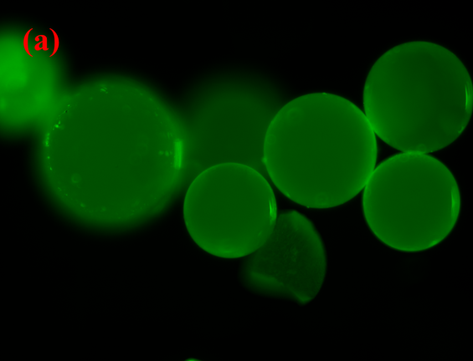 | 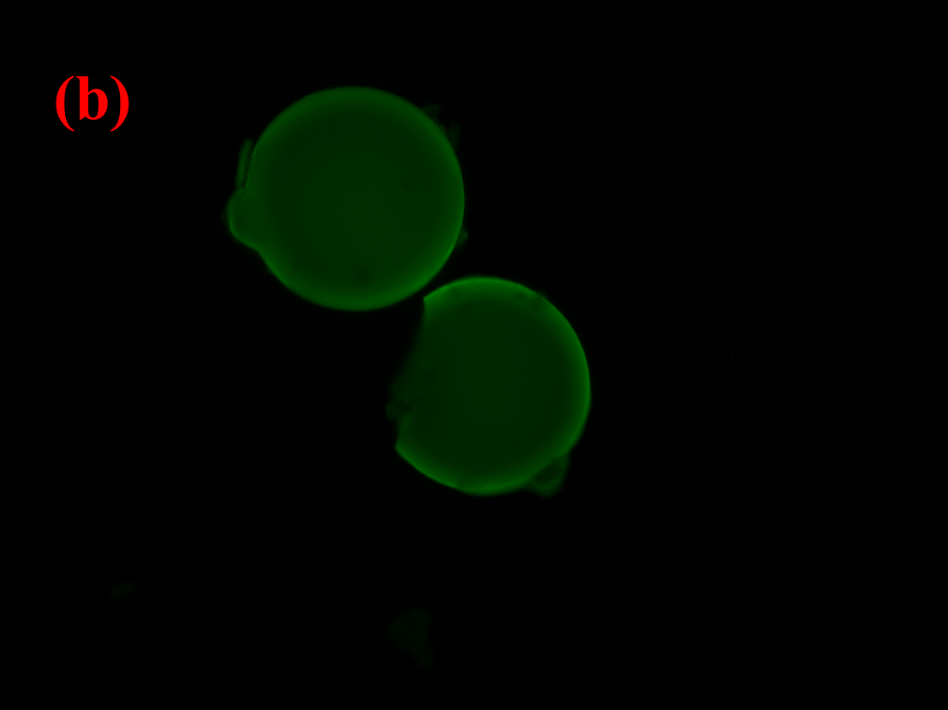
Fig. S3. Fluorescence analysis of immobilized CALB (a) surface (b) Cross-section

Fig. S4. N₂ adsorption-desorption isotherm of (a) resin XRZ04B (b) enzyme-loaded XRZ04B (c) CALB@resin-CAB

Fig. S5. Pore size distribution curves of resin XRZ04B (Black square■), enzyme-loaded resin XRZ04B (Red circle●) and CALB@resin-CAB (Blue Triangles▲).

Fig. S6. Optimization of enzyme-catalyzed biodiesel production (a) Temperature (b) Types of organic solvents (c) Organic solvent content
Fig. S7. Batch stability of CALB@resin-CAB catalyzed biodiesel production.

Fig. S8. CALB@resin-CAB catalyzed production of biodiesel in flow reaction, flow rate: 1-20 Bv/h

Table S1. Esterification activity and protein leakage rates of different immobilized enzymes.
Immobilized enzyme | Specific enzyme activity（PLU/g） | Protein leakage rate（%）
enzyme-loaded resin | 13214.1±2.3 | 8.4±0.6
CALB@resin-CAB | 12685.5±2.6 | 2.1±0.1
Novozym 435 | 10067.9±3.2 | 8.5±0.4
coated Novozym 435 | 9665.2±2.5 | 2.2±0.2

Table. S2 The physical properties of as-prepared samples.
Sample | S_{BET}  (m²·g⁻²) | Pore capacity (cm³·g⁻¹) |  | Average pore size (nm) | most probable pore size (nm)
resin XRZ04B | 161.17 | 0.44 | 17.73 |  | 22.49
enzyme-loaded resin XRZ04B | 3.24 | 0.01 | 15.77 |  | 16.04
CALB@resin-CAB | 34.00 | 0.09 | 18.39 |  | 21.13

Table S3. Effect of molar ratio of Oil and methanol on conversion of Palm acidification oil.
Molar ratio of oil to alcohol (mol:mol) | Actual conversion rate (%) |  | Theoretical Conversion Rate (%) | Actual/Theoretical Relative Conversion Rate (%)
1:1 | 32.1 | 33.3 |  | 96.4
1:2 | 62.4 | 66.7 |  | 93.6
1:3 | 92.1 | 100 |  | 92.1
1:4 | 92.0 | 100 |  | 92.0
1:5 | 90.4 | 100 |  | 90.4
1:6 | 88.6 | 100 |  | 88.6

