Supplement 1. Papers Included in the CBFM Review
- King M, Fa’asili U. A network of small community-owned village fish reserves in Samoa. In: Partnerships for Protection. Routledge; 2014. p. 235–42.
- Clements C, Bonito V, Grober-Dunsmore R, Sobey M. Effects of small, Fijian community-based marine protected areas on exploited reef fishes. Marine Ecology Progress Series. 2012;449:233–43.
- Akimichi T. Indigenous resource management and sustainable development: Case studies from Papua New Guinea and Indonesia. Anthropological Science. 1995;103(4):321–7.
- Almany GR, Hamilton RJ, Bode M, Matawai M, Potuku T, Saenz-Agudelo P, et al. Dispersal of Grouper Larvae Drives Local Resource Sharing in a Coral Reef Fishery. Current Biology. 2013 Apr;23(7):626–30.
- Aswani S. Customary Sea Tenure in Oceania as a Case of Rights-based Fishery Management: Does it Work? Rev Fish Biol Fisheries. 2005 Aug;15(3):285–307.
- Léopold M, Beckensteiner J, Kaltavara J, Raubani J, Caillon S. Community-based management of near-shore fisheries in Vanuatu: What works? Marine Policy. 2013 Nov;42:167–76.
- Hamilton RJ, Hughes A, Brown CJ, Leve T, Kama W. Community-based management fails to halt declines of bumphead parrotfish and humphead wrasse in Roviana Lagoon, Solomon Islands. Coral Reefs. 2019 Jun;38(3):455–65.
- Smallhorn‐West PF, Stone K, Ceccarelli DM, Malimali S, Halafihi T, Bridge TCL, et al. Community management yields positive impacts for coastal fisheries resources and biodiversity conservation. CONSERVATION LETTERS. 2020 Nov;13(6):e12755.
- Quimby B, Levine A. Adaptive capacity of marine comanagement: a comparative analysis of the influence of colonial legacies and integrated traditional governance on outcomes in the Pacific. Reg Environ Change. 2021 Mar;21(1):10.
- Jupiter SD, Epstein G, Ban NC, Mangubhai S, Fox M, Cox M. A Social–Ecological Systems Approach to Assessing Conservation and Fisheries Outcomes in Fijian Locally Managed Marine Areas. Society & Natural Resources. 2017 Sep 2;30(9):1096–111.
- Blythe J, Cohen P, Eriksson H, Cinner J, Boso D, Schwarz AM, et al. Strengthening post-hoc analysis of community-based fisheries management through the social-ecological systems framework. Marine Policy. 2017 Aug;82:50–8.
- King M, Faasili U. Community‐based management of subsistence fisheries in Samoa. Fisheries Management Eco. 1999 Apr;6(2):133–44.
- Hoffmann TC. The Reimplementation of the Ra’ui: Coral Reef Management in Rarotonga, Cook Islands. Coastal Management. 2002 Oct;30(4):401–18.
- Ison S, Hills J, Morris C, Stead SM. Sustainable financing of a national Marine Protected Area network in Fiji. Ocean & Coastal Management. 2018 Sep;163:352–63.
- Smallhorn‐West PF, Bridge TCL, Malimali S, Pressey RL, Jones GP. Predicting impact to assess the efficacy of community‐based marine reserve design. CONSERVATION LETTERS. 2019 Jan;12(1):e12602.
- Lauer M, Aswani S. Indigenous Knowledge and Long-term Ecological Change: Detection, Interpretation, and Responses to Changing Ecological Conditions in Pacific Island Communities. Environmental Management. 2010 May;45(5):985–97.
- Albert S, Grinham A, Gibbes B, Tibbetts I, Udy J. Indicators of coral reef ecosystem recovery following reduction in logging and implementation of community-based management schemes in the Solomon Islands. Pac Conserv Biol. 2014;20(1):75.
- Léopold M, Cakacaka A, Meo S, Sikolia J, Lecchini D. Evaluation of the effectiveness of three underwater reef fish monitoring methods in Fiji. Biodivers Conserv. 2009 Dec;18(13):3367–82.
- Dumas P, Jimenez H, Léopold M, Petro G, Jimmy R. Effectiveness of village-based marine reserves on reef invertebrates in Emau, Vanuatu. Envir Conserv. 2010 Sep;37(3):364–72.
- Doulman DJ. Community-based fishery management. Marine Policy. 1993 Mar;17(2):108–17.
- Crean K. Centralised and community-based fisheries management strategies: case studies from two fisheries dependent archipelagos. Marine Policy. 1999 May;23(3):243–57.
- Steenbergen DJ, Raubani J, Gereva S, Naviti W, Arthur C, Arudere A, et al. Tracing innovation pathways behind fisheries co-management in Vanuatu. Ambio. 2022 Dec;51(12):2359–75.
- Johannes RE. The Renaissance of Community-Based Marine Resource Management in Oceania. Annu Rev Ecol Syst. 2002 Nov;33(1):317–40.
- Williamson JE. Social attitudes towards marine resource management in two Fijian villages. 2006;7(2).
- Hair C. Social and economic challenges to community-based sea cucumber mariculture development in New Ireland Province, Papua New Guinea. Marine Policy. 2020.
- Fache E. Small-scale managed marine areas over time_ Developments and challenges in a local Fijian reef fishery. Journal of Environmental Management. 2018.
- Aswani S. One size does not fit all_ Critical insights for effective community-based resource management in Melanesia. Marine Policy. 2017.
- Rohe JR. Multiple Drivers of Local (Non-) Compliance in Community-Based Marine Resource Management: Case Studies from the South Pacific. Frontiers in Marine Science. 2017.
- Robertson T, Greenhalgh S, Korovulavula I, Tikoibua T, Radikedike P, Stahlmann-Brown P. Locally managed marine areas: Implications for socio-economic impacts in Kadavu, Fiji. Marine Policy. 2020 Jul;117:103950.
- Sulu RJ, Eriksson H, Schwarz AM, Andrew NL, Orirana G, Sukulu M, et al. Livelihoods and Fisheries Governance in a Contemporary Pacific Island Setting. PLOS ONE. 2015.
- Hamilton RJ, Giningele M, Aswani S, Ecochard JL. Fishing in the dark-local knowledge, night spearfishing and spawning aggregations in the Western Solomon Islands. Biological Conservation. 2012 Jan;145(1):246–57.
- Cohen PJ, Cinner JE, Foale S. Fishing dynamics associated with periodically harvested marine closures. Global Environmental Change. 2013 Dec;23(6):1702–13.
- Ford AK. Evaluation of coral reef management effectiveness using conventional versus resilience-based metrics. Ecological Indicators. 2018.

Supplement 2. Statistical Methods
See the following pdf of Statistics in R https://drive.google.com/file/d/13W27pmyH9gN3qASzve2Wjt2B1-leUxM8/view?usp=sharing

Supplement 3. Extended Results
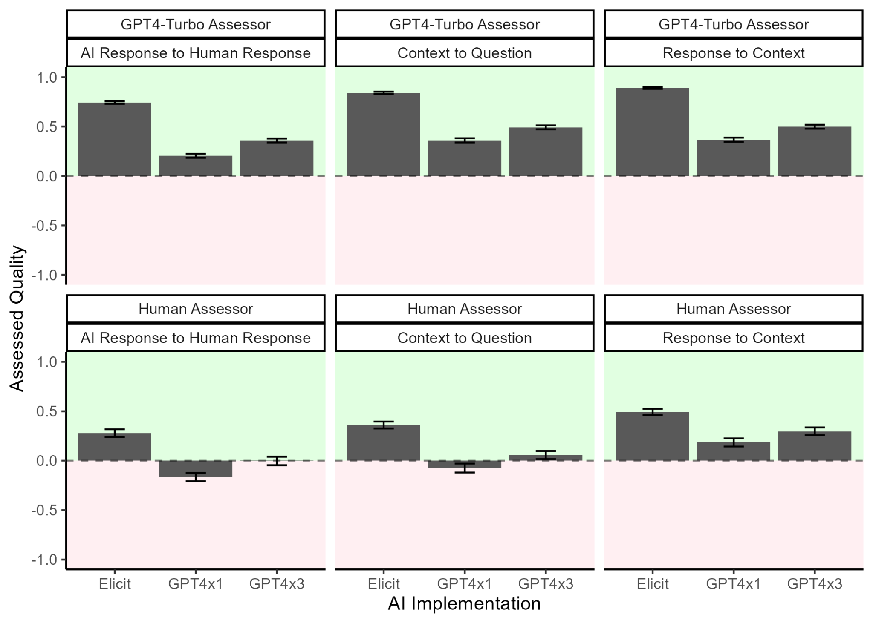
Figure S1. GPT-4 Quality Assessor. In addition to assessment by the team of human researchers. We had GPT-4 undertake the same assessment five times. (a) The first five times we provided the human response as the ‘gold standard’ and asked GPT-4 to assess the other response. These ratings are consistent in pattern to those of the human evaluators (Figure 3)

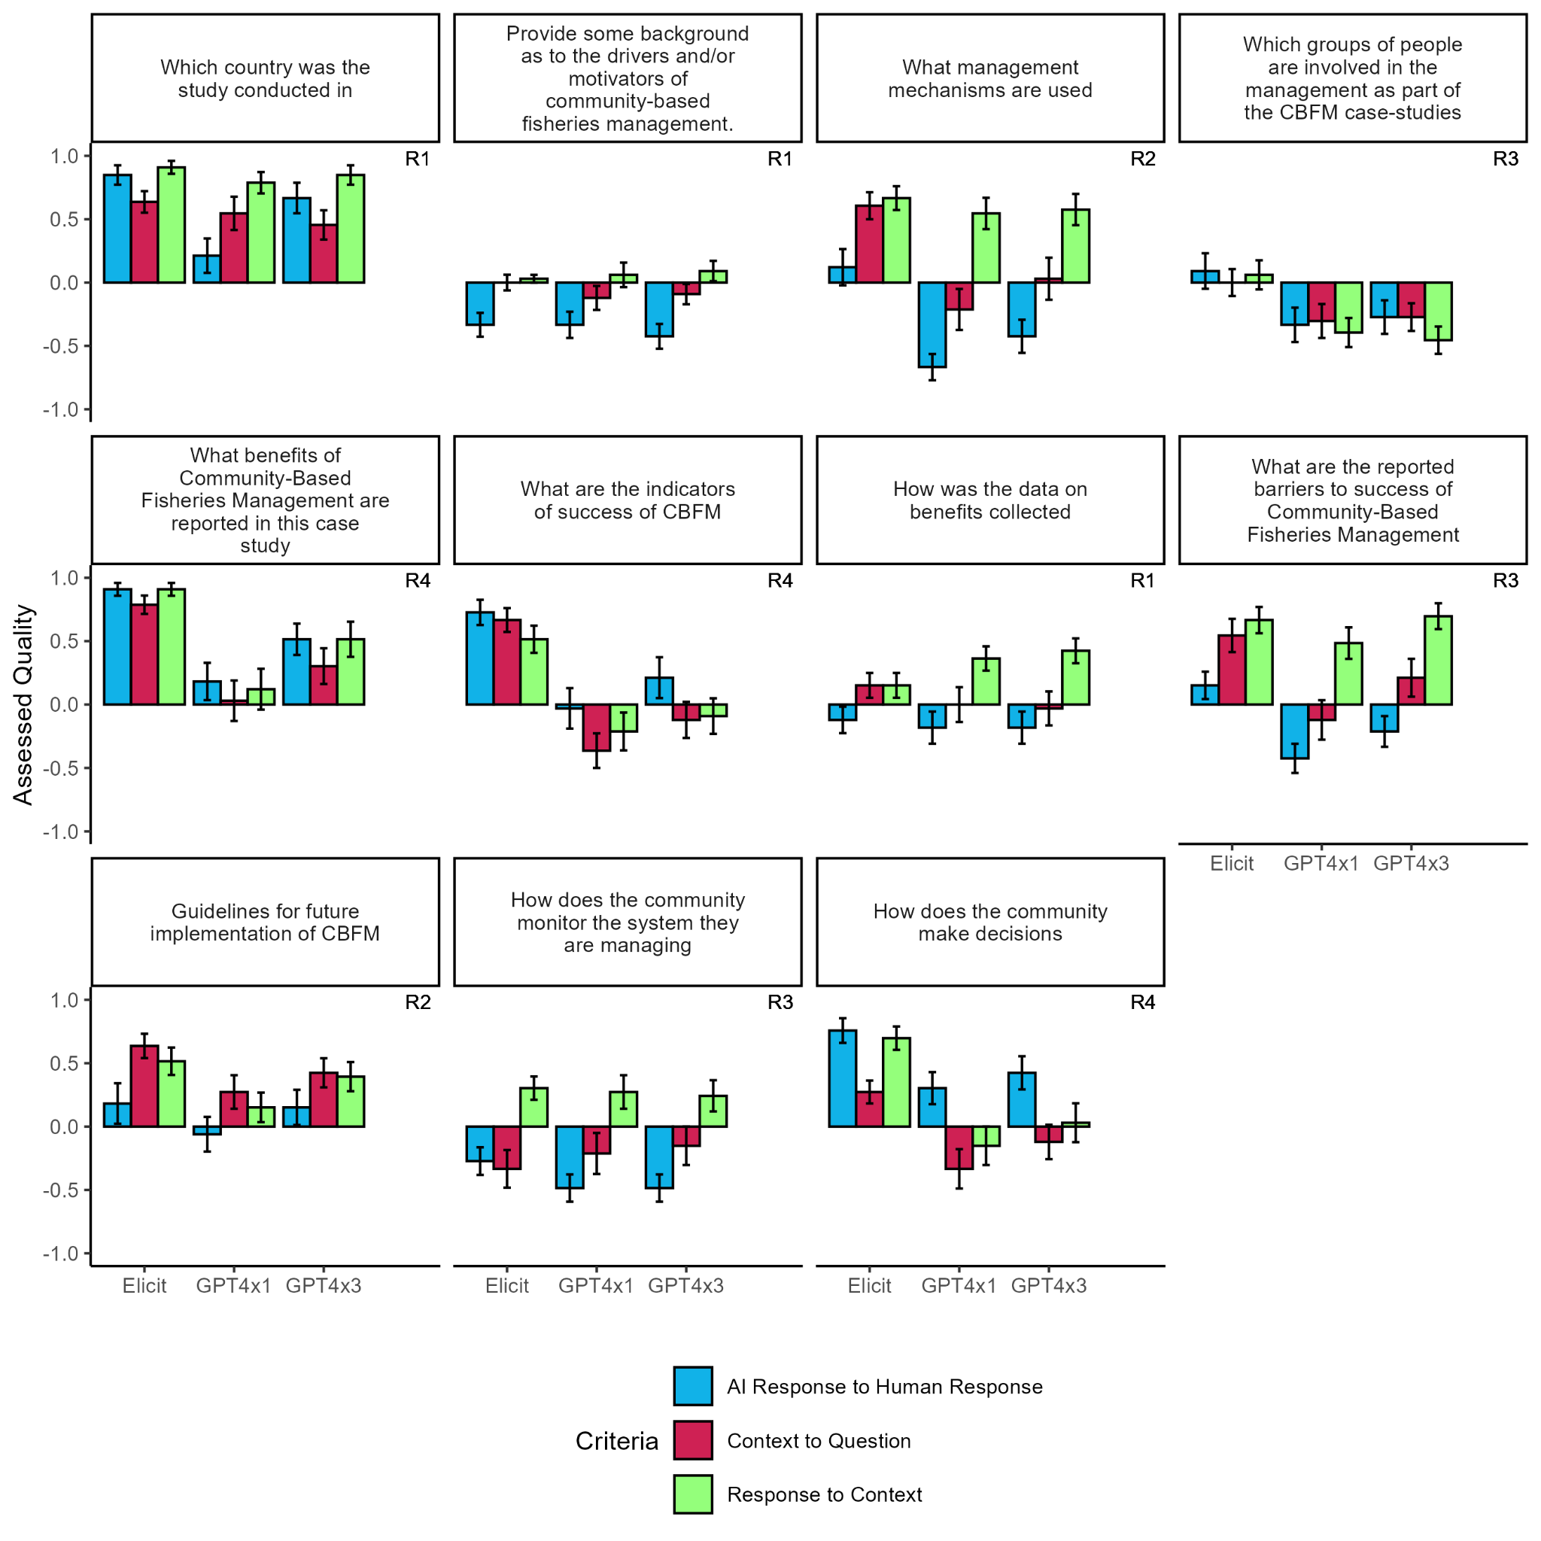
Figure S2. Mean Quality of AI responses for each question. The mean difficulty rating according to the human extractors is shown by the height of the yellow dot on the right of each pl

