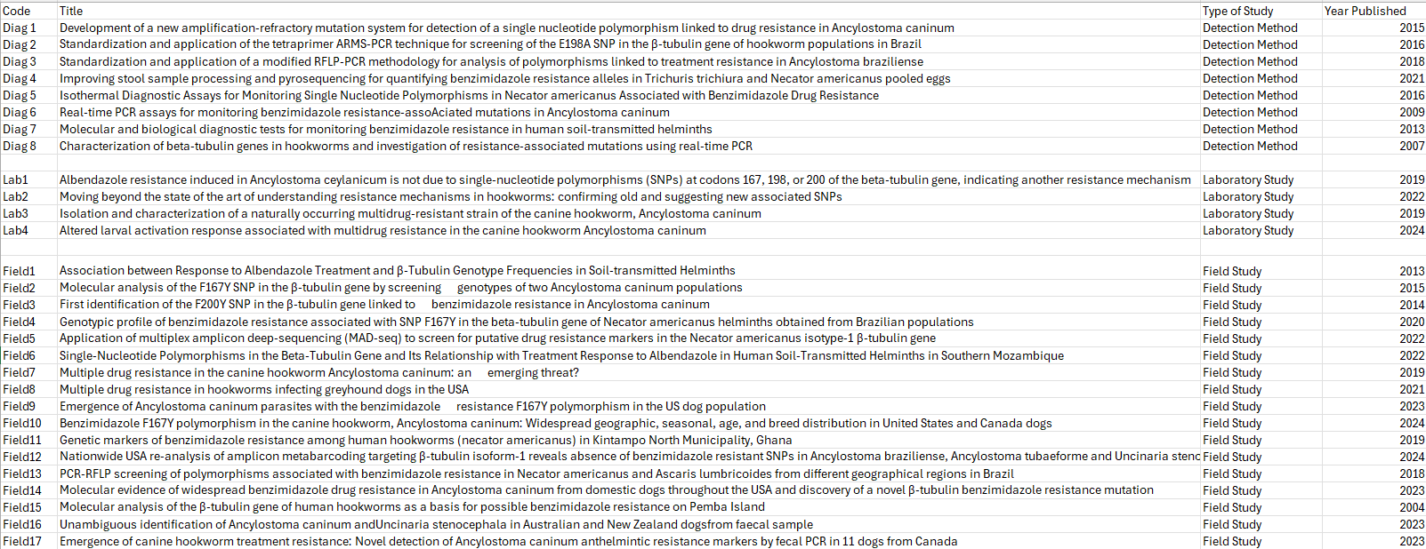
Supplementary Table 1. Study codes of the eligible reports.

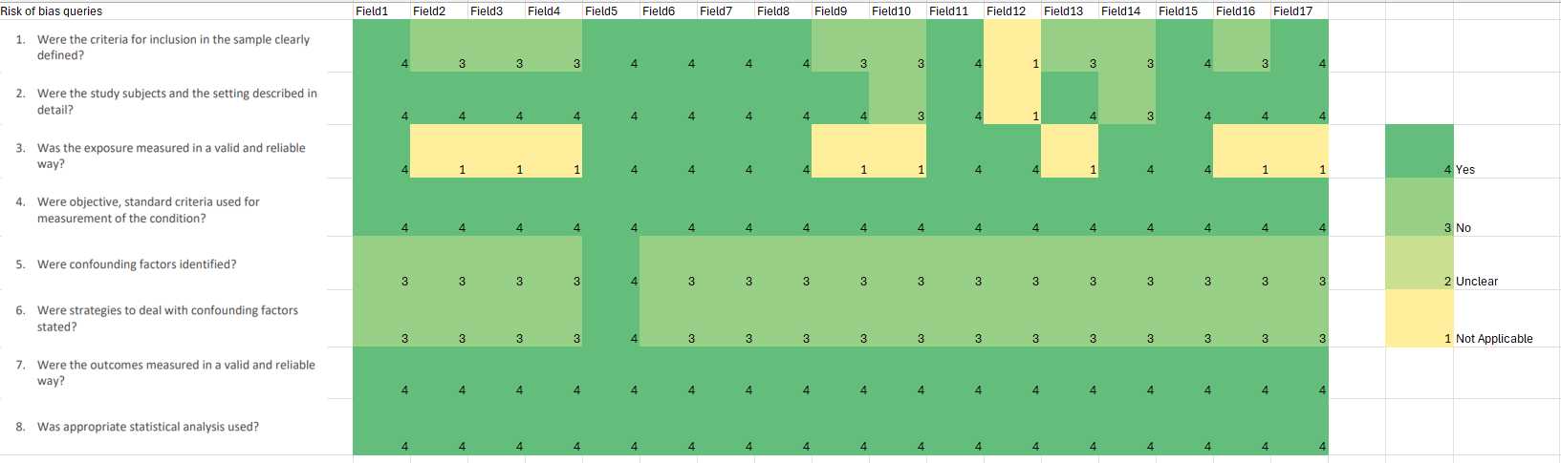
Supplementary Figure 1. The risk of bias assessment of field studies included in this systematic review. The JBI Critical Appraisal Checklist For
Analytical Cross-Sectional Studies was used in the analysis.
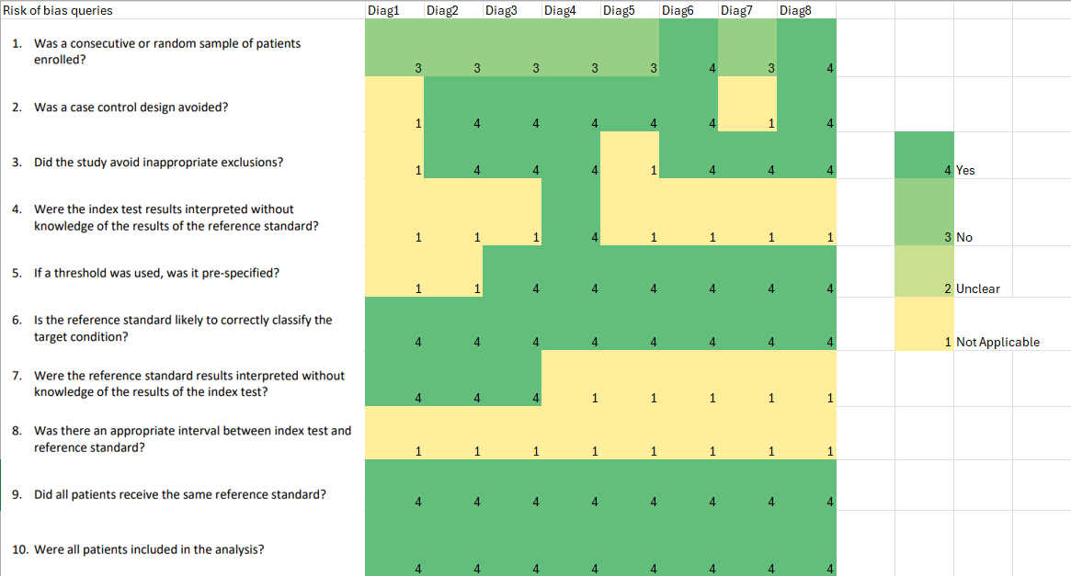
Supplementary Figure 2. The risk of bias assessment of studies that reported SNP detection methods included in this systematic review. The JBI Critical Appraisal Checklist For Diagnostic Test Accuracy Studies was used in the analysis.
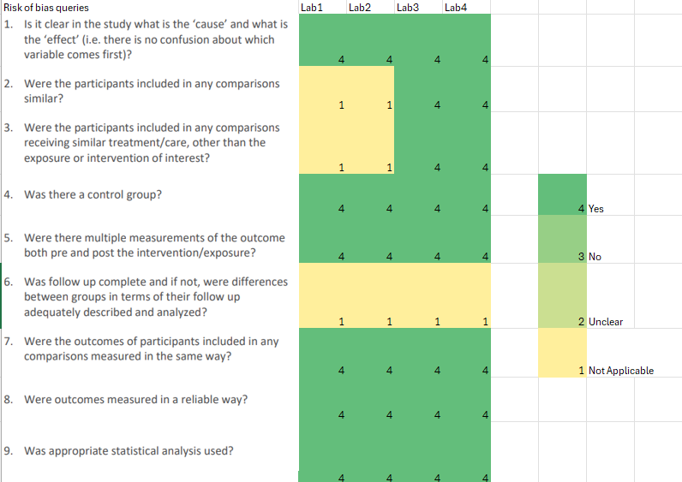
Supplementary Figure 3. The risk of bias assessment of laboratory studies included in this systematic review. The JBI Critical Appraisal Checklist For Quasi-Experimental Studies was used in the analysis.

