Supplementary Information
for
“Neoantigen evolution and response to checkpoint inhibitor immunotherapy in colorectal cancer”
Alanna Sholokhova, Kamran Kaveh, Ivana Bozic
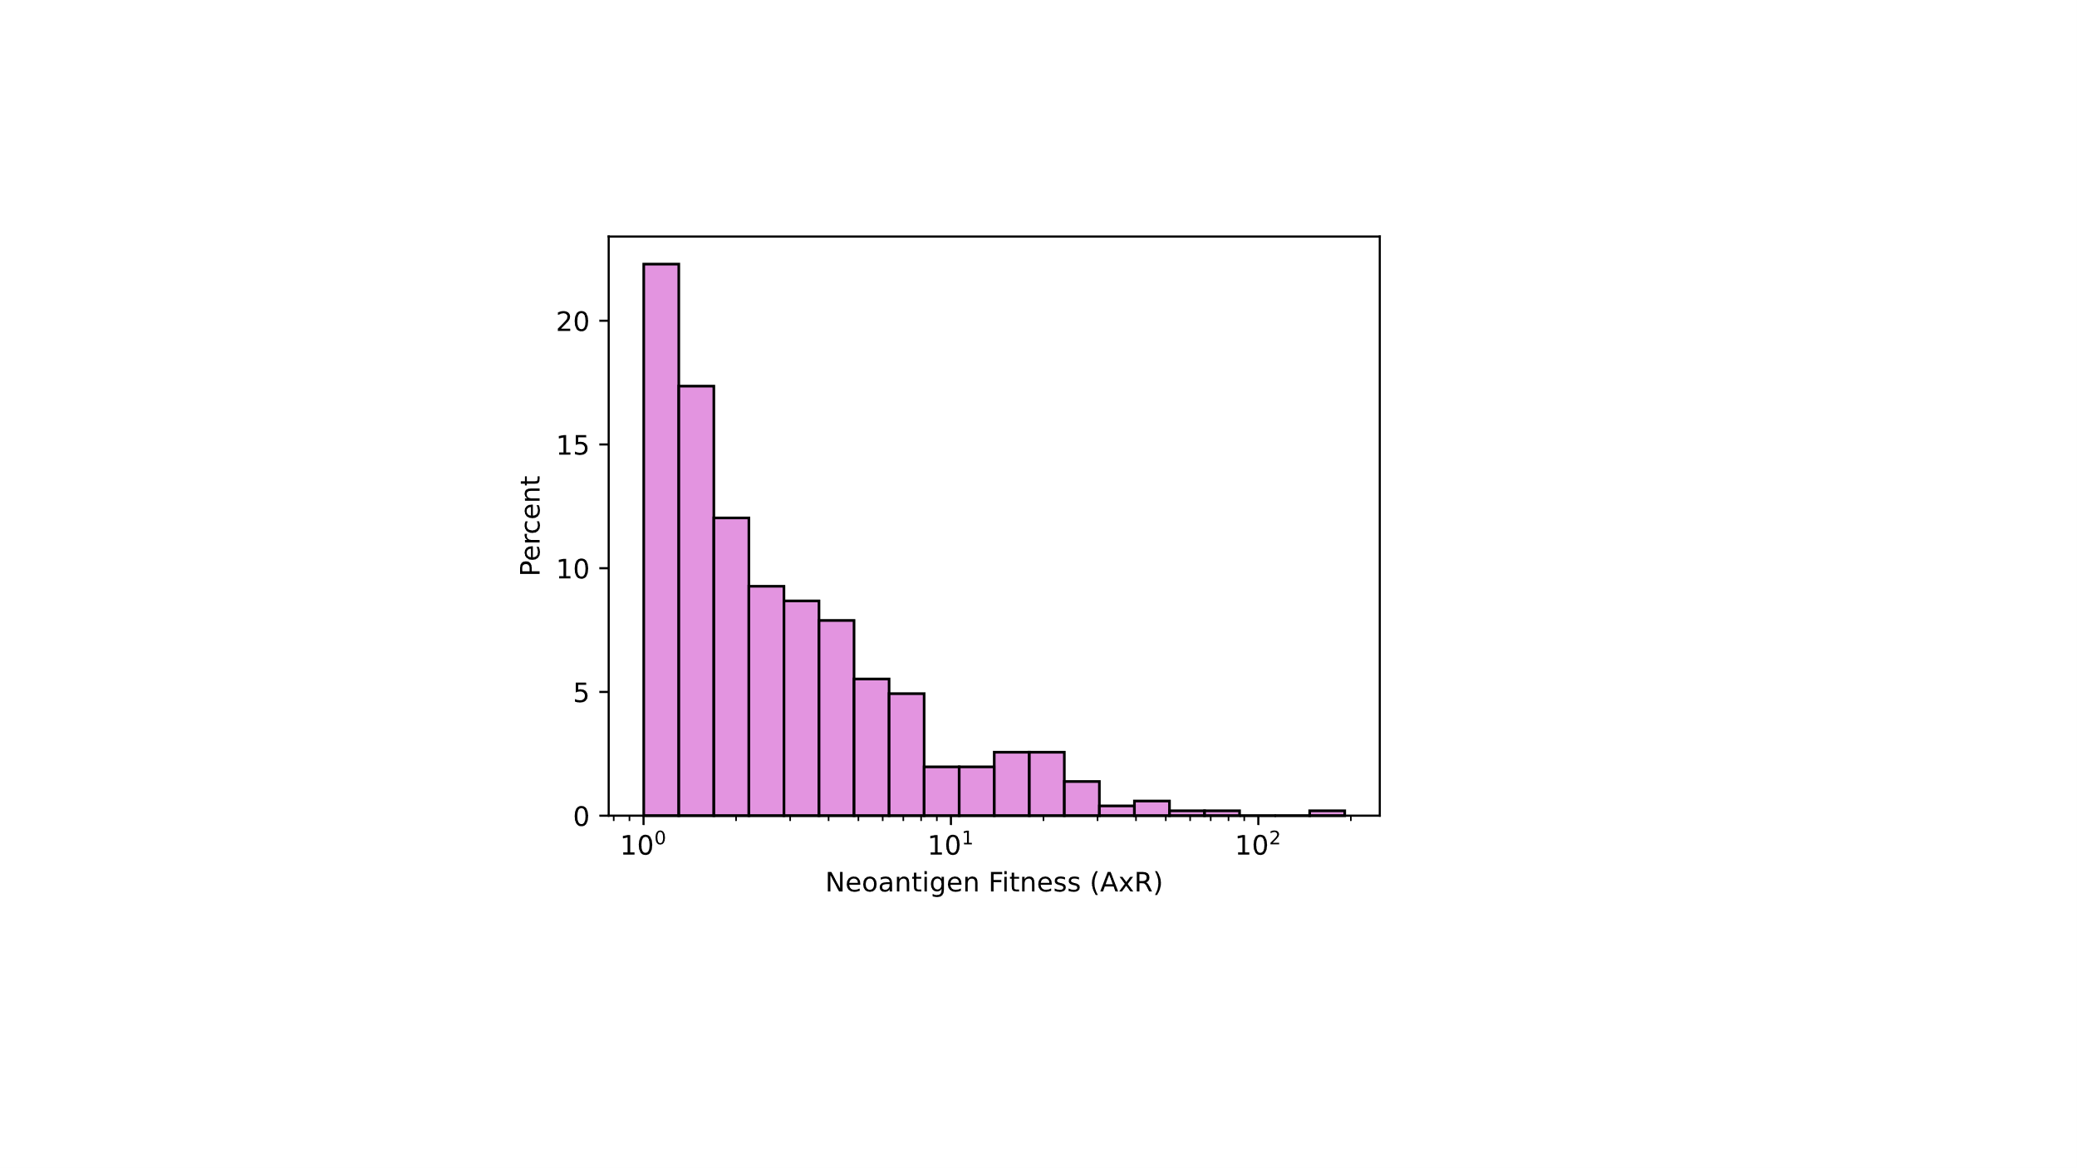
Supplementary Figure 1: Fitness scores of strong CRC neoantigens
The distribution of the fitness scores of strong CRC neoantigens are plotted with an x-axis on a log-scale.

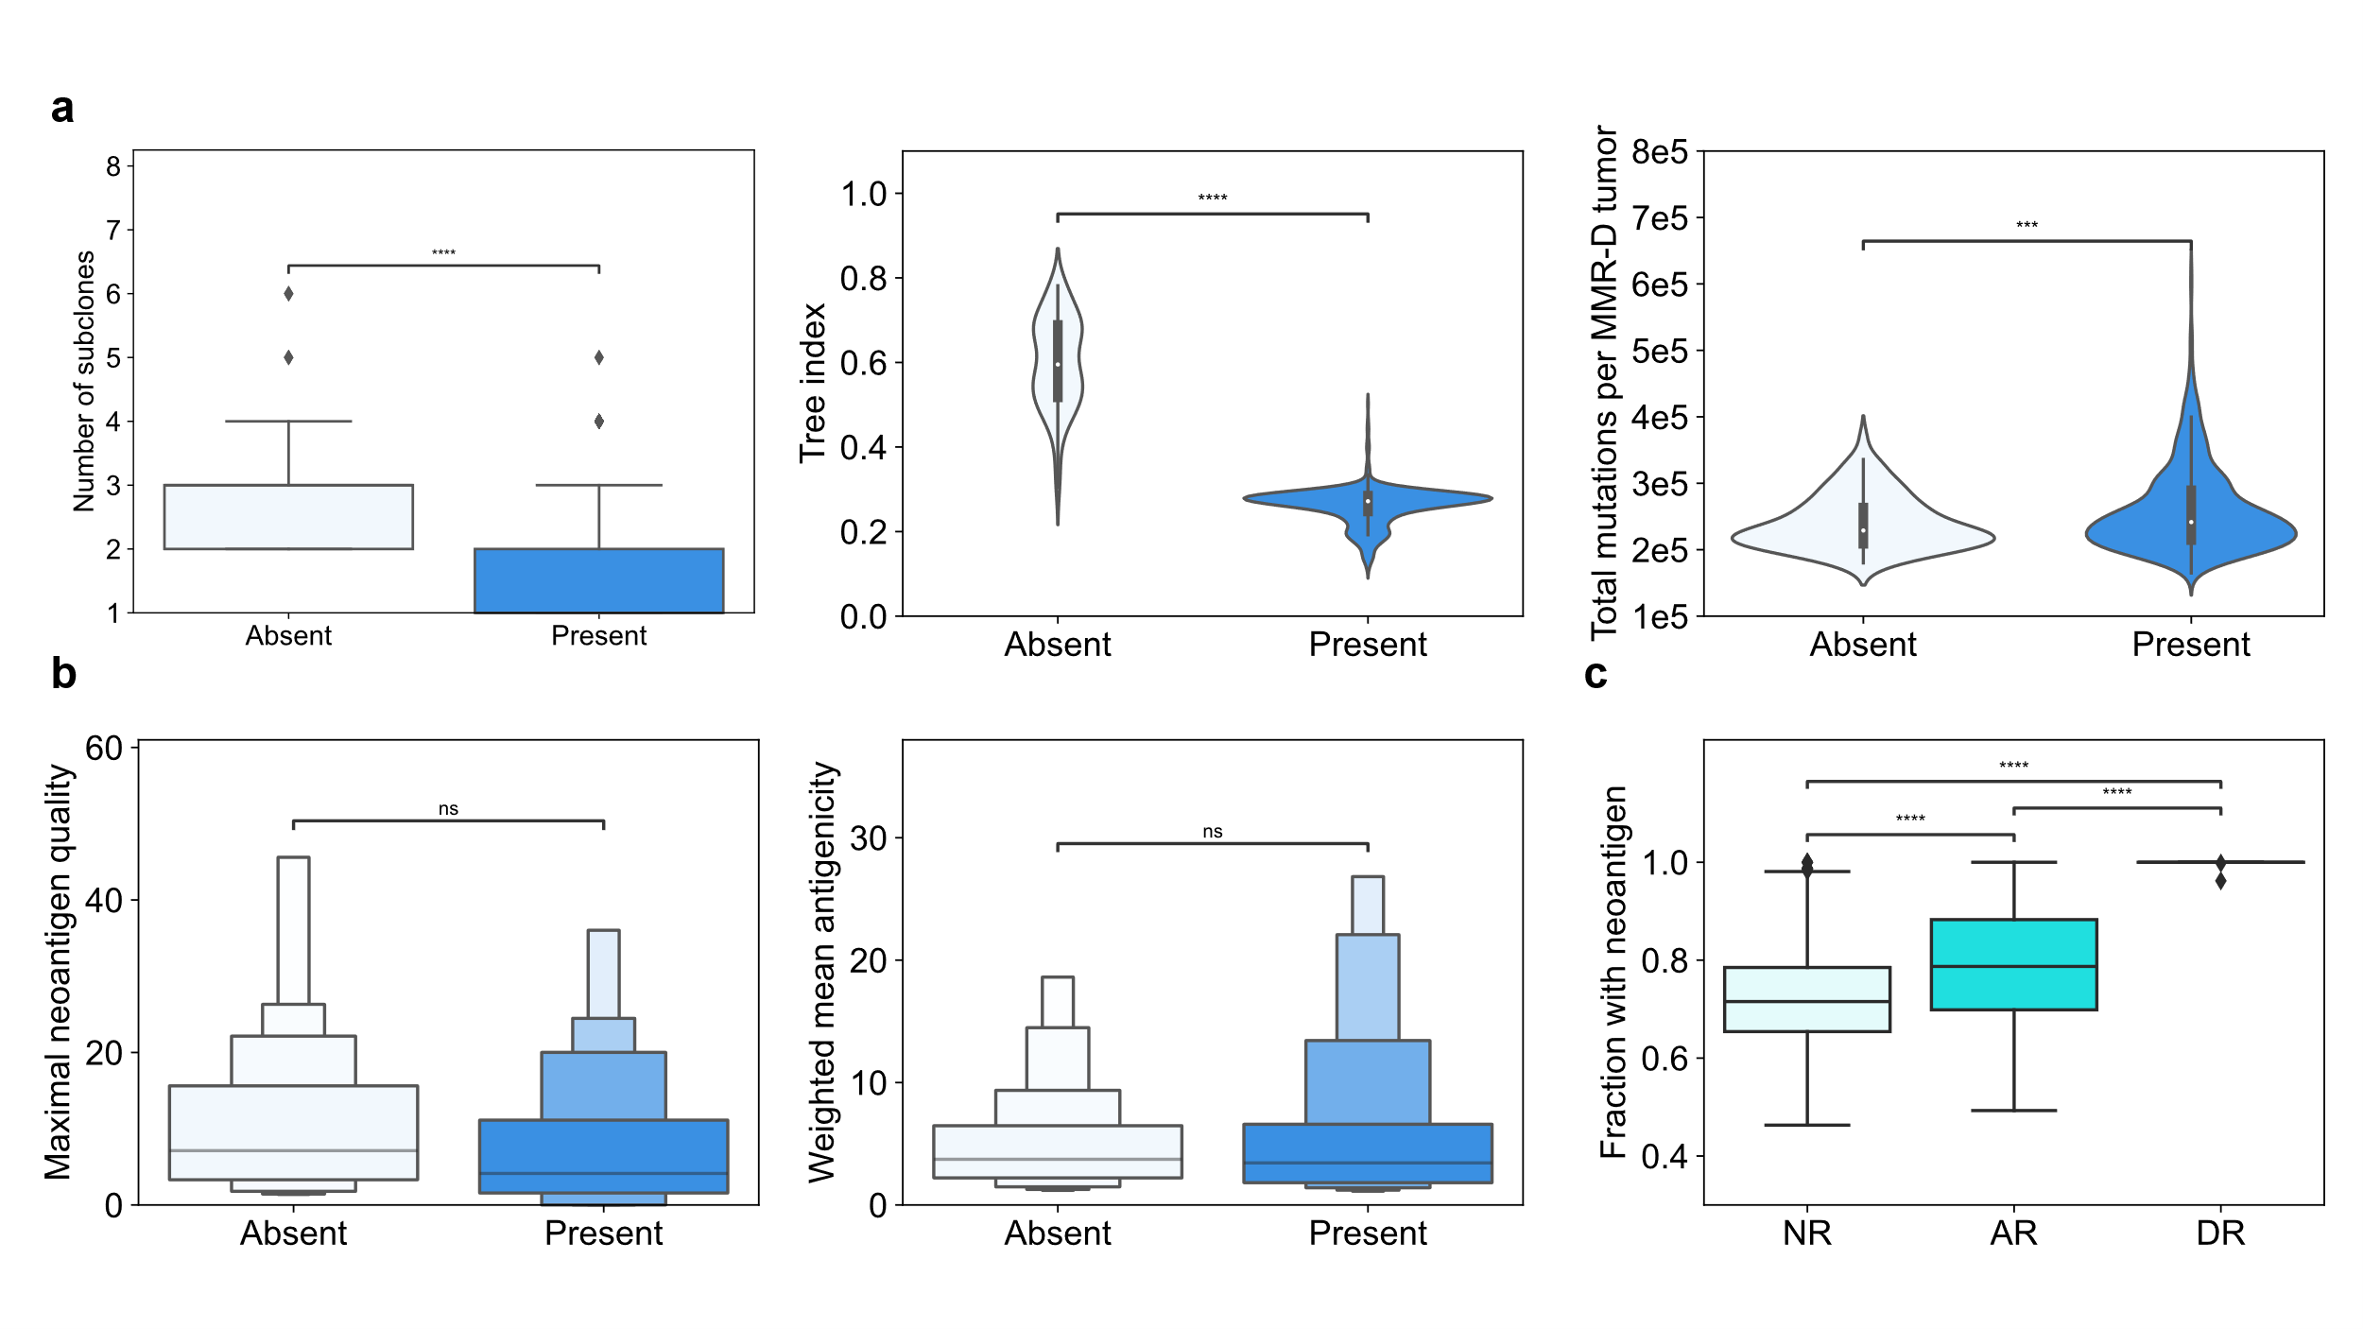
Supplementary Figure 2: Characterizing durable responses in tumors with and without clonal neoantigens
MMR-D in-silico tumors with durable response to therapy (DR) typically have a clonal neoantigen, but this is not strictly necessary to achieve DR. To understand how DR is achieved in the absence of a clonal neoantigen, we plot the determinants of response to therapy in both groups: DR without a clonal neoantigen, labeled “Absent” (pale blue), and DR with a clonal neoantigen, labeled “Present” (deep blue). a, Subclonal architecture in the tumor is displayed, in terms of heterogeneity, the tree index, and the total number of mutations per tumor at the start of treatment. b, Boxenplots demonstrate that DR tumors tend to have similar neoantigen quality. c, The fraction of cells containing at least one neoantigen at the beginning of treatment for each MMR-D tumor is depicted via boxplots, with outliers included. DR tumors have a neoantigen fraction extremely close to 1, regardless of whether they contain a clonal neoantigen or not.

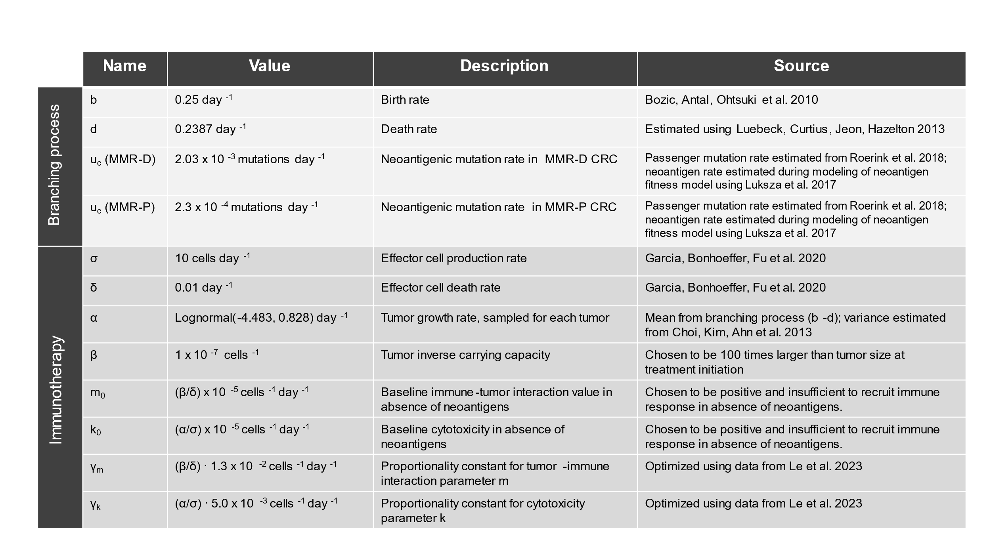
Supplementary Table 1: Parameters for branching process and immunotherapy models
Parameters for both branching process model and immunotherapy model are either sourced from literature, chosen to have reasonable values given the biological context, or fit to clinical data.

