Supplementary Material

Targeting mitochondrial metabolism to improve the tumor microenvironment: A bibliometric study and brief review (1994-2024)
Huilan Zheng ¹, Gang Wang ², Jingping Wu ³, Ming Liu ^{4*}, Hongbin Cheng ^{5*}

Supplementary Figures
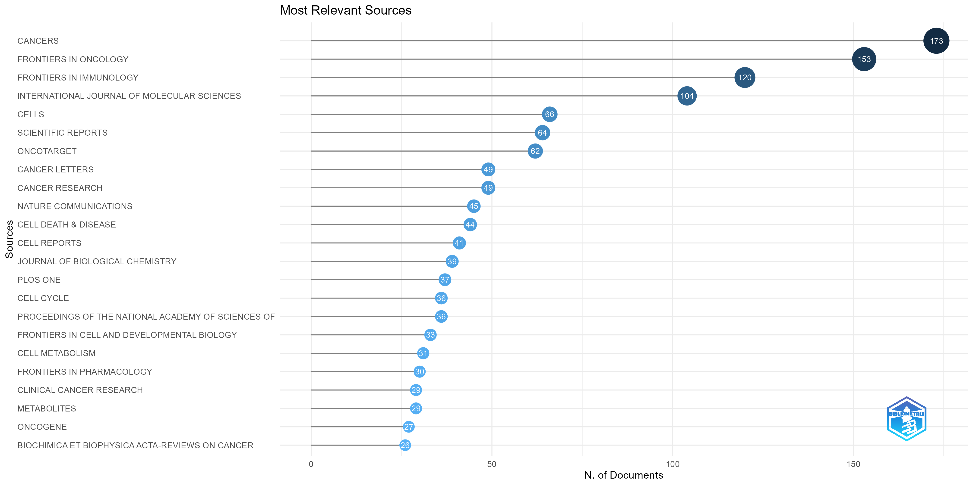
Figure 1 Analysis of core journals across all literature types
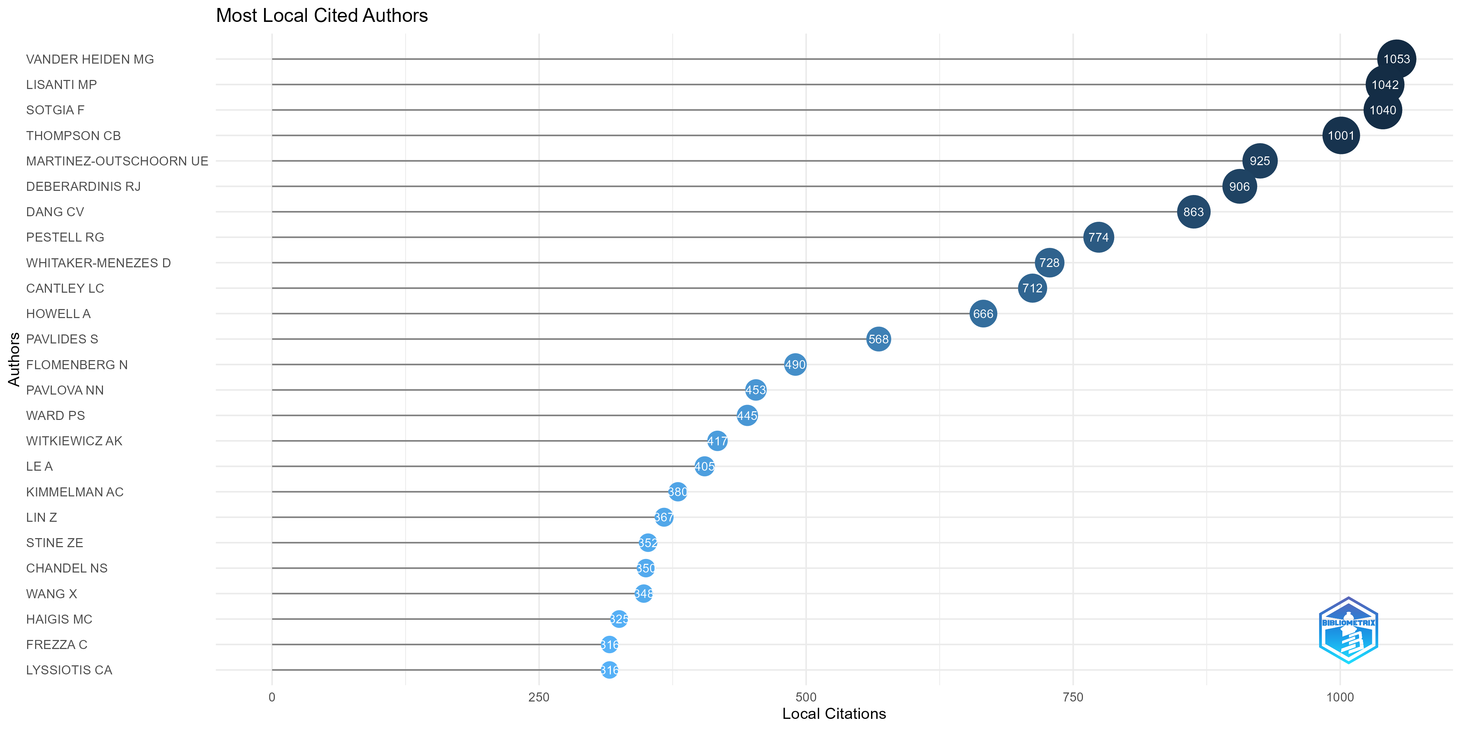
Figure 2 Analysis of most local cited authors across all literature types
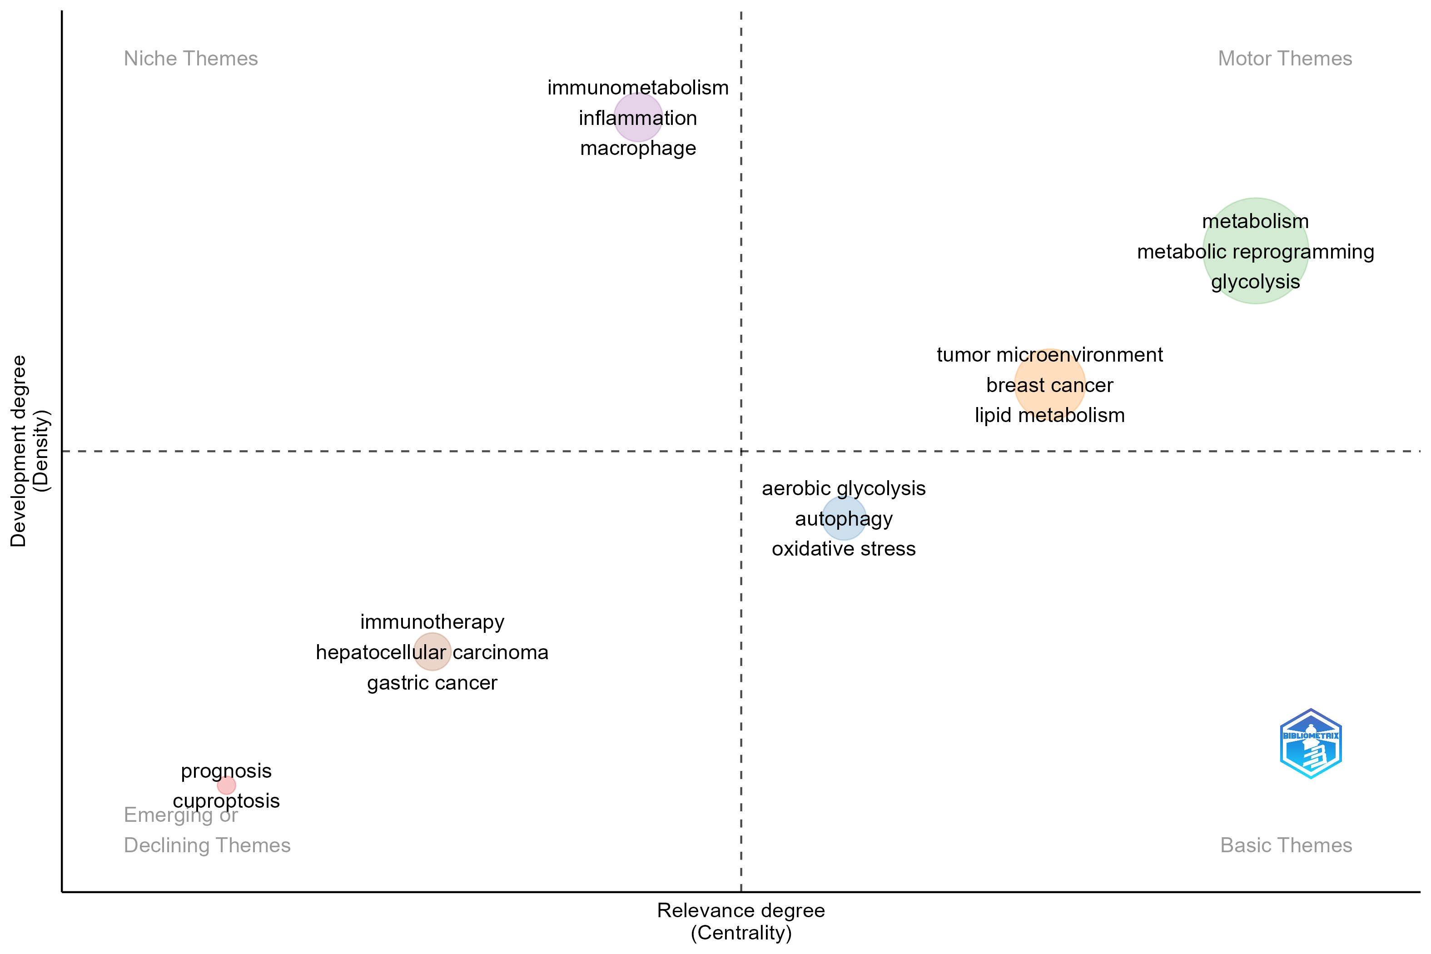
Figure 3 Analysis of keywords across all literature types

Supplementary Tables
Table 1 Top10 most-cited global documents across all literature types
Rank | Title | First Author | Year | Journal | Total Citations | DOI
1 | The Emerging Hallmarks of Cancer Metabolism | Pavlova NN | 2016 | Cell Metabolism | 3499 | 10.1016/j.cmet.2015.12.006
2 | Metabolic reprogramming: a cancer hallmark even warburg did not anticipate | Ward PS | 2012 | Cancer Cell | 2318 | 10.1016/j.ccr.2012.02.014
3 | The M2 splice isoform of pyruvate kinase is important for cancer metabolism and tumour growth | Christofk HR | 2008 | Nature | 2141 | 10.1038/nature06734
4 | Aerobic glycolysis: meeting the metabolic requirements of cell proliferation | Lunt SY | 2011 | Annual Review of Cell and Developmental Biology | 2099 | 10.1146/annurev-cellbio-092910-154237
5 | Fundamentals of cancer metabolism | Deberardinis RJ | 2016 | Science Advances | 1802 | 10.1126/sciadv.1600200
6 | A guide to immunometabolism for immunologists | O'Neill LAJ | 2016 | Nature Reviews Immunology | 1753 | 10.1038/nri.2016.70
7 | Tumor cell metabolism: cancer's Achilles' heel | Kroemer G | 2008 | Cancer Cell | 1714 | 10.1016/j.ccr.2008.05.005
8 | The transcription factor Myc controls metabolic reprogramming upon T lymphocyte activation | Wang RN | 2011 | Immunity | 1475 | 10.1016/j.immuni.2011.09.021
9 | Glutamine supports pancreatic cancer growth through a KRAS-regulated metabolic pathway | Son J | 2013 | Nature | 1413 | 10.1038/nature12040
10 | Understanding the Intersections between Metabolism and Cancer Biology | Vander Heiden MG | 2017 | Cell | 1383 | 10.1016/j.cell.2016.12.039

Table 2 Top10 most-cited local references across all literature types
Rank | Title | First Author | Year | Journal | Citations | DOI
1 | Understanding the Warburg effect: the metabolic requirements of cell proliferation | Heiden MGV | 2009 | Science | 848 | 10.1126/SCIENCE.1160809
2 | Hallmarks of cancer: the next generation | Hanahan D | 2011 | Cell | 752 | 10.1016/J.CELL.2011.02.013
3 | On the origin of cancer cells | Warburg O | 1956 | Science | 666 | 10.1126/SCIENCE.123.3191.309
4 | Beyond aerobic glycolysis: transformed cells can engage in glutamine metabolism that exceeds the requirement for protein and nucleotide synthesis | Deberardinis RJ | 2007 | Proceedings of The National Academy of Sciences of The United States of America | 418 | 10.1073/PNAS.0709747104
5 | The Emerging Hallmarks of Cancer Metabolism | Pavlova NN | 2016 | Cell Metabolism | 413 | 10.1016/J.CMET.2015.12.006
6 | c-Myc suppression of miR-23a/b enhances mitochondrial glutaminase expression and glutamine metabolism | Gao P | 2009 | Nature | 324 | 10.1038/NATURE07823
7 | Reductive glutamine metabolism by IDH1 mediates lipogenesis under hypoxia | Metallo CM | 2012 | Nature | 314 | 10.1038/NATURE10602
8 | Myc regulates a transcriptional program that stimulates mitochondrial glutaminolysis and leads to glutamine addiction | Wise DR | 2008 | Proceedings of The National Academy of Sciences of The United States of America | 307 | 10.1073/PNAS.0810199105
9 | The Metabolism of Tumors in The Body | Warburg O | 1927 | Journal of General Physiology | 289 | 10.1085/JGP.8.6.519
10 | Metabolic reprogramming: a cancer hallmark even warburg did not anticipate | Ward PS | 2012 | Cancer Cell | 282 | 10.1016/J.CCR.2012.02.014

