Additional file 4. Trend of changes in specificity and PPV depending on contaminant proportion using all dilution samples. A specificity, B PPV. Specificity and PPV of Green Cleaner was generally higher compared to SCRuB in entire degree of contamination levels.

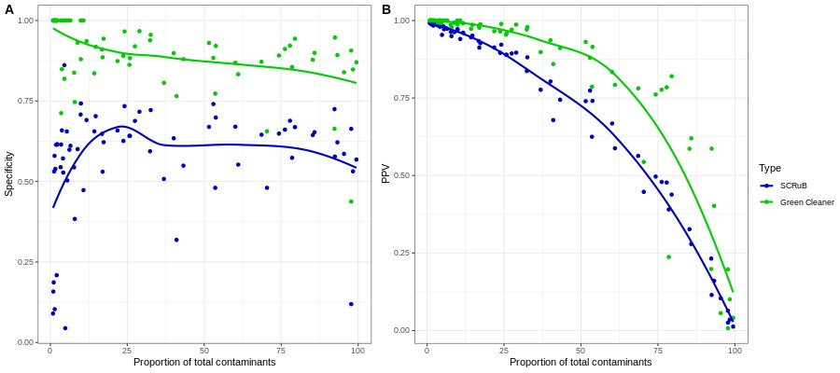

Additional file 5. The majority of contaminant ASV features that were removed from Green Cleaner but are still remained in SCRuB correspond to category 3 ASV which do not exist in the blank extraction control.

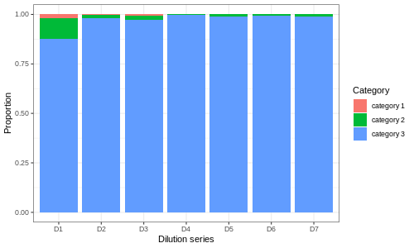

Additional file 6. As the proportion of contamination increases, the proportion of the most abundant 10 contaminant taxa also increase proportionally. The most abundant 10 contaminant taxa are displayed in color, while the other contaminant ASVs and genuine features are in grayscale.

