Supporting Information

Heterogeneous Catalytic Oxidation of 5-hydroxymethylfurfural (5-HMF) To 2,5-Diformoylfuran (DFF) Using Fe₃O₄@C Catalyst

Rama Jaiswalª, Kalluri V.S. Ranganath*

ª Dept. of Chemistry, Institute of Science, Banaras Hindu University, Varanasi

E-mail: ranganath.Chem@bhu.ac.in

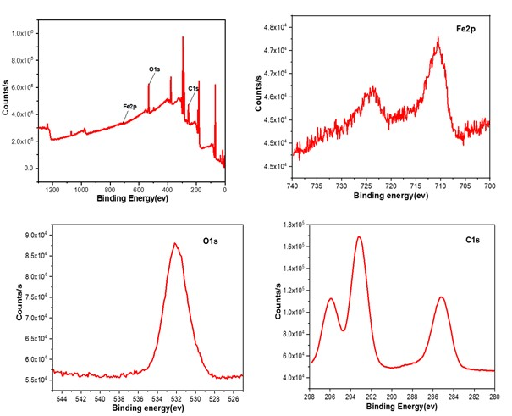

Fig. S1: XPS of a heterogeneous catalyst, Fe₃O₄@C

DFF analysis
The confirmation of DFF were done by HPLC, UV-Vis spectroscopy$.$
$$\% conversion= \frac{no. of moles of product formed}{initial no. of moles of substrate}×100$$
$$\% selectivity= \frac{no. of moles of product formed}{total no. of moles of products}×100$$

Fig. S2 Calibration curve plotted against concentration of HMF (Using HPLC, UV-detector, 483 nm).

min
0.0
2.5
5.0
7.5
10.0
12.5
15.0
17.5
20.0
0
25
50
75
Detector A 283nm

2
.
229

2
.
634

7
.
212

12
.
127

Fig. S3 HPLC chromatogram of DFF from HMF using H₂O₂ as Oxidant

min
0.0
2.5
5.0
7.5
10.0
12.5
15.0
17.5
20.0
22.5
0
50
100
150
Detector A 283nm

6
.
933

11
.
495

Fig. S4 HPLC chromatogram of DFF from HMF using TEMPO as Oxidant

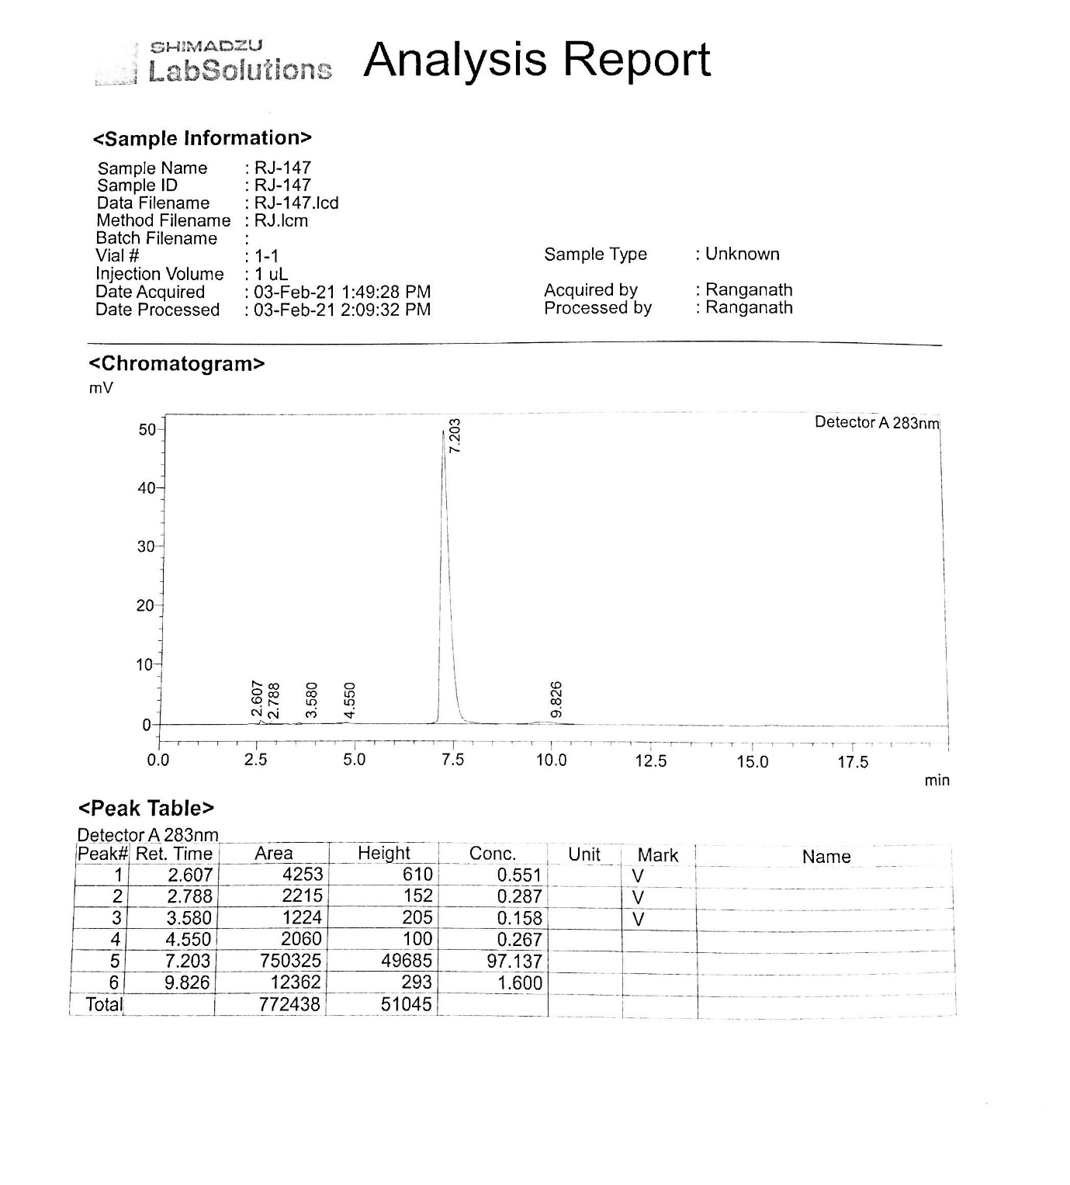
Fig. S5 HPLC chromatogram of DFF from HMF using molecular oxygen as Oxidant

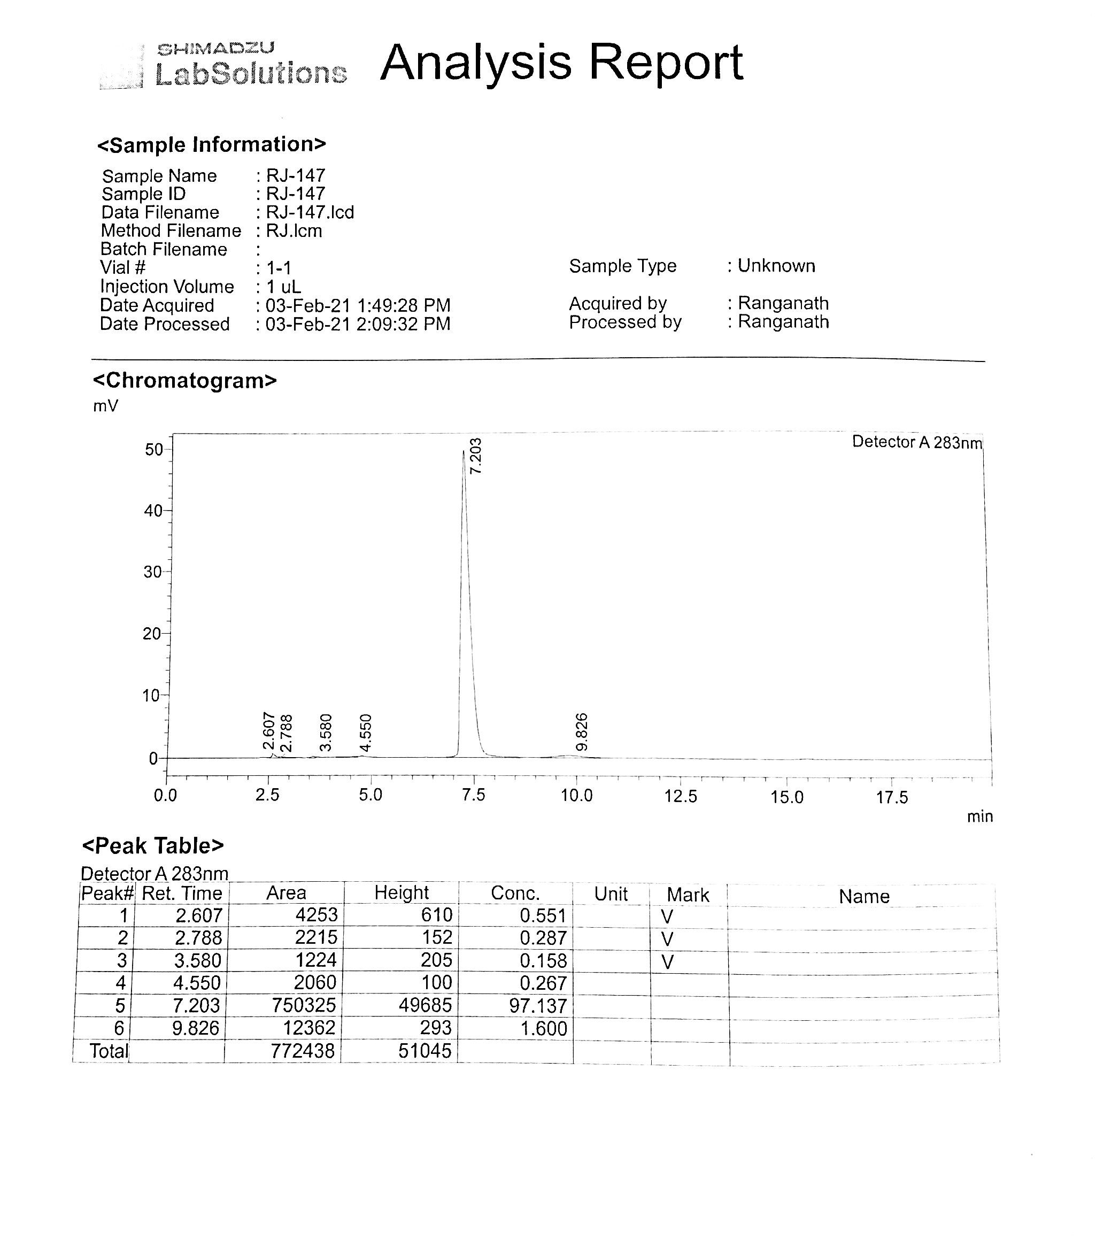
Fig. S6 HPLC chromatogram of DFF from Glucose using H₂O₂ as Oxidant

In figure S10, UV-Vis graph represent lambda max. value for Glucose (A), DFF (B) i.e. obtained from glucose and (C) also for DFF obtained from HMF.

Fig. S7 UV-Vis spectra of reaction mixture after removal of the catalysts from the reaction mixture

In summary, we developed a new heterogeneous catalyst, operable under mild conditions, for the selective oxidation of HMF to DFF using Fe₃O₄@C catalyst. Under optimized reaction conditions, we used water as a solvent.

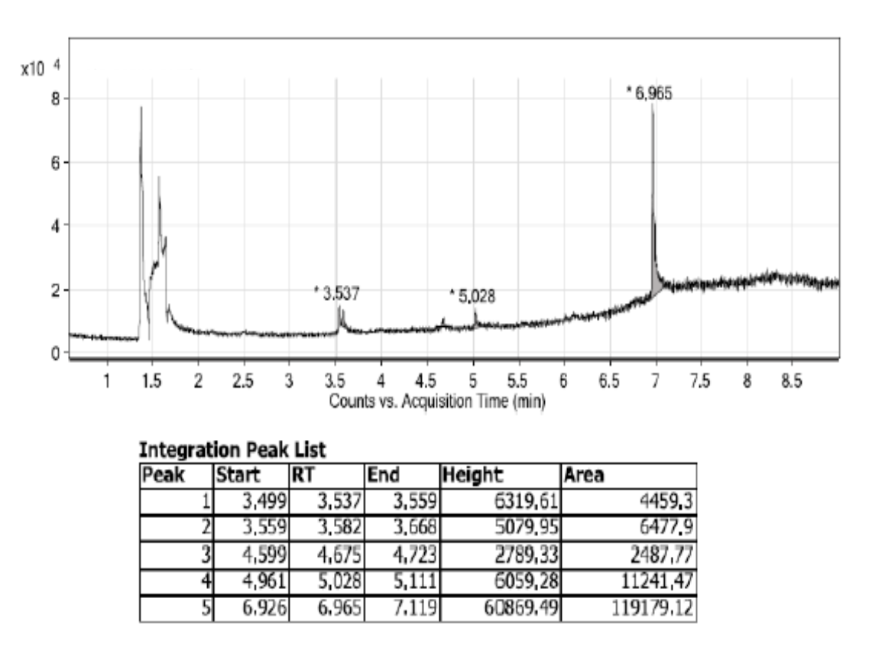
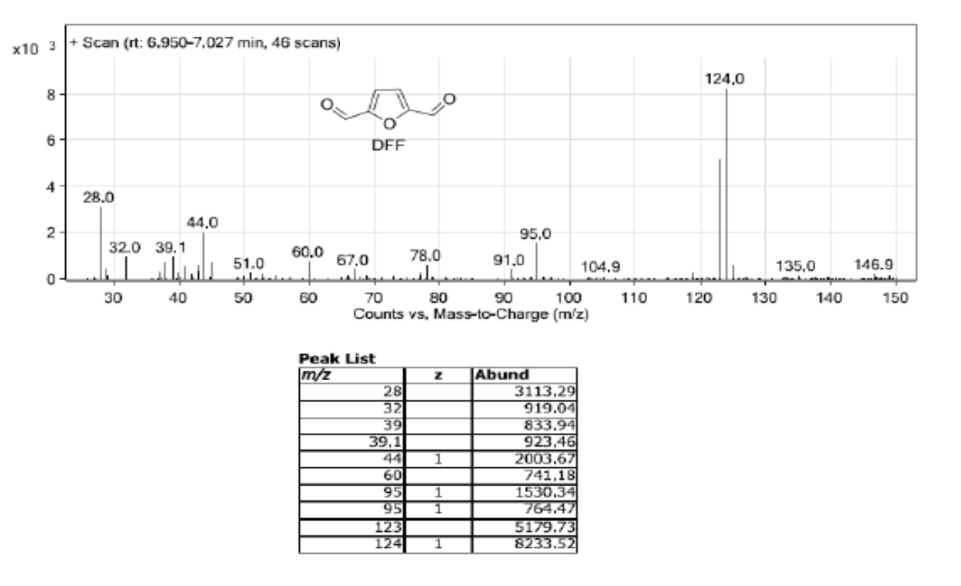

Fig. S8 GC/MS of the reaction mixture.

