APPENDICES

Appendix A. Studies included in systematic review and meta-analysis

A1. Tan AJQ, Lee CCS, Lin PY, Cooper S, Lau LST, Chua WL, et al. Designing and evaluating the effectiveness of a serious game for safe administration of blood transfusion: a randomized controlled trial. Nurse Educ Today. 2017;55:38-44. https://doi.org/10.1016/j.nedt.2017.04.027
A2. Bayram SB, Caliskan N. Effect of a game-based virtual reality phone application on tracheostomy care education for nursing students: a randomized controlled trial. Nurse Educ Today. 2019;79:25-31. https://doi.org/10.1016/j.nedt.2019.05.010
A3. Ignacio J, Chen HC. The use of web-based classroom gaming to facilitate cognitive integration in undergraduate nursing students: a mixed methods study. Nurse Educ Pract. 2020;46:102820. https://doi.org/10.1016/j.nepr.2020.102820
A4. Gutierrez-Puertas L, Garcia-Viola A, Márquez-Hernández VV, Garrido-Molina JM, Granados-Gamez G, Aguilera-Manrique G. Guess it (SVUAL): an app designed to help nursing students acquire and retain knowledge about basic and advanced life support techniques. Nurse Educ Pract. 2021;50:102961. https://doi.org/10.1016/j.nepr.2020.102961
A5. Calik A, Kapucu S. The effect of serious games for nursing students in clinical decision-making process: a pilot randomized controlled trial. Games Health J. 2022;11(1):30-37. https://doi.org/10.1089/g4h.2021.0180
A6. Gu R, Wang J, Zhang Y, Li Q, Wang S, Sun T, et al. Effectiveness of a game-based mobile application in educating nursing students on flushing and locking venous catheters with pre-filled saline syringes: a randomized controlled trial. Nurse Educ Pract. 2022;58:103260. https://doi.org/10.1016/j.nepr.2021.103260
A7. Elzeky ME, Elhabashy HM, Ali WG, Allam SM. Effect of gamified flipped classroom on improving nursing students’ skills competency and learning motivation: a randomized controlled trial. BMC Nurs. 2022;21(1):316. https://doi.org/10.1186/s12912-022-01096-6
A8. Sarvan S, Efe E. The effect of neonatal resuscitation training based on a serious game simulation method on nursing students' knowledge, skills, satisfaction and self-confidence levels: a randomized controlled trial. Nurse Educ Today. 2022;111:105298. https://doi.org/10.1016/j.nedt.2022.105298
A9. Rosa-Castillo A, García-Pañella O, Roselló-Novella A, Maestre-Gonzalez E, Pulpón-Segura A, Icart-Isern T, et al. The effectiveness of an Instagram-based educational game in a Bachelor of Nursing course: an experimental study. Nurse Educ Pract. 2023;70:103656. https://doi.org/10.1016/j.nepr.2023.103656
A10. Tang Y, Gu R, Zhao Y, Wang J, Zhang Y, Li Q, et al. Effectiveness of a game-based mobile application in educating nursing students on venous blood specimen collection: a randomized controlled trial. Games Health J. 2023;12(1):63-72. https://doi.org/10.1089/g4h.2022.0085
A11. Kulakaç N, Çilingir D. The effect of a serious game-based web application on stoma care education for nursing students: a randomized controlled trial. Teach Learn Nurs. 2024;19(1):e126-32. https://doi.org/10.1016/j.teln.2023.10.001

Appendix B. Forest plots for the sensitivity analysis

B.1. Sensitivity analysis for knowledge
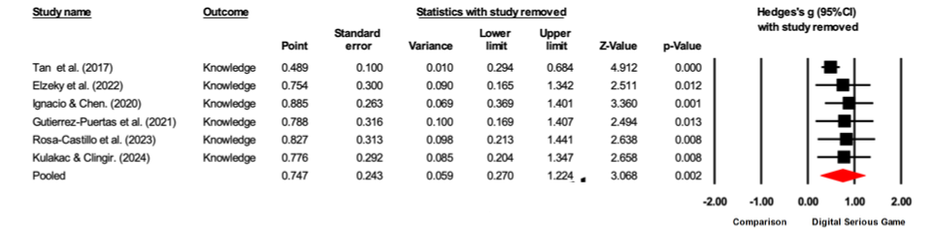
B.2. Sensitivity analysis for confidence
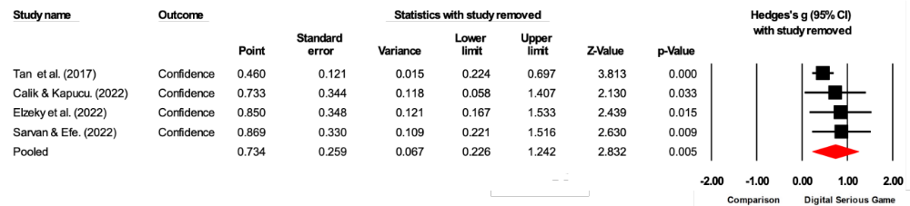
B.3. Sensitivity analysis for performance
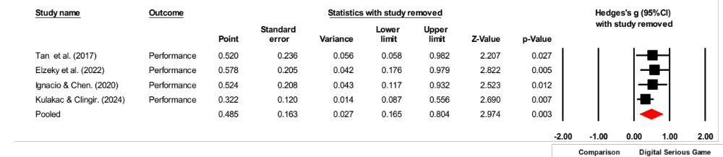

Appendix C. Funnel plots

C.1. Funnel plot for knowledge
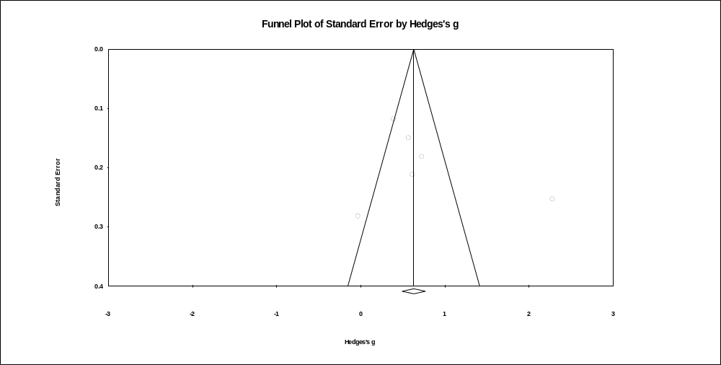
C.2. Funnel plot for confidence
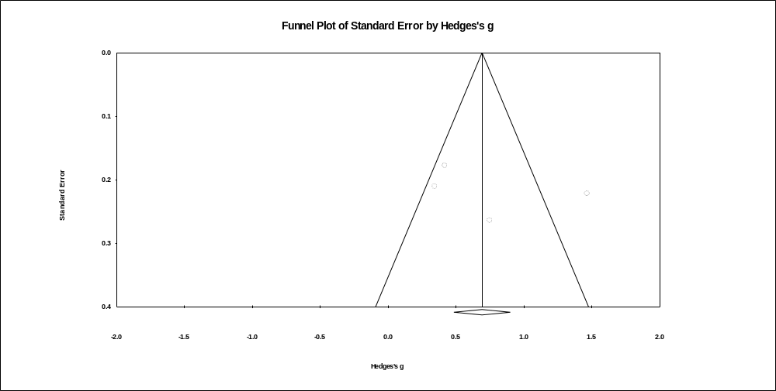

C.3. Funnel plot for performance
