Supplementary Materials
Table S1 Key reagents used in this study
Reagent type | Designation | Source | Identifiers | Additional
Cell line | Rat pituitary tumor cells | BNCC | GH3
Cell line | Rat gonadotroph adenoma cell line | BNCC | GT1-1
Cell line | Human embryonic kidney cell | BNCC | 293T
Cell line | Mouse Embryonic Osteoblasts Cells | BNCC | MC3T3-E1
Antibody | anti-Cathepsin K (EPR19992) (rabbit monoclonal) | Abcam | ab207086 | WB (1:1000)  IHC (1:1000)
Antibody | anti-S6K (49D7) (rabbit monoclonal) | CST | 2708T | WB (1:1000)
Antibody | anti-pS6K (Ser371) (rabbit monoclonal) | CST | 9208T | WB (1:1000)
Antibody | anti-4E-BP1 (53H11) (rabbit monoclonal) | CST | 9644T | WB (1:1000)
Antibody | anti-p4E-BP1 (Thr37/46) (236B4) (rabbit monoclonal) | CST | 2855T | WB (1:1000)
Antibody | anti-UCHL1 (D3T2E) (rabbit monoclonal) | CST | 13179T | WB (1:1000)
Antibody | anti-TLR4 (E5D8T) (rabbit monoclonal) | CST | 38519S | WB (1:1000)
Antibody | Mouse and Rabbit specific HRP/DAB Detection IHC Kit | Abcam | ab64264 | WB (1:5000)  IHC (1:5000)
Protein | Recombinant  human CTSK protein | Bio Vision | 1026-10
Drug | Everolimus (RAD001) | Selleckchem | S1120 | Dissolved in DMSO
Drug | Odanacatib (MK-0822) | Selleckchem | S1115 | Dissolved in DMSO

Table S2 PCR primers of mRNAs used for qRT-PCR
 | Sequences (5'to3')
GAPDH-F | GCATCTTCTTGTGCAGTGCC
GAPDH-R | GATGGTGATGGGTTTCCCGT
RANKL-F | GATGAAAGGAGGGAGCACG
RANKL-R | GCAGGGAAGGGTTGGACAC
OPG-F | CAGAGAAGCCACGCAAAAGTG
OPG-R | AGCTGTGTCTCCGTTTTATCCT
CTSK-F | TCCTCAACAGTGCAAGCGAA
CTSK-R | CCAGCGTCTATCAGCACAGA

Table S3 CTSK siRNA sequences
RNA | Sequences (5'to3')
CTSK siRNA | CCAUAACCUUGAGGCUUCUTT
CTSK siRNA-NC | UUCUCCGAACGUGUCACGUTT

Supplementary Tables
Table S4 Clinical variable analyses of BIPAs
 | BIPAs  146 | Non-BIPAs  1291 | χ²/T | P
Age, y | 52.6±11.5 | 48.2±14.0 | 3.701 | ＜0.001
LTD, mm | 29.5±13.5 | 21.2±9.7 | 8.813 | ＜0.001
Volume of tumor, cm³ | 12.6 (3.4-31.1) | 4.9 (1.1-11.2) | 9.470 | ＜0.001
Apoplexy, n (%) | 45 (30.8) | 221 (17.1) | 16.329 | ＜0.001
NGTR, n (%) | 44 (30.1) | 111 (8.6) | 63.236 | ＜0.001
Headache, n (%) | 63 (43.2) | 404 (31.3) | 8.409 | 0.004
FPAs, n (%) | 36 (24.7) | 430 (33.3) | 4.479 | 0.034
Note: Skewed data are expressed as mean with SD or median (interquartile range) categorical data are expressed as n (%). Abbreviations: BIPAs: bone invasive pituitary adenomas, LTD: the largest tumor diameter, NGTR: not gross total resection, FPAs: functioning PAs.

Table S5 The characteristics of 137 recurrent patients
No | Age | Sex | BMI | DM | HTN | Invasion | Function | RFS | GTR | LTD
18 | 68 | F | 1 | No | No | BIPAs | FPAs | 10 | Yes | 10
55 | 47 | M | 1 | No | Yes | BIPAs | FPAs | 13 | Yes | 22
68 | 31 | M | 4 | No | No | BIPAs | FPAs | 14 | Yes | 20
94 | 70 | F | 2 | No | Yes | BIPAs | FPAs | 12 | Yes | 15
132 | 51 | M | 2 | No | No | BIPAs | FPAs | 15 | Yes | 18
156 | 38 | F | 3 | No | No | BIPAs | FPAs | 13 | Yes | 46
245 | 66 | F | 3 | No | Yes | BIPAs | FPAs | 16 | Yes | 10
487 | 56 | F | 2 | No | No | BIPAs | FPAs | 25 | No | 75
715 | 53 | M | 4 | No | Yes | BIPAs | FPAs | 13 | Yes | 20
834 | 64 | F | 1 | No | No | BIPAs | FPAs | 21 | No | 47
1176 | 40 | M | 3 | No | No | BIPAs | FPAs | 35 | No | 20
1271 | 50 | M | 3 | No | Yes | BIPAs | FPAs | 20 | No | 45
1313 | 57 | M | 2 | No | No | BIPAs | FPAs | 15 | No | 39
1459 | 58 | F | 1 | No | No | BIPAs | FPAs | 15 | Yes | 34
25 | 48 | F | 3 | No | No | BIPAs | NFPAs | 11 | No | 55
40 | 67 | M | 4 | No | Yes | BIPAs | NFPAs | 22 | No | 32
63 | 58 | F | 3 | No | No | BIPAs | NFPAs | 12 | No | 58
72 | 62 | M | 1 | No | Yes | BIPAs | NFPAs | 15 | No | 42
116 | 67 | F | 2 | Yes | Yes | BIPAs | NFPAs | 14 | No | 61
131 | 37 | M | 2 | No | No | BIPAs | NFPAs | 16 | Yes | 2
293 | 54 | F | 2 | No | No | BIPAs | NFPAs | 17 | No | 30
330 | 38 | M | 2 | No | No | BIPAs | NFPAs | 16 | Yes | 20
433 | 48 | F | 2 | No | No | BIPAs | NFPAs | 20 | No | 40
501 | 55 | F | 1 | No | No | BIPAs | NFPAs | 36 | No | 50
567 | 43 | F | 2 | Yes | Yes | BIPAs | NFPAs | 40 | No | 31
620 | 53 | M | 1 | No | No | BIPAs | NFPAs | 32 | Yes | 20
756 | 57 | F | 1 | No | No | BIPAs | NFPAs | 48 | No | 20
829 | 34 | M | 2 | No | No | BIPAs | NFPAs | 29 | Yes | 33
831 | 58 | F | 2 | Yes | Yes | BIPAs | NFPAs | 16 | No | 61
832 | 57 | M | 2 | Yes | Yes | BIPAs | NFPAs | 23 | No | 29
1009 | 72 | F | 4 | No | No | BIPAs | NFPAs | 48 | No | 37
1082 | 44 | M | 1 | No | No | BIPAs | NFPAs | 38 | Yes | 17
1124 | 63 | F | 2 | No | No | BIPAs | NFPAs | 56 | Yes | 30
1173 | 55 | F | 1 | No | Yes | BIPAs | NFPAs | 26 | No | 40
1257 | 47 | M | 3 | No | No | BIPAs | NFPAs | 22 | No | 52
1356 | 68 | F | 4 | Yes | Yes | BIPAs | NFPAs | 26 | No | 45
1400 | 64 | F | 1 | No | No | BIPAs | NFPAs | 19 | Yes | 37
1411 | 61 | F | 2 | No | No | BIPAs | NFPAs | 40 | Yes | 13
1446 | 56 | F | 2 | No | No | BIPAs | NFPAs | 28 | No | 26
1489 | 63 | M | 3 | No | No | BIPAs | NFPAs | 21 | No | 40
2 | 35 | F | 1 | No | No | IPAs no bone | FPAs | 14 | No | 10
10 | 45 | F | 2 | Yes | No | IPAs no bone | FPAs | 14 | Yes | 25
159 | 40 | F | 2 | No | No | IPAs no bone | FPAs | 18 | Yes | 36
209 | 38 | F | 2 | No | No | IPAs no bone | FPAs | 20 | Yes | 26
242 | 40 | F | 2 | No | Yes | IPAs no bone | FPAs | 11 | Yes | 18
517 | 62 | F | 2 | Yes | Yes | IPAs no bone | FPAs | 29 | Yes | 20
564 | 36 | F | 3 | No | Yes | IPAs no bone | FPAs | 37 | Yes | 26
663 | 31 | F | 1 | No | No | IPAs no bone | FPAs | 45 | No | 50
779 | 63 | F | 2 | Yes | No | IPAs no bone | FPAs | 30 | Yes | 10
867 | 36 | M | 2 | No | No | IPAs no bone | FPAs | 47 | Yes | 11
981 | 37 | M | 3 | No | No | IPAs no bone | FPAs | 28 | No | 20
984 | 21 | M | 4 | No | No | IPAs no bone | FPAs | 19 | Yes | 15
1090 | 62 | F | 3 | Yes | Yes | IPAs no bone | FPAs | 58 | Yes | 5
1097 | 47 | F | 2 | No | No | IPAs no bone | FPAs | 24 | No | 45
1280 | 48 | M | 1 | No | Yes | IPAs no bone | FPAs | 44 | Yes | 25
1320 | 27 | M | 2 | No | Yes | IPAs no bone | FPAs | 20 | No | 38
108 | 76 | F | 2 | Yes | Yes | IPAs no bone | NFPAs | 16 | Yes | 21
178 | 55 | F | 3 | No | No | IPAs no bone | NFPAs | 15 | Yes | 22
336 | 69 | F | 1 | No | No | IPAs no bone | NFPAs | 26 | Yes | 20
407 | 55 | M | 2 | No | No | IPAs no bone | NFPAs | 29 | No | 27
410 | 59 | F | 2 | No | No | IPAs no bone | NFPAs | 23 | Yes | 31
448 | 58 | M | 1 | No | Yes | IPAs no bone | NFPAs | 28 | Yes | 40
466 | 57 | F | 2 | No | No | IPAs no bone | NFPAs | 23 | Yes | 33
535 | 58 | F | 2 | No | Yes | IPAs no bone | NFPAs | 19 | No | 29
644 | 45 | F | 2 | No | No | IPAs no bone | NFPAs | 18 | Yes | 5
949 | 60 | M | 2 | No | Yes | IPAs no bone | NFPAs | 57 | No | 24
958 | 64 | F | 3 | No | No | IPAs no bone | NFPAs | 16 | No | 55
968 | 54 | F | 1 | No | No | IPAs no bone | NFPAs | 38 | No | 30
1075 | 73 | M | 2 | No | No | IPAs no bone | NFPAs | 34 | No | 16
1249 | 38 | F | 3 | No | No | IPAs no bone | NFPAs | 50 | No | 31
1342 | 52 | F | 1 | No | No | IPAs no bone | NFPAs | 46 | Yes | 24
1364 | 46 | M | 2 | No | No | IPAs no bone | NFPAs | 26 | No | 39
1387 | 70 | F | 3 | No | Yes | IPAs no bone | NFPAs | 42 | No | 33
1440 | 54 | F | 2 | No | Yes | IPAs no bone | NFPAs | 50 | Yes | 25
165 | 58 | F | 4 | No | No | Non-IPAs | FPAs | 17 | Yes | 6
254 | 62 | F | 2 | No | No | Non-IPAs | FPAs | 21 | Yes | 5
609 | 15 | F | 3 | No | No | Non-IPAs | FPAs | 36 | Yes | 12
614 | 31 | M | 2 | No | Yes | Non-IPAs | FPAs | 32 | Yes | 2
691 | 51 | F | 2 | No | No | Non-IPAs | FPAs | 45 | Yes | 10
917 | 47 | M | 1 | No | Yes | Non-IPAs | FPAs | 19 | Yes | 5
925 | 17 | F | 2 | No | Yes | Non-IPAs | FPAs | 31 | Yes | 5
926 | 18 | F | 2 | No | No | Non-IPAs | FPAs | 36 | Yes | 20
991 | 26 | F | 4 | No | Yes | Non-IPAs | FPAs | 53 | Yes | 10
1152 | 42 | F | 1 | No | No | Non-IPAs | FPAs | 47 | Yes | 18
1162 | 28 | F | 2 | No | No | Non-IPAs | FPAs | 23 | No | 9
1188 | 52 | F | 1 | Yes | Yes | Non-IPAs | FPAs | 22 | Yes | 14
1199 | 31 | M | 1 | No | No | Non-IPAs | FPAs | 22 | No | 55
1215 | 49 | F | 2 | No | No | Non-IPAs | FPAs | 30 | No | 17
1240 | 44 | F | 1 | Yes | Yes | Non-IPAs | FPAs | 64 | No | 32
1243 | 15 | M | 1 | No | No | Non-IPAs | FPAs | 21 | No | 30
1247 | 45 | F | 4 | No | Yes | Non-IPAs | FPAs | 42 | Yes | 10
1250 | 48 | F | 2 | No | Yes | Non-IPAs | FPAs | 21 | No | 15
1258 | 53 | F | 3 | No | Yes | Non-IPAs | FPAs | 21 | Yes | 20
1286 | 12 | F | 2 | No | No | Non-IPAs | FPAs | 36 | No | 13
1289 | 47 | F | 2 | Yes | Yes | Non-IPAs | FPAs | 55 | Yes | 14
1291 | 23 | F | 1 | No | No | Non-IPAs | FPAs | 68 | No | 46
1346 | 68 | M | 2 | No | No | Non-IPAs | FPAs | 31 | Yes | 10
1397 | 9 | F | 1 | No | No | Non-IPAs | FPAs | 21 | No | 30
1398 | 35 | F | 3 | No | No | Non-IPAs | FPAs | 54 | No | 20
1447 | 35 | M | 2 | No | No | Non-IPAs | FPAs | 37 | Yes | 15
1464 | 18 | F | 2 | No | No | Non-IPAs | FPAs | 18 | Yes | 18
1465 | 46 | F | 3 | No | Yes | Non-IPAs | FPAs | 19 | No | 45
1483 | 61 | M | 2 | No | Yes | Non-IPAs | FPAs | 22 | Yes | 18
30 | 26 | M | 2 | No | No | Non-IPAs | NFPAs | 11 | Yes | 28
32 | 55 | F | 2 | No | No | Non-IPAs | NFPAs | 12 | Yes | 24
51 | 72 | F | 2 | No | Yes | Non-IPAs | NFPAs | 13 | Yes | 17
54 | 66 | M | 2 | No | Yes | Non-IPAs | NFPAs | 12 | No | 42
86 | 74 | M | 2 | No | No | Non-IPAs | NFPAs | 15 | Yes | 27
158 | 71 | M | 2 | No | No | Non-IPAs | NFPAs | 19 | Yes | 32
196 | 51 | M | 2 | Yes | No | Non-IPAs | NFPAs | 16 | Yes | 15
219 | 63 | M | 2 | Yes | Yes | Non-IPAs | NFPAs | 16 | Yes | 8
276 | 45 | F | 2 | No | Yes | Non-IPAs | NFPAs | 18 | Yes | 30
370 | 55 | M | 1 | No | No | Non-IPAs | NFPAs | 27 | Yes | 6
405 | 53 | M | 1 | No | No | Non-IPAs | NFPAs | 19 | Yes | 10
411 | 60 | M | 2 | Yes | No | Non-IPAs | NFPAs | 20 | Yes | 26
475 | 66 | M | 1 | No | No | Non-IPAs | NFPAs | 26 | Yes | 30
683 | 67 | M | 1 | No | No | Non-IPAs | NFPAs | 35 | Yes | 20
737 | 70 | M | 1 | No | Yes | Non-IPAs | NFPAs | 37 | Yes | 20
750 | 39 | M | 2 | No | No | Non-IPAs | NFPAs | 39 | Yes | 30
790 | 69 | M | 1 | No | No | Non-IPAs | NFPAs | 40 | Yes | 18
822 | 48 | F | 1 | No | Yes | Non-IPAs | NFPAs | 36 | No | 20
862 | 49 | M | 2 | No | No | Non-IPAs | NFPAs | 37 | Yes | 20
901 | 38 | M | 2 | No | No | Non-IPAs | NFPAs | 44 | Yes | 15
929 | 71 | M | 1 | No | Yes | Non-IPAs | NFPAs | 26 | Yes | 25
947 | 28 | F | 1 | No | No | Non-IPAs | NFPAs | 41 | No | 18
972 | 65 | F | 3 | No | Yes | Non-IPAs | NFPAs | 46 | Yes | 20
977 | 71 | F | 1 | No | No | Non-IPAs | NFPAs | 58 | Yes | 15
1003 | 26 | M | 3 | No | No | Non-IPAs | NFPAs | 21 | No | 25
1004 | 77 | F | 3 | Yes | Yes | Non-IPAs | NFPAs | 24 | No | 20
1087 | 71 | M | 2 | No | Yes | Non-IPAs | NFPAs | 28 | Yes | 20
1165 | 51 | M | 2 | No | No | Non-IPAs | NFPAs | 48 | Yes | 30
1172 | 44 | M | 4 | No | No | Non-IPAs | NFPAs | 48 | Yes | 20
1174 | 42 | F | 2 | No | No | Non-IPAs | NFPAs | 51 | Yes | 22
1214 | 55 | F | 4 | Yes | Yes | Non-IPAs | NFPAs | 40 | Yes | 25
1273 | 59 | M | 2 | No | No | Non-IPAs | NFPAs | 54 | Yes | 25
1357 | 43 | F | 1 | No | No | Non-IPAs | NFPAs | 58 | Yes | 12
1377 | 32 | M | 3 | No | No | Non-IPAs | NFPAs | 57 | Yes | 20
Note：RFS: recurrence free survival, HTN: hypertension, BMI:1: 18.5-23.9; 2: 24-28; 3: 28-32; 4: ≥32.

Supplementary Figures

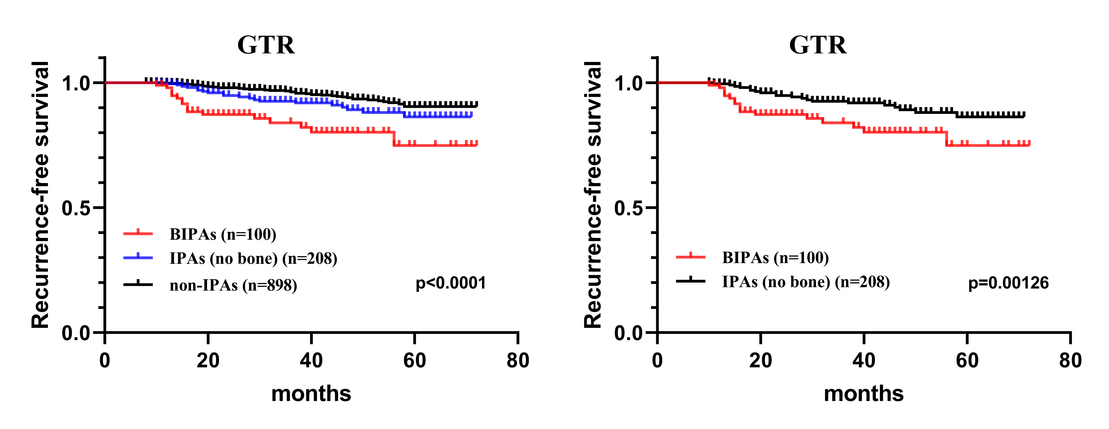
Fig S1. RFS analysis in patients with GTR.

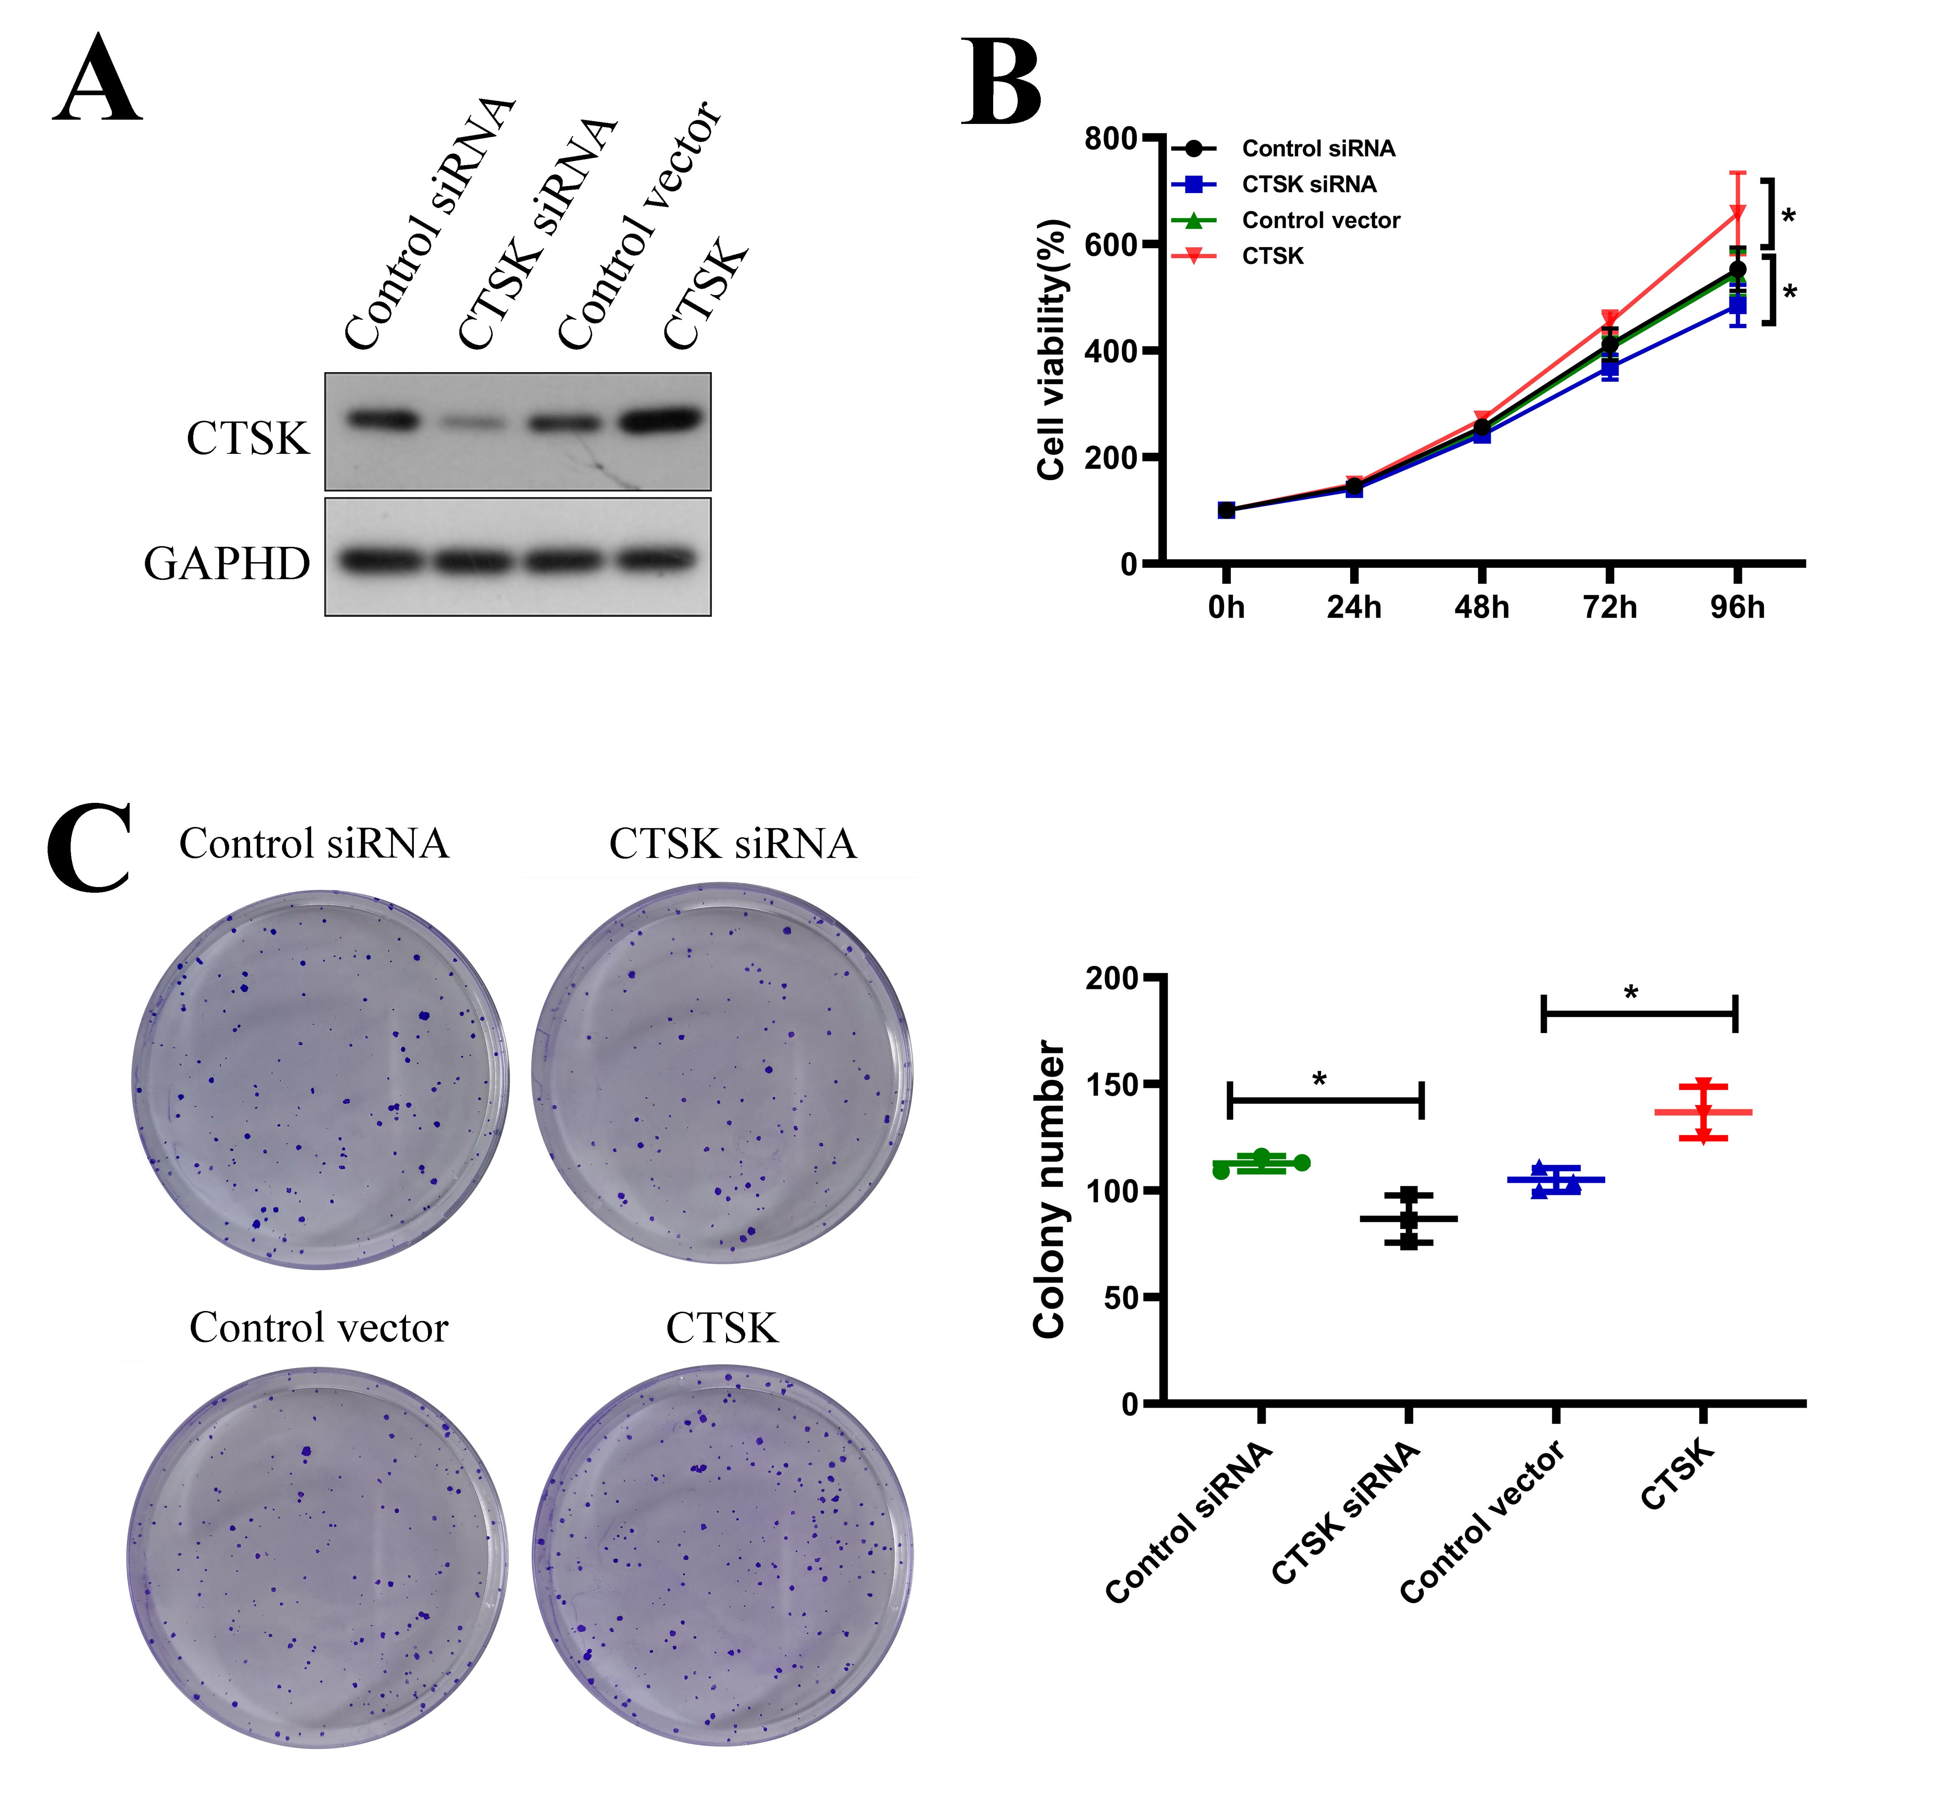
Fig S2 Elevated CTSK promoted pituitary adenoma cell proliferation in vitro. A: WB analysis showed that CTSK expression was decreased in CTSK knockout cells and increased in CTSK overexpression cells. B: CCK8 assays showed the effect of CTSK on proliferation of GT1-1 cells. C: Colony formation assay showed the effect of CTSK on the colony ability of GT1-1cells. Data are presented as the mean ± SD, **: p<0.01, ***: p<0.001.

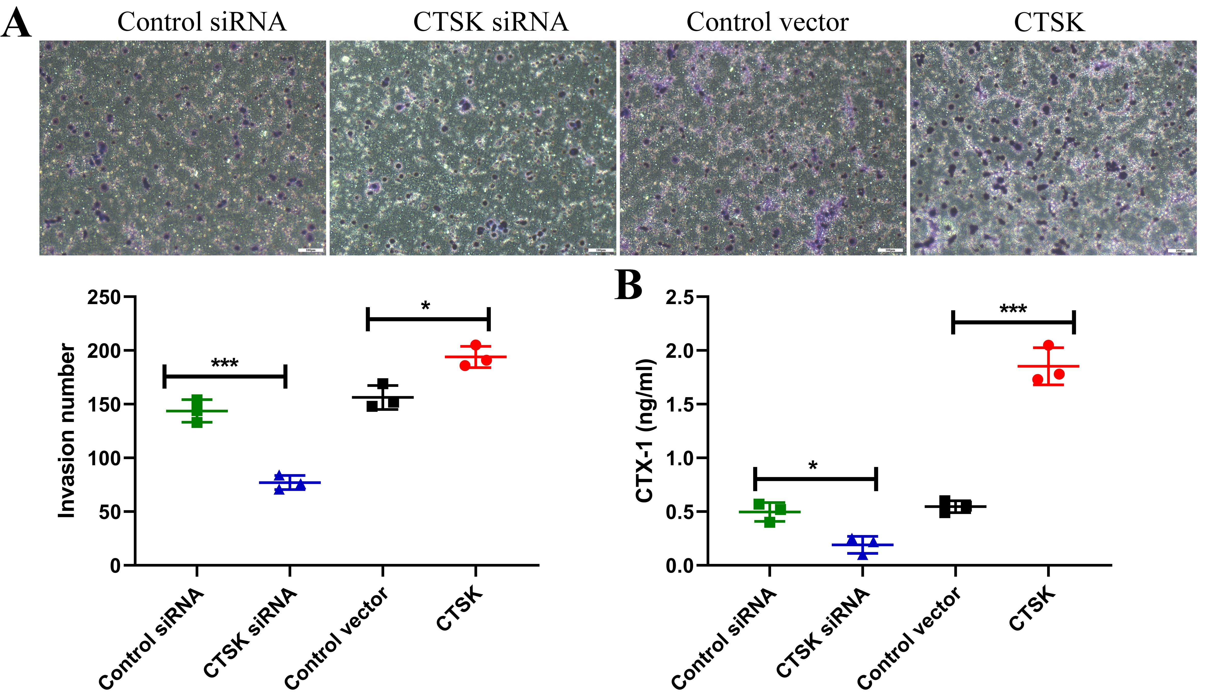

Fig S3. Elevated CTSK promoted pituitary adenoma cell invasion in vitro. A: Transwell invasion assay showed the effect of CTSK on invasion of GT1-1 cells. B: ELISA sassy was used to assess the level of CTX-1. Data are presented as the mean ± SD; *P < 0.05, **P < 0.01, ***P < 0.001.

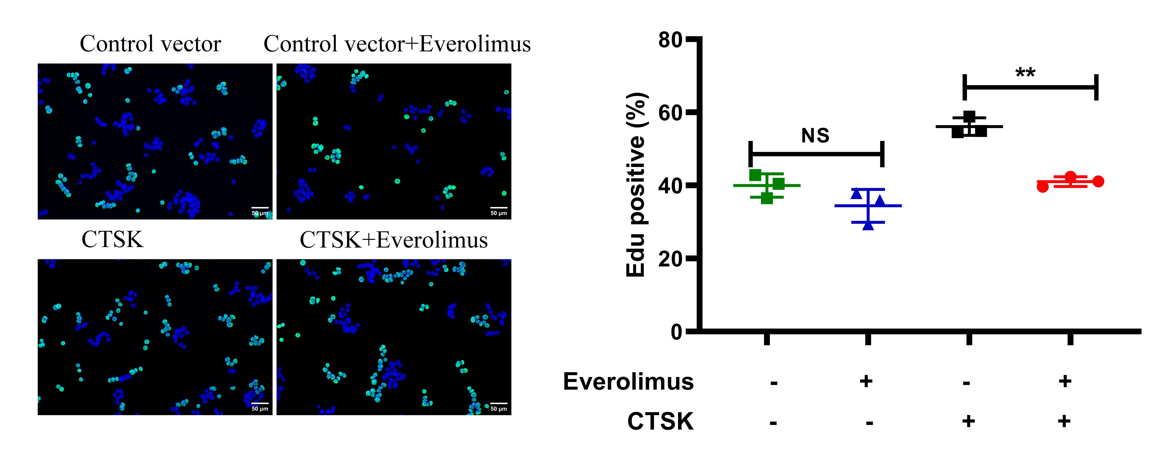

Fig S4. The effect of Everolimus on the proliferation ability of GH3 cells. A: EdU staining assays were used to assess proliferation of GH3 cells treated with or without Everolimus. (***: p<0.001, **: p<0.01)

Fig S5. CTSK promoted pituitary adenoma cell proliferation via the mTOR signaling pathway. A: 293T cells were co-transfected with pcDNA3.1-CTSK-HA, pcDNA3.1-Ub-His, and pcDNA3.1-Raptor-Flag. The ubiquitination of Raptor was examined using western blot with His-tag antibody in whole cell lysates and immune precipitates by Flag-tag antibody. B: GH3 cells were co-transfected with pcDNA3.1-CTSK-HA, pcDNA3.1-Ub-His, and pcDNA3.1-Raptor-Flag and treated with or without ODN. The ubiquitination of Raptor was examined. C: 293T cells were co-transfected with pcDNA3.1-CTSK-HA, pcDNA3.1-UCH-L1-Myc, pcDNA3.1-Ub-His, and pcDNA3.1-Raptor-Flag. The ubiquitination of Raptor was examined.

