Appendix A (supplementary data):
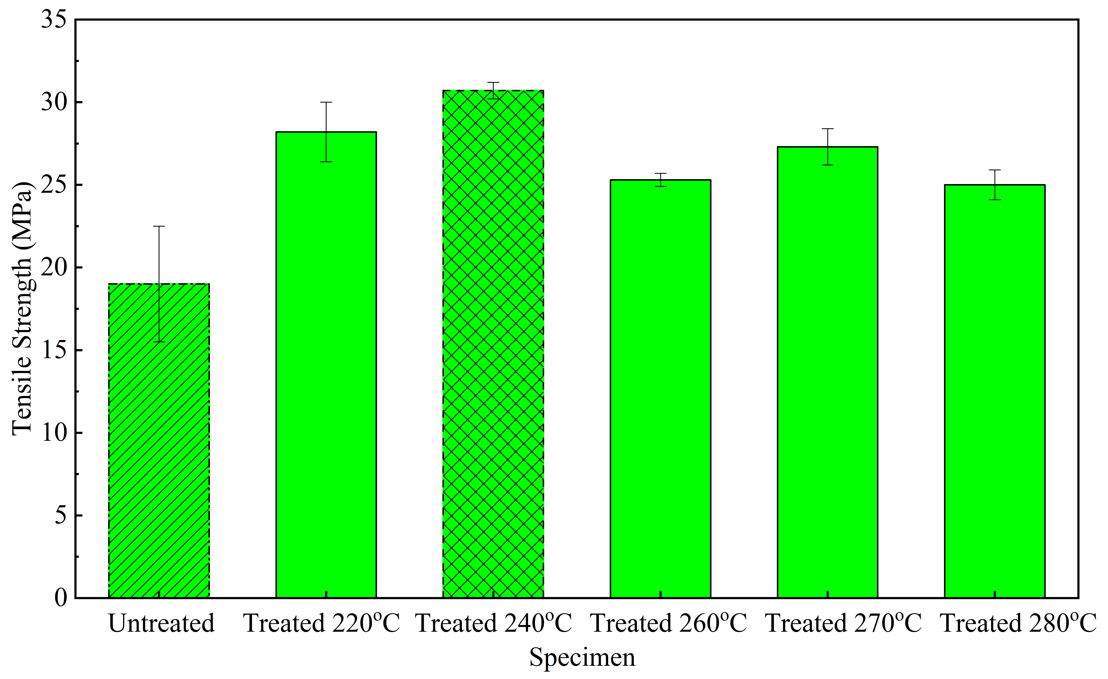

Fig. 1A Average tensile strength of printed ABS samples at different thermal treatments

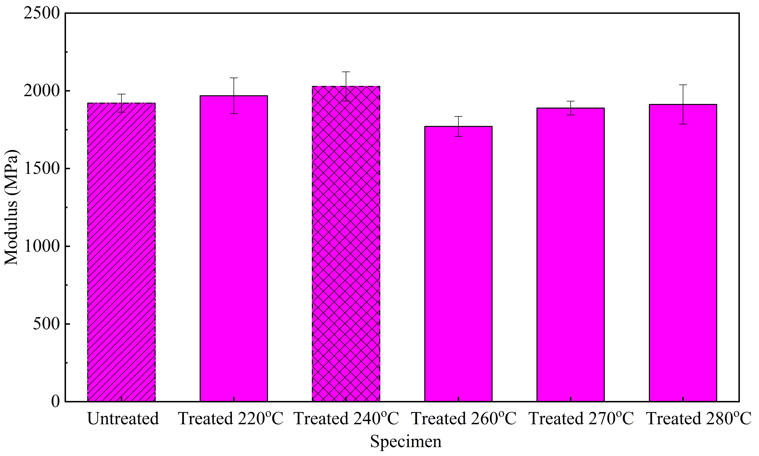

Fig. 2A Average elastic modulus of printed ABS samples at different thermal treatments

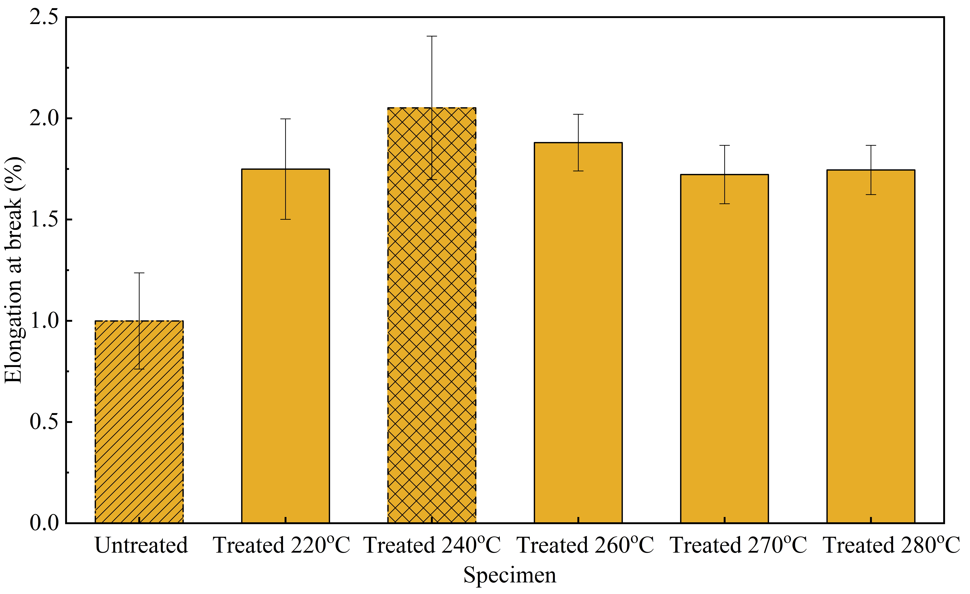

Fig. 3A Average elongation at break of printed ABS samples at different thermal treatments

