Partial white mold resistance in a Brazilian-adapted common bean panel

Givanildo Rodrigues da Silva¹, Thiago Alexandre Santana Gilio^{1,2}, Maria Celeste Gonçalves-Vidigal³, Kelly Lana Araújo¹, Marco Antonio Aparecido Barelli¹, Lorenna Lopes Souza³, Leonarda Grillo Neves¹, Marcial Pastor-Corrales⁴

¹University of Mato Grosso State “Carlos Alberto Ryes Maldonado”, Cáceres 78200-000, MT, Brazil.
²Mato Grosso Federal University, Av. Alexandre Ferronato, 1200, Sinop 78550-728, MT Brazil.
³Department of Agronomy, State University Maringá, Av. Colombo, 5790, Maringá, 87020-900, PR, Brazil
⁴U.S. Department of Agriculture, Agricultural Research Service, Soybean Genomics and Improvement Laboratory, Beltsville Agricultural Research Center, Beltsville, MD, 20705, USA.
*Corresponding Authors: Givanildo_rod@hotmail.com (Givanildo Rodrigues da Silva); thiago.gilio@ufmt.br (Thiago Alexandre Santana Gilio)

Supplemental Material

Figure S1. BLUP values of the seedling straw test (SST).
Figure S2. BLUP values of the Straw test (ST).
Figure S3. Heatmap of Pearson correlation coefficients using the no adjusted disease score (A) and network plot (B) of traits related to white mold reactions according to the straw test (ST, Terán et al., 2006) and seedling straw test (SST, Arkwazee & Myers, 2017) in the BL panel.
Figure S4. Histogram of the adjusted values of the evaluated traits in the BL panel.
Figure S5. Q‒Q plots of p values obtained for traits considered for gene annotation.

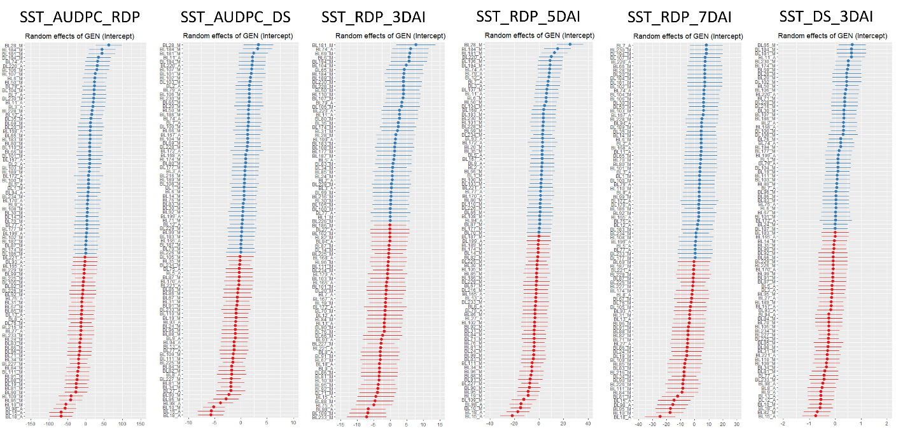
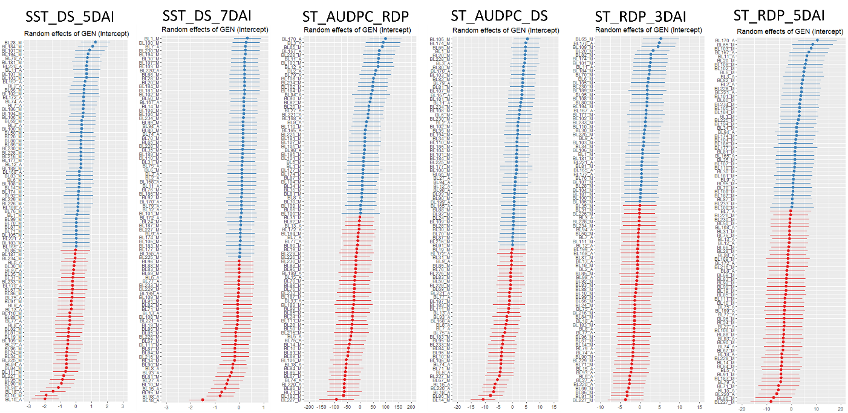
Figure S1. BLUP values of Seedling Straw Test (SST). The traits are combinations among the disease score adjusted mean (DS), relative disease progress (RDP), days after inoculation (DAI), and the area under disease progress (AUDPC) evaluated at 7th DAI.

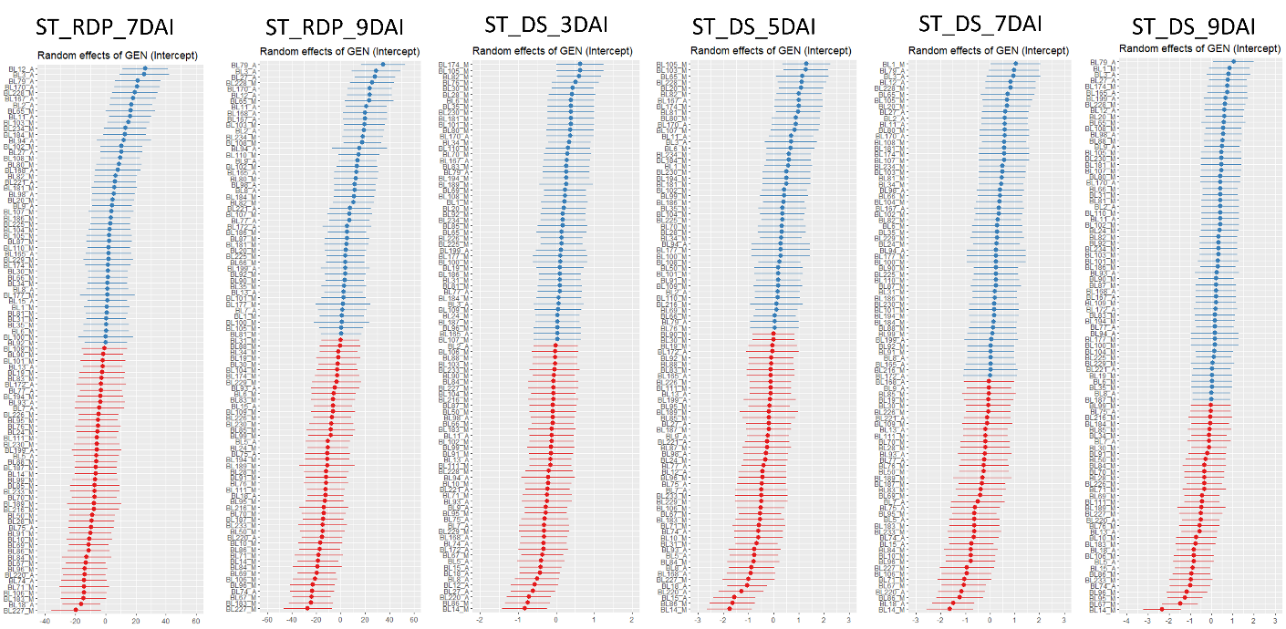
Figure S2. BLUP values of Straw Test (ST). The traits are combinations among the disease score adjusted mean (DS), relative disease progress (RDP), days after inoculation (DAI), and the area under disease progress (AUDPC) evaluated at 9th DAI.

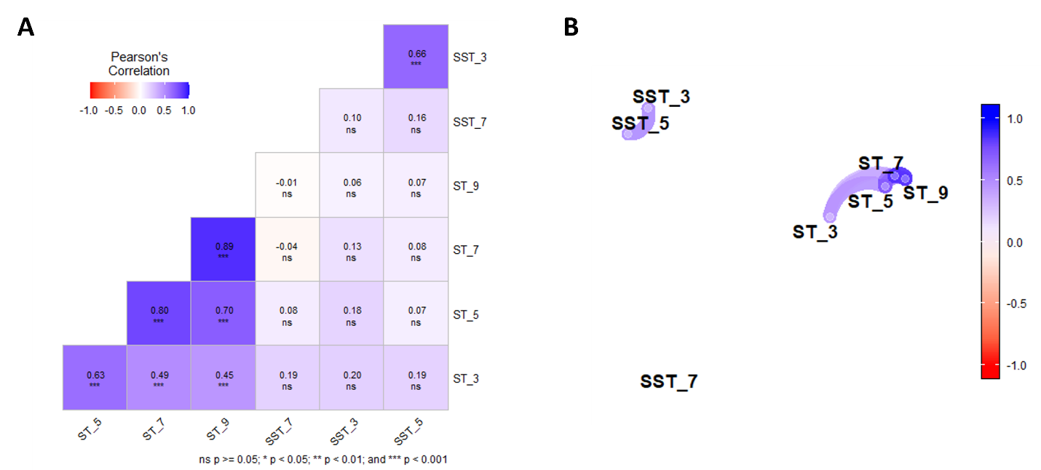
Figure S3. Heatmap of Pearson correlation coefficients using the disease score non-adjusted (a) and network plot (b) of traits for white mold reaction using the straw test (ST, Terán et al., 2006) and seedling straw test (SST, Arkwazee & Myers, 2017) in the BL panel. The method is indicated by the ST and SST prefix, respectively. Disease score by DS, the relative disease progress by RDP in the 3rd, 5th, 7th, and 9th days after inoculation (DAI), respectively. The area under the disease progress curve (AUDPC) is included.
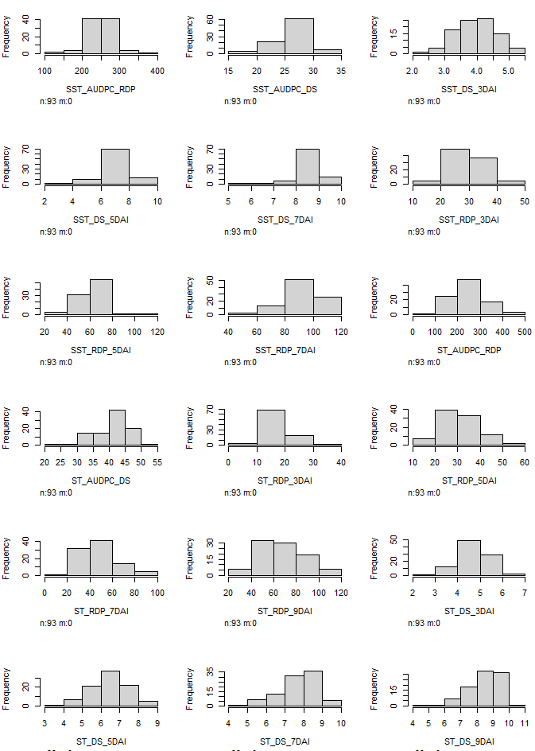
Figure S4. Histogram of the adjusted values of evaluated traits in BL panel. The method is indicated by the ST and SST prefix, respectively. Disease score by DS, the relative disease progress by RDP in the 3rd, 5th, 7th, and 9th days after inoculation (DAI), respectively. The area under the disease progress curve (AUDPC) is included.

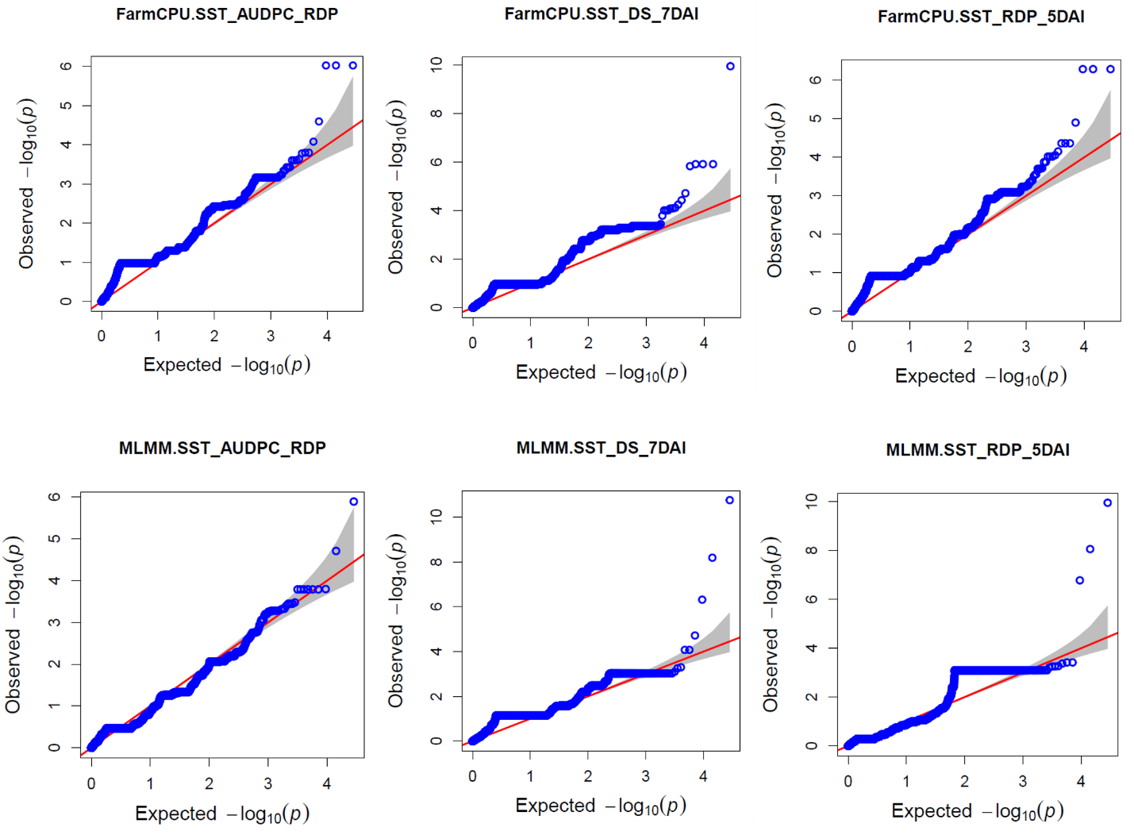
Figure S5. Q-Q plots of p-values obtained to traits considered to gene annotation. The method is indicated by the ST and SST prefix, respectively. Disease score by DS, the relative disease progress by RDP in the 3rd, 5th, 7th, and 9th days after inoculation (DAI), respectively. The area under the disease progress curve (AUDPC) is included. The first prefix before the dot indicate the model.

