SUPPLEMENTAL CONTENT

Supplemental Methods

Figure S1: Initial visit height by short stature etiology
Figure S2: Discrepancy between predicted heights generated by PGS_{height} and MPH, by pathologic subgroup
Figure S3: Change in discrimination with additional adjustment for initial visit height

Supplemental Tables (.xlsx file)
Table S1: Phecodes related to pathologic causes of short stature used to exclude subjects from the overall population of adults and children
Table S2: Phecodes related to pathologic causes of short stature used to exclude subjects from the overall population of adults and children
Table S3: Descriptive statistics for general population cohort
Table S4: Results from discrimination analyses in the primary analysis testing the benefit of adding PGS_{height} to MPH
Table S5: Results from discrimination analysis in the sensitivity analysis which additionally adjusted the baseline model for initial visit height

Supplemental Methods

Standardizing adult height data to a common reference standard: Age- and sex- standardized pediatric height measurements are typically based upon the Centers for Disease Control and Prevention (CDC) reference standards for the U.S. population. To standardize adult height measurements, a reference population was derived from National Health and Nutrition Examination Survey (NHANES) between 2001 and March 2020. Sex-specific means and standard deviations of measured height were calculated for the NHANES population, accounting for sample weights provided by NHANES and complex survey design, as instructed.²¹ Adult heights were converted to centimeters and an SDS was calculated by subtracting adult heights by the respective sex-specific NHANES mean height and dividing this difference by the sex-specific NHANES standard deviation.
Predicting expected adult height using a polygenic score for height: Mid-parental height (MPH) estimates reflect a child’s predicted final height, whereas a standardized polygenic score (PGS_{height}), reflects a child’s expected deviation from the adjusted average height of participants in the height GWAS. To convert the PGS_{height} estimate to an expected adult height, a linear prediction model for height SDS was developed among BioVU adults of European ancestry (N=33,637). For each adult, height SDS was calculated as the median across all measurements. A multivariable linear regression model was used, regressing a person’s median height SDS on their PGS_{height} with the top 10 within-ancestry principal components (PCs) as covariates. For every 1 standard deviation (s.d.) in the PGS_{height}, there was a 0.63 s.d. increase in height. The model explained 39.1% of the variance in height in this population, with the PGS_{height} accounting for the majority of this variance (Adjusted R²=38.1%). This model was then used to compute an expected adult height SDS for each child in the short stature cohort.

Figure S1: Idiopathic and pathologic short stature are associated with a lower height at the initial visit with the endocrinologist. Violin plots comparing initial visit height SDS by short stature etiology in the short stature cohort. The overall pediatric population is included as a reference. The clinical threshold for short stature (≥2 s.d. below the CDC reference standard mean) is labelled with a red, dashed line.

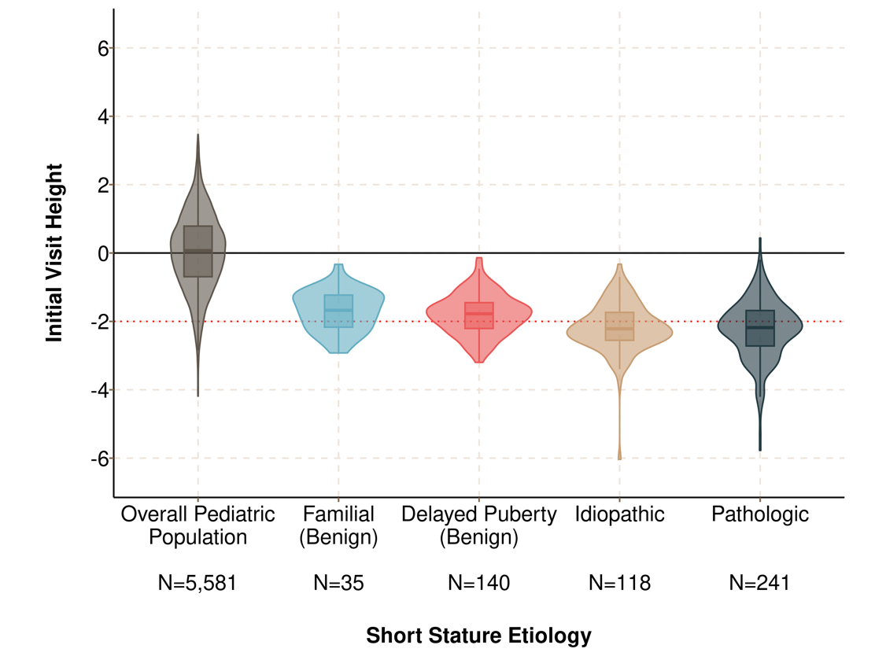

Figure S1: Among children with pathologic short stature secondary to growth hormone deficiency or systemic disease, children are predicted to be shorter than their MPH-based height prediction. Violin plots comparing height predictions by method (MPH and PGS_{height}) for each sub-group of pathologic short stature. Growth hormone deficiency excludes participants diagnosed with growth hormone deficiency clinically with a normal (≥10ng/ml) peak GH response to provocation. The PGS_{height} was converted to a predicted adult height by deriving a model predicting height as a function of PGS_{height} and 10 principal components in the population of BioVU adults. Cohen’s d statistics (shown above each pair) were used to estimate the standardized mean difference in height predictions generated using the PGS_{height} and MPH. Paired samples Wilcoxon rank sum tests were used to test the significance of within-person differences. ***: Wilcoxon p<0.001. n.s.: p>0.05.

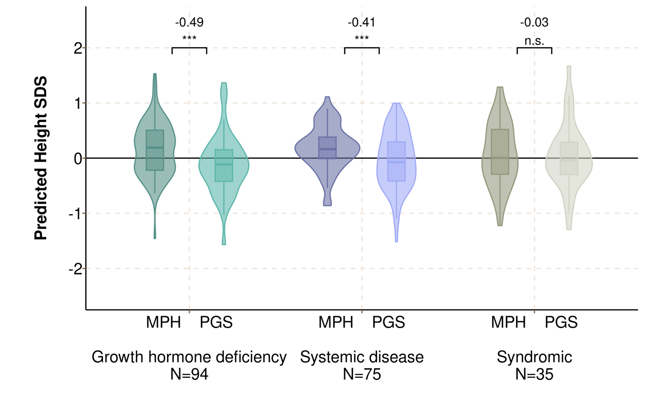

Figure S2: PGS_{height} improves discrimination even after adjustment for initial visit height. Forest plot comparing discrimination (AUC) between ISS and pathologic short stature when using a model with only age, sex, and 10 PCs (black), with addition of the initial visit height (yellow), with addition of the MPH (blue), and with addition of the PGS_{height} (purple). Additional sensitivity analyses examined subgroups of children: 1) outside of the expected parental height range (discrepancy between child’s measured and MPH ≥ 2 standard deviations) and 2) meeting the clinical definition of short stature at the initial visit (height SDS ≤ -2).

