Supp. Fig. 1-12
Close-up views of the major selection signals in the BF (domesticated; green) and WBM (wild; blue). (top to bottom) Schematic representation genes within the defined ROI (LOC[#] genes’ labels are omitted to avoid overlapping); window measures of differentiation between the two populations, calculated as the averaged Fst across all positions within the window; estimations of nucleotide diversity, calculated as the Tajima’s D (TajD), Waterson’s theta (tW) and Pairwise theta (tW) across all positions within the window; selection signals in WBM and BF populations, where each data point represents a window’s composite likelihood of a selective sweep (CLR) in WBM and BF. Gaps in the reference ZF genome (yellow).

BF1-Chr1
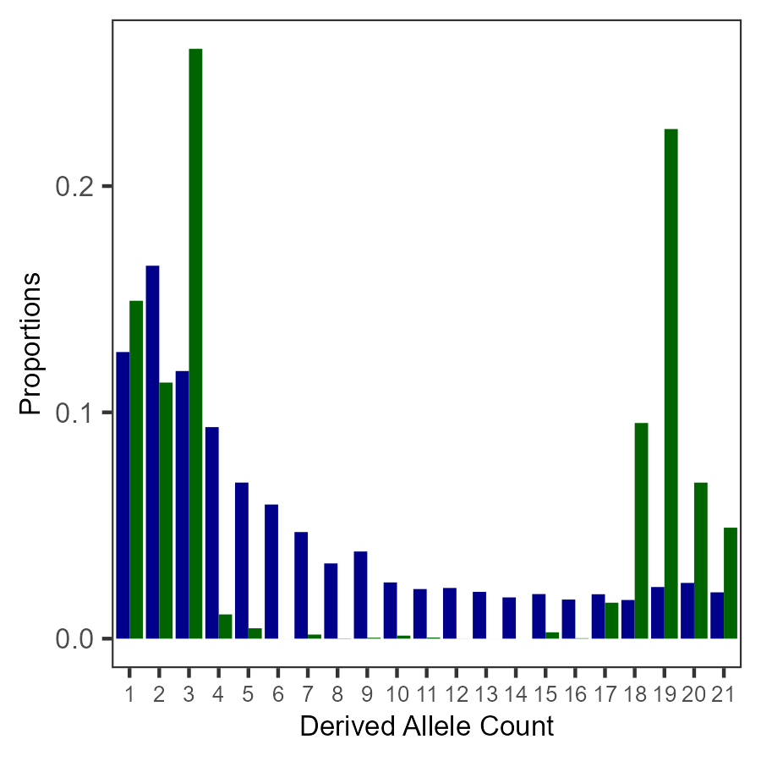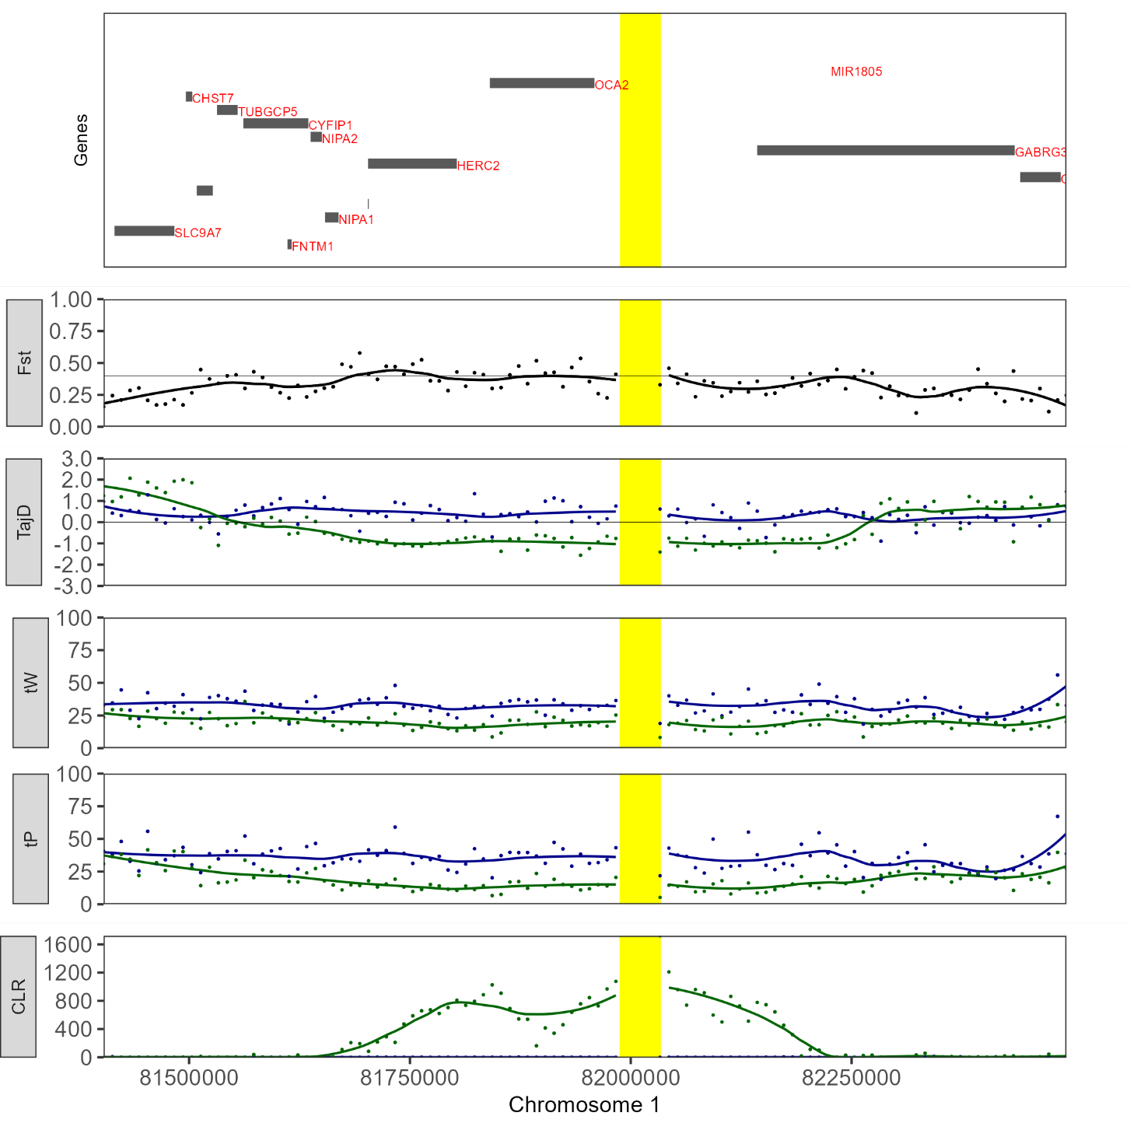
BF2-Chr1
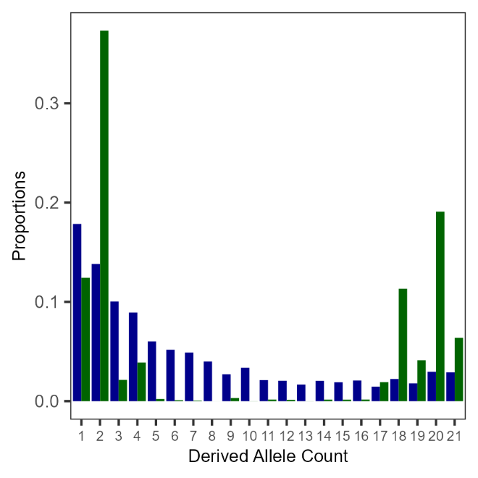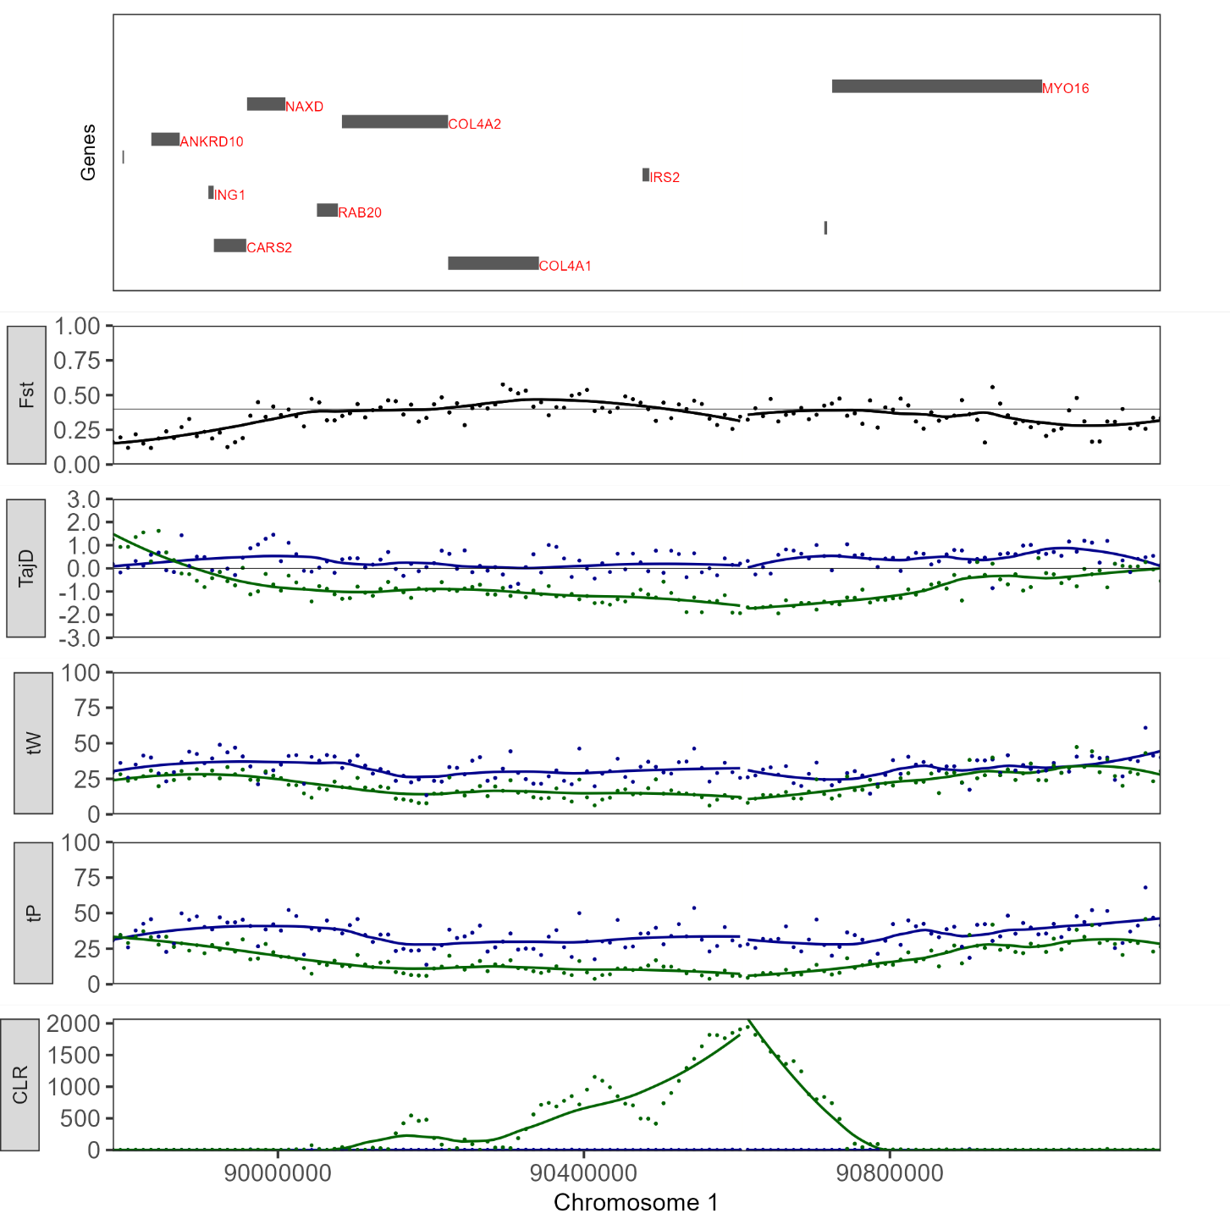
BF3-Chr1A
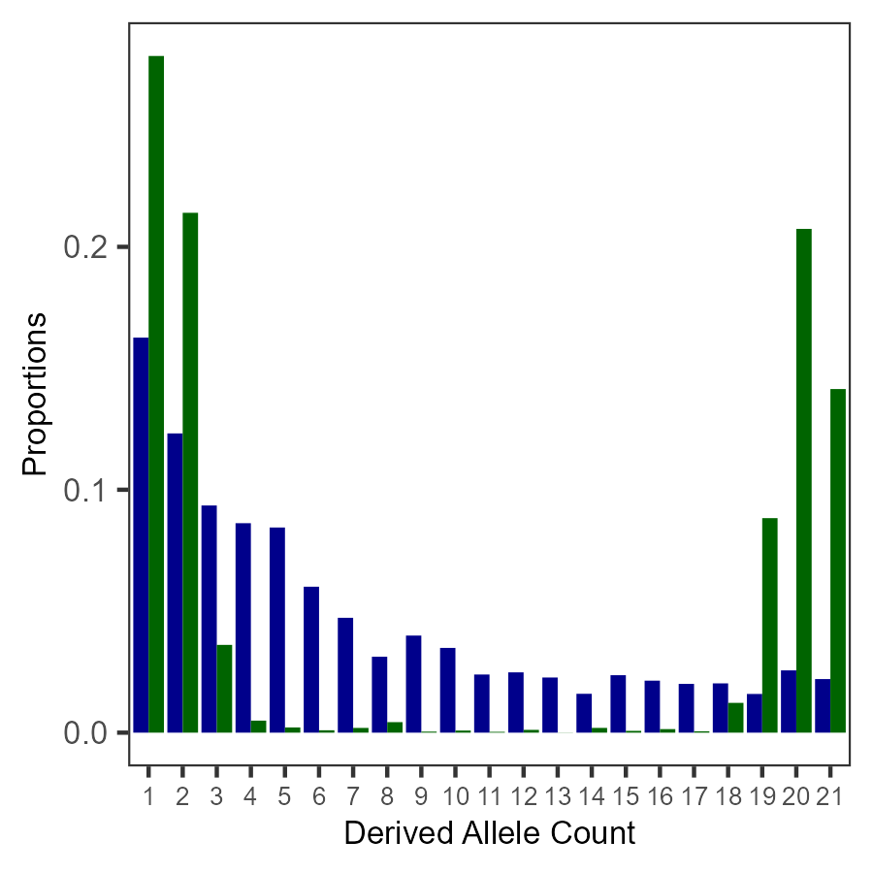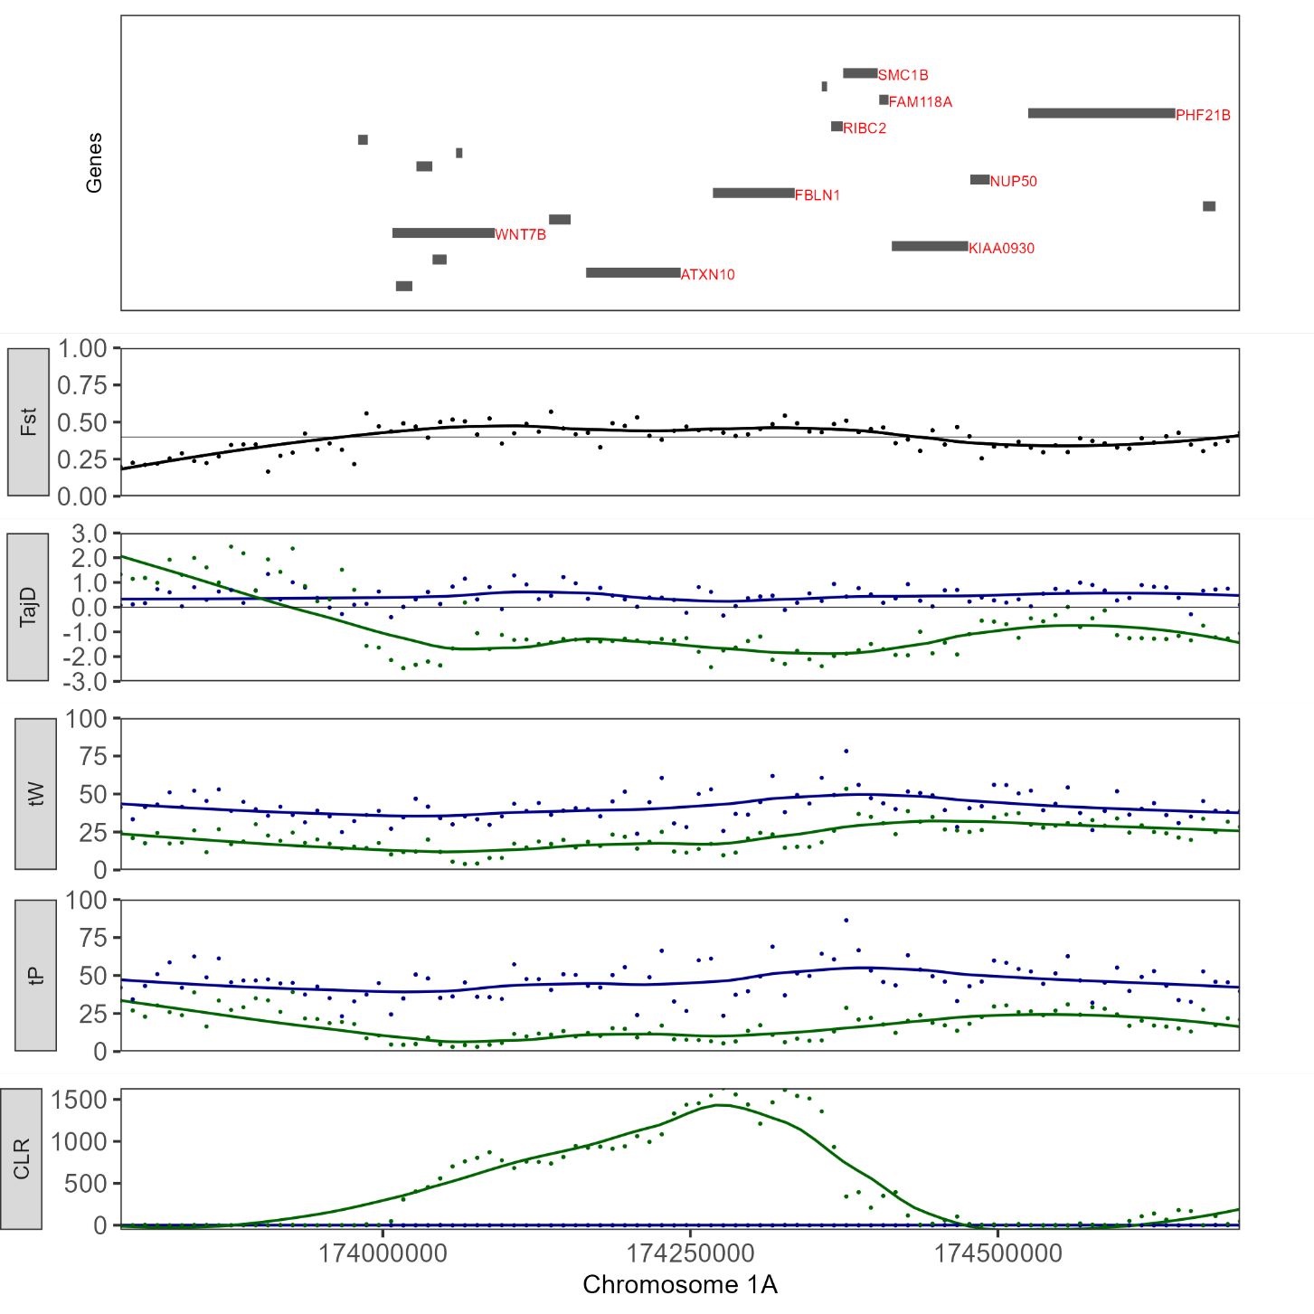
BF4-Chr2
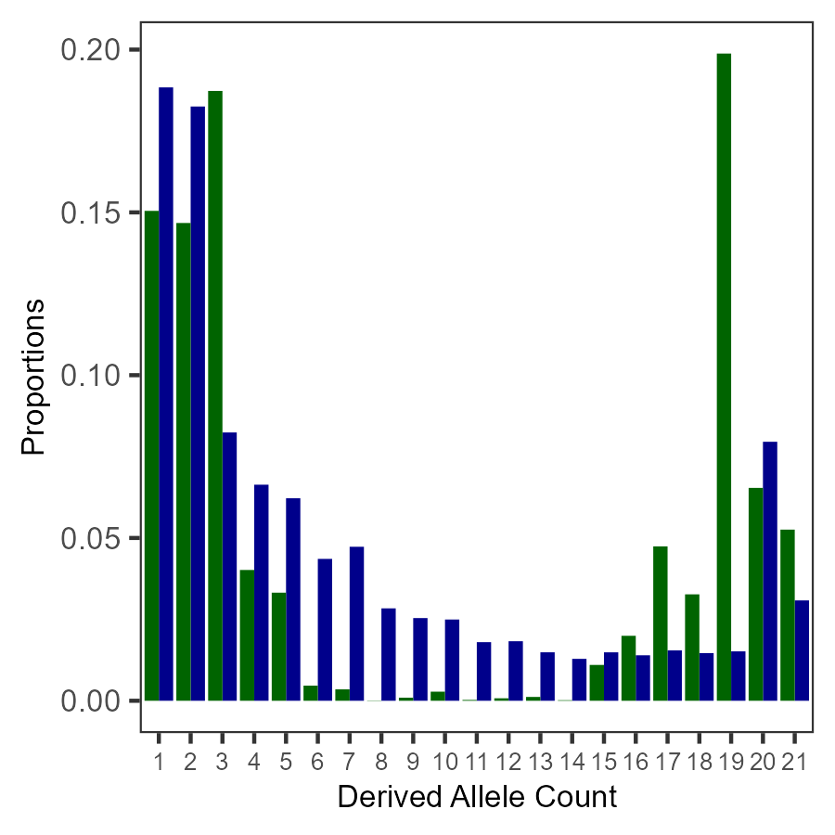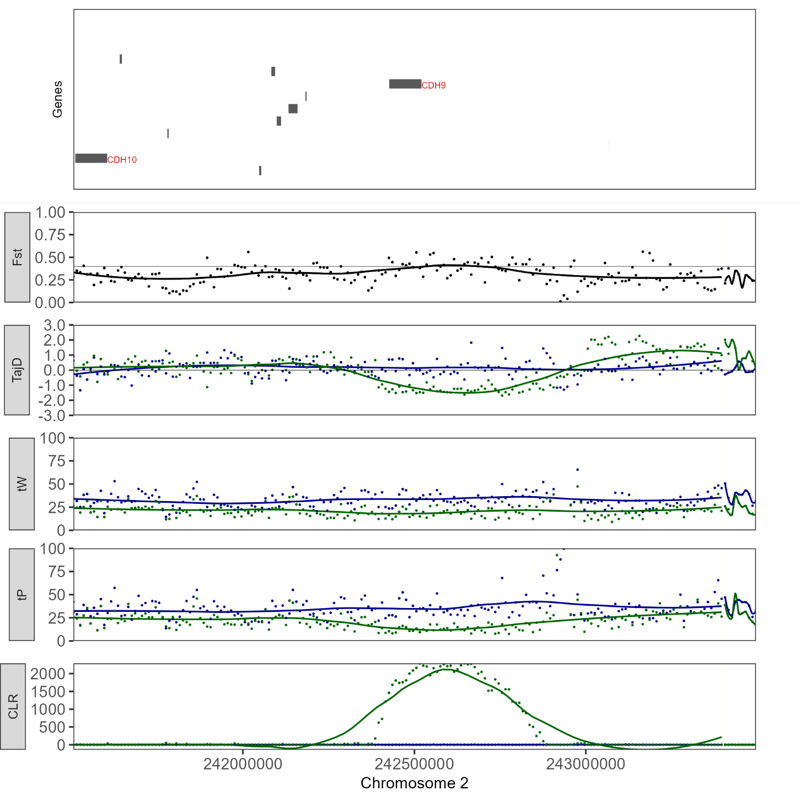
BF5-Chr2
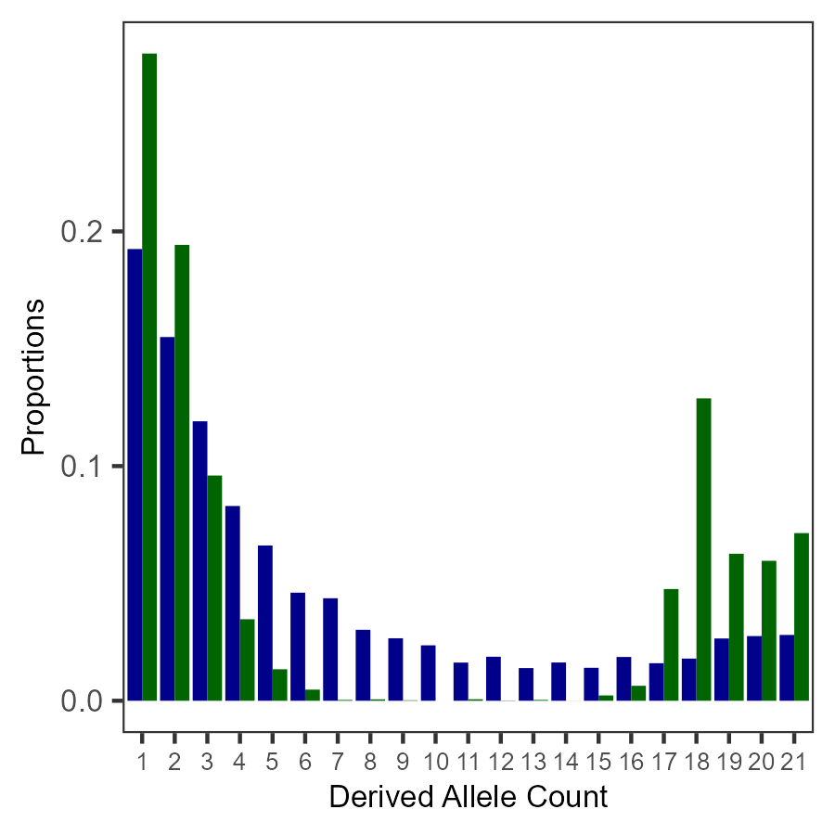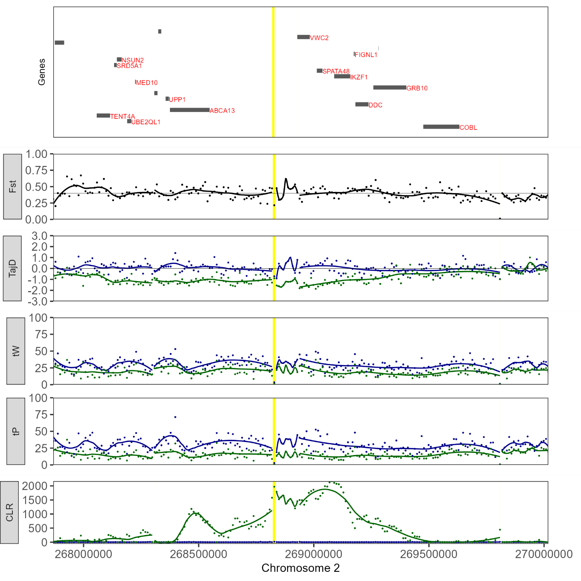
BF6-Chr4
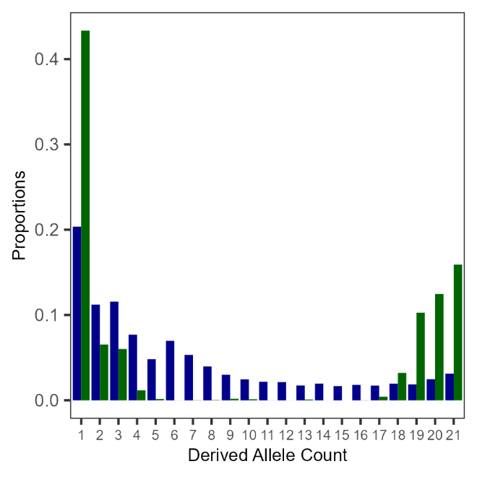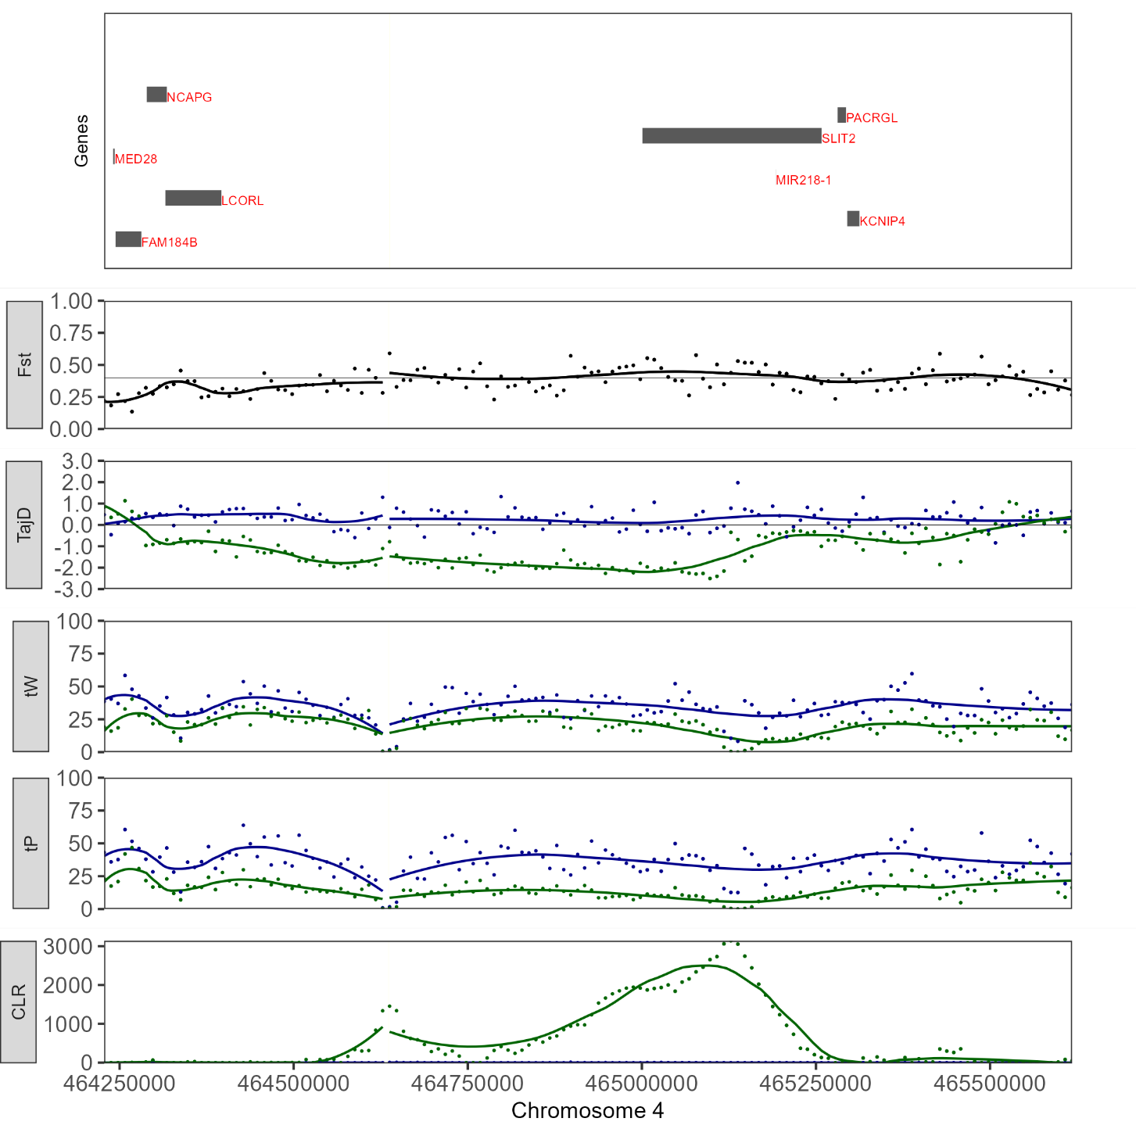
BF7-Chr4
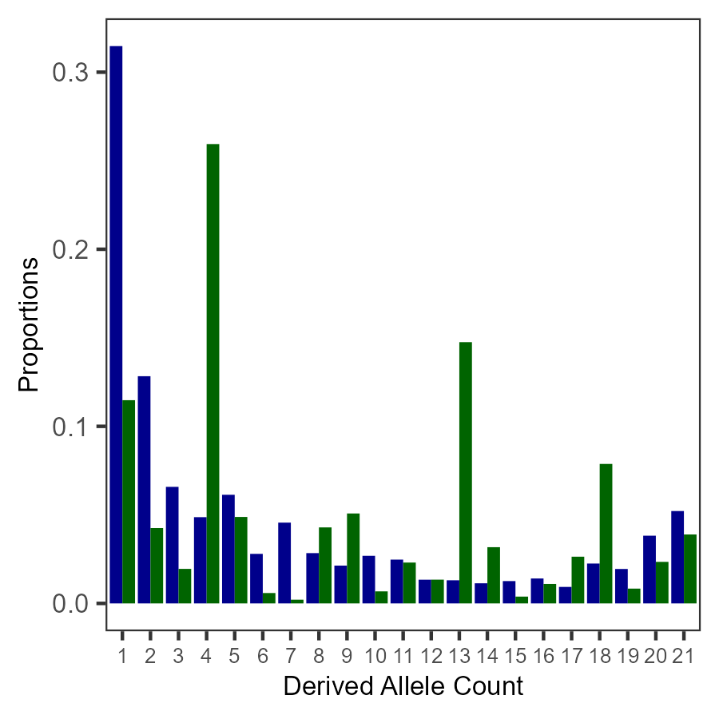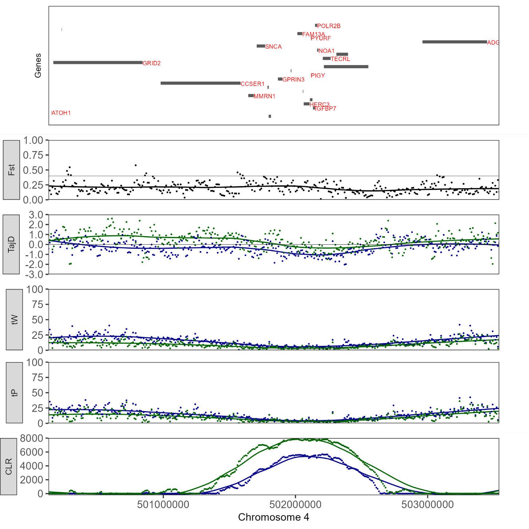
BF8-ChrZ
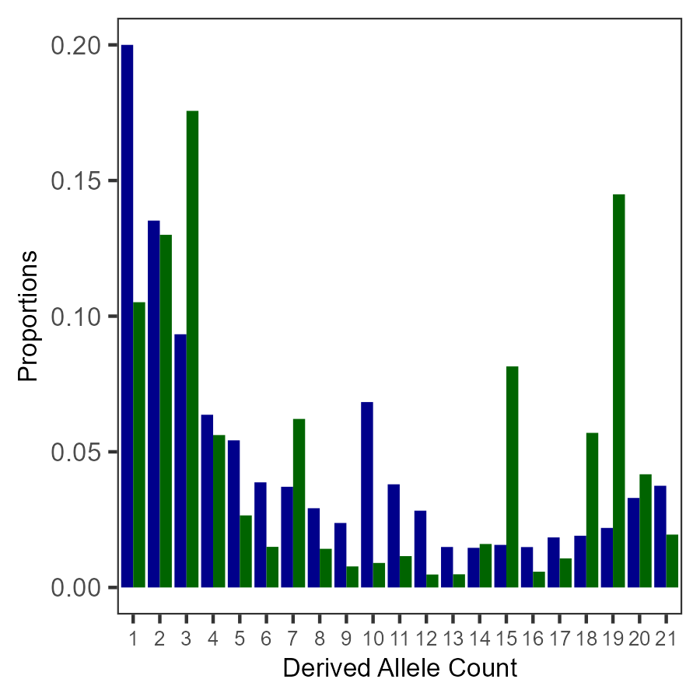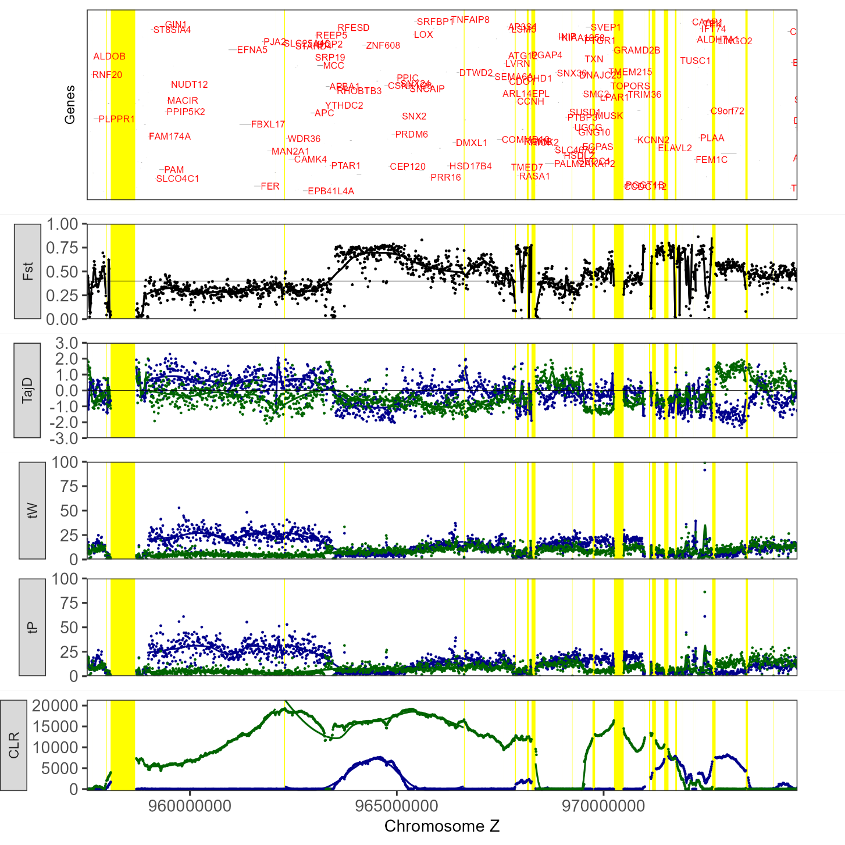
WBM1-Chr1
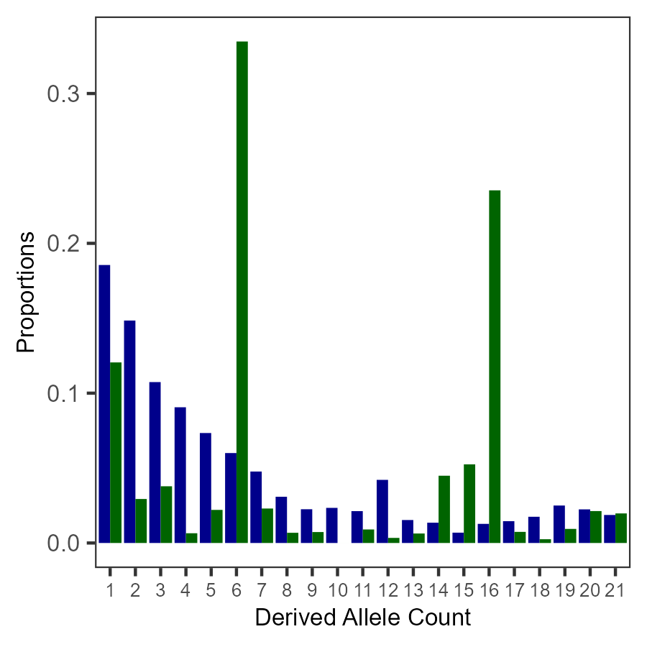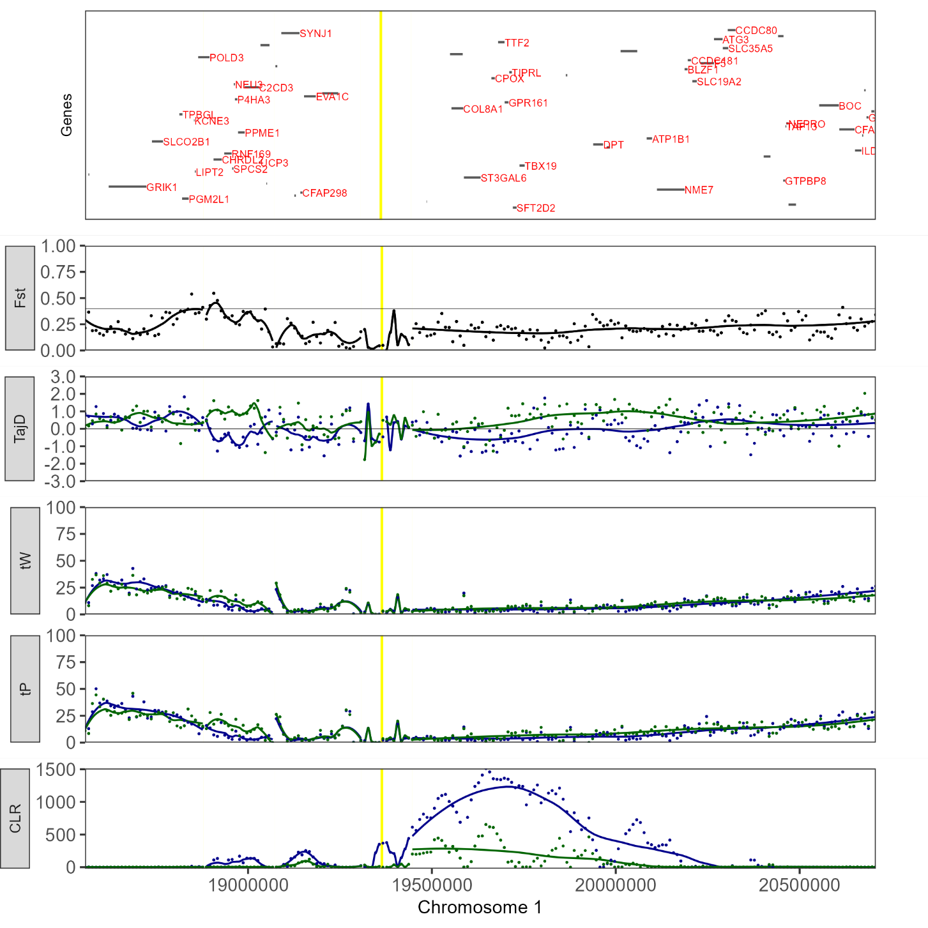
WBM2-Chr1A
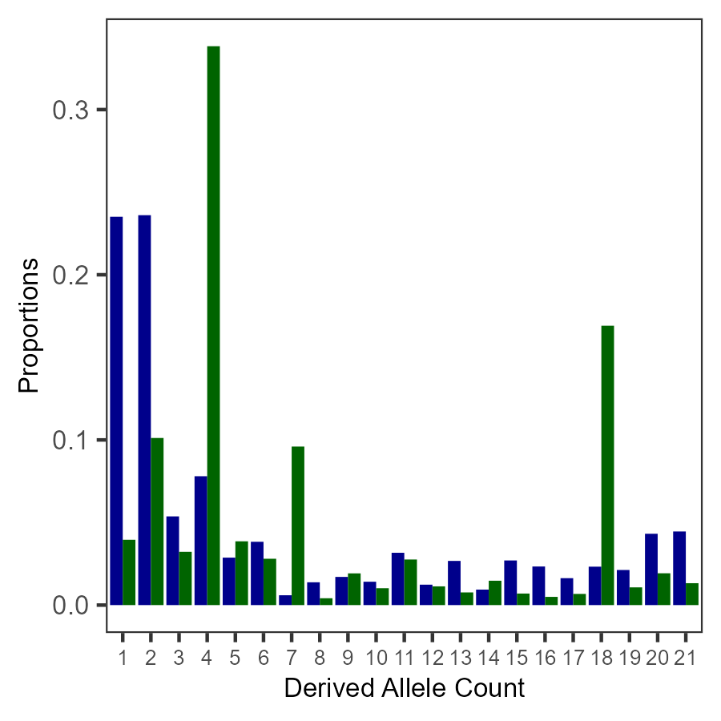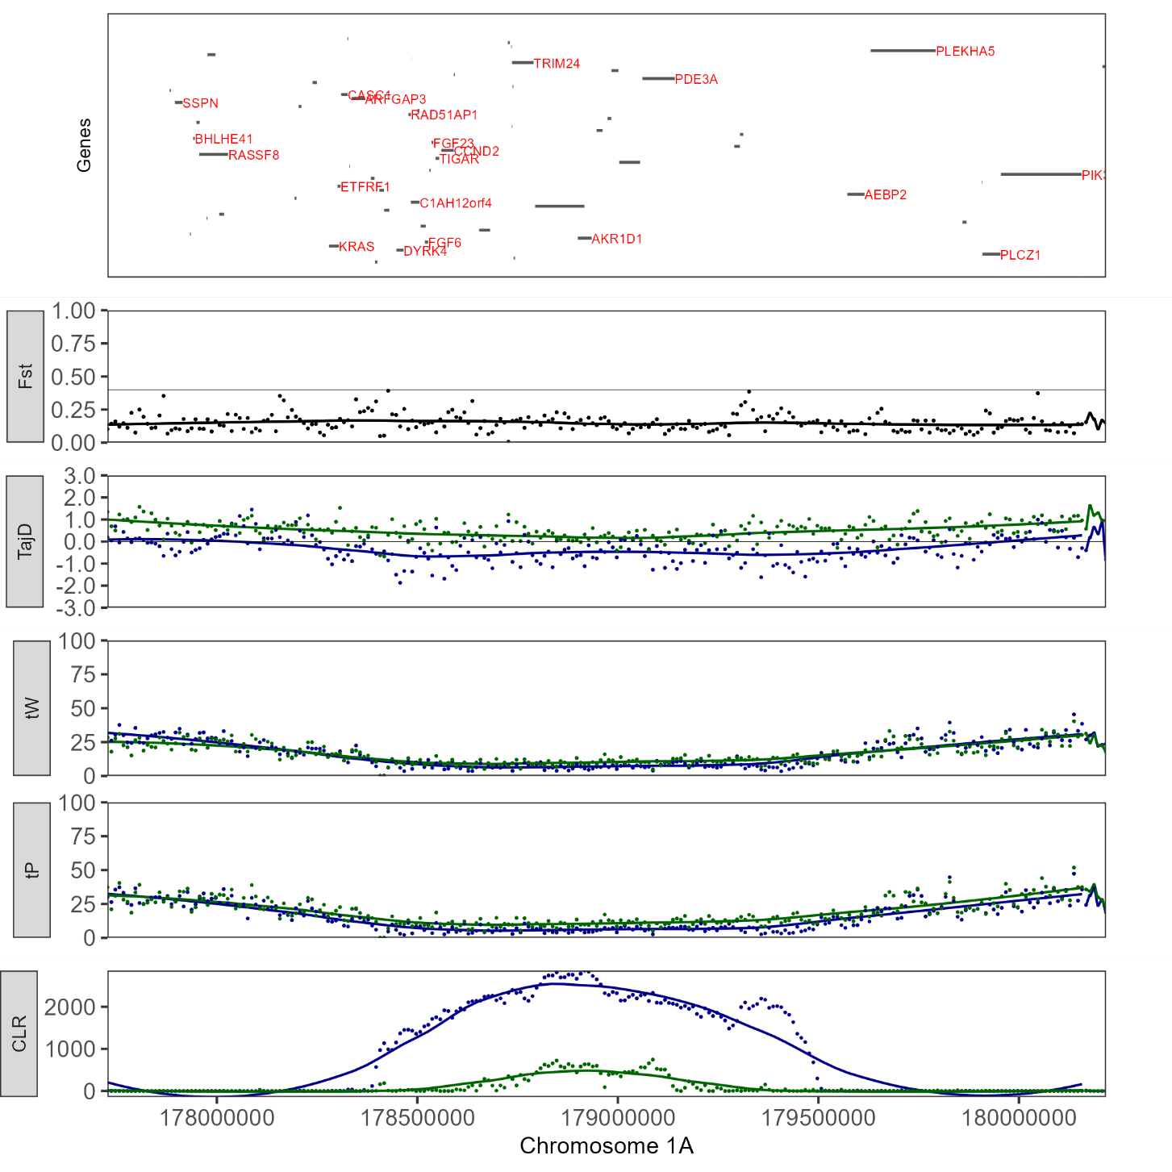
WBM3-Chr2
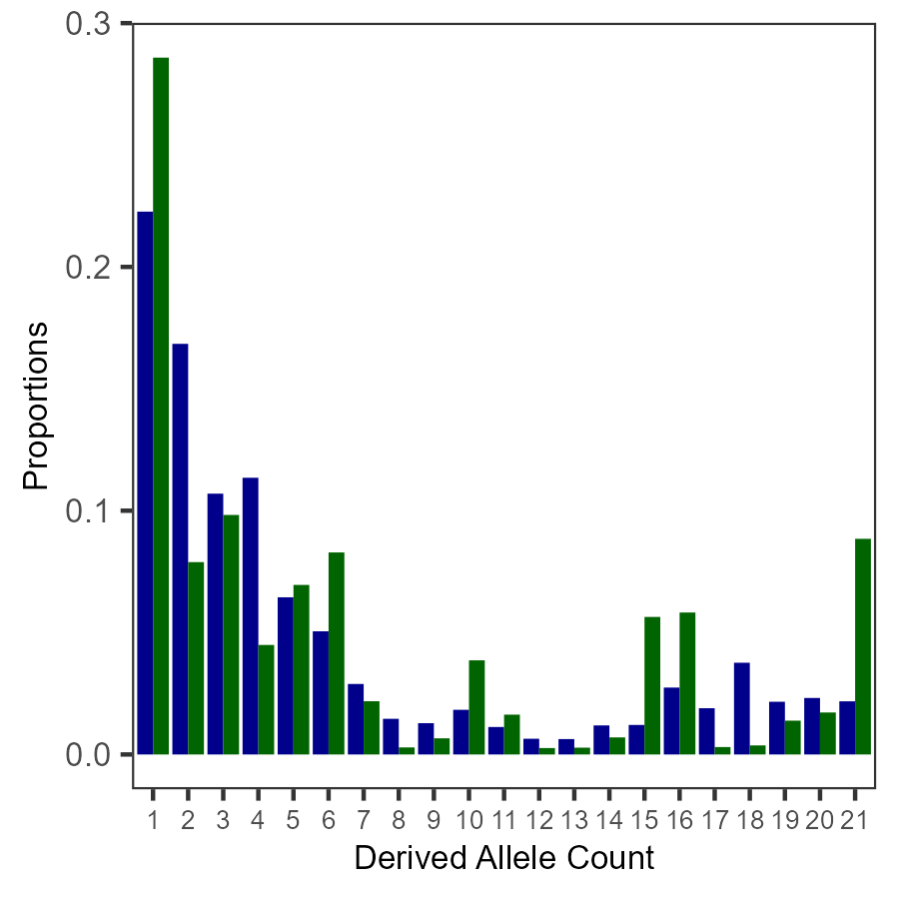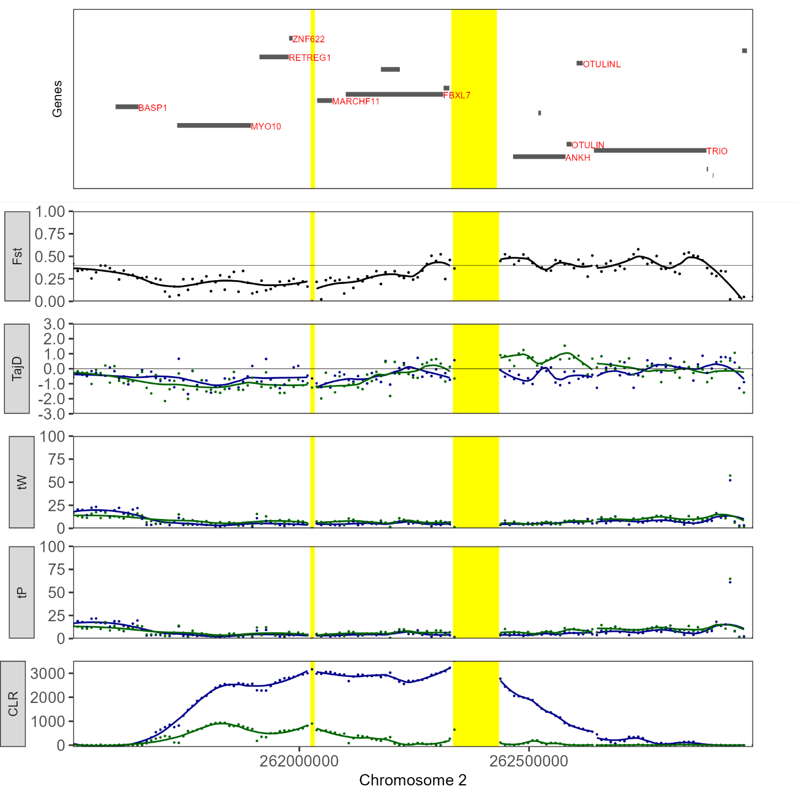
WBM4-Chr3
