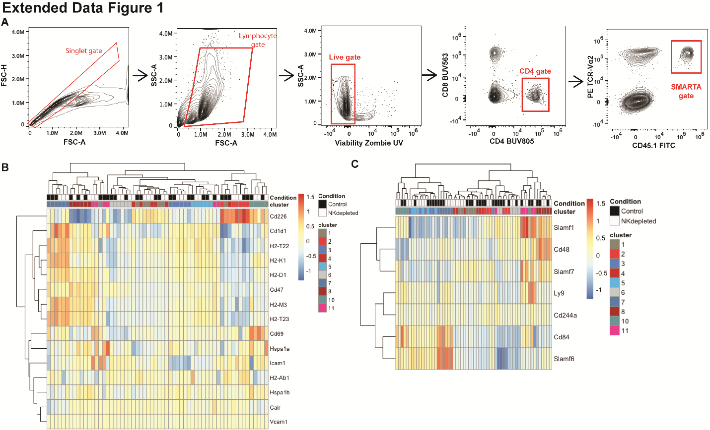Extended Data Figure 1. CD4 T cell susceptibility and resistance to NK-cell suppression appears independent of known NK-cell receptor systems. A) Gating strategy for sorting SMARTA. Clusters collapsed via pseudobulking and analyzed via DESeq2 B) Heatmap of traditional NK cell receptor ligands. C) Heatmap of signaling lymphocyte activation molecule (SLAM) receptors among all 12 clusters (expression of Slamf2 and Slamf9 too sparse among all clusters to include in heatmap).

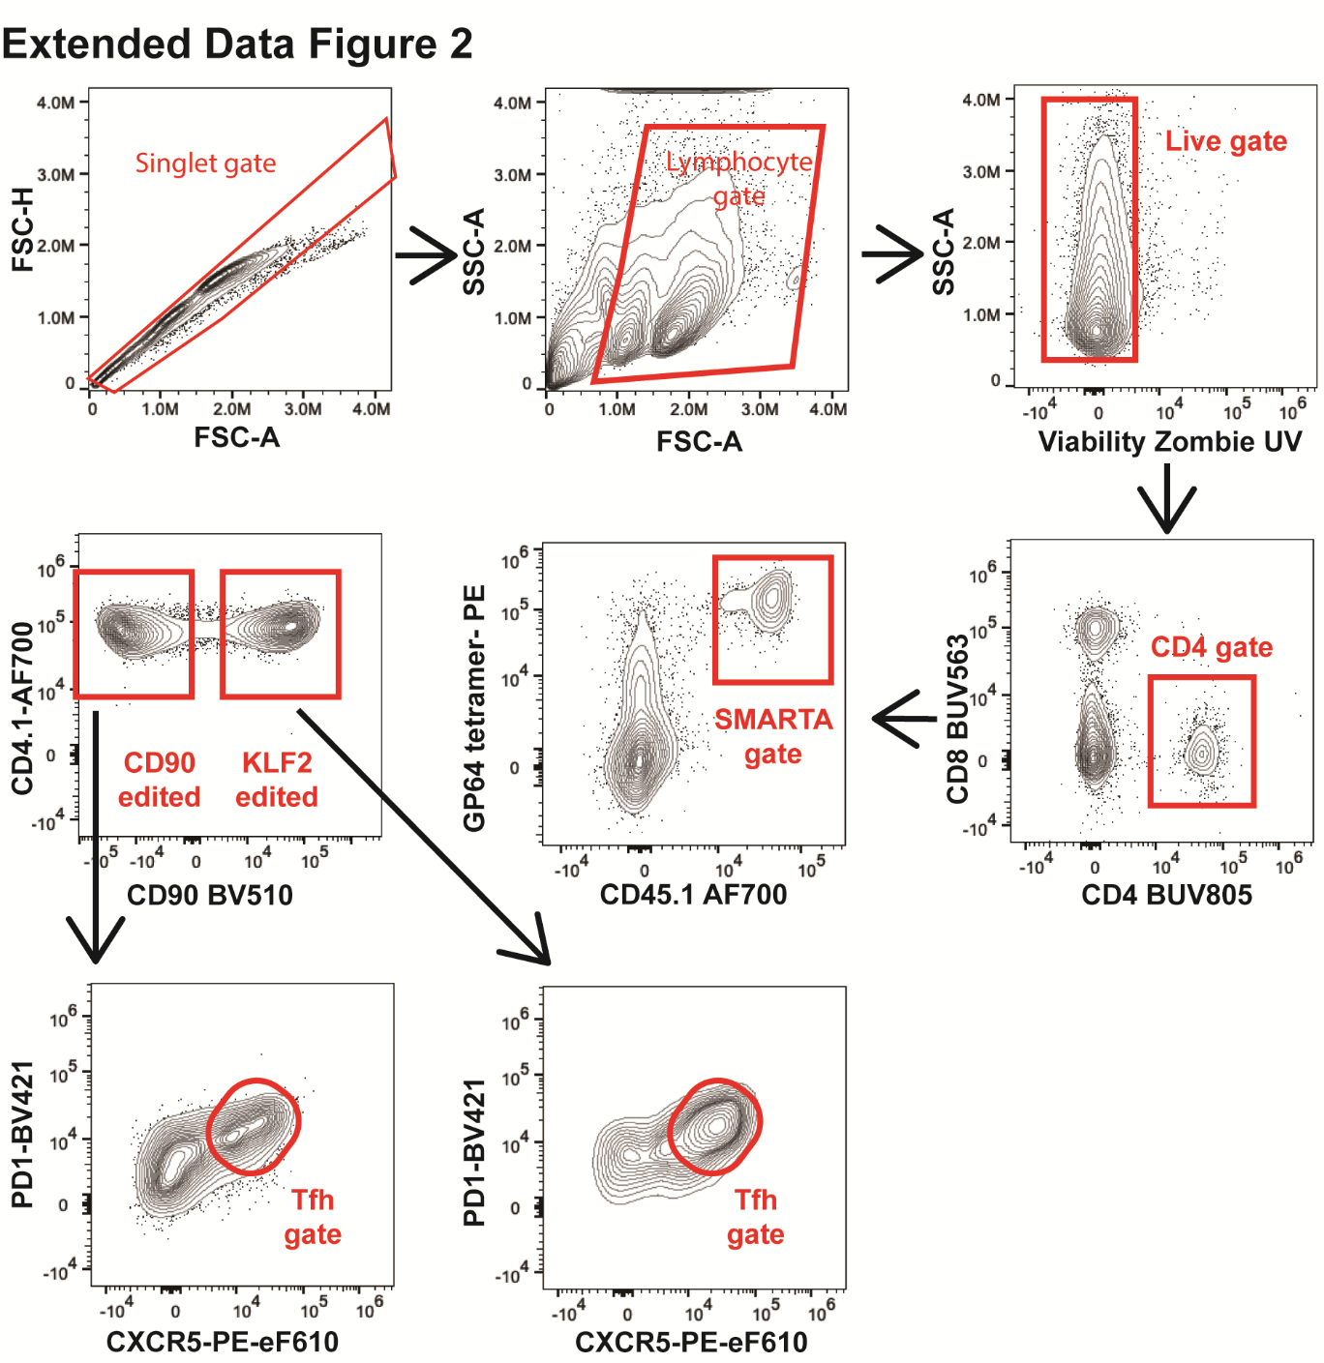
Extended Data Figure 2. Gating strategy for edited SMARTA. CD90 editing efficiency was >99% so this was used as an exclusionary gate. As these mice were analyzed at day 7 post infection PD1 instead of SLAMF1 was used in combination with CXCR5 to determine Tfh cells.
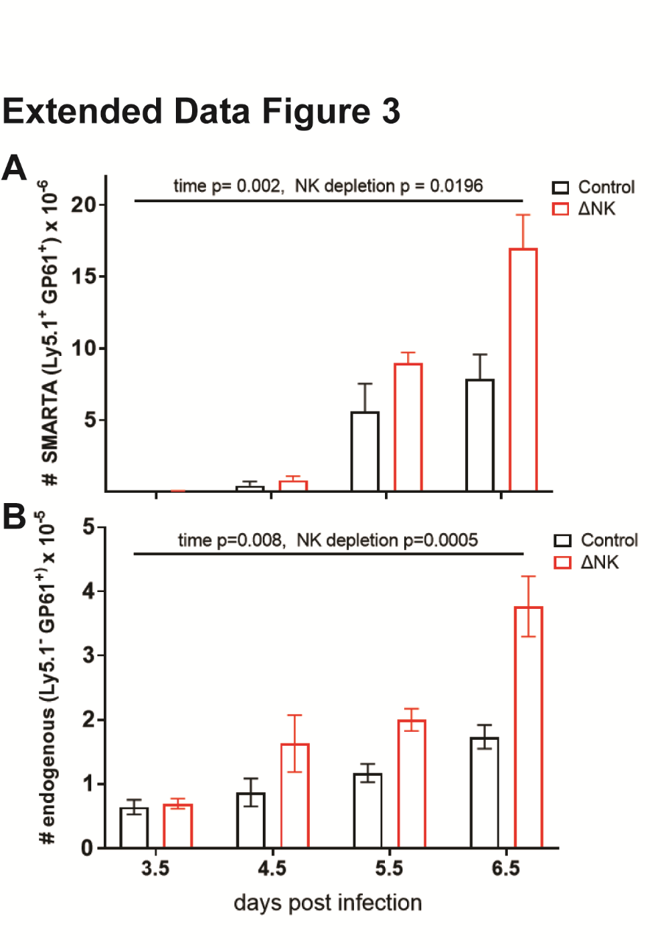
Extended Data Figure 3. The endogenous GP-61 tetramer response does not differ from the SMARTA response. Mice were depleted of NK cells as above and a low number of SMARTA were transferred (50,000 vs 500,000). Lymphoid organs were harvested at the indicated time points post infection and the number of SMARTA and the endogenous response are graphed. Statistical analysis performed via One-way ANOVA. Depicted is the mean ± SEM.

