Supplementary information

An aging-sensitive compensatory secretory phospholipase that confers neuroprotection and cognitive resilience
Vicidomini et al.

The PDF file includes:
Extended Data Figures 1 to 7
Supplementary Tables 1 to 6

Extended Data Fig. 1 Down-and upregulated biological pathways in DGCs following inducible synapse loss.
RNA was obtained from DGCs following genetic upregulation of Klf9 as described in Results and Methods. Functional enrichment analysis of RNA-seq dataset was performed using g:Profiler https://biit.cs.ut.ee/gprofiler/gost.

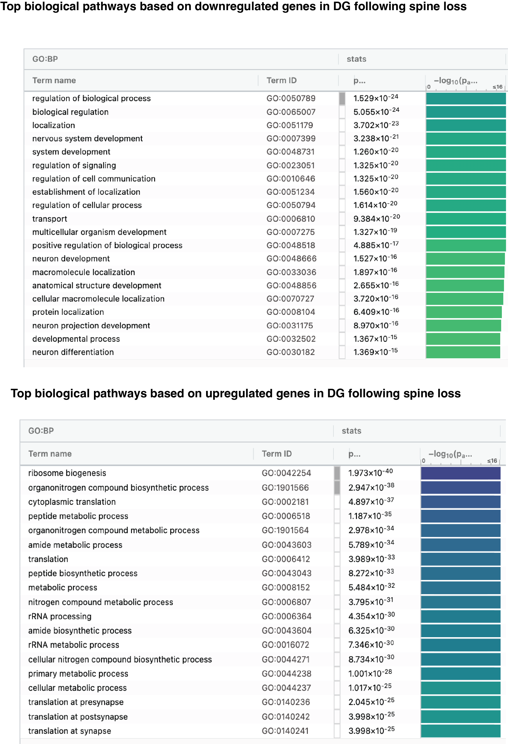
Extended Data Fig. 2 Supporting data for inducible deletion of Pla2g2f in DGCs
a, Experimental design to validate Pla2g2f deletion in CamKIIα-Cre^{ERT2}-Pla2g2f ^{f/f} bigenic mice injected with either vehicle (Ctrl) or tamoxifen (Pla2g2f cKO). Mice were injected at 7 months and 5 months later (12 months) dentate gyrus was dissected for RNA isolation and quantitative reverse transcription polymerase chain reaction (qRT-PCR).
b, qRT-PCR of Pla2g2f expression in Ctrl and Pla2g2f cKO mice. Gene expression is measured relative to Gapdh (n=6 Ctrl, n=3 Pla2g2f cKO). Data are displayed as mean ± SEM; **P<0.005, [unpaired t-test]
c, CamKIIα-Cre^{ERT2}-Pla2g2f ^{f/f} bigenic mice were injected with vehicle (Ctrl) or tamoxifen (Pla2g2f cKO), for Pla2g2f deletion, for 5 days; 5 weeks later, mice were injected with CamKIIα -mCherry lentivirus to label dendritic spines of DGCs; 4 months later spine analysis was performed.
d, Representative images of DGCs of 20 months old mice expressing CamKIIα-mCherry lentivirus (scale bar 100μm).
e, Experimental design to virally delete Pla2g2f in the dentate gyrus of 12 months old Pla2g2f ^{f/f} mice and to label adult-born DGCs using retrovirus expressing tdTomato. Analysis of dendritic spine density of adult-born DGCs, astrocytes, and microglia was performed 5 weeks after retrovirus injection (13 months old mice).
f, Representative images of dentate gyrus of 13 months old mice expressing CamKIIα -GFP (Ctrl) or CamKIIα -Cre^{ERT2}-GFP and tdTomato expressing retrovirus to label adult-born DGCs (scale bar 100μm).

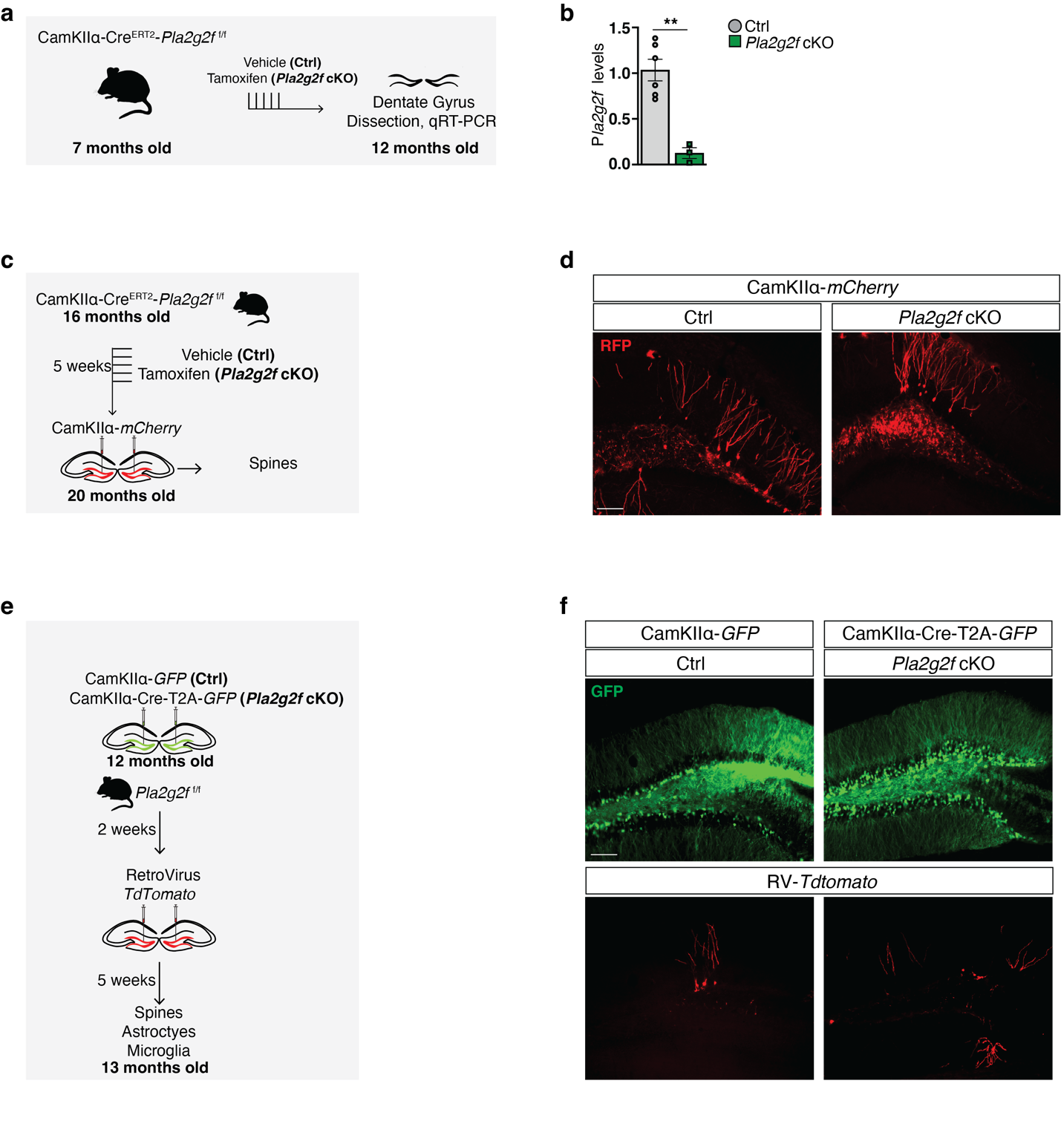

Extended Data Fig. 3 Deletion of Pla2g2f in DGCs of 12 months old mice does not change mossy fiber terminal size and mossy fiber terminal filopodial number of adult-born DGCs and number of parvalbumin inhibitory neuron synapses on CA3
a, Experimental design to virally delete Pla2g2f in the dentate gyrus of 12 months old Pla2g2f ^{f/f} mice and to label adult-born DGCs using retrovirus expressing tdTomato. Analysis of parvalbumin (PV) positive puncta density in subregion CA3ab and mossy fiber terminals of adult-born DGCs in CA3ab was performed 5 weeks after retrovirus injection (13 months old mice).
b, Representative images and quantification of PV+ puncta density in CA3ab stratum pyramidale (n=7 Ctrl, n=5 Pla2g2f cKO; scale bar 10μm). Data are displayed as mean ± SEM
c, Representative images and quantification of tdTomato positive filopodia per MFT (filopodial extensions) and mossy fiber terminal (MFT) area of 5 weeks old abDGC in CA3 (n=4 Ctrl, n=5 Pla2g2f cKO; scale bar 10μm). Data are displayed as mean ± SEM

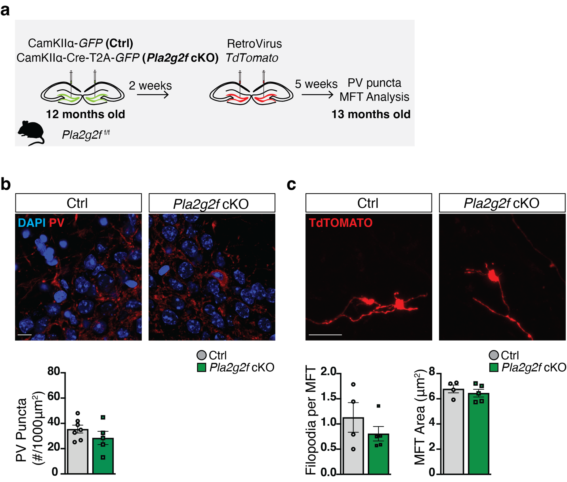
Extended Data Fig. 4 Deletion of Pla2g2f in DGCs of middle-aged mice does not affect anxiety-like behavior and novel object recognition.
a, 12 months old CamKIIα -Cre^{ERT2}-Pla2g2f ^{f/f} bigenic mice were injected with vehicle (Ctrl) or tamoxifen (Pla2g2f cKO), for Pla2g2f deletion for 5 days and behavioral testing was performed 5 weeks later in 13 months old mice.
b-e, Ctrl and Pla2g2f cKO mice underwent behavioral testing for (c) locomotion (Open Field, OF), (d) anxiety-like behavior (Elevated Plus Maze, EPM) and (e) spatial learning and memory (Novel Object Location, NOL and Novel Object Recognition, NOR) (n=10 Ctrl, n=7 Pla2g2f cKO). Data are displayed as mean ± SEM;****P<0.0001, ***P=0.0010 [unpaired t-test in c (left and right panels), d, e (middle and right top panels); repeated measures two way ANOVA in c (middle panel) and e (top left panel, and middle and bottom right panel)].

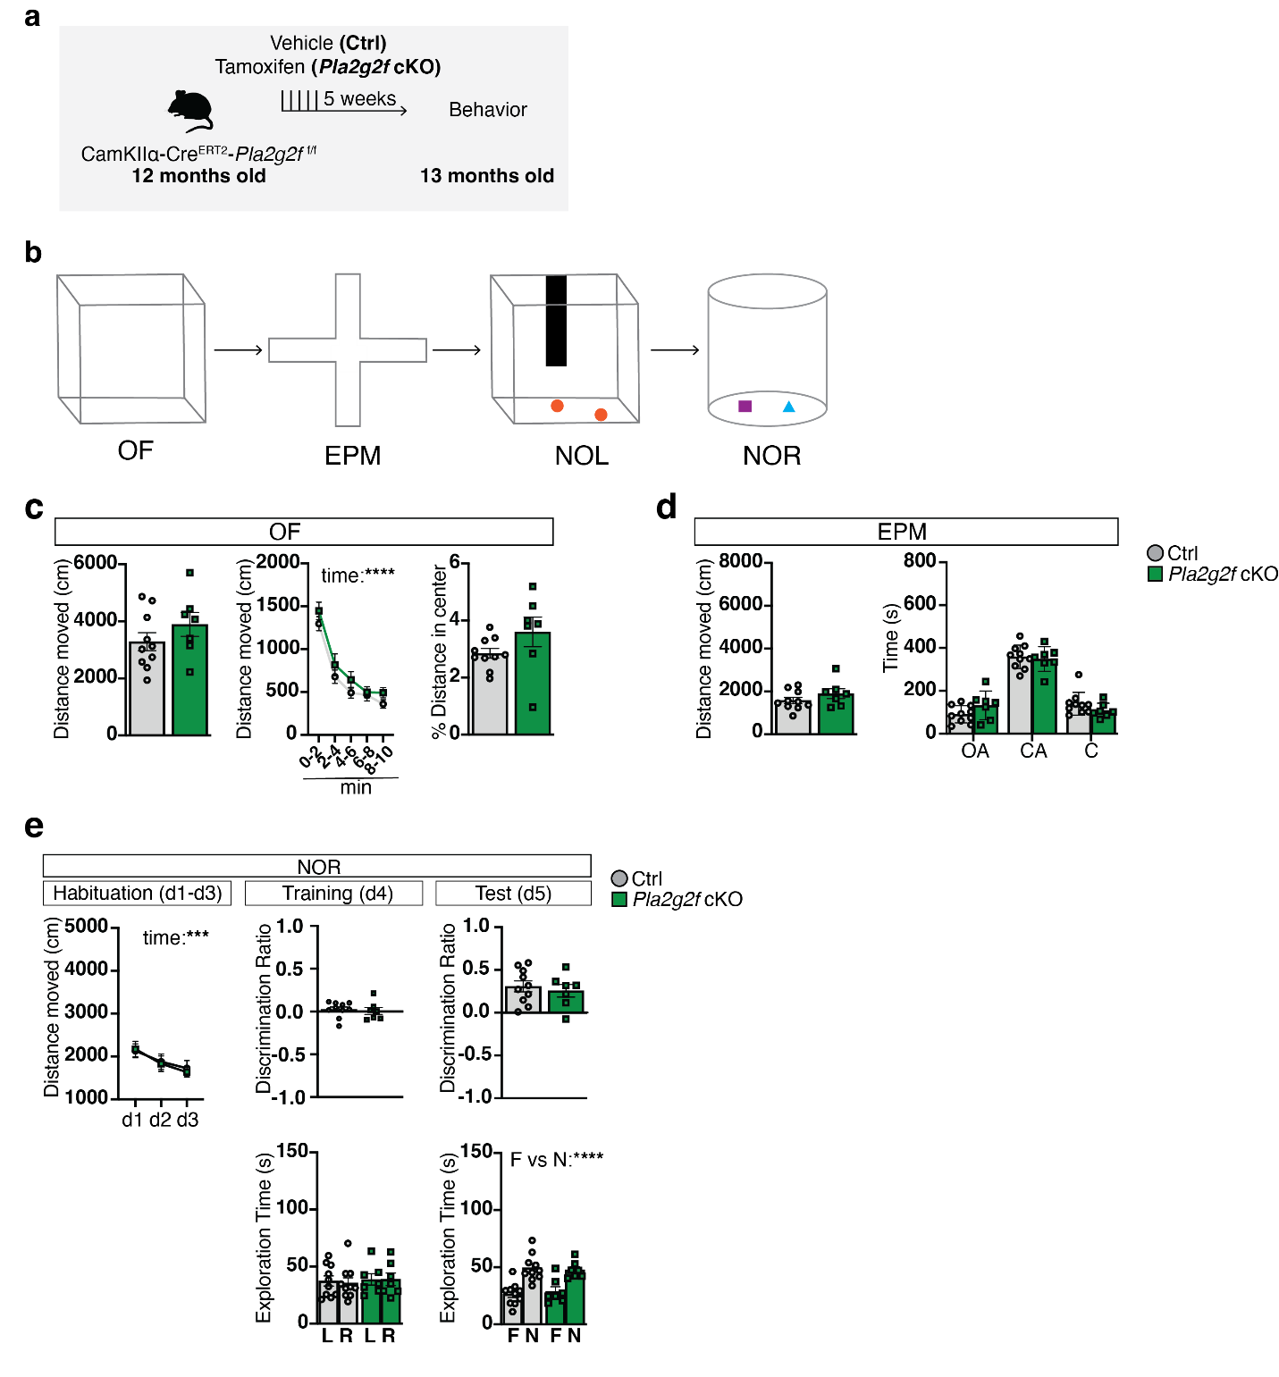
Extended Data Fig. 5 Boosting Pla2g2f expression in DGCs of aged mice does not affect anxiety-like behavior and novel object recognition.
a, Experimental design to boost Plag2f2 expression in DGCs of 16 months old of C57Bl/6J mice. Behavioral testing was performed 5 weeks following viral injections in 17 months old mice.
b-e, Ctrl and Pla2g2f OE mice at 17 months underwent behavioral testing for (c) locomotion (Open Field, OF), (d) anxiety-like behavior (Elevated Plus Maze, EPM) and (e) spatial learning and memory (Novel Object Location, NOL and Novel Object Recognition, NOR). (n=9 Ctrl, n=9 Pla2g2f OE). For EPM, OA: Open arms, CA: closed arms. Data are displayed as mean ± SEM;****P<0.0001, *P<0.05 [unpaired t-test in c (left and right panels), d, e (middle and right top panels); repeated measures two way ANOVA in c (middle panel) and e (top left panel, and middle and bottom right panel)].

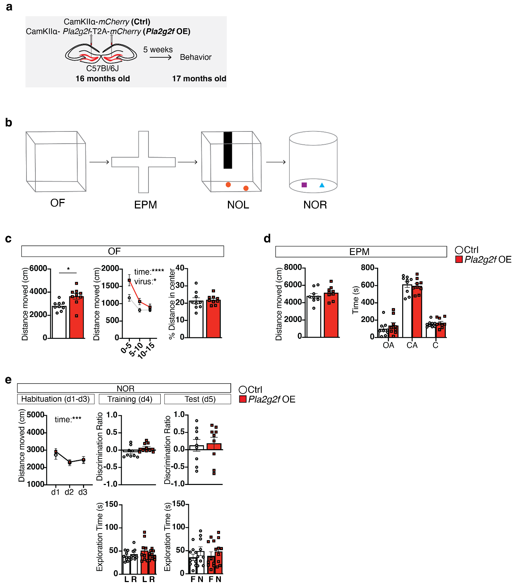
Extended Data Fig. 6 Boosting Pla2g2f expression in DGCs in middle-aged mice modifies trajectory of aging-associated cognitive decline
a, Schematic conveying the hypothesis tested in this experiment. Specifically, boosting Pla2g2f expression in middle-aged mice (12 months old) prevents age-associated cognitive decline in aged mice (19 months old).
b, Experimental design to boost Pla2g2f expression in DGCs of 12 months old of C57Bl/6J mice. Behavioral testing (OF, NOL, CFC) was performed 7 months later (19 months old mice).
c, Representative images of 19 months old mice dentate gyrus expressing either CamKIIα -mCherry (Ctrl) or CamKIIα -Pla2g2f-T2A-mCherry (Pla2g2f OE) lentiviruses (scale bar 100μm).
d, Locomotion was assessed in Open Field (OF) behavioral test (n=6 Ctrl, n=9 Pla2g2f OE). Data are displayed as mean ± SEM.
e, Hippocampal dependent learning and memory was assessed in Novel Object Location test. Discrimination Ratio at training represents: (exploration time of left (L) object -exploration time of right (R) object)/(exploration time of left object + exploration time of right object). Discrimination Ratio at test represents: (exploration time of the moved (M) object - exploration time of unmoved(U) object)/(exploration time of the moved object +exploration time of unmoved object) (n=6 Ctrl, n=9 Pla2g2f OE). Data are displayed as mean ± SEM.
f, Contextual fear memory was assessed in pre-exposure-dependent contextual fear conditioning paradigm as the percentage of time spent freezing during retrieval. Baseline freezing was calculated during pre-exposure to context. (n=6 Ctrl, n=9 Pla2g2f OE). Data are displayed as mean ± SEM; [unpaired t-test in d (left and right panels), e (middle top panel) and f (left panel); unpaired one-tailed t-test in e (right top panel) and f (right panel); repeated measures two way ANOVA in d (middle panel) and e (top left and bottom middle and right panels)].

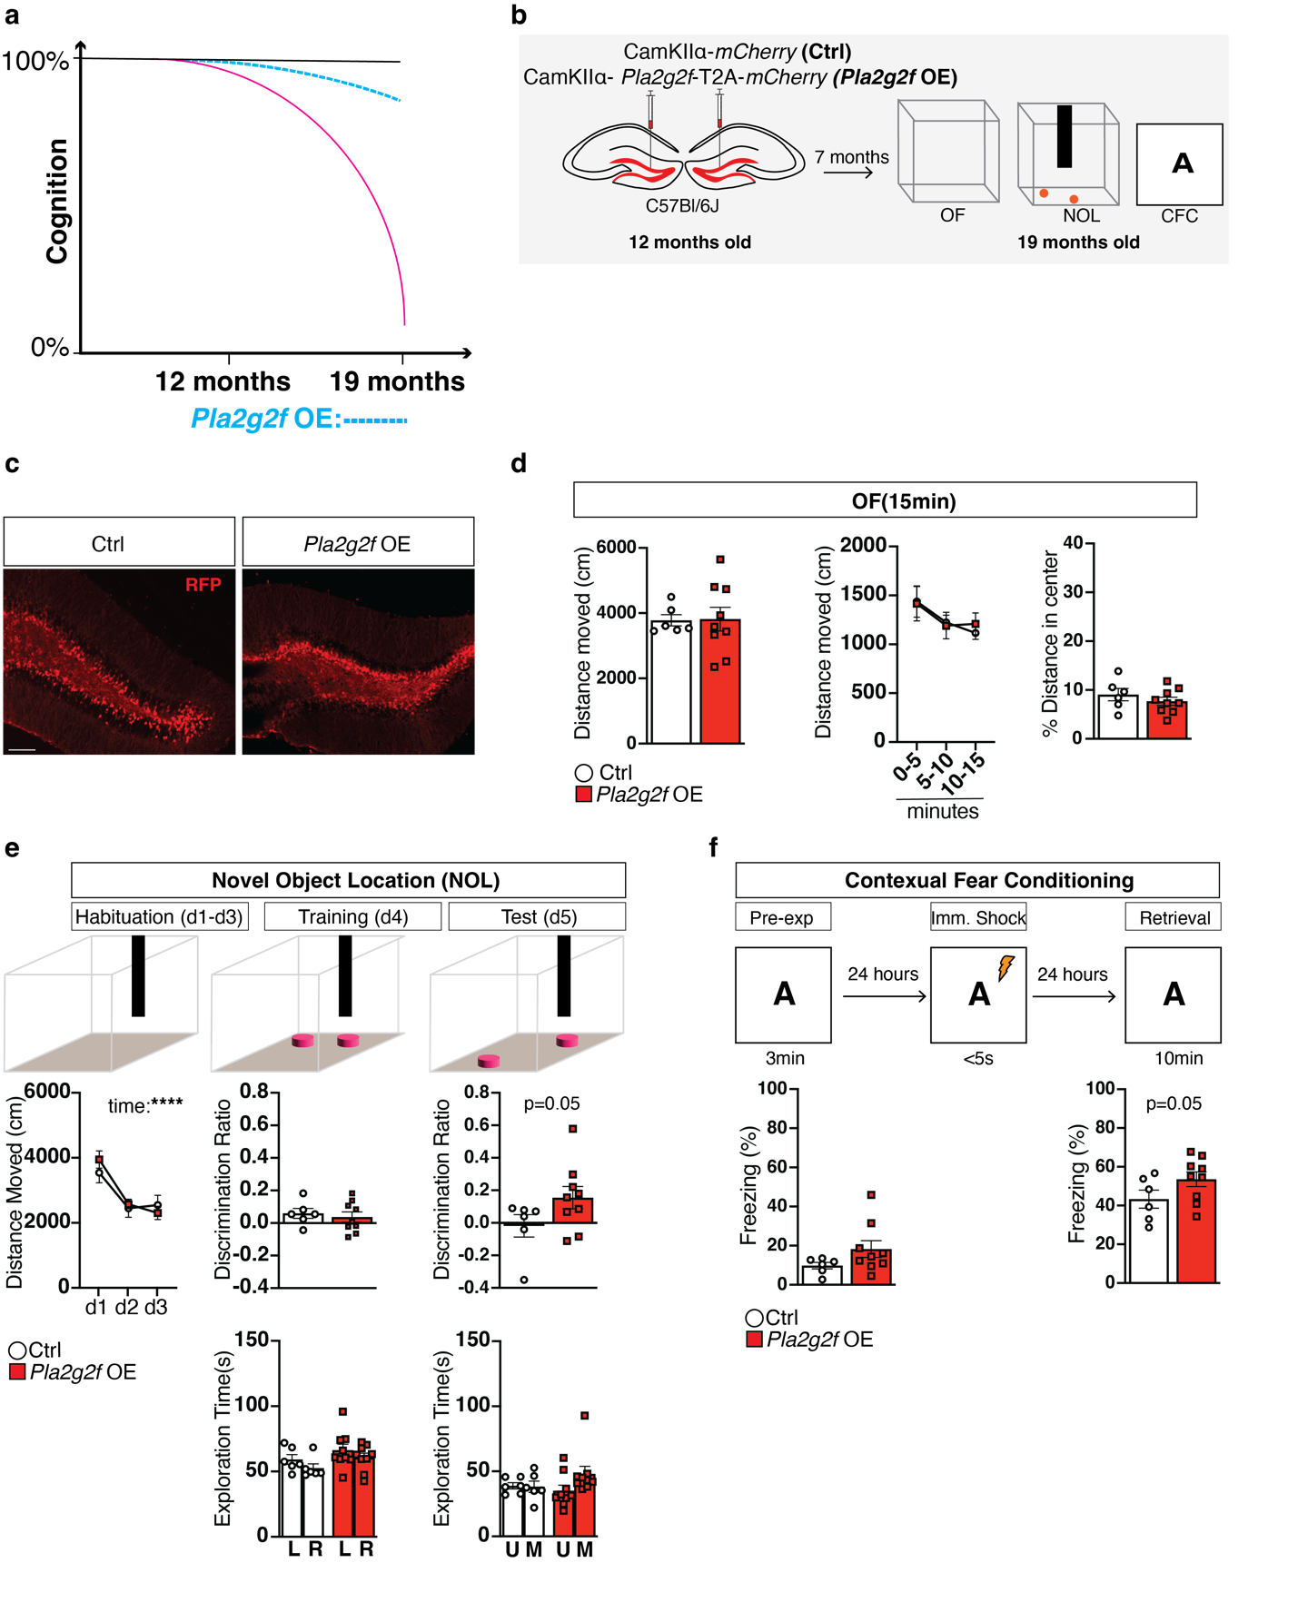

Extended Data Fig. 7 Supporting data documenting lipidomic changes in the dentate gyrus of Pla2g2f cKO mice.
a, Breakdown of the number of lipid species detected in each class (left) and total lipid signal detected in each sample (right).
b, Ridgeplot of average Log2(fold change) of lipids in Pla2g2f cKO mice vs. WT controls. Heatmap showing z score of lipid signals from c) sphingolipid, d) glycerolipid, e) glycerophospholipid, and f) cholesterol classes. Normalized ion intensities of lipids from g) ceramide (Cer), h) phosphatidylserine (PS), i) phosphatidic acid (PA), j) diacylglycerol (DAG), and k) Lysophosphatidylethanolamine (LPE) classes. Average lipid intensities were normalized by dividing over the maximal signal between the two groups.

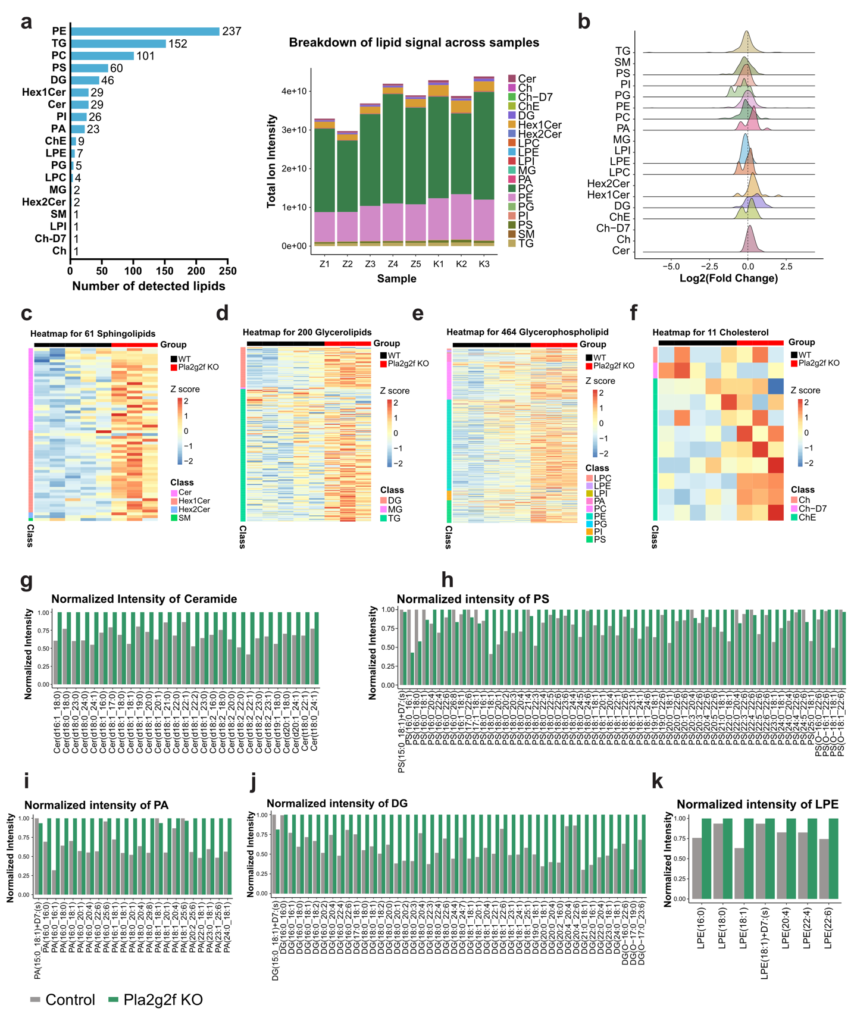
Supplementary Table 1. List of downregulated genes in dentate gyrus following Klf9 overexpression induced synapse loss. Analysis was done using a Benjamini Hochberg adjusted P value cutoff of 0.001 and a log fold-change (LFC) ratio cutoff of 0.25.
Supplementary Table 2. List of upregulated genes in dentate gyrus following Klf9 overexpression induced synapse loss. Analysis was done using a Benjamini Hochberg adjusted P value cutoff of 0.001 and a log fold-change (LFC) ratio cutoff of 0.25.
Supplementary Table 3. Lipidomics data from the dentate gyrus of Pla2g2f cKO and WT mice. All data from UHPLC-MSMS were pre-processed using the LipidSearch version 5.0 SP (Thermo Fisher Scientific). Lipids with parent and at least one acyl chain detected (grade A and B) were analyzed using the EdgeR ¹²⁶ package which calculates log2-transformed fold change (logFC), PValue, and false discovery rate (FDR) based on likelihood ratio test. Mean1 and Mean2 columns contain average ion intensity for Pla2g2f cKO group and WT group, respectively. The last 8 columns contain lipid ion intensity detected in each sample (Z: WT group, K: Pla2g2f cKO group).
Supplementary Table 4. Reactome pathways enriched in Pla2g2f cKO vs WT group. Lipid-related gene enrichment analysis was conducted using LipidSig 2.0¹¹⁷ and Reactome pathway database ¹²⁷. Pathways were ranked by -Log10(p-value).
Supplementary Table 5. KEGG pathways enriched in Pla2g2f cKO vs WT group. Lipid-related gene enrichment analysis was conducted using LipidSig 2.0 ¹¹⁷ and KEGG database ¹²⁸. Pathways were ranked by -Log10(p-value).
Supplementary Table 6. Complete statistics for all main and extended data figures.

