Supplementary Materials

Empathy strengthens the effect of emotion on beauty

Contents:
- Structural equation models with other traits as predictors of beauty and emotion (aesthetic reward, music reward, art fluency, openness to experience, and impulsiveness) (linked here)
- Empathy (QCAE) score histogram (linked here)
- Barplots showing counts of image and song beauty, happiness, and sadness ratings (linked here)
- Correlations between happiness and sadness of participants, images, and songs (linked here)
- Barplots showing mean felt happiness and sadness ratings, split by mood induction group (linked here)

Structural equation models with other traits as predictors of beauty and emotion (music reward, aesthetic reward, art fluency, openness to experience, and impulsiveness)

Response variable | Predictor variable | Estimate | SE | z | p
beauty | BMRQ | 0.31 | 0.03 | 12.27 | < 0.001 | ***
beauty | perceived happiness | 0.45 | 0.02 | 21.37 | < 0.001 | ***
beauty | perceived sadness | 0.50 | 0.02 | 22.62 | < 0.001 | ***
beauty | felt happiness | -0.02 | 0.01 | -1.80 | 0.073
beauty | felt sadness | 0.01 | 0.01 | 0.45 | 0.651
beauty | stimulus duration | 0.01 | 0.00 | 3.05 | 0.002 | **
beauty | BMRQ * perceived happiness | 0.03 | 0.01 | 3.29 | < 0.001 | ***
beauty | BMRQ * perceived sadness | 0.05 | 0.01 | 5.58 | < 0.001 | ***
beauty | BMRQ * felt happiness | 0.08 | 0.01 | 9.93 | < 0.001 | ***
beauty | BMRQ * felt sadness | -0.02 | 0.01 | -1.91 | 0.057
perceived happiness | BMRQ | 0.16 | 0.04 | 3.81 | < 0.001 | ***
perceived sadness | BMRQ | 0.24 | 0.04 | 6.52 | < 0.001 | ***
felt happiness | BMRQ | 0.33 | 0.01 | 25.52 | < 0.001 | ***
felt sadness | BMRQ | 0.05 | 0.01 | 5.13 | < 0.001 | ***
Table 1. Structural equation model with music reward (BMRQ) as the modulator in the relationship between emotion and song beauty (N = 164). The model explains 49% of the variance of the image beauty variable. Bold values indicate statistical significance. Interaction factors are highlighted in gray. * p < 0.05, ** p < 0.01, *** p < 0.001.

Response variable | Predictor variable | Estimate | SE | z | p
beauty | AReA | 0.24 | 0.02 | 12.20 | < 0.001 | ***
beauty | perceived happiness | 0.57 | 0.04 | 14.50 | < 0.001 | ***
beauty | perceived sadness | 0.09 | 0.04 | 2.43 | 0.015 | *
beauty | felt happiness | -0.07 | 0.02 | -3.48 | < 0.001 | ***
beauty | felt sadness | -0.04 | 0.01 | -3.26 | 0.001 | **
beauty | stimulus duration | 0.00 | 0.00 | 1.85 | 0.064
beauty | AReA * perceived happiness | -0.05 | 0.01 | -8.93 | < 0.001 | ***
beauty | AReA * perceived sadness | 0.00 | 0.01 | -0.65 | 0.513
beauty | AReA * felt happiness | 0.01 | 0.01 | 1.71 | 0.086
beauty | AReA * felt sadness | 0.00 | 0.01 | 0.26 | 0.793
perceived happiness | AReA | 0.20 | 0.02 | 8.27 | < 0.001 | ***
perceived sadness | AReA | 0.10 | 0.02 | 5.75 | < 0.001 | ***
felt happiness | AReA | 0.18 | 0.02 | 11.40 | < 0.001 | ***
felt sadness | AReA | 0.04 | 0.02 | 2.27 | 0.023 | *
Table 2. Structural equation model with aesthetic reward (AReA) as the modulator in the relationship between emotion and image beauty (N = 164). The model explains 44% of the variance of the image beauty variable. Bold values indicate statistical significance. Interaction factors are highlighted in gray. * p < 0.05, ** p < 0.01, *** p < 0.001.

Response variable | Predictor variable | Estimate | SE | z | p
beauty | art fluency | 0.23 | 0.03 | 8.18 | < 0.001 | ***
beauty | perceived happiness | 0.46 | 0.02 | 22.66 | < 0.001 | ***
beauty | perceived sadness | 0.51 | 0.02 | 21.45 | < 0.001 | ***
beauty | felt happiness | 0.08 | 0.01 | 6.56 | < 0.001 | ***
beauty | felt sadness | 0.02 | 0.02 | 1.23 | 0.217
beauty | stimulus duration | 0.01 | 0.00 | 4.98 | < 0.001 | ***
beauty | art fluency * perceived happiness | -0.05 | 0.02 | -3.30 | 0.001 | **
beauty | art fluency * perceived sadness | 0.00 | 0.02 | 0.11 | 0.911
beauty | art fluency * felt happiness | 0.12 | 0.02 | 7.88 | < 0.001 | ***
beauty | art fluency * felt sadness | 0.02 | 0.02 | 1.05 | 0.295
perceived happiness | art fluency | 0.06 | 0.05 | 1.41 | 0.160
perceived sadness | art fluency | 0.03 | 0.05 | 0.65 | 0.515
felt happiness | art fluency | 0.15 | 0.01 | 11.46 | < 0.001 | ***
felt sadness | art fluency | 0.22 | 0.02 | 9.65 | < 0.001 | ***
Table 3. Structural equation model with art fluency (AFS) as the modulator in the relationship between emotion and song beauty (N = 106). The model explains 51% of the variance of the image beauty variable. Bold values indicate statistical significance. Interaction factors are highlighted in gray. * p < 0.05, ** p < 0.01, *** p < 0.001.

Response variable | Predictor variable | Estimate | SE | z | p
beauty | art fluency | 0.30 | 0.05 | 5.82 | < 0.001 | ***
beauty | perceived happiness | 0.56 | 0.04 | 15.62 | < 0.001 | ***
beauty | perceived sadness | 0.12 | 0.04 | 3.32 | 0.001 | **
beauty | felt happiness | -0.03 | 0.02 | -1.19 | 0.236
beauty | felt sadness | -0.03 | 0.02 | -2.15 | 0.032 | *
beauty | stimulus duration | 0.01 | 0.00 | 2.46 | 0.014 | **
beauty | art fluency * perceived happiness | -0.08 | 0.01 | -8.76 | < 0.001 | ***
beauty | art fluency * perceived sadness | -0.06 | 0.03 | -2.25 | 0.025 | *
beauty | art fluency * felt happiness | 0.03 | 0.01 | 2.51 | 0.012 | **
beauty | art fluency * felt sadness | 0.04 | 0.01 | 3.24 | 0.001 | **
perceived happiness | art fluency | 0.07 | 0.05 | 1.50 | 0.134
perceived sadness | art fluency | -0.12 | 0.03 | -3.49 | < 0.001 | ***
felt happiness | art fluency | 0.15 | 0.01 | 12.93 | < 0.001 | ***
felt sadness | art fluency | 0.23 | 0.02 | 10.89 | < 0.001 | ***
Table 4. Structural equation model with art fluency (AFS) as the modulator in the relationship between emotion and image beauty (N = 106). The model explains 42% of the variance of the image beauty variable. Bold values indicate statistical significance. Interaction factors are highlighted in gray. * p < 0.05, ** p < 0.01, *** p < 0.001.

Response variable | Predictor variable | Estimate | SE | z | p
beauty | openness | 0.17 | 0.02 | 8.40 | < 0.001 | ***
beauty | perceived happiness | 0.46 | 0.02 | 21.80 | < 0.001 | ***
beauty | perceived sadness | 0.51 | 0.02 | 22.73 | < 0.001 | ***
beauty | felt happiness | 0.01 | 0.01 | 0.69 | 0.491
beauty | felt sadness | -0.02 | 0.01 | -1.33 | 0.184
beauty | stimulus duration | 0.01 | 0.00 | 3.41 | 0.001 | **
beauty | openness * perceived happiness | -0.03 | 0.01 | -2.32 | 0.020 | *
beauty | openness * perceived sadness | 0.00 | 0.01 | -0.38 | 0.708
beauty | openness * felt happiness | 0.03 | 0.01 | 3.20 | 0.001 | **
beauty | openness * felt sadness | 0.02 | 0.01 | 1.33 | 0.183
perceived happiness | openness | 0.09 | 0.02 | 5.02 | < 0.001 | ***
perceived sadness | openness | 0.08 | 0.02 | 3.52 | < 0.001 | ***
felt happiness | openness | 0.26 | 0.01 | 22.10 | < 0.001 | ***
felt sadness | openness | 0.05 | 0.02 | 2.99 | 0.003 | **
Table 5. Structural equation model with openness to experience (Big 5) as the modulator in the relationship between emotion and song beauty (N = 164). The model explains 47% of the variance of the image beauty variable. Bold values indicate statistical significance. Interaction factors are highlighted in gray. * p < 0.05, ** p < 0.01, *** p < 0.001.

Response variable | Predictor variable | Estimate | SE | z | p
beauty | openness | 0.17 | 0.02 | 9.36 | < 0.001 | ***
beauty | perceived happiness | 0.58 | 0.04 | 15.51 | < 0.001 | ***
beauty | perceived sadness | 0.11 | 0.04 | 3.09 | 0.002 | **
beauty | felt happiness | -0.06 | 0.02 | -3.10 | 0.002 | **
beauty | felt sadness | -0.03 | 0.01 | -2.62 | 0.009 | **
beauty | stimulus duration | 0.00 | 0.00 | 1.73 | 0.085
beauty | openness * perceived happiness | -0.05 | 0.01 | -8.53 | < 0.001 | ***
beauty | openness * perceived sadness | -0.04 | 0.01 | -3.98 | < 0.001 | ***
beauty | openness * felt happiness | 0.05 | 0.01 | 5.36 | < 0.001 | ***
beauty | openness * felt sadness | 0.05 | 0.02 | 3.17 | 0.002 | **
perceived happiness | openness | 0.03 | 0.02 | 1.16 | 0.245
perceived sadness | openness | 0.00 | 0.02 | 0.16 | 0.875
felt happiness | openness | 0.27 | 0.01 | 18.70 | < 0.001 | ***
felt sadness | openness | 0.05 | 0.02 | 2.36 | 0.018 | *
Table 6. Structural equation model with openness to experience (Big 5) as the modulator in the relationship between emotion and image beauty (N = 164). The model explains 42% of the variance of the image beauty variable. Bold values indicate statistical significance. Interaction factors are highlighted in gray. * p < 0.05, ** p < 0.01, *** p < 0.001.

Response variable | Predictor variable | Estimate | SE | z | p
beauty | impulsiveness | -0.11 | 0.02 | -5.61 | < 0.001 | ***
beauty | perceived happiness | 0.46 | 0.02 | 21.21 | < 0.001 | ***
beauty | perceived sadness | 0.52 | 0.02 | 23.67 | < 0.001 | ***
beauty | felt happiness | 0.04 | 0.01 | 3.85 | < 0.001 | ***
beauty | felt sadness | 0.01 | 0.01 | 0.54 | 0.592
beauty | stimulus duration | 0.01 | 0.00 | 3.85 | < 0.001 | ***
beauty | impulsiveness * perceived happiness | 0.00 | 0.01 | 0.32 | 0.747
beauty | impulsiveness * perceived sadness | -0.02 | 0.01 | -3.19 | 0.001 | **
beauty | impulsiveness * felt happiness | -0.07 | 0.01 | -8.72 | < 0.001 | ***
beauty | impulsiveness * felt sadness | -0.02 | 0.02 | -1.07 | 0.285
perceived happiness | impulsiveness | 0.00 | 0.02 | 0.08 | 0.938
perceived sadness | impulsiveness | -0.03 | 0.02 | -2.01 | 0.044 | *
felt happiness | impulsiveness | -0.10 | 0.02 | -6.28 | < 0.001 | ***
felt sadness | impulsiveness | 0.15 | 0.01 | 10.91 | < 0.001 | ***
Table 7. Structural equation model with impulsiveness as the modulator in the relationship between emotion and song beauty (N = 164). The model explains 47% of the variance of the image beauty variable. Bold values indicate statistical significance. Interaction factors are highlighted in gray. * p < 0.05, ** p < 0.01, *** p < 0.001.

Response variable | Predictor variable | Estimate | SE | z | p
beauty | impulsiveness | 0.04 | 0.02 | 1.66 | 0.096
beauty | perceived happiness | 0.59 | 0.04 | 15.89 | < 0.001 | ***
beauty | perceived sadness | 0.12 | 0.04 | 3.24 | 0.001 | **
beauty | felt happiness | -0.04 | 0.02 | -1.87 | 0.062
beauty | felt sadness | -0.03 | 0.01 | -3.03 | 0.002 | **
beauty | stimulus duration | 0.01 | 0.00 | 2.48 | 0.013 | *
beauty | impulsiveness * perceived happiness | -0.03 | 0.01 | -4.29 | < 0.001 | ***
beauty | impulsiveness * perceived sadness | -0.04 | 0.01 | -4.09 | < 0.001 | ***
beauty | impulsiveness * felt happiness | -0.01 | 0.01 | -1.31 | 0.190
beauty | impulsiveness * felt sadness | 0.00 | 0.01 | 0.21 | 0.837
perceived happiness | impulsiveness | -0.02 | 0.03 | -0.61 | 0.544
perceived sadness | impulsiveness | 0.03 | 0.03 | 1.11 | 0.268
felt happiness | impulsiveness | -0.11 | 0.01 | -7.36 | < 0.001 | ***
felt sadness | impulsiveness | 0.16 | 0.01 | 13.26 | < 0.001 | ***
Table 8. Structural equation model with impulsiveness as the modulator in the relationship between emotion and image beauty (N = 164). The model explains 41% of the variance of the image beauty variable. Bold values indicate statistical significance. Interaction factors are highlighted in gray. * p < 0.05, ** p < 0.01, *** p < 0.001.

Empathy (QCAE) score histogram

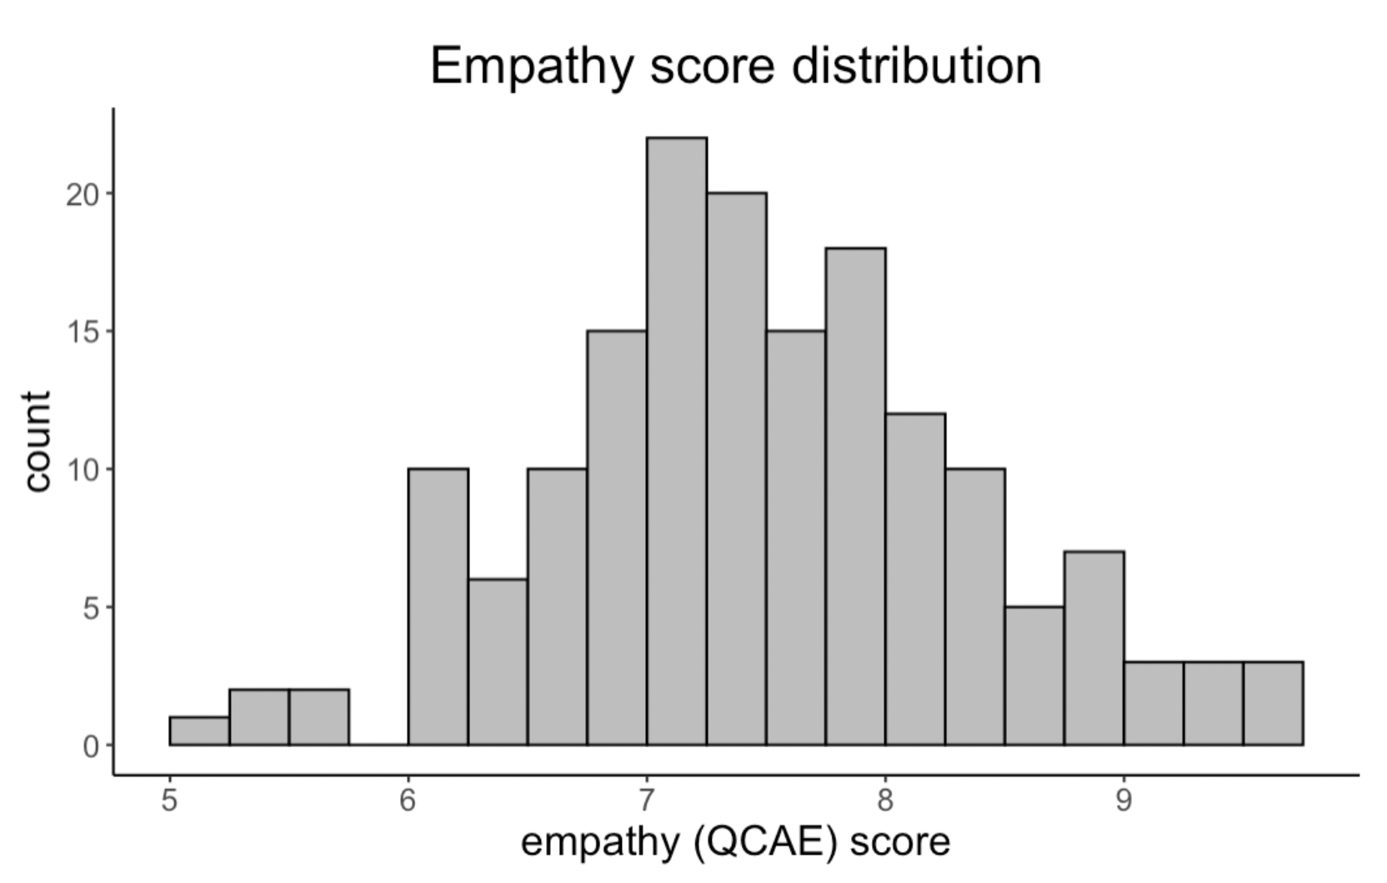

Figure 1. Empathy (QCAE) histogram, 5.7±0.6 (M±SD), N = 164.
Barplots showing counts of image and song beauty, happiness, and sadness ratings

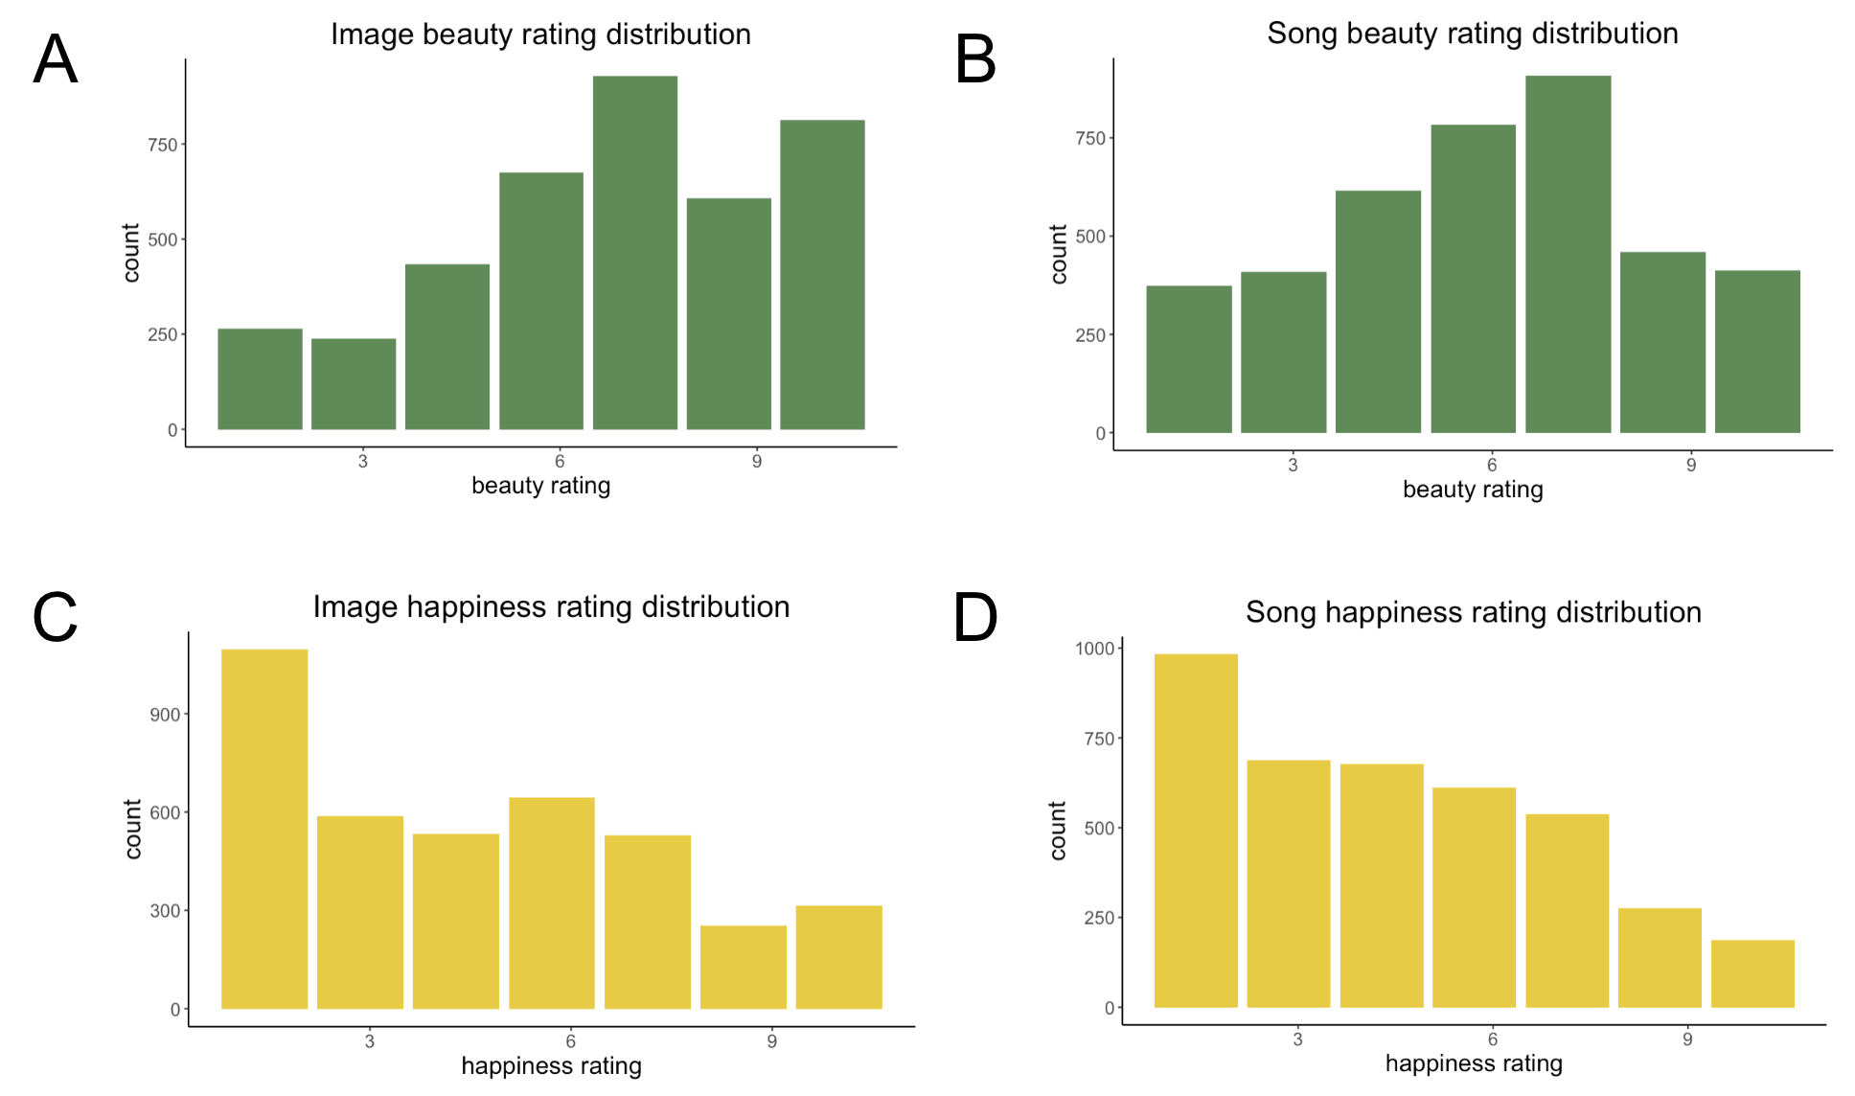

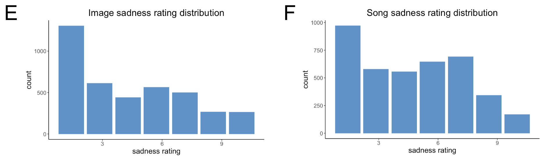

Figure 2. Barplots showing counts of image and song beauty, happiness, and sadness ratings on a 10-point Likert scale from “Not at all” to “Very.” Plots include ratings for each stimulus (24 images and 24 songs) from all 164 included participants.

Correlations between happiness and sadness of participants, images, and songs

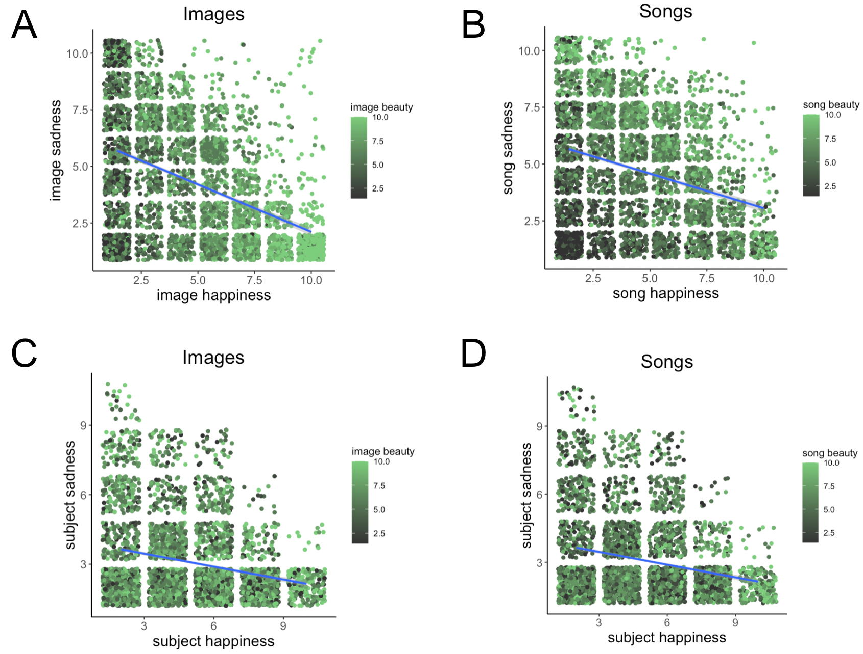

Figure 3. Scatterplots and regression lines showing the correlations between perceived and felt happiness and sadness as well as associated beauty rating (color). N = 164.

Barplots showing mean felt happiness and sadness ratings, split by mood induction group

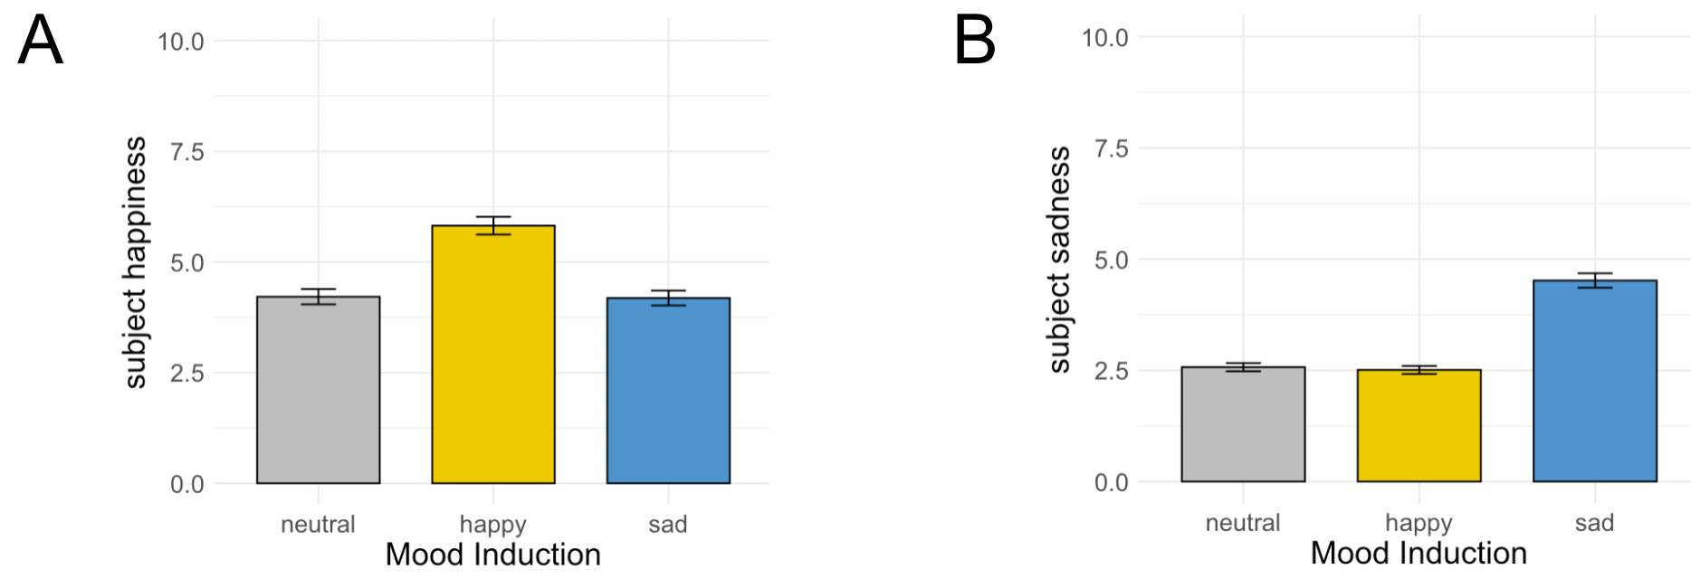

Figure 4. Barplots showing mean felt happiness and sadness ratings with standard errors, split by mood induction group.

