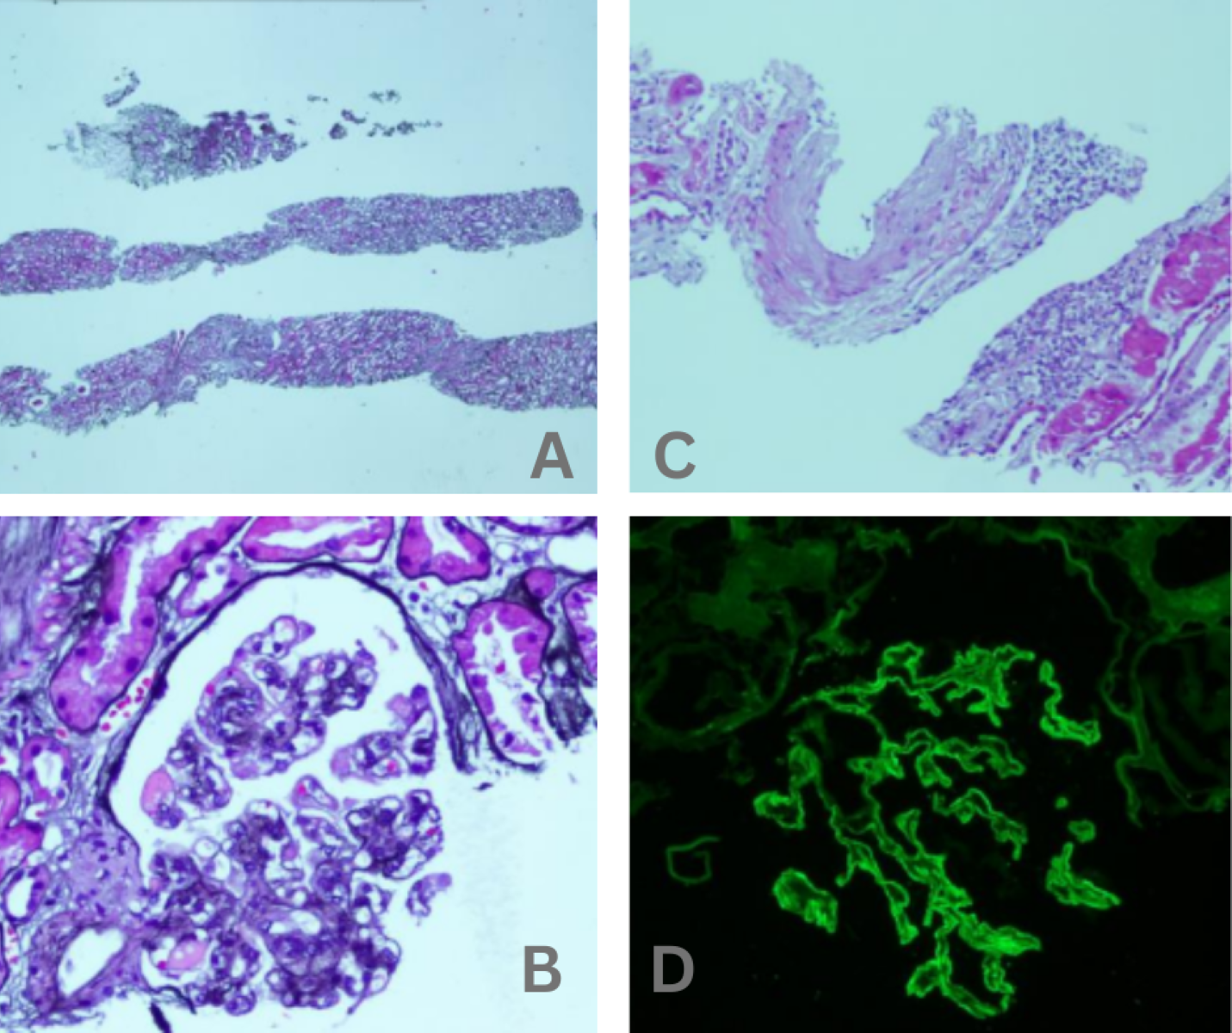
Figure 1: (A) Low-power view of renal biopsy demonstrating extensive interstitial fibrosis and tubular atrophy, indicative of chronic kidney damage; (B) Renal biopsy showing thickening of the vascular walls, complicating membranous nephropathy; (C) High power view of renal biopsy under periodic acid Schiff (PAS) staining showing subepithelial immune complex deposits; (D) Immunofluorescence staining of renal biopsy showing IgG deposits.
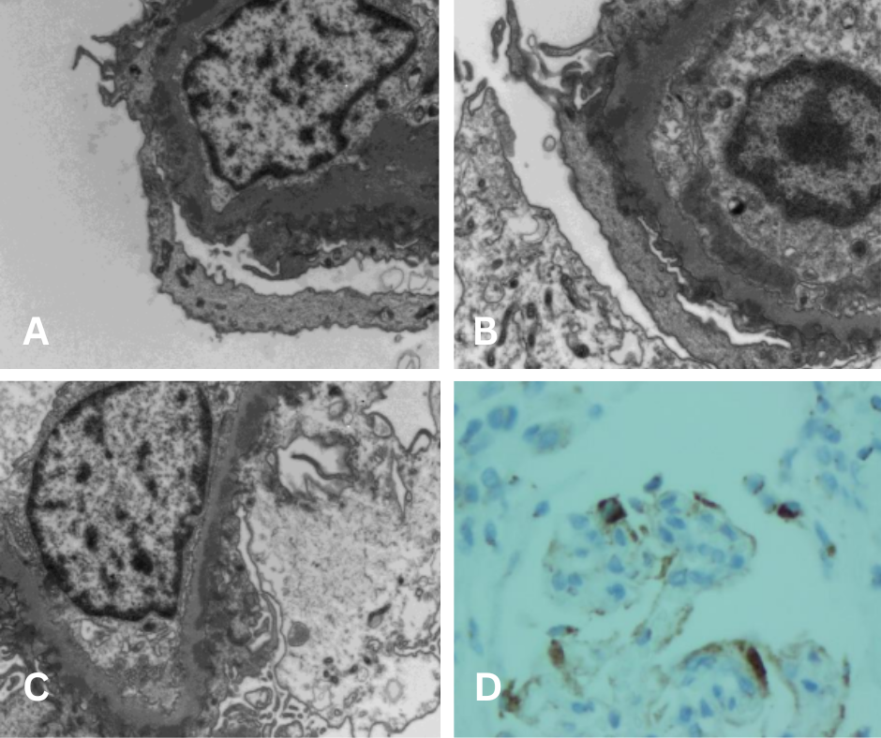
Figure 2: (A-C) Electron microscopy of renal biopsy revealing dense subepithelial electron-dense deposits characteristic of membranous nephropathy, detailing the damage in the glomerular basement membrane; (D) Immunohistochemical staining for NELL-1 in a renal biopsy sample showing positive expression, indicating the role of pathogenesis in MN.

Figure 3: Key pathways involved in the pathogenesis of membranous nephropathy.

