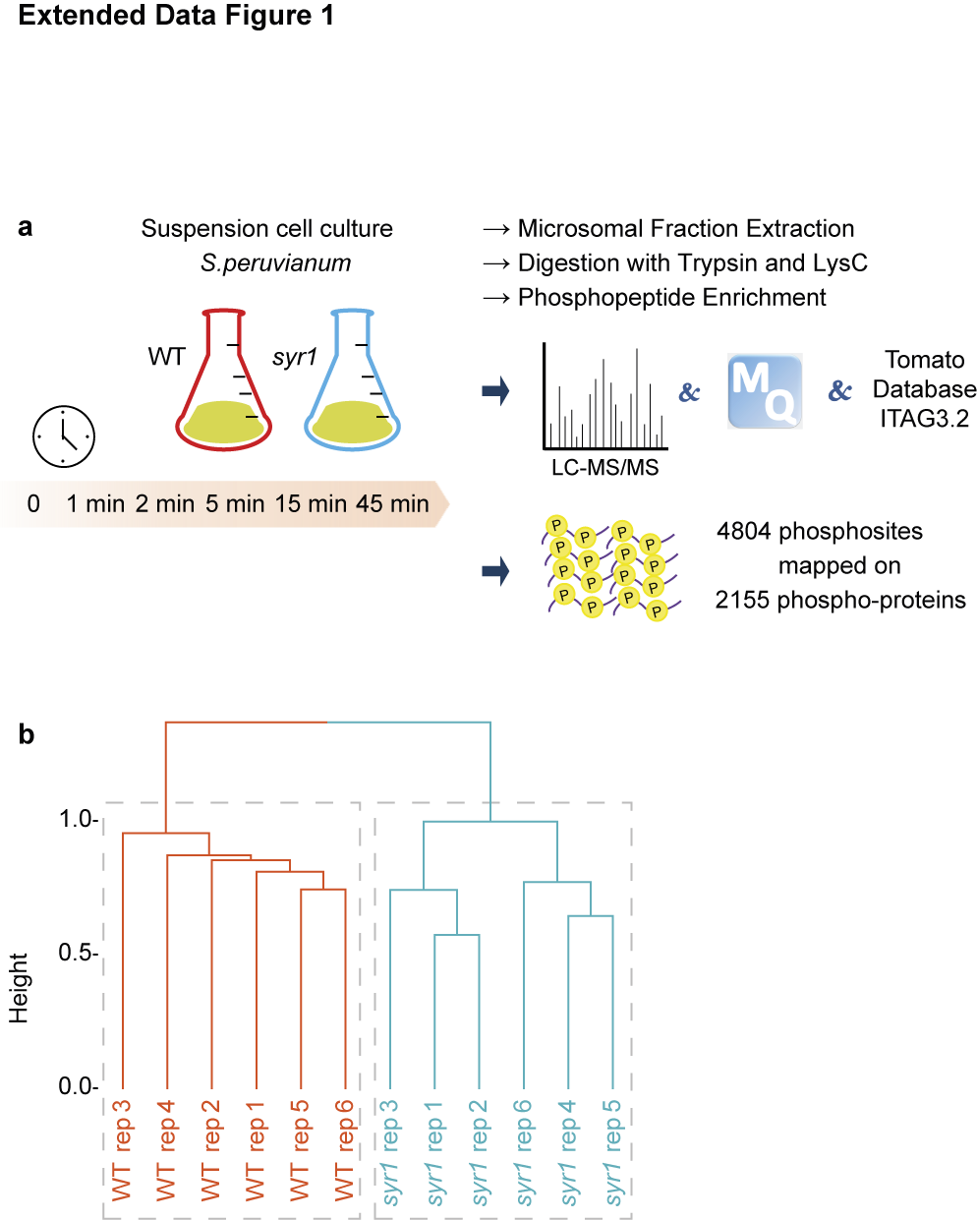
Extended Data Fig. 1 | Design of the phospho-proteomics experiment. a, ﻿﻿ Phospho-proteomics workflow. Samples were harvested from WT and syr1 cell cultures before and at 5 time points after systemin treatment in six biological replicates, resulting in a total of 72 samples. From each sample, the microsomal membrane fraction was extracted and digested with trypsin and LysC. After phospho-peptide enrichment, samples were analyzed by LC-MS/MS. Raw files were transferred to MaxQant for peptide quantification using the tomato proteome database ITAG3.2 as the reference. b, Hierarchical clustering of the 72 samples clearly separated the two genotypes.

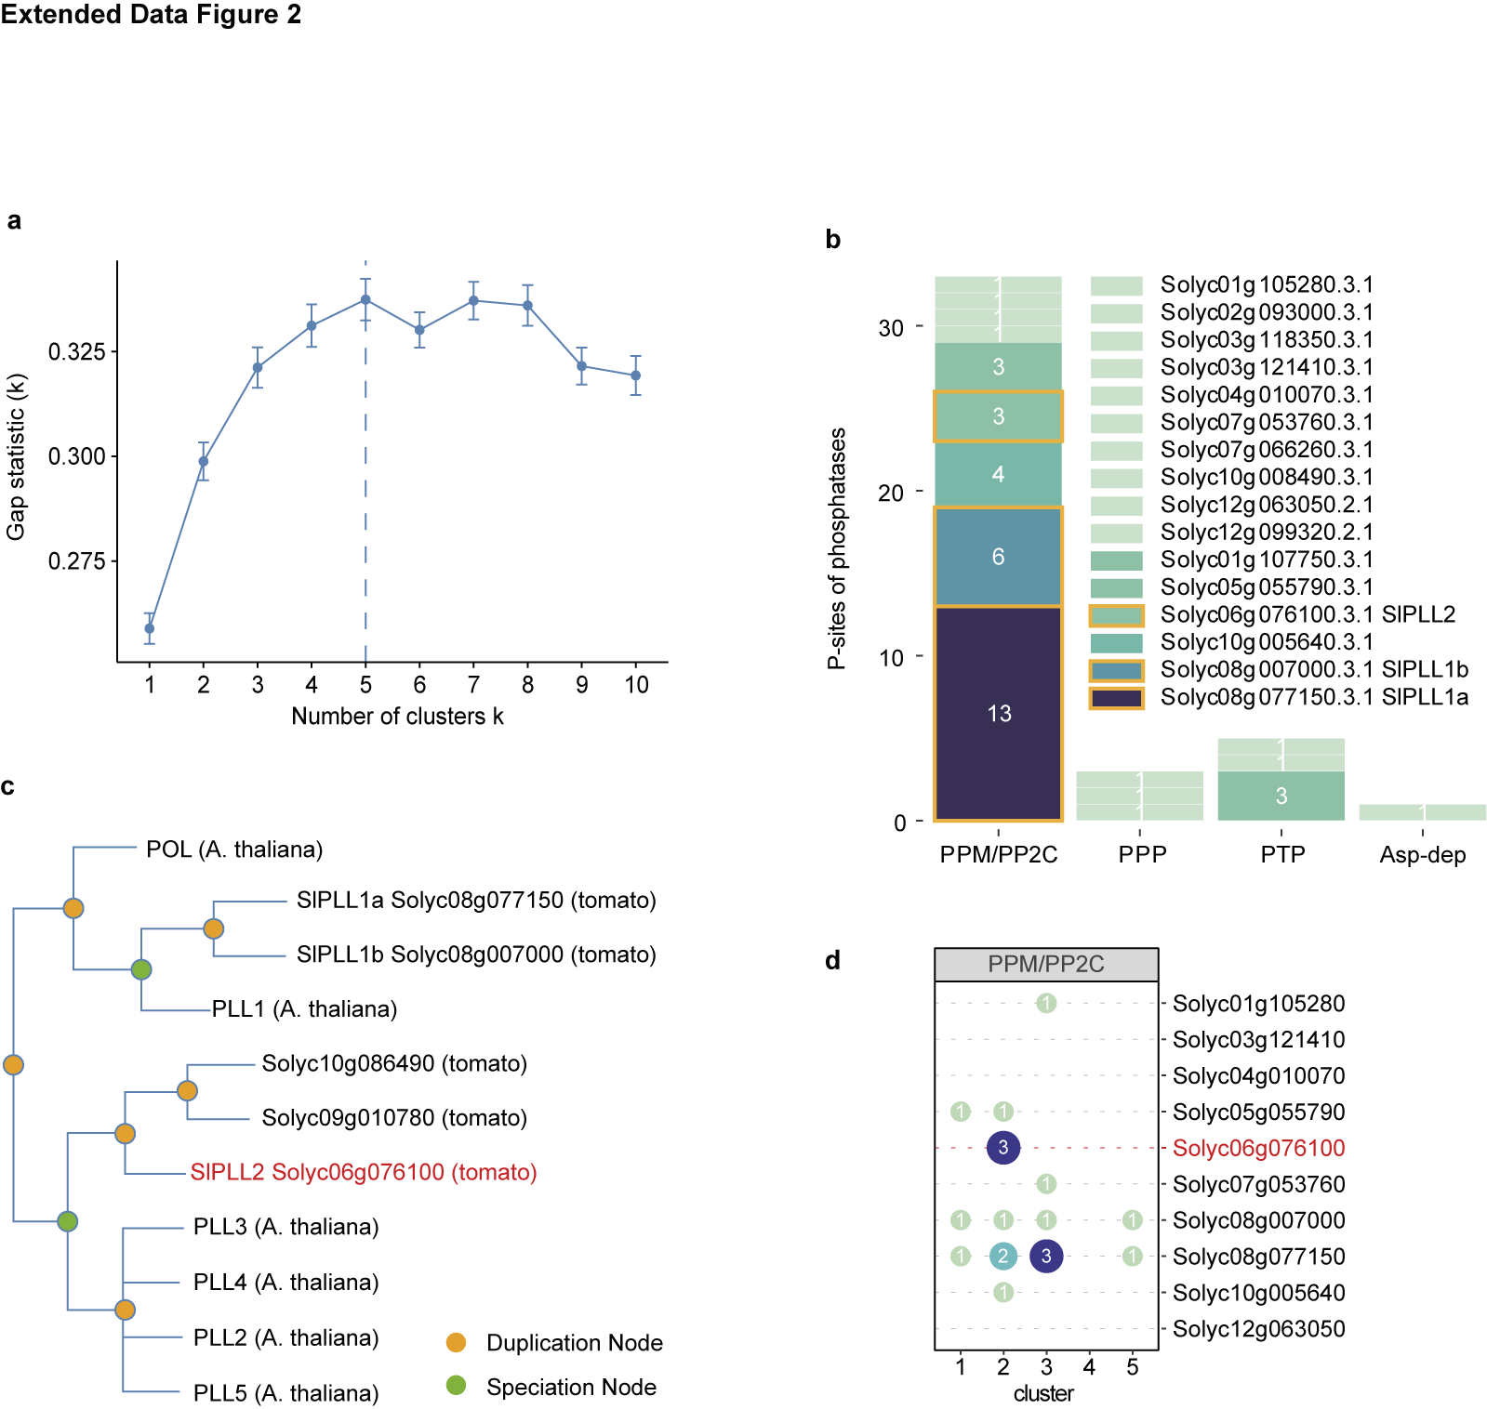
Extended Data Fig. 2 | Selection of PLL2 as a candidate phosphatase specifically involved in systemin signaling. a, ﻿﻿ Gap statistic identifies the optimal number of clusters as K = 5. The K-means clustering algorithm requires a predefined number of clusters K that is chosen to best describe the structure of the data. Gap statistics showed that the cluster structure showed maximum distance from the random uniform distribution of points with K = 5. 10 was set as the upper limit for K and 100 bootstrapping runs were performed in fviz_nbclust⁴² (method = "gap_stat”). b, Protein phosphatases represented in this phosphoproteome dataset belonged to four different families: metallo-dependent protein phosphatases (PPM)/ type 2C protein phosphatases (PP2C), phosphoprotein phosphatases (PPP), protein tyrosine phosphatases (PTP) and aspartate (Asp)-dependent phosphatases. Intensity of shading is used to indicate the number of detected phospho-sites with darker colors indicating more phospho-sites for a given protein. Most phospho-sites were found in POLTERGEIST-LIKE phosphatases (boxed in orange). c, Phylogenetic tree of POL family proteins from Arabidopsis and tomato. The tree was generated by PhyloGenes (v4.1) based on GIGA algorithm⁵⁴. SlPLL2 (highlighted in red) is located in a sister clade to Arabidopsis PLL2 – PLL5. d, SlPLL2 has three phospho-sites that show a transient drop in intensity at 1 min after systemin treatment (cluster 2). Cluster distribution is shown for the phospho-sites of PPM/PP2C family phosphatases. The number of phospho-sites in each cluster is reflected by the intensity of color shading and size of the dots. SlPLL2 (Solyc06g076100) stands out as all three differentially phosphorylated sites belong to cluster 2.

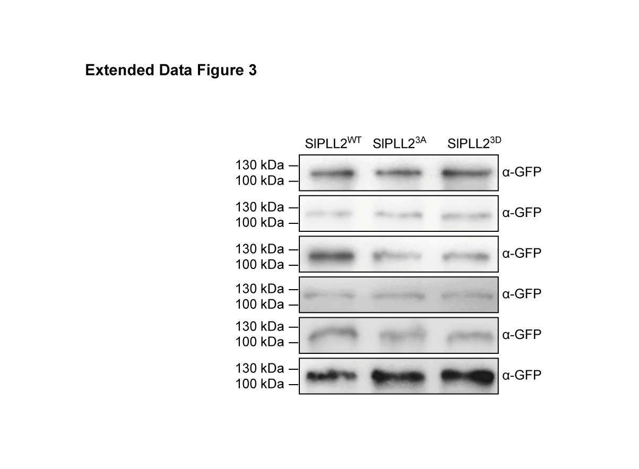
Extended Data Fig. 3 | Quantification of SlPLL2 variants in protein extracts used for phosphatase activity assays shown in Fig. 2a, b. ﻿﻿ SlPLL2^{WT}, SlPLL2^{3A} and SlPLL2^{3D} were expressed as C-terminal GFP fusion proteins in N. benthamiana, and purified from leaf extracts by GFP-trap (Chromotek). Abundance of the GFP fusion proteins was analyzed by anti-GFP immunoblotting. In each of the six independent experiments, similar expression levels were observed for the three SlPLL2 variants.

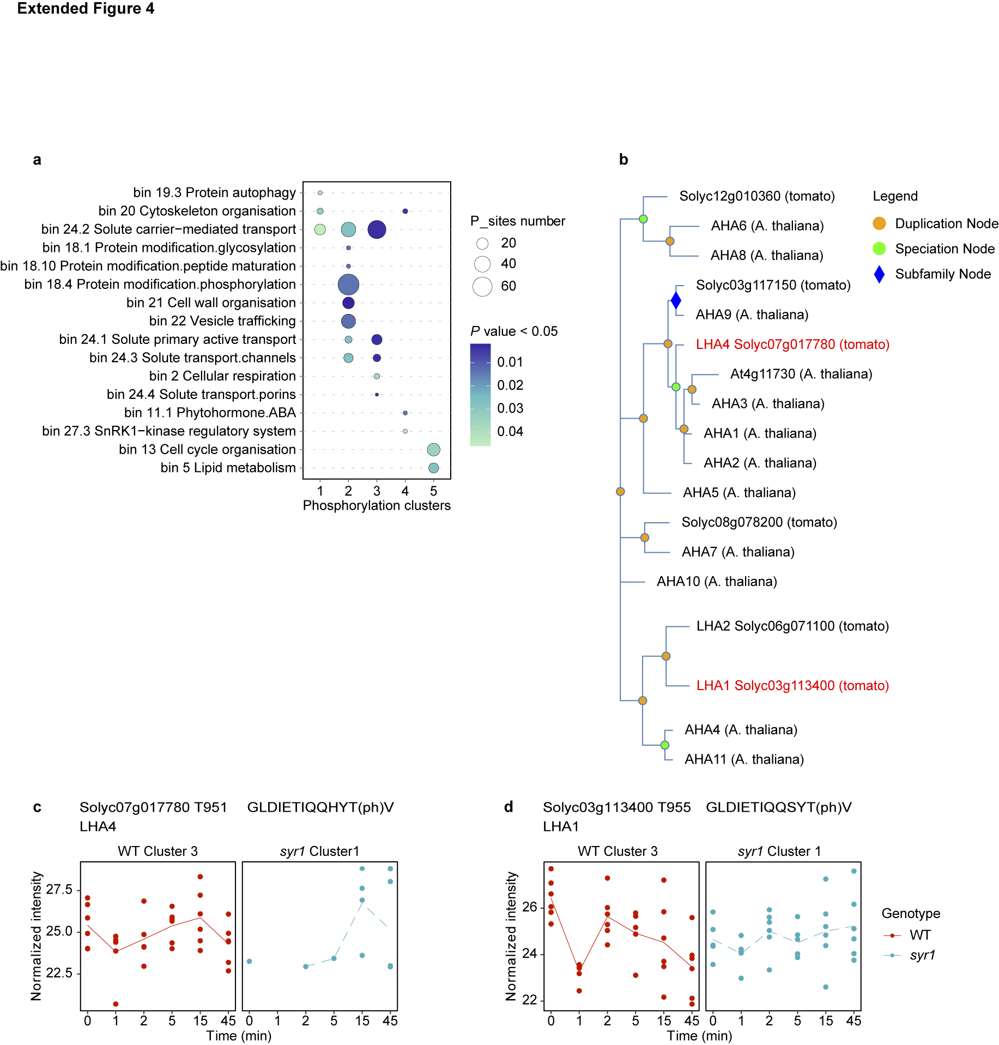

Extended Data Fig. 4 | Identification of plasma membrane proton pumps LHA1 and LHA4 as candidate substrates of SlPLL2. ﻿﻿ a, over-representation analysis of biological processes in the five clusters. The proteins represented by the phospho-sites in each of the five clusters were subjected to MapMan over-representation analysis. MapMan bins of biological processes that were significantly (P <0.05) enriched are plotted according to cluster number. The size of the dots reflects the number of phospho-sites for each bin, color shading indicates P value. Bins related to solute transport (bin 24) are enriched in clusters 2 and 3 including LHA1 and LHA4. b, phylogenetic analysis of tomato and Arabidopsis P-type H⁺-ATPases. The tree was generated by PhyloGenes (v4.1) based on GIGA algorithm⁵⁴. LHA1 and LHA4 are highlighted in red. c, d normalized intensity of phosphorylation of the regulatory threonine T951 of LHA4 (c, Solyc07g017780) and T955 of LHA1 (d, Solyc03g113400) is shown in a time series after systemin treatment of the S. peruvianum wild-type (WT; red) and syr1 (blue) cell cultures in six biological replicates. The trendline connects the mean intensity at each time point.
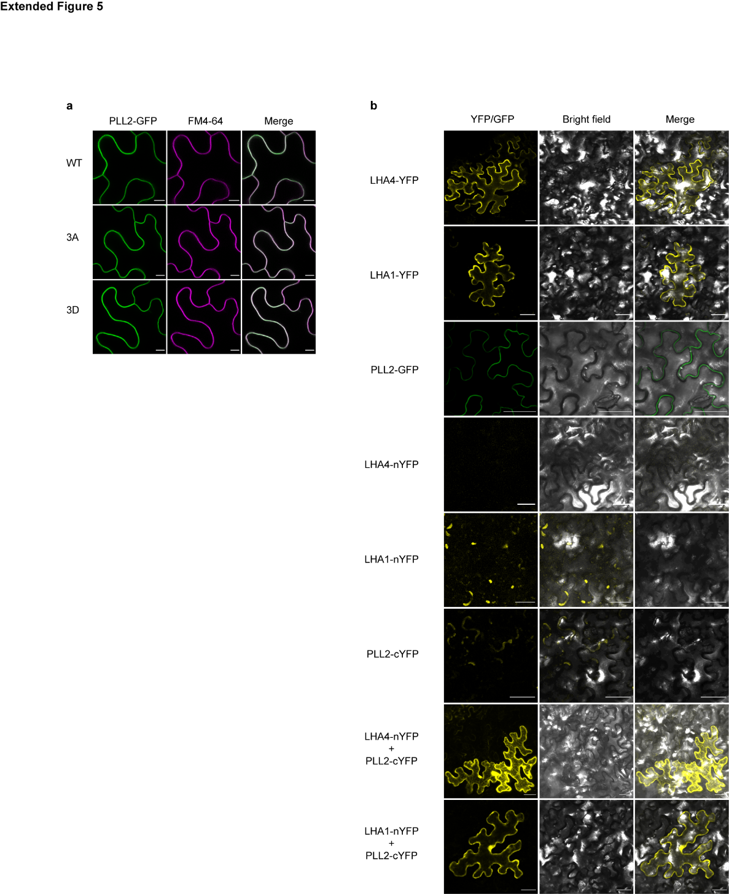
Extended Data Fig. 5 | LHA1/4 and SlPLL2 interact at the plasma membrane. ﻿ a, SlPLL2 localizes to the plasma membrane irrespective of the phosphorylation status of S142-S151-S160. SlPLL2-GFP (WT, 3A and 3D mutants) were transiently expressed in N. benthamiana leaves. Leaf pieces were incubated in 10 µM FM4-64 (plasma membrane marker) 15 min before confocal imaging using a Zeiss LSM900 microscope in the red (FM4-64) and green (GFP) channels, respectively; scale bar = 10 µm. b, Interaction of LHA1/4 and SlPLL2 is indicated by bimolecular fluorescence complementation (BiFC). Tomato H⁺-ATPases (LHA1 and LHA4) fused with nYFP, and SlPLL2 with cYFP were transiently expressed in N. benthamiana leaves. LHA1 and LHA4 fused with full-length YFP, and SlPLL2 with GFP were used as positive controls. Negative controls included leaves expressing LHA1-nYFP, LHA4-nYFP or SlPLL2 -cYFP alone; scale bar = 50 μm.

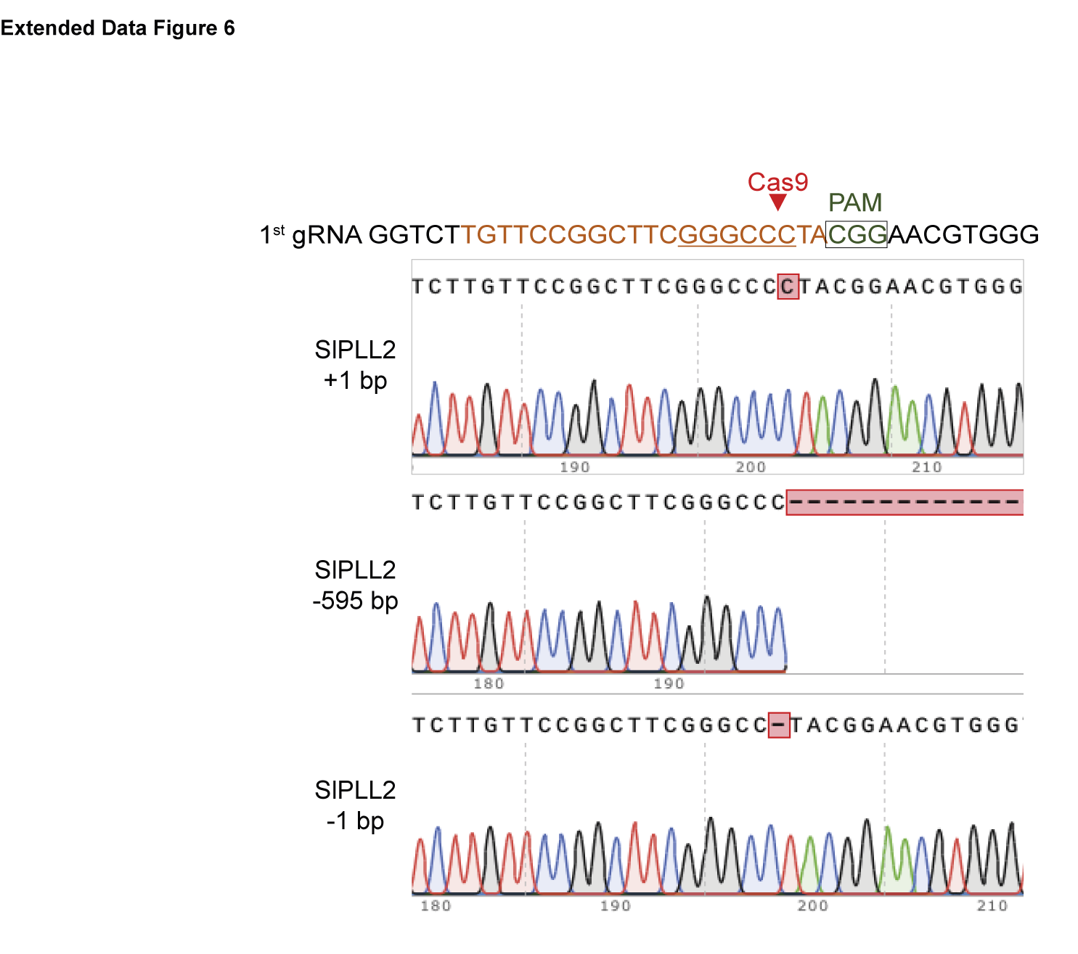
Extended Data Fig. 6 | Three independent pll2 alleles were used in this study. Sequence analysis revealed three independent CRISPR/Cas9-generated mutations at the 1st guide RNA resulting in the addition of one, and deletion of 1 or 595 base pairs (boxed in red) from the SlPLL2 locus. These mutations resulted in truncated proteins of 145, 147, and 219 amino acids, respectively. The PAM sequence is indicated in green; the Cas9 cleavage site is located 3 bp upstream of the PAM sequence (red arrow).

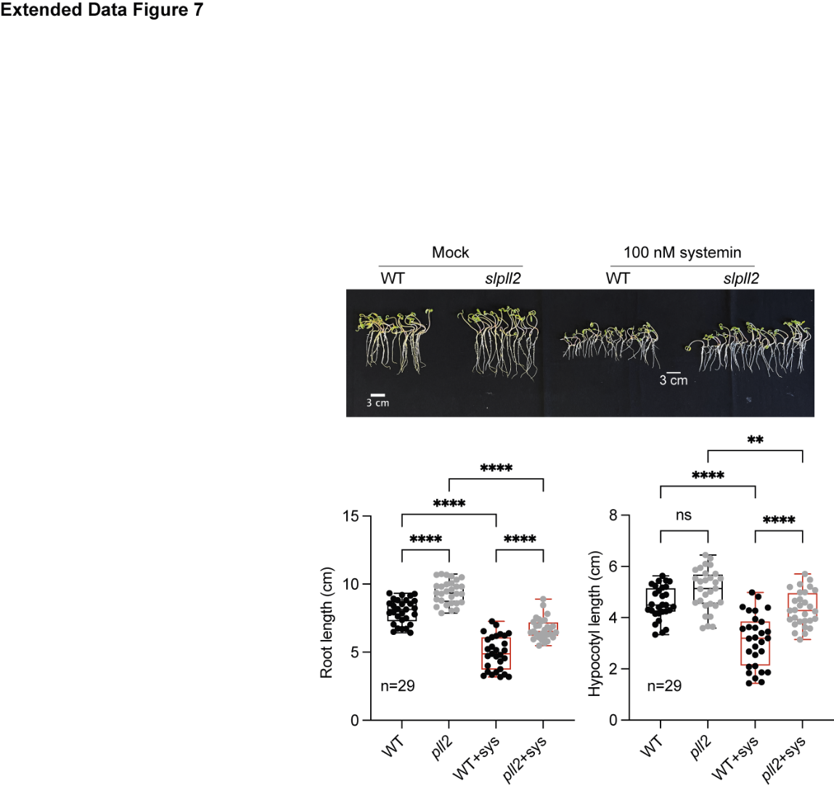
Extended Data Fig. 7 | Systemin-mediated inhibition of root and hypocotyl growth is reduced in pll2. Tomato wild-type (WT) and slpll2 seedlings were grown on ATS media with or without 100 nM systemin. After seven days of growth, root and hypocotyl length were determined in Fiji and analyzed by ANOVA followed by Tukey test. Asterisks indicate significant difference at **P < 0.01 and ****P < 0.0001; ns: not significant, n = 29 seedlings grown in three independent experiments. Box plots display the first and third quartiles split by the median; whiskers extend to include the maximum and minimum values.

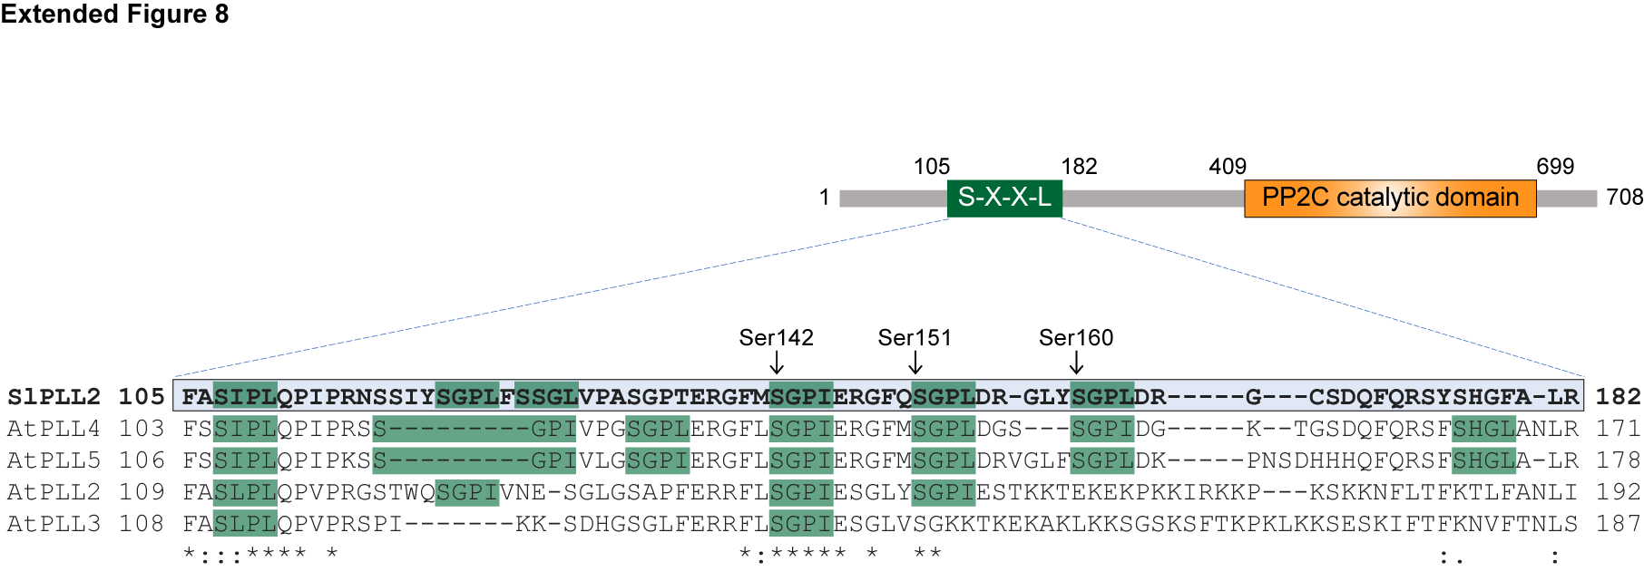

Extended Data Fig. 8 | Domain structure of SlPLL2 and conserved phosphorylation sites in its regulatory N-terminus. Regulatory phosphorylation sites are mostly conserved between tomato SlPLL2 and Arabidopsis PLL4/5 but differ in function. The sequence alignment shows seven predicted phosphorylation sites in the SXXL/I sequence context (green) in the N-terminal regulatory domain of PLLs. Six of these sites (mutated en block) were shown to be important for the AtPLL4/5 mediated inhibition of pattern-triggered immunity²⁷. Three of these sites, Ser142, Ser 151 and Ser 160 of SlPLL2, were found here to regulate SlPPL2 activity for the activation of herbivore defense signaling.

