Supplementary Materials (A1)

The topographic parameters
- TWI
TWI indicates the potential of wetness and flow accumulation in a basin (Riazi et al. 2023). This index shows the direction of flow under gravity at every point in basin that quantifies the wetness conditions of an area by considering the upslope contributing area and slope length. The flooding and the TWI have a direct association (Samanta et al. 2018). In addition, TWI displays the soil moisture conditions (Luu et al. 2023) that calculated as:
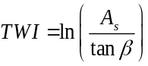 (1)
where As denotes the upslope area per unit of contour length (m²/m) and β characterizes the topographic gradient or local slope gradient in degree. TWI varies from 3.58 to 14.14 across WSP (Fig. 3(a)).

- Slope / Aspect / Elevation
Slope (Fig. 3(b)) plays a crucial role in flood dynamics and distribution. The slope of terrains influences generation surface runoff (khosravi, 2018) (Riazi et al. 2023), drainage patterns of basins, infiltration (Khaddari et al. 2023), erosion, and velocity of water flowing (Luu et al. 2023) aggravate the flood risk. Aspect (Fig. 3(c)) by affected on runoff directions and slope stability (Al-Juaidi 2023; Luu et al. 2023) is an essential flood conditioning factor (Hasan et al. 2023). The elevation (Fig. 3(d)) is one of the effective flash flood causative factors (Seydi et al. 2023) and is closely associated with flash flood generation (Luu et al. 2023).

- Curvature / Plan Curvature
The curvature represents topographical morphometric conditions (Luu et al. 2023) and has an important influence on the generation of runoff and erosion (Khosravi et al. 2019). This parameter is classified into three classes including flat, convex, and concave (Seydi et al. 2023). Areas with flat curvature are more likely to experience flooding (Tehrany et al. 2015a, b). The two main types of curvature are plan and profile curvature. In this study, plan curvature is used to describe how curvature appears along a horizontal plane (Saravanan and Abijith 2022). A positive curvature value indicates a convex slope gradient in the upward direction, while a negative value signifies a concave upward slope gradient. A curvature value of zero denotes the absence of curvature (Al-Juaidi 2023). The plan curvature map of the WSP ranges from -3.49 to 3.55 (Fig. 3(e)).

- Distance to river
Stream overflow is an importance factor on flash flood. Distances from drainage systems (stream network) are associated with flood spreads in basins (Al-Juaidi 2023). A flood-prone area is one that is adjacent to a river (Khosravi et al. 2018). When the distance to the stream is considerable, the likelihood of flood occurrence is diminished (Pham et al. 2020).
In this study, based on the Euclidean distance tool, the distance to the stream network map is segmented into four buffer zones. In Fig. 3(f), the distance ranged from 0 to 39160 m.

- Catchment Area
Catchment areas (Fig. 3(g)) have a strong association with flash flooding, which is a crucial parameter affecting flooding (Yin et al. 2023). In addition to affecting how runoff accumulates, and flows, this parameter can also affect the volume and speed of runoff (Gao et al. 2018).

The meteorological parameters
- Rainfall
Rainfall is one of the main forcing climatic factors that cause runoff generation (Nikolopoulos et al. 2011) and flash flooding (Khosravi et al. 2018; Abedi et al. 2022; Al-Juaidi 2023; Riazi et al. 2023). The magnitude of flooding increases proportionally with the amount of rain and snowfall at a given location. Estimating and mapping precipitation is an essential step in a flood susceptibility study, especially at the scale of a large watershed where climatological variables experience spatiotemporal changes (Khaddari et al. 2023). So, in the study, the daily rainfall of the ERA-5 Land was examined during long-term (2001-2020) (Fig. 4(a)). Quantile Mapping (QM) (Katiraie-Boroujerdy et al. 2020; Enayati et al. 2021), a popular algorithm for reducing systematic errors in climate model simulations, was used to minimize biases in the grid-based datasets opposing observations.

- Temperature
The inadequate number and incomplete coverage of the area, resulting from the inappropriate spatial distribution of temperature measurement stations in arid and semi-arid regions, led to the utilization of remotely sensed images in this study. The annual ERA5-Land grid-based temperature data for the region study in the period from 2001 to 2020 was selected. To minimize biases and enhance the accuracy of grid-based datasets, a bias-correction method (Mao et al. 2015; Ji et al. 2020) was implemented. For this purpose, QM was employed (Fig. 4(b)).

The water-related parameters
- SPI
The stream power index (SPI) is used to quantify the erosive power (Poudyal et al. 2010) (Luu et al. 2023) or potential erosion of surface runoff at specific points (Yang et al. 2023) and flowing surface water (Jebur et al. 2014), too. A higher SPI represents a higher stream power (Khosravi et al. 2019)(Yang et al. 2023). SPI is calculated using the following formula (Moore et al. 1991):
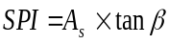 (2)
where A_{s} represents the area of a particular basin, and β denotes the local slope gradient, measured in degrees. The SPI values in this study region were from 0 to 2813528 (Fig. 5(a)).

- STI
Sediment Transport Index (STI) is defined as an indicator of the transportation of sediment in the stream networks (Rahmati et al. 2019). Specifically, it indicates the erosion and deposition processes of an area and considers the impact of topography on erosion. In addition, it describes the motions of waterborne sediments caused by water flow (Saravanan and Abijith 2022). STI varies from 0 to 9026 in the WSP, based on Fig. 5(b).
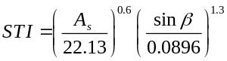 (3)

- Flow accumulation / MRVBF
Flow accumulation (Das 2018, 2020; Liu et al. 2021; Ahmed et al. 2023) results in an output raster illustrating the total cumulative flow received from upstream areas to a specific location inside the borders (Zhang et al. 2020). The Multi-resolution Valley Bottom Flatness (MRVBF), introduced by (Gallant and Dowling, 2003), aims to detect valley bottoms by employing a slope classification limited to convergent areas, which are more likely to contain water compared to simply low areas (Huang et al. 2014; Mueller et al. 2016). The Flow accumulation and MRVBF maps of the study region are shown in Figs. 5(c, d).

Geological Parameters
- Geology
The lithology conditions influence the hydrological properties of basins (Ward and Robinson 1975) such as flow accumulation (Luu et al. 2023), drainage pattern, overflow capacity (Bui et al. 2019), and infiltration (Hammami et al. 2019; Saravanan and Abijith 2022; Khaddari et al. 2023). Various lithology units exhibit varying levels of permeability and display varying susceptibilities to flooding (Lee et al. 2012; Choubin et al. 2019; Costache et al. 2020). The lithology map of WSP at the scale 1:100,000 collected from National Geoscience Database of Iran (Fig. 6(a)).

- Land use/land cover map (LULC)
The LULC affects flood susceptibility directly and/or indirectly through anthropogenic practices, such as desertification, deforestation, urbanization, and agriculture (Apollonio et al. 2016; Das 2020; Khaddari et al. 2023), and has a significant effect on flash flooding (Al-Juaidi 2023). LULC factor controls many important hydrological processes of the basin such as runoff, infiltration, evapotranspiration, and sediment (Seydi et al. 2023). LULC map was collected from Sentinel-2 with a 10 m resolution and by local data and terrain observations was modified. Based on LULC map (Fig. 6(b)), the WSP is consists of users: broadleaf forests, shrublands, grasslands, croplands, urban areas, sparse vegetation, Juniper forest, permanent water bodies, herbacious wetlands, haloxylon, salty land, and gardens.

Vegetation Parameter (NDVI)
NDVI indicates the coverage the region with vegetation that an inverse association between the NDVI and flash flooding is shown (Seydi et al. 2023). In other words, infiltration and runoff are reduced as the NDVI increases, indicating more vegetation coverage (Shafizadeh-Moghadam et al. 2018). The regions with the sparse vegetation coverage display high prone for flooding due to the low storage capacity of water (Caprario and Finotti 2019). Fig. 6(e) indicates that the NDVI values within the study region range from -0.01 to 1.

Soil Parameters
- Infiltration (Saturated hydraulic conductivity)
Saturated hydraulic conductivity (K_{s}) is a critical parameter in the prediction of soil hydraulic behavior that delineates the velocity of water flow. It characterizes the intrinsic capacity of soil to transmit water within saturated zones (Gootman et al. 2020). In addition to assessing the dynamics and quality of soil water, K_{s} stands as a fundamental determinant in understanding soil moisture dynamics (Arisanty et al. 2022).
To calculate K_{s}, the Pedotransfer Function (PTFs) (Gamie and De Smedt 2018; Rahmati et al. 2018) is employed along with soil physical characteristics, namely soil texture and soil organic matter (SOM) (Duan et al. 2012; Gootman et al. 2020), which are estimated using the DSM method. (Saxton and Rawls 2006) formula is a widely applied method for estimating K_{s} by PTFs approach that is modified based on organic matter content:

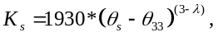 (4)
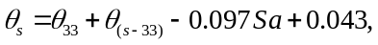 (5)
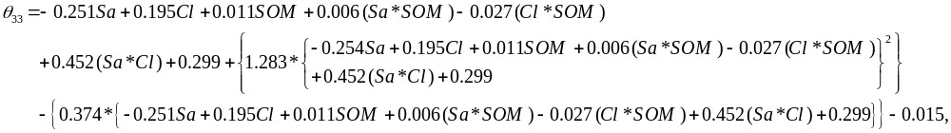 (6)
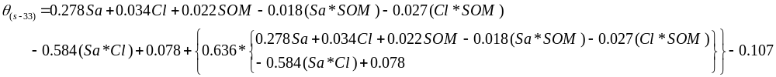
(7)
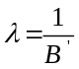 (8)
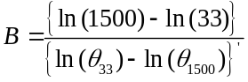 (9)
(10)

where K_{s} is saturated hydraulic conductivity (mmh⁻¹), SOM is soil organic matter content (%), Cl is clay (%), Sa is sand (%), θ_{s} is saturated soil moisture (%v), λ is slope of logarithmic tension-moisture curve (Arisanty et al. 2022). The maps of sand, silt, clay, soil organic matter and infiltration are shown in Fig. A 1.

- CN
The curve numbers (CN) were estimated by the US Soil Conservation Service (SCS) (SCS 1972) method. The inputs for the calculation of CN were hydrological soil groups and LULC map. The hydrological soil groups map was generated based on the infiltration maps. According to Fig. 6(d), CN values within the WSP range from 45 to 100.

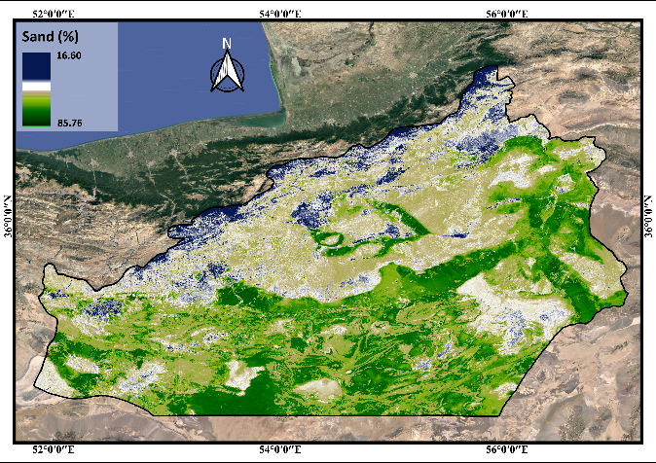  (a) Sand | 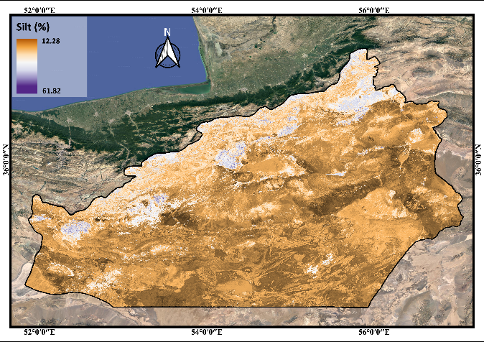  (b) Silt
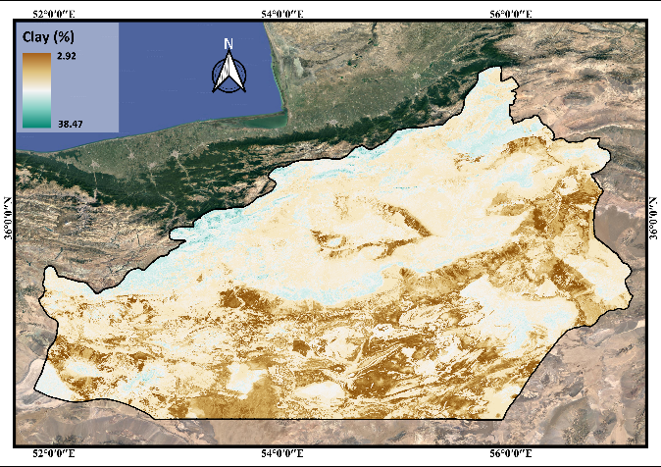  (c) Clay | 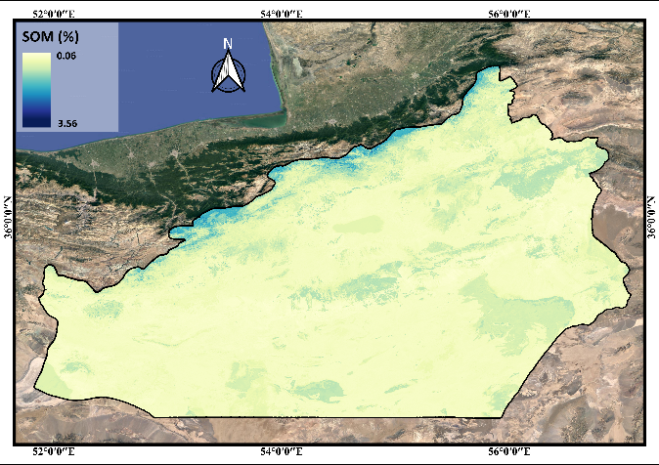  (d) SOM
Fig. A1 The soil parameters of flash flood causative factors in the WSP

References
Abedi R, Costache R, Shafizadeh-Moghadam H, Pham QB (2022) Flash-flood susceptibility mapping based on XGBoost, random forest and boosted regression trees. Geocarto Int 37:5479–5496. https://doi.org/10.1080/10106049.2021.1920636
Ahmed A, Al Maliki A, Hashim B, et al (2023) Flood susceptibility mapping utilizing the integration of geospatial and multivariate statistical analysis, Erbil area in Northern Iraq as a case study. Sci Rep 13:1–13. https://doi.org/10.1038/s41598-023-39290-4
Al-Juaidi AEM (2023) The interaction of topographic slope with various geo-environmental flood-causing factors on flood prediction and susceptibility mapping. Environmental Science and Pollution Research 30:59327–59348. https://doi.org/10.1007/s11356-023-26616-y
Apollonio C, Balacco G, Novelli A, et al (2016) Land use change impact on flooding areas: The case study of Cervaro Basin (Italy). Sustainability (Switzerland) 8:996. https://doi.org/10.3390/su8100996
Arisanty D, Rahmawati N, Rosadi D (2022) Soil Physical Characteristics and Saturated Hydraulic Conductivity in the Landform of Barito Delta, Kalimantan, Indonesia. Appl Environ Soil Sci 2022:. https://doi.org/10.1155/2022/9118461
Bui DT, Tsangaratos P, Ngo PTT, et al (2019) Flash flood susceptibility modeling using an optimized fuzzy rule based feature selection technique and tree based ensemble methods. Science of the Total Environment 668:1038–1054. https://doi.org/10.1016/j.scitotenv.2019.02.422
Caprario J, Finotti AR (2019) Socio-technological tool for mapping susceptibility to urban flooding. J Hydrol (Amst) 574:1152–1163. https://doi.org/10.1016/j.jhydrol.2019.05.005
Choubin B, Moradi E, Golshan M, et al (2019) An ensemble prediction of flood susceptibility using multivariate discriminant analysis, classification and regression trees, and support vector machines. Science of the Total Environment 651:2087–2096. https://doi.org/10.1016/j.scitotenv.2018.10.064
Costache R, Pham QB, Sharifi E, et al (2020) Flash-flood susceptibility assessment using multi-criteria decision making and machine learning supported by remote sensing and GIS techniques. Remote Sens (Basel) 12:106. https://doi.org/10.3390/RS12010106
Das S (2020) Flood susceptibility mapping of the Western Ghat coastal belt using multi-source geospatial data and analytical hierarchy process (AHP). Remote Sens Appl 20:100379. https://doi.org/10.1016/j.rsase.2020.100379
Das S (2018) Geographic information system and AHP-based flood hazard zonation of Vaitarna basin, Maharashtra, India. Arabian Journal of Geosciences 11:1–13. https://doi.org/10.1007/s12517-018-3933-4
Duan R, Fedler CB, Borrelli J (2012) Comparison of Methods to Estimate Saturated Hydraulic Conductivity in Texas Soils with Grass. Journal of Irrigation and Drainage Engineering 138:322–327. https://doi.org/10.1061/(ASCE)IR.1943-4774.0000407
Enayati M, Bozorg-Haddad O, Bazrafshan J, et al (2021) Bias correction capabilities of quantile mapping methods for rainfall and temperature variables. Journal of Water and Climate Change 12:401–419. https://doi.org/10.2166/wcc.2020.261
Gallant JC, Dowling TI (2003) A multiresolution index of valley bottom flatness for mapping depositional areas. Water Resour Res 39:. https://doi.org/10.1029/2002WR001426
Gamie R, De Smedt F (2018) Experimental and statistical study of saturated hydraulic conductivity and relations with other soil properties of a desert soil. Eur J Soil Sci 69:256–264. https://doi.org/10.1111/ejss.12519
Gao H, Cai H, Duan Z (2018) Understanding the impacts of catchment characteristics on the shape of the storage capacity curve and its influence on flood flows. Hydrology Research 49:90–106. https://doi.org/10.2166/nh.2017.245
Gootman KS, Kellner E, Hubbart JA (2020) A comparison and validation of saturated hydraulic conductivity models. Water (Switzerland) 12:2040. https://doi.org/10.3390/w12072040
Hammami S, Zouhri L, Souissi D, et al (2019) Application of the GIS based multi-criteria decision analysis and analytical hierarchy process (AHP) in the flood susceptibility mapping (Tunisia). Arabian Journal of Geosciences 12:1–16
Hasan MH, Ahmed A, Nafee KM, Hossen MA (2023) Use of machine learning algorithms to assess flood susceptibility in the coastal area of Bangladesh. Ocean Coast Manag 236:. https://doi.org/10.1016/j.ocecoaman.2023.106503
Huang C, Chen Y, Wu J (2014) Mapping spatio-temporal flood inundation dynamics at large riverbasin scale using time-series flow data and MODIS imagery. International Journal of Applied Earth Observation and Geoinformation 26:350–362. https://doi.org/10.1016/j.jag.2013.09.002
Jebur MN, Pradhan B, Tehrany MS (2014) Optimization of landslide conditioning factors using very high-resolution airborne laser scanning (LiDAR) data at catchment scale. Remote Sens Environ 152:150–165. https://doi.org/10.1016/j.rse.2014.05.013
Ji X, Li Y, Luo X, et al (2020) Evaluation of bias correction methods for APHRODITE data to improve hydrologic simulation in a large Himalayan basin. Atmos Res 242:104964. https://doi.org/10.1016/j.atmosres.2020.104964
Katiraie-Boroujerdy PS, Naeini MR, Asanjan AA, et al (2020) Bias correction of satellite-based precipitation estimations using quantile mapping approach in different climate regions of Iran. Remote Sens (Basel) 12:2102. https://doi.org/10.3390/rs12132102
Khaddari A, Jari A, Chakiri S, et al (2023) A Comparative Analysis of Analytical Hierarchy Process and Fuzzy Logic A Comparative Analysis of Analytical Hierarchy Process and Fuzzy Logic Modeling in Flood Susceptibility Mapping in the Assaka Watershed , Morocco. https://doi.org/10.12911/22998993/165958
Khosravi K, Pham BT, Chapi K, et al (2018) A comparative assessment of decision trees algorithms for flash flood susceptibility modeling at Haraz watershed, northern Iran. Science of the Total Environment 627:744–755. https://doi.org/10.1016/j.scitotenv.2018.01.266
Khosravi K, Shahabi H, Pham BT, et al (2019) A comparative assessment of flood susceptibility modeling using Multi-Criteria Decision-Making Analysis and Machine Learning Methods. J Hydrol (Amst) 573:311–323. https://doi.org/10.1016/j.jhydrol.2019.03.073
Lee MJ, Kang JE, Jeon S (2012) Application of frequency ratio model and validation for predictive flooded area susceptibility mapping using GIS. International Geoscience and Remote Sensing Symposium (IGARSS) 895–898. https://doi.org/10.1109/IGARSS.2012.6351414
Liu J, Xiong J, Cheng W, et al (2021) Assessment of Flood Susceptibility Using Support Vector Machine in the Belt and Road Region. Natural Hazards and Earth System Sciences Discussions 1–37
Luu C, Ha H, Bui QD, et al (2023) Flash flood and landslide susceptibility analysis for a mountainous roadway in Vietnam using spatial modeling. Quaternary Science Advances 11:100083. https://doi.org/10.1016/j.qsa.2023.100083
Mao G, Vogl S, Laux P, et al (2015) Stochastic bias correction of dynamically downscaled precipitation fields for Germany through Copula-based integration of gridded observation data. Hydrol Earth Syst Sci 19:1787–1806. https://doi.org/10.5194/hess-19-1787-2015
Moore ID, Grayson RB, Ladson AR (1991) Digital terrain modelling: A review of hydrological, geomorphological, and biological applications. Hydrol Process 5:3–30. https://doi.org/10.1002/hyp.3360050103
Mueller N, Lewis A, Roberts D, et al (2016) Water observations from space: Mapping surface water from 25 years of Landsat imagery across Australia. Remote Sens Environ 174:341–352. https://doi.org/10.1016/J.RSE.2015.11.003
Nikolopoulos EI, Anagnostou EN, Borga M, et al (2011) Sensitivity of a mountain basin flash flood to initial wetness condition and rainfall variability. J Hydrol (Amst) 402:165–178. https://doi.org/10.1016/J.JHYDROL.2010.12.020
Pham BT, Phong T Van, Nguyen HD, et al (2020) A comparative study of kernel logistic regression, radial basis function classifier, multinomial naive bayes, and logistic model tree for flash flood susceptibility mapping. Water (Switzerland) 12:239. https://doi.org/10.3390/w12010239
Poudyal CP, Chang C, Oh HJ, Lee S (2010) Landslide susceptibility maps comparing frequency ratio and artificial neural networks: A case study from the Nepal Himalaya. Environ Earth Sci 61:1049–1064. https://doi.org/10.1007/s12665-009-0426-5
Rahmati M, Weihermüller L, Vanderborght J, et al (2018) Development and analysis of the Soil Water Infiltration Global database. Earth Syst Sci Data 10:1237–1263. https://doi.org/10.5194/essd-10-1237-2018
Rahmati O, Kalantari Z, Samadi M, et al (2019) GIS-based site selection for check dams in watersheds: Considering geomorphometric and topo-hydrological factors. Sustainability (Switzerland) 11:5639. https://doi.org/10.3390/su11205639
Riazi M, Khosravi K, Shahedi K, et al (2023) Enhancing flood susceptibility modeling using multi-temporal SAR images, CHIRPS data, and hybrid machine learning algorithms. Science of the Total Environment 871:162066. https://doi.org/10.1016/j.scitotenv.2023.162066
Samanta S, Kumar D, Babita P (2018) Flood susceptibility analysis through remote sensing , GIS and frequency ratio model. Appl Water Sci 8:1–14. https://doi.org/10.1007/s13201-018-0710-1
Saravanan S, Abijith D (2022) Flood susceptibility mapping of Northeast coastal districts of Tamil Nadu India using Multi-source Geospatial data and Machine Learning techniques. Geocarto Int 37:15252–15281. https://doi.org/10.1080/10106049.2022.2096702
Saxton KE, Rawls WJ (2006) Soil Water Characteristic Estimates by Texture and Organic Matter for Hydrologic Solutions. Soil Science Society of America Journal 70:1569–1578. https://doi.org/10.2136/sssaj2005.0117
SCS (1972) SCS. (Soil Conservation Service), National Engineering Handbook
Seydi ST, Kanani-Sadat Y, Hasanlou M, et al (2023) Comparison of Machine Learning Algorithms for Flood Susceptibility Mapping. Remote Sens (Basel) 15:192. https://doi.org/10.3390/rs15010192
Shafizadeh-Moghadam H, Valavi R, Shahabi H, et al (2018) Novel forecasting approaches using combination of machine learning and statistical models for flood susceptibility mapping. J Environ Manage 217:1–11. https://doi.org/10.1016/j.jenvman.2018.03.089
Tehrany MS, Pradhan B, Jebur MN (2015a) Flood susceptibility analysis and its verification using a novel ensemble support vector machine and frequency ratio method. Stochastic Environmental Research and Risk Assessment 29:1149–1165. https://doi.org/10.1007/s00477-015-1021-9
Tehrany MS, Pradhan B, Mansor S, Ahmad N (2015b) Flood susceptibility assessment using GIS-based support vector machine model with different kernel types. Catena (Amst) 125:91–101. https://doi.org/10.1016/j.catena.2014.10.017
Ward RC, Robinson M (1975) Principles of hydrology, vol: 367. London: McGraw-Hill
Yang D, Zhang T, Arabameri A, et al (2023) Flash-flood susceptibility mapping: a novel credal decision tree-based ensemble approaches. Earth Sci Inform. https://doi.org/10.1007/s12145-023-01057-w
Yin Y, Zhang X, Guan Z, et al (2023) Flash flood susceptibility mapping based on catchments using an improved Blending machine learning approach. Hydrology Research 54:557–579. https://doi.org/10.2166/NH.2023.139
Zhang H, Cheng X, Jin L, et al (2020) A method for dynamical sub-watershed delimitating by no-fill digital elevation model and defined precipitation: A case study of Wuhan, China. Water (Switzerland) 12:486. https://doi.org/10.3390/w12020486

