Supporting information (SI)
SI table 1. Multivariate Cox proportional-hazards models of the collagen turnover markers PRO-C8, C3M, PRO-C3, rec1M, PRO-C8 and CA19-9 as continuous variable to predict overall survival (OS) and progression-free survival (PFS)
Pro-C8 (OS) | P-value | Hazard ratio | 95,0% CI for hazard ratio |  |  | CA19-9 Baseline (OS) | P-value | Hazard ratio | 95,0% CI for hazard ratio
Pro-C8 (OS) | P-value | Hazard ratio | Lower | Upper |  | CA19-9 Baseline (OS) | P-value | Hazard ratio | Lower | Upper
Age | 0,001 | 1,057 | 1,024 | 1,092 |  | Age | 0,001 | 1,049 | 1,020 | 1,080
PRO-C8 | 0,002 | 1,129 | 1,045 | 1,220 |  | CA19-9 Baseline | 0,078 | 1,000 | 1,000 | 1,000
Gender (male 0, female 1) | 0,191 | 0,627 | 0,312 | 1,261 |  | Gender (male 0, female 1) | 0,263 | 0,674 | 0,339 | 1,344
CA19-9 Baseline | 0,062 | 1,000 | 1,000 | 1,000 |  | height | 0,451 | 0,994 | 0,978 | 1,010
height | 0,254 | 0,990 | 0,974 | 1,007 |  | Weight | 0,789 | 0,996 | 0,968 | 1,025
Weight | 0,706 | 1,006 | 0,976 | 1,037 |  | CEA at baseline | 0,645 | 1,000 | 0,999 | 1,001
CEA at baseline | 0,550 | 1,000 | 0,999 | 1,001 |  | M status | 0,140 | 1,740 | 0,834 | 3,629
M status | 0,216 | 1,596 | 0,760 | 3,351
C3M (OS) | P-value | Hazard ratio | 95,0% CI for hazard ratio |  |  | PRO-C3 (OS) | P-value | Hazard ratio | 95,0% CI for hazard ratio
C3M (OS) | P-value | Hazard ratio | Lower | Upper |  | PRO-C3 (OS) | P-value | Hazard ratio | Lower | Upper
Age | 0,001 | 1,056 | 1,023 | 1,089 |  | Age | 0,003 | 1,047 | 1,016 | 1,079
Gender (male 0, female 1) | 0,379 | 0,734 | 0,368 | 1,464 |  | Gender (male 0, female 1) | 0,320 | 0,702 | 0,349 | 1,411
CA19-9 Baseline | 0,018 | 1,000 | 1,000 | 1,000 |  | CA19-9 Baseline | 0,844 | 1,000 | 1,000 | 1,000
height | 0,446 | 0,994 | 0,978 | 1,010 |  | height | 0,936 | 1,001 | 0,984 | 1,017
Weight | 0,883 | 1,002 | 0,973 | 1,032 |  | Weight | 0,248 | 0,983 | 0,955 | 1,012
CEA at baseline | 0,746 | 1,000 | 0,999 | 1,001 |  | CEA at baseline | 0,614 | 1,000 | 0,999 | 1,001
M status | 0,257 | 1,531 | 0,733 | 3,200 |  | M status | 0,040 | 2,285 | 1,038 | 5,027
C3M | 0,001 | 1,043 | 1,016 | 1,070 |  | PRO-C3 | 0,005 | 1,002 | 1,001 | 1,004
rec1M (OS) | P-value | Hazard ratio | 95,0% CI for hazard ratio |  |  | PRO-C8 (PFS) | P-value | Hazard ratio | 95,0% CI for hazard ratio
rec1M (OS) | P-value | Hazard ratio | Lower | Upper |  | PRO-C8 (PFS) | P-value | Hazard ratio | Lower | Upper
Age | <0,001 | 1,072 | 1,034 | 1,112 |  | Age | 0,012 | 1,043 | 1,009 | 1,078
Gender (male 0, female 1) | 0,080 | 0,539 | 0,270 | 1,077 |  | Gender (male 0, female 1) | 0,789 | 1,105 | 0,533 | 2,289
CA19-9 Baseline | 0,016 | 1,000 | 1,000 | 1,000 |  | CA19-9 Baseline | 0,387 | 1,000 | 1,000 | 1,000
height | 0,619 | 0,995 | 0,978 | 1,014 |  | height | 0,732 | 0,997 | 0,981 | 1,014
Weight | 0,878 | 0,998 | 0,967 | 1,029 |  | Weight | 0,863 | 1,003 | 0,972 | 1,034
CEA at baseline | 0,907 | 1,000 | 0,999 | 1,001 |  | CEA at baseline | 0,617 | 1,000 | 0,999 | 1,001
M status | 0,190 | 1,648 | 0,780 | 3,478 |  | M status | 0,247 | 1,591 | 0,725 | 3,494
reC1M | 0,034 | 1,007 | 1,000 | 1,013 |  | PRO-C8 | 0,022 | 1,091 | 1,012 | 1,176

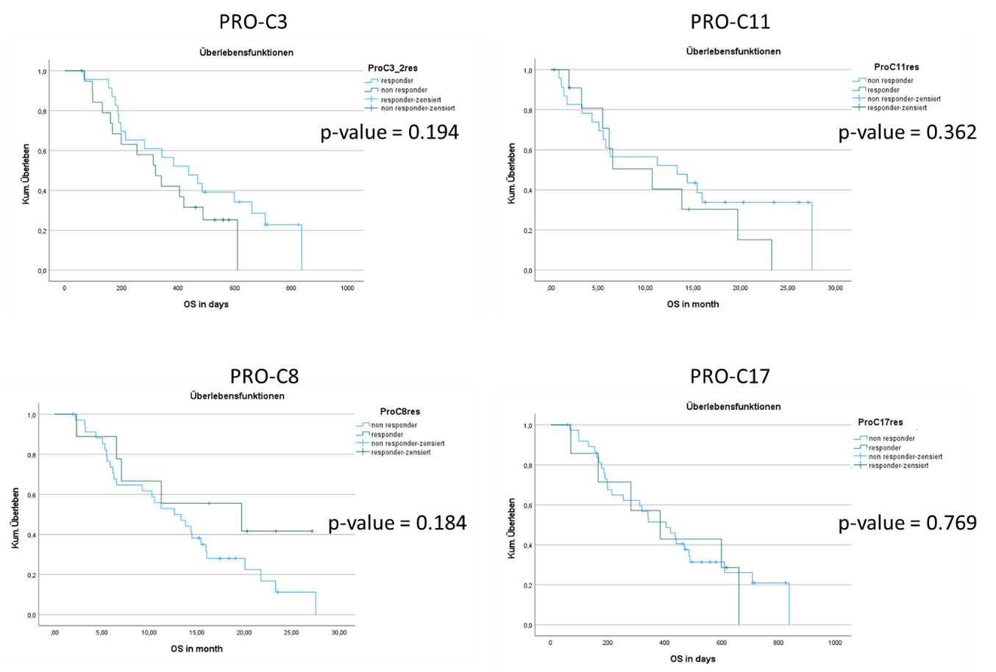
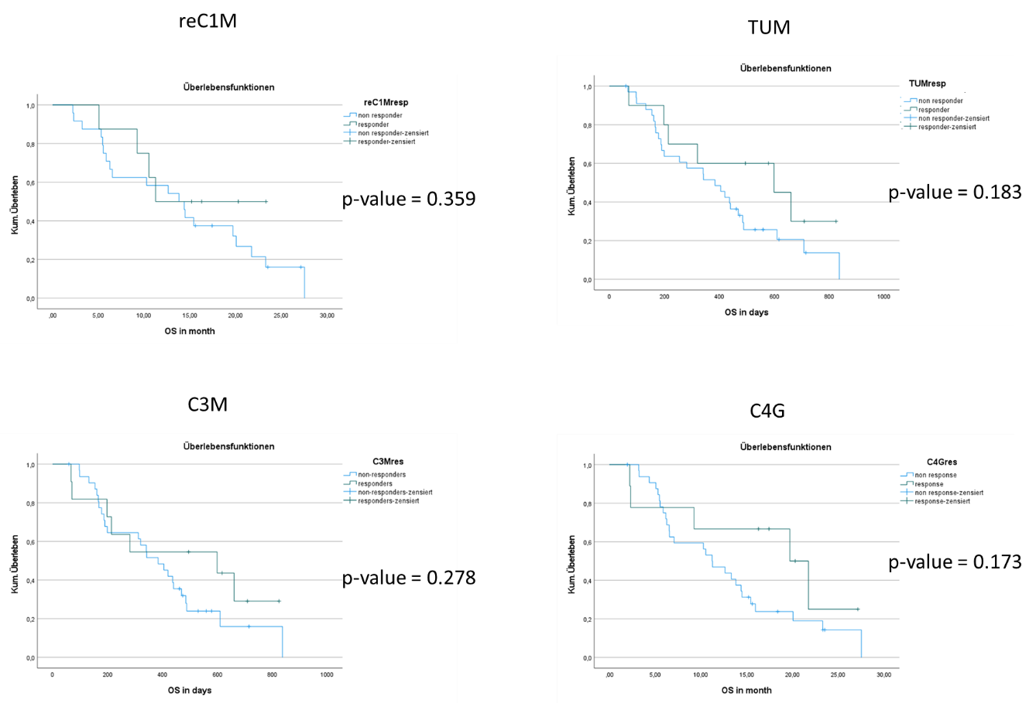
SI figure 1. Kaplan-Meier survival plots of patients with biliary tract cancer (BTC) who responded to chemotherapy with a ≤20 % reduction of biomarker levels after first chemotherapy compared to baseline versus non-responders.

