Hierarchically porous composites containing mining tailings-based geopolymer and zeolite 13X: application for carbon dioxide sequestration

Mariana Schneider^{1,2}, Enrique Rodríguez-Castellón², M. Olga Guerrero-Pérez³, Dachamir Hotza¹, Agenor De Noni Junior¹, Regina de Fátima Peralta Muniz Moreira¹*

¹ Department of Chemical Engineering and Food Engineering, Federal University of Santa Catarina, 88040-900 Florianópolis, SC, Brazil
² Department of Inorganic Chemistry Faculty of Sciences, University of Málaga, 29071 Málaga, Spain
³ Department of Chemical Engineering, Faculty of Sciences, University of Málaga, 29071 Málaga, Spain

*Corresponding author: R F P M Moreira (regina.moreira@ufsc.br)

Supplementary data

.
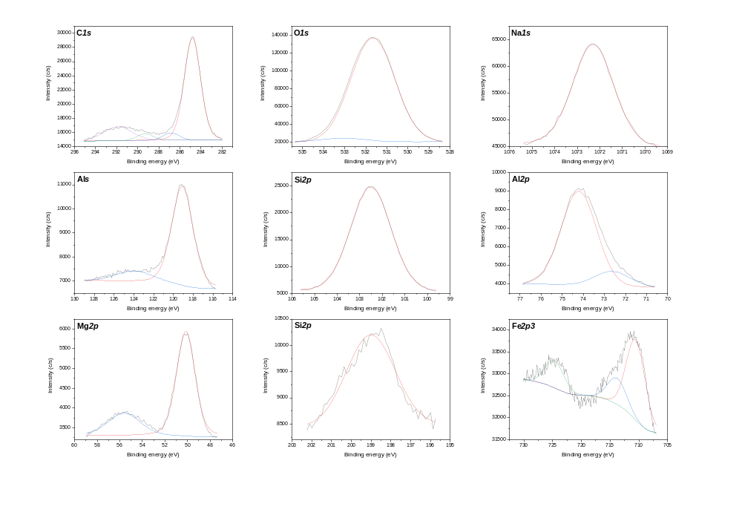
Figure 1S. Deconvolution spectra of the Z13X sample.

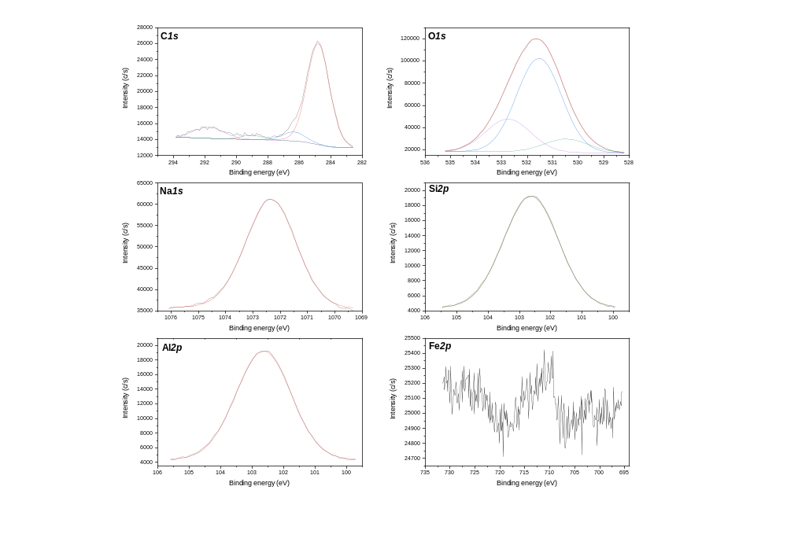
Figure 2S. Deconvolution spectra of the GP sample

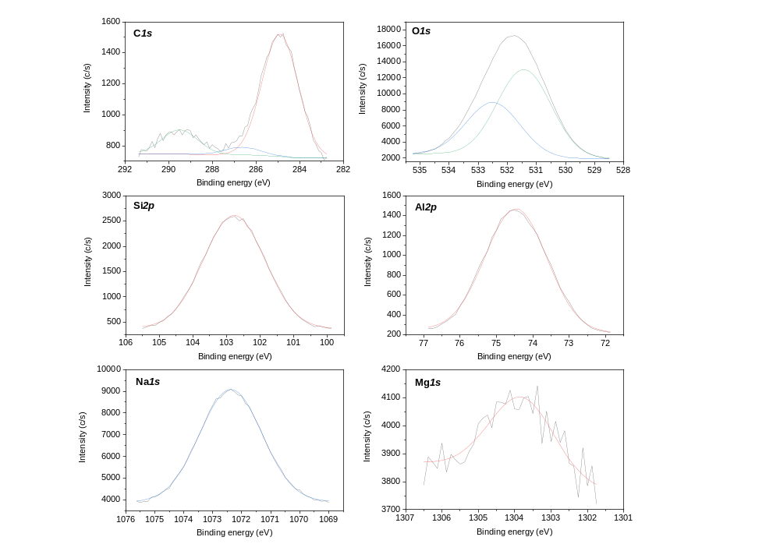 Figure 3S(a). Deconvolution spectra of the Z5 sample.

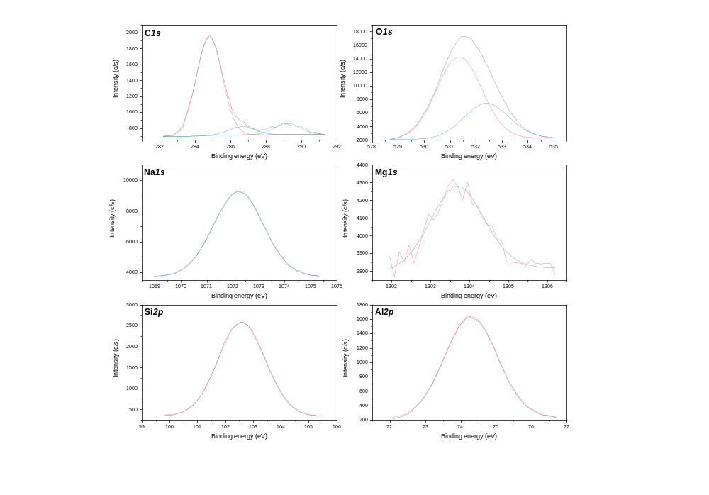
Figure 3S(b). Deconvolution spectra of the Z10 sample.

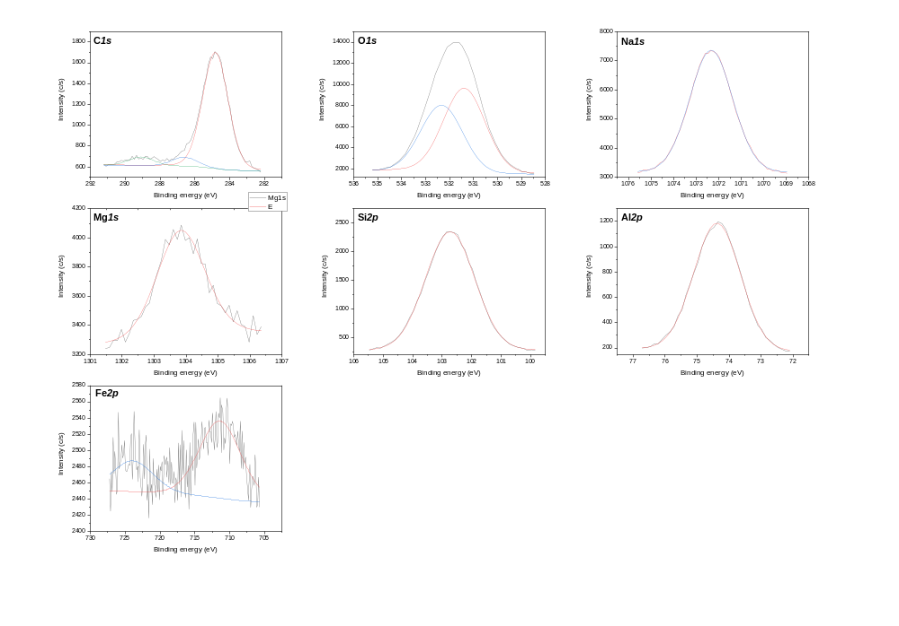
Figure 3S(c). Deconvolution spectra of the Z20 sample.
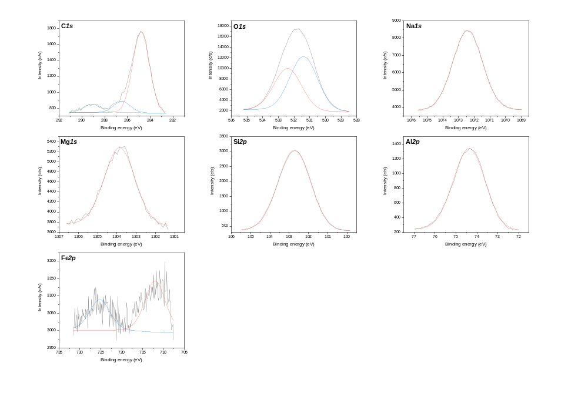
Figure 3S(d). Deconvolution spectra of the Z30 sample.

Table 1S. XPS quantification of the deconvoluted peaks.
 | Area peaks (%)
 | GP |  |  |  |  | Z13X |  |  |  | x | Z5 |  |  | x | Z10 |  |  |  | Z20 |  |  |  | Z30
C1s | 284.8 eV  77.59 | 286.4 eV  7.57 | 289.0 eV  3.41 | 291.3 eV  11.44 | x | 284.8 eV  72.24 | 286.9 eV  5.31 | 289.3 eV  4.82 | 291.9 eV  17.62 |  | 284.9 eV  79.33 | 286.6 eV  4.95 | 289.5 eV  15.72 |  | 284.8 eV  82.60 | 286.6 eV  7.61 | 289.2 eV  9.79 |  | 284.8 eV  86.80 | 286.6 eV  6.75 | 289.1 eV  6.45 |  | 284.8 eV  80.37 | 286.5 eV  11.09 | 289.1 eV  8.54
O1s | 530.5 eV  9.63 | 531.5 eV  67.05 | 532.8 eV  23.32 | - |  | 531.6 eV  96.37 | 533.1 eV  3.63 | - | - |  | 531.4 eV  62.40 | 532.5 eV  37.60 | - |  | 531.3 eV  69.63 | 532.4 eV  30.37 |  |  | 531.4 eV  56.80 | 532.3 eV  43.20 |  |  | 531.4 eV  56.82 | 532.4 eV  43.18
Na1s | 1072.6 eV  100 | - | - | - |  | 1072.3 eV  100 | - | - | - |  | 1072.8 eV  100 | - | - |  | 1072.2 eV  100 | - |  |  | 1072.3 eV  100 | - |  |  | 1072.4 eV  100 | -
Al2s | - | - | - | - |  | 119.1 eV  83.92 | 123.9 eV  16.08 | - | - |  |  |  | -
Mg1s |  |  |  |  |  |  |  |  |  |  | 1303.8 eV  100 |  |  |  | 1303.7 eV  100 |  |  |  | 1303.8 eV  100 |  |  |  | 1303.8 eV  100
Si2p | 102.4 eV  100 | - | - | - |  | 102.5 eV  100 | - | - | - |  | 102.7 eV  100 | - | - |  | 102.6 eV  100 | - |  |  | 102.7 eV  100 |  |  |  | 102.7 eV  100
Al2p | 74.3 eV  100 | - | - | - |  | 72.7 eV  13.83 | 74.2 eV  86.17 | - | - |  | 74.5 eV  100 |  | - |  | 74.3 eV  100 |  |  |  | 74.4 eV  100 |  |  |  | 74.4 eV  100
Mg2p | - | - | - | - |  | 50.2 eV  72.08 | 55.6 eV  27.92 | - | -
Fe2p | 711.1 eV  100 | - | - | - |  | 710.6 eV  60.09 | 713.8 eV  19.59 | 724.7 eV  20.32 | - |  |  |  |  |  |  |  |  |  | 711.4 eV  70.83 | 723.9 eV  29.17 |  |  | 712.0 eV  62.09 | 725.2 eV  37.91
Cl2p | - | - | - | - |  | 199.0 eV  100 | - | - | -

