Supplementary information for:

Artificial particles and soil communities change heterospecific plant-soil feedbacks interactively
Benedikt Speißer¹*, Stephanie Gurres^{1,2}, Rutger A. Wilschut³, Mark van Kleunen^{1,4}
¹Ecology, Department of Biology, University of Konstanz, 78464 Konstanz, Germany
²Systems Toxicology, Department of Biology, University of Konstanz, 78464 Konstanz, Germany
³Department of Nematology, Wageningen University and Research, 6708 PB Wageningen, The Netherlands
⁴Zhejiang Provincial Key Laboratory of Plant Evolutionary Ecology and Conservation, Taizhou University, Taizhou 318000, China
*corresponding author: benedikt.speisser@uni-konstanz.de
ORCID:
Benedikt Speißer: 0000-0003-0459-4304
Rutger A. Wilschut: 0000-0002-2559-9799
Mark van Kleunen: 0000-0002-2861-3701

Supplementary Results
PSF_{RD}:
For the plant-soil feedback effect on root diameter (PSF_{RD}), the results were in line with the pattern we found for PSF_{SRL} (C7 × soil community: p < 0.001; C9 × soil community: p = 0.03; Supplementary Figure 2A). For the initially depleted soil community, PSF_{RD} was positive for the low, but rather neutral for the high EPDM concentration (low: 0.23 ± 0.04, high: -0.05 ± 0.05). In contrast, for the intact community, PSF_{RD} was slightly negative for the low, but rather neutral for the high EPDM concentration (low: -0.09 ± 0.04, high: 0.03 ± 0.02). For the initially depleted community, PSF_{RD} was rather neutral for the low, but slightly positive for the high PHA concentration (low: 0.05 ± 0.04, high: 0.194 ± 0.04). For the intact community, PSF_{RD} was generally rather neutral (low: 0.01 ± 0.03, high: -0.03 ± 0.04).
PSF_{RTD}:
When the soil community had initially been depleted, the plant-soil feedback effect on root tissue density (PSF_{RTD}) was frequently positive, whereas it was frequently negative when the soil community was intact, but this was not true for all material-treatment combinations (Fig. 3B). We found very strong evidence that particle addition in general affected PSF_{RTD} interactively with the soil community (C1 × soil community: p < 0.001), but also that these effects differed between glass and microplastic particles (C2 × soil community: p < 0.001; Supplementary Figure 2B). For the initially depleted soil community, particle presence resulted in a positive PSF_{RTD} compared to a negative PSF_{RTD} in soil without added particles (particles absent: -0.35 ± 0.04, particles present: 0.29 ± 0.05). In contrast, for the intact community, particle addition tended to have a minor effect (particles absent: -0.10 ± 0.09, particles present: -0.13 ± 0.04). With regard to the material type, microplastics led to a weaker positive PSF_{RTD} compared to glass for the initially depleted community (glass: 0.59 ± 0.05, microplastics: 0.21 ± 0.06) but tended to have only a minor effect for the intact community (glass: -0.15 ± 0.07, microplastics: -0.13 ± 0.04). Further, there was strong evidence (C7 × soil community: p < 0.01) that, for the initially depleted community, the high EPDM concentration resulted in a shift from a positive to a slightly negative PSF_{RTD} (low: 0.29 ± 0.08, high: -0.13 ± 0.19). For the intact community, PSF_{RTD} was generally negative, but tended to be slightly weaker with the high EPDM concentration (low: -0.29 ± 0.14, high: -0.22 ± 0.1).

Supplementary Table 1 Results of linear mixed-effects models testing the effects of soil community (intact vs. initially depleted), different microplastics in low and high concentrations (material treatment), and the interaction of both factors on total plant biomass and root-weight ratio (RWR) of Centaurea jacea. Fixed effects were assessed using log-likelihood ratio tests (Zuur et al., 2009). Log-likelihood ratios (LLR) are approximately χ²-distributed. P values < 0.05 are indicated in bold, p values < 0.1 are indicated in italics.
 |  | Total biomass |  | RWR
Fixed effects | df | LLR | p | LLR | p
Initial leaf area | 1 | 3.40 | 0.065 | 6.81 | 0.009
Material treatment (M) | 10 | 33.95 | < 0.001 | 36.81 | < 0.001
Soil community (S) | 1 | 32.61 | < 0.001 | 7.41 | 0.006
M×S | 10 | 14.20 | 0.16 | 8.89 | 0.54
Random effects |  | SD |  | SD
Block |  | 0.0023 |  | 0.0362
Residual |  | 0.1951 |  | 0.0499

Supplementary Table 2 Results of linear mixed-effects models testing the effects of soil community (intact vs. initially depleted community), orthogonal contrasts comparing specific material treatment combinations (material type, i.e. glass and different microplastics, and low vs. high concentrations; Supplementary Table 3), and the interaction of both factors on total plant biomass and root-weight ratio (RWR) of Centaurea jacea. Fixed effects were assessed using log-likelihood ratio tests (Zuur et al., 2009). Log-likelihood ratios (LLR) are approximately χ²-distributed. P values < 0.05 are indicated in bold, p values < 0.1 are indicated in italics.
 |  | Total biomass |  | RWR
Fixed effects | df | LLR | p | LLR | p
Initial leaf area | 1 | 3.40 | 0.065 | 6.81 | 0.009
C1 (particles vs no particles) | 1 | 1.06 | 0.30 | 3.35 | 0.067
C2 (glass vs plastics) | 1 | 6.47 | 0.011 | 2.03 | 0.15
C3 (individual vs mixed plastics) | 1 | 2.30 | 0.13 | 6.08 | 0.013
C4 (degradable vs conventional) | 1 | 0.08 | 0.78 | 13.36 | < 0.001
C5 (PE vs EPDM) | 1 | 8.25 | 0.004 | 7.27 | 0.007
C6 (low vs high glass) | 1 | 0.00 | 0.97 | 6.28 | 0.012
C7 (low vs high EPDM) | 1 | 10.49 | 0.001 | 5.33 | 0.021
C8 (low vs high PE) | 1 | 1.23 | 0.27 | 0.78 | 0.38
C9 (low vs high PHA) | 1 | 4.93 | 0.026 | 0.22 | 0.64
C10 (low vs high mix) | 1 | 5.86 | 0.015 | 0.00 | 0.95
Soil community (S) | 1 | 32.61 | < 0.001 | 7.41 | 0.006
C1×S | 1 | 4.58 | 0.032 | 0.45 | 0.50
C2×S | 1 | 2.55 | 0.11 | 3.96 | 0.046
C3×S | 1 | 1.22 | 0.27 | 0.26 | 0.61
C4×S | 1 | 0.06 | 0.80 | 0.22 | 0.64
C5×S | 1 | 1.02 | 0.31 | 0.47 | 0.49
C6×S | 1 | 1.37 | 0.24 | 2.39 | 0.12
C7×S | 1 | 2.84 | 0.092 | 0.62 | 0.43
C8×S | 1 | 0.60 | 0.44 | 0.01 | 0.90
C9×S | 1 | 0.25 | 0.62 | 0.23 | 0.63
C10×S | 1 | 1.13 | 0.29 | 0.87 | 0.35
Random effects |  | SD |  | SD
Block |  | 0.0023 |  | 0.0361
Residual |  | 0.1951 |  | 0.0499

Supplementary Table 3 A priori orthogonal contrasts used to assess effects of different microplastics on plant-soil feedbacks. Capital C with number indicates the respective contrast and colors (grey vs. blue) represent the respective groups compared in each specific contrast. C1 tested the effect of particle addition by comparing the average of the grouped material treatments (low and high concentrations of glass and microplastics) to the control (no added material). C2 tested the overall effects of plastics by comparing the average of the grouped microplastics to the average of low and high glass. C3 tested the effect of mixing the plastic types by comparing the average of the low and high microplastic mix to the average of the grouped individual microplastics. C4 tested the effect of the biodegradable plastic by comparing the average of the low and high biodegradable PHA to the average of the grouped conventional plastics (EPDM and PE). C5 tested whether the two conventional plastics had different effects by comparing the average of the low and high EPDM to the average of the low and high PE. C6 to C10 compared the high vs. low concentration of each individual material type.
PSF contrast of the materials treatments
 | C1 | C2 | C3 | C4 | C5 | C6 | C7 | C8 | C9 | C10
Control
Glass low
Glass high
EPDM low
EPDM high
PE low
PE high
PHA low
PHA high
Mix low
Mix high

Supplementary Table 4 Results of linear mixed-effects models testing the effects of soil community (intact vs. initially depleted), material treatment (glass and different microplastics in low and high concentrations), and the interaction of both factors on PSF_{RD} (root diameter) and PSF_{RTD} (root-tissue density) for Crepis biennis. Fixed effects were assessed using log-likelihood ratio tests (Zuur et al., 2009). Log-likelihood ratios (LLR) are approximately χ²-distributed. P values < 0.05 are indicated in bold, p values < 0.1 are indicated in italics.
 |  | PSF_{RD} |  | PSF_{RTD}
Fixed effects | df | LLR | p | LLR | p
Initial leaf area | 1 | 0.12 | 0.73 | 3.79 | 0.051
Material treatment (M) | 10 | 3.83 | 0.95 | 35.28 | < 0.001
Soil community (S) | 1 | 26.42 | < 0.001 | 38.19 | < 0.001
M×S | 10 | 28.90 | 0.001 | 37.21 | < 0.001
Random effects |  | SD |  | SD
Block |  | 0.0172 |  | 0.0026
Residual |  | 0.0854 |  | 0.2594

Supplementary Table 5 Results of linear mixed-effects models testing the effects of soil community (intact vs. initially depleted), orthogonal contrasts comparing specific material treatment combinations (material type, i.e. glass and different microplastics, and low vs. high concentrations; Supplementary Table 3), and the interaction of both factors on PSF_{RD} (root diameter) and PSF_{RTD} (root-tissue density) for Crepis biennis. Fixed effects were assessed using log-likelihood ratio tests (Zuur et al., 2009). Log-likelihood ratios (LLR) are approximately χ²-distributed. P values < 0.05 are indicated in bold, p values < 0.1 are indicated in italics.
 |  | PSF_{RD} |  | PSF_{RTD}
Fixed effects | df | LLR | p | LLR | p
Initial leaf area | 1 | 0.12 | 0.73 | 3.80 | 0.051
C1 (particles vs no particles) | 1 | 0.82 | 0.36 | 13.55 | < 0.001
C2 (glass vs plastics) | 1 | 1.30 | 0.25 | 6.30 | 0.012
C3 (individual vs mixed plastics) | 1 | 0.28 | 0.60 | 5.49 | 0.019
C4 (degradable vs conventional) | 1 | 0.66 | 0.41 | 6.32 | 0.012
C5 (PE vs EPDM) | 1 | 0.01 | 0.92 | 0.54 | 0.46
C6 (low vs high glass) | 1 | 0.04 | 0.85 | 3.70 | 0.054
C7 (low vs high EPDM) | 1 | 0.01 | 0.94 | 2.11 | 0.15
C8 (low vs high PE) | 1 | 0.05 | 0.82 | 2.04 | 0.15
C9 (low vs high PHA) | 1 | 0.07 | 0.79 | 0.00 | 0.97
C10 (low vs high mix) | 1 | 0.49 | 0.48 | 0.12 | 0.73
Soil community (S) | 1 | 26.42 | < 0.001 | 38.19 | < 0.001
C1×S | 1 | 0.23 | 0.63 | 14.00 | < 0.001
C2×S | 1 | 0.54 | 0.46 | 12.15 | < 0.001
C3×S | 1 | 0.51 | 0.48 | 1.73 | 0.19
C4×S | 1 | 1.02 | 0.31 | 0.87 | 0.35
C5×S | 1 | 1.63 | 0.20 | 0.01 | 0.92
C6×S | 1 | 1.46 | 0.23 | 0.15 | 0.70
C7×S | 1 | 21.06 | < 0.001 | 6.74 | 0.009
C8×S | 1 | 0.03 | 0.86 | 1.60 | 0.21
C9×S | 1 | 4.84 | 0.028 | 0.42 | 0.52
C10×S | 1 | 0.10 | 0.75 | 3.63 | 0.057
Random effects |  | SD |  | SD
Block |  | 0.0172 |  | 0.0026
Residual |  | 0.0854 |  | 0.2594

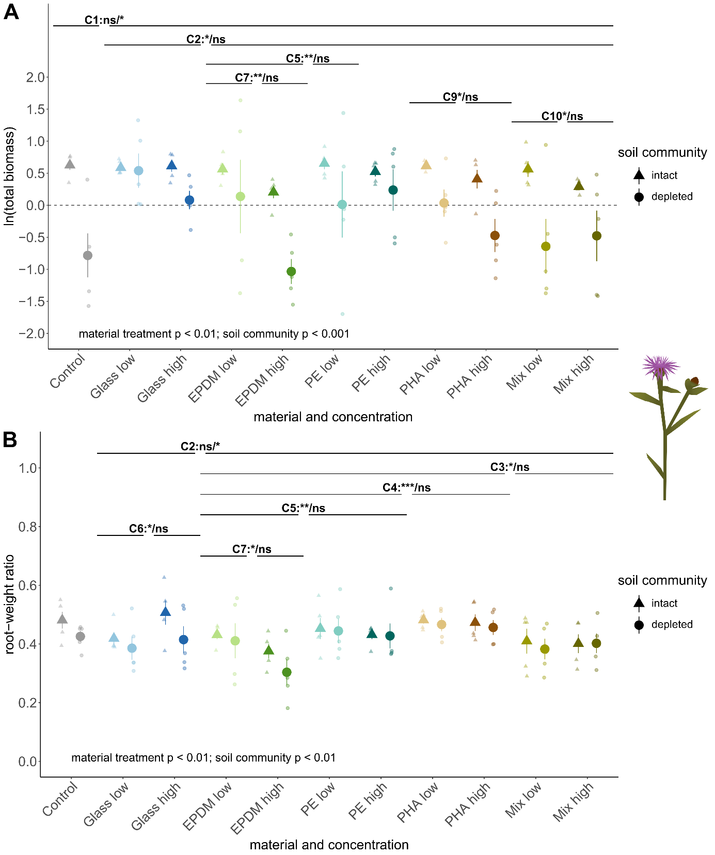

Supplementary Figure 1 Effects of different materials (indicated by different colors) in low (light colors) or high (dark colors) concentrations (A) and an intact or initially depleted soil community (B) on total plant biomass of Centaurea jacea during the conditioning phase. P values refer to basic models (Supplementary Table 1). Horizontal lines indicate significant results based on the contrast models (specific contrast: significance main contrast/significance contrast-soil-community interaction) and asterisks indicate which groups differ significantly from each other (Supplementary Table 2; *** p < 0.001, ** p < 0.01, * p < 0.05).

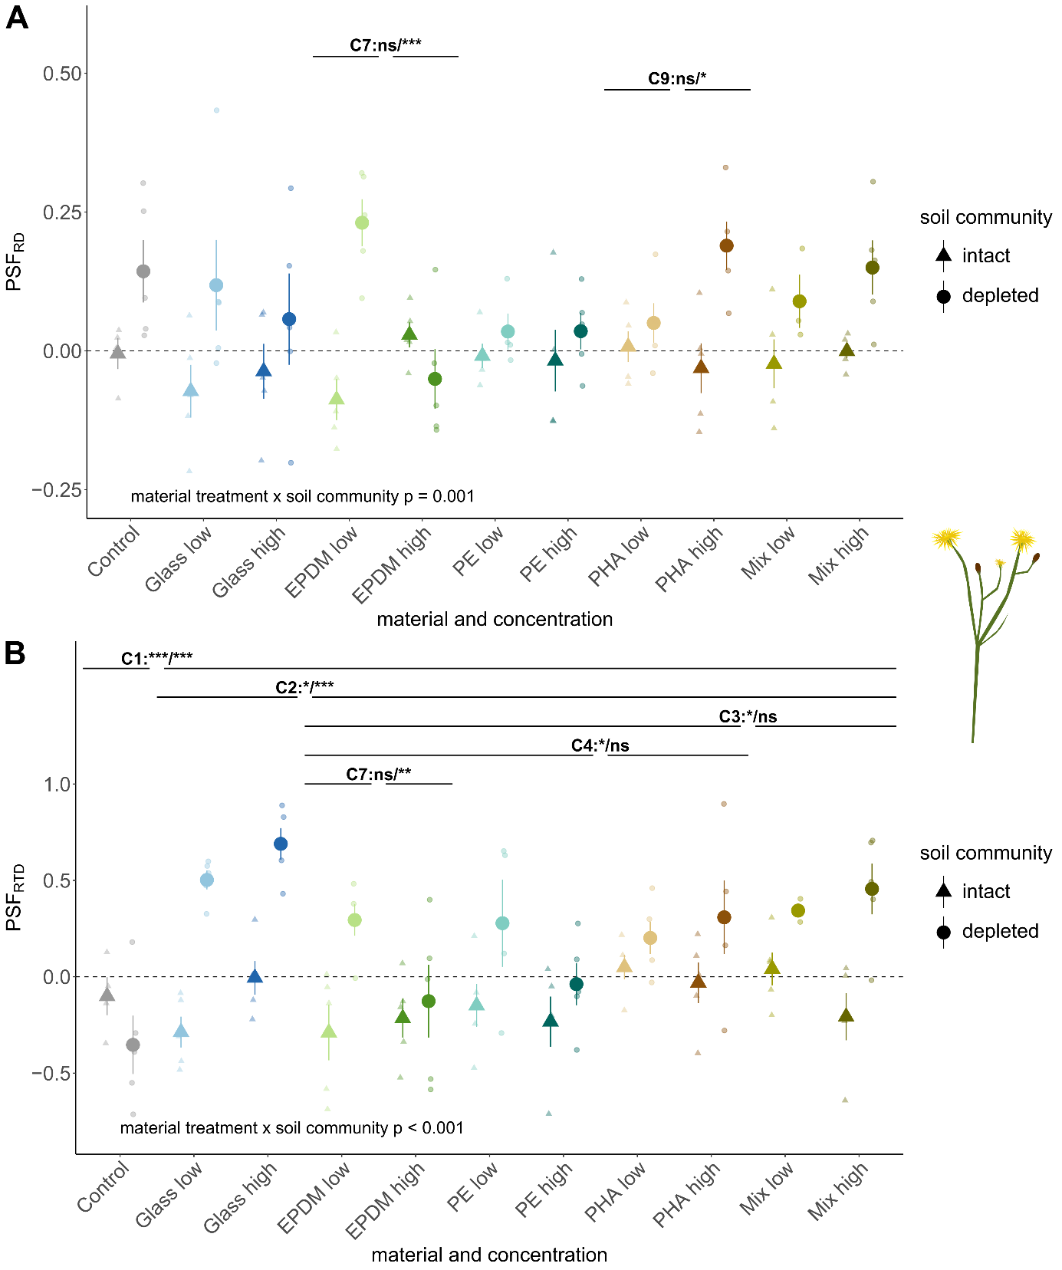Supplementary Figure 2 PSF root-morphology responses of Crepis biennis. Effects of different materials (different colors) in low (light colors) or high (dark colors) concentrations and intact (triangles) or initially depleted (circles) soil community on plant-soil feedbacks based on root diameter (PSF_{RD}; A) and root-tissue density (PSF_{RTD}; B). Large symbols represent mean values of the specific treatment group, error bars show the respective standard error. Small symbols represent individual replicates. P values refer to basic models (Supplementary Table 4). Horizontal lines indicate significant results based on the contrast models (specific contrast: significance main contrast/significance contrast-soil-community interaction) and asterisks indicate which groups differ significantly from each other (Supplementary Table 5; *** p < 0.001, ** p < 0.01, * p < 0.05).

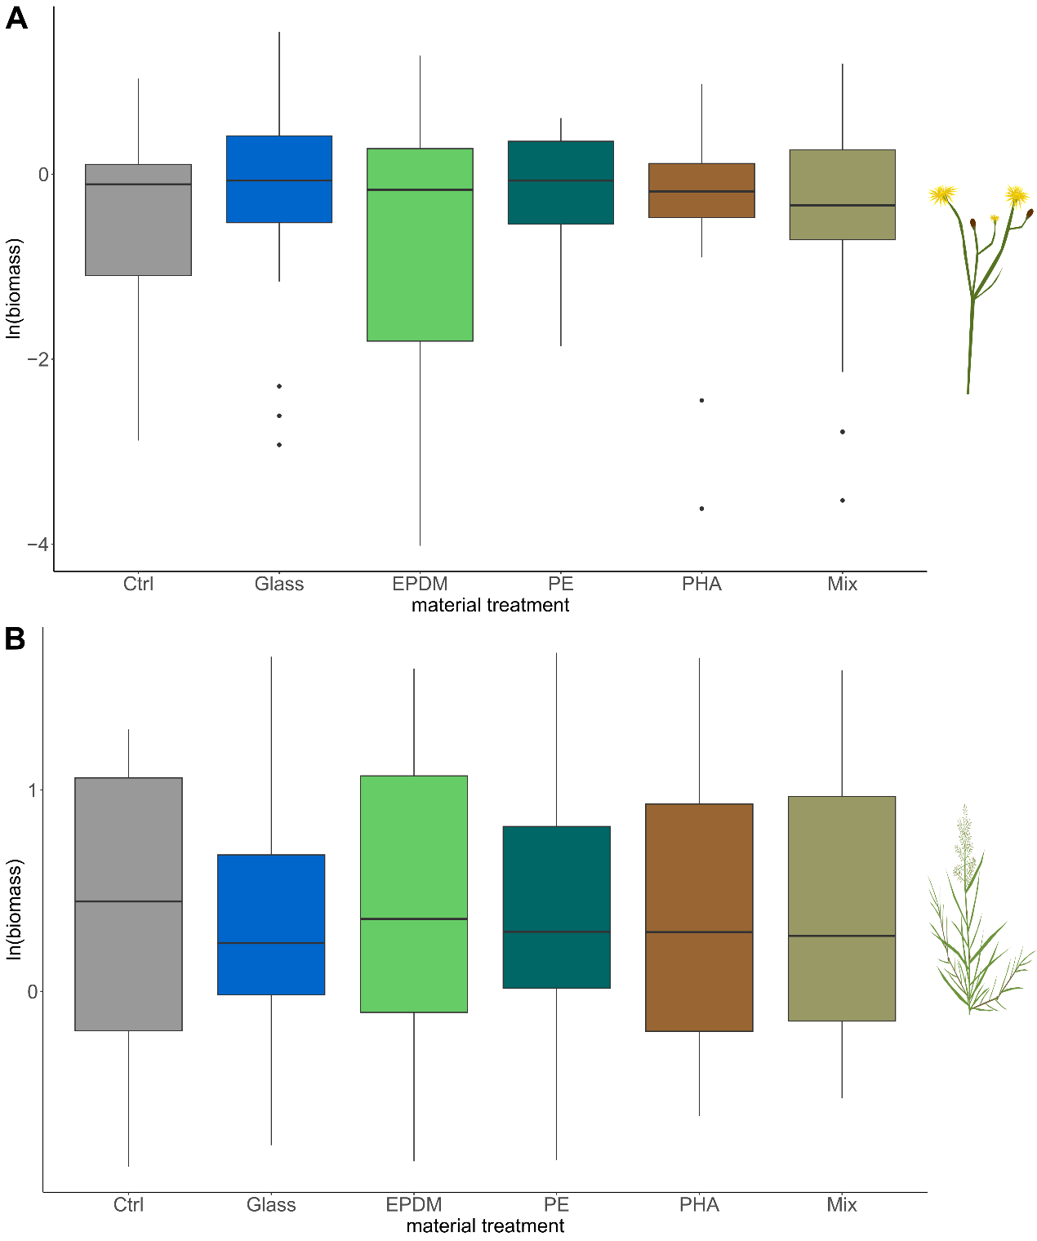
Supplementary Figure 3 Effects of glass and microplastic-particle addition on the productivity of Crepis biennis (A) and Eragrostis minor (B). There was no evidence for an overall effect of particle addition on plant productivity independent of soil conditioning or the initial state of the soil community.

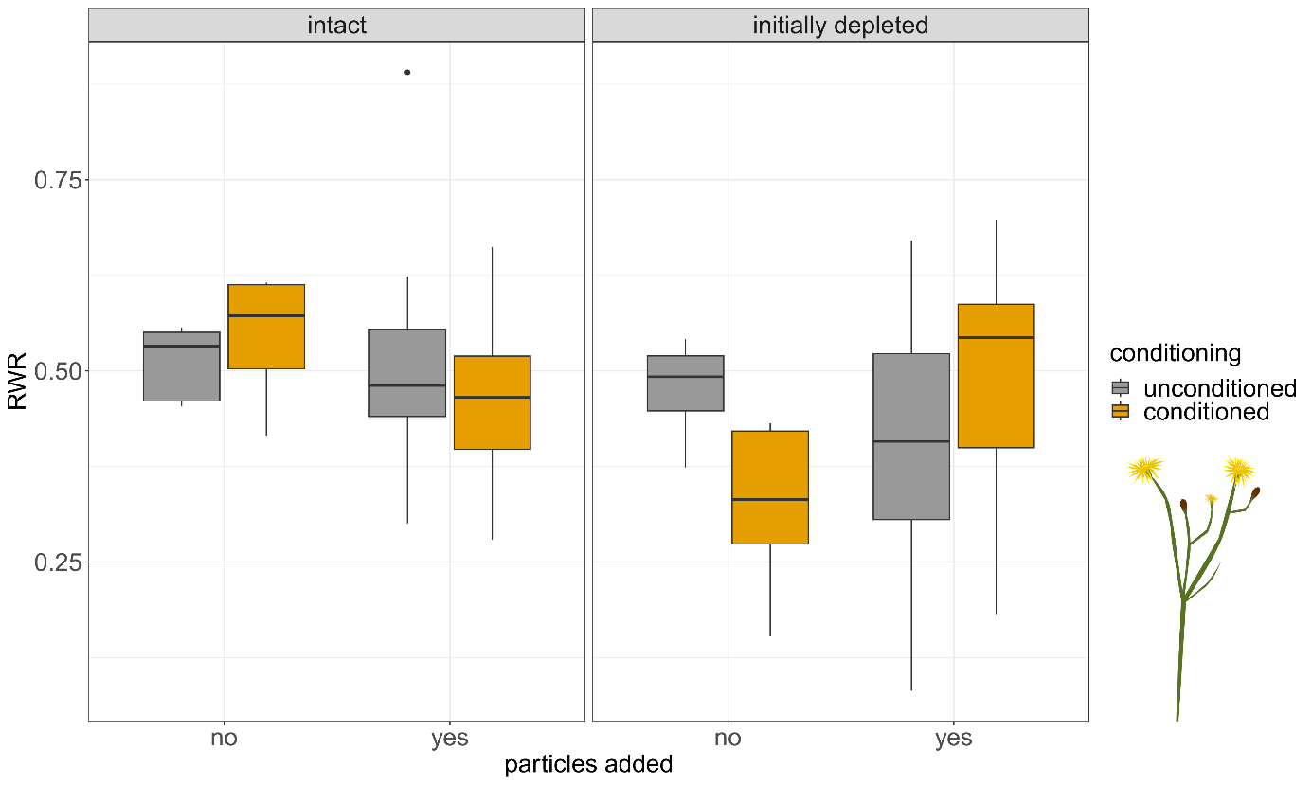Supplementary Figure 4 Root-weight ratio (RWR) of C. biennis depending on conditioning (colors), initial state of the soil community (panels), and particle addition (x-axis), i.e. contrast 1 (Supplementary Table 3). Lower RWR indicates proportionally lower root biomass.

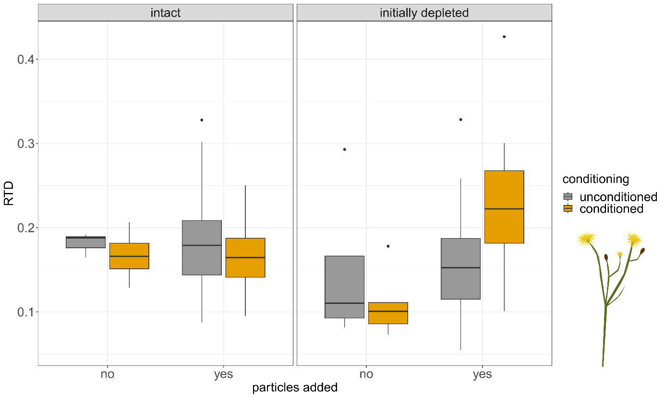Supplementary Figure 5 Root-tissue density (RTD) of C. biennis depending on conditioning (colors), initial state of the soil community (panels), and particle addition (x-axis), i.e. contrast 1 (Supplementary Table 3). Lower RTD indicates less dense roots (lower weight per volume).
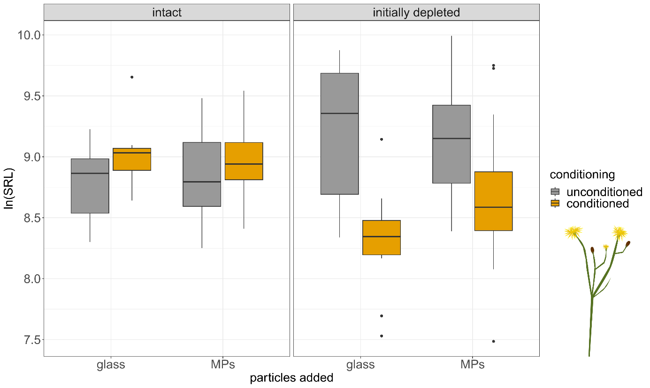
Supplementary Figure 6 Specific root length of C. biennis depending on conditioning (colors), initial state of the soil community (panels), and material type of added particles (x-axis), i.e. contrast 2 (Supplementary Table 3). Higher SRL indicates longer roots per root mass.

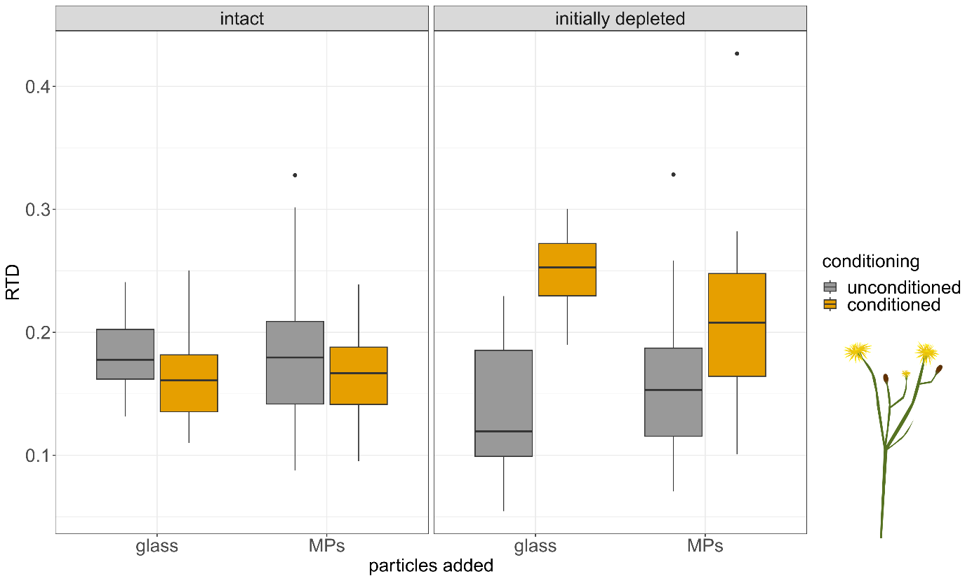
Supplementary Figure 7 Root-tissue density (RTD) of C. biennis depending on conditioning (colors), initial state the of soil community (panels), and material type of added particles (x-axis), i.e. contrast 2 (Supplementary Table 3). Lower RTD indicates less dense roots (lower weight per volume).

