Supplementary Material
Supplementary Figure 1. Coding sequence and amino acid sequence of McZFP1.
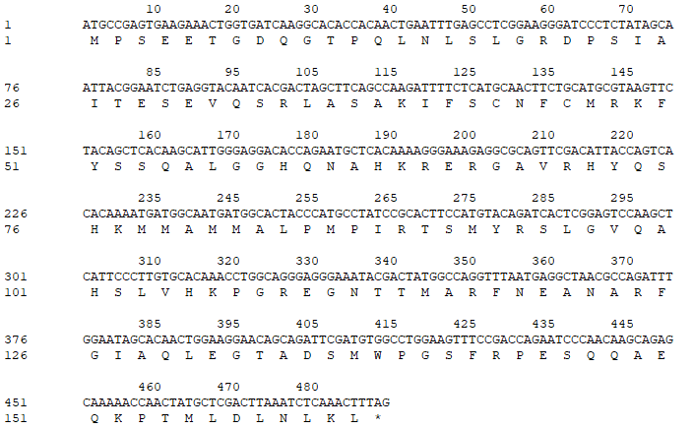

Supplementary Figure 2. The expression levels of McZFP1 in 7-day-old seedlings of WT, and McZFP1 overexpression (OE) lines analyzed by qRT-PCR.

Supplementary Figure 3. Overexpression of McZFP1 has no significant effect on seed germination under mannitol treatment. (A) The seeds germination phenotypes of WT and McZFP1 OE lines under control and mannitol treatment for 12 days. (B) The germination rate of WT and McZFP1 transgenic seeds germinated in 1/2 MS with 0 or 300 mM mannitol for 15 days.
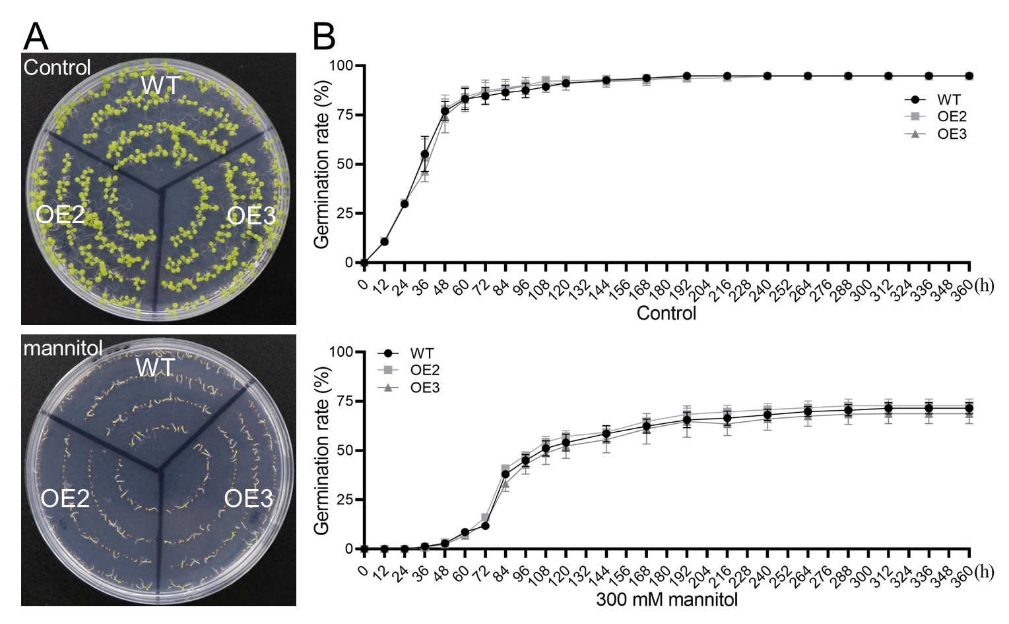

Supplementary Figure 4. Overexpression of McZFP1 increased ABA sensitivity in transgenic Arabidopsis. (A) The seeds germination phenotypes of WT and McZFP1 OE lines in 1/2 MS with 0, 1, and 2 μM ABA for 5 days. (B) The germination rate of WT and McZFP1 transgenic seeds germinated in 1/2 MS with 0, 1, and 2 μM ABA for 15 days.
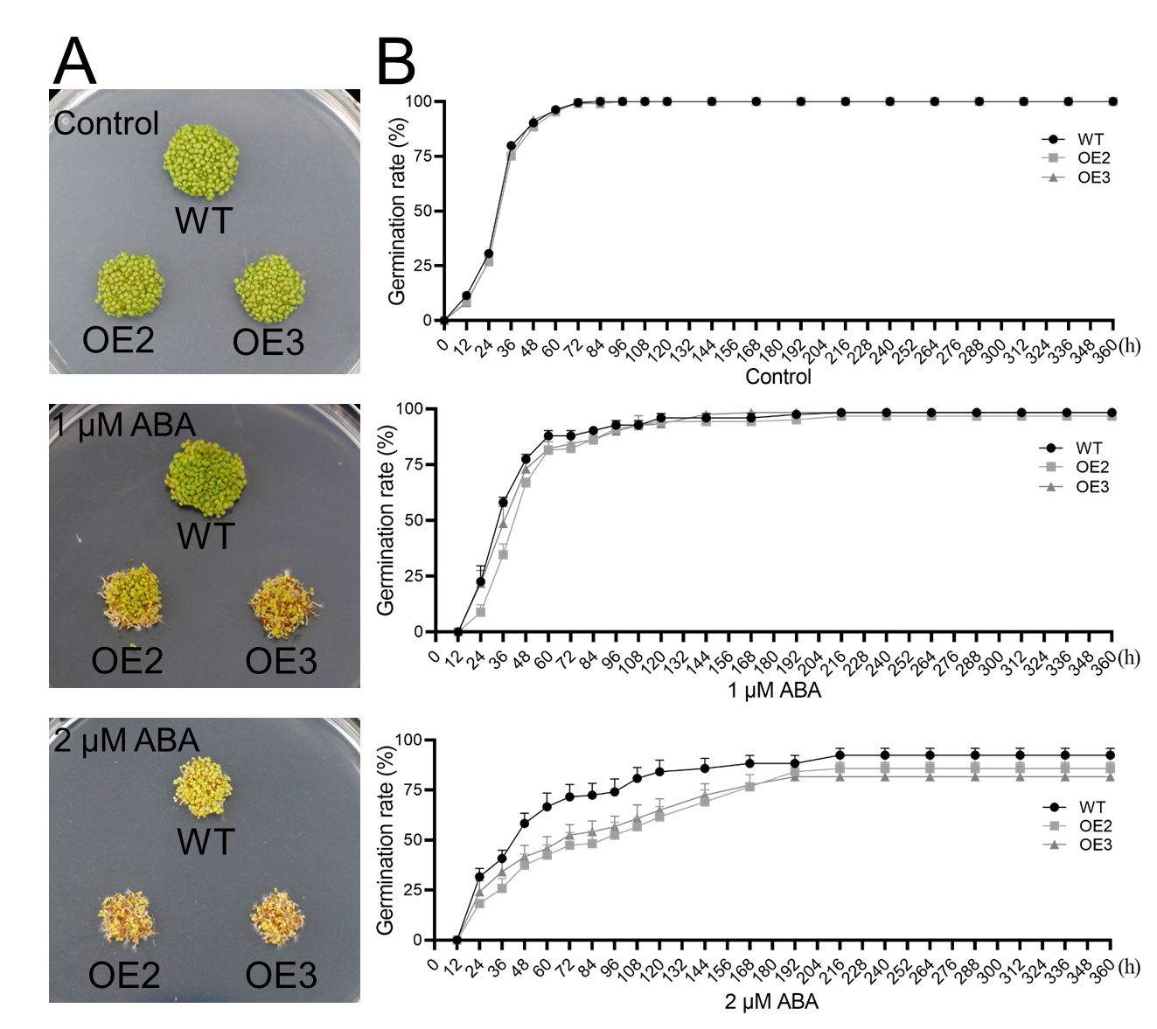

Supplementary Table 1 (Table S1). Details of gene primers used in this article.

 | Name |  | Sequence (5’-3’) | Description
 | McZFP1 | Forward | 5'-ATGCCGAGTGAAGAAACTG-3' | cDNA clone
 | McZFP1 | Reverse | 5'-CTTAAATCTCAAACTTTAG-3' | cDNA clone
 | McZFP1 OE | Forward | 5’-TTTGGAGAGGACACGCTCGAGATGCCGAGTGAAGAAACTG-3’ | pGate8-GFP
 | McZFP1 OE | Reverse | 5’-GCTCACCATGAATTCCTCGAGAAGTTTGAGATTTAAGTCG-3’ | pGate8-GFP
 | McZFP1-GFP | Forward | 5’-TTTGGAGAGGACACGCTCGAGATGCCGAGTGAAGAAACTG-3’ | pGate8-GFP
 | McZFP1-GFP | Reverse | 5’-GCTCACCATGAATTCCTCGAGAAGTTTGAGATTTAAGTCG-3’ | pGate8-GFP
 | BD-McZFP1 | Forward | 5’-ATGGCCATGGAGGCCGAATTCATGCCGAGTGAAGAAACTG-3’ | pGBKT7
 | BD-McZFP1 | Reverse | 5’-TCGACGGATCCCCGGGAATTCCTAAAGTTTGAGATTTAAG-3’ | pGBKT7
 | McZFP1 | Forward | 5’-TGCCGAGTGAAGAAACTGGT-3’ | real-time qRT-PCR
 | McZFP1 | Reverse | 5’-GCATTCTGGTGTCCTCCCAA-3’ | real-time qRT-PCR
 | McACTIN | Forward | 5’-GCTCCAAGGGCTGTGTTCC-3’ | real-time qRT-PCR
 | McACTIN | Reverse | 5’-TCTTTCTGTCCCATGCCAAC-3’ | real-time qRT-PCR
 | AtTCL1 | Forward | 5’-CCAAGTTCACTCATAGCTCTCA-3’ | real-time qRT-PCR
 | AtTCL1 | Reverse | 5’-CCCACCACTCTTCTTGCTATTA-3’ | real-time qRT-PCR
 | AtTCL2 | Forward | 5’-ATCTTTCGAATGCACAGACTTG-3’ | real-time qRT-PCR
 | AtTCL2 | Reverse | 5’-GTTTGTGGGAACAATGATCACA-3’ | real-time qRT-PCR
 | AtTRY | Forward | 5’-CGGTGATAGGTGGGATTTGATA-3’ | real-time qRT-PCR
 | AtTRY | Reverse | 5’-TGGTATGTTTGTGGGAAGATGA-3’ | real-time qRT-PCR
 | AtCPC | Forward | 5’-TGAGTAGTATCGAATGGGAAGC-3’ | real-time qRT-PCR
 | AtCPC | Reverse | 5’-GCCGTGTTTCATAAGCCAATAT-3’ | real-time qRT-PCR
 | AtETC1 | Forward | 5’-AGTCGAAGCATCTTAAGACCAA-3’ | real-time qRT-PCR
 | AtETC1 | Reverse | 5’-ACCTTTCACCGACAAGCTTATA-3’ | real-time qRT-PCR
 | AtETC2 | Forward | 5’-GCAAACTAAGTTCACTCGATCC-3’ | real-time qRT-PCR
 | AtETC2 | Reverse | 5’-CTCATTTGCCTTTCTTCCTACG-3’ | real-time qRT-PCR
 | AtETC3 | Forward | 5’-ACCAACTCCATCGTTACTTCTT-3’ | real-time qRT-PCR
 | AtETC3 | Reverse | 5’-GCATTCGAGAGACCAAATCTTC-3’ | real-time qRT-PCR
 | AtGL1 | Forward | 5’-ACTGGCTCAAAAAGATGTCCTA-3’ | real-time qRT-PCR
 | AtGL1 | Reverse | 5’-TAAGCTCAAAATCGTCGTCATG-3’ | real-time qRT-PCR
 | AtGL2 | Forward | 5’-TCTTTAGAGATGAAGCTCGTCG-3’ | real-time qRT-PCR
 | AtGL2 | Reverse | 5’-CTGTCTTGTCCCTTGGATAAGT-3’ | real-time qRT-PCR
 | AtGL3 | Forward | 5’-CAAAACGAGGAAGACGATTCAA-3’ | real-time qRT-PCR
 | AtGL3 | Reverse | 5’-CAACGCCTGAAGAAGAAGATTC-3’ | real-time qRT-PCR
 | AtEGL3 | Forward | 5’-ATCAGCGAATTGTATGAACAGC-3’ | real-time qRT-PCR
 | AtEGL3 | Reverse | 5’-TATCCGTTAGACCAGCATAACC-3’ | real-time qRT-PCR
 | AtTTG1 | Forward | 5’-TTCCTTCGATTGGAACGATGTA-3’ | real-time qRT-PCR
 | AtTTG1 | Reverse | 5’-GCAAGTCTTAACAAAGGCGTA-3’ | real-time qRT-PCR
 | AtTTG2 | Forward | 5’-AGAAGATGAGTGAAGGTTGTGT-3’ | real-time qRT-PCR
 | AtTTG2 | Reverse | 5’-GAATCTGAAGTTCCGGGATTTG-3’ | real-time qRT-PCR
 | AtWER | Forward | 5’-CACTGGAATCGTATTGCCAAAA-3’ | real-time qRT-PCR
 | AtWER | Reverse | 5’-ATAAGATCCTCTTCTTGCTCGG-3’ | real-time qRT-PCR
 | AtRHD6 | Forward | 5’-TAAAGATCCACAAAGCCTAGCA-3’ | real-time qRT-PCR
 | AtRHD6 | Reverse | 5’-GATTCGAATTCCTGTCTCGTTG-3’ | real-time qRT-PCR
 | AtRHD2 | Forward | 5’-GAGAACAGTCAGAGAACACGTA-3’ | real-time qRT-PCR
 | AtRHD2 | Reverse | 5’-TTCGTTTCAGCAAAGTAAGCTC-3’ | real-time qRT-PCR
 | AtRHD4 | Forward | 5’-TTTGTGGAGACTGAGCAAATTG-3’ | real-time qRT-PCR
 | AtRHD4 | Reverse | 5’-GCTTCTTCAGGTTGGACAATTT-3’ | real-time qRT-PCR
 | AtRSL1 | Forward | 5’-CAAACCATGGAAATGGAGACTG-3’ | real-time qRT-PCR
 | AtRSL1 | Reverse | 5’-GCTTGATCTTTCCATTCGTACC-3’ | real-time qRT-PCR
 | AtRSL2 | Forward | 5’-GCCTCTATGCAAGGAAAAGAAG-3’ | real-time qRT-PCR
 | AtRSL2 | Reverse | 5’-CGTAATGAACTGCTTCCTCAAG-3’ | real-time qRT-PCR
 | AtRSL4 | Forward | 5’-CTGATCCTCAAAGCCTTTATGC-3’ | real-time qRT-PCR
 | AtRSL4 | Reverse | 5’-AATGGTGCGTACATCCATAGAT-3’ | real-time qRT-PCR
 | AtLRL1 | Forward | 5’-CTAAAATCCGAGCTAGGAGAGG-3’ | real-time qRT-PCR
 | AtLRL1 | Reverse | 5’-CGATGCCTTGTCTGTCTTATTG-3’ | real-time qRT-PCR
 | AtLRL2 | Forward | 5’-CAGCCATGCAATATCTACAAGG-3’ | real-time qRT-PCR
 | AtLRL2 | Reverse | 5’-GGTATCTTTAACGAAGGGGCTA-3’ | real-time qRT-PCR
 | AtLRL3 | Forward | 5’-ACAATCTCTTTTCCACGCTCTA-3’ | real-time qRT-PCR
 | AtLRL3 | Reverse | 5’-TTCTTGGAGAGACTTCATACGC-3’ | real-time qRT-PCR
 | AtEIL1 | Forward | 5’-TTGAAGAAAGCTTGGAAAGTCG-3’ | real-time qRT-PCR
 | AtEIL1 | Reverse | 5’-TTTGATTGCCTCACAAGCTTAC-3’ | real-time qRT-PCR
 | AtEIN3 | Forward | 5’-CTGCAGATCACAACAACTTTGA-3’ | real-time qRT-PCR
 | AtEIN3 | Reverse | 5’-CATCCATCGTTCCTACTACTCC-3’ | real-time qRT-PCR
 | AtZFP1 | Forward | 5’-TCTATAGTTCACAAGCGCTAGG-3’ | real-time qRT-PCR
 | AtZFP1 | Reverse | 5’-CAAGGAGGAGAGAGTCATCTTG-3’ | real-time qRT-PCR
 | AtZFP3 | Forward | 5’-AGACGAAGAAAGAGACGTTCAT-3’ | real-time qRT-PCR
 | AtZFP3 | Reverse | 5’-TCTGTGGATGTTGTAGATTCGT-3’ | real-time qRT-PCR
 | AtZFP5 | Forward | 5’-TAACGACGTCATTTCAGAGACA-3’ | real-time qRT-PCR
 | AtZFP5 | Reverse | 5’-GACCAATCTTCGTTGTACACAC-3’ | real-time qRT-PCR
 | AtZFP6 | Forward | 5’-TTAAACGTGCACAGATGTTAGC-3’ | real-time qRT-PCR
 | AtZFP6 | Reverse | 5’-AAGCCACTTAGAACTCGAAGAA-3’ | real-time qRT-PCR
 | AtZFP8 | Forward | 5’-CGGAAGCTAGATCATACTACGG-3’ | real-time qRT-PCR
 | AtZFP8 | Reverse | 5’-ACCTAAAGGACTTCCGTTGATT-3’ | real-time qRT-PCR
 | AtGIS | Forward | 5’-CAGTTAGGACTATGGCGTCTAC-3’ | real-time qRT-PCR
 | AtGIS | Reverse | 5’-ATAGTTGAGTTTGAGAACGGGT-3’ | real-time qRT-PCR
 | AtGIS2 | Forward | 5’-AAAACCACATTGCTGCTTCTAG-3’ | real-time qRT-PCR
 | AtGIS2 | Reverse | 5’-TACGACATAACCCTAATCTCGC-3’ | real-time qRT-PCR
 | AtGIS3 | Forward | 5’-GAAAGAGCGTCAACAGCTTAAA-3’ | real-time qRT-PCR
 | AtGIS3 | Reverse | 5’-CTGATCCAGCGTTTGAGAAATT-3’ | real-time qRT-PCR
 | AtZP1 | Forward | 5’-CCTTTGAGCAAGACACTAAAGG-3’ | real-time qRT-PCR
 | AtZP1 | Reverse | 5’-TTACTCGCCGTGGATTGTATTA-3’ | real-time qRT-PCR
 | AtDREB1A | Forward | 5’-CGTTTCAGGATGAGATGTGTGA-3’ | real-time qRT-PCR
 | AtDREB1A | Reverse | 5’-CTCATCGTGCATATAAAACGCA-3’ | real-time qRT-PCR
AtRD29A |  | Forward | 5’-TTCTGTAAGGACGACGTTTACA-3’ | real-time qRT-PCR
 |  | Reverse | 5’-CGTACTCGTTACATCCTCTGTT-3’ | real-time qRT-PCR
AtRD29B |  | Forward | 5’-GAAACCAAAGATGAGTCGACAC-3’ | real-time qRT-PCR
 |  | Reverse | 5’-TTTTTCGTAAACCGGAGTCAAC-3’ | real-time qRT-PCR
AtRAB18 |  | Forward | 5’-GGAGGAAGAAGGGAATAACACA-3’ | real-time qRT-PCR
 |  | Reverse | 5’-GGGAAGCTTTTCCTTGATCTTG-3’ | real-time qRT-PCR
AtCOR15A |  | Forward | 5’-CATTAGCAGATGGTGAGAAAGC-3’ | real-time qRT-PCR
 |  | Reverse | 5’-TCTCAGCTTCTTTACCCAATGT-3’ | real-time qRT-PCR
AtCOR15B |  | Forward | 5’-GATGGCGAGAAAACAAAAGACT-3’ | real-time qRT-PCR
 |  | Reverse | 5’-CTTCTGCTTTACCCTCTACGAA-3’ | real-time qRT-PCR
 | AtACTIN2 | Forward | 5’-GACCTTGCTGGACGTGACCTTAC-3’ | real-time qRT-PCR
 | AtACTIN2 | Reverse | 5’-GTAGTCAACAGCAACAAAGGAGAGC-3’ | real-time qRT-PCR

